

Cover Page
BMHP5014:
Component 1
CHANGEMAKERS: CREATIVITY and VALUE CREATION
Zarah Ahmed
Davina Sawyers
Student Number: 2407363

Task 1 – Concept Map

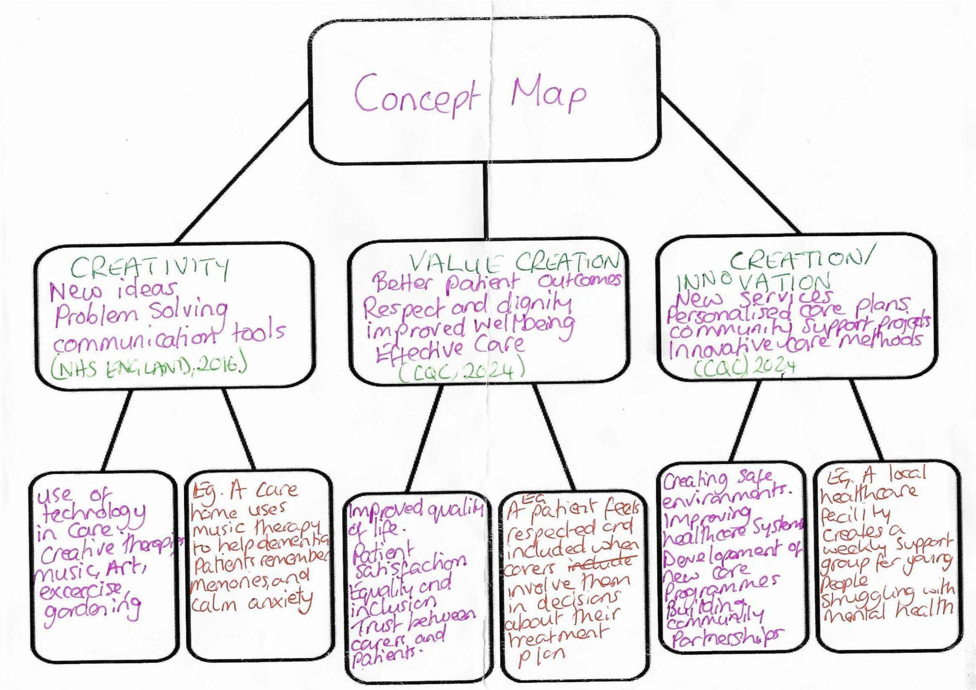

Creativity
Creativity is important in Health and social care because it helps professionals improve the quality of care and meet individuals' needs. Creativity means to use new ideas, problem-solving skills, and different approaches to help support individuals in a person-centred care way. For example, care workers may use music therapy, art, or digital communication to help patients feel more comfortable and included. (NHS England 2016)
Value Creation
Value in Health and social care means providing effective, safe, and person-centred care which is beneficial to individuals and communities. Creative ideas and value because they can improve the patients' experiences and create good relationships between the carer and patient. When patients feel respected and involved in their care, they are more likely to be trusting of professionals and engage with their treatment plan. This can lead to a higher quality of care and overall improved well-being. ( CQC, 2024)

Creation/Innovation
Creation is the act of developing new services, systems, or activities to meet societal evolution. In Health and social care, creation may include support groups and healthcare technology. Creativity and value creation are closely connected to creation because creative ideas lead to improved services. Therefore, creativity and value creation all work together to support person-centred care and positive outcomes in health and social care. ( CQC, 2024 ). An important innovation of this would be the use of AI ( artificial intelligence) in adult social care. For example, remote monitoring could alert a nurse or member of staff if an elderly patient were to fall. Research found that digitally mature healthcare providers operate approximately 10% more efficiently than those who are less digitally mature organisations (Department of Health and Social Care, 2022)

Task 2 - Self-Reflection of Group Activity

Convergent/Divergent
Description
In class today, we did an activity involving paperclips and what we could make out of them by brainstorming and coming up with ideas. I had a partner in this task, also.
Feelings
The first thing we did was recognise and understand the task. Initially, I thought it was a silly idea and that there wasn’t much that could be done with such a basic item. My partner, however, seemed more optimistic, which then led me to think a bit more positively in terms of thinking outside the box.
Analysis
Divergent thinking helps to be more creative and explorative when tackling a problem or a task, looking at things from all angles and creating ideas. (Runco, 2012). Convergent thinking is just using one solution and focusing on that. (Killgore, 2010)
On beginning the task, I began to actually enjoy thinking of different ways to make something out of essentially nothing; it lightened the lesson. The only downside was that there wasn’t too much scope for creativity with such a basic object.
Gibbs reflective cycle
Using Gibbs’ reflective model, I was able to assess and reflect on the task. Gibbs’ Reflective Cycle is a framework that helps to put together a concept by breaking down an experience and then being able to process it. This is by Description, Feelings, Evaluation, Analysis, Conclusions, and an Action plan. ( Niada, 2021)
Evaluation
We made jewellery, a fishhook, hooks for general hanging of items, but the one surprising idea from my partner was a button/hook extender on clothing, such as trousers or skirts. I was very impressed by this one. This would be an example of divergent thinking.
Conclusion/Action plan
This led me to believe that by expanding my mind and thinking more creatively, I get a better sense of achievement and satisfaction from my work, so I will be applying this in future work, study, and life situations in general.

Task 3 - Case Study of a UK innovation

CASE STUDY: THE USE OF ARTIFICIAL INTELLIGENCE IN RADIOLOGY FOR CANCER DETECTION
The NHS is under a lot of pressure to detect early stages of cancer and find the not-so-obvious signs of cancer. Artificial Intelligence(AI) is becoming an important tool in radiology. It helps doctors and radiologists find cancer earlier and more accurately by analysing images such as CT scans, mammograms, and MRIs. AI can identify small changes in images that a human may not spot, especially in the early stages of cancer. (McKinney et al., 2020)
One area where AI has been useful is breast cancer screening. McKinney et al(2020) studied an AI system that was designed to analyse mammograms. The researchers found that the AI system reduced the number of cancers that were missed and also reduced the number of false alarms. This means the patients are likely to get the right diagnosis.
For example, a woman attends a routine breast screening appointment. Her mammogram shows a very small abnormal area that is difficult to see. The AI highlights this and lets the radiologist know that there needs to be more investigation done. After further investigation, additional testing, and a biopsy, the woman was diagnosed with stage 1 breast cancer. Because the cancer was found early, the treatment can begin quickly, giving the patient a better chance of recovery. (McKinney et al., 2020).
AI is also helping with the detection of lung cancer. Ardila et al.2019 developed a deep learning system that analysed low-dose CT scans to look for signs of lung cancer. The study showed that the AI system could accurately identify cancerous lung nodules and, in some cases, performed better than radiologists. Detecting lung cancer at an early stage can improve treatment options and lead to a better survival rate.
Although AI has many benefits, it also has its limitations. AI relies on a large amount of high-quality data and may not work as well if the data used to train it doesn’t represent all patient groups. There are also concerns over the patient's privacy and who is responsible if an AI system makes a mistake. For these reasons, AI should not replace radiologists. Instead, it should just be a tool that helps support them in making clinical decisions. (Ardila et al.,2019).
In conclusion, AI is helping radiologists to detect difficult-to-find cancers more accurately and at an earlier stage. This can lead to better outcomes and faster treatments for patients. However, human expertise is needed to make final decisions and ensure patients receive effective and safe care.

Mental Health Stigma Among Young Men
Mental health stigma remains a significant issue in health and social care, especially among young men. Although mental health problems such as anxiety and depression are common in early adulthood and adolescence, many young men avoid or delay seeking treatment or professional support. This contributes to poorer mental health outcomes, increased risk of suicide, and reduced access to appropriate care.
Gulliver, Griffiths, and Christensen (2010) conducted a systematic review examining barriers to mental health help-seeking among young people. After analysing 22 studies, they found that stigma, embarrassment, poor mental health literacy and a strong preference to be self-reliant were the main reasons why young people didn’t seek support. Many participants feared that they would be judged or looked down upon and be seen as weaker for asking for the support they needed. The authors concluded that reducing stigma and improving the understanding of mental health are crucial to seeking help earlier.
A more systematic review by Sheikh et al (2025) focused on adolescent boys and young men. The review found that typical masculine norms, including being seen to be strong, independent, and emotionally in control, discouraged young men from communicating or discussing their emotions and vulnerabilities, or accessing the mental health services available. The researchers also found practical barriers such as limited knowledge of the available services, concerns about confidentiality, and actually accessing the appropriate care. They concluded that the mental health services should be better designed to meet the needs of young men by creating accessible and non-judgmental environments and challenging the harmful gender stereotypes through education and public awareness campaigns.
Overall, both studies demonstrated that mental health stigma is driven by social attitudes, gender expectations, and limited mental health knowledge. Addressing these barriers is crucial and necessary for improving access to care and promoting positive mental health outcomes among young men.

Task 5 - Podcast

My-recording.mp3

Task 6 - NHS Leadership Framework Analysis

Summary of the NHS Framework
The NHS Leadership Framework identifies the leadership knowledge, skills, and behaviours required by all members of staff working in the NHS, regardless of their role or seniority. It is based on the principle that all leadership is the responsibility of all staff and is essential for delivering safe, high-quality patient care. The framework is organised into seven domains:
Demonstrating Personal Qualities, Working with Others, Managing Services, Improving Services, Setting Direction, Creating the Vision, and Delivering the Strategy. (NHS Leadership Academy,2011) Delivering Personal Qualities focuses on self-awareness, integrity, and resilience. Working with Others encourages collaboration, communication, and respect among multidisciplinary teams. Managing Services involves planning resources and effective service delivery. Improving Services emphasises innovation, quality improvement, and evaluating performance. Setting Direction requires leaders to use evidence and sound judgment when making decisions. Creating the Vision focuses on inspiring staff with shared goals, while Delivering the Strategy ensures that plans are successfully implemented through effective leadership and teamwork.
Together, these seven domains help the NHS organisations develop effective leaders who can improve patient outcomes, support staff development, and promote a culture of continuous improvement. ( NHSLeadership Academy, 2011; West et al., 2015)
Improving Services to Encourage Creativity and Improve Care
A leader can use the Improving Services domain to encourage creativity by involving staff to identify problems and developing innovative solutions. (NHS Leadership Academy, 2011). For example, a ward manager could organise regular quality improvement meetings where multi-disciplinary teams discuss patients' feedback and suggest changes to clinical practice. Leaders can encourage staff to test new ideas through small improvement projects and use evidence to evaluate whether changes improve patient outcomes. Supporting staff to learn from both successful and unsuccessful initiatives creates a culture where innovation is valued rather than feared. This is an example of Transformational leadership. Leaders who recognise staff contributions, promote collaboration, and provide opportunities for professional development are more likely to increase staff engagement. (West et al., 2015). This approach helps improve patient safety, service quality, and efficiency while supporting the NHS's commitment to continuous improvement in person-centred care

On Reflection
During this module, I completed several weekly tasks as part of the Changemakers: Creativity and Creating Value component of the course. Rather than completing one 2,000-word assignment at the end of the term, the work was divided into smaller tasks. For Component Two, I created a poster and delivered a pitch for a campaign of my choice, which focused on mental health and exercise in young males.
Overall, I found this approach more manageable than completing one large assignment. However, reflecting on the process, I realised that although each task was only a few hundred words, I underestimated the amount of research and preparation required. According to Gibbs' Reflective Cycle, reflection enables individuals to learn from experience by analysing their actions and identifying areas for improvement (Gibbs, 1988).
This experience has made me recognise the importance of planning my time more effectively and allowing sufficient time for research, reading, and writing to achieve the best possible outcomes. Divergent thinking has helped me be more creative with my timing and study plan, whilst convergent thinking helps me to lock in and focus on one task at a time. Reflecting on my learning has also helped me identify both my strengths and areas for development. I have realised that seeking feedback from my lecturer and peers is an important part of the learning process and that I should not be afraid to ask for support when needed. This reflective process will help me evaluate my work more effectively and continue to improve my academic skills in future assignments and my professional skills in my job role. (Johns, 2001).

Reference List
Ardila, D. et al. (2019) ‘End-to-end Lung Cancer Screening with three-dimensional Deep Learning on low-dose Chest Computed Tomography’, Nature Medicine, 25(6), pp. 954–961. Available at: https://doi.org/10.1038/s41591-019-0447-x. (Accessed May 31st,2026)
Care Quality Commission (2024) Regulation 9: Person-centred care. Available at: Care Quality Commission Official Website (Accessed: 15 May 2026).
Department of Health and Social Care (2022). A plan for digital health and social care. Available at: GOV.UK Official Website (Accessed: 22 May 2026).
Gibbs, G. (1988) Learning by Doing: A Guide to Teaching and Learning Methods. Further Education Unit.
Gulliver, A., Griffiths, K.M. and Christensen, H. (2010) ‘Perceived Barriers and Facilitators to Mental Health help-seeking in Young people: a Systematic Review’, BMC Psychiatry, 10(1). Available at: https://doi.org/10.1186/1471-244x-10-113.(Accessed: June 28th, 2026)
Johns, C. (2001) ‘Reflective practice: Revealing the [he]art of caring’, International Journal of Nursing Practice, 7(4), pp. 237–245. Available at: https://doi.org/10.1046/j.1440-172x.2001.00283.x.
Killgore, W.D.S. (2010) Convergent Thinking - an overview | ScienceDirect Topics, www.sciencedirect.com. Available at: https://www.sciencedirect.com/topics/psychology/convergent-thinking. (Accessed May 29th, 2026)
McKinney, S.M. (2020) ‘International evaluation of an AI system for breast cancer screening’, Nature, 577(7788), pp. 89–94. Available at: https://doi.org/10.1038/s41586-019-1799-6. (Accessed May 31st, 2026)
NHS England (2016) Person-centred care. Available at: NHS England Official Website (Accessed: 15 May 2026).
NHS Leadership Academy (2013) Healthcare Leadership Model. Available at: https://www.leadershipacademy.nhs.uk/resources/healthcare-leadership-model/ (Accessed: 28 June 2026).
Niada, L. (2021) LibGuides: Reflective Writing: Reflection Models, libguides.westminster.ac.uk. Available at: https://libguides.westminster.ac.uk/reflectivewriting.(Accessed May 27th, 2026)
Runco, M.A. (2012) Divergent Thinking - an overview | ScienceDirect Topics, Sciencedirect.com. Available at: https://www.sciencedirect.com/topics/psychology/divergent-thinking. (Accessed May 27th, 2026)
Sheikh, A. et al. (2024) ‘Why do young men not seek help for affective mental health issues? A systematic review of perceived barriers and facilitators among adolescent boys and young men’, European Child & Adolescent Psychiatry, 34(2). Available at: https://doi.org/10.1007/s00787-024-02520-9. (Accessed: June 28th, 2026)
West, M. et al. (2015) Leadership and Leadership Development in Health Care, The King’s Fund. Available at: https://www.kingsfund.org.uk/insight-and-analysis/reports/leadership-development-health-care. (Accessed: June 2026).

