Researching and Analysing Data
EMPL: 4012
JUNE 2017
LEVEL: 4

TUTOR: Sheraz Alam Malik

SUBMITTED BY
KAZI ZAHIRUL ISLAM
ID: 1605334



Table of Contents

Prof. Russell Ackoff’s definitions of data, information, knowledge, understanding and wisdom 2
Potential sources of information to solve workplace problems 2
The ways in which math skills, knowledge and reasoning are integral to most employment areas 3
Statistics in the interpretation and analysis of data-averages, types of graph, arithmetic mean and standard deviation 4
The development of skills needed to utilise information gathered in a critical and analytical way 12
Ethical implications to gather data 17
References 18

Prof. Russell Ackoff’s definitions of data, information, knowledge, understanding, and wisdom
Data: It refers the raw facts that are not organised and does not provide any concrete information or result that is helpful (Remenyi, 2013). Data is collected from primary sources such as an interview of target people, market survey etc.
Information: It refers the structured and organised facts that provide meaningful result and can be interpreted. When the raw data is processed systematically, them useful information is generated.
Knowledge: It is the process of collecting information is the suitable manner through which taking decision is possible and the analysis of can be performed. Knowledge is deterministic and supports to formulate suitable decisions.
Understanding: It is a probabilistic, analytical, interpellation and cognitive process that synthesize new knowledge using the previously gathered knowledge (Giard and John, 2010). Knowledge is the learning process but understanding is memorizing process. An individual can take useful action who has an understanding because synthesize of knowledge can be performed by them.
Wisdom: It is a non-probabilistic, non-deterministic and extrapolative process. Wisdom refers the capability to enhance effectiveness in the use of knowledge and understanding. Wisdom is using judgment, a mental function and adds value. It includes ethical and moral part of a human that differs between rights and wrong, good and bad.

Potential sources of information to solve workplace problems
Online shopping is a common phenomenon these days and it is a very powerful tool to increase the sales of organisations. To solve the workplace problems, the information is collected from article 1 of online shopping and the high street that is based on John Lewis Collect + scheme. Collect+ is a technique of online shopping provided by John Lewis to the customers where people can purchase a product through online from the 5,000 independent retailers for a fixed charge (Butler, 2017). To increase the sales, John Lewis provides customer to buy product form the convenient independent stores nearer to the customers. The company has an agreement with 5,000 independent retailers across the UK so that customers can purchase John Lewis product if there have no retail stores of JL in the location of buyers. The traditional ‘click and collect’ method of online purchase requires more time if because the time of delivery depends on the locations of the customers and JL retail stores. As a result, the company does not attract more customers and the rivals get an advantage in the locations where JL has no retail stores.
To solve the problem, JL has developed collect+ scheme to retain current customers and attract new customers also. To develop this solution, the company has conducted research. The sources of information of this research are a primary source and secondary sources. In case of primary sources, the company has conducted a market survey with a set of the preset questionnaire where the feedback of prospective customers has been collected (Wilson, 2010). The primary data helped identifying the convenient methods of online buying of customers. In addition, the company has also used secondary sources of information. The secondary data is collected from the business magazine, journals, business report, and others. After analysing the primary and secondary data, JL has figured out the limitations in the ‘click and collect’ methods and introduced collect+ scheme that brings more sales for the company and attract many new customers.

The ways in which math skills, knowledge, and reasoning are integral to most employment areas
The business environment is rapidly changing and many new problems are facing by businesses that need to be solved efficiently. In this circumstance, calculation skills, knowledge and problem-solving reasoning are taking importance place in the employment areas. There are many mathematical tools such as mean, median, mode, standard deviations etc. are used to solve the business problems. The data-driven management is used by the management of business organisations to develop logical solutions for complex problems of the business and helps to formulate an effective path to get rid of problems (Giard and John, 2010). In the current business environment, reasoning, knowledge and mathematical skills are inevitable to manage accounts, target sales, forecasting cost, and others.
In the research perspective, the qualitative research is not supportive at all the time. Most of the cases, quantitative research provides more accurate result because the raw data is processed using sophisticated mathematical tools. As a result, the management of an organisation can apply their knowledge and reasoning capability to reach into effective decision making (Hair, 2015). In the case, John Lewis has applied mathematical tools to process the data collected from primary sources so that the JL management can determine the percentage of people who prefer the collect+ scheme and benefits that it provides. So, it can be said that in the employment areas, reasoning, knowledge, and numeracy skills are mandatory to know.

Statistics in the interpretation and analysis of data-averages, types of graph, arithmetic mean and standard deviation
To process the raw data collected by John Lewis, different statistical tools are used to get appropriate and accurate findings so that the effective decision making is possible. The statistics data analysis tools are interpreted below:
Arithmetic mean: It provides the average of the total value of the collected data. The calculation method is that the total sum of the number is divided by the total number of terms in the data. For example, if there are 100 people are participated in the survey, and the sum total is 300, then the sum total is divided by the number of participants and the outcome is the arithmetic mean. Arithmetic mean formula is as follows:
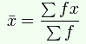
Figure 1: Average calculation method
Source: (Sarkissian, 2017)
Standard deviation: It is the statistical tool that measures the accepted levels of differences about the set of mean data (Remenyi, 2013). Low standard deviation indicates closer to the arithmetic mean and high standard deviation indicates the bigger differences from the arithmetic mean. The lower standard deviation refers good accuracy of the arithmetic mean. Standard deviation is performed to find out the degree of inconsistency in the collected set of data. The formula is as follows:
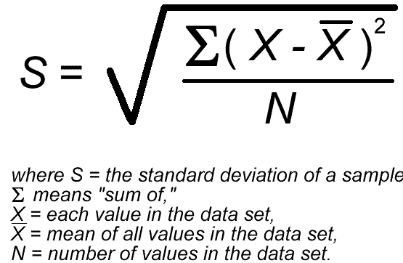
Figure 2: Standard deviation formula (Sarkissian, 2017)
Types of the graph: Statistical results are illustrated through various graph, for example, column chart, pie chart, scatter diagram, and tend line, bar chart, histogram and others. These graphs depict the result of process data in a graphical manner so that the users can easily understand the findings.
To collect the raw data, John Lewis has used a structured questionnaire survey where the sample size is 100. The company has used convenient sample technique where the sample is collected from various parts of the UK. The questionnaire includes five questions that are answered by the participants. The survey questionnaire is as follows:
Name of the Customer:
Age:
Questions |  | Disagree | Neutral | Agree
I prefer online shopping
I believe it saves time
I online shopping is less risky
I take collect + scheme service of John Lewis often
I think collect + is easier than “click and collect”

Mean, median and mode calculation
Question 1
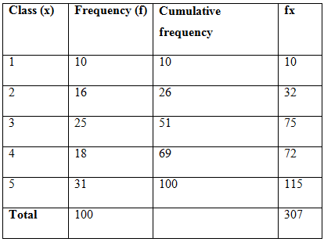
Mean = 307/100 = 3.07
Median = (31+1)/2 = 16th value = 2.
Mode = 2
Question 2
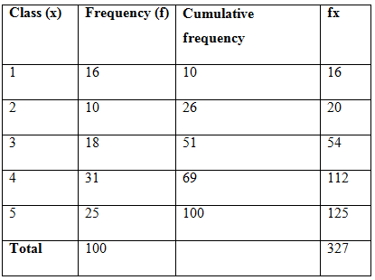
Mean = 327/100 = 3.27
Median = (18+1)/2 = 9.5th value = 3
Mode = 3
Question 3
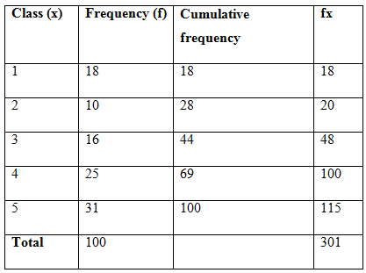
Mean = 301/100 = 3.01
Median = (25+1)/2 = 13th value = 3
Mode = 3
Question 4
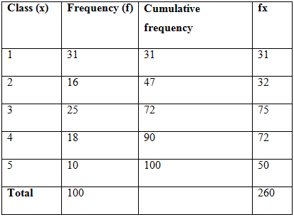
Mean = 260/100 = 2.60
Median = (25+1)/2 = 13th value = 3
Mode = 3
Question 5

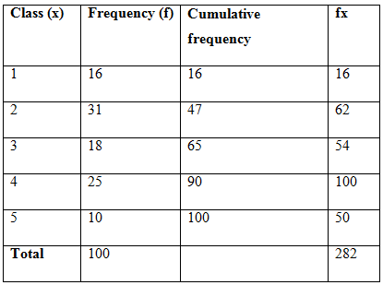
Mean = 282/100 = 2.80
Median = (25+1)/2 = 13th value = 4
Mode = 4
Standard deviation calculation
Question 1
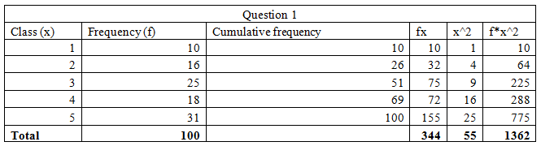
Standard deviation = 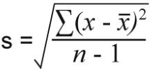
= 1.359
Question 2
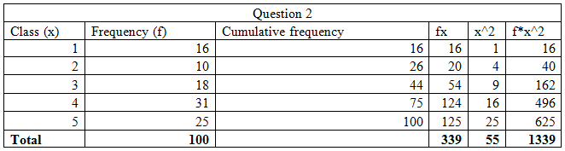
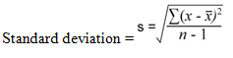
= 1.401

Question 3
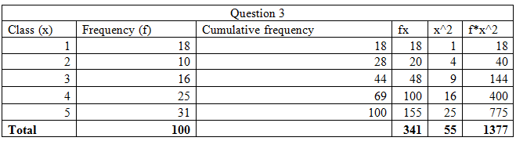
= 1.488

Question 4
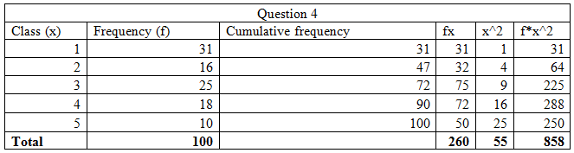
= 1.372

Question 5
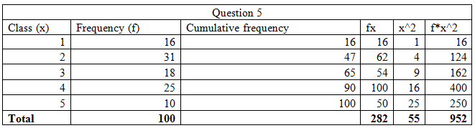
= 1.273

Basic computer uses for numerical handling-excel spreadsheets, databases
There are many computers that is used to process the raw data collected from the survey Microsoft Excel spreadsheets and database software provides an accurate result of the input data. The survey data of John Lewis is processed using Microsoft Excel and database that are presented below:

Graphs and charts based on the survey result
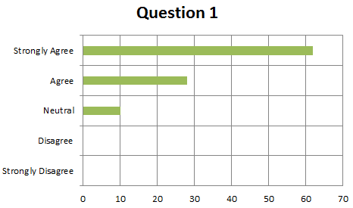

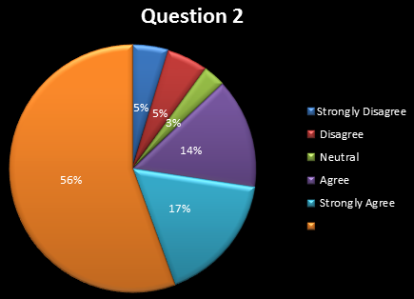

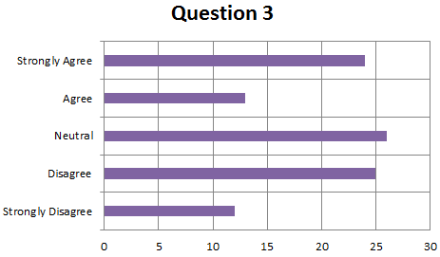

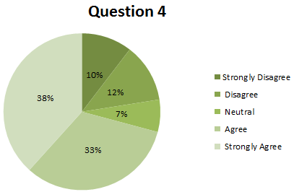

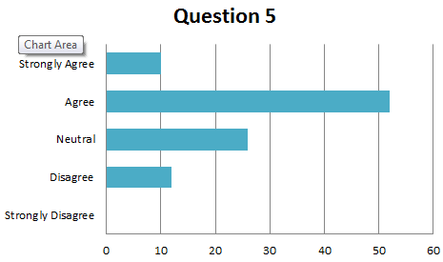
The bar charts and pie chart, column chart and pie chart are formulated based on the questionnaire survey data of prepared by John Lewis for the research.

The development of skills needed to utilize information gathered in a critical and analytical way
To determine the online shopping response of collect+ scheme of the John Lewis, the primary data requires analyse. After analysing the primary data, meaningful information will gather by the management of JL to understand the context and helps to apply their wisdom to take appropriate decision.
Primary data analysis
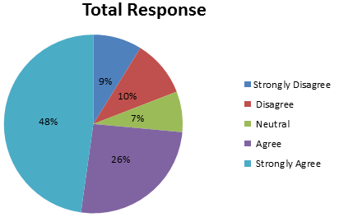
Figure 3: Total response of the survey participant
Source: (Author)
The pie chart shows the survey result of John Lewis where most of the customers are agreed with the online shopping is convenient and most of the people have done online shopping frequently. However, to get more accuracy in the survey data, further analysis has been conducted:
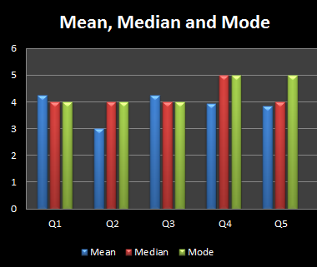
Figure 4: Mean, median and mode analysis
Source: (Author)
Mean, median and mode analysis are shown in the column chart that clearly depicts the response average, median, and mode and indicates that most of the participants have positive perception to the online shopping service of John Lewis.
Standard deviation analysis
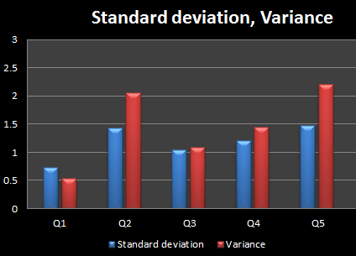
Figure 5: Standard deviation
Source: (Author)
The accuracy of the information is demonstrated by the standard deviation. The standard deviation variance indicates that the result of the data has little deviation so that the findings of the analysis will provide credible and relevant result about collect+ scheme service of John Lewis.
Secondary data analysis
Online shopping is a very popular method of shopping to the people of UK because it saves their time, removes locations barrier and reduces hassle (Combe, 2012). It is very convenient and people can purchase their desired products anytime from any place. People are very busy in the UK so that online shopping is more flexible for them. As a result, every supermarket retail company is giving the opportunity to the customers for online shopping.
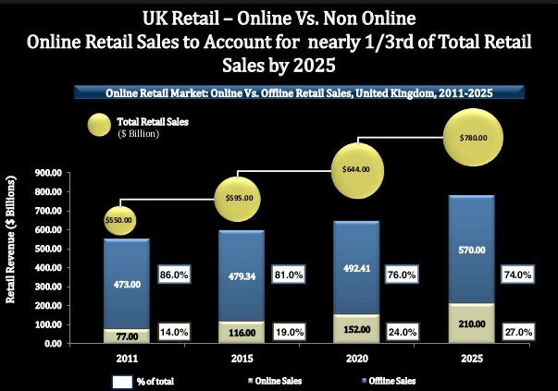
Figure 6: UK retail online shopping (Sullivan, 2016)
The above figure shows the trends of online shopping of the UK people. In 2011, 14% people of the UK were shopped in online and in 2015 this trend was increased and reached 19% milestones. It has predicted that by 2020 online shopping will reach 24% and 27% by 2025. So, it is very clear that the popularity of online shopping is increasing so that John Lewis has more opportunity to attract potential customers for their online shopping.
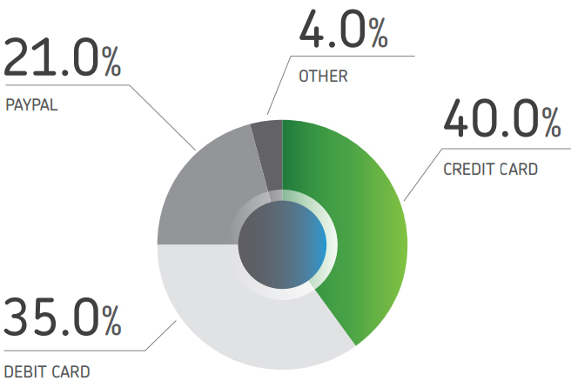
Figure 7: Payment preference in online shopping by UK people
Source: (Sullivan, 2016)
In the online shopping, payment method is an important issue because without payment customer cannot purchase products. The above figure shows that 35% people of UK are using a debit card in the online shopping, 40% are using a credit card and 21% are using PayPal. So, John Lewis must consider the payment methods that are convenient for most of the customers of the UK. If the company allows many methods of payment, it will encourage customers to purchase products because often customers may not have sufficient money on their debit card, but they can purchase using their credit card.

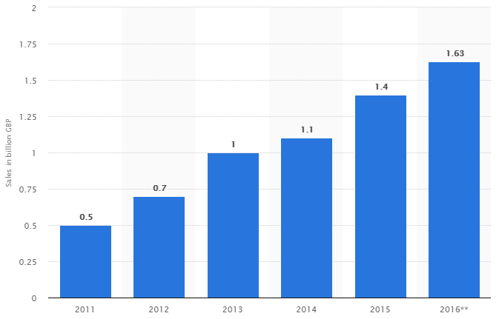
Figure 8: John Lewis online selling trend
Source: (Statista, 2017)
The above figure shows that the online selling trends of John Lewis are continuously increasing. In 2011, the online selling was only £0.5bn, 2012 it was £0.7bn, in 2016 £1.63bn sales were happened in online. So, it indicates that the customers of John Lewis are preferred online shopping. So, to increase the selling via online, the following recommendations are given:
- John Lewis should convey the information of their collect+ scheme service to as many as people of the UK.
- John Lewis should increase the mutual agreement with as many as independent retailers so that customers at every corner of the UK can purchase the products of the company that reduces the power of competitors.
- The company should allow all sorts of payment methods in the online purchase so that every customer can take the online shopping service of the company.

Ethical implications to gather data
The ethical issue is a vital part of the research because misleading information will provide an inaccurate result that misguides the users of the information. In every stage of the research, research ethics must be maintained by the researchers and survey participants. The researcher should follow data protection act where the personal information of participant must be protected from disclosing publicly. The questionnaire should be related to the objectives of the research and the unethical or inappropriate question should not include (Wilson, 2010). In addition, the survey participants should provide accurate information of each question and avoid giving a false answer. Moreover, in case of secondary data, the time of data is very important. If the secondary data is old then the credibility of data is reduced. In data processing, the data should be processed in proper ways and avoid giving misleading data input to get a favourable result.

References
Butler, S. (2017). John Lewis to extend online shopping empire via thousands of corner stores. [online]. Available at: https://www.theguardian.com/business/2013/feb/21/john-lewis-online-shopping-collect?INTCMP=ILCNETTXT3487 [Accessed 29 Dec. 2017].
Combe, C. (2012). Introduction to e-Business. Burlington: Routledge.
Gierd, J. and John and G. (2010). A leader’s guide to knowledge management. New York: Business Expert Press.
Hair, J. (2015). Essentials of business research methods. London: M. E. Sharpe.
Remenyi, D. (2013). Case study research. London: Academic Conference Limited.
Sarkissian, N. (2017). Arithmetic Mean: Definition, Formula & Example. [online]. Available at: https://study.com/academy/lesson/arithmetic-mean-definition-formula-example.html [Accessed 29 Dec. 2017].
Statista (2017). Annual gross online sales online trend. [online]. Available at: https://www.statista.com/statistics/420362/john-lewis-online-sales-united-kingdom/ [Accessed 29 Dec. 2017].
Sullivan, F. (2016). New mega trends shaping the future of Great Britain. [online]. Available at: https://www.slideshare.net/FrostandSullivan/new-mega-trends-shaping-the-future-of-the-united-kingdom [Accessed 29 Dec. 2017].
Wilson, J. (2010). Essentials of business research. London: SAGE Publications.

