Ysgol Yr Afan - 5010
03/01/2024
Address: 14 The Grove, Cardiff, CF3 3HG
Company Details: Established in 1998 with over 25 years of experience in architectural design, engineering, and construction work. Total amount of employees at 40 including ICE and RIBA accredited specialist.
Dear Ysgol Yr Afan,
We at Clean Construction Ltd trust this letter finds you well and are excited to embark on the joint venture with the Welsh Government to provide this community with a ‘state of the art’ infant school in Port Talbot. We want to assure of our commitment to the deliverance of this excellent new school and will provide details below on how we propose to share information, coordinate, and manage the operation as the construction work progresses.
Sincerely,
Clean Construction Ltd

Contents
Clean Construction Ltd JV Welsh Government 3
BIM Maturity for Ysgol Yr Afan 4
Level 0 – No collaboration with CAD Drawings 4
Level 1 – 3D models and 2D drawings 4
Level 2 – Multiple 3D models for multiple projects on one platform 4
Level 3 – Single work-shared model for a variety of projects 4
Level 4, Level 5 & Level 6 5
What does BIM Maturity provide for this construction project? 5
Enhanced Collaboration 6
Efficient Design and Planning 6
Compliance with International Standards 6
Naming Conventions 6
CDE (Common Date Environment) 6
BEP (BIM Execution Plan) 7
CAFM systems 7
LOD / LOI (Level of Details and Level of Information 8
LOD / LOI 100 – Basic Overview 8
LOD / LOI 200 - Intermediate Details 8
LOD / LOI 300– Expert details 9
LOD / LOI 350 – Coordinated 9
LOD / LOI 400 – Ready for Construction 9
Proposed use of LOD and LOI through RIBA. 11
References 12

Clean Construction Ltd JV Welsh Government
Templar Park Industrial Estate, E Moors Rd, Cardiff CF24 5EW
(02920) 777890
www.cleanconstructionltd.co.uk/projects
admin@cleanconstructionltd.com
Project Title: Ysgol Yr Afan
Project Number: 5010

Dear Sir / Madam,
I am reaching out in response to our appointment as the lead consultant for the Ysgol Yr Afan project and joint venture with the Welsh Government. At Clean Construction Ltd, we want to provide you with a comprehensive overview of how BIM (Building Information Modelling) process will benefit your project at each stage starting from the initial planning and preparing to future utilisation. In line with your request, we will provide examples on how the use of LOD and LOI has been used on previous projects and how this will be implemented for our project in Ysgol Yr Afan. We will also outline the measures implemented to demonstrate the competencies and skills of the project team in fulfilling the BIM Maturity requirements as well as improve your knowledge on the best suited CAFM system for the school.

BIM Maturity for Ysgol Yr Afan

When Clean Construction Ltd are conducting the project, we want to ensure that as we proceed with the work, that you are completely familiar with what we are currently doing, what we are planning to do next and be able to keep track of time management on the job. This can all be done through BIM maturity. There are distinct levels to BIM Maturity that are used for all diverse types of construction jobs. As the job becomes more advanced, the higher the level of BIM maturity is used. See below an explanation for Level 0 – Level 03.

Level 0 – No collaboration with CAD Drawings
This BIM level is considered to have no collaboration with the use of BIM and only contains 2D drawings that contain information using CAD. The files are only shared through a hardcopy to stakeholders. (ASC Technology Solutions, 2022)

Level 1 – 3D models and 2D drawings
Level 1 is a combination of using 2D drawings and an introduction to 3D models that are shared through CDE (common data environment) which is usually managed by the contractor. This is looked at as a partial collaboration as stakeholders’ manager their own data and is independently published. (ASC Technology Solutions, 2022)

Level 2 – Multiple 3D models for multiple projects on one platform
Level 2 involves all stakeholders working on a 3D model that is shared through a CDE. This is a file that would be on an IFC that allows it to be collaborative with multiple several types of software’s and involves designers, engineers, and contractors to be able to use it and share the same model. Level 2 is the first level collaboration takes place. (ASC Technology Solutions, 2022)

Level 3 – Single work-shared model for a variety of projects
Also known as OpenBIM, Level 03 provides the maximum utilisation of a CDE that allows all stakeholders involved to work on a single shared model and every project member has appropriate access to update or review when required. This level provides an entire new building process through the opportunity to identify clash detection and BIM coordination. (ASC Technology Solutions, 2022)

Level 4, Level 5 & Level 6
These 3no levels bring BIM maturity to a position that it can identify time expectation of the construction in the preconstruction stage, cost estimation, building sustainability and energy consumption. Both are new additions to BIM maturity and only major infrastructure projects are in the position to date to be using this type of method.
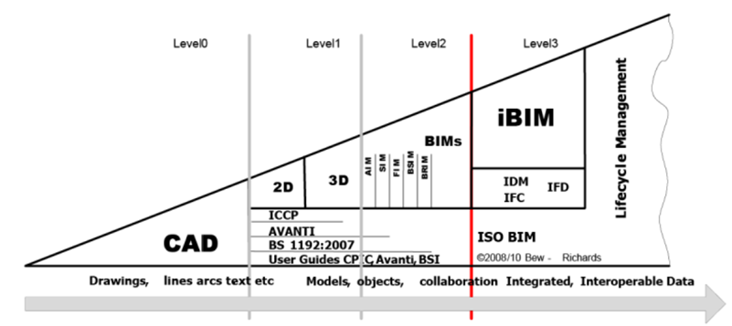
Figure 1: Representation of the Bew-Richards BIM Maturity model (BibLus, 2019).
As a company, we employ a BIM maturity level of 02, where project teams utilise 3D models with data compatible in an open format like IFC, merged into a consolidated file known as a federated model. This approach allows for the visualisation of building designs, moving away from traditional drawings, and facilitates the efficient scheduling of construction work across various phases. Throughout the design and construction stages, we are committed to assuring our clients that we adhere to BS EN ISO 1965 standards (Designing Buildings, 2017).

What does BIM Maturity provide for this construction project?
BIM maturity can play a significant role in making a construction project a success and has numerous important aspects that will always benefit both the client and the contractor during pre-phase construction and whilst the project is being constructed. Please see below, what we feel are important aspects that will benefit:

Enhanced Collaboration
Promotes collaborative working amount stakeholders including the client, engineers, architects, and contractors and cultivates a shared understanding for the design and construction phase plan. This reduces potential errors through communication and all team members will work from the same up-to-date model.

Efficient Design and Planning
BIM maturity provides a detail model that encourages stakeholders to get a visualise grasp on final product, but also identified potential clashes before they occur on site. This gives engineers and architects the opportunity to rectify this issue and supply a new optimised design that helps in efficient project planning enabling better sequence and resource allocation.

Compliance with International Standards
International standards such as ISO 19650 need to be adhered to and BIM maturity ensures compliances by providing common framework for information management throughout the project.

Naming Conventions
We consistently implement predefined guidelines for naming files in our projects, ensuring uniformity in our work while also facilitating easy identification of documents. This approach aids in organising project data systematically, promoting efficient file management. For instance, we employ standardised naming and coding conventions for every CAD drawing, ensuring consistency across our drawings and fostering coherence in our overall project documentation.

CDE (Common Date Environment)
The implementation of a centralised Common Data Environment (CDE) facilitates collaborative information management, ensuring all stakeholders have access to the latest project updates, thereby minimising discrepancies. This offers the advantage of achieving results based on coordinated data, potentially reducing construction costs and time. For instance, in the case of Ysgol Yr Afan, diverse inputs from stakeholders including architects, landscapers, and electrical and plumbing services are incorporated into the CDE at specific project milestones as outlined in the employers' information requirements. (McPartland, R, 2016).

BEP (BIM Execution Plan)
This constitutes a pivotal element of BIM maturity, delineating project-specific BIM requirements, encompassing roles and responsibilities. The plan serves as a guide for proficient information management during construction phases and aligns with the client's specified project requirements. Unlike a standardised BEP for all projects, its effective implementation depends on stakeholders comprehending the unique needs and objectives set forth by the client for the specific project (M. Lucrecia Real, 2021)

CAFM systems

We recognise Ysgol Yr Afan's interest in ensuring continuous asset tracking through a Computer-Aided Facilities Management (CAFM) system. Your request indicates the need for a CAFM system that offers comprehensive asset tracking capabilities, providing a holistic understanding for lifelong monitoring. There is a spectrum of CAFM systems available, ranging from simple solutions like Excel spreadsheets to more advanced options such as Enterprise Asset Management (EAM). Implementing a CAFM system will empower Ysgol Yr Afan with strategic planning tools, facilitating capital planning for new assets and overall improvement of the school. It plays a crucial role in determining equipment locations and performing other vital planning functions. Adopting a CAFM system promotes proactive facility management, minimising reactive responses to maintenance and service requirements. This proactive approach enhances safety by reducing the risk of accidents or compliance violations, as emphasised by (www.wbdg.org, n.d.).
There are multiple different types of CAFM systems such as EAM, IWMS and CMMS. There are several types of CAFM systems such as EAM, IWMS and CMMS. For the service that you require, we can provide you with a IWMS (Integrated Workplace Management System) as this type allows users to have access to room reservations, asset management and environmental sustainability. This can all be used by different teams at the same time as it will be at one point of access. (Ocean, J, 2021).
I am going to provide the different details required in both a LOD and LOI format and how each level shows progressive information you can receive:

LOD / LOI (Level of Details and Level of Information

Our team acknowledges the consequences of both inadequate and excessive modelling of systems and components, which can result in costly rework and delays. BIM LOD provides crucial support to multiple teams throughout the project lifecycle, enhancing cost analysis, resource planning, and overall control.
Our BIM modelling services encompass the creation of accurate, clash-free 3D models with LOD levels ranging from 100 to 500. These models empower architects, engineers, contractors, construction firms, drafters, and design consultants to articulate the progression of component geometry and information across various project stages. Successfully implementing BIM projects for diverse construction firms, we tailor Levels of Development from LOD 100 to 500 to meet their specific needs and requirements.

LOD / LOI 100 – Basic Overview
LOD 1 may have a model that is graphically represented including a generic representation of structure in the building but will not have information related to the model element. For example, it will not provide information such as tonnage, accurate measurement, and cost per square foot. This can be used in further LODs. (constructible.trimble.com, n.d.). This will provide basic information and generalised specification for conceptual understanding.

LOD / LOI 200 - Intermediate Details
This will provide approximate sizes of elements and can provide stakeholder with an initial idea of items for placement of items in the facility and more detailed information for the development of design and provides specific components for performance. This includes specification for major building elements. For example, it could provide a brief overview of direction of air conditioning systems or pipe work. (constructible.trimble.com, n.d.).

LOD / LOI 300– Expert details
LOD will have the functionalities to include information about location, size or even the quality of the elements and requires further detailed information for decision making and performance criteria for key components and systems. It also provides the opportunity to be able to measure on the model to get an accurate finding of how an item is going to fit prior to it being installed. (constructible.trimble.com, n.d.).

LOD / LOI 350 – Coordinated
LOD 350 is required for when a model is asked to be coordinated. This will include the building being coordinated and can interface with systems that are represented. For example, our model will include showing support brackets that connect to the ceiling for pipe work and will provide benefits to the engineers when marking out the points. (constructible.trimble.com, n.d.).

LOD / LOI 400 – Ready for Construction
LOD 400 will supply both graphical and non-graphic information in the model and will have a guidance for assembly and installation procedures. This provides the opportunity to have items delivered at the correct time required and fabricated. (constructible.trimble.com, n.d.).
As the Ysgol Yr Afan project advances, our utilisation of LOD will evolve accordingly. We propose commencing with LOD 200 to furnish the school with a comprehensive set of information right from the project's inception. This initial LOD level will involve modelling the architect's design, providing an exceptional representation of the school's appearance before any construction work begins. This approach allows for effective communication with the school as the project progresses, facilitating discussions about the optimal placement of various elements within the building. This encompasses a range of items, from tanks (hot/cold water tanks) to welfare facilities. A visual representation of LOD levels is provided below.
LOD 200 | 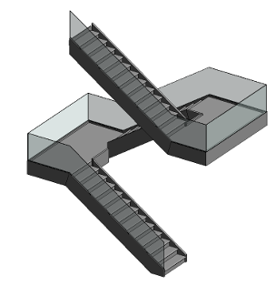
LOD 300 | 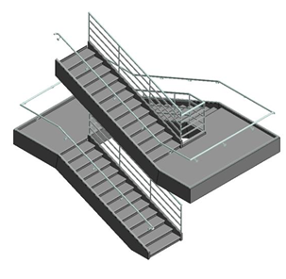
LOD 350 | 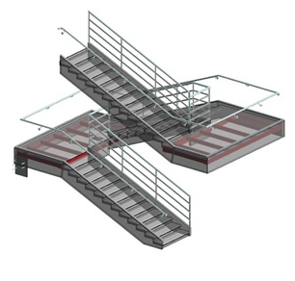
LOD 400 | 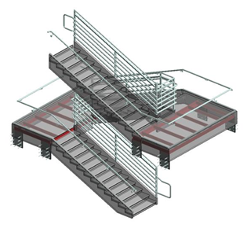
Table 1: Showing the Development of LODs (LEVEL OF DEVELOPMENT (LOD) SPECIFICATION, n.d.).

Proposed use of LOD and LOI through RIBA.
How we propose to use the LOD and LOI format is through RIBA stages. RIBA stages is a widely used system in the UK that is designed to set out how a construction project should be considered at every stage. The RIBA stages commence at stage 0, involving the preparation of project requirements and a review of potential risks or budgetary considerations. Stage 1 focuses on preparations to initiate work, encompassing agreements on project budgets, work program preparations, sourcing, and any necessary approvals from local authorities. Moving to Stage 2, the emphasis is on developing the school's desired design through meetings with the school and other stakeholders, including the local council. This ensures that our design meets the standards specified by the school. Stage 3 involves the submission of application plans, ensuring the inclusion of building control compliance testing. RIBA Stage 4 marks the unveiling of the initial design of the building, presented through architectural drawings or a 3D model. This provides an opportunity to initiate system preparations and outline the construction phases. Advancing to Stage 5, construction work begins on-site, marking the commencement of material preparation and quality inspections. Stage 6 signifies the handover of the completed building to the client, involving a thorough inspection, project performance review, and addressing any final issues. If there are any last-minute issues (snags) that need addressing, this stage is where they are resolved. Stage 7 marks the commencement of the building's use. This is when the client moves into the school, and we can implement the use of the CAFM system for asset management (Gilby, Z, 2022). Please refer below for a representation of the RIBA stages.
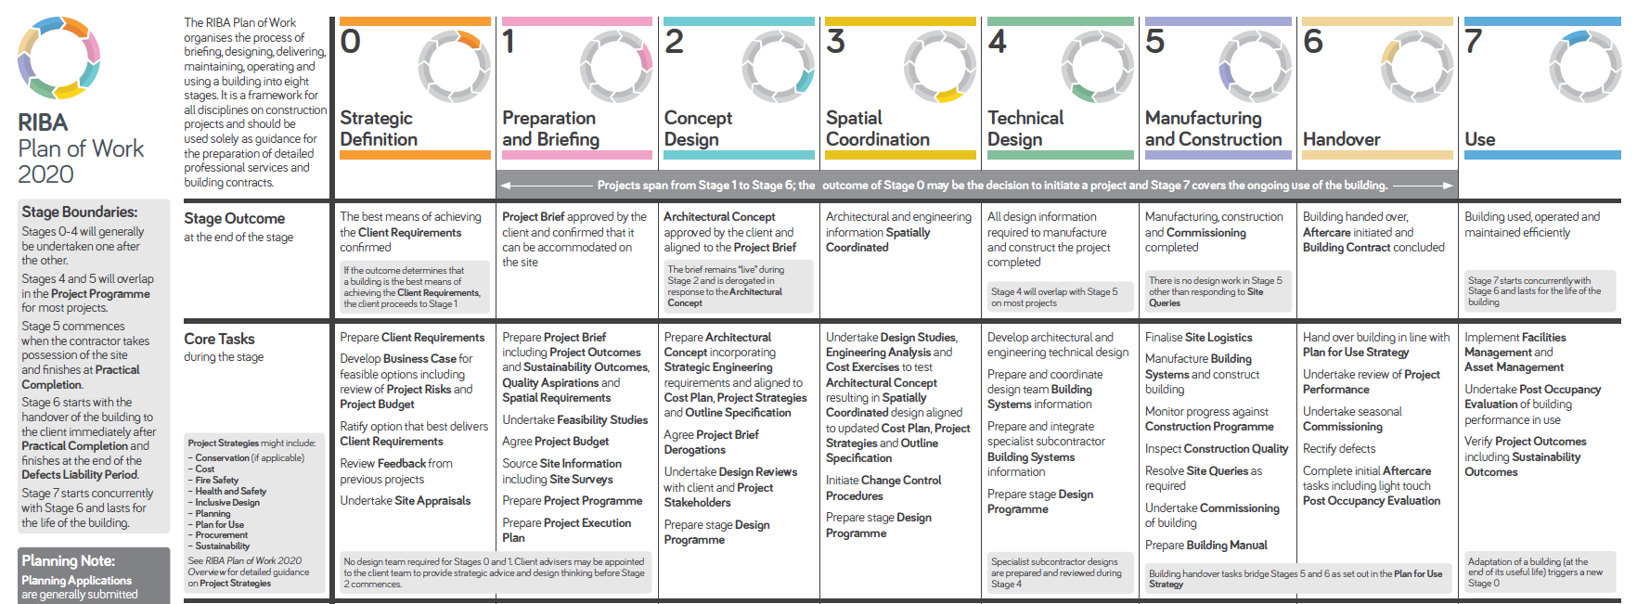
Figure 1: Representation of the RIBA stages set out from Stage 1 – Stage 7
If you have additional questions about any topics we have covered, I would be grateful to arrange a formal meeting for further discussion.
Yours Sincerely,
Clean Construction Ltd


References
ASC Technology Solutions (2022) BIM Levels (BIM Level 0-6) & Level of Development (LOD 100 - 500). [online] Available at: https://www.linkedin.com/pulse/bim-levels-level-development-lod-ascbimservices#:~:text=Different%20level%20of%20BIM%20represents [Accessed 5 Jan. 2024].
BibLus (2019). BIM maturity Levels: from stage 0 to stage 3. [online] BibLus. Available at: https://biblus.accasoftware.com/en/bim-maturity-levels-from-stage-0-to-stage-3/.
constructible.trimble.com. (n.d.). How HVAC LOD Levels Impact Your 3D BIM Model. [online] Available at: https://constructible.trimble.com/construction-industry/hvac-lod-levels-how-they-impact-your-3d-model.
designing buildings (2017). ISO 19650 - Designing Buildings Wiki. [online] Designingbuildings.co.uk. Available at: https://www.designingbuildings.co.uk/wiki/ISO_19650.
Gilby, Z. (2022). What Are the RIBA Stages? [online] Extension Architecture. Available at: https://extensionarchitecture.co.uk/blog/what-are-the-riba-stages/#:~:text=The%20RIBA%20Plan%20of%20Work.
LEVEL OF DEVELOPMENT (LOD) SPECIFICATION (n.d.). Available at: https://bimforum.org/wp-content/uploads/2023/10/LOD-Spec-2023-Part-I-Public-Comment-Draft-2023-12-28.pdf [Accessed 11 Jan. 2024].
Ocean, J. (2021). Facility Management Software. Best 2023 CAFM System. CAFM Software. [online] Revizto. Available at: https://revizto.com/en/facility-management-software/ [Accessed 10 Jan. 2024].
McPartland, R. (2016). What is the Common Data Environment (CDE)? [online] NBS. Available at: https://www.thenbs.com/knowledge/what-is-the-common-data-environment-cde.
M. Lucrecia Real (2021). Keys aspects of a BIM Execution Plan (BEP) [online] Available at: https://www.e-zigurat.com/en/blog/keys-aspects-bim-execution-plan-bep/#:~:text=The%20BIM%20Execution%20Plan%20is,and%20tools%20to%20be%20used.
www.wbdg.org. (n.d.). Computer-Aided Facilities Management (CAFM) | WBDG - Whole Building Design Guide. [online] Available at: https://www.wbdg.org/facilities-operations-maintenance/computer-aided-facilities-management-cafm#:~:text=CAFM%20systems%20consist%20of%20a [Accessed 10 Jan. 2024].

‌
‌

