

Cover page

Title | The role of critical thinking in academic success
Name | Misbah Omar
Student ID | 2406888
Module code | LCBB4012
Lecturer | Dr Lizeta Demetriou
Date | 12/10/2025

Table of contents:
- Introduction…………………p.3
- Definition of critical thinking……………. p.4
- Importance of critical thinking for academic success………p.5 3.1 Prioritising quality sources & evidence ………. p.5
3.2 Better argumentation & synthesis………. p.5
3.3 Improved grades & learning outcomes……..p.6
4) Critical thinking strategies in academic context……p.7
5) Conclusion………………p.8
6) References……………...p.9

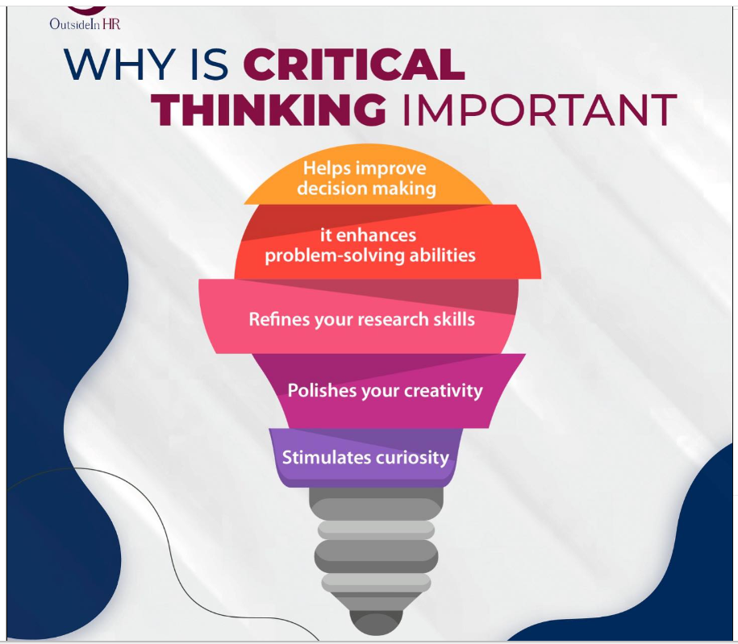

Academic report on critical thinking

1.Introduction.

At university, students are expected to do more than remember facts. They are expected to understand questions and explain what they are learning. This is where critical thinking becomes important. The aim of this report is to explain what critical thinking means, why it is important for academic work, and give an example of how student can use it in their studies.

2. Definition of critical thinking

There is no single university definition of critical thinking. But many scholars agree on key elements. Critical thinking generally refers to the process of analysing claims and evidence, evaluating their strengths and weaknesses, and forming reasoned, well-justified conclusions. According to research, critical thinking, involves analytical and reflective skills to evaluate, (Rivas et al 2024). Others emphasize that it is a metacognitive process: to be aware of one’s own thinking, biases, and assumptions (Rott, Kohnen & Fischer 2024). In simpler terms: critical thinking means not accepting everything you read or hear at face value, but asking question you or hear at face value, but asking questions like: what is the evidence? Are there alternative interpretations? What assumptions underlie this claim? Do I see any bias or weak reasoning?

The Importance of Critical Thinking for Academic Success

I think critical thinking is important in school because it helps me understand things better, not just memorize them. It lets me ask questions, look at different opinions, and make my own conclusions. This is useful when I write essays, solve problem, or take part in class discussion. It also helps me tell the difference between facts and opinions and think more clearly.

  - Prioritising quality source & evidence

When working on academic assignments, it’s important to use reliable and credible sources like peer-reviewed articles, academic nooks, and journal papers. Critical thinking plays a key role in helping me evaluate whether a source is trustworthy-whether the research method is solid, or if the author is making unsupported decisions claims. Especially today, with so much misinformation around, being able to tell the difference between strong academic work and something biased or poorly researched is an essential skill.

  - Better Argumentation & Synthesis

In many assignments, it’s not enough to just summarise information. I also need to form my own argument, back it up with evidence, considers another viewpoint, and come to a clear conclusion. Critical thinking really helps me do this more effectively. It allows me to look at different perspectives, spot contradictions, and make my argument more balanced and thoughtful. Techniques like Socratic questioning also help me dig deeper by challenging assumptions and thinking about the wider impact of ideas.

3.3 Improved Grades 7 Learning Outcomes

one study involving secondary school student found a high correlation between critical thinking and academic performance basically, the better the critical thinking, the better grades. Another article from MDPI explains that student with stronger critical thinking skills tend to do better in exams and coursework because they can use what they have learned in mor flexible, thought ways not just memories facts. Studies show a strong connection between critical thinking and academic success.
One study found a high correlation between critical thinking and grades. According to MDPI, student with better critical thinking preform better in exam because they apply knowledge more flexibly. It also supports well- being, helping student manage stress by reflecting and question more effectively.

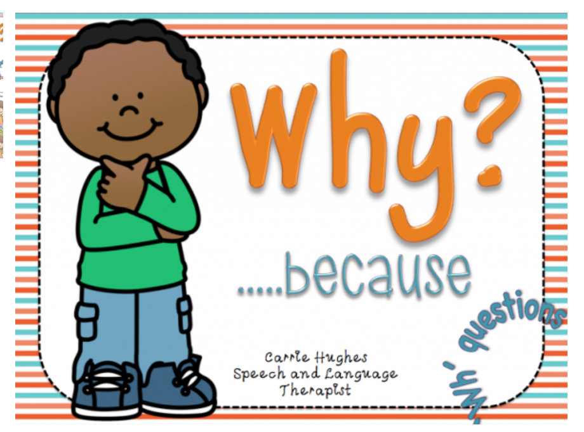
4: Critical thinking strategies in academic context

When reading academic text, I use this method by asking:

- What is the author’s main point and what assumptions support it?
- Is the evidence strong and reliable?
- Are there alternative views or counterarguments?
- What are the implications if the claim is true or false?

- Could there be other explanations or opinions?

By doing this regularly, I say more engaged with the material and think more critically, which really helps with writing essays, discussing topics in class, and studying for exam One
useful habit I have found: when I am reading source for an essay, I keep a short list of 5-7 key question like these and answer them in brief notes. This makes it easier to come back later and include thoughtful analysis in my writing.

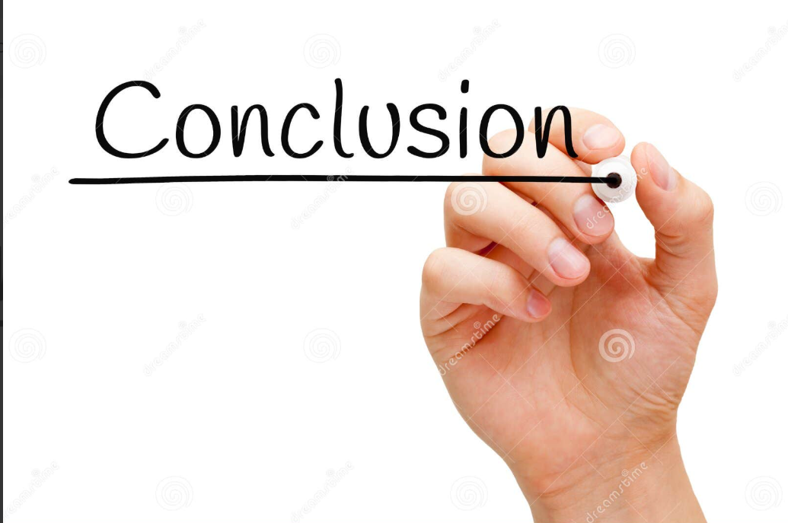

5: Conclusion

To sum up, critical thinking is not just about thinking harder. It’s structured way of questioning, analysing, and reflecting on information. It helps me avoid simply accepting ideas at face value and allows me to build stronger, more reasoned arguments. Studies clearly show that stronger critical thinking skills are linked to better academic performance and deeper learning.

One strategy I find especially useful is Socratic questioning. It’s a practical technique I can apply right way when reading, writing, essays, or taking part in discussions. By making this kind of questioning a regularly habit, I am not justb improving my academic work. I am developing a skill that will benefit me far beyond my studies.

6: Reference

El Yazidi,R.(2023) Strategies for Promoting Critical Thinking in the Classroom. International journal of English Literature and Soicial Science (IJELS).

Rott,D.,Kohnen,M,& Fischer,C. (2024) “the importance of promoting critical thinking in schools. Ecamples from Germany.” Journal Name/ Publisher.

Rivas,S. et al. (2024) “Analysis of the contribution of critical thinking and psychological well-being to academic performance.” Frontiers in Education.

2025: critical thinking and education: A bibliometric mapping of the research literature.

