Linnea Strileckis
Transcription

The following transcription includes the first five pages of the St. Gallen Bible from the twelfth century. It was produced on parchment in the Abbey of St. Gall in Switzerland and contains books of the Old Testament in Latin. Included in the manuscript are notes in Latin and German. For the purposes of this exercise, the side notes have been left out and the original text has been transcribed. The text was written in two columns per page. I have broken the transcription to signify the transitions between columns, therefore totaling ten columns of transcription. Portions of the text have been smudged away or contain holes; these areas have been denoted with […].
The complete text can be found online as indicated in the reference portion of this exercise. The original can be found at the Stiftsbibliothek in St. Gallen, Switzerland. Following the transcription are images of the pages that I have transcribed.

At the beginning of the manuscript, there is an illumination containing the text - SIG MONASE SANC GALLI.

F[olio] S[ensu] L[ato] D[eo] F[olio] R[egnauit] U[enerate] mei desideratas ac
cepi literas. qui q[uo]da[momodo] p[rae]sagio fu
turo[rum]. cu[m] danihel[a]e fortit[um] e[t] nom[inis].
obsecrantis. ut translatu[m] inlat[…]am
lingua[m] de hebreo sermon[a]e petatheu
cu[m] moysi n[ost]ro[rum] aurib[is] tradere[t]. p[er]icu
losu[m] opus certe obtrectato[rum] latratib[is]
patens. q[ui]d me asser [re] in lax int[er]p[re]tu[m] sugil
ingeniu[m] noua p[er]ueterib[is] coder. ita
ingeniu[m] q[ua]si uniu[m] p[ro]bantes. cu[m] ego se
pismire testat[um] si. m[er]e p[er]uili porcione
intabernaculu[m] di offere que possi[um]
nec opes altieri[s]. alio[rum] paup[er]tate [se] seda
ri. Q[uod]d[am] ut audere[m]. orienis studiu[m] me p[ro]
uocaint. q[uid] edicioni antique [se]. t[ra]nslaci
one[m] theodocionis miscuit. asterisco
[autem] obelo. id stella. [secundum] [autem] oxera [omnis]. op[u]s
omne distingues. du[m] aut inlucensce
re fac[tum] que min[us] an[um] fuerant. aut sup[er]
flua queq[ue] [se] ingulat [autem] [con]fodit. maxi
meq[ue] euangelistaru[m] [autem] ap[rae]lo[rum] aucto
ritas p[er]mulgauit. inq[uae]b[is] multa […]ue
teri testam[en]to ligim[us]. que [se] in[o]nris codi
cib[is] n[on] habent[em]. ut e[dde] illud. Exegipto
uocaui filiu[m] meu[m]. [autem] q[ua]m nah[oc]are[is] uo
cabit[ur]. et indeb[i]t[um]. inque[m] [con]punxer[unt]. [autem]
flamina deuentre ei[s] fluent aq[uae] unie[nt].
Et g[e]n[er]e oculus uidit. nec aurais audunt.

nec incor[um] ho[m]is ascendit. q[uam] p[re]parauit d[eu]s
diligentib[is] se. Et multa alia q[uam] p[re]priu[m]
cyntarma desiderant. Int[e]rogem[is] [er]g[o]
eos. ubi hec [se] scripta fuit. [autem] cu[m] dicer n[on]
pottering. delibris herbraicis p[er]feram[um].
P[er] m[e]u[um] testimoniu[m] c[um] moose. sed[e]m in osaia
t[er]cui[m] inh[oc] acharia. q[uoquer tu[m] inp[er] uerbus. q[ui]ntu[m]
eque [se] in isaia. Q[uo]d[dam] multi ignorantes apo
crif[eria] deliram[en]ta sectant[um]. [autem] hyberas neni
as libris autenticis p[re]fer[um]. Causas erroris
n[on] e[t] meu[m] exponere. Judei prudenti factu[m]
dicing e[ss]e [con]silio. ne ptolemeus uni di
cultor eri[m] ap[um] hebreos duplice[m] diminta
t[iae] dep[er]henderet. Q[uod]d[am] maxime iccirco fa
ciebant. Q[uia] inplatonis dogma cadere
uidebat[re]. Deniq ubicu[m]q[ue] sacratu[m] aliq[ui]d
scriptura testat[re] de pater [autem] filio [autem] sp[er]us co[mmun]
aut alit[er] int[er]p[re]tati s[um]. aut o[mn]ino tacuer[um].
ut [autem] regi satis facerent. [autem] archanu[m] fidei
n[on] dinulgarent. Et nescio q[uid] s[u]p[eru]m auctor
[…] cellulas alexandrie mendacio suo
exstruxerit q[uidi]b[is] duns eade[m] scriptitarent. dictitarent.
cu[m] arist[er]ex eide[m] ptolomei yre epacritc
tug id p[er]tector. [autem] multo p[rae]t p[re]re iose
plus nichil tale retulerint. s[…] ba
silica [con]gregatosd [son]tulisse seribeb[…]
phatasse. Aluid e[t] eni[m]. alludi e[ss]e imp[re]
te[m]. ibi sp[atia]e uentura p[rae]dic[um]. hic erudicio et
u[n] bo[rum] copia ea que intelligit t[r]ussert. nisi
forte putandus e[t] tulli[s] oeconomicu[m] xe
nofontis. [autem] Platonie phitogora[m]. [autem] de
moistens p[er] thesifonte. afflat[is] rethorico
spu[atia]u[m] transtulisse. Aut alti[m] de eisde[m] libris

p[er] h[orum] int[um] p[er]tes. alit[is] p[er] aplo[ne]s sp[e]c[i] s[an]c[ti]s testi
moria texuit. ut q[uod]d[am] illi tacuer[e] hisc[er]
ptu[m] e[ss]e mentiti s[um]. Q[uad]d[arum] [con]g[regare]. D[ur]a nam[um] uete
res [re]. minime. S[u] p[re] prior[um] studia. indo
mo diu[ini] q[uod]d[am] possum[us] laboram[us]. Illi int[um]
p[er]tati s[um] an[num] aduentu[m] [de]xp[er]i. [autem] q[uod]d[am] nescie
b[on]a[es]t. dubs p[er]tulere sentencus. Nos p[re]
passione[m] [autem] resurrectione[m] ei[us]. n[on] ta[n] p[er]phe
cia[m] qua[m] historia[m] scribim[is]. Aut[em] eni[m] au
dita. aut[em] uisa narrant[ur] q[uod]d[am] meti[us] intelli
gim[us]. meti[is] [autem] p[er]serim[is]. Audi q[uid] emule [se] ob
trectator ausculta. n[on] da[m]no. n[on] rep[re]hen
do lax. S[u] [con]fident[is] cunctis illis aplo[ne]s
p[re]fero. P[er] isto[rum] os m[er] x[er]p[er]c sonat. q[uam] san[um] [er
photos int[um] sp[er]alia charismata posits le
go. inq[uidi]b[is] ultimu[m] peen gradu[m] un[um] p[re]tes
tenent. Q[uod]d[am] liquors torq[uem]ris. [re] Q[uod]d[am] imp[er]i
to[rum] annuls [con]tra me [con]citas. Sicubi t[er]
intiis lactone indeor errare. int[er]roga
hebreos. diu[m] saru[m] urbu[er]i magistros [con]su
le. q[uod]d[am] illi h[abe]nt de x[er]p[er]o. tui codicesu[m] h[abe]nt.
A luide[m]. si [con]tra se p[er]ea abap[re]lis userpata
testimonia p[er]baner[re]. [autem] amendaciora s[u]
exemplaria lata qua[m] [quoddam]. [quoddam] qua[m]
hebrea. Veru[m] hec [se] [con]tra inuidos. Dunc te
p[rae]tor desideri [legitur]m[e]n. ut qui tantu[m] op[is]
me subire fecisti. [autem] agenesi exordu[m]
cap[r]e. oracionib[is] iues. q[uam] possi[m] eode[m]
s[u]p[em] q[uam] seripti s[u] libri. inlatinu[m] eos trans
serre sormonem.

[I]N PRINCIPIO creauit d[eu]s celu[m] [se] [autem]
terra[m]. terra aut[em] erat inani et ua
cua. [autem] tenebre sup[er] facie[m] abyss. et
sp[e]c[i] di ferebat [re] sup[er] aquas. Dixit q[ue] d[eu]s. Fiat
lux. Et facta e[t] lux. Et uidit d[eu]s luce[m] q[uod]d[am]
esset bona. [autem] dunsit luce[m] atenenebris nocte[m].
Factu[m] q[ue] e[t] uesp[er]e [autem] mane. dies un[is]. Dixit q[uam]q[ue]
d[eu]s. Fiat firmam[en]tu[m] inmedio aquaru[m]. [autem] dini
dat aq[ua]s q[uid]s. Et fecit d[eu]s firmam[en]tu[m[.
dikisit q[ue] aq[ua]s que[se] errant sub firmam[en]to ab
his due [se] erant sup[er] firmam[en]tu[m] {autem] factu[m] e[t]
ita. Uocanitq[ue] d[eu]s firmam[en]tu[m] celu[m]. Et fa
ctu[m] e[t] uesp[er]e. [autem] mane. dies sed[i]s. Dix[it] uero
d[eu]s. Congregentur aqua [se] que [se] sub celo [se] s[u] in
locu[m] unu[m]. [autem] appareag arida. Factu[m] q[ue] e[t] ita.
Et uocauit d[eu]s arida[m] terra[m]. Se q[uo]q[ue] aciones q[ue] aq[ua]
r[um}. appellauit maria. Et indit d[eu]s q[uo]d[dam] cet[um]
bonu[m]. [autem] ait. Germinet terra herba[m] ui ren
te[m]. [autem] faciente[m] semen. [autem] lignu[m] pomiferu[m]
faciens fructu[m] uirta gen[us] suu[m]. cui[us] sem[en] inse
met ipso sit sup[er] terra[m]. Et factu[m] e[t] ita.
Et p[er]tulit terra herba[m] uirente[m]. [autem] afferente[m]
sem[en] uirta gen[us] suu[m]. lignu[m]q[ue] faciens fructu[m].
[autem] h[omin]us unu[m] q[uod]d[am] q[ue] sem[en]te[m] specie[m] sua[m].
Et uidit d[eu]s q[uod]d[am] e[ss]et bonu[m]. Factu[m]q[ue] e[t] uesp[er]e
[autem] mane. Dies terci[is]. Dixit au[m] d[eu]s. Fiant lu
minaria infirmem[en]to celi. ut dini dant
die[m] ac nocte[m]. [autem] sint insigna. act[em]pra di
es. [autem] annos. [autem] luceant infirmam[en]to celi.
[autem] inluminet terra[m]. Factu[m] q[ue] e[t] ita. Fec[um]q[ue]
d[eu]s duo magna luminaria. luminare

maids. ut p[er]esset die. [autem] luminare min[us].
ut p[er]esset nocti. [autem] stellas. [autem] posuit eas in
firmam[en]to celi. ut lucerne sup[er] terra[m].
[autem] p[er] e[ss]ent diet ac nocti. [autem] diui dereni lu
ce[m] ac tenebras. Et uidit d[eu]s q[uod]d[am] e[ss]et bonu[m].
Et factu[m] e[t] uesp[er]e [autem] mane. dies q[ua]rt[is]. Dix[it]
etia[m] d[eu]s. P[er] decant aqua [se] reptile anime [se] ui
unties. [autem] volatile sup[er] terra[m] sub firmam[en]to
celi. Creauit q[ue] d[eu]s cetegrandia et omne[m]
anima[m] uiuente[m] atq[ue] motabile[m]. qua[m] pro
duxerant aqua [se] insp[er]es suas. Et omne uo
lattice s[ecun]d[e]m genus suum. Et uidit d[eu]s q[uod]d[am]
e[ss]et bonu[m]. b[e]n[e] dixit q[ue] eis dic[en]s. crescite et
mulitiplcammi. [autem] replete aq[ua]s maris. a
uesq[ue] multiplicent[ur] sup[er] terra[m]. Et factu[m]
e[t] uesp[er]e [autem] mane dies q[ua]nt[is]. Dixit q[uo]q[ue] d[eu]s.
P[er] ducat terra anima[m] uniente[m] ing[e]n[um] suo.
in m[en]ta [autem] reptilia. [autem] bestias t[er]re s[e]c[un]d[um] spe
cies suas. Factu[m] q[ue] e[t] ita. Et fec[um] d[eu]s besti
as t[er]re [se] iuxta spe[cie]s suas. Et inm[en]ta et omne
reptile t[er]re ing[e]n[um] suo. Et uidit d[eu]s quod
e[ss]et bonu[m] [autem] ait. Faciam[us] homine[m] adima
gine[m] [autem] sumilitudine[m] n[ost]ram. [autem] p[rae]sit piscib[us]
maris. Et uolatilib[us] cell. Et bests. uniuer
seq[ue] [se] t[er]re [se]. omniq[ue] reptile q[uo]d[dam] mouet[ar] int[er]ra.
Et creauit d[eu]s ho[ra]em adimagine[m] sua[m]. ad i
magine[m] di[um] creait illu[m]. masculu[m] et femi
na[m] creauit illos. Benedict q[ue] illis d[eu]s. et ait.
Crescite et multiplicamini. et replete t[er]ra[m].
[autem] subicite ea[m]. [autem] d[ami] abimini piscib[us] ma
ris. [autem] uolatilib[us] celi. [autem] unin[em]sis animanti
b[us] que [se] mouent[ar] sup[er] t[er]ra[m]. Dixit q[ue] d[eu]s. Ecce
dedi uobis omne[m] herba[m] afferente[m] sem[en]

sup[er] t[er]ra[m]. [autem] unim[em]sa ligna que [se] hu[men]t insect
ipsis sem[en]te g[e]n[t]is sui. ut sint uobis inseca[m].
et cunctis animantib[us] t[er]re [se]. omniq[ue] uolu
cri celi. [autem] immersji que [se] mouent[ar] in[er]ra. [autem]
inq[ui]b[us] e[t] anima uiuens. ut ha[m]ut aduescendu[m].
Et factu[m] e[t] ita. Viditq[ue] d[eu]s cunetta que fec[um].
[autem] erant ualde bona. Et factu[m] e[t] uesp[er]e et
mane. dies sext[is]. Igit[ar] p[er]fectis[um] ceti [autem] t[er]ra.
[autem] omnis ornat[um] eo[rum]. [con]pleuit q[ue] d[eu]s die
septimo opus suu[m] q[uod]d[am] fecerat. [autem] req[uid]euit die
septimo. abuni i[t]iso op[er]e q[uod]d[am] patrarat. Et
b[e]n[e] dixit diet septimo. [autem] s[an]c[t]i ficanit illu[m]. quia
in ipso cessauerat abomni op[er]e suo q[uod]d[am] crea
uit d[eu]s ut faceret. Iste g[e]n[er]aciones ceti [se] [autem] t[er]re [se]
q[ua]ndo creata s[um]. indie q[uibis] fec[um] d[omi]n[o]s d[eu]s celu[m] et
t[er]ra[m]. [autem] omne uirgulti[m] agri. an[num] qua[m] oriret[re]
int[er]ra. omne[m] q[ue] herba[m] regionis. pri[us] qua[m] ger
minaret. Non eni[m] pleura d[omi]n[u]s d[eu]s sup[er] terra[m].
[autem] homo n[on] erat q[uid] op[er]aret[re] t[er]a[m]. s[uis] sonsascen
debat de terra. irrigans unin[em]s[am] sup[er]ficiem
t[er]re. Formauit g[enus] d[omi]n[u]s d[eu]s homine[m] delimo t[er]re.
[autem] inspirauit infacie[m] ci[us] spiraculu[m] uite. et
fact[us] e[t] homo manima[m] uniente[m]. Plantaue
rat au[m] d[omi]n[u]s d[eu]s paradisu[m] uoluptatis ap[rae]cipi
o. inquire posit homine[m] que[m] formatera.
P[re] duxitq[ue] d[omi]n[u]s d[eu]s de humo omne lignu[m] pulchru[m]
insu. [autem] aduescendu[m] suaue. Lignu[m] etia[m] [se] inte
inmedio paradisi. lignu[m]q[ue] sciencie boni [autem]
mali. [autem] fluui[s] egrediebat[re] de loco holu-ta
tis adireigandu[m] paradisu[m]. q[uid] inde dini di
t[er] inq[uam] tour capita. nom[en] uni phison. ipse
e[t] q[uid] circuit omne[m] t[er]ra[m] eiulath. ubi nacit[re]
auru[m]. Et auru[m] terre [se] illi[s] optimu[m] e[t] ibiq[ue]

inuenit b[re]delliu[m]. [autem] lapis onichin[is]. Et
nom[en] fluuio s[e]c[un]do geon. ipse e[t] q[uid] circuit
omne[m] t[er]ra[m] [se] ethiopie [se]. Nom[en] u[no] fluminis
t[um]cu[r] tygrus. ipse uadit [con]tra assirios. Flu
ui[s] au[m] q[ua]rt[is]. ipse e[t] eufrates. Tulit ergo
d[omi]n[us] d[eu]s ho[m]i[n]e[m]. [autem] posuit eu[m] inparadiso uo
luptatis. ut op[er]aret[re] [autem] custodiret illum.
p[er]cepit q[ue] ei dic[en]s. Ex omni ligno paradi
si comede. de ligno au[m] sciencie [se] boni et
mali ne comedas. In q[uod] cu[m]q[ue] die com
ederis exeo. morte moirerais. Dix[it] q[uod]q[ue] d[omi]n[u]s
d[eu]s. N[on] e[t] bonu[m] e[ss]e ho[m]i[n]em solu[m] faciem[us] ei ad
uitoriu[m] simile sui. Formatis g[aris] d[omi]n[u]s d[eu]s
de humo cunctis animanbib[us] t[er]re [se]. et uni
[uen]sis uolatilib[is] celi. adduxit eu ad ada[m].
ut uideret q[ui]d uocaret ea. Omne eni[m] q[uod]d[a,m]
uncut ada[m] anime [se] uiuentis. Ipsu[m] e[t] nom[en]
ei[s]. Appelleuit q[ue] ada[m] nominib[us] suis cunc
ta animancia [autem] uni[ver]sa uolatilia celi [se]
et om[nipote]n bestias terre [se]. Ada[m] u[ne] n[on] inuenieba
t[er] auditor similis ei[s]. In misit g[o] d[omi]n[u]s d[eu]s
sopore[m] in ada[m]. cu[m] q[ue] obdormisset. tulit u
na[m] de costs ei[s]. [autem] replevin carne[m] [se]. Et
edificauit d[omi]n[u]s d[eu]s costa[m] qua[m] tulerat de aa
da[m] inmubere[m]. [autem] adduxit ea[m] ad ada[m]. Dix
itq[ue] ada[m]. Hoc nunc os exossib[is] meis. [autem] ca
ro deuiro su[m]pta e[t]. Qua[m] obre[m] relinq[uen]t
homo patrem suu[m] [autem] matrem. [autem] adherebit
uxorial sue [se]. [autem] e[t]r[e] duo incarne una. Era[n]t
au[m] uterq[ue] nudi. ada[m] s[e]ct[um] [autem] utor ei[s]. et n[un]c
rubescebant. S[is] et serpens erat callidi
dior cunctis animantib[is] e[t]re [se] q[uem] fecerat

d[omi]n[u]s d[eu]s. q[uid] dixit admuliere[m]. cur p[er]cepit
obis d[eu]s. ut n[on] comederetis de o[mn]i ligno
paradisi. [re] Cui [cum] [per] respondit mulier[e]. Defru
ctu ligno[rum] que [se] s[uis] inparadiso uescimur[re].
defructu u[no] lingo q[uod]d[am] e[t] inmedio paradisi.
p[er]cepit nob[is] d[eu]s ne comederem[us]. [autem] ne tan
gerem[us] illud. ne forte moriam[re]. morte mo
remind. scit eni[m] d[eu]s. q[uod]d[am] inq[uo] cu[m]q[ue] die com
ederetis exeo. ap[er]ient [re] oculi uri[m]. et eritis
sic[um]dii. scents bonu[m] et malu[m]. Vidit g[er]
muller q[uoud]d[am] bonu[m] e[ss]et lignu[m[ aduescendu[m]. [autem] pul
chru[m] oculis. aspectuq[ue] deditq[ue] uiro
suo. q[uid] commedia. [autem] ap[er]tis[um] oculi ambos[rum]. cu[m]q[ue]
agnouissent e[ss]e senudos. [con]suer[re] folia ficus.
[autem] fecer[re] s[uis] p[er]i hom[inem] ata. Et cu[m] audissent
uoce[m] d[omi]n[im] di[um] deambulantis inparadiso ad
aura[m] p[ost] meridie[m]. abscondit se ada[m] et uxo[rum]
ei[s] afacie d[omi]ni di[um] inmedio ligni paradisi.
Vocauitq[ue] d[omi]n[i]s d[eu]s ada[m]. [autem] dix[it] ei. Ubi es. Q[uam] ui
ait. Uoce[m] tua[m] audini inparad[is]so et timui.
eo[s] q[uod]d[am] nudus esse[nt]. [autem] abscondime. Cui dix[it].
Q[ui]s eni[m] indicati t[er] nudus esses. [re] n[is] q[uod]d[am] ex
ligno deq[uo] p[re]cep[er]a[m] t[er] ne comederes come
disti. Dixit q[ue] ada[m]. Mulier qua[m] dedisti
socia[m] in[ter] dedit in[ter] de ligno [autem] comedi.
Dix[it] q[ue] d[omi]n[u]s d[eu]s admuliere[m]. [re]q[uam]re hoc fecisti[re].
Que [se] resplendit. Serpens decepitine. et co
medi. Et ait d[omi]n[u]s d[eu]s ad serpente[m]. Q[uod] a fecisti
hoc. meledictus es int[um] onia[m] animancia
[autem] bestias t[er]re [se]. sup[er]perctus tuu[m] gradieris.
[autem] t[er]ra[m] comedes cunctis dieb[is] uite [se] tue [se].

Inimicicias pona[m] nit[em] te [autem] muliere[m]. [autem]
sem[en] tuu[m]. [autem] sem[en] ei[s]. Ipsa [con]teret cap[rae] tuum.
[autem] tu insidiaberis calcaneo ei[s]. Mulieri
q[uo]q[ue] dix[it]. Multiplicabo eri[mu[mas tuas. [autem] con
cept[us] tuos. Indolore praise folios. [autem] sub ui
ri potestate ris. [autem] ipse d[omi]n[o] abit[re] tue. [re] Ade [se]
u[no] dix[it]. Q[u]a audits uoce[m] uxore[m]s tue [se]. [autem] c[onc]edi
sti de ligno. exq[uo] p[rae]cep[er]a[m] t[re] ne c[um]cederes. ma
ledicta t[ermin]a t[er]ra inop[er]e tuo. Inlaborib[us] c[um] edes
ea[m] cunctis dieb[is] dieb[is] inte [se] tue [se]. Spinas [autem] tri
bulos germinabit t[er]. [autem] c[um] edes herbas t[er]re [se].
Insudore uult[is] tui uesceris pane. donecre
uertaris int[er]ra[m] de q[uam] su[m]pt[us] es. q[uid]a pulses. [autem]
in puluere[m] reuerteris. Et[re] uocauit ada[m]
nom[en] uxorilocal sue [se] cua [se]. eo q[uod]d[am] mat[um] e[ss]et cun
cto[rum] uni enciu[m]. Fecit q[uo]q[ue] d[omi]n[u]s d[eu]s ada[m] [autem]
uxorial ei[s] tunicas pellicias. [autem] induit eos.
[autem] ait. Ecce ada[m] cactus e[t] q[uam] si un[os] ex nob[is].
scions bonu[m] [autem] malu[m]. N[unc] g[or]ne forte mit
tat manu[m] sua[m]. [autem] suma etia[m] delino
uite [se]. [autem] c[um] edat. [autem] uiuat ineternu[m]. E[is] mi
sit cu[m] d[omi]n[u]s d[eu]s deparadiso uoluptatis. ut
op[er]aret[re] t[er]ra[m] de q[uam] su[m]pt[os] e[t]. E necitq[ue] ada[m]
[autem] collocauit an[um] parad[isum] su[m] uoluptatis
cherub. [autem] fla[m]meu[m] gladiu[m] atq[ue] u[m]satile[m]
ad custodienda[m] uia[m] ligni inte [se]. Ada[m]
u[no] cognouit eua[m] [se] uxore[m] sua[m]. que [se] [con]cepit
[autem] pep[er]it cain dec[en]s. Possedi ho[m]i[n]e[m] p[er]deum.
Rursu[m] q[ue] pep[er]it s[upe]r[u]m ei[s] abel. Fuit au[m] abel
pastor ouiu[m]. [autem] cam agricola. [re] Factu[m] e[t]
au[m] p[er] multos dies. ut offerret cain de fru
ctib[is] t[er]re [se] munera d[omi]no. Abel q[uo]q[ue] obtulit
de p[er]mogenitis regis sui. [autem] de adipib[isum]

eo[rum]. Et respex[um] d[omi]n[u]s ad abel [autem] admunera
ei[s]. ad cain u[no] [autem] admunera illi[s] n[on] respexit.
Iratusq[ue] e[t] cain uehem[en]ter. [autem] [con]cidit uult[is] ei[s].
Dix[it] q[ue] d[omi]n[u]s adeu[m]. Q[uam] re irat[is] es [re]. [autem] cur [con]cidit faci
es tua. [re] N[on] ne si b[onu]m egeris recipies. sin au[m[ ma
le. stati[m] inforib[us] peccatu[m] aderito. sed sub te
erit appetit[us] ei[s]. [autem] tu d[omi]n[um] abets illi[s]. Dix[it] q[ue]
cain ad abel fr[ateru]m suu[m]. Egrediam [re] foras.
Cu[m] q[ue] cent[um] in agro. [con]surrex[um] cain adu[er]sus abel
f[i]rm[um] suu[m]. [autem] int[um] sec[um] eu[m]. Et ait d[omi]n[us] ad cain.
Ubi e[t] abel fr[ater] tuus [re]. Q[uid] respondent. Nescio. Nu[n]q[ui]d
custos fr[ater]is mei ego sum. [re] Dix[it] q[ue] adeu[m]. Q[uod]d[am] fe
cisti. [re] You sanguines fr[ater]is tui klampt adme
de t[er]ra. Nunc g[ar] maledict[is] eris sup[er] t[er]ra[m]. que [se] a
p[er]uit os suu[m]. [autem] suscepit sanguine[m] fr[ater]is tui
demand tua. Cu[m] op[er]at[is] furies ea[m]. n[on] debit t[erre]
fructose suos. vagus [autem] p[ro]fugus eris sup[er] t[er]ram.
Dix[it] q[ue] cain ad d[om]in[en]. Maior e[t] uni q[uid] tas mea. qua[m]
ut uenia[m] merear. Ecce eicis me hodie afa
cte t[er]re. [autem] ufacie tua abscondar. et{ter]ro va
gus [autem] p[ro]fugus in t[er]ra. Omnix g[ar] q[uid] inuenerit
me. occident me. Dix[it] q[ue] d[omi]n[u]s. Neq[uam] qua[m] ita
fiet. S[uis] omnis q[uid] occiderit cain. septuplu[m]
punnet [re]. Posuit q[ue] d[omi]n[u]s cain insignu[m]. ut n[on] eu[m]
int[er]ficeret omnis q[uid] inuenisset eu[m]. Egress[is] q[ue]
cain acacia d[omi]ni. habitauit in t[er]ra cujus ad
orientale[m] plaga[m] eden. Cognouit au[m] cain
uxore[m] sua[m]. que [se] [con]cepit [autem] pep[er]it enoch. et
no[m]i[n]e didii sui enoch. Porro enoch genet irath.
[autem] irath genuit maui abel. [autem] maui abel ge
nuit mathusalem. [autem] mathusalem gen[us] la
mech. Q[uid] accept duas uxores.

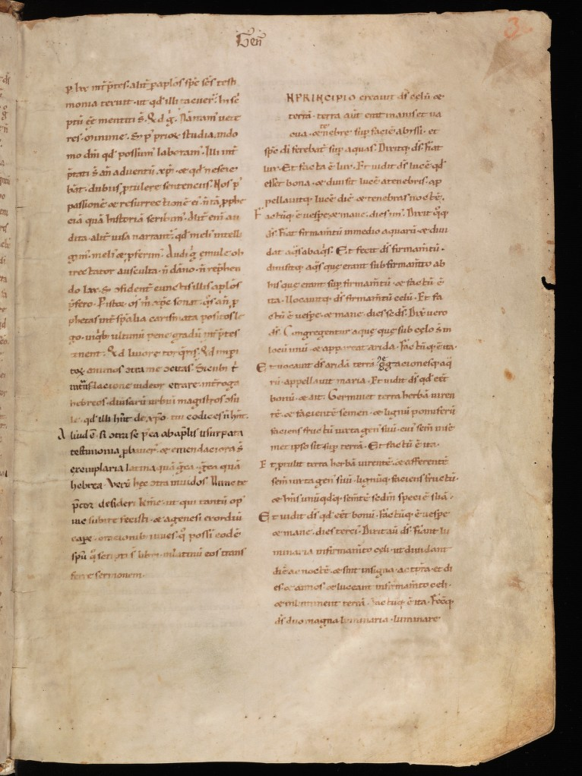
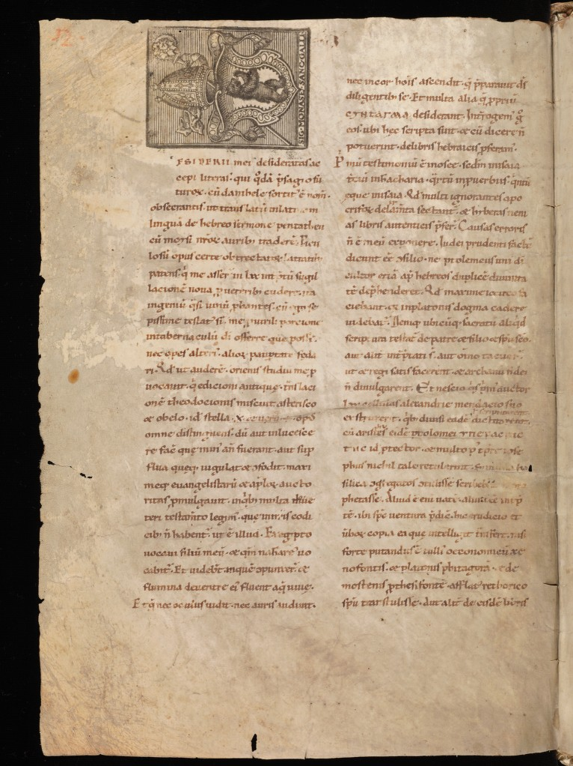
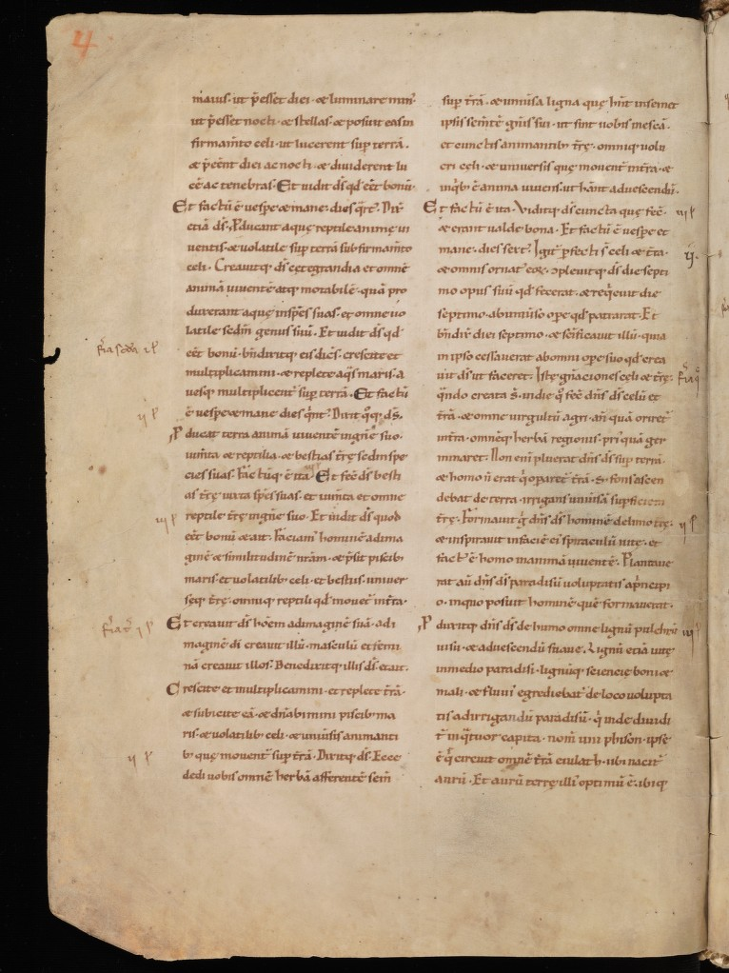
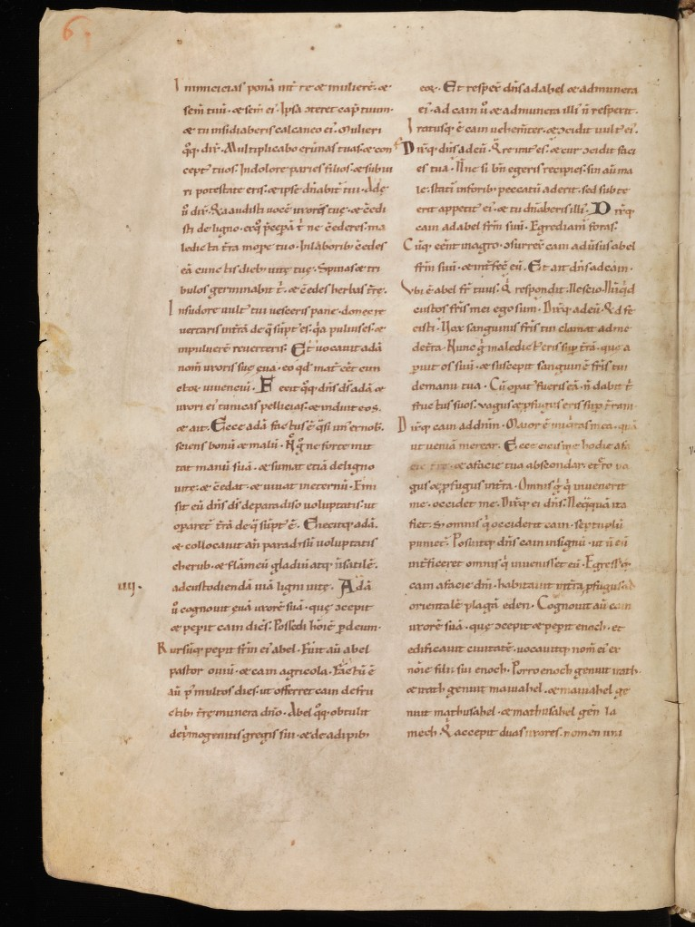

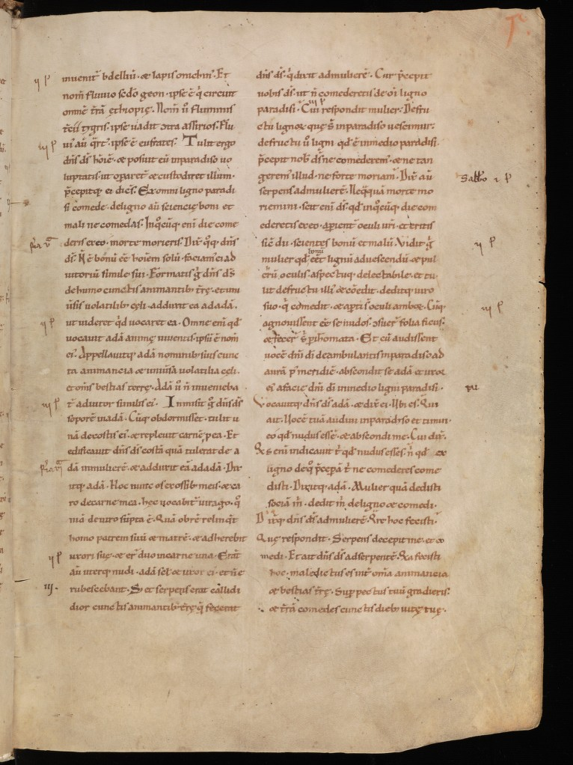

References:

Capelli, Adriano. Translated by Heimann, David and Kay, Richard. The Elements Of Abbreviation In Medieval Latin Paleography. (Lawrence, Kansas: Kansas Printing Services, 1982). s

St. Gallen, Stiftsbibliothek, Cod. Sang. 3: Bible (Gn, EX, Lv, Nm, Dt, Ios, Idc, Rt)
http://www.e-codices.unifr.ch/en/list/one/csg/0003

