Systems Engineering - Design of Experiments Methodology

Tegan Ingram

University of Wales Trinity Saint David
Ordinance, Munitions and Explosives Engineering

Supervisor: Dave Holley
March 2026

Table of Contents
List of Figures 2
List of Tables 3
Acronym List 3
Abstract 4
1. Introduction 5
1.1 Introduction to Taguchi Methods 5
1.1.1 How Taguchi Works 5
1.1.2 Advantages 6
1.1.3 Disadvantages 6
1.1.4 Other Available Methods 7
1.2 Introduction to Experiment 7
1.2.1 Variables 7
2. Methodology 7
2.1 Apparatus 7
2.2 Method 8
3. Experimental Data 10
3.1 Initial Experiments 10
3.1.1 Results Table 10
3.1.2 Results Graphs 11
3.2 Verification Experiment 11
4. Discussion of Results 12
4.1 Initial Experiments 12
4.2 Validation Experiment 12
Conclusion 12
Reflection 12
References 13

List of Figures
Figure 1 – Taguchi Product Design Factors Diagram [3] 5
Figure 2 – Labelled Catapult System 8
Figure 3 – Initial Experiments Results Graphs 11

List of Tables
Table 1 – Standard Orthogonal Arrays [4] 6
Table 2 – Orthogonal Array L₈ Example 6
Table 3 – Control Factors and Their Levels 8
Table 4 – Orthogonal Array Table L₈ 9
Table 5 - Orthogonal Array Table L₈ Populated 9
Table 6 – Initial Experiment Results Table 10
Table 7 – Verification Trials Results 11

Acronym List
Design of experiments – DOE
Signal-to-noise Ratio - SNR

Abstract
The manufacturing sector is constantly looking to improve the quality of the products made. Companies desire that products are manufactured correctly first time. With increased competition within the industry there is a need for businesses to not just satisfy customers’ needs, but to impress customers with the quality of the products that are produced. This report relates Genichi Taguchi’s statistical methods for design of experiments to an experiment conducted with a small catapult. The results of the experiment can be linked to using such methods to design experiments and thus design processes for manufacturing. The effectiveness of the Taguchi method is evaluated during this report. A verification trial based off the results of an initial experiment with the catapult is conducted in which the method is proved to be functional.

Introduction
Quality products can be produced when dependable processes are in place; to make a process dependable, variation must be diminished. Design of experiments (DOE) is an approach used to discover a set of process variables/factors that are especially important to a process/system and then the level at which these factors should be controlled can be determined [1].

1.1 Introduction to Taguchi Methods
Genichi Taguchi designed statistical methods that would improve the quality and efficiency of products and processes. They were developed to produce high quality products in Japan post-World War 2 [2]. The purpose of his method is to design processes that are not susceptible to factors that cannot be controlled. Figure 1 shows the process of the Taguchi method.
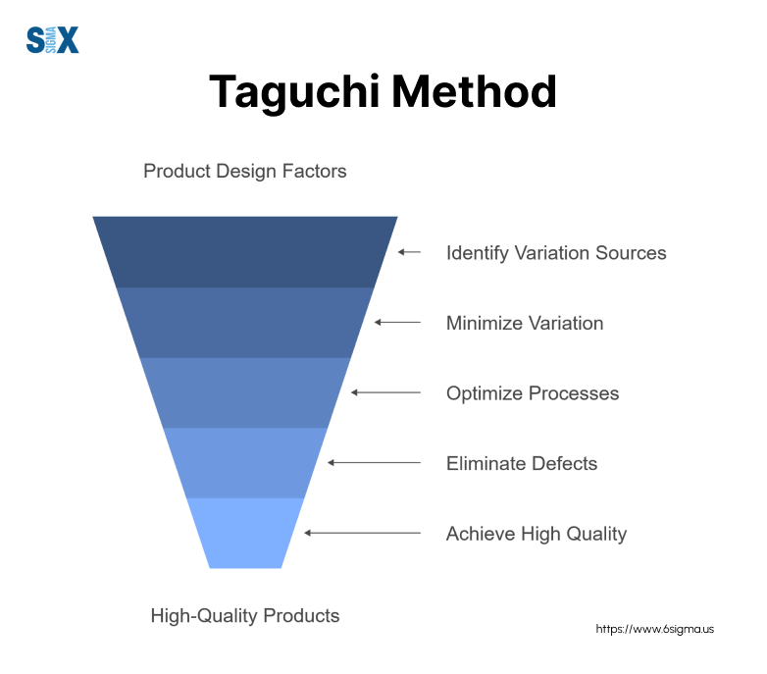
Figure 1 – Taguchi Product Design Factors Diagram [3]

1.1.1 How Taguchi Works
His method incorporates orthogonal arrays which enables an engineer to test a selection of combinations while ensuring each factor level has still been tested equally and individually. This construct was developed to make the DOE technique more applicable and reduces the size of experiments, thus saving time and resources [4].

1.1.1.1 Orthogonal Arrays
Orthogonal arrays are a pre-determined mathematical construct. Table 1 contains examples of standard orthogonal arrays. Table 2 is an example of an L₈ (2⁷) orthogonal array (the same as will be used in the experiment conducted later in this report).
Table 1 – Standard Orthogonal Arrays [4]
Two-level | Three-level | Four-level | Mixed-level
L₄ (2³) | L₉ (3⁴) | L₁₅(4⁵) | L₁₈(2¹, 3⁷)
L₈ (2⁷) | L₂₇ (3¹³) | L₆₄(4²¹) | L₃₆(2¹¹, 3¹²)
L₁₆ (2¹⁵) | L₈₁ (3⁴⁰)
L₃₂ (¹¹³)
L₁₂ (2¹¹)

Table 2 – Orthogonal Array L₈ Example
Experiment No. | Columns
 | 1 | 2 | 3 | 4 | 5 | 6 | 7
Experiment 1 | 1 | 1 | 1 | 1 | 1 | 1 | 1
Experiment 2 | 1 | 1 | 1 | 2 | 2 | 2 | 2
Experiment 3 | 1 | 2 | 2 | 1 | 1 | 2 | 2
Experiment 4 | 1 | 2 | 2 | 2 | 2 | 1 | 1
Experiment 5 | 2 | 1 | 2 | 1 | 2 | 1 | 2
Experiment 6 | 2 | 1 | 2 | 2 | 1 | 2 | 1
Experiment 7 | 2 | 2 | 1 | 1 | 2 | 2 | 1
Experiment 8 | 2 | 2 | 1 | 2 | 1 | 1 | 2

1.1.1.2 Signal-to-Noise Ratio (SNR)
Regularly used in quality control, SNR evaluates the quality of a product/process by comparing desired signal with unwanted variation (noise) [5]. This quantifies how robust the system is and, resultantly, conditions where noise has a lower influence can be identified and optimal settings can be selected.

1.1.2 Advantages
Unlike some methods, the results of the Taguchi method show a mean performance characteristic value that is close to the target value instead of a value that is within certain limits [6]. This challenges the general view that working within tolerances is sufficient for a product/process. Instead, when the mean target is met it shows that the process is controlled, thus creating a more reliable product for the customer and for real world use.

1.1.3 Disadvantages
For some Taguchi’s method can be complex and difficult to understand. For it to be accurately conducted, a deep understanding must be had. Consequently, those who have not got a knowledge of the method will require training and time to research the method and its uses.

1.1.4 Other Available Methods

1.1.4.1 Shainin Method
The Shainin method, developed by Dorian Shainin is another quality control technique. It uses observation prior to experimental investigations, and searches for a dominant cause using the process of elimination and leveraging to solve problems in processes [8]. This method differs from Taguchi method as it is seen as more simplistic and is commonly used for rapid experimentation.

1.2 Introduction to Experiment
The experiment is to be conducted to determine the factors that, when changed, will be most formative of the range of a catapult. It is predicted that a 45° angle for the stop position (stop position 3, level 2) and maximum pull back (170, level 2) will provide the greatest range for the catapult.

1.2.1 Variables

1.2.1.1 Independent Variables
The independent variables (also called the control factors in this type of experiment) are band front position, band anchor position, stop position, pull back, and operator.

1.2.1.2 Dependent Variables
The variable being measured is the range that the ball travels through the air. This is measured from the base of the catapult and is the distance, horizontally, that the ball travels before initial impact with the table.

1.2.1.3 Control Variables
The variables being controlled during this trial included the operator that was measuring the distance, the environmental conditions in which the trial was conducted, the time between pull back and release as well as the weight and dimensions of the ball used.

Methodology

2.1 Apparatus
The equipment needed to conduct the experiment is as follows: a catapult (see Figure 1), a tape measure, a ball, and operators.

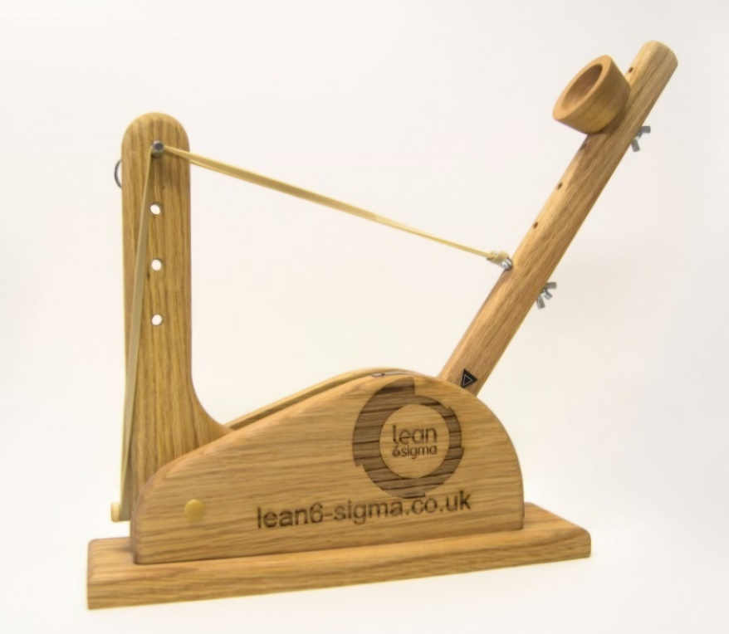
Stop Position
Pull Back Scale
Band Anchor Position
Band Front Position
Figure 2 – Labelled Catapult System

2.2 Method
The steps followed to conduct the experiment with Taguchi methodology are as follows:
Step 1 Identify main functions, side effects and failure mode [7] - The main function of the system was to propel a ball. The side effects included rolling, sound, as well as kinetic energy being transferred to the base of the catapult. Examples of failure modes identified are overloading, operator fatigue and insufficient energy input.
Step 2 Identify noise factors, testing conditions and quality characteristics [7] – Noises included human error with reading the measuring equipment, increasing temperature in the room and wear in the equipment.
Step 3 Identify objective function to be optimised [7] – The object function to be optimised is the range of the catapult.
Step 4 Identify control factors and levels [7] - Control factors and levels were identified and added to Table 3.
Table 3 – Control Factors and Their Levels
Step 5 Select orthogonal array matrix [7] - Table 4 shows the orthogonal array matrix that is used in the experiment and Table 5 shows this array populated.
Table 4 – Orthogonal Array Table L₈
Table 5 - Orthogonal Array Table L₈ Populated

Step 6 Conduct matrix experiment [7] - Results of the experiment can be seen in 3.1.1 Results Table.
Step 7 Analyse the data, predict optimum levels [7] - The graphs in 3.1.2 Results Graphs, show an analysis of the data, with the slopes indicating which factors have the greatest impact on the outcome of the experiments.
Step 8 Perform verification experiment and plan future action [7] - Key features were identified as stop position and pull back. Based off this knowledge the only variables changed within the verification firings were the stop position and pull back point, this allowed the upper and lower firing distances to be identified. The other variables stayed as front position 2, operator A, and band anchor 2. Results of the verification trial can be seen in 3.2 Verification Experiment.

Experimental Data

3.1 Initial Experiments
The initial eight experiments were conducted, Table 6 (variable range) shows the range measured in each. Figure 3 shows the graphs created from the pre-set formulas within the spreadsheet.

3.1.1 Results Table
Table 6 – Initial Experiment Results Table

3.1.2 Results Graphs

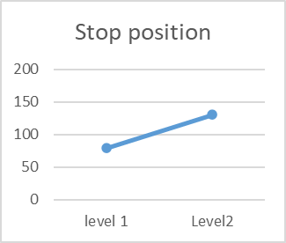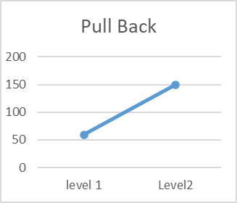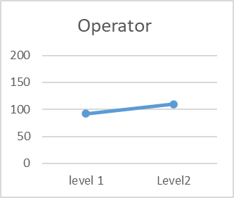
Figure 3 – Initial Experiments Results Graphs

3.2 Verification Experiment
Table 7 – Verification Trials Results
The experiment was conducted a final time by operator A with the stop position at point 3, front position at 2, pull back to 155 and band anchor at 2. The results of this final trial were the ball travelling 142cm.

Discussion of Results

4.1 Initial Experiments
The graphs in Figure 3 show that front position, stop position and pull back can be identified as key features of the experiments. This can be concluded due to the gradient seen between the levels. The impact that the operator and anchor position had is not as great in comparison. These findings influenced the verification trial, with stop position and pull back being chosen to find the upper and lower range of the catapult. A middle value for front position was used due to it also being a key feature. Operator and band anchor were kept at level 1. The overall impact that the operator had on the system was minimal, however without further investigation it cannot be said whether this is due to the system being robust to human variation or a similarity between the operators selected.

4.2 Validation Experiment
The upper and lower levels of stop position and pull back were used during this trial. The midpoint was calculated as 142.92cm. The final firing was done and the result of such was that the ball travelled 142cm. This validated the experiment by having been only 0.92cm from the predicted distance.

Conclusion
Ultimately, Taguchi’s method is a reliable way to identify sources of variation within a product/process. The method has been tried and tested in many industries and the close result in the validation trial proved why the method is so popular. The initial hypothesis that stop position 3 and maximum pull back to 170 would provide the greatest range for the catapult was proven correct. The key features identified as being stop position, pull back and front position give a greater understanding of the system’s tolerances. Taguchi’s method, although found initially confusing by many, is an efficient way to conduct an experiment.

Reflection
During the initial experiment, a factor that had initially not been thought of became an issue. Between experiments there was a variation in the time that that the arm was held back in the pull back position. Due to the design of the system, holding the catapult’s arm back allowed the tension in the elastic band to deteriorate. A solution was proposed. This was counting to five after pulling the arm back, it allowed sufficient time as well as controlling the variation. The experiments were reconducted with this as a control variable.
A further study regarding the systems tolerance to human variation would be required to fully understand this system. Both operators were similar is height and strength. If an operator with a different aptitude had been chosen it may have been seen as a key factor, hence the operator should still be considered as a factor at this stage and should not be considered a noise.
Measuring was observed as a factor that may have caused an incorrect result within the experiment. Measuring by eye where the ball landed was a difficult task. The team decided that an initial shot would be conducted to show a region in which the ball may land. This meant that the operator measuring had an idea of where the ball was likely to impact. To improve this system, a slow-motion video camera that allowed the user to rewatch where the ball landed may have been sufficient, however more costly.
Overall, the experiment was successful with the validation trial proving that the method is reliable. Had the realisation regarding tension on the elastic band not been made, this may not have been the case.

References

[1] | J. Antony, “Training for design of experiments using a catapult,” Quality and Reliability Engineering International, vol. 18, no. 1, pp. 29-35, 2002.
[2] | G. Taguchi and M. S. Phadke, “Quality Engineering through Design Optimization,” Quality Control, Robust Design, and the Taguchi Method, pp. 77-96, 1984.
[3] | Editorial Team, “The Guide to the Taguchi Method: A Robust Quality and Efficient Experimentation,” Six Sigma, 8th October 2024. [Online]. Available: https://www.6sigma.us/process-design/taguchi-method/. [Accessed 15 April 2026].
[4] | R. K. Roy, Design of Experiments Using the Taguchi Approach, New York: John Wiley & Sons, 2001.
[5] | K. Krishnaiah and P. Shahabudeen, Applied Design of Experiments and Taguchi Methods, New Delhi: PHI Learning, 2012.
[6] | K. M. J. Rashid, “Optimize the Taguchi method, the signal-to-noise ratio, and the sensitivity,” International Journal of Statistics and Applied mathematics, vol. 8, no. 6, pp. 64-70, 2023.
[7] | K. V. Sabarish and P. Paul, “An experimental analysis on structural beam with Taguchi orthogonal array,” Materials Today Proceedings, vol. 22, pp. 874-878, 2020.
[8] | S. H. Steiner and R. J. MacKay, “An Overview of the Shainin System for Quality Improvement,” Quality Engineering, vol. 20, pp. 37-41, 2008.
[9] | S. K. Karna and R. Sahai, “An Overview on Taguchi Method,” An overview on Taguchi method, vol. 1, pp. 11-18, 2012.

