Entrepreneurship LCBB5001

Name: Maiyara Mable Florian Santana
Lecturer: Masud Ibrahim

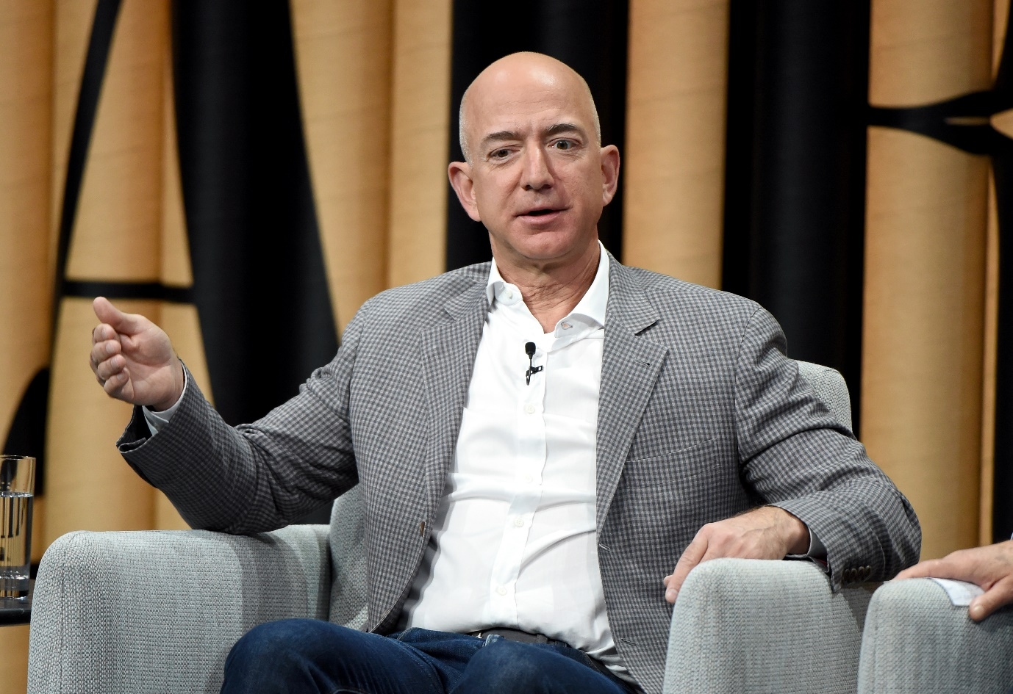

Table of Content
Introduction 3
Jeff Bezos History 3
Jeff Bezos’s Achievements 3
Jeff Bezos’s Motives 4
Jeff Bezos’s Entrepreneurial Traits 5
Conclusion 6
Reference list 7

Introduction
The report focuses on Jeff Bezos as a favourite entrepreneur, highlighting his history, achievements, motives, and entrepreneurial traits. Entrepreneurship is a critical aspect of a business life that contributes significantly to its successful performance. Diandra and Azmy (2020) define entrepreneurship as starting and managing a business venture to create value and achieve financial success. Based on this definition, the main types of entrepreneurships include opportunity-based and necessity-based, innovation-driven, high-growth, venture capital-backed, and technology-enabled entrepreneurship. Therefore, healthy business organisations depend on entrepreneurship to overcome business uncertainties.

Jeff Bezos History
Jeffrey Bezos, commonly known as Jeff Bezos, was born in New Mexico on 21 January 1964. According to Furgang (2018), he grew up mainly as an adopted child since his teen parents divorced just a year into their marriage. The troubled childhood life is among the critical factors that contributed to his strong desire to make a mark in the field of technology, like his role model, Steve Jobs, at a very tender age. He enrolled at Princeton University, graduating with electrical engineering and computer science honours in 1986. Jeff Bezos foresaw an opportunity associated with emerging digital technologies, such as the internet and social media; thus, he quit his lucrative career at Wall Street and moved to Seattle, Washington, to start a virtual bookstore from the garage in 1994 (Gillespie, 2015). He worked with a few employees to develop software for the business, which he named Amazon.com. The company sold its first book in 1995, marking his monumental role in the growth of the global e-commerce industry. Statista Research Department (2024) indicates that the company has expanded beyond selling online books to other retail products, generating over 576 billion US dollars in revenue. Therefore, Jeff Bezos is a favourite entrepreneur due to his firm conviction to make a mark in technology from a tender age and a rough childhood.

Jeff Bezos’s Achievements
Jeff Bezos made significant growth in global e-commerce through the establishment and continued success of Amazon.com, which he started from their family's garage in Seattle, Washington, in 1994 as an online bookstore. According to Gillespie (2015), he predicted an opportunity in the emerging digital technology in the 1990s following the emergence of the internet; hence, he took advantage of this growth potential to start the company, which has since grown to become one of the world's giants in the global e-commerce industry. The company has expanded beyond virtual books to thousands of consumer goods and cloud-based services. Qumer and Purkayastha (2015) identify rapid growth in cloud computing business, increased online sales, and introduction of appropriate initiatives to attract customers as the main factors behind the company's rapid growth since its establishment in 1994—moreover, the introduction of third-party services that allowed independent retailers to sell different items through the website. Notably, the company provides these third-party services at a fee, which has contributed significantly to the company's rapid revenue growth. Therefore, through Jeff Bezos’s visionary leadership, Amazon.com is currently the world’s leading marketplace and product search engine.
Blue Origin is another critical achievement for Jeff Bezos as an entrepreneur. McCurdy (2019) maintains that Jeff Bezos founded the space exploration company in 2000 to reduce the expense of space exploration through technological advancement. The project's goal is to broaden space exploration to individuals willing to pay for the services. Jeff Bezos supported the project by selling 1 billion US dollars of Amazon's stock annually. McCurdy (2019) indicates that Blue Origin is another critical Jeff Bezos achievement since the company was named one of the 13 chosen companies to collaborate with NASA to work on 19 projects focusing on lunar and Martian exploration in August 2019. The company's contribution towards these projects includes developing accurate and reliable landing systems and creating engine nozzles for the projects' liquid-propellant rockets. Moreover, in partnership with NASA, Blue Origin is currently working on constructing and launching reusable rockets from their renovated facility near the Kennedy Space Centre. The company's success in the new field is an achievement since it demonstrates Jeff Bezos's childhood conviction to make a mark in the technology field.

Jeff Bezos’s Motives
Entrepreneurship mainly involves starting and managing a business venture to create value and achieve financial success. Furgang (2018) indicates that Jeff Bezos's teen parents divorced a year into their marriage, forcing him to grow up under the foster care of his Cuban American father, Miguel Bezos. Their troubled childhood motivated Jeff Bezos to work hard and make a mark in technology. Admittedly, this conviction led him to join Princeton University and pursue a technology-related course, which later became a critical pillar of his success in the field of technology. Jeff Bezos had different motives for starting Amazon.com and Blue Origin, his critical ventures.
The motive behind starting Amazon.com was his entrepreneurial mindset and desire to create the world’s most customer-centric retail company. Gillespie (2015) indicates that Jeff Bezos saw a great opportunity in the rapid growth of the internet; hence, he wanted to take advantage of technological advancement to start a company that would provide customers with the best possible shopping experience. In this regard, he focused on online book retail, which would make millions of books available to customers in different parts of the world at relatively lower prices than conventional physical books. Amazon.com is an example of technology-enabled, innovation-led and opportunity-led entrepreneurship since Jeff Bezos wanted to take advantage of the opportunities associated with the growing popularity of the internet by introducing a unique innovation that would revolutionise the customer experience. Therefore, making a mark in the technology industry was the primary motive that drove Jeff Bezos to start Amazon.com, through which he intended to create the world’s most customer-centric company.
The motive for starting the space exploration company Blue Origin was to expand space exploration to anyone willing to pay for the journey. McCurdy (2019) indicates that he intended to achieve this through advanced technologies to reduce space exploration expenses significantly. The company works closely with NASA to develop accurate and reliable landing systems and engine nozzles for liquid-propelled rockets to promote lunar and Martian exploration. Blue Origin's focus on technological advancement has significantly lowered exploration expenses. Soon, any person who intends to explore the space will do so at relatively lower costs. McCurdy (2019) further indicates that the company has partnered with NASA to construct and launch reusable rockets, which will lower exploration expenses. Therefore, Jeff Bezos's motive of broadening space exploration to anybody willing to pay is evident through the focus of Blue Origin’s projects.

Jeff Bezos’s Entrepreneurial Traits
Jeff Bezos's achievements in the field of technology are attributed to his positive entrepreneurial traits. Admittedly, he is a visionary leader, a big thinker, and a fantastic learner. These traits have significantly strengthened his ability to influence different stakeholders towards achieving his goals. Mullins (2016) indicates that entrepreneurs require the above traits to promote the successful performance of their business ventures. Therefore, this section highlights how to develop these traits in the future.
Visionary leadership is a critical entrepreneurial trait that drove Jeff Bezos to significant success in the technology industry. Zhou et al. (2018) maintain that entrepreneurs depend on this trait to promote creativity through continuous research and development. In this regard, visionary leaders can envision future opportunities and communicate them effectively to employees to ensure successful execution. Jeff Bezos foresaw great potential in e-commerce back in 1994 when he founded Amazon.com at a time when other companies considered it a less viable venture. Therefore, developing this trait through training and development is critical to successfully navigating the current highly dynamic business landscape, ensuring enhanced business performance.
The analysis of Jeff Bezos’s achievements indicates that he is a big thinker. According to Tampubolon and Harati (2019), entrepreneurs must continuously generate new ideas to ensure they achieve goals. Jeff Bezos is a big thinker since he worked with a few employees in his family garage to create Amazon.com. Notably, this entrepreneurial trait is responsible for the company's continuous success and other businesses in which Jeff Bezos has invested. Therefore, to succeed in the future business landscape, developing this trait further through training and development and exposure to various challenging business situations is critical.
Finally, Jeff Bezos is a fantastic learner, a trait that has enabled him to succeed in various businesses. Baker et al. (2019) observe that entrepreneurs must listen to their instincts and learn continuously from different stakeholders to promote decision-making and organisational performance. Jeff Bezos listens and learns continuously from his employees, enabling him to develop ingenious business ideas that have contributed to the continued success of Amazon and other companies under Jeff Bezos's ownership, such as Blue Origin and Washington Post. Notably, this trait is critical for successful performance in the current dynamic business landscape since it ensures flexibility in decision-making. Therefore, developing this trait further through training and development is critical to successful future performance as an entrepreneur.

Conclusion
The discussion demonstrates that Jeff Bezos is a successful entrepreneur whose abilities have enabled him to succeed in different industries. Notably, his journey as an entrepreneur began with the establishment of Amazon, which has grown to become the world's leading e-commerce business and product search engine. Moreover, founding the Blue Origin further indicated his entrepreneurial trait. The most prevalent achievements of Jeff Bezos include founding Amazon.com, an e-commerce giant and Blue Origin, a space exploration venture. The achievements originated from his desire to revolutionise customers' shopping experience and reduce exploration expenses to make it available to anyone willing to pay for such services. The critical entrepreneurial traits behind Jeff Bezos's success in different technology industries include visionary leadership, thinking big, and fantastic learning. Therefore, developing these skills is critical to starting a successful venture in the rapidly changing business landscape.

Reference list
- Castro, M.P. and Zermeño, M.G.G., (2020). Being an entrepreneur post-COVID-19–resilience in times of crisis: a systematic literature review. Journal of Entrepreneurship in Emerging Economies. Available at: Being an entrepreneur post-COVID-19 – resilience in times of crisis: a systematic literature review | Emerald Insight [ Accessed on 20th July, 2024]
- Diandra, D. and Azmy, A.,( 2020). Understanding definition of entrepreneurship. International Journal of Management, Accounting and Economics. Available at: (PDF) Understanding Definition of Entrepreneurship (researchgate.net) [Accessed on 19th July, 2024]
- Furgang, A., (2018). Jeff Bezos: Tech Entrepreneur and Businessman. Enslow Publishing, LLC.
- Gillespie, K., (2015). Jeff Bezos.
- McCurdy, H.E.,( 2019). Blue Origin: The Entrepreneur as Philanthropist. Financing the New Space Industry: Breaking Free of Gravity and Government Support. Available at: Blue Origin: The Entrepreneur as Philanthropist (researchgate.net) [ Accessed on 15th July]
- Mullins, L.J., (2016). Management and organisational behaviour.11th ed. Pearson Education Limited. Available at: nibmehub.com/opac-service/pdf/read/Management & Organisational Behaviour.pdf [ Accessed 25th July, 2024]
- Qumer, S. M., and Purkayastha, D., (2015). Amazon.com’s Business Model and its Evolution. IBS Hyderabad.
- Statista Research Department, (2024). Amazon: Annual net sales 2004-2023. Statista. Available at: https://www.statista.com/statistics/266282/annual-net-revenue-of-amazoncom/ [Accessed 24 July 2024].
- Tampubolon, M. and Harati, R. (2019). Role of organisational culture, communication and leadership style on job satisfaction. International Journal of Research in Business and Social Science. Available at: (PDF) Role of organizational culture, communication and leadership style on job satisfaction (researchgate.net) [ Accessed on 26th July 2025]
- Zhou, L., Zhao, S., Tian, F., Zhang, X. and Chen, S., 2018. Visionary leadership and employee creativity in China. International Journal of Manpower. Available at: (PDF) Visionary leadership and employee creativity in China (researchgate.net) [Accessed on 26th July 2024]

