
APPENDIX GA36c

LEVEL 6 ASSESSMENT SPECIFICATION
Student name: | Jessica McCabe | Student ID number: | 1800105
Programme: | Primary
Module: | Principles of Pedagogy
Module code: | M6X01438/C | Contribution to Overall Module Assessment (%): | 100%
Lecturer: | Siân Brooks | Internal Verifier: | Siân Brooks
Assignment Title: | ‘Describe a learning event which has happened during your recent school experience. Reflect upon what took place, connecting events to theories of learning and teaching. Make recommendations about how you could improve your own practice in the light of this. Produce a poster to illustrate how you would develop the elements of an effective learning environment.’ | Word count (or equivalent): | 5,000 or equivalent.
Submission deadline: | 17/10/18 (23.59) | Return date of provisional marks & written feedback: | 14/11/18
Submission method: | All written assessments, where practical and possible, must be submitted via Turnitin unless otherwise instructed by the Lecturer. (Please DO NOT put this assessment specification into Turnitin or it will match many similarities with other students’ submissions.)  Alternative submission method (if applicable):  Late submission of the assessment will result in a late penalty mark. Penalties for late submission: Up to one week late, maximum mark of 40%. Over one week late, 0%. Only the Extenuating Circumstances Panel may approve a change to submission dates.
Academic honesty / referencing: | Academic honesty is required. In the main body of your submission you must give credit to authors on whose research and ideas your work is based. Append to your submission a reference list that indicates the books, articles, etc. that you have used, cited or quoted in order to complete this assessment.
Module Learning Outcomes
(from module syllabus)
1. understand, synthesise and evaluate the main theories that underpinning learning, behaviour and assessment in the primary school
2. reflect critically on how learning theories inform the planning and provision of high quality learning environments, demonstrating a clear understanding of how theory and practice are interrelated
3. organise knowledge and learning through the use of a range of information sources, and present work appropriately.

Describing a learning event which has happened during your classroom observation.
Part 1: Observation of an event within the classroom.
The learning event occurred within a school in the outskirts of an urban city in the south of Wales. The school had a high amount of EAL children as well as 14% of children coming from an ethnic minority, 11% of those children having English as an additional language. Furthermore, around 52% of children within the school have additional learning needs as well as an above average percentage of free school meals of 33.6%. The School also has some Looked After Children (LAC). The school has 384 pupils in their care, where the ration to student – teacher is 19:1 and is a green support school. They are a UNCRC Rights respecting school where all children are listened to and their rights are upheld. (School Guide UK, 2018; Estyn, 2014)
For this assignment, the school, teacher and pupils have been anonymised to protect their identity and to up here to the guidelines set you by BERA (2018). Each child will be identified to child 1, child 2 and so on, the teacher will be identified as teacher and the school will not be named throughout this assignment. My observation method was taking notes on how the children and teachers interacted during their well-being check in time. This was carried out by taking notes on the children’s and the adult’s responses.
During the time I was in school I observed an incident which showed children understanding, exploring and explaining their emotions and empathising with the other children’s emotions in their class. When the children arrive at school they had to put their pictures within buckets which had different emotions on, the children chose the bucket which described how they were feeling the best. After this, the class then carried out a ‘check in time’ where they talked and looked at how the children were feeling and talked about why they felt the way they did. During the check in time the children told the teacher why they were feeling the way they did, some children’s responses were the following:
Child | Emotion | Reason
1 | Excited | It was their birthday.
2 | Tired | They didn’t have a good night sleep.
3 | Happy | They had a nice breakfast.
4 | Sad | They didn’t see their dad in the morning.
5 | Tired | They had to wake up early for school.
6 | Sad | They didn’t want to be in school and wanted to go home.
7 | Happy | It was nearly the weekend.
8 | Worried | They were not ‘brainy’ enough for school.
9 | Worried | Their mum would miss them while they were at school.
These responses highlight the importance for children to explore their emotions and explain how they are feeling. This enables other children to understand other children’s emotions as well as for teacher to be aware on children’s well-being. This also allowed the teachers to keep track on how the children were feeling with the teaching assistant making notes of how the children were feeling and their reasons for that which allows the adults to ensure the child’s well-being is being upheld.
Each of the children’s responses highlighted several links to attachment and children’s social and emotional understandings as well as developmental factors. Child 4’s response highlighted that the child may be feeling sad and upset due to having attachment issues. This could be linked then linked to attainment and progress during their time at school. Child’s 6 response in which they felt sad because they didn’t want to be in school could stem from a number of issues some could include not feeling safe at school and attachment. Child 8’s response could be linked to self-esteem. Child 9’s response can also be linked to attachment issues.
These responses highlight the importance of checking in with children and their emotions and the reasons of which these emotions stem from. Children need to talk and listen to others about their emotions to gain social and emotional development which can allow children to understand why they are feeling this way. The school has a duty of care for the children and for teachers and other supporting adults it is vital that they are aware of how the children in their care are feeling and for then the responsible adults to act upon and create a safe environment to support the child in which may need help in understanding their emotions and well-being.
The observation of the well-being check in allowed the teacher to acknowledge how the children were feeling and then talked to the children how they can overcome these feelings. The approach the teacher used was calm and empathetic which allowed the children to be open and honest with the teacher. The teacher had created a trusting relationship with the class to allow the children to disclose how they were feeling. The safe environment which the teacher created allowed honesty from the children. The environment was calm, the children were sat in a circle where they felt safe and relaxed.
I choose to look at this critical incident as it was a new approach to myself where I had not seen this before within schools in England. This allowed me to see the importance of understanding children’s emotional well-being within a school environment and how the teachers dealt with how the children were feeling.
Although the approach had many advantages which allowed children to understand their emotions and to understand how others around them were feeling. I felt that some children may not want to talk about how they were really feeling this could be due to not wanting their peers to hear how they are feeling, them not understanding truly how they are feeling and not knowing how to explain their emotions.
Children have many rights in their lives and education, the UNRCR states in Article 13: “Children have the right to freedom of expression” as well as in Article 29: “…the education of the child shall be directed to: the development of the child’s personality, talents and mental and physical abilities to their fullest potential...” (UNCRC, 1989: pp 5-9) This has a huge impact on how children have a right to express how they feel and the education they receive supports their development and abilities. Children in Wales receive Personal and Social Development, Well-being and cultural diversity as a part of an Area for Learning from the age of 3 to 7 as statutory framework, through the Foundation Phase. (Welsh Government, 2015) This area of learning is fundamental for children to understand their own and other’s emotions.
The children also highlighted attachment issues maybe surrounding their emotions which will be explored further in Part 2 highlighting Bowlby’s Attachment Theory (Bowlby, 1969; Crowley, 2014)
This observation is linked to module content such as: Learning Environment and Self-esteem, children as learners, learning theories, play and active learning, exploratory talk, foundation phase, thinking and metacognition, outdoor learning and attachment.

Part 2: Theory.
The observation has allowed me to look at supporting theories to allow child development and how these theories underpin learning outcomes for the pupils.
The Foundation Phase is supported by key theorist’s such as Isaacs, Vygotsky, Piaget, Montessori. These theorists highlight the importance of play and learning. Isaacs believed there was an importance of play in natural environments and children can be observed to get detailed knowledge of the children. (Isaacs, 1971, citied in Pugh and Duffy, 2014) Vygotsky highlights the social aspect of development. (Vygotsky, 1978) Piaget (1951) suggests active learning and play can allow detailed observations and cognitive development. Montessori suggests that play is a child’s work and that is how they learn best. (Brown and Patte, 2013) These theorists highlight the importance of play and development within the Foundation phase and child development. The learning event allowed the children to meet multiple strands from the statutory framework.
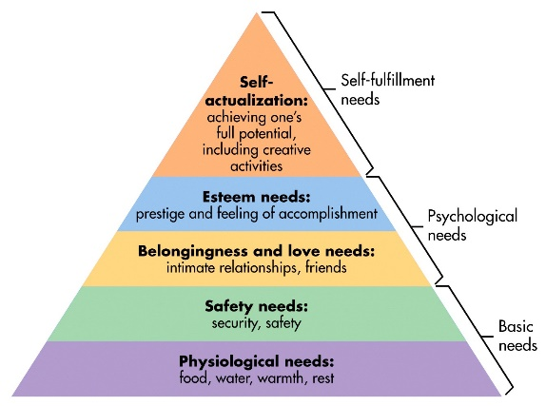
The learning environment enabled the children to feel safe which allows them to progress through to being able to learn. Maslow (1943) highlights that children’s basic needs need to be met for children to develop and learn effectively. Once these needs have been met only then can children learn and develop to their fullest.

McLeod (2018)

Children need to be engaged in their learning and their emotions play a huge aspect of how children can engage as well as the teachers. Children as learners and active learning is essential to also help improve their well-being. This is supported by Piaget’s idea that children are active learners. (Jarvis and Chandler, 2002) Cohen et al (2014, cited in Pritchard, 2009: pp 105) states “schools exist to promote learning. Teachers are catalysts for learning.” This highlights the importance of adults are needed to be effective to empower and promote learning, this can help children to raise awareness of their development and learning.
Social and emotional well-being is linked to Bowlby’s attachment theory. There are three types of attachment: Ambivalent, Avoidant and Disorganised. These types of attachment can have a huge impact of children’s self-esteem and well-being. Ambivalent type means the child cannot rely on their needs being met, Avoidant the child believes their needs will not be met and Disorganised the child is severely confused with no strategy with how to deal with how their needs can be met. (Bowlby, 1969)
Attachment Type | Care Giver Is | Child Is
Ambivalent | - Inconsistent  - Sometimes Sensitive  - Sometimes Neglectful | - Anxious  - Insecure  - Angry
Avoidant | - Distant  - Disengaged  - Neglectful | - Withdrawn  - Doesn’t explore  - Quiet
Disorganised | - Frightened  - Passive  - Extremely frightening | - Depressed  - Angry  - Passive  - Unresponsive
Bowlby (1969)
Part 3: Reflect and Innovate.
An effective learning environment is essential for children to learn and develop within their education and childhood. During my observations, I found that a calm and flexible learning environment helped the children to feel safe and engaged to learn.
The poster I have designed is set out in a foundation phase class, where there is an inside and outside learning environment. The inside classroom environment consists of:
Area | Use/Resources
Carpet area | Used for class activities and teaching. Relaxed teaching area  Calm displays surrounding the area, different coloured carpet spots for children to sit on.  ICT (IPADS) are used in this area when the provision of play is used.
Well-being area | For children to go when they feel sad/worried/anxious.  Children can write and/or talk about how they are feeling, Check-in Buckets.  A safe place to talk about their well-being.
Work/tabled area | Area for class work and tasks. The area is set out as two big groups where children can sit comfortably to complete their work
Small world area | This area is for children to explore toys such as barbies, cars, small figurines etc.
Literacy Continuous Provision area | Literacy continuous provision is a tough tray or work station where children can complete tasks to help with their literacy skills and learning.
Numeracy Continuous Provision area | Numeracy continuous provision area is a tough tray or work station where children can complete tasks to help complete talks for their numeracy skills and learning.
Messy play area | Messy play area is an area for junk modelling, painting and anything creative and messy.
Role play area | The role play area will have different dressing up as well as a theme such as a kitchen, rocket-ship, princess castle etc.
Quiet/reading area | This area will be used by the children for reading and an area where they can relax. This area allows children to take time to themselves or in small groups.

The outside area consists of:
Area | Use/Resources
Free Play area | To be used by the children as they please. This area the children can play whatever games they want. Resources such as skipping ropes, balls, tennis sets, building blocks, stilts etc.
Climbing frame area | The climbing frame area can be used by children to explore different movements of their body for physical development and being outside their comfort zone.
Scooters/bike track | This area has scooters and bikes for children to develop their gross motor skills and physical development.
Continuous Provision area | This continuous provision area is for children to explore a topic of their choice.
Area of topic or theme | This is designed by the children. The children can explore this area of the themes they have decided to learn about. This allows children to choose their own learning and to be engaged with the activities.
Area of Continuous Provision (Tough Tray) | This area of Continuous Provision is set out in a tough tray which will mainly be using their fine/gross motor skills.
Sand/Water area | Sand and water area will have different activities for children to explore using both areas.
Forest school/Mud kitchen area | A forest school and mud kitchen area have a small camp fire, resources such as pallets, sheets etc for den building, mud kitchen for role play. This area will enable children to explore the outside environment and wildlife.
Tee pee quiet area | This quiet area allows the children to take time out and relax in an outside environment, the children can read books in here as well as do some colouring/drawing.

These areas within the classroom lay out are essential for children to become active learners. These areas allow children to be engaged and independent learners. The areas are all set out to have higher order thinking tasks to get the children to think about what they are doing and learning. Adult support is in key areas such as the continuous provision areas, messy play, in all the outside areas. An effective learning environment need to be able to allow children to link it to their own real-life experiences to make it meaningful.
The outdoor environment allows children to explore and actively engage within the environment. This provision is essential for children’s learning and development. Outdoor learning is recognised all over the world as an essential way for children to learn and develop and is apart of the Foundation Phase Framework (Welsh Government, 2015) The outdoor classroom helps educators improve their schools and communities by having students connect with one another and through creating awareness of environmental concerns.” (Jelmburg and Goodman, 2008: pp 5) This is also highlighting social issues regarding the outdoor environment this can allow children to engage in social issues surrounding them as well as being aware of how these issues make them feel creating an active learning environment where they can connect with the world around them. “Teaching children outside a classroom, almost regardless of what we are teaching, increase vitality of learning.” (Sedgwick, 2012: pp 3) this backs up Piaget’s theory that “children are active learners” (Jarvis and Chandler, 2002). Outdoor learning can be used as an area of self-esteem and emotional well-being as this environment creates a positive atmosphere. Edgington (2002: pp 9) support this by stating “Outdoor learning makes a major contribution to children’s development.”
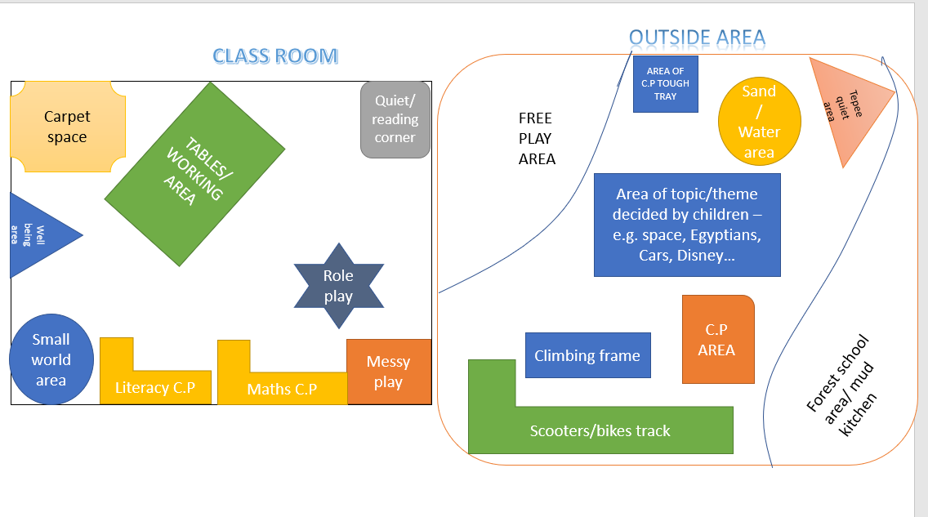
References:
- Bowlby, J. (1969) Attachment and Loss: Vol. 1 Attachment. New York: Basic
- British Educational Research Association [BERA] (2018) Ethical Guidelines for Educational Research. 4th edn. London: BERA. [Online] Available from: https://www.bera.ac.uk/wp-content/uploads/2018/06/BERA-Ethical-Guidelines-for-Educational-Research_4thEdn_2018.pdf?noredirect=1 [accessed 04 October 2018]
- Brown, F. and Patte, M. (2013) Rethinking Children’s Play. London: Bloomsbury
- Crowley, K. (2014) Child Development: A practical introduction. London: Sage.
- Edgington, M. (2002) The Great Outdoors – developing children’s learning through outdoor provisions. London: The British Association of Early Childhood Education.
- Estyn (2014) Inspection Report. Cardiff: Inspectorate for Education and Training in Wales.
- Jarvis, M. and Chandler, E. (2002) Angles on Child Psychology. Cheltenham: Nelson Thornes.
- Jelmburg, J. and Goodman, G. (2008) The outdoor classroom. New Jersey: Hampton Press.
- Maslow, A. H. (1943) A Theory of Human Motivation. Psychological Review. Vol. 40, No. 4: 370 – 396.
- McLeod, S. A. (2018) Maslow’s hierarchy of needs. [Online] Availible from: https://simplypsychology.org/maslow.html [accessed 23 October 2018]
- Piaget, J. (1959) Play, Dreams and Imitations in Childhood. London: Routledge and Kegan Paul.
- Pritchard, A. (2009) Ways of Learning: Learning Theories and Learning Styles in the Classroom. Abington: Routledge.
- Pugh, G. and Duffy, B. (Eds.) (2014) Contemporary Issues in the Early Years. (6th ed.) London: Sage
- School Guide UK. (2018) School Guide. [Online] Available from: https://www.schoolguide.co.uk/schools/ [accessed 03 October 2018].
- Sedgwick, F. (2012) Learning Outside the Primary Classroom. London: Routledge.
- United Nations Convention. [UNCRC] (1989) United Nations Convention of the Rights of the Child. New York: UN General Assembly. [Online] Availible from: https://downloads.unicef.org.uk/wpcontent/uploads/2010/05/UNCRC_united_nations_convention_on_the_rights_of_the_child.pdf?_ga=2.208312978.1215365856.15144688841038199695.1514468884 [Accessed 12 October 2018]
- Vygotsky, L. S. (1978) Mind in society: The development of higher psychological processes. Cambridge: Harvard University Press.
- Welsh Government. (2015) Curriculum for Wales: Foundation Phase Framework. Cardiff: Department for Education and Skills. [Online] Availible from: http://gov.wales/docs/dcells/publications/150803-fp-framework-en.pdf [accessed 12 October 2018]

