NAME: SHELIMA BEGUM MIAH
STUDENT NUMBER: 1707655
MODULE TITLE: PROBLEM SOLVING AND DECISION MAKING
MODULE LECTURERS NAME: MUSHFIQUR RAHMAN
MODULE REF: BMSK4004
WORD COUNT: 4562

Executive Summary
UK grocery retailing industry is concentrated. The Big 4 retailers, namely, Tesco, Asda, Sainsbury’s plc and Morrisons generated 68.8% of the total industry sales during 2017. Tesco Plc leads the industry with its 27.8% market share. Though concentrated, the big retailers are facing tough competition regarding price from the discount retailers like Aldi & Lidl. Operational efficiency, effectiveness and quality is identified as the sources from where discount retailers are getting incentive for engaging in the price war with the industry leaders like Tesco Plc who positioned themselves as the cost leader in the industry. Making the best use of the disruptive technological innovation & e-retailing facilities, which helps in ensuring high customer responsiveness, online specialized retailers like Ocado, Waitrose and catalogue seller Argos are increasing their loyal customer base in a compounding rate.
Tesco Plc, though still is the market leader, lost its market share to the close competitors, discount retailers and online retailers throughout the last 5 years of operation. In this report, the problems that are creating the operational inefficiency & ineffectiveness at Tesco Plc and are causing the deterioration of the competitive position of Tesco Plc.
Weak presences in the online segment, slow response to the technological changes, inefficient backward integration & unfavorable operational structure are identified to be the source of inefficiencies, ineffectiveness and low customer responsiveness at Tesco Plc. Tesco Plc can reduce the number of outlets; strengthen online presence, install of virtual stores & direct sales option, acquire online retailer or online catalogue seller, perform divestitures & form credible collaboration with the suppliers to solve these issues.

Contents
Executive Summary 2
1. Brief introduction of Tesco Plc 4
2. the scope & impact of the complex issues at Tesco Plc 5
2.1: Identification of the Problems and solution 5
2.2: Evaluation of the problems 8
2.3: Alternative solutions available to Tesco 10
2.4: Decision making techniques to solve the problems 11
2.5: Communication with the stakeholders & co-ordination plan 14
3. SWOT analysis 15
5. PEST Analysis 17
6. Conclusion 18
References 19

1. Brief introduction of Tesco Plc
Tesco Plc, British grocery retailer, is one of the BIG 4 retailers of the market leading grocery retailing industry of the UK with its market share of 27.6% (in terms of % of the total industry revenue generated)(statista.com, 2018). The retailer serves through its6553 outlets (including super markets, convenience stores, hyper market & super stores) and online retailing platform in the markets including India, Thailand, Ireland, Hungary, Malaysia, & Czech Republic in addition to UK. The retailer was valued as the 3rd largest retailer globally in terms of brand value(Ft.com, 2018). Though grocery is the main line of the business run by the Tesco Group, it as a part of the business line portfolio diversification strategy (I.e. in addition to its geographic diversification effort) runs some subsidiaries including Tesco Bank, Tesco Mobile, Tesco Family Dining Ltd etc which are involved in serving non-correlated industries like financial industry & telecom industry etc.
Tesco plc positioned itself as the cost leader in the market. But the organization is continuously losing market share to the online grocery retailers like Argos & Waitrose etc and discount retailers like Aldi & Lidl etc. The management of Tesco found it difficult to keep its position as a cost leader due to the operational structure i.e. more focus on the brick & mortar retailing rather than on the online retailing. In addition, as time passes, the market growth of the online grocery retailing segment is undergoing compounding growth reflecting the changes in the buying behaviour of the customers. As Tesco has comparably less strong position in the online retailing segment in comparison to the other Big 3 retailers, it also has been deprived of taking participation in such compounding growth trend in the online retailing segment (i.e. currently the contribution of the online retailing segment is 15% of the industry and is expected to grow to 25% by 2020)(Kantarworldpanel.com, 2018).
Over the last three years, discount retailers like Aldi & Lidl, leading retailers like Sainsbury’s Plc&Asda stores limited and online retailers like Waitrose experienced increasing growth while Tesco Plc experienced a decreasing growth which is currently negative growth rate.
Management team of Tesco pointed on the issues related to the inefficient operational structure, supply chain problems, pricing issues & brand loyalty as the reason of such downfall. Throughout the report, the reasons behind such continuous downfall are discussed and the impact of these & options available to overcome the issues are evaluated.

2. the scope & impact of the complex issues at Tesco Plc
CEO of Tesco Plc, Dave Lewis pointed out some issues that should be dealt with in order to improve operational, financial & market performance. Considering the issues cited by Dave Lewis & the research recommendation made by the researchers, the problems are identified & evaluated for decision making purpose in this segment.

2.1: Identification of the Problems and solution
There are 4 problems identified but the matter is one which is the reduction of the market as all of the problems identified directly or indirectly contributes to the reduction of the market share.
Pricing issues: Tesco Plc developed its brand value as the cost leader in the market & so customers form their expectation accordingly. A surprise in the trend causes the reduction in the size customer base of the Tesco. One factor is the recession which forces to break the status quo (Hogarth-Scott, 2017). The recession in the market made discount retailers like Aldi&Lidl a better place to shop from. After realizing the impact, Tesco management announced £200 million price cut effort but it was too late. Deterioration of relationship with the suppliers, cannibalization effect due to the subsidiaries poor performance & expensive operational structure (high expense on the stores) are identified to be reason which are making the operations at Tesco costly & thus reducing the capability to charge low price without affecting the profit margin.
Brand loyalty Vs changes in the buying behaviour: Due to some effective marketing & sales schemes (i.e. Clubcard), Tesco has been able to keep a strong & large loyal customer base. But the potency of such innovative schemes is reducing as it has been drowned out by the price promises (Ruddick, 2018). Besides losing loyal customer base to the discount retailers, Tesco also loses market to the online grocery retailers like Ocado& Waitrose and catalogue sellers like Argos.
The degree of the customer losing is high due to the changes in the customer buying behaviour. Customers now a day’s puts more weight on the comfort while shopping as technological innovation made life easy. This trend can be assessed by looking at the growth rate of the contribution of the online retailing segment to the grocery retailing industry sales revenue. It was approximately 15% during 2017 and is expected to be 25% by 2020.

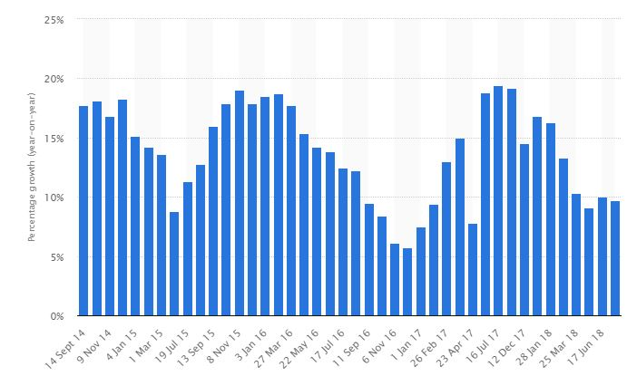
Figure 3: Revenue growth rate of Ocado(Statista.com, 2018)
Figure 3 shows the revenue growth rate of the online grocery retailer Ocado over time which has been more than 5% on average over the last 4 years. But on average the rate is negative for Tesco Plc.
Considering the need of strong presence in the online platform Salisbury’s Plc acquired Argos which is online catalogue seller of more than 30,000 grocery products ((Dede, 2018).Asda stores ltd acquired Waitrose which is an online grocery retailer to make its online segment strong so that it can take participate in the huge growth of this segment. But Tesco failed to make such acquisition which would give the organization to have a ready-made strength in the online segment.
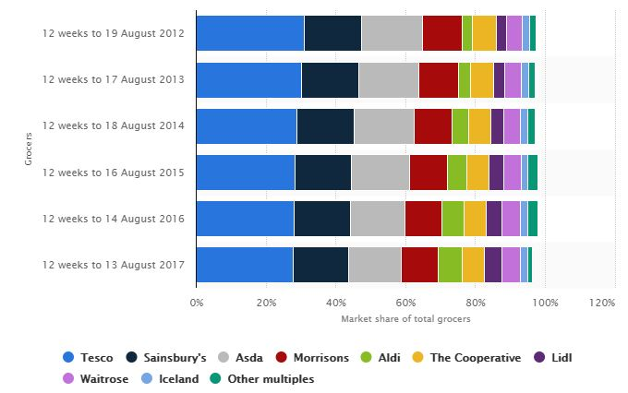
Figure 4: market share trend (Statista.com, 2018)
Figure 4 shows that the market share of the BIG 4 retailers (Sainsbury’s Plc, Asda&Morrisons) was almost constant over the last 6 years except that of Tesco Plc. This indicates the inability of the Tesco management to treat the changes in the customer buying behaviour accordingly. As such, Asda introduced virtual stores which make the customers capable of order products when they are busy with their daily life staffs. This helped the organization to reduce the cost of operation & order management in addition to helping in showing the customer responsiveness. Sainsbury’s Plc introduced direct sales option which makes the customers capable of purchasing goods directly from the local suppliers. This helped the organization to reduce the stock management cost & to improve relationship with the suppliers & customers.
Operational Structure: Among the grocery retailers throughout the UK, Tesco limited operates through the largest number of brick & mortar outlets. The number is currently 6553(Dede, 2018). . In order to maintain the stores, Tesco plc has to bear large amount of fixed cost which affects the profit margin & reduces the ability to charge lowest price. In addition, Tesco Plc is comparably less concern about the continuous technological innovation underlying the retailing process. Adaptation of innovations like virtual stores & direct sales etc may require large one time investment but have long term positive impact on the customer satisfaction improving& operational cost reduction (i.e. order management cost, customer complaint management cost , supply chain management cost & inventory management cost etc).
Cannibalization effect& supply chain issue: Tesco plc generally acquires the suppliers to reduce the dependence of the suppliers which helps it to increase the control over the supply chain & sourcing cost. But the management ignores the bad side of the acquisition which is the cannibalization effect. Such acquisition also diverts the focus from the core business activities as management have to bother about the performance of the organization acquired through backward integration. Poor performance of the acquired organization (i.e. inability source at the lowest possible cost) also reduces the ability to be competitive.

2.2: Evaluation of the problems
As stated earlier, There are 4 problems identified but the matter is one which is the reduction of the market as all of the problems identified directly or indirectly contributes to the reduction of the market share. In this section the scope & range of the problems are evaluated.
1. being slow in recognising buying behaviour change & technological innovations
Result: Loss of market share to online retailers, discount retailers & retailers adopting sophisticated technologically efficient operational process and low customer satisfaction.
Due to being slow in adapting continuous technological innovation underlying the retailing process like virtual stores &Direct sales option, Tesco Plc lost a portion of its loyal customer base to the online retailers Argos, Waitrose &Ocado and retailers like Sainsbury’s Plc, Asda stores Ltd &Morrisons who adopted the technologically sophisticated operational process (i.e. order management, supply chain management, inventory management).
Though these would require large one time investment but have long term positive impact on the customer satisfaction improving& operational cost reduction (i.e. order management cost, customer complaint management cost, supply chain management cost & inventory management cost etc). Thus, the attitude of maintain status quo contributes to the loss of the market share to discount retailer like Aldi&Lidl as the ability to charge low price is affected.
2. Loss of the focus to the non-core operational issues
Result: High operational cost & business risk (i.e. high degree of operating leverage)
The decision to acquire the suppliers to reduce the dependence of the suppliers though helps to increase the control over the supply chain & sourcing cost contributes in diverting the focus from the core business activities as management have to bother about the performance of the organization acquired through backward integration. In addition, poor performance at the acquired subsidiaries reduces the impact of the control gained over the supply chain & sourcing cost. These issues indirectly contribute to the inability of the charging lowest possible price. Thus this can be seen as one of the reasons explaining why Tesco found it difficult to involve in a price war with the discount retailers like Aldi&Lidl.

Inefficient operational structure
Result: high operational cost & low customer satisfaction
The cost structure of Tesco contains large portion of fixed cost which increases the business risk. Large portion of the fixed cost consists of its brick & mortar outlet maintenance cost (i.e. the number of outlets is 6553). The number was even high in 2017 (i.e. approximately 7000). But later after understanding the impact, the management decided to reduce the number of outlets to the current level & started to make its online presence strong.
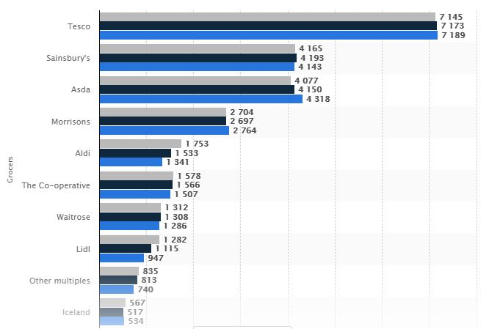
Figure 5: Spending by grocers in a store over the last three years (as descending order- 2017, 2016, and 2015) (Statista.com, 2018)
Figure 5 shows that the level of yearly spending by the grocers in one outlet of the Tesco is far higher than that of competitors but still the margin is not competitive due to high aggregate store maintenance and other operational costs.

2.3: Alternative solutions available to Tesco
Alternative solution 1: Reducing the number of outlets, strengthening online presence & installation of virtual stores &direct sales option
Reduction of number of brick & mortar outlets, which are pointed out to be useless in ensuring easy access to the customers as buying behaviour is changed (i.e. can shop by ordering online without going to the outlets), will help to reduce the operating leverage & business risk.
In addition, investment in the projects like collaboration with the search engines, search engine optimization so that site traffic can be increased and collaboration with the TEC support providers for site designing & maintenance purpose so that shopping cart abandonment can be reduce etc will help to make the online operational segment more strong. Such adoption may require the requirement of Tech-savvy people and training of the employees so that they can cope with the new operational process. A work-environment modification program will also be required to be adopted.
With an intension to get its loyal customer base it previous place, Tesco can invest in the projects like virtual store placement &direct sales option addition in the grocery apps offered by it.
Alternative solution 2: Acquisition of the online retailer or online catalogue seller
In order to get access to the online strong customer base in the online segment, Tesco can acquire online grocery catalogue seller like Argos is acquired by Sainsbury’s Plc or online grocery retailer like Ocado. This option will help Tesco in increasing customer base, regaining the customer lost to the online retailers, reducing operational cost and diversifying business portfolio. This option will give the most immediate result but involves high level of risk (i.e. inappropriate acquisition price).
Alternative Solution 3: Divestitures & credible collaboration with the suppliers
This option involvesselling of the suppliers acquired though backward integration and formation of the short term credible collaboration with the suppliers so that the exposure to the cannibalization effect can be reduced and Tesco management can have the opportunity to review the suppliers performance after a period of time. Thus, this option is expected to increase the ability to charge the lowest possible price and to help to be the market leader of the industry.

2.4: Decision making techniques to solve the problems
While evaluating the alternative options to solve a matter, the management should focus on 4 issues:
1. Financial feasibility & impact: While analyzing financial feasibility, the management should focus on the timely access to the required fund required to implement the solution at the desirable cost. The impact should be assessed in terms of the return. Different techniques like NPV, IRR, cost benefit analysis, discounted payback period analysis & cash flow discounting analysis etc can be applied to assess the return from each of the option (Dede, 2018). These appraisals should be based on the incremental benefit and should consider the time value of money. As these techniques require estimation, the management should be careful in forecasting cash flows.
2. Operational technical feasibility&impact: Management should consider whether it has access to the required HR resource (i.e. training facility, skilled people) and technical resources (i.e. is collaboration with the TEH firm possible? Are required technologies available?)(TOFAN, 2017). The operational benefit (i.e. non-financial benefit) like reduction of customer compliant, reduction of the lead time, reduction of deliver time, reduction of the management burden, increased control over operation and reduction of the stock management etc should be considered in the appraisal process.
3. Legal and organizational feasibility & impact: Management should assess whether regulators & low will allow the planned option or project and whether there will be any resistance from the groups & communities like Environmental Protection Agency. The impact of the project on the organizational corporate image should also be taken into consideration.
4. Market feasibility and impact: Some options may not have immediate impact but may have long term positive impact. As such, some projects will be directed to gain market share in the potential market which is expected to be emerged. On the hand, the impact of certain project may wipe out within short due to disruptive technological innovation. And so, market feasibility should be taken into consideration while forming decisions.
5. Cannibalization effect: The impact of a certain solution/project on the other areas of operation & business should also be taken into consideration. As such, the alternative solution 1may reduce the sales revenue generated through the brick & mortar store segment of the organization.
Management can use different decision making tools in the process of choosing the best fit solution to solve a problem. Following are some effective decision making used widely.
Grid Analysis/ simple decision matrix: The approach involves the evaluation of the alternative solution against a set of criteria & scoring according to the weight.The matrix provides the systematic framework to analyze multiple options (Dede, 2018).
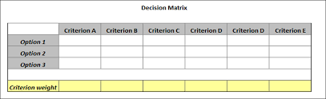
Figure 6: simple decision matrix(Dede, 2018)
Game theory: Game theory provides a platform which urges the consideration of the impact of the responses or retaliatory action to be made by the competitors, regulatory body & employees etc(Acur and Bititci, 2017). The problem with the framework is that this involves the narrowing of the assumptions regarding the potentials difficulties to make the game solvable.
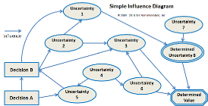
Figure 7: Simple influence diagram (TOFAN, 2017)

Pro/Con: This approach requires the analysis of the pros & cons, strengths & weakness and opportunity & threats associated with the options. This is a form of paired comparison technique is not easy to apply when there are large number of options available.
Multi-voting/ Delphi method: Multi voting decision making ensure participation of heights number of related stakeholders and helps to eliminate the lower priority alternatives options/ solutions. Decision made through the technique is tend to be more successful as multiple analyses involve and spontaneous participation of the stakeholders is ensured (Dede, 2018).
There are many other techniques some of which are discussed above like NPV analysis, cost-benefit analysis and some of which are not applicable in this case. I.e. trial & error method is not applicable for decision making in this case as the cost of the error can be huge & there may not be second chance to recover the loss.
The following framework is developed to value the alternative solutions available to the Tesco.
 | Criteria 1  NPV | Criteria 2  Cannibalization effect | Criteria 3  Legal & organization feasibility | Criteria 4  Market feasibility | Criteria 5  Technical impact | Total score
Alt 1
Alt 3
Alt 3
Criteria Weight | 30% | 10% | 10% | 30% | 20%

2.5: Communication with the stakeholders & co-ordination plan
In the decision making process, Tesco management should follow the brainstorming process in generating the ideas to solve the problem and should implement the Delphi method in decision making. This is so as these will help to ensure the highest involvement of the stakeholders. The ensuring of the spontaneous involvement of the stakeholders in the solution implementation (i.e. change management process) will help to create required environment which attracts the respects to the change.
Following communication and co-ordination plan is directed to improve the involvement of the stakeholders:
What? | By whom | To who | Frequency/time | Feedback mechanism
Communicating the need for change/solution | Business development head | Higher management | First week/ once | Face to face interactive meeting and report presentation
Influence creation to make the stakeholders agreeable | PR &Hr team  Influencing individuals within the organization | All other internal stock holders | 2nd week/ once | E-mail, dash board, face to face conversation (formal/informal)
Collaboration with the suppliers & TECH support providers | PR team & procurement team | Supplier, target company management | 3rd& 4th week | Formal meeting
Idea inviting, screening, appraisal & selection | Management | All teams | 4th& 5th week | Formal meeting
Project team formation, responsibility allocation & project planning | Business development team,  Al team heads & management team | Project team | 6th& 7Th week | Formal meeting

3. SWOT analysis
Strengths:
- Tesco operates through 6553 stores in approximately 4500 localities which gives it the largest access to the diversified section of customers(Wood, 2018).
- Tesco is well-diversified in terms of both geographically (i.e. market presence in Europe, Asia, North & South America) & strategically (i.e. serves grocery retailing industry, financial industry, telecom industry, appeals industry, electronic industry & software industry)
- Local sourcing & large customer base facilitates economy of scale.
- As Tesco acquired many suppliers, it has high control over the supply chain.
- Patent rights in developing technologies, loyalty programs (i.e. clubcard) & long standing history of being cost leader in the market helps Tesco in developing a loyal customer base(Martinell and Sparks, 2016).
Weakness:
- Though well diversified, Tesco is highly dependent on the UK market. I.e. approximately, 67% of its profit generated from the UK market. It could make it position in the overseas market(Ft.com, 2018). As such, after 9 years of operation it had to close its Japan operation in 2012 and at the same time it also had to close its fresh & easy chain in US.
- Cannibalization effect is that affecting Tesco’s progress badly. As such, the poor performance of Tesco Finance, subsidiary of Tesco Plc in the financial industry, during the credit crisis period affected the group’s performance badly.
- Inefficient backward integration caused the company to suffer. As such, buyouts of Nobbies garden centre& Giraffe restaurant is found to be non-profitable as later the company had to sell these at loss(Statista.com, 2018). Due to such decisions, the company had to bear high sourcing cost & lost it focus on the core business activities which results in the fact that the management find it difficult to win the price war with the discount retailers.
- Frequent controversies have been affecting the company image in the market. I.e. financial performance overstatement issue & price fixing issues etc.
- Tesco had to bear high fixed operations maintenance cost due to it large portfolio of brick & mortar outlets.
- In addition, poor presence in the online retailing segment exposing to the risk of market share loss as this segment is experiencing compounding growth reflecting changes in the buying behavior & technological innovation.
Opportunities:
- The CAGR of the UK grocery market is 5% and as a market leader Tesco is expected to be the main beneficiary of such growth(Ruddick, 2018).
- Opportunity to explore market in the emerging market through strategic acquisition.
- Opportunity to regain the access to the market where it failed though the formation of joint venture.
- The company is planning the strengthening of the online segment & closing some brick & mortar outlets. I.e. planning acquisition of online catalogue seller & installation of virtual store & direct selling options and closed down some stores which cause the reduction of number of stores from 7817 in 2016 to 6553 in 2018(Walker, 2018).
- Opportunity of reduction of operating burden & sourcing cost by selling some of the suppliers acquired through buyouts & backward integration and formation of short term credible commitment based strategic alliance with the suppliers.
Threats:
- The recession in the market made discount retailers like Aldi&Lidl a better place to shop from.
- Due to changes in the buying behaviour & technological behaviour customers are switching to the online retailers and close competitors who have technologically sophisticated operations (i.e. virtual store, direct sales option in grocery app) like Sainsbury Plc intended to improve customer experience (Kantarworldpanel.com, 2018).
- Tight regulation & tax policy.

5. PEST Analysis
Political Factors
Tesco has operations in 14 countries worldwide and thus high exposure to the differences in the regulatory framework among these markets. As such, Tesco has operation in the 6 countries of belongs to Europe i.e. Ireland, Czech Republic, Slovakia, Hungary, Turkey and Poland(Hogarth-Scott and Rice, 2017). The Brexit decision thus have negative impact on the after tax revenue generated from the markets in the EU member countries. In addition, as Tesco sources some of its products from the European & Asian countries, it also has exposure to the risks of deterioration of the trade relationship of the UK with these countries. Potential changes in the regulatory framework also may have negative impact of the Tesco’s performance. I. e. Local authority approved the tax advantages to the large super markets known as “Tesco Tax” but this was refused by UK govt(Rowley, 2017).
Some political events also helped Tesco Plc. I. e. accession of china to the WTO reduced barrier in making expansion to the market.
Economic factor
The recession in the market made discount retailers like Aldi&Lidl a better place to shop from. And as there is low switching cost to the customers, Tesco had to experience market share loss. But the recessionary stage of the market is also expected to benefit the whole grocery market as during such situation customers are expected spend more on the home and less out of the home which increases demand for the grocery items.
The labour is cost increasing at a higher rate which was 11% during 2017(Clarke et al, 2018). This is increasing the cost of operation and affecting the capacity to charge low price which is the prerequisite of being cost leader in the market. I.e. total compensation paid by the company was £5.1 billion in 2017(Lindgreen and Hingley, 2018). Besides, due to the increase in the space rates & rents, Tesco is facing fixed cost increment issue as it runs the heights number (i.e. 6553) of outlets among the grocery retailers in the UK(Acur and Bititci, 2017).

Socio-economic factor
Changes in the buying, ageing of the population and shopping behaviour changes force the grocery retailer to break the status quo. Customers are now putting more weight on the comfort while making shopping decisions. And thus they are switching to the online retailing segment. This is why online retailers like Waitrose &Ocado are doing well and big retailers like Sainsbury’s plc is planning to improve its online presence by acquiring online catalogue seller like Argos(Martinell and Sparks, 2016).. Demand of the technologically sophisticated retailing process is also increasing as a result. I. e. direct sales facilities, in-store Wi-Fi, online payment facilities and virtual stores are found to be effective in improving customer experience.
Due to changes in the consumption pattern & health consciousness, the demand for the non-organic food increased and Tesco cope with the issues appropriately.
Technological Factor
Technological innovation changed the operational process of the retailers. I.e. direct sales facilities, in-store Wi-Fi, online payment facilities and virtual stores are some common example which the retailers had to install to keep the customer satisfied(Rowley, 2017). The compounding growth of the online retailing segment can also be explained though the technological progress.

6. Conclusion
Tesco Plc is the leading grocery retailers in the UK market but currently facing huge competition from the online retailers, discount retailer & close competitor with sophisticated technology laid operational & customer serving process. This is due to is weak presences in the online segment, slow response to the technological changes, inefficient backward integration & unfavorable operational structure. Tesco Plc can reduce the number of outlets; strengthen online presence, install of virtual stores & direct sales option, acquire online retailer or online catalogue seller, perform divestitures & form credible collaboration with the suppliers to solve the current issues.

References
Acur N. and Bititci U. (2017) A balanced approach to strategy process, International Journal of Operations & Production Management, Vol. 24 issue 4, pp.388-408;
Clarke I., Bennison D. and Guy C. (2018) The Dynamics of UK Grocery Retailing at the Local Scale, International Journal of Retail & Distribution Management, Vol. 22 Issue 6, pp.11-20.
Dede, T. (2018).DECISION-MAKING PROCESS TECHNIQUES USED IN THE OPTIMIZATION OF CONSTRUCTION PROJECTS. E-Journal of New World Sciences Academy, 13(2), pp.128-136.
Ft.com. (2018). Tesco boss runs into wholesale problems | Financial Times. [online] Available at: https://www.ft.com/content/0ab5daee-1622-11e7-b0c1-37e417ee6c76 [Accessed 7 Jun. 2018].
Hogarth-Scott S. and Rice S. (2017) The New Food Discounters: Are They a Threat to the Major Multiples?, International Journal of Retail & Distribution Management, Vol. 22 Issue 1, pp.20-28;
Kantarworldpanel.com. (2018). Grocery Market Share - Kantar Worldpanel. [online] Available at: https://www.kantarworldpanel.com/en/grocery-market-share/great-britain/snapshot [Accessed 2 Jul. 2018].
Lindgreen A. and Hingley M. (2018) The impact of food safety and animal welfare policies on supply chain management: The case of the Tesco meat supply chain, British Food Journal, Vol. 105 Issue 6, pp.328-349;
Martinell E. and Sparks L. (2016) Food retailers and financial services in the UK: a co-opetitive perspective, British Food Journal, Vol. 105 Issue 9, pp.577-590;
Rowley J. (2017) Building brand webs: Customer relationship management through the Tesco Clubcard loyalty scheme, International Journal of Retail & Distribution Management, Vol. 33 Issue 3, pp.194-206
Ruddick, G. (2018). Tesco crisis: everything you need to know. [online] Telegraph.co.uk. Available at: https://www.telegraph.co.uk/finance/newsbysector/epic/tsco/11181686/Tesco-crisis-what-you-need-to-know.html [Accessed 3 Aug. 2018].
Ruddick, G. (2018). Tesco crisis: everything you need to know. [online] Telegraph.co.uk. Available at: https://www.telegraph.co.uk/finance/newsbysector/epic/tsco/11181686/Tesco-crisis-what-you-need-to-know.html [Accessed 13 Jul. 2018].
Statista.com (2018). Great Britain: Grocery market share 2015-2017 | UK Statistics. [online] Statista. Available at: https://www.statista.com/statistics/280208/grocery-market-share-in-the-united-kingdom-uk/ [Accessed 7 Aug. 2018].
statista.com (2018). Topic: Tesco PLC. [online] www.statista.com. Available at: https://www.statista.com/topics/3807/tesco-plc/ [Accessed 14 Jul. 2018].
TOFAN, C. (2014). Optimization Techniques of Decision Making - Decision Tree. Advances in Social Sciences Research Journal, 1(5), pp.142-148.
Walker, I. (2018). Tesco sales grow fastest among big 4 supermarkets. [online] MarketWatch. Available at: https://www.marketwatch.com/story/tesco-sales-grow-fastest-among-big-4-supermarkets-2018-02-06 [Accessed 2 Aug. 2018].
Wood, Z. (2018). Five problems for Tesco's new boss to deal with. [online] the Guardian. Available at: https://www.theguardian.com/business/2014/jul/21/five-probems-tesco-dave-lewis [Accessed 3 Aug. 2018].

