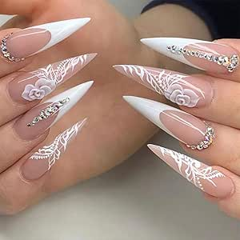 |  |  |  | ANGELA  ZIGOVA

Experience
2001 -2003
Pedicurist• Cosmetics • Star Beauty Nails Salon
2004-2008
Pedicurist • Cosmetisc • Silviana Beauty Salon
2008-2016
Pedicurist • Cosmetics • Angel Beauty Salon

Education
The London School Beauty & Nails , London ,UK
- graduated with honors

Comunitation
English, Czech, Polish, German

Leadership
I am a friendly person, I have a lot of experience working with pedicure tools and nail polish. I can communicate with people in a friendly way.

References
references available upon request
6 splott road
Cardiff ,CF22 7BZ
 |  | 07443291668
 |  | zigovaangela@gmail.com
 |  | www.zigovaangela.co.uk

