Internet Technology and Security Assignment 1
1902388
joseph williams
2019
1 | Introduction
2 | Requirements
3 | Implementation
3.1 | Validation
4 | Evaluation
4.1.1 | Usefulness
4.1.2 | Accessibility
4.1.3 | Search Engine Optimisation
4.2 | Usefulness within my website
4.3 | Search Engine Optimisation
4.4 | Accessibility within my website
5 | References

1.
Introduction

Within this report, I will be reviewing my website including an introduction to my website where I describe what it is about and who does it target as viewers but also who would find the information on the website relevant. I will also include screenshots of each page of my website in order to show the content within the page but also the layout I chose for my website. Within the same section, I will include proof of validation for both of my CSS and HTML code within the website. Finally, I will be covering the usability, accessibility and also search engine optimisations that websites should offer and what roles they have within web development. I will provide an evaluation that covers my website’s quality, including things such as; usefulness, search engine optimisation and also accessibility that I have included or should have included.

2.
Requirements

My website was designed to be a small website comprised of many information and pictures about the game Counter-Strike. I believe that I fulfilled this design when I created the website while also trying to add in some more features within CSS / HTML where they could be used to link with the topic that I chose. Within the website, I went over the history of the game and also the things most people do not see about the game. My website is mainly targeted towards 16+ who may be interested in Counter-Strike tournaments however, my website can be understood even by people who may have only played the game casually. I wanted my website to open people’s eyes to the competitive side of this video game and the importance it has in some peoples lives. I believe that anyone who has heard of counter-strike and may be interested in watching or playing it will find all of the information within my website relevant however, I think that some parts may be in too much detail for some people to want to read.

3.
Implementations
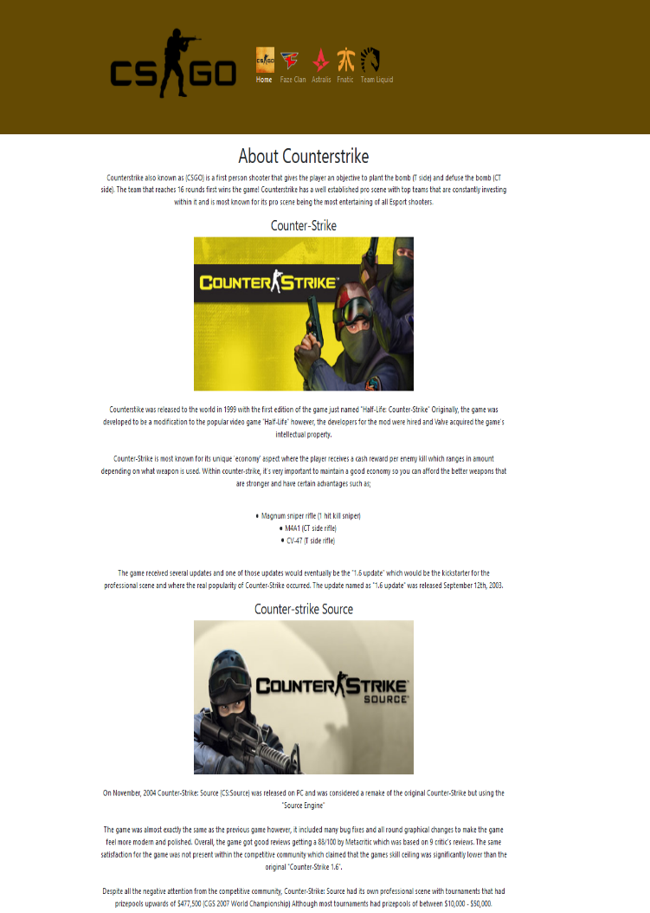
The home page includes a navigation bar that allows you to navigate the entire website and also highlights what page you are currently on. I have many paragraphs within the first page of my website where I go into detail about each version of Counter-Strike ranging from the early 1999 version all the way up to the modern version of the game.

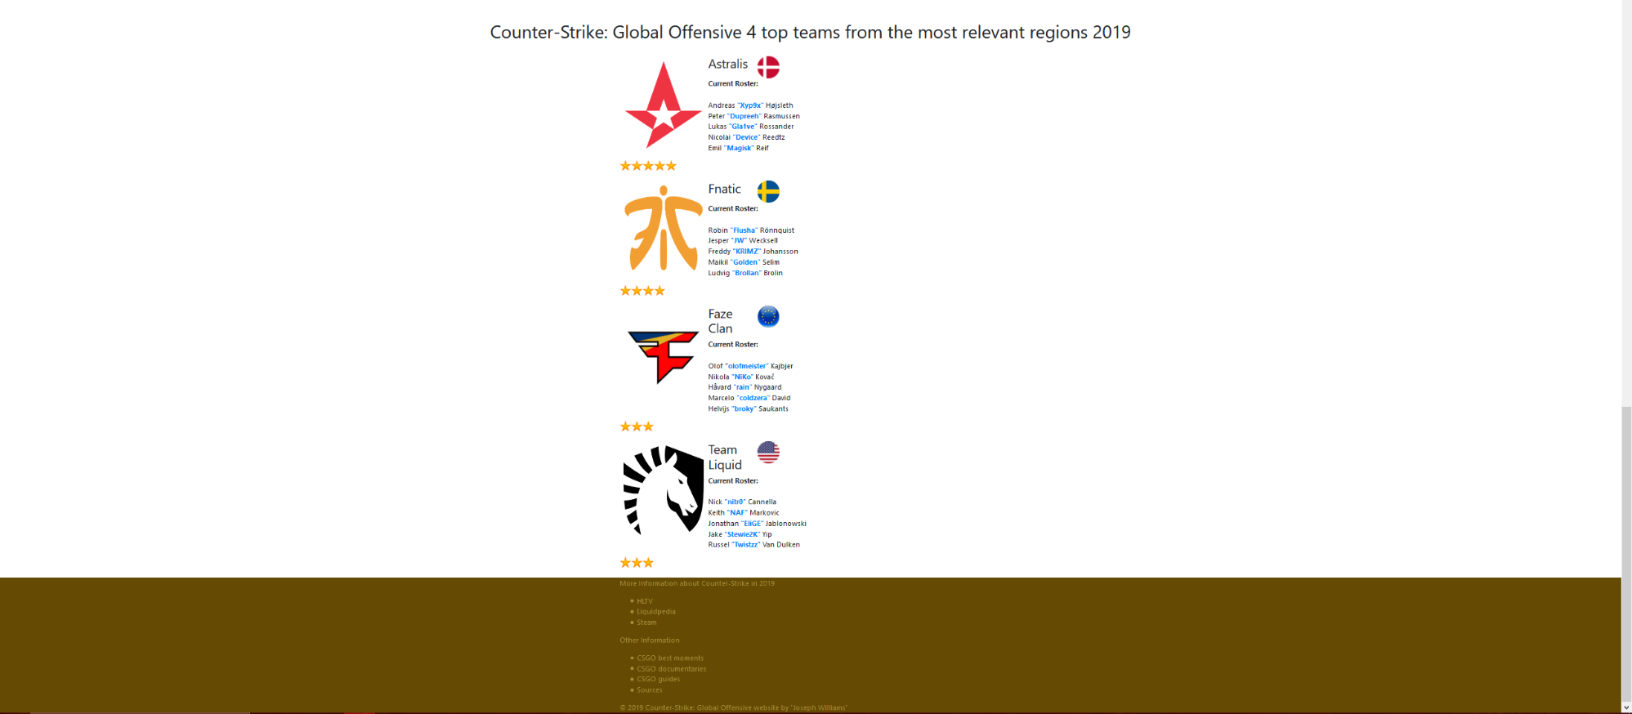

This is part of my home page where I wanted to include four teams from the most important regions within the game. These four regions (North America, Europe, Sweden, Denmark) have been within the top level of the competitive scene since the game has released. At the bottom of the page, I have a footer section that includes links to many sites related to Counter-Strike that some people may find interesting. I also have included a list of Documentaries, Best moments videos and guides for the game. Finally, I have a link to download a file that has all of my sources used to create the website (Images, links to websites etc…) and I have a section at the bottom displaying that it is made by me.

The second page is about one of the teams within the game “CSGO” it also includes a navigation bar that allows you to navigate the entire website and also highlights what page you are currently on. This page includes an Iframe at the top that links to a YouTube video that shows one of their tournament wins. I included this video because it really captures what competitive CSGO is all about.
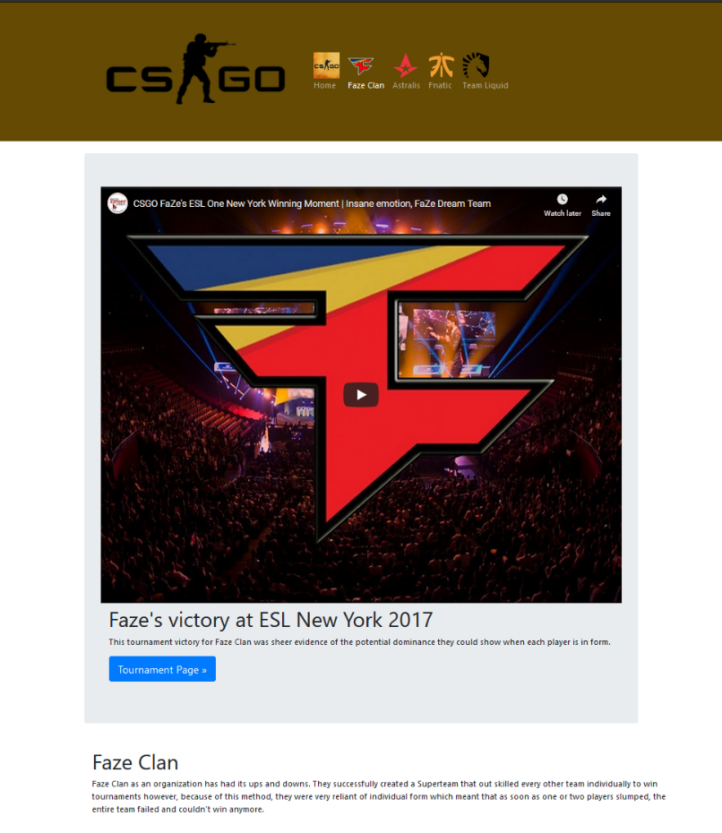

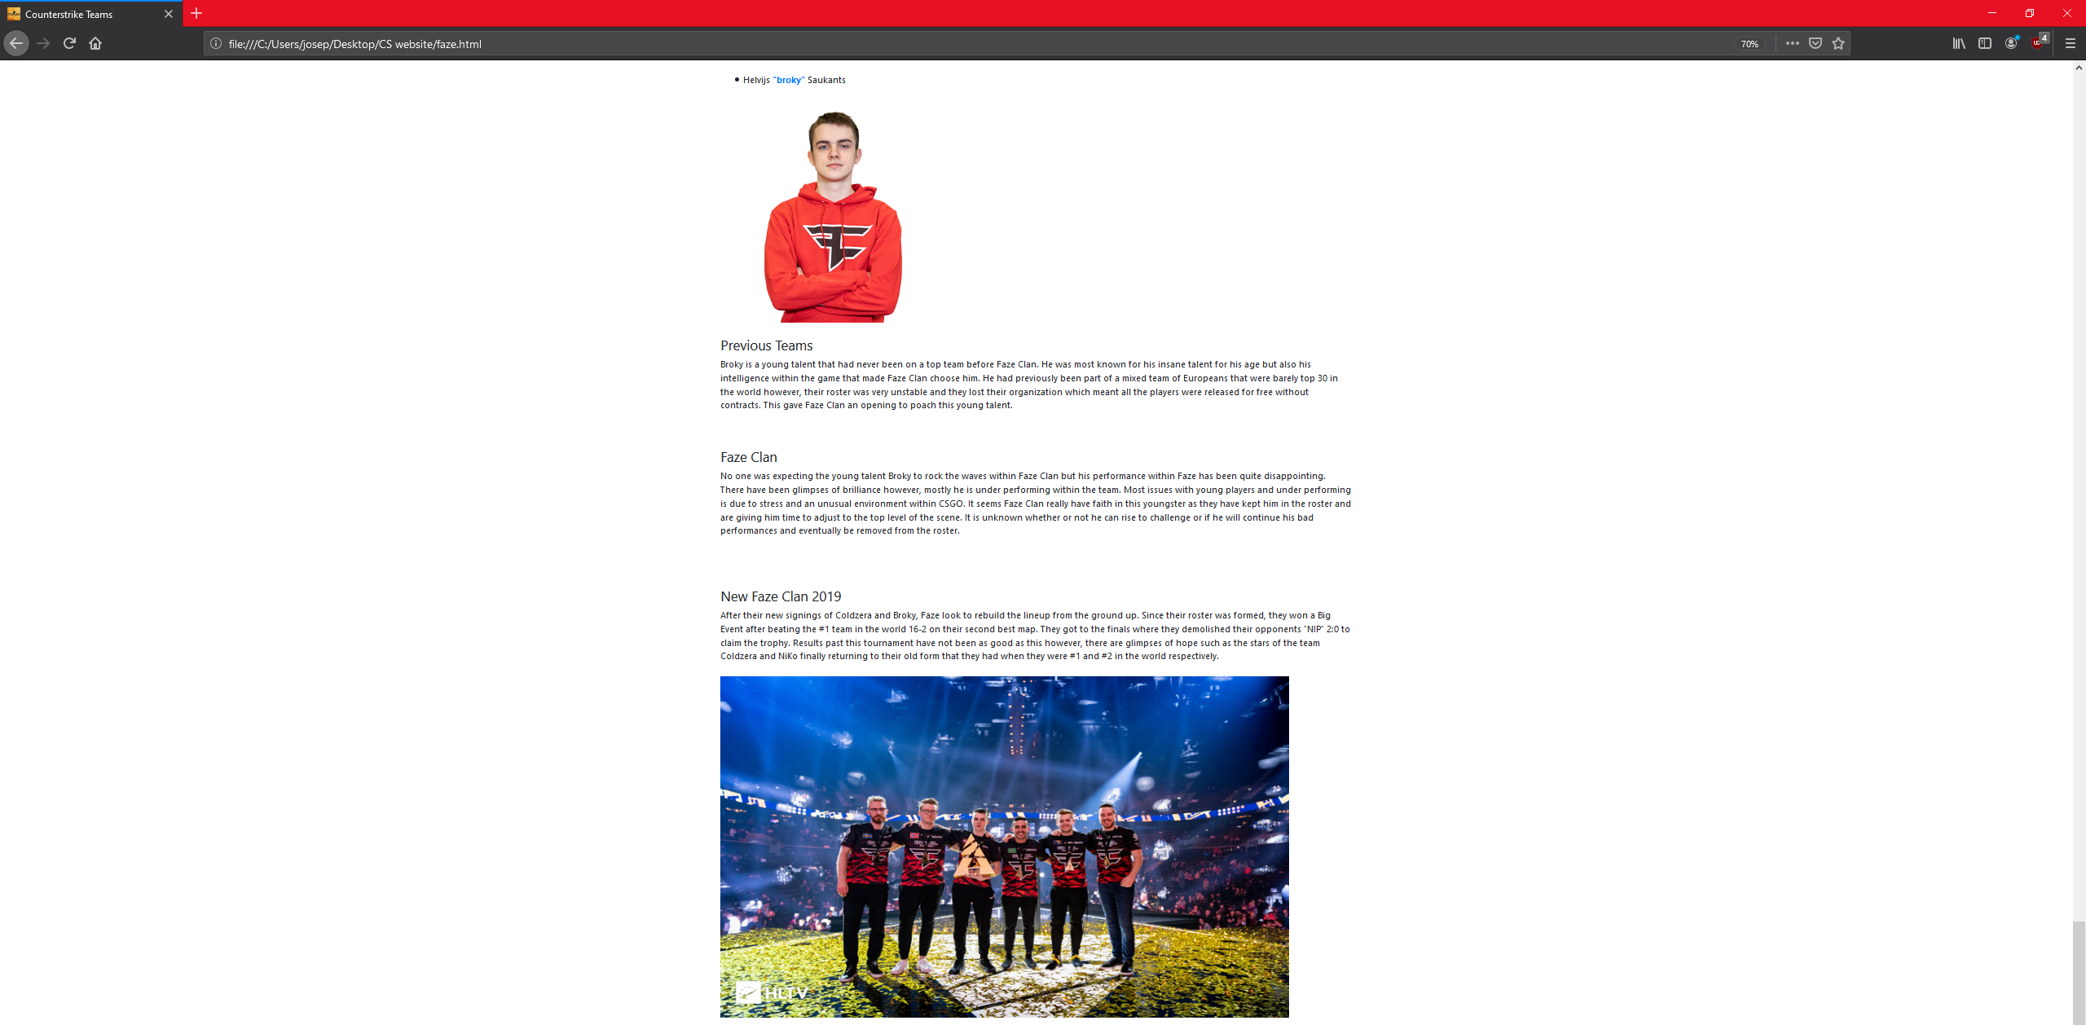

Throughout this page, I have many paragraphs that go into detail of the history of the players at Faze Clan CSGO. It includes an image of themselves and their name and nickname in game. I included an image to conclude my page as I wanted to show the amount of people that watch these tournaments and the amount of effort and money that goes into creating / hosting them. The bottom of my page also includes the footer with links.

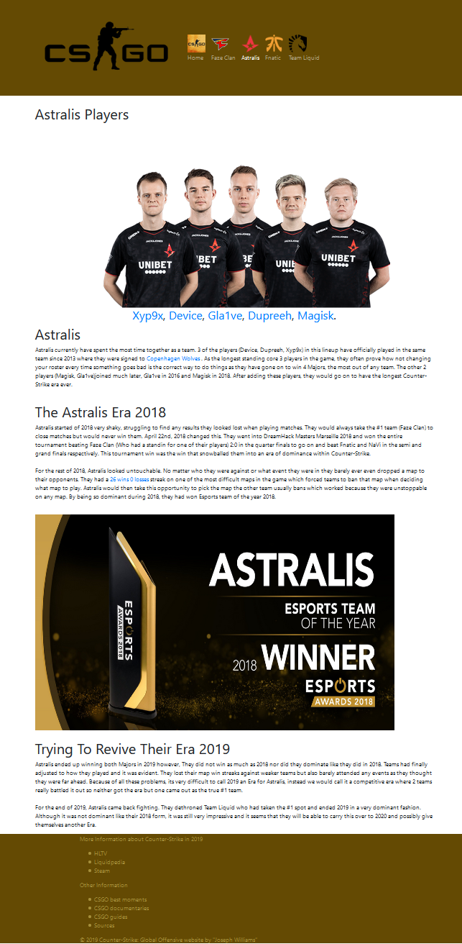
The third page of my website is similar to my second where I have a navigation bar that highlights the page you are currently on. However, I chose to make a small change to the layout and combine all the player pictures in order to make the page much more compact. I have a small section underneath the player pictures where it states their in-game name and also links to an external website that gives you more details about them. Towards the bottom of the page there is an image and under that is my footer that includes links.
The fourth page of my website has a layout almost identical to the previous page. I wanted to make compact pages as I didn’t want to force the user to scroll a lot just to find the information they are seeking. Like my previous pages, it also has a navigation bar that highlights what page you are on and also includes multiple paragraphs with pictures. The bottom of my page features a footer which is identical to its previous pages as I wanted to keep the footer and the navigation bar the same throughout the website for consistency.
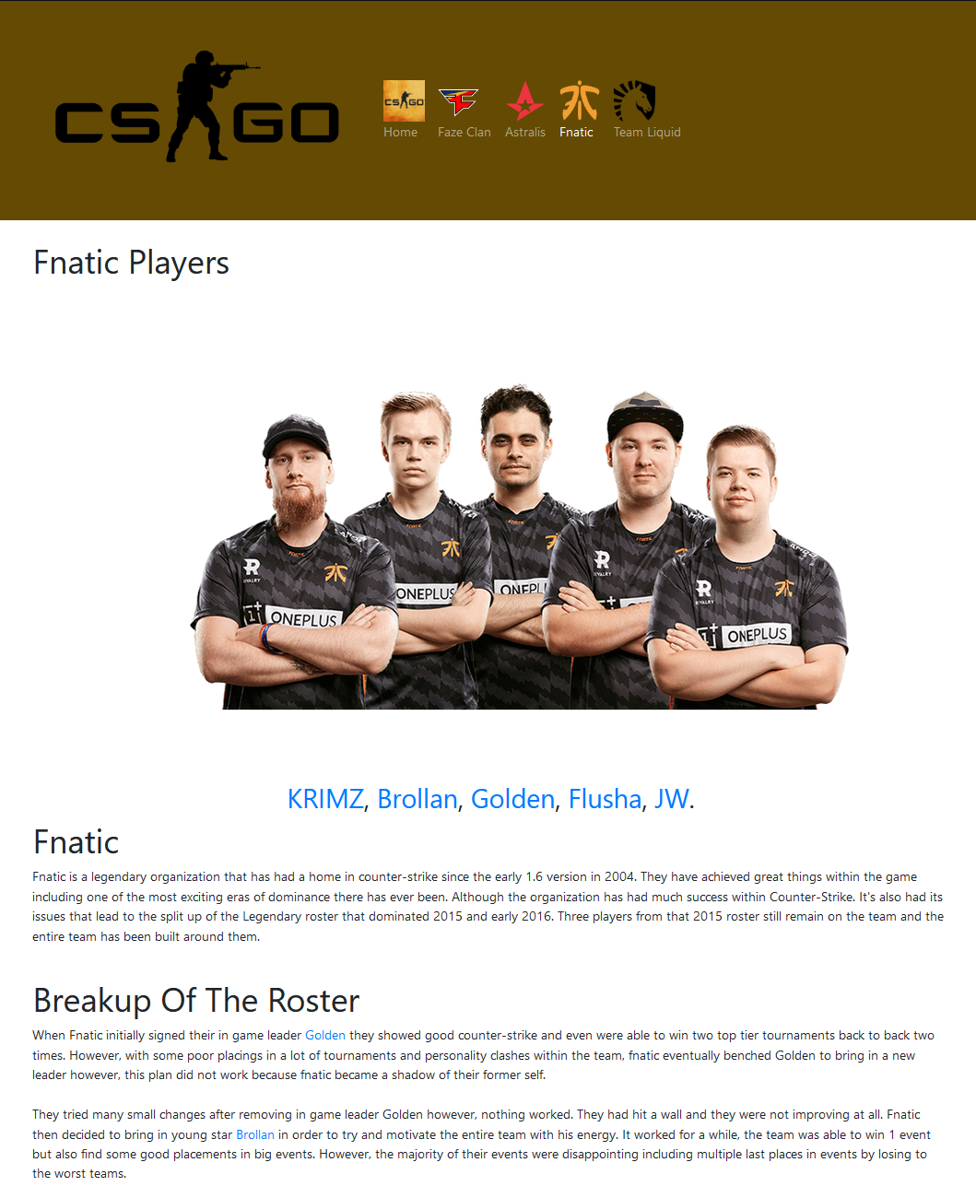

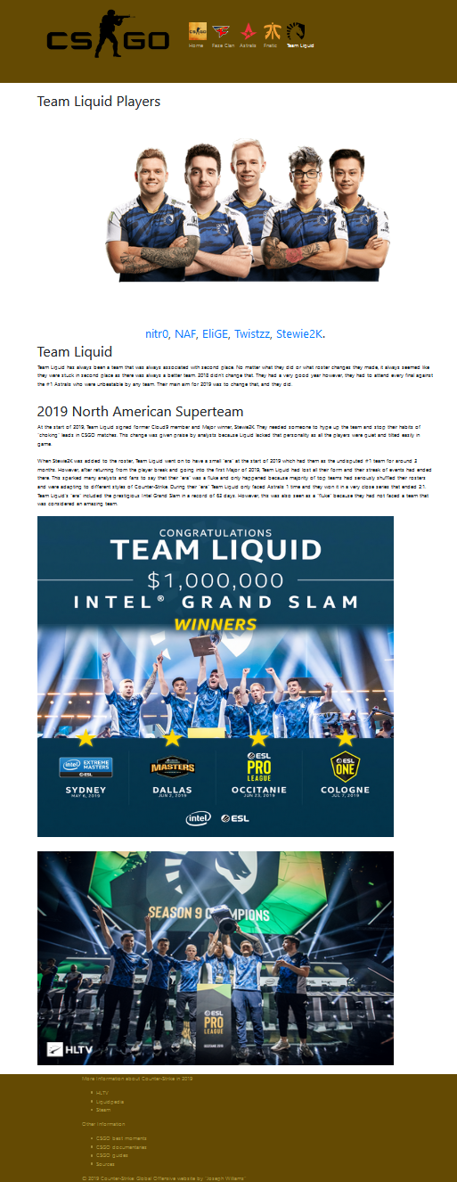
The final page of my website is again, laid out in the same way as the previous 2 in order to compact as much information as possible to make the website less exhausting to find the information needed. It includes the same navigation bar that highlights the current page you are on and also includes paragraphs with images including an achievement of the Intel Grand Slam which is a CSGO award. At the bottom of the page is my footer which is identical to all the other pages by including relevant links for the game. I ensured my footer was like this for consistency through the website.
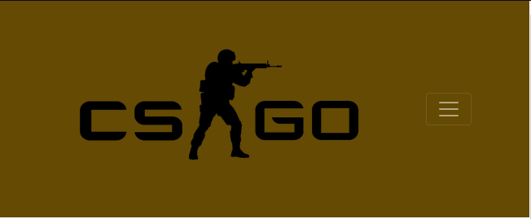
Finally, this is what my navigation bar looks like when you resize the window or use a smaller device.

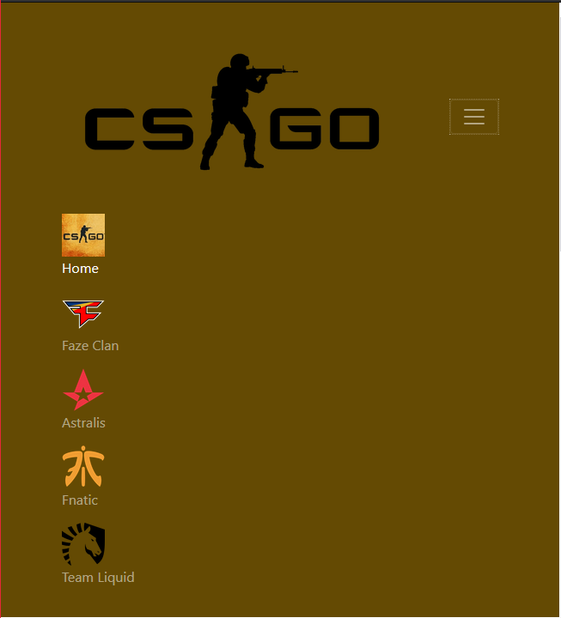
You are able to click the three lines which then extend the navigation bar vertically so that you can access any page. This still highlights what page you are on.

3.
3.1
Validation

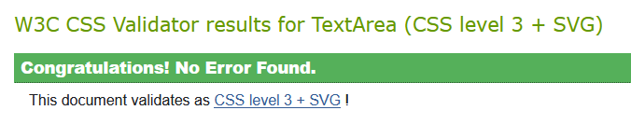
CSS
http://jigsaw.w3.org/css-validator/#validate_by_input

My CSS file had no errors when scanned with the online Validation tool.

HTML
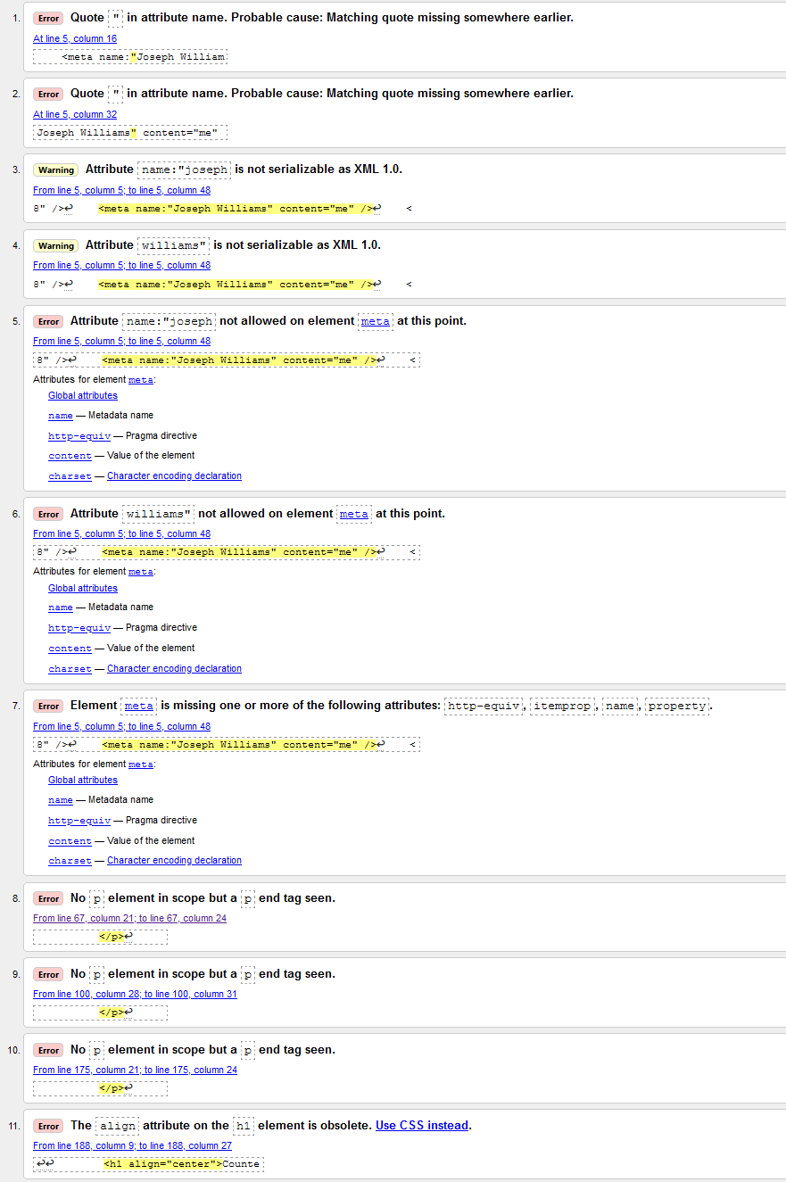
https://validator.w3.org/#validate_by_input
To fix the following errors (1 – 7) I had to simply change my code from:
<meta name:"Joseph Williams" content="me" />
To
<meta name="Joseph Williams" content="me" />

To fix the following errors (8 – 10) I had to simply add extra paragraph tags after my list code so that they were not part of the same paragraph.

The final error was removing a line of code I could simply put into CSS. To fix this error, I created a new class called .heading and use the CSS code text-align: center; This made my code neater by putting unnecessary code into the stylesheet which also meant that I could reuse it for anything I needed it for past then.
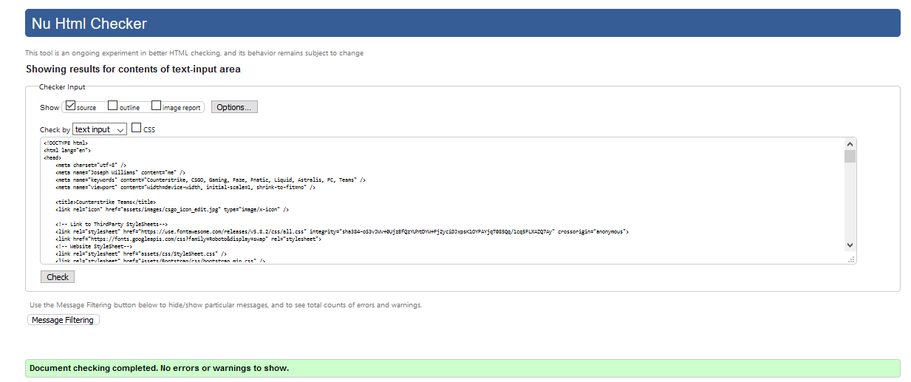
https://validator.w3.org/#validate_by_input

4.
Evaluation
4.1
Usefulness, Search Engine Optimisation and Accessibility
4.1.1
Usefulness
The term ‘usefulness’ when talking about a website usually includes the following:
[1]
“
Presentation of information and choices in a clear and concise way
A lack of ambiguity and the placement of important items in appropriate areas
Ensuring that the content works on various devices and browsers
“
This tells us in order for a website to have a good usefulness, it needs to be simple or easy to find information you are looking for even for people who may find it difficult. This can be done by simply spacing things out well. If you have multiple paragraphs together it is very daunting for some people to read and find the information that they want. However, if you were to have appropriate headings and each topic split into separate paragraphs that are spaced out then they can find all the information they need without any unneeded hassle.

According to the report by Abuqaddom et al, [1] a website’s usability can be measured easily by using things such as looking at the literature used so you can see the different factors e.g. understandability, learnability etc… There is also the technique of usability testing. This is used to evaluate a website by testing it on many types of users than can:
“
Identify any usability problem
Determine participant satisfaction with the website
“
These usability testing methods however, have limitations. Usually the ‘users’ chosen to test the website aren’t usually actual users of the website which means they may not know or be interested in the type of website it actually is or may not be able to use certain aspects of the site because they are not its target audience. It is also very time consuming and it does not guarantee that every usability factor is measured.
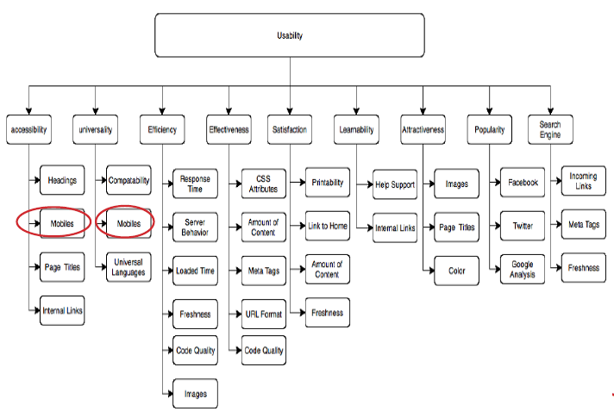
Abuqaddom et al. [reference], during a conference proposed their own model which separated each usability category.
(Screenshotted from the PDF downloaded from https://ieeexplore.ieee.org/document/8809145)

4.1.2
Accessibility
Accessibility within websites refers to making a website that is accessible to all users no matter what their race, nationality, religion or disability is. According to Grantham et al, [2] “Website accessibility includes, but is not limited to, the communication style of the text as well as the technical development of the website.” Having a good communication style of text within your website is crucial so that people who have trouble seeing or need things laid out simply can still enjoy your website as well as get all the information they are seeking. [2]Because websites are becoming much more advanced, they are also becoming more complicated which means less accessible for those who may face difficulties using these websites. A good way to fix this issue would be to ensure that you offer help somewhere in your website. An example of this could be having section in your footer with ‘Useful Links’ where the user can get information without having to navigate your entire website.

4.1.3
Search Engine Optimisation (SEO)
[3]Search Engine Optimisation is used to make sure that a website can be found easily by people trying to find it through a search engine e.g. Google, Bing etc… These search engine optimisations are very important if you want your website to be a success because without them it would be near impossible for someone to find your website unless you gave them the URL. According to Li et al. [4], “SEO, on the other hand, is the practice of optimizing web pages in a way that improves their ranking in the organic search results, also known as natural or algorithmic search results for targeted keywords.” This quote shows us that SEO works by linking key words of your site to what people are searching for on browsers. [4]There are many companies that offer SEO for your website where they attempt to link specific query terms that are relevant to your website. After paying these companies to organise your website for search engines, you could be at the top of the list of results when typing in a specific query which always results in more visitors to your website.

4.2
Usefulness within my website
Within my website, information is displayed in a very simple way where everything has headings corelating to what’s inside the paragraph under it. My paragraphs are spaced out so you can see clearly where each start and where each end. My website’s layout is set into specific areas for each piece of content. For example, if you wanted to find out about Faze Clan within CSGO then you simply need to click on “Faze Clan” within the navigation bar. My website works on many different browsers. However, it does have issues when using a device with a small screen because one section of my website doesn’t support screen smaller than a specific size because of the images so it cuts letters off the names. However, 99% of the website is usable including the navigation bar that collapses and can be opened to allow smaller devices to use it.

4.3
Search Engine Optimisation within my website
Within my HTML code, I have added tags so that people may find my website easier when searching for it online. Using these tags if any of the keywords are inputted into a browser then my website should show up. An example of some of the tags used were: “CSGO”, “Faze”, Counter Strike”, “Gaming” etc… These tags work to allow search engines to make a link with the specific tags by using them as keywords. However, it is very basic, and I would need to add more complicated and detailed tags to get views to my website.

I have also made sure to optimize page speed as much as I could by using JPEG images where possible. However, because I do not have a lot of images on my website, the loading time is still fast even with a few PNG files.

4.4
Accessibility within my website
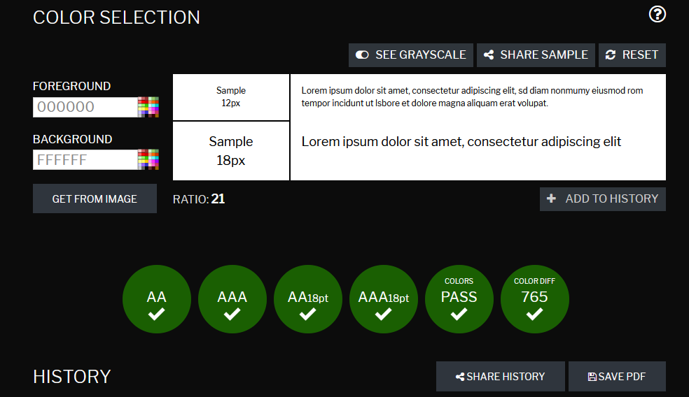
My website has a high level of accessibility as I have made sure it followed the [5]4 principles of accessibility. I did this by making sure my text size is consistent throughout the website and that my images include appropriate <alt> tags describing what the image is. My websites font is accessible because its black font on a white background however, I could improve my footer’s colours as it can be hard to read for people who may be colour blind.
https://contrastchecker.com/

On my website, I have many headings that clearly show the user exactly what each section of writing is about e.g. “Counter-Strike 1.6” talks about the 1.6 version of counterstrike. My page layout makes it very accessible because it flows like an article and is separated clearly into many paragraphs.

Finally, I do not have any assistive technology such as [6] speech input or screen readers / magnification software because the majority of them are now [7] built into windows directly so that you can have these benefits on every website / program. One thing I would add would be way to switch between colour formats of the site so if you are a certain type of colour blind, you can switch that colour to other colours. E.g. Yellow becomes Green etc….

References

[1] | I. Abuqaddom, H. Alazzam , A. Hudaib and F. Al-Zaghoul, "A measurable website usability model: Case Study University of Jordan," in International Conference on Information and Communication Systems (ICICS), Irbid, 2019.
[2] | J. Grantham, E. Grantham and D. Powers, "Website accessibility: an Australian view," in AUIC '12: Proceedings of the Thirteenth Australasian User Interface Conference - Volume 126, Darlinghurst, 2012.
[3] | J. Strickland, howstuffworks, N/A N/A N/A. [Online]. Available: https://computer.howstuffworks.com/search-engine-optimization.htm. [Accessed 1 January 2020].
[4] | K. Li, Z. Lin and B. Xing, "Running and Chasing -- The Competition between Paid Search Marketing and Search Engine Optimization," in 2014 47th Hawaii International Conference on System Sciences, Waikoloa, 2014.
[5] | M. Fitzwater, "Understanding the 4 principles of accessibility," Discovery & User Experience dept, 13 June 2018. [Online]. Available: https://blogs.libraries.indiana.edu/redux/2018/06/13/understanding-the-4-principles-of-accessibility/. [Accessed 1 January 2020].
[6] | Anonymous, "Types of Assistive Technology," UC Burkeley, N/A N/A N/A. [Online]. Available: https://webaccess.berkeley.edu/resources/assistive-technology. [Accessed 1 January 2020].
[7] | Microsoft, "Assistive technology partners," Microsoft, N/A N/A N/A. [Online]. Available: https://www.microsoft.com/en-gb/accessibility/assistive-technology-partners. [Accessed 1 January 2020].

marking criteria and Student FEEDBACK

This section details the extent to which the assessment criteria are demonstrated by you, which in turn determines your mark. The marks available for each category of skill are shown. Lecturers will use the space provided to comment on the achievement of the task(s), including those areas in which you have performed well and areas that would benefit from development/improvement.

Common Assessment Criteria Applied (Assignment 1) | Marks available | Marks  awarded
1. Engagement with Literature Skills

Demonstrates good engagement with relevant literature and a good discussion of the concepts. The section on Usability (please note the correct term) is more detailed than the other two concepts and the supporting related research is also missing for these two. I would have liked to see the same level of detail. (Grade mark: 60.00%) | 25 | 15
2. Knowledge and Understanding Skills

Demonstrates a good understanding of the standards used to design and implement a website with a generally good understanding of the validation results. A good evaluation of the website based on the specified criteria has been provided. (Grade mark: 70.00%) | 20 | 14
3. Cognitive and Intellectual Skills

4. Practical Application Skills

A very good attempt featuring a simple website with well-thought-out content. The main navigation menu is also an interesting concept but note the contrast of the logo against the header background is low. Very good use of external links throughout the content. There is, however, room for improvement. Some things to note: You have done well to break up the text content of your website with spacing and images, but avoid centring the entire content of a long page of text and bullet text items. Generally, I would have liked to see some of your content split up into more than one column on larger screen sizes and some more variation of the content and concepts used e.g. adding a form, using navigation styles for the footer links instead of a bullet list. See your report for additional comments. (Grade mark: 64.00%) | 50 | 32
5. Transferable Skills for Life and Professional Practice

The report is of a good standard. See your report for additional suggested improvements. (Grade mark: 60.00%) | 5 | 3

Assignment Mark (Assessment marks are subject to ratification at the Exam Board. These comments and marks are to give feedback on module work and are for guidance only until they are confirmed. ) | Late Submission Penalties (tick if appropriate) |  | 64%
 | Up to 1 week late (40% Max) |  | 64%
 | Over 1 week late (0%) |  | 64%

