19 February 2025
Joseph O'Donnell (2118883)
ijnr construction ltd

MAtchstick arena – eia report
uwtsd – University of Wales trinity saint david

Contents
1.0 Introduction 3
2.0 Project Description 3
3.0 Baseline Environmental Conditions 4
3.1 Air Quality 4
3.2 Water Resources 4
3.3 Land contamination 4
3.4 Flood Risks 4
3.5 Noise & Vibration 5
3.6 Socio-Economic Factors 5
4.0 Impact Assessment 6
4.2 Air Quality 6
4.3 Traffic and infrastructure 6
4.4 Drainage system 6
5.0 Mitigation Strategies 7
5.1 Air Quality 7
5.2 Water Resources 7
5.3 Biodiversity 7
5.4 Noise & Vibration 7
5.5 Traffic Congestion 7
6.0 Environmental Risk & Monitoring Plan 7
6.1 Visual Inspection 7
6.2 Sensors 8
7.0 Emergency Response Plans 8
8.0 Stakeholder Engagement 8
8.1 Local authorities 8
8.2 Local Residents and communities 8
8.3 Environmental Groups 8
9.0 Conclusion and Recommendations 8
9.1 Recommendations 9
9.2.1 Strengthening Air Quality Control 9
9.2.2 Enhancing Water Resource Protection 9
9.2.4 Noise & Vibration Management 9
References 9
Appendix 10
Appendix A: Flood risk and Pollution prevention – Former bus station, Merthyr Tydfil 10

1.0 Introduction
  - This Environmental Impact Assessment (EIA) report has been prepared in respect of the proposed development of the Matchstick Arena in Merthyr Tydfil. INJR Construction, ACE Capital Project Ltd and on behalf of the Merthyr Tydfil Council , intend to submit an application for outline planning permission in Summer 2025.
  - The scoping report is submitted in order to assist the council with the adoption of a scoping opinion under Town and Country planning Regulation 2011.
  - In accordance with Regulation 13, this report contains:
  - A plan sufficient to identify the land.
  - Brief description of the nature and purpose of the development and its possible effects on the environment.

2.0 Project Description
2.1 The site is located in the city centre of Merthyr Tydfil, situated on a previously used bus station. To the north of the location is Castle Street and to the east in Avenue De Clichy.
2.2 To the east of the project location, is located the river taff including the Merthyr Tydfil car park.
2.3 A site plan is provided at figure 1. This illustrates the broad location and extent of other proposed developments in the general location.
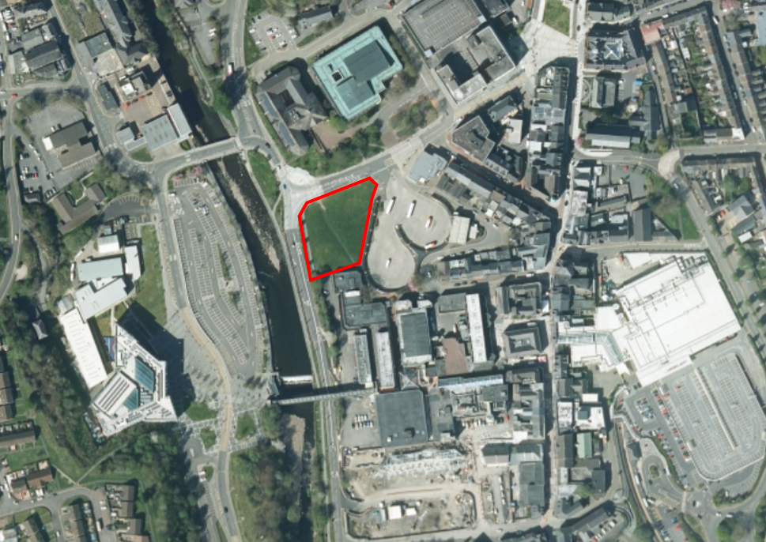
Figure 1: Location of Matchstick area (DigiMap, 2024).

3.0 Baseline Environmental Conditions
Environmental conditions that are covered below highlighting surrounding areas.

3.1 Air Quality
Current pollutions levels are at 6.7µg/m3.
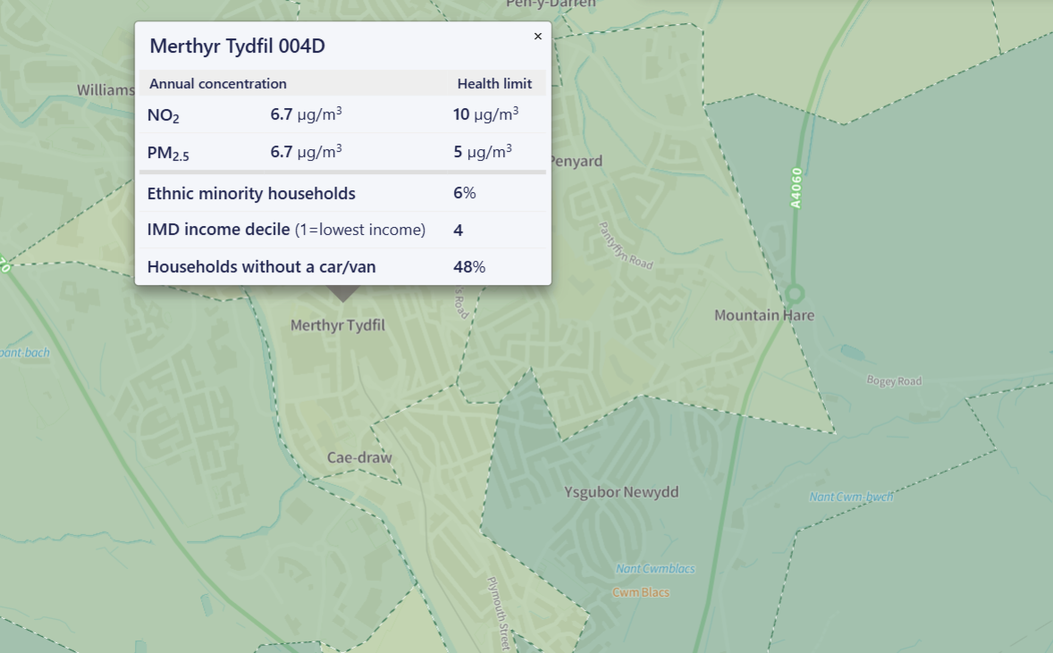
Figure 2: Showing air pollution hotspots (Friends of the earth, 2023)

3.2 Water Resources
Surface and groundwater quality is high with the river taff being adjacent to the construction project.
3.3 Land contamination
If any evidence of potential contamination is discovered during the approved development that was not previously identified, all development works must be stopped immediately. The Local Planning Authority and the Environmental Health Department should be contacted within 2 working days, and a plan to investigate the risks and any necessary remedial measures must be submitted to, agreed upon, and approved in writing by the Local Planning Authority before development works can recommence. (NRW P/23/0032, 2023)
Upon completion of the development and prior to the first occupation of the site, sufficient evidence must be provided to confirm that any required remedial measures have been successfully implemented, or to confirm that no unexpected contamination was encountered. (NRW P/23/0032, 2023)
To minimise the risks from land contamination to the future users of the land, neighbouring properties, controlled waters, ecological systems, and to ensure the development can be carried out safely without unacceptable risks to workers, neighbours, or other offsite receptors. (NRW P/23/0032, 2023)

3.4 Flood Risks
Flood risk maps confirm the site to be within Zone C2 area contained in Technical Advice Note (TAN) 15. This requires the local authority to determine if the development of this location is justified. (Appendix A). (NRW P/23/0032, 2023)
The FCA and hydraulic model show:
- The site is predicted to flood to a maximum depth of 0.37m during the 1% plus climate change annual probability flood event.
- The southeast part of site is predicted to flood to a maximum depth of 0.5m during the 0.1% annual chance of a flood event. This is a tolerable limit in TAN15.
- There are several access routes from the site that remain flood free during all events.
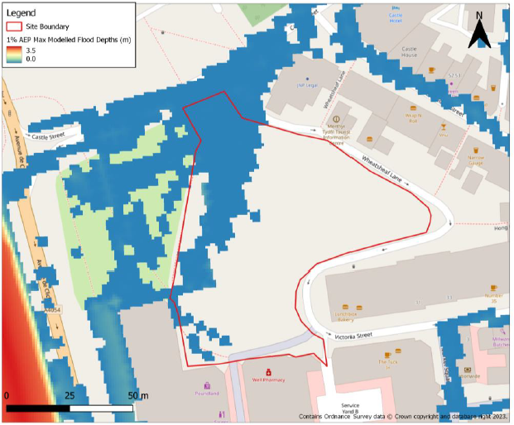
Figure 3: Showing 1.0% AEP flood depth in the area of Matchstick Arena (NRW P/23/0032, 2023)

3.5 Noise & Vibration
A noise assessment has been carried out for the project. Construction activities at the Matchstick Arena are expected to generate varying levels of noise until completion in August 2026, with the level of impact dependent on the specific tasks underway at any given time. Noise emissions will be limited to the designated working hours of 8:00am to 6:00pm, Monday to Friday, unless prior approval is obtained from the local authority for work outside of these times.

3.6 Socio-Economic Factors
Employments opportunities with the construction work and employment once construction completed. Current employment levels are low within the area, leading to commutes to further cities and towns.

Environmental Factor | Impact Type | Severity  (Low / Medium / High) | Duration  (Short / Long) | Mitigation Required?  (Yes / No)
Air Quality | Dust & Emissions | High | Short | Yes
Water Resources | Contamination | Medium | Long | Yes
Biodiversity | Habitat destruction | Low | Long | Yes
Noise & Vibration | Construction Activities | Medium | Short | Yes
Economic Factors | Employment | Low | Long | No
Table 1. Identifying the severity with environmental factors in the area.

4.0 Impact Assessment
The list below provides an assessment carried out for the construction of Matchstick arena and its impacts to the local area of Merthyr Tydfil.

4.2 Air Quality
Construction work may result in the emission of dust from exposed soil, earth, vehicle movement or concreting. Construction of Matchstick arena may result in emission due to wind blowing over, in addition to emission of nitrogen, carbon monoxide and sulphur dioxide from vehicle exhausts. Local air quality in the surrounding area with respect to pollutants is good and does not exceed the UK’s national Air Quality objectives. Dust could arise from excavation, backfilling of foundation, road construction or general housekeeping.

4.3 Traffic and infrastructure
Traffic movement will be primarily associated with the construction work, during delivery of plant, equipment, aggregate and concrete. The existing site entrance in the north of the construction job will require improvement to facilitate on-going traffic. No unacceptable impact on the road networks or rights of way are envisaged.

4.4 Drainage system
A potential risk exists for spills and leakage of oil from construction machinery which could contaminate ground water, soils and surface water. During construction, activities could potentially cause changes to surface and water drainage from vehicle movement, removal of the vegetated topsoil and the introduction of foundations. There is also a need for water for general construction works, hygiene, dust suppression and wheel washing facilities.
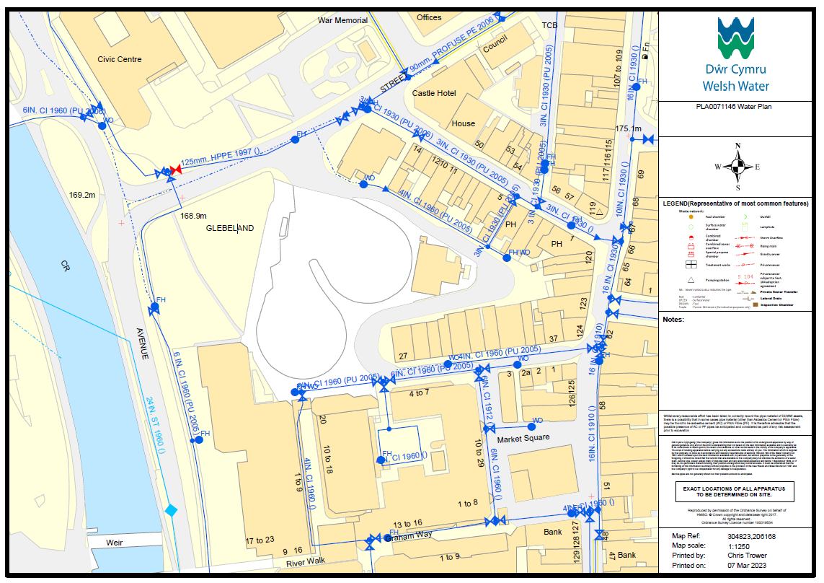
Figure 4: Showing current water plan in the Glebelands area. (Welsh Water P/23/0032, 2023)
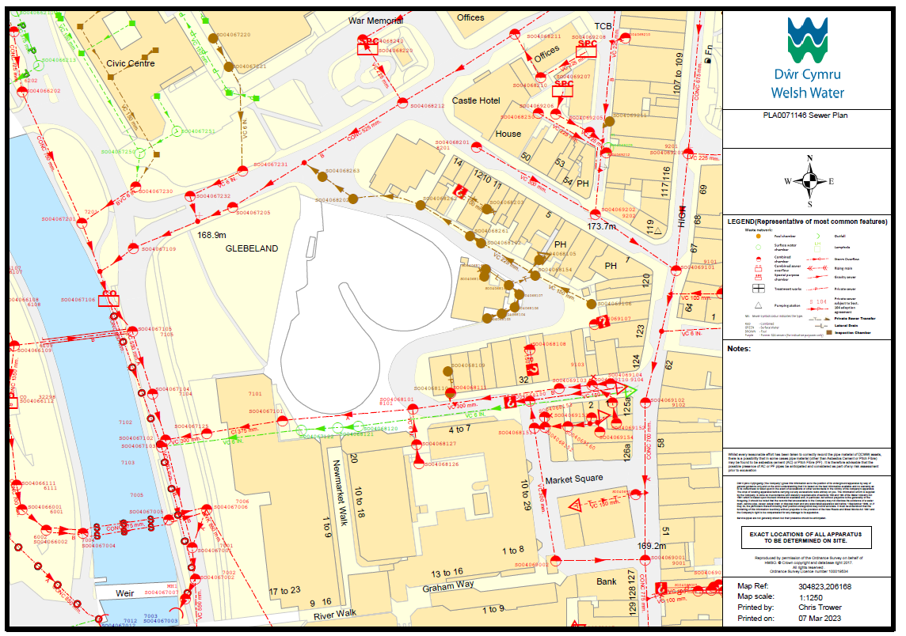
Figure 5: Showing current sewer plan in the Glebelands area. (Welsh Water P/23/0032, 2023)

5.0 Mitigation Strategies
The below are mitigation strategies to reduce the negative impacts of potential environmental factors.

5.1 Air Quality
Dust suppression techniques including water sprays, barriers and ensuring workers wear appropriate respiratory protection during high-risk dust activities.

5.2 Water Resources
Implementation of drainage systems preventing excessive run off from construction site.
5.3 Biodiversity
Preserve green areas around the location of Matchstick Arena, with additional tree installation for any removed during construction. The use of sustainability in the construction project utilised.

5.4 Noise & Vibration
Installation of noise barriers during construction such as fencing and design walls. Restricted working hours to remain the same during construction.

5.5 Traffic Congestion
Traffic measure controls used to prevent build up. This includes the use of traffic Marshall or temporary lights when required.

6.0 Environmental Risk & Monitoring Plan
The below environmental risk to the construction project and the monitoring plan for these risks to reduce the impact of environmental factors

6.1 Visual Inspection
Visual inspections to be used in measures to look at the air quality of the dust levels that are on site. This will be required as a daily task for the supervisor of the construction work to ensure dust levels to not affect works and pedestrians in a local proximity.

6.2 Sensors
Sensors to be implemented for multiple risk mitigation procedures. Air quality monitoring stations and sensor data to be used on a weekly basis to assess air quality is followed at a regulated basis. Noise meters will be used to detect noise levels (dB) during construction work using sensitive receptors. This will be done as needed to reduce noise pollution if exceeding noise regulations.

7.0 Emergency Response Plans
To address unexpected environmental hazards that can occur during the construction phase, the emergency responses for the potential EIA risks are below.
Potential Risk | Emergency Response
Severe air pollution event | Temporary suspension of dust-generating activities, notify authorities
Water contamination detected | Immediate halt of discharge, initiate cleanup, investigate source
Biodiversity damage observed | Implement restoration measures, notify environmental agencies
Excessive noise complaints | Review work schedule, install additional noise barriers
Traffic accidents due to congestion | Coordinate with traffic police, implement detours
Table 2: Highlighting emergency response plans.

8.0 Stakeholder Engagement
Key stakeholders are to have engagement during the construction phases in order to ensure compliance with the safety measure that are being used effectively. The key groups involves:

8.1 Local authorities
Consistent contact with local authorities to be followed during construction to ensure compliance with regulations including environmental laws, approved land usages and the assessment of traffic impact that are caused in contention with the work progressing. If there are any habitat protection concerns, this will include contact with wildlife organisations to address.

8.2 Local Residents and communities
Contact with local communities that can be impacted by noise, air pollution and water contamination but happen on a regular basis to prevent emergency response plans are required. This will include contact with the Merthyr Tydfil College that is within close proximity to the construction project, as well as local residency shops. This is to reduce the potential affects of business whilst construction work progresses.

8.3 Environmental Groups
Environmental groups are to be in contact with the contractor for the project to ensure general public health and safety for contractors on the project, and local stakeholders are safe within the boundary of the site project.

9.0 Conclusion and Recommendations
In conclusion, while the development of the Matchstick Arena presents potential environmental challenges, the implementation of mitigation measures, effective monitoring, and proactive stakeholder engagement will enable the project to be executed sustainably, balancing economic growth with environmental protection.

9.1 Recommendations
To strengthen environmental management and enhance project sustainability, the following recommendations are proposed:

9.2.1 Strengthening Air Quality Control
Real-time air quality monitoring should be enhanced using automated sensors to track pollution levels. Regular site inspections and immediate corrective actions should be taken if air quality thresholds are exceeded. Additional vegetation buffers should be considered to further reduce dust dispersion.

9.2.2 Enhancing Water Resource Protection
Introduce stormwater collection and filtration systems to prevent contamination of the River Taff. Ensure strict compliance with wastewater disposal standards by implementing water recycling measures for construction activities.

9.2.4 Noise & Vibration Management
Implement soundproof barriers in high-impact areas to further reduce noise pollution. Use low-noise equipment and construction techniques to limit noise impact on nearby residents and businesses. Develop a construction scheduling plan that prioritizes off-peak working hours to reduce disturbances.

References
DigiMap (2024). Aerial Roam. [online] Edina.ac.uk. Available at: https://digimap.edina.ac.uk/roam/map/aerial.
Friendsoftheearth (2023). Air pollution | Friends of the Earth. [online] Friends of the Earth. Available at: https://friendsoftheearth.uk/climate/air-pollution?utm_source=google&utm_medium=cpc&utm_campaign=climate [Accessed 29 Apr. 2025].
NRW P/23/0032 (2023). Documents for P/23/0032 [online] NEC. Available at: https://enterprise.merthyr.gov.uk/PublicAccess_LIVE/SearchResult/RunThirdPartySearch?FileSystemId=DC&FOLDER1_REF=P/23/0032 [Accessed 30 Apr. 2025]
Welsh Water P/23/0032 (2023). Documents for P/23/0032 [online] NEC. Available at: https://enterprise.merthyr.gov.uk/PublicAccess_LIVE/SearchResult/RunThirdPartySearch?FileSystemId=DC&FOLDER1_REF=P/23/0032 [Accessed 30 Apr. 2025]

Appendix

Appendix A: Flood risk and Pollution prevention – Former bus station, Merthyr Tydfil



 

