

Programme:
Certificate of Higher Education Skills for the Workplace (Health & Social
Care)

Module:
Introduction to Health and Social Care

Student name: Gabriel Kingsley Oduro
Student ID:2516583
Module name: Introduction to Health and Social Care
Module code: LCHS4003
Task 1 and Task 2
Lecturer name: Muhammad Aliyu

Domiciliary Care Services in the UK
History, Current Practice and Key Challenges
Module: Introduction to Health and Social Care | Module code: LCHS4003 | Name: Gabriel Kingsley Oduro | Student ID: 2516583 | Lecturer name: Muhammad Aliyu

What is domiciliary care?

Domiciliary care is a community-based social care service that provides practical and personal support to people in their own homes. It is commonly used by older adults, disabled people, individuals living with long-term conditions, and those recovering after illness or hospital discharge (Department of Health, 2015). Support may include help with washing, dressing, meals, medication and everyday routines. The central aim of domiciliary care is to help people remain safe, dignified and as independent as possible in familiar surroundings, rather than moving into institutional care. In England, this form of home-based support sits within the wider adult social care system Care Quality Commission, 2025).
Typical support: personal care, meals, medication prompts, mobility support and companionship.
A brief history

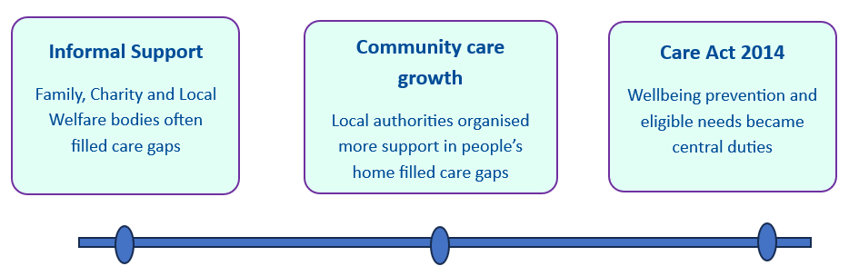
Domiciliary care developed from older arrangements in which daily support was provided mainly by families, charities and local welfare bodies rather than a clearly defined home-care system. Across the twentieth century, local authorities took on a stronger role in community care, and domiciliary services became more organised within adult social care. Over time, policy increasingly favoured supporting people in their own homes instead of treating institutional care as the default option (HomeCare Compliance Consultancy, 2025). This reflected a broader move towards independence, dignity and more personalised support. In England, the Care Act 2014 became a major modern framework because it placed wellbeing, prevention and the meeting of eligible needs at the centre of adult social care duties. That legal and policy shift helped embed domiciliary care more firmly within community-based support systems in England today.

How the service works today

Today, domiciliary care usually begins with a needs assessment carried out by the local authority when an adult appears to need care and support. If eligible needs are identified, a care and support plan is prepared setting out desired outcomes, the services to be provided and how those needs will be met under the Care Act 2014 (Care Act, 2014). Care is then delivered in the person’s home by care workers, with visits shaped around individual circumstances rather than a standard routine. Support may include help with washing, dressing, meals, medication prompts, mobility, continence needs and companionship, while some agencies also assist with household tasks and night care (NHS, 2023; CQC, 2025). Services may be arranged directly by councils or purchased from private and voluntary providers, reflecting the mixed economy of adult social care in England. In practice,

good domiciliary care is expected to be person-centred: staff should understand the person’s background, preferences and goals, and support independence, dignity and control rather than
Person-centred care means support should reflect the person's background, preferences and goals, and should strengthen independence rather than simply complete tasks for them.
simply completing tasks for them (Godfrey, Young and Shannon, 2018). This approach aims to match support to changing needs while helping people remain safely at home. High-quality homecare depends on continuity, communication, safeguarding, and regular review so that support changes as needs change (CQC, 2025).
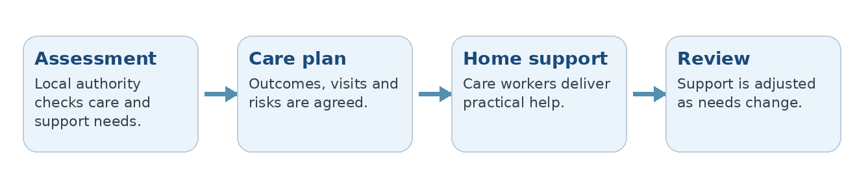

Challenges facing Domiciliary Care

- Workforce Shortage
Workforce shortages remain one of the most serious problems facing domiciliary care. Recruiting and retaining staff is difficult because the work is demanding, travel between visits can be tiring, and employment conditions are often less attractive than in other sectors. Skills for Care reports that domiciliary care had the highest vacancy rate among main adult social care services in England in 2024/25, at 9.9%, while turnover in CQC non-residential services remained high (Skill for Care, 2024; PLMR, 2025). This instability affects continuity of care because service users may experience frequent staff changes, rushed visits or gaps in support. The Care Quality Commission has also reported delays in accessing homecare because of shortages of homecare and reablement staff (CQC, 2025). In practice, this can weaken relationships, reduce trust and make personalised care harder to sustain.

Reference List
Boland, L., Légaré, F., Perez, M.M.B., Menear, M., Garvelink, M.M., McIsaac, D.I., Painchaud Guérard, G., Emond, J., Brière, N. and Stacey, D. (2017). Impact of home care versus alternative locations of care on elder health outcomes: an overview of systematic reviews. BMC Geriatrics, [online] 17(1). doi:https://doi.org/10.1186/s12877-016-0395-y.
Care Act (2014). Care Act 2014. [online] Legislation.gov.uk. Available at: https://www.legislation.gov.uk/ukpga/2014/23/contents.
Care Quality Commission (2025). Personal care registration for homecare agencies - Care Quality Commission. [online] Cqc.org.uk. Available at: https://www.cqc.org.uk/guidance-regulation/providers/registration/personal-care-registration-homecare-agencies [Accessed 22 Mar. 2026].
Centre for Ageing Better (2025). Our Ageing Population | the State of Ageing 2025. [online] Centre for Ageing Better. Available at: https://ageing-better.org.uk/our-ageing-population-state-ageing-2025 [Accessed 22 Mar. 2026].
CQC (2025). CQC warns lack of investment in community services threatens shift towards care outside hospital – and risks ‘erosion’ of care quality - Care Quality Commission. [online] Cqc.org.uk. Available at: https://www.cqc.org.uk/press-release/cqc-warns-lack-investment-community-services-threatens-shift-towards-care-outside [Accessed 22 Mar. 2026].
Department of Health (2015). Domiciliary care | Department of Health. [online] Health. Available at: https://www.health-ni.gov.uk/articles/domiciliary-care [Accessed 22 Mar. 2026].
Godfrey, M., Young, J. and Shannon, R. (2018). Person-centred care: meaning and practice. [online] Nih.gov. Available at: https://www.ncbi.nlm.nih.gov/books/NBK508103/.
HomeCare Compliance Consultancy (2025). HomeCare Compliance Consultancy. [online] HomeCare Compliance Consultancy. Available at: https://www.hc-compliance.co.uk/blog-1-1/domiciliary-care-has-its-roots-in-early-charitable-and-community-based-health-support-evolving-significantly-over-the-past-century.
NHS (2023). Help at home from a paid carer - Social care and support guide. [online] nhs.uk. Available at: https://www.nhs.uk/social-care-and-support/care-services-equipment-and-care-homes/homecare/ [Accessed 22 Mar. 2026].
PLMR (2025). CQC State of Care 2024/25: What It Tells Us About the Sector Providers Are Navigating - PLMR. [online] PLMR. Available at: https://plmr.co.uk/2025/10/cqc-state-of-care-2024-25-what-it-tells-us-about-the-sector-providers-are-navigating/.
Skill for Care (2024). Adult social care - Care Quality Commission. [online] Cqc.org.uk. Available at: https://www.cqc.org.uk/publications/major-report/state-care/2024-2025/access/asc [Accessed 22 Mar. 2026].
The King's Fund (2024). Adult Social Care: Key Facts and Figures. [online] The King’s Fund. Available at: https://www.kingsfund.org.uk/insight-and-analysis/data-and-charts/key-facts-figures-adult-social-care [Accessed 22 Mar. 2026].
Yi, Y., Liu, J. and Jiang, L. (2023). Does home and community-based services use reduce hospital utilization and hospital expenditure among disabled elders? Evidence from China. Frontiers in Public Health, [online] 11. doi:https://doi.org/10.3389/fpubh.2023.1266949
- Funding Pressure and Rising Demand
Domiciliary care is also under strain because demand is rising faster than resources. England’s population is ageing, and the number of people aged 65 and over is projected to grow substantially over coming decades, increasing the need for home-based support. At the same time, adult social care is funded largely through local authorities, whose budgets remain under pressure despite higher overall spending (The King’s Fund, 2024; Centre for Ageing Better, 2025). When funding does not keep pace with need, access can be delayed and care packages may be harder to secure or sustain. The Care Quality Commission has warned that community services need investment and

that some people still face delays in accessing homecare. This matters because unmet need can undermine independence, safety and wellbeing (CQC, 2025).
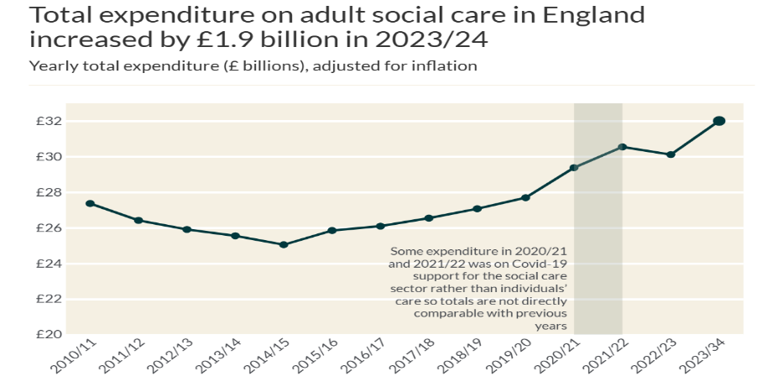
Figure 1: Total expenditure on adult social care in England. Source: NHS England 2023/24

Why the service matters

Domiciliary care matters because it allows many people to remain in their own homes instead of moving prematurely into residential care. For many service users, familiar surroundings support dignity, routine, emotional wellbeing and a stronger sense of control over everyday life. Home-based support can also reduce avoidable hospital admission or delayed discharge by helping people manage safely after illness or during long-term conditions (Yi, Liu and Jiang, 2023). Families benefit as well, because paid carers can share practical responsibilities and reduce pressure on unpaid relatives. In a wider sense, domiciliary care is essential to community-based social care because it connects personal support with prevention, independence and local living rather than institutional dependence (Boland et al., 2017). These benefits explain why homecare remains so important across England today.
Conclusion: domiciliary care is an essential part of social care in England because it supports independence, dignity and quality of life within the home. It enables many people to live safely in familiar surroundings, yet persistent workforce shortages and funding pressures continue to affect access, continuity and the consistent delivery of high-quality care.

Ambulance Services in the UK: Origins, Current Functioning and Importance to Service Users
Student name: Gabriel Kingsley Oduro
Student ID:2516583
Module name: Introduction to Health and Social Care
Module code: LCHS4003
Lecturer name: Muhammad Aliyu

1. Introduction
The ambulance services form an indispensable component of the UK healthcare system as it offers urgent evaluation, treatment and transportation services to individuals who experience sudden sickness or injury.

2. Origins and Historical Context
The development of ambulance services in the UK was based on a less structured system where the injured or seriously ill persons were frequently transported by the police, local authorities or the volunteering organisations instead of a special emergency service. In major cities, a more formal ambulance delivery started to emerge towards the end of the nineteenth and early twentieth centuries and emergency planning during the wartime prepared emergency planning to a greater extent (Pollock, 2013). A major turning point came with the creation of the NHS in 1948, following the National Health Service Act 1946. This was important since the provision of ambulances became integrated into a universal health system where services were to be availed according to the need. That historical shift laid the foundation for today’s more coordinated ambulance service (London Ambulance Service NHS Trust, 2025; UK Parliament, 1946).

3. How Ambulance Services Function Today
Today, ambulance services operate as part of the wider urgent and emergency care system rather than as a simple transport service. When a 999 call is made, handlers use structured pre-triage questions introduced through NHS England’s Ambulance Response Programme to identify clinical risk and decide the most appropriate response (Turner et al., 2017). This is to imply that the most ill patients are supposed to be served first followed up by the rest who may be given a telephone guidance, on-site care, referred to another service, or conveyed to hospital as the need arises. The role of paramedics has been enhanced to more of a clinical practitioner with the capability to assess, diagnose, treat, administer medicine, release and refer patients in both the emergency and out of hospital environment, which demonstrates how the role has become more of a clinical practitioner compared to earlier years (Stott et al., 2024). Nevertheless, the service is pressured. According to the February 2026 Ambulance Quality Indicators of NHS England, average response times in England in Category 2 have stayed above the national standard, meaning that the increasing demand and system overload are still impacting the service even with the reforms over services (NHS England, 2026). Hospital handovers are also a long process and delay crews as well as decrease the availability of vehicles and complicate the service to provide patient-centred care to patients at all times.
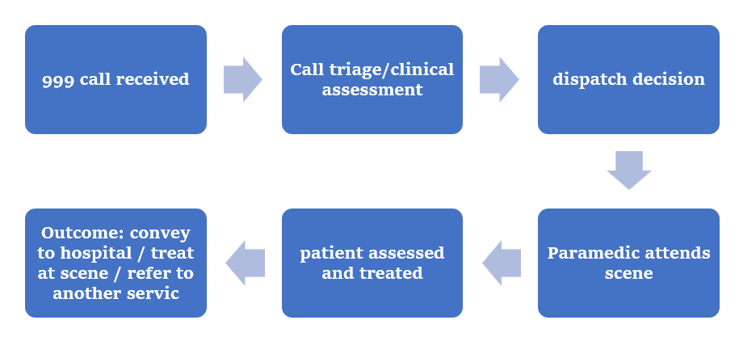
Figure 1: Simplified pathway of modern ambulance service response in the UK, showing triage, on-scene assessment and possible care outcomes.

4. Importance to Service Users’ Quality of Life
The services provided by ambulances enhance the quality of life since the service will not only save lives but help people to reduce pain, fear and uncertainty during crisis situations. A quick, medically rigorous reaction might avoid an illness deteriorating and may link individuals to the appropriate type of care without undue time lag that reinforces improved results and less hazardous care courses (NHS England, 2017). Particularly in the elderly, individuals with chronic illnesses and in acute distress, whose health might be jeopardized by speed of response and reassurance, this becomes crucial. Dignity and confidence is another area which is held by ambulance clinicians in providing immediate treatment, effective communication and professional advice to patients and families. Such newly developed models as video triage can also enhance patient experience when it is clinically appropriate (Bell et al., 2021).

5. Conclusion
The ambulance services have evolved into a more general transport service as a part of UK healthcare as well as a more general clinical service. These are now evaluating, treating and transferring patients besides transporting them to hospital. Despite the pressures of operations, they are crucial to the wellbeing and outcome of service users because they provide them with rapid intervention, reassurance and access to care at the right time.

REFERENCES
Bell, F., Pilbery, R., Connell, R., Fletcher, D., Leatherland, T., Cottrell, L. and Webster, P. (2021). The acceptability and safety of video triage for ambulance service patients and clinicians during the COVID-19 pandemic. British Paramedic Journal, 6(2), pp.49–58. doi:https://doi.org/10.29045/14784726.2021.9.6.2.49.
England, N. (2026a). Ambulance Quality Indicators Systems Indicators for February 2026. [online] GOV.UK. Available at: https://www.gov.uk/government/statistics/ambulance-quality-indicators-systems-indicators-for-february-2026 [Accessed 22 Mar. 2026].
London Ambulance Service NHS Trust (2025). Our history – a timeline - London Ambulance Service NHS Trust. [online] London Ambulance Service NHS Trust - accidents, traffic accidents, car, vehicle. Available at: https://www.londonambulance.nhs.uk/about-us/our-history/our-history-a-timeline/ [Accessed 22 Mar. 2026].
NHS England (2017). NHS England Ambulance Response Programme. [online] England.nhs.uk. Available at: https://www.england.nhs.uk/urgent-emergency-care/improving-ambulance-services/arp/ [Accessed 22 Mar. 2026].
NHS England (2026b). Statistical Note: Ambulance Quality Indicators (AQI). [online] Available at: https://www.england.nhs.uk/statistics/wp-content/uploads/sites/2/2026/03/20260312-Stats-Note-of-AQI-LB32C-1.pdf.
Pollock, A. (2013). Ambulance services in London and Great Britain from 1860 until today: a glimpse of history gleaned mainly from the pages of contemporary journals. Emergency Medicine Journal, [online] 30(3), pp.218–222. doi:https://doi.org/10.1136/emermed-2011-200086.
Stott, H., Goodenough, T., Jagosh, J., Gibson, A., Harris, N., Liddiard, C., Proctor, A., Schofield, B., Walsh, N., Booker, M.J. and Voss, S. (2024). Understanding paramedic work in general practice in the UK: a rapid realist synthesis. BMC Primary Care, [online] 25(1). doi:https://doi.org/10.1186/s12875-024-02271-1.
Turner, J., Jacques, R., Crum, A., Coster, J., Stone, T. and Nicholl, J. (2017). Ambulance Response Programme Evaluation of Phase 1 and Phase 2 Final Report. [online] Available at: https://www.england.nhs.uk/wp-content/uploads/2017/07/ARPReport_Final.pdf.
UK Parliament (1946). 1946 National Health Service Act. [online] UK Parliament . Available at: https://www.parliament.uk/about/living-heritage/transformingsociety/livinglearning/coll-9-health1/health-01/ [Accessed 22 Mar. 2026].

