

International Business LCMB7014

British American Tobacco International Business in Romania


Source: (British American Tobacco, 2023)

Student name: Jinalben Gujrati
Student Number: 2212012
Lecturer: Dr Hossein Shokri
Submission Date: 3rd May 2023

Table of Contents
Introduction 1
Company Background 2
Company’s Objectives and Strategies 4
Countries’ Specifications 5
Home Country 5
Host Country 6
External Analysis 7
A Comparative PESTEL Analysis 8
➢ Market Analysis 13
Host Country Analysis 15
Country’s National Diamond 15
Country Business Risks (Romania) 18
Internal Analysis 20
Global value chain 20
SWOT Analysis 22
International Strategies 23
Primary activities 26
Support Activities 27
Entry Modes 27
Corporate Social Responsibility 29
Conclusion 31
References 32

Introduction
Tobacco is a heavily regulated and contentious business that has encountered several difficulties throughout the years. British American Tobacco (BAT) is a market leader in this sector, having operations in over 200 countries. This research attempts to give a thorough examination of BAT's internationalisation strategy, with an emphasis on its entry into the Romanian market.
The report will begin with a brief introduction of BAT and the report's objectives. Following that, a literature analysis will be done to investigate the various internationalisation tactics and analytical frameworks that may be utilised to evaluate BAT's plan. This will involve a look at management-specific, industry-specific, and country-specific aspects (Annual Report of BAT, 2021). The report's primary body will examine BAT's internationalisation approach, including its management structure, allocation of resources, marketing initiatives, and human resource management methods. The study will also assess industry-specific elements like the competitive environment and technical advancements, as well as country-specific aspects like the political and legal framework, cultural issues, and economic considerations.
Furthermore, the paper will investigate BAT's entrance tactics in Romania, which include foreign subsidiaries, acquisition, and joint ventures. The chosen entry mechanism will be evaluated based on its viability for the Romanian market, alignment with firm goals, and benefits and drawbacks (Leach, 2020). Lastly, the paper will look at the different steps that BAT management has taken to mitigate national risks in Romania. This will entail identifying national risks such as political, economic, social, and cultural risks, as well as evaluating risk mitigation techniques.
Ultimately, the purpose of this research is to give a thorough examination of BAT's internationalisation strategy, focusing on the numerous elements that have impacted the company's decision-making processes. The report's conclusions will have ramifications for BAT's future internationalisation strategy, as well as for other multinational corporations working in the tobacco sector or other highly regulated industries.

Company Background
British American Tobacco (BAT) is a global tobacco corporation based in London, England. In 1902, major British tobacco corporations, notably Imperial Tobacco and the American Tobacco Company, merged to form the company. BAT is now one of the world's major tobacco firms, having operations in over 200 countries.
BAT's product portfolio covers a diverse variety of tobacco-related items such as cigarettes, cigars, pipe tobacco, and chewing tobacco. Dunhill, Lucky Strikes, Pall Mall, and Rothmans are among the company's most popular cigarette brands (Sustar & Trontelj, 2019). 50,397 employees are working there. In response to changing customer tastes and rising regulatory constraints on traditional tobacco products, BAT has begun to invest in alternative goods such as e-cigarettes and heated tobacco devices in recent years.
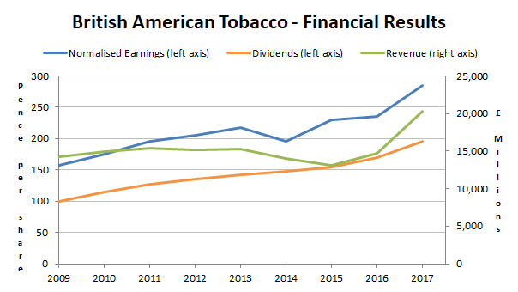
Figure 1: Financial Results of BAT
(Source: Wiśniewska, 2020)
Despite severe regulatory and public health difficulties, BAT has continued to grow its global operations. In several countries, particularly growing markets such as Brazil, India, and Indonesia, the corporation has a large market share (Wisniewska, 2020).
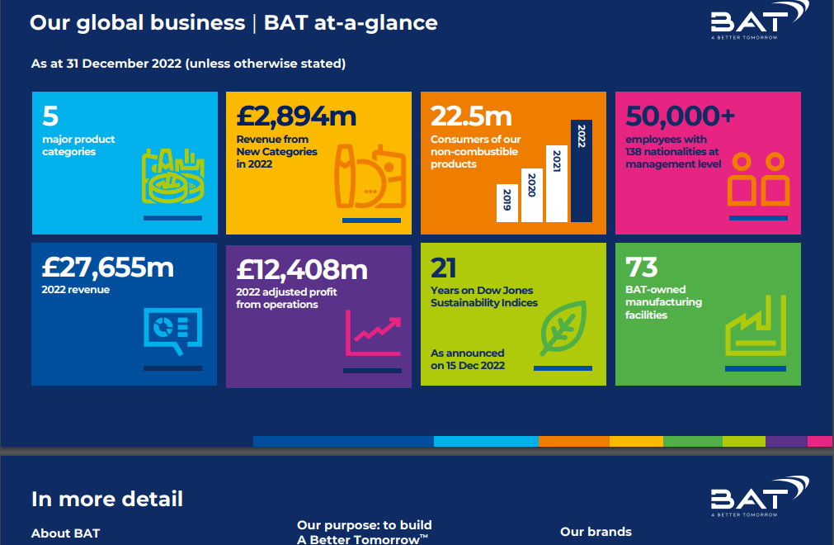
Figure 2: BAT global business
Sources: (British American Tobacco, 2020)

Company’s Objectives and Strategies
British American Tobacco (BATprincipal)'s goal is to retain and expand its market dominance in the global cigarette sector (Yerramilli, 2019). This has been including extending its product line, investing in R&D, and targeting new markets.
BAT's main strategy is to expand its product offering beyond conventional cigarettes. In recent years, the corporation has made investments in alternative goods including e-cigarettes and heated tobacco devices (Sustar & Trontelj, 2019).
Another critical strategy for BAT is to spend on R&D to increase the quality and safety of its goods. Many research institutes have been investigate the health impacts of smoking and to produce new products that are less damaging to customers (Leach, 2020).
BAT has also targeted emerging markets aggressively, notably in Asia, Africa, and South America. In recent years, demand for tobacco products has increased significantly in these regions, and BAT has attempted to create a strong presence in those markets through advertising and promotional efforts adapted to local preferences and tastes (Sustar & Trontelj, 2019).
BAT has used a multi-domestic approach to internationalisation. This entails customising its products, advertising, and distribution tactics to each local market's demands and tastes. This strategy has enabled BAT to be more responsive to local competition and laws(Leach, 2020).
Overall, BAT's aims and plans indicate a commitment to preserving and expanding its worldwide tobacco market dominance while simultaneously responding to changing customer preferences and regulatory contexts (Yerramilli, 2019).
Table 1: Objectives and Strategies of BAT

Countries’ Specifications
It is critical to examine the distinctive features of the nations in which British American Tobacco (BAT) operates while examining the company's internationalisation strategy. Each nation has its own set of political, legal, cultural, and economic elements that might impact a company's market entry, product creation, and distribution strategies. While expanding into Romania, for example, BAT had to handle the country's strong smoking culture, shifting tobacco legislation, and economic realities that impacted supply chain management. BAT was able to build a strategy that responded to local requirements and tastes while still matching the company's broader aims and principles by analysing these country-specific characteristics.
Home Country (UK)
The UK government has taken many steps to reduce tobacco consumption, including a ban on smoking in public places and the implementation of plain package legislation. BAT has been required to comply with these restrictions while simultaneously pushing for its interests in policy-making. In comparison to other nations, the UK has a relatively low smoking prevalence, which has presented issues for BAT in terms of preserving market dominance (Ivanescu & Botoc, 2020). As a result, the corporation has diversified its product lines and invested in alternative items such as e-cigarettes. The United Kingdom is a wealthy country with a generally stable economy. This has given BAT the opportunity to sell higher-priced, premium cigarette products to UK customers. Yet, the firm has also encountered difficulties as a result of currency volatility and supply chain interruptions.
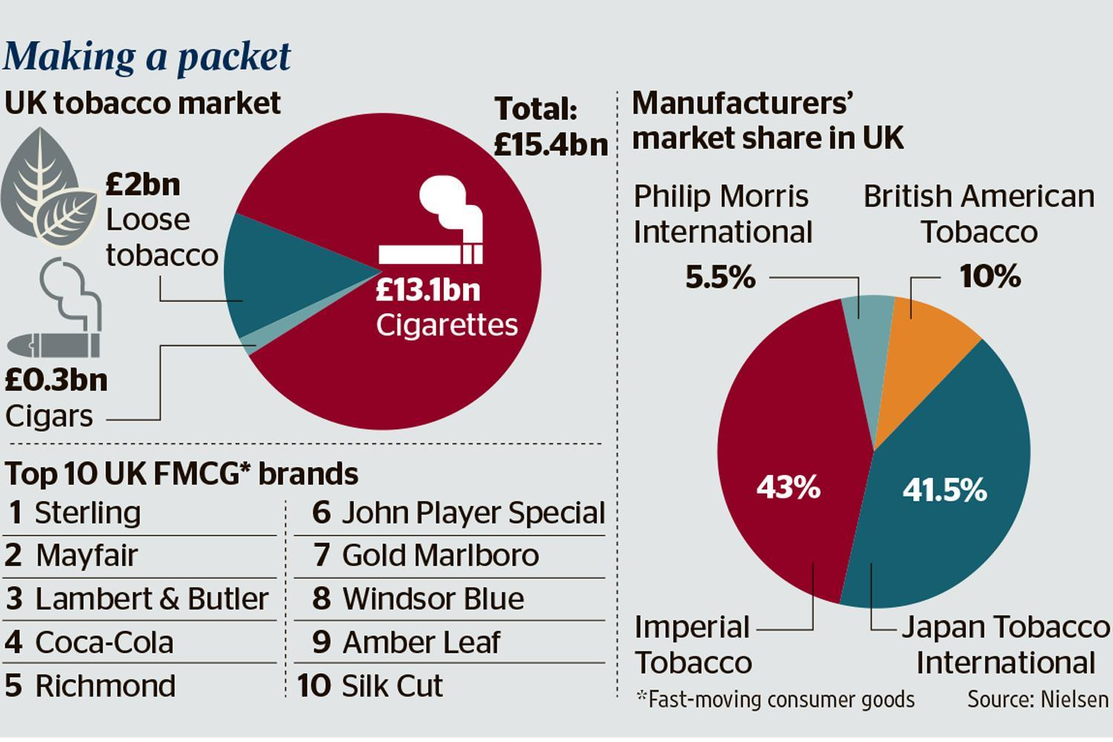
Figure 2: UK Tobacco Market
Source: (Ivanescu & Botoc, 2020)
Host Country (Romania)
Romania is a member of the European Union (EU), and as such is subject to EU tobacco-related rules and directives. In recent years, the Romanian government has introduced a number of tobacco-control measures, including a ban on smoking in public areas and increased tobacco-product tariffs. These rules have posed difficulties for BAT and other cigarette firms doing business in Romania. BAT, on the other hand, has worked extensively with Romanian government officials to guarantee regulatory compliance and to preserve favourable ties with regulators (Ivanescu & Botoc, 2020). Romania has a significant smoking culture, with a large percentage of the population smoking cigarettes on a regular basis. This has given BAT the opportunity to build a strong market presence and launch new goods adapted to regional preferences and tastes. Romania is a low-income country in comparison to other EU member states. This has given BAT the opportunity to provide more economical cigarette products to Romanian customers. However, the firm has also encountered difficulties due to the country's economic situation, such as currency volatility and supply chain delays.
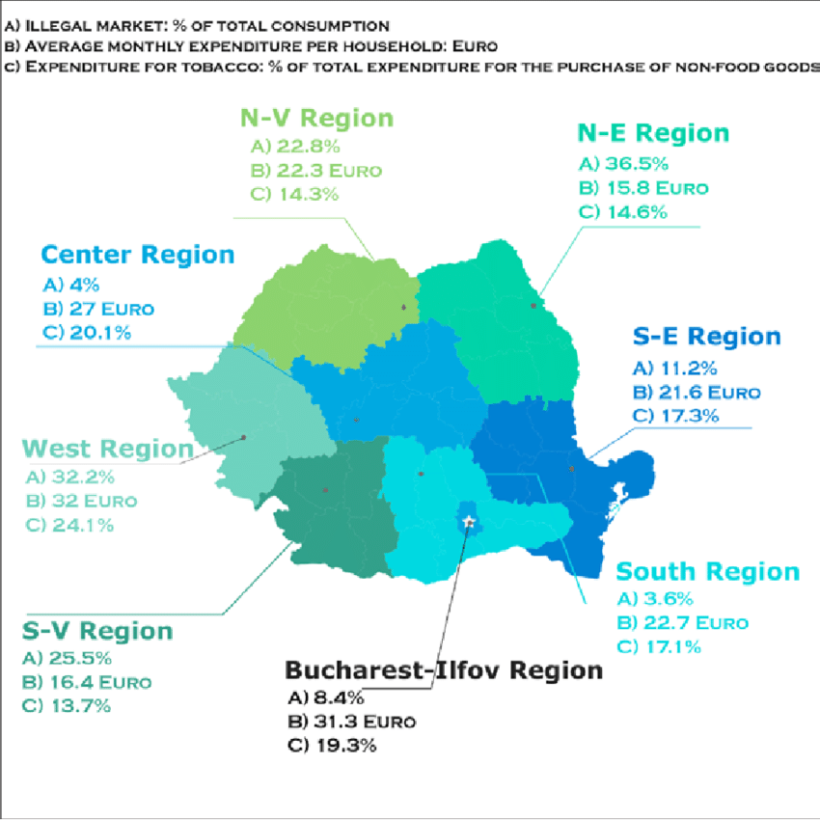
Figure 3: Romania Tobacco Consumption Patterns
Source: (Matei, 2019)
BAT was able to establish a strategy that is adapted to the unique demands and preferences of the Romanian market while still matching with the company's broader aims and principles by taking these aspects into account.

External Analysis
British American Tobacco (BAT) must do a thorough examination of the external environment in which it works in order to design a successful internationalization plan. This research entails assessing a variety of macroenvironmental elements that affect the company's operations and capacity to compete in various marketplaces. These influences include BAT's industry, competitive dynamics, economic trends, social and cultural considerations, and technology advancements (British American Tobacco, 2020). This study may also assist BAT in identifying new markets and development prospects, as well as possible risks and obstacles.

A Comparative PESTEL Analysis
PESTEL analysis is a tool used to analyse the external environment and assess the impact
of six key external factors in a business or industry and by analysing these factors,
business can develop strategies to mitigate risks, capitalize on opportunities and remain
competitive in the market (Johnson, et al., 2017).
Parameters | 
Political | - multi-party democratic democracy so corruption remains a problem and there are questions about the judiciary's independence (Ivanescu & Botoc, 2020). | - stable and well-established democracy with a solid legal system and property rights protection  - It has a history of openness to foreign investment and free commerce
Economic | - GDP is $250 billion in 2020.  - member of the European Union, and economic reforms have been made to attract foreign investment (Matei, 2019).  - income inequality and poverty issues | - It has one of the greatest economies in the world  - highly developed financial sector and advantageous tax policy  - issues as a result of Brexit and its possible impact on trade and investment.
Social | - population of Romania is roughly 19.5 million people,  - find younger staff may face difficulties because of the low birth rate and ageing population | - Because the UK has a varied and multicultural population, firms like BAT may customise their products and services to different parts of the population.  - It is also dealing with issues such as an ageing population and income disparity (Kyriakopoulos, et al., 2021).
Technological | - It has a talented workforce.  - burgeoning technology industry and IT and software development.  - focusing on innovation and technology. | - It has a highly trained workforce and sophisticated technological industries, which provide chances for businesses to innovate and produce new products.  - there are fears about how automation and artificial intelligence may affect jobs.
Environmental | - The geography of Romania is diversified, including mountains, forests, and coastal areas.  - there have been worries about deforestation and pollution. | - It has enacted environmental legislation aimed at lowering carbon emissions and encouraging sustainable activities.  - raised concerning the impacts of global warming and the necessity of a transition to a low-carbon industry (Ivanescu & Botoc, 2020).
Legal | - civil law system and has undergone legislative changes to improve the business climate.  - questions regarding the judiciary's independence and the legal system's efficacy in enforcing contracts (Matei, 2019). | - It has a well-established legal system that protects intellectual property and enforces contracts.  - there have been concerns about Brexit's influence on the legal environment and commercial deals.

Thus, Romania provides both chances and problem organizations trying to develop and UK provide both possibilities and problems for enterprises trying to grow globally(Matei, 2019).
Industry Five Forces
British American Tobacco (BAT) is a cigarette company that competes in a highly regulated and competitive business with severe entry hurdles. Porter's Five Forces framework is a valuable tool for understanding the competitive forces the action in this business.
- Threat of Entrance
Due to considerable financial needs, rigorous restrictions, and strong rivalry, the tobacco sector has high barriers to entrance. These constraints make it difficult for new entrants to compete with established corporations like BAT (British American Tobacco, 2020). Furthermore, the tobacco sector is subject to severe laws, particularly in industrialised nations, making it difficult for new entrants to meet these standards. As a result, the danger of new entrants is minimal in this market – Medium Extent
- Bargaining power of Suppliers
The tobacco business is strongly reliant on tobacco leaf suppliers, who may influence prices and supply. Yet, because BAT has a diversified supply base and can negotiate pricing and terms, suppliers' negotiating leverage is reduced (Dinh, et al., 2019). Furthermore, BAT has built solid connections with its suppliers and engaged in sustainable sourcing processes, which helps to manage risks associated with supply chain interruptions and pricing volatility. Overall, while suppliers have bargaining leverage, BAT retains some control over the issue – Low Extent
- Bargaining power of Buyers
The tobacco business is highly concentrated, with a few major firms dominating the market. As a result, purchasers have less bargaining power. Governments and public health groups, on the other hand, may put substantial pressure on firms like BAT through legislation and taxation. Several factors might diminish demand for tobacco products, affecting pricing and market share (Dinh, et al., 2019). Furthermore, consumer tastes have shifted over time, with a greater emphasis on health, reducing purchasers' negotiating power even further – High Extent
- Threat of Substitutes
Substitutes like e-cigarettes and vaping products pose an increasing challenge to the tobacco business. These alternatives are growing more popular among consumers and have the potential to diminish demand for traditional tobacco products. Despite its entry into the e-cigarette sector, BAT remains largely focused on traditional tobacco products. As a result, the prospect of alternatives continues to pose a substantial risk to BAT and the tobacco industry as a whole (Dinh, et al., 2019). – High Extent
- Competitive Rivalry
The tobacco business is extremely competitive, with a few major competitors dominating the market. BAT is up against stiff competition from the likes of Philip Morris International and Japan Tobacco International, which may influence pricing and market share. Furthermore, the sector is susceptible to ongoing innovation and product development, which might result in a pricing race to the bottom (British American Tobacco, 2020). To preserve its market position, BAT has responded to these difficulties by investing in brand distinction, product innovation, and cost-cutting measures. – High Extent
To summarise, the tobacco business is a difficult and complex area in which BAT works. Although entrance obstacles and supplier negotiating power safeguard existing firms, the industry confronts major issues linked to regulations, substitutes, and competitive rivalry.
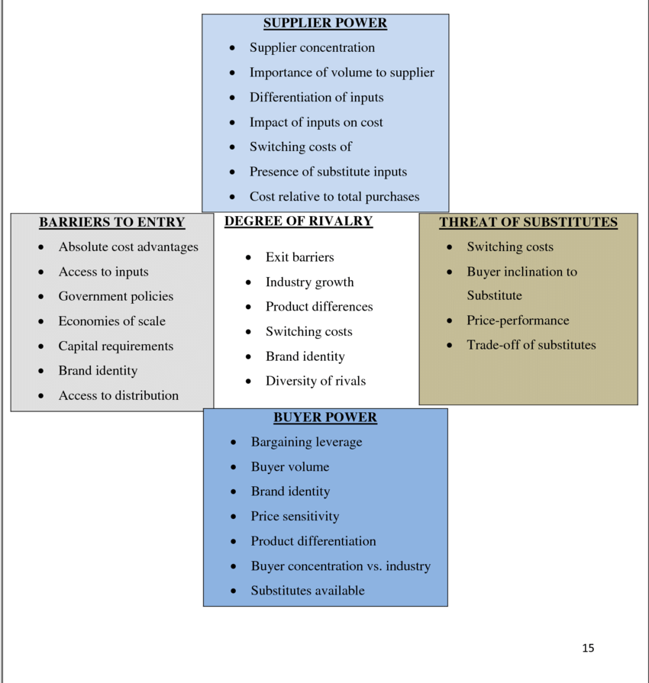
Figure 5: Industry Five Forces
Source: (Dinh, et al., 2019)
- Market Analysis
The market study is critical for British American Tobacco (BAT) in Romania to comprehend the competitive environment and market potential. The following section offers an overview of the Romanian tobacco market, including market size, important success factors, and rivals.
- Market size
It has a population of around 19.5 million inhabitants, and the tobacco industry is valued at approximately €3 billion. The market has grown steadily in recent years, with an upward trend in demand for premium as well as luxury tobacco products (Johnson, et al., 2017). Moreover, Romania is home to the highest cigarette consumption in the European Union, providing a potential for BAT to increase its market share (Investment, 2019).
- Key Success Factors
Because the tobacco market is so competitive, firms like BAT must concentrate on numerous key success criteria, such as brand awareness, innovative products, and distribution networks. BAT has a significant brand presence in Romania thanks to the popularity of its Kent and Lucky Strike brands among Romanian customers. Furthermore, BAT has invested in product innovation, such as Glo, a heated tobacco product that has gained popularity in Romania (Johnson, et al., 2017). With collaborations with wholesalers and retailers around the country.
- Competitors
The tobacco industry in Romania is very competitive, with numerous significant firms vying for market share. Japan Tobacco International (JTI) and Philip Morris International are BAT's primary competitors in Romania (PMI) (Johnson et al., 2017). JTI's Winston and Camel brands have a strong brand presence in Romania, but PMI's Marlboro brand has a large market share. Imperial Brands and local brands like as Doina and Carpati are other rivals in the market.
- Market Position
In Romania, BAT has a limited market share compared to its competitors, JTI and PMI. The corporation, on the other hand, has been investing in increasing its market share through product innovation and brand awareness. The firm has also created a solid distribution network, which has aided in expanding its market reach in Romania (Investment, 2019). Despite heavy market rivalry, BAT has been able to preserve its position by focusing on premium goods and brand uniqueness.
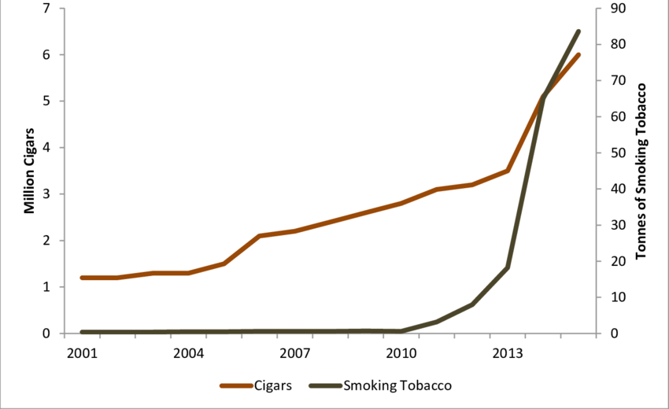
Figure 6: Romania Tobacco Sales (2001-2015)
(Source: Johnson et al., 2017)

Host Country Analysis
The tobacco industry is one of the significant contributors to the Romanian economy, with a
market size of $2.5 billion in 2020. This industry provides direct employment to around
30,000 people and indirect employment to many more. One of the reasons for BAT’s success
in Romania is the high prevalence of smoking in the country with nearly 25% of adults
smoking regularly according to the WHO.
Country’s National Diamond
Michael Porter's National Diamond model gives a framework for examining a country's competitive edge in a certain industry. Factor circumstances, demand conditions, linked and related industries, and strategic alignment, structure, and competition are all interrelated components in the model.
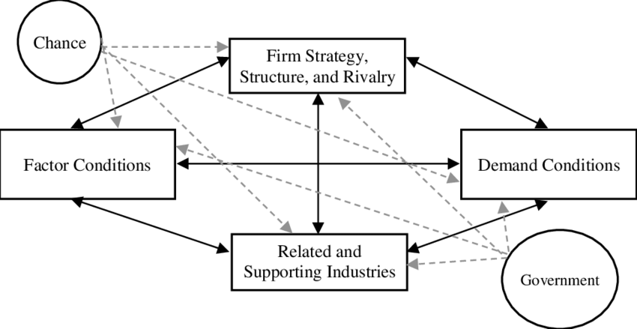
Figure 7: National Diamond Model
Source: (Patesan & Bucur, 2020)
- Factor condition
- Brand recognition
- Market knowledge and expertise
- Investment in a manufacturing facility
- Adaptability to changing market conditions
Ex. Romania has a low-cost labour force and an abundance of farmland suitable for tobacco cultivation. BAT has advanced machinery and technology to process tobacco products efficiently (British American Tobacco, 2020).
- Demand Condition
- Buyer’s needs, habits and preferences
- Popular cigarette brands like Kent, Dunhill, Lucky Strike, Pall Mall etc
- Wide distribution network including online platform, wholesalers, retailers etc
- Innovation and sustainability and focus on customer needs
Ex. There is a high demand for cigarettes in Romania because of the prevalence of smoking. More than 25% of adults do daily smoking according to WHO.
- Related and supporting industry
- Tobacco growers and suppliers- supply chain of high-quality tobacco
- Packaging manufacturers-timely and cost-effective production
- Retailers and Distributors- Accessibility and Availability
- Advertising and Marketing agencies-create effective campaigns and promotion
Ex. Romania has a well-developed transportation and logistics sector, making it easier for BAT to import raw materials and export finished products. BAT also works closely with local suppliers for packaging materials and other inputs (British American Tobacco, 2020).
- Firm Strategy, Structure and Rivalry
- Strategy- A distinct corporate mission by providing a wider range of entertaining and less dangerous items for BAT’s customers, BAT want to improve tomorrow by minimising the health effect of the company.
- Structure- Romania has a hierarchical organizational structure that allows for efficient decision-making and clear communication channels and it places a strong emphasis on employee training and development to ensure that its workforce is equipped with the skills and knowledge necessary to meet the demand of the market and the company also leverages technology to improve production processes and supply chain management
- Rivalry- domestic and international competitors like Phillip Morris International, Japan Tobacco International and Imperial Brands PLC as well TDR (Tutunul Dunarji) a subsidiary of Japan Tobacco International and Transilvania Tobacco, a Romanian-owned tobacco company (Euromonitor International, 2021).
Overall, Romania has a favourable National Diamond for the tobacco sector with skilled workforce labour, advanced technology etc

Country Business Risks (Romania)
Country business risk refer to the likelihood of adverse impact on business when operating in a specific country risk be like as under:
Political and Regulatory Risks | The political situation in Romania may be volatile, and changes in government can result in changes in legislation and policies that may influence the tobacco business. For example, the Romanian government implemented legislation in 2019 prohibiting smoking in all public places, including pubs and restaurants. This might have an immediate impact on BAT's product sales. Furthermore, when working with government officials, there is a possibility of corruption and bureaucratic hurdles, which can raise the cost of conducting business ( (Euler, 2019).
Economic Risks | Romania has a tiny and growing economy, which might pose economic risks to BAT. Economic insecurity, inflation, and currency fluctuations can all influence the company's profitability (Johnson, et al., 2017). Furthermore, Romania's GDP per capita is much lower than the EU average, which may have an influence on the demand for high-end tobacco products.
Social and Cultural Risks | Romania has one of the highest smoking rates in Europe, but there is also a rising awareness of the health concerns linked with smoking. As views regarding smoking alter and demand tobacco products diminishes, BAT may face social and cultural problems (Euler, 2019). The government is also taking steps to lower smoking rates, such as raising tobacco product tariffs.
Legal Risks | Romania has severe rules regarding tobacco advertising and packaging, which may limit BAT's ability to effectively sell its products. Tobacco products marketed in Romania, for example, must have graphic health warnings covering at least 65% of the package (Johnson, et al., 2017). Furthermore, there is a potential for litigation and legal action to be taken against the corporation, particularly in relation to health risks connected to smoking.
Supply Chain Risks | Romania's logistics and distribution infrastructure is somewhat undeveloped in comparison to other European nations, which might have an influence on the efficiency and dependability of BAT's supply chain (Euler, 2019). This might result in product delivery delays or greater transportation expenses.
BAT can take numerous actions to mitigate these risks, including
- To create a positive regulatory environment, close ties with government officials and stakeholders must be established.
- Doing market research to better understand customer preferences and producing goods that reflect shifting views regarding smoking.
- Creating a strong supply chain strategy that can overcome infrastructural problems and assure consistent product delivery (Johnson, et al., 2017).
- Investing in marketing methods that adhere to Romanian legislation, such as coming up with novel ways to incorporate graphic health warnings on packaging.
Finally, BAT faces various business risks while operating in Romania, including regulatory and political risks, economic exposure, cultural and social risks, legal ramifications, and distribution network risks. To maintain long-term success in the market, the organisation must successfully identify and manage these risks. BAT can capitalise on the benefits presented by the Romanian market, such as a big and expanding number of smokers, by taking aggressive actions to control these risks.
Table 6: Company Business Risks for Romania and Management
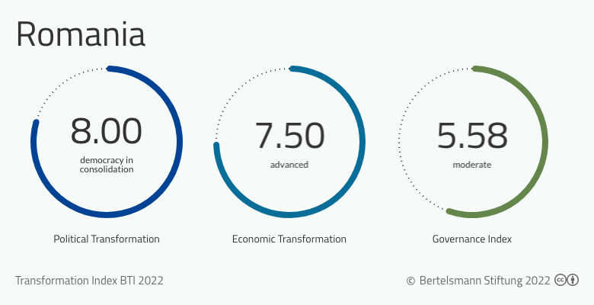
Figure 8: BTI 2022 Romania
Source: (Euler, 2019)

Internal Analysis
British American Tobacco is a multinational tobacco company that has been operating in Romania for over two decades. This internal analysis will examine the company’s strengths and weaknesses within the Romanian market.

Global value chain
A global value chain refers to the process of designing, producing and distributing goods and services across different countries and regions, with each stage adding value to the final product (Diik & Trienekens, 2012).
Global Production | BAT, being a worldwide firm, obtains raw materials and manufactures its goods in a number of nations. The company's manufacturing network spans various nations, including Romania. To achieve economies of scale, lower manufacturing costs, and maintain a consistent supply of high-quality tobacco products to its consumers, the firm uses its global production capabilities (Gereffi & Lee, 2019).
Global Marketing | BAT has a strong worldwide marketing strategy that focuses on increasing brand recognition and customer loyalty. To reach its target demographic, the organisation employs a combination of traditional and digital marketing methods. BAT promotes its goods while also participating in corporate social responsibility efforts to generate a favourable brand image (Gereffi & Lee, 2019). Yet, BAT must adhere to country-specific rules regarding cigarette promotion and packaging, which may limit the company's ability to expand.
Global HRM | Global human resource management: Since BAT has a diversified workforce scattered across various nations, the corporation must manage its human resources on a worldwide basis. BAT's human resources strategy involves attracting and keeping exceptional individuals, developing leadership abilities, and cultivating an innovative and collaborative culture (Gereffi & Lee, 2019). To guarantee that its workers have the skills and knowledge required to fuel the firm's success, the company invests in employee training and development programmes. Furthermore, BAT must follow labour laws and regulations in each nation in which it operates.
Table 7: Global Value Chain
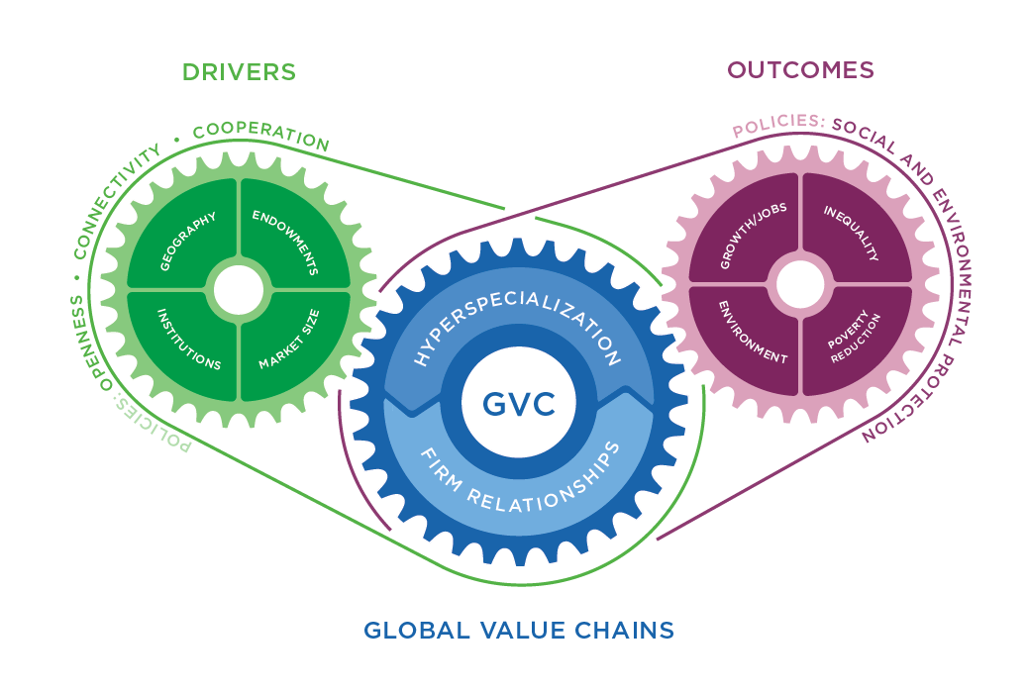
Figure 9: Global Value Chains
Source: (Gereffi & Lee, 2019)

SWOT Analysis
Strengths | - A strong brand portfolio with international recognition  - High market share and a well-established presence in a number of nations  - Supply chain management and a strong distribution network  - A diverse choice of goods is available, including both classic and novel items such as e-cigarettes (Marketline Advantage, 2023).
Weaknesses | - Dependency on tobacco products, which are subject to regulatory constraints and is in decline in various areas.  - Diversification into other product areas is limited.  - Tobacco products pose a reputational risk owing to their detrimental consequences (Reuters, 2019).
Opportunities | - There is an increasing desire for low-risk goods and alternatives to standard tobacco products.  - Growth into new regions as demand for tobacco goods rises  - Expansion into new product categories, such as cannabis and CBD goods (Marketline Advantage, 2023)  - Product development innovation to meet changing customer demands and regulatory requirements
Threats | - Rising tobacco product regulations, including limitations on packaging and promotion  - Health concerns and shifting customer tastes are driving down demand for traditional tobacco products.  - Competition from other tobacco corporations and rising players in low-risk products is fierce (Global Data, 2019).  - Currency fluctuations and geopolitical concerns in BAT's operating countries
Table 8: SWOT Analysis

International Strategies
International strategies are the plans and actions taken by businesses to expand their operations outside their native market and into foreign markets. Below are some examples of worldwide tactics used by British American Tobacco (BAT):
Global Standardization Strategy | BAT has established a worldwide standardisation approach in which it delivers the same product and marketing mix across all territories. This technique enables BAT to lower production costs, capitalise on economies of scale, and create consistent brand awareness across several nations (Cavusgil, et al., 2020).
Localization Strategy | In addition to worldwide standards, BAT employs a localization strategy, in which it tailors its goods and marketing mix to each local market's tastes and cultural variations. BAT, for example, has launched flavoured cigarettes in Indonesia and menthol cigarettes in the United States (Dikova, et al., 2020).
Strategic Alliances | BAT has created strategic agreements with local enterprises in order to enter new markets or increase its position in existing regions. In Indonesia, for example, BAT created a joint venture with PT Bentel International Investment (Dikova, et al., 2020).
Mergers and Acquisitions | Mergers and acquisitions have also been utilised by BAT to enter new markets or acquire competitors. For example, BAT purchased the remaining 57.8% of Reynolds American Inc. in 2017 to expand its position in the industry (Cavusgil, et al., 2020).
Innovation Strategy | BAT has spent on research & development in order to develop innovative products and lessen the harm caused by existing tobacco products. BAT, for example, has created goods such as e-cigarettes and tobacco heating items, which have acquired appeal in a variety of regions (Dikova, et al., 2020).
Table 9: International Strategies
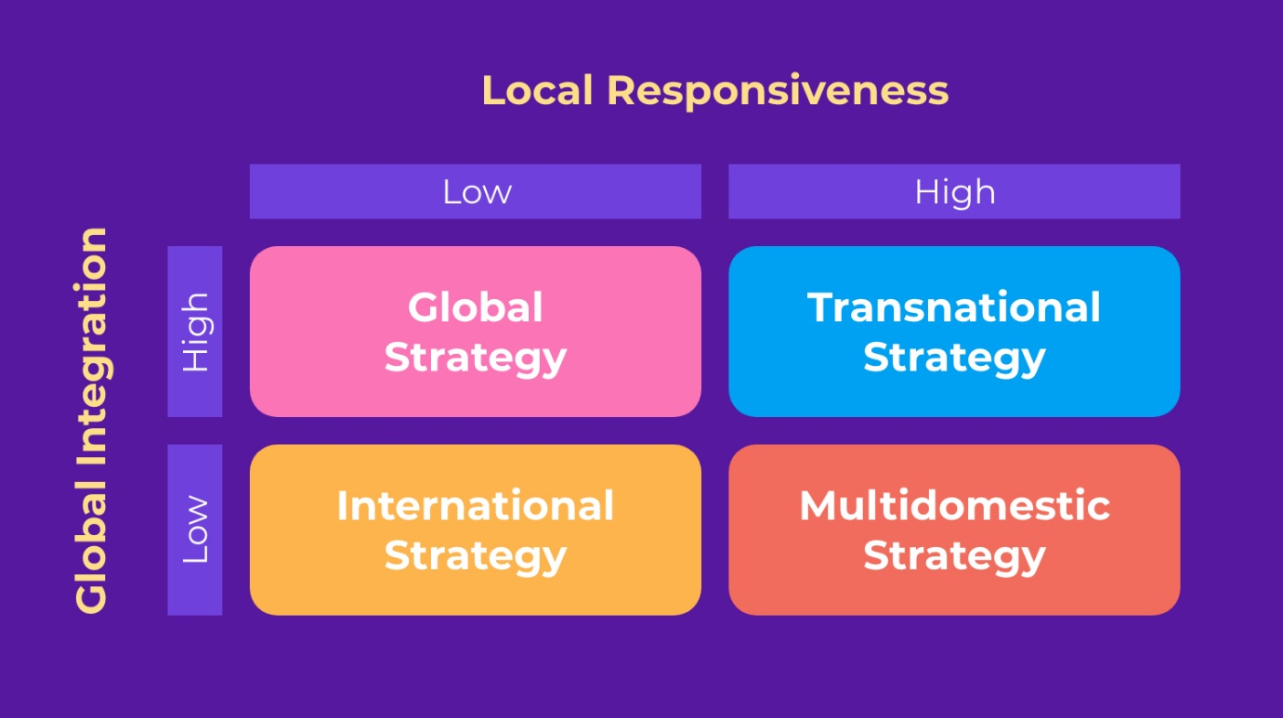
Figure 10: International Business Strategies
Source: (Dikova, et al., 2020)
Global Strategy | Transnational strategy | International strategy | Multidomestic strategy
- High-quality product | - Research and Development | - Product innovation | - Product localization
- Promoting sustainability | - Sustainability | - Marketing and Brand building | - Local manufacturing and Distribution
- Corporate Social Responsibility | - Global supply chain | - CSR and sustainability
- Adopting a multi-channel distribution approach
Source: (British American Tobacco, 2020) and (Sustainability Report of BAT, 2020)

Primary activities
Inbound logistics
- Material around the world- leaf, paper etc
- Tobacco farmer
- Transport
- Manufacturing facilities
Operations
- Finished product- cigarettes and cigars
- Modern techniques
- High quality product
- Efficient operations
Outbound logistics
- Retailers and wholesalers
- Distribution network
- Distribution channel-direct delivery, timely and efficient delivery
Marketing and sales
- Advertising
- Sponsorship
- promotions
- product placement
- strong sales force-maximum product availability
Service
- Training and education programs
- Corporate social responsibility (BAT Roamnia, n.d.)

Support Activities
Human Resources
- Training and development program
- Building a diverse and inclusive workforce
- Ensuring compliance with local labour law
Research and development
- Developing a new tobacco products and technologies
- Invest in R&D
- Focus on product meet local market needs and regulatory requirements
Information Technology
- Global IT team
- Solution to support business operations
- Technology infrastructure to support its manufacturing, sales and distribution operations.
Legal and Compliance
- Complying with local laws and regulation
- Has a dedicated legal and compliance team
Purchase and procurement
- Suppliers and contract
- Leaf- Brazil, Zimbabwe
- Emerging tobacco- Uganda, Kenya
- Paper – Asia and Europe

Entry Modes
An entry mode is the key in which a company enters a foreign market to choose a best aligns with their strategic objectives’ resources and capabilities as well as the regulatory and cultural conditions of the target market (Hollensen, 2009).
Exporting | BAT can export its products from the United Kingdom to Romania. This entry strategy involves little expenditure, and the firm may reach its clients through local distributors (Cui , et al., 2019).
Licensing | BAT can licence the manufacturing and distribution of its goods to a Romanian business. This manner of entry allows BAT to join the market swiftly and cheaply, while the local partner benefits from BAT's strong brand recognition (Johanson & Vahlne, 2019).
Franchising | BAT has the option of franchising its brand to a Romanian firm. This way of entrance is similar to licencing, except the local partner has more control over the franchise's functioning (Cui et al., 2019).
Joint Venture | BAT can organise a joint venture with a local Romanian firm to produce and market its products. This way of entry allows BAT to share the investment and risks with the local partner while receiving access to the local market knowledge of its partner (Cui , et al., 2019).
Wholly-Owned Subsidiary | BAT can create a wholly-owned subsidiary in Romania to manufacture and market its products. This entry approach gives BAT entire control over its market operations, but it demands substantial investment and local market expertise (Johanson & Vahlne, 2019).
BAT entered and operated in the Romanian market through a mixture of entry techniques. BAT, for example, launched a joint venture with a Romanian business, Carpatcement Holding SA, in 1997 to produce and market its products in Romania. Then, in 2003, BAT purchased a 90% interest in TUTUN-CTC, a local tobacco manufacturer, in order to increase its market dominance in the nation. In summary, BAT has expanded its position in Romania through joint ventures and wholly-owned subsidiaries, as well as through licencing and franchising agreements.
Table 10: Entry Modes
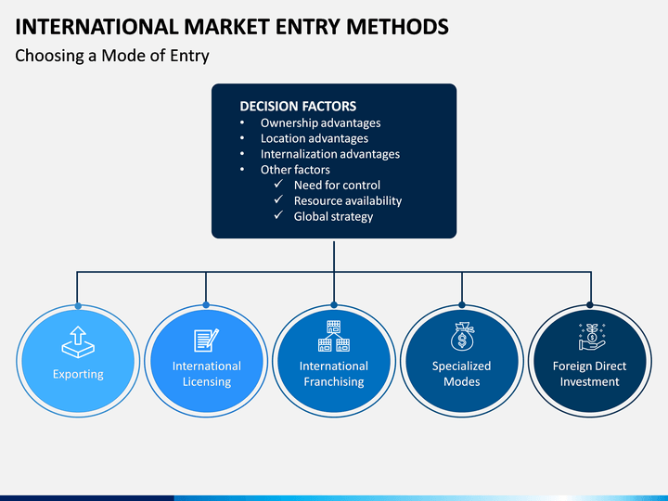
Figure 11: Entry Modes
Source: (Johanson & Vahlne, 2019)

Corporate Social Responsibility
Corporate Social Responsibility (CSR) is the attempt of a corporation to incorporate social and environmental issues into its business operations and relationships with stakeholders (Rugman & Verbeke, 2019). British American Tobacco (BAT) has conducted a number of CSR projects in Romania in order to promote long-term growth and improve the company's reputation.
"Farmers Sustainability Project,"
It is one of BAT's CSR activities in Romania, which aims to assist tobacco farmers in adopting sustainable agricultural techniques and improving their lives (Yang & Li, 2020). BAT offers farmers training and technical help in areas like soil management, crop diversification, and alternative income streams this initiative. In addition, the corporation fosters social development in rural areas by offering education, healthcare, and infrastructure assistance.
"Responsible Retailing"
This programme promotes responsible tobacco product sales and usage. BAT partners with merchants through this initiative to implement age verification and tobacco control measures in their stores, such as limiting advertising and marketing (Business and Human Rights Resource Centre , 2021). The firm also provides merchants with training and support to educate them on the health concerns connected with tobacco usage as well as the significance of appropriate sales practices.
“Health initiatives”
The company has launched awareness campaigns to encourage smokers to quit smoking and provide access to smoking cessation products. Additionally, BAT has been implemented to reduce underage smoking in Romania.
“Human Right”
BAT In December 2020, the first cigarette business to release a human rights report was BAT on Human Rights Day. The study outlines efforts to uphold human rights throughout our worldwide supply chain and corporate operations (British American Tobacco, 2023).
Moreover, BAT Romania has introduced a number of environmental efforts in its operations, such as trash reduction and energy-saving measures (Sustainability report of BAT, 2021). To lower its carbon footprint and encourage sustainable energy practises, the corporation has also invested in renewable energy sources such as solar panels.
Overall, BAT's CSR actions in Romania show the company's dedication to fostering sustainable development and ethical business practices (Tobacco Atlas, 2019). These efforts not only assist the areas in which BAT works but also contribute to the company's reputation as a good corporate citizen.

Conclusion
Finally, this research examined British American Tobacco's internationalisation strategy in Romania using a variety of analytical frameworks, including PESTEL analysis, Porter's Five Forces analysis, and the national diamond framework. The paper also covered the company's entrance options, worldwide value chain, market analysis, and Romanian CSR activities.
These findings show that BAT has successfully adopted an internationalisation strategy in Romania, employing management-specific variables, industry-specific factors, and country-specific factors to develop its activities there. Through its CSR activities, the company has also shown a dedication to sustainable development and responsible business practices, which has helped to improve its reputation in Romania.
Nonetheless, the research identifies several risks and problems associated with doing business in Romania, such as corruption, political instability, and legal and regulatory concerns (World Business Council for Sustainable Development, 2019.). BAT has used a variety of tactics to reduce these risks, including developing strong ties with local stakeholders and applying ethical business practices.
Ultimately, BAT's Romanian internationalisation approach might serve as a good case study for other multinational firms looking to grow into emerging nations. Companies may handle the risks and challenges of internationalization and achieve sustainable growth in new markets by employing analytical frameworks and applying ethical business practices.

References
British American Tobacco. 2020. Annual report and accounts 2019. https://www.bat.com/group/sites/UK__9D9KCY.nsf/vwPagesWebLive/DOBNZ69F/$file/BAT_AR19_BOOKMARKED.PDF?openelement
British American Tobacco. 2021. Annual report and accounts 2020. https://www.bat.com/group/sites/UK__9D9KCY.nsf/vwPagesWebLive/DOBNZ69F/$file/BAT_AR20_BOOKMARKED.PDF?openelement
British American Tobacco - Our strategic approach to sustainability. Available at: https://www.bat.com/group/sites/uk__9d9kcy.nsf/vwPagesWebLive/DO726NTL.
BAT Romania
https://www.batromania.ro/group/sites/BAT_9W3KJ6.nsf/vwPagesWebLive/DO9WQDWW
Business and Human Rights Resource Centre. 2021. British American Tobacco. https://www.business-humanrights.org/en/british-american-tobacco
Business and Human Rights Resource Centre. 2021. British American Tobacco. https://www.business-humanrights.org/en/british-american-tobacco
Cavusgil, S. T., Knight, G., and Riesenberger, J. R. 2020. International business: The new realities (5th ed.). Pearson.
Corporate Register. 2021. British American Tobacco sustainability reports. https://www.corporateregister.com/search/results?publisher=british-american-tobacco
Corporate Register. 2021. British American Tobacco sustainability reports. https://www.corporateregister.com/search/results?publisher=british-american-tobacco
Cui, L., Li, S., and Li, Y. 2019. Entry mode research: Past and future. Journal of International Business Studies, 50(4), 555-577.
Dijk, P.M. van and Trienekens, J. (2012) Global value chains : linking local producers from developing countries to international markets. Edited by P.M. van Dijk and J. Trienekens. Amsterdam: Amsterdam University Press. Available at: https://doi.org/10.1515/9789048514991.
Dikova, D., van Witteloostuijn, A., and Lyulka, V. 2020. International business research in the emerging markets context: What is different? Journal of World Business, 55(2), 101015.
Dinh, T. H. L., Ngo, L. V., and Nguyen, T. T. H. 2019. Porter’s five forces analysis of the tobacco industry in the UK. Journal of Open Innovation: Technology, Market, and Complexity, 5(3), 73.
Dima, A. M., Ghinea, C., & Munteanu, M.I. (2017). The Romanian Tobacco Market Trends and Perspectives. Procedia Economics and Finance,39, 697-710
Euler Hermes. 2019. Country report: Romania. https://www.eulerhermes.com/en_global/economic-research/analysis-and-forecasts/romania.html
Euromonitor International. 2019. Tobacco in the United Kingdom. https://www.euromonitor.com/tobacco-in-the-united-kingdom/report
European Commission. (2021). EU market Access Database: Tobacco Sector in Romania.
https://madb.europa.eu/madb/barriers_details.htm?barrier_id=18106
Gereffi, G., and Lee, J. 2019. Why the world suddenly cares about global supply chains. Journal of Supply Chain Management, 55(2), 1-6.
https://onlinelibrary.wiley.com/doi/full/10.1111/j.1745-493X.2012.03271.x?casa_token=8-0E-ocZCLAAAAAA%3AczF7YM_ajgjrs8nvXrsv-CljFPLx-JGaj2BK3huy01dG7Yp3mee25HvFwACvYuApUpl2ypv1RTARMQ
Gereffi, G., Humphrey, J., and Sturgeon, T. 2019. The governance of global value chains. Review of International Political Economy, 26(1), 78-104.
https://www.tandfonline.com/doi/abs/10.1080/09692290500049805
GlobalData. 2019. British American Tobacco PLC: SWOT analysis. https://www.globaldata.com/store/report/gdce1652m--british-american-tobacco-plc-swot-analysis/
Hollensen, S. (2009) Entry mode strategy in global marketing. London: Henry Stewart Talks.
Ivanescu, I. M., and Boțoc, C. 2020. The impact of PESTEL factors on the tobacco industry in Romania. Journal of Environmental Management and Tourism, 11(4), 803-813.
Johanson, J., and Vahlne, J.-E. 2019. The Uppsala model on evolution of the multinational business enterprise—from internalization to coordination of networks. International Marketing Review, 36(2), 190-202.
https://www.emerald.com/insight/content/doi/10.1108/02651331311321963/full/html
Johnson, G., Scholes, K., Whittington, R., Angwin, D., and Regner, P. 2017. Exploring strategy (11th ed.). Pearson Education.
Kyriakopoulos, G. L., Molesworth, M., and Paliwoda, S. J. 2021. The impact of PESTEL factors on tobacco consumption in the United Kingdom. Journal of Business Research, 123, 586-595.
Leach, P. 2020. British American Tobacco moves into cannabis market with Organigram deal. The Guardian. https://www.theguardian.com/business/2020/feb/13/british-american-tobacco-moves-into-cannabis-market-with-organigram-deal
MarketLine. 2019. British American Tobacco Plc: SWOT analysis. https://store.marketline.com/report/mlip1443--british-american-tobacco-plc-swot-analysis/
Marginean, S. (2016). Corporate Social Responsibility in Tobacco Industry- A study of British American Tobacco. Economic Insight-Trends a Challenges, 68(4), 70-80.
Matei, D. 2019. The Romanian tobacco industry in the context of PESTEL analysis. In Proceedings of the 23rd International Conference on Business Excellence (pp. 633-644). Sciendo.
Ngo, L. V., Luong, H. T. T., and Nguyen, H. H. 2018. PESTEL analysis of the tobacco industry in the UK. International Journal of Research in Business and Social Science, 7(3), 61-71.
Pateșan, A. C., and Bucur, M. F. 2020. National diamond analysis of the UK. Theoretical and Applied Economics, 27(3), 173-190.
Reuters. 2019. British American Tobacco Plc - Strategy, SWOT and corporate finance report. https://www.reuters.com/companies/BATS.L/key-metrics/swot
Rugman, A. M., and Verbeke, A. 2019. Global corporate strategy and trade policy: Tariff liberalization and the competitiveness challenge. Oxford University Press.
https://books.google.co.uk/books?hl=en&lr=&id=1HM5DwAAQBAJ&oi=fnd&pg=PT11&dq=Rugman,+A.+M.,+and+Verbeke,+A.+2019.+Global+corporate+strategy+and+trade+policy:+Tariff+liberalization+and+the+competitiveness+challenge.+Oxford+University+Press.&ots=VOJwo1MOFf&sig=kzxSFkoyLp5PN24eivnpq3VY6Nw&redir_esc=y#v=onepage&q&f=false
Sustar, J., and Trontelj, T. 2019. The use of social media in corporate communication: A case study of British American Tobacco. Corporate Communications: An International Journal, 24(4), 656-670.
Tobacco Atlas. 2019. British American Tobacco: Corporate social responsibility. https://tobaccoatlas.org/company/british-american-tobacco/
UK Trade and Investment. 2019. UK country risk assessment. https://www.gov.uk/guidance/country-risk-assessment-united-kingdom
Wiśniewska, E. 2020. British American Tobacco's sustainability report 2019: Environmental and social issues. Journal of Corporate Responsibility and Leadership, 7(3), 21-35.
World Business Council for Sustainable Development. 2019. British American Tobacco: Business leadership criteria for carbon pricing.
Yang, D., and Li, L. 2020. International business research: What’s left for us to do? Journal of International Business Studies, 51(4), 589-610.
Yerramilli, S. 2019. Strategic analysis of British American Tobacco. Journal of Business and Management, 21(2), 23-29.

