LCLM4002 Digital Skills
Assignment Title: Digital Skills - Portfolio of tasks
Task 2 – Informative Poster
Student ID:2410661
Submission Date:

My Professional Identity
How to Create a Chart in a Word Document.
Introduction:
The Poster will teach how to create a chart in a Word document will an easily understandable and smart way. Follow the steps one after one to create a chart in your Microsoft Word Document.

Step Five: Editing Chart Design

After you complete filling in the data, you can edit the design of your chart. Double-click on the chart, and it will show and suggest different designs of the chart. You can choose your own. You can add chart elements, edit, data, and select data and change the font or colour if you need to.
Step Three: Selecting the Chart Type

After your dialogue box is open, then click on the chart types. There are varieties of types of charts including Column charts, line charts, pie charts, and bar charts. As you can see, I have selected the column-type chart.

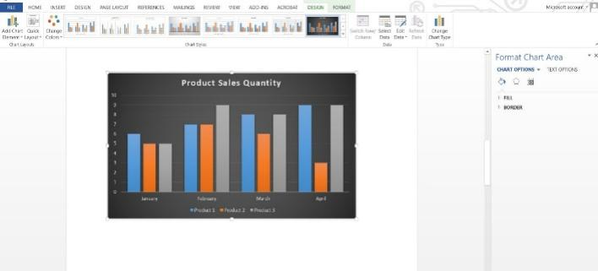
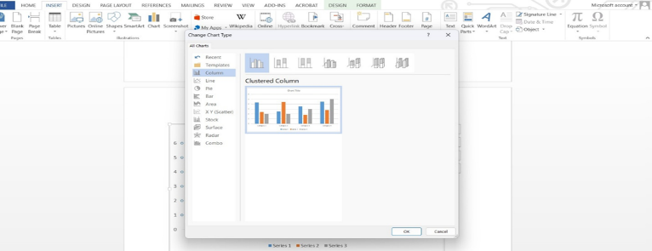
Step One: Open Microsoft Word from your Computer



Step Four: Entering the Data and Information

This is one of the crucial steps in creating a chart. A Microsoft Excel spreadsheet will open in the word as shown in the picture. Now, replace the default data on your requirement. If you update the data, the chart will automatically update the data in time. After you fill in your information close the Excel sheet.
Step Two: Finding the Insert Tab
Find Insert Tab at the top of the document and click on “Chart” which will open the Dialogue Box.

Step Six: Resizing and Positioning

As the chart is completed and in place, you can easily drag it to move around and place where you need to. You can also resize the chart and do a lot more edits on it.
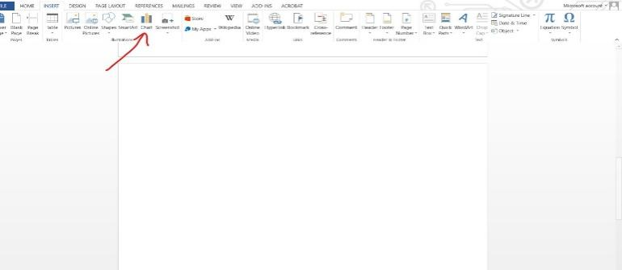
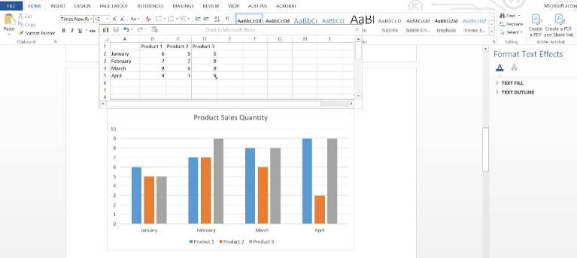
Conclusion

Following these six simple steps, now you can create a good quality chart in a Microsoft Word document.

