Part 2
Table of Contents
Part Two
Application for ethical approval………………………………………………………………………..2
Letter to parents…………………………………………………………………………………………..14
Consent Form for the parents………………………………………………………………………… 15
Consent Form for School………………………………………………………………………………..16
Questionnaire
Pupils………………………………………………………………………………………………17
Interview Questions
Pupils’ Questions…………………………………………………………………………………19
Staff Questions…………………………………………………………………………………...20

APPLICATION FOR ETHICAL APPROVAL

RESEARCH STUDENTS
This form is to be completed by the student within SIX months for full-time students and TWELVE months for part time students, after the commencement of the research degree or following progression to Part Two of your course.

Once complete, submit this form via the MyTSD Doctoral College Portal at (https://mytsd.uwtsd.ac.uk).

This document is also available in Welsh.

RESEARCH STAFF ONLY
All communications relating to this application during its processing must be in writing and emailed to pgresearch@uwtsd.ac.uk , with the title ‘Ethical Approval’ followed by your name.

STUDENTS ON UNDERGRADUATE OR TAUGHT MASTERS PROGRAMMES should submit this form (and receive the outcome) via systems explained to you by the supervisor/module leader.

In order for research to result in benefit and minimise risk of harm, it must be conducted ethically. A researcher may not be covered by the University’s insurance if ethical approval has not been obtained prior to commencement.

The University follows the OECD Frascati manual definition of research activity: “creative work undertaken on a systematic basis in order to increase the stock of knowledge, including knowledge of man, culture and society, and the use of this stock of knowledge to devise new applications”. As such this covers activities undertaken by members of staff, postgraduate research students, and both taught postgraduate and undergraduate students working on dissertations/projects.

The individual undertaking the research activity is known as the “principal researcher”.

Ethical approval is not required for routine audits, performance reviews, quality assurance studies, testing within normal educational requirements, and literary or artistic criticism.

Please read the notes for guidance before completing ALL sections of the form.

This form must be completed and approved prior to undertaking any research activity. Please see Checklist for details of process for different categories of application.

SECTION A: About You (Principal Researcher)
1 | Full Name: |  | Lucy Angharad Evans
2 | Tick all boxes that apply: |  | Member of staff: | ☐ | Honorary research fellow: | ☐
 | Undergraduate Student | ☒ | Taught Postgraduate Student | ☐ | Postgraduate Research Student | ☐

3 | Institute/Academic Discipline/Centre: | Initial Teacher Education, Yr Athrofa
4 | Campus: | Carmarthen Campus
5 | E-mail address: | 2000871@student.uwtsd.ac.uk
6 | Contact Telephone Number: | 07980 895066
 | For students:
7 | Student Number: | 2000871
8 | Programme of Study: | BA (Hons) Primary Education with QTS (BA3)
9 | Director of Studies/Supervisor: | Julia Holloway

SECTION B: Approval for Research Activity
1 | Has the research activity received approval in principle?  (please check the Guidance Notes as to the appropriate approval process for different levels of research by different categories of individual) |  | YES | ☒ | NO | ☐
 |  |  |  |  | Date
2 | If Yes, please indicate source of approval (and date where known): Approval in principle must be obtained from the relevant source prior to seeking ethical approval | Research Degrees Committee |  | ☒ | 16.11.2023
2 |  | Institute Research Committee |  | ☐
2 |  | Other (write in) |  | ☒ | Jo Bamsey (Lecturer) 16.11.23

SECTION C: Internal and External Ethical Guidance Materials
 | Please list the core ethical guidance documents that have been referred to during the completion of this form (including any discipline-specific codes of research ethics, location-specific codes of research ethics, and also any specific ethical guidance relating to the proposed methodology). Please tick to confirm that your research proposal adheres to these codes and guidelines. You may add rows to this table if needed.
1 | UWTSD Research Ethics & Integrity Code of Practice | ☒
2 | UWTSD Research Data Management Policy | ☒
3 | BERA (2018)  GDPR (2018) | ☒

SECTION D: External Collaborative Research Activity
If there are external collaborators then you should gain consent from the contact persons to share their personal data with the university. If there are no external collaborators then leave this section blank and continue to section E.
1 | Institution
2 | Contact person name
3 | Contact person e-mail address
4 | Is your research externally funded? |  | YES | ☐ | NO |  | ☒
5 | Are you in receipt of a KESS scholarship? |  | YES | ☐ | NO |  | ☒
6 | Are you specifically employed to undertake this research in either a paid or voluntary capacity? | Voluntary | YES | ☐ | NO | ☒
7 |  | Employed | YES | ☐ | NO | ☒
8 | Is the research being undertaken within an existing UWTSD Athrofa Professional Learning Partnership (APLP)? | If YES then the permission question below does not need to be answered. | YES | ☐ | NO |  | ☒
9 | Has permission to undertake the research has been provided by the partner organisation? | (If YES attach copy)  If NO the application cannot continue | YES | ☐ | NO |  | ☒

Where research activity is carried out in collaboration with an external organisation
10 | Does this organisation have its own ethics approval system? | YES | ☐ | NO | ☒
 | If Yes, please attach a copy of any final approval (or interim approval) from the organisation (this may be a copy of an email if appropriate).

SECTION E: Details of Research Activity
1 | Indicative title: | How do pupils and staff in year 5 perceive parental engagement in school and learning?
2 | Proposed start date: | 27th November 2023 | Proposed end date: | 1st December 2023
Introduction to the Research (maximum 300 words per section)
Ensure that you write for a Non-Specialist Audience when outlining your response to the points below:
- Purpose of Research Activity
- Proposed Research Question
- Aims of Research Activity
- Objectives of Research Activity
Demonstrate, briefly, how Existing Research has informed the proposed activity and explain
- What the research activity will add to the body of knowledge
- How it addresses an area of importance.
3 | Purpose of Research Activity  The goal of this research assignment is to obtain a better grasp of the value of parental engagement and to broaden my understanding of how beneficial this method is for Year five pupils.  - Investigate how parental involvement is encouraged in a KS2 classroom.  - To put various research instruments to the test in the field.  - To get a better knowledge of research concepts.  - To learn about the beliefs and reasonings underlying the encouragement of parental involvement in school.  - Determine how parental involvement influences learning in the classroom.  - To gain a better understanding of how pupils and staff perceive parental involvement by paying close attention to feedback.  The value of investigating parental engagement is widely recognised and endorsed by many professionals in education, psychology, sociology, and child development, which is why I feel it is vital to explore. My interest in parental participation has been piqued by the research of Lev Vygosky, Joyce Epstein, and Karen Mapp, and each theory will be explored during my project with a link to this form.
4 | Research Question  “How do pupils and staff in year 5 perceive parental engagement in school and learning?”
5 | Aims of Research Activity  - To explore pupils’ and teachers’ perceptions on parental engagement  - To critically evaluate different research tools  - To personally develop a more in-depth knowledge of the benefits of parental engagement.  - To improve my own professional and future practice  - To understand how children can be influenced by their parents during school.  - To consider and utilise the ethical principles behind research.  - To conduct and utilise research methodology in future practice.
6 | Objectives of Research Activity  - To gain a full understanding on the perceptions that pupils and teachers have on parental engagement in school being used as an aid to learn.  - To encourage all teachers and pupils to complete the questionnaire.  - To complete a whole class interview to capture their views on parental engagement and the benefits this has to pupil development.  - To complete a whole class interview to determine if perceptions change when children are being interviewed individually.  - To reflect critically on the process of both interviews and questionnaires utilised for collecting data.
Proposed methods (maximum 600 words)
Provide a brief summary of all the methods that may be used in the research activity, making it clear what specific techniques may be used. If methods other than those listed in this section are deemed appropriate later, additional ethical approval for those methods will be needed. You do not need to justify the methods here but should instead describe how you intend to collect the data necessary for you to complete your project.
7 | Staff members within the class will be interviewed and invited to respond to key questions, such as:  - What is the purpose of parental engagement as an aid to learning?  - what methods do you use to communicate with parents? For example, online platforms such as google classroom etc?  - what do you find are the positives in involving parents for learning?  - what do you believe are the negatives towards involving parents with learning?  - How do you think parents influence children in relation to the Four Purposes and the Curriculum for Wales?  - In relation to collaborative working, how do you find parental engagement linking from school to the children’s home?  Then, an interview will be conducted within the classroom in an informal setting, where one by one I will interview the staff in the class to gather their opinion on parental engagement. I will be taking notes of all responses to help broaden my own knowledge whilst deciphering the difference between the opinions of both teachers. Checking in on the teachers every so often will assert their comfortability with asking the questions, and if they are not happy to proceed with the process, the interview will be stopped instantly.  Secondly, all pupils will be involved in an interview at the end of the session, the interview technique will differ slightly as I will ask questions and encourage children to have an open discussion with myself whilst sitting at their own tables, to write down their answers as a group to promote collaborative discussion. Each table will have their own paper in which they do not need to take note of their names for confidentiality purposes. The use of the term “people that look after you” will be asked as each child’s home lives are different. The questions will be:  - How do your parents/ people that look after you help you outside of school? For example, do they help you with homework, do they ask you questions about the school day?  - How do your parents/ people who look after you communicate with your teachers?  - Why do you think it is important that your parents/ people that look after you help you with your schoolwork?  - Does your parents/ people that look after you ask you about the school day?  - What is your favourite part of your parents/ people that look after you helping you with your schoolwork?  In relation to the interview, all pupils who have received consent from their parents will complete a questionnaire using Microsoft Forms to complete the research further. The link will be shared for the pupils on the Monday morning, to allow them to familiarise themselves with the questions. The questions will not require names for this data and the questions will be completed individually with support if required. Again, the use of the term “people that look after you” will be asked as each child’s home lives are different. The questions asked will be:  - What do you like about your parents/ people that look after you helping you with your schoolwork?  - Do you feel like your parents/ people that look after you can talk to your teachers about anything? For example, if you need help, can they easily ask your teachers questions?  - Do you know how your parents/ people that look after you communicate with your parents? Do you use anything online?  - What do you enjoy about your parents/ people that look after you helping you with schoolwork?  - Do you feel comfortable talking to your parents/ people that look after you about things that happen in school?  - Why do you think it is important your parents/ people that look after you communicate with your teachers?  - What are important things your parents/ people that look after you help you with outside of school?  - Can your parents/ people that look after you see any achievements/ awards you receive in school?  - Do your parents/ people that look after you like hearing about things you do in school? Does this help you at home?  - If you have an issue with school, can your parents/ people that look after you talk to your teachers easily?
Location of research activity
Identify all locations where research activity will take place.
8 | - The school mentioned will be named School A.  - The school is a small school in an urban area.  - It is an English medium primary.  - The class taking part in the research consists of 31 pupils, aged between 9 and 10.  - The school has 479 pupils enrolled and attendance record of 95.2%.
Research activity outside of the UK
If research activity will take place overseas, you are responsible for ensuring that local ethical considerations are complied with and that the relevant permissions are sought. Specify any local guidelines (e.g. from local professional associations/learned societies/universities) that exist and whether these involve any ethical stipulations beyond those usual in the UK (provide details of any licenses or permissions required). Also specify whether there are any specific ethical issues raised by the local context in which the research activity is taking place, for example, particular cultural and/or legal sensitivities or vulnerabilities of participants. If you live in the country where you will do the research then please state this.
9 | N/A

10 | Use of documentation not in the public domain: Are any documents NOT publicly available? | NO | ☒
10 |  | YES | ☐
11 | If Yes, please provide details here of how you will gain access to specific documentation that is not in the public domain and that this is in accordance with the current data protection law of the country in question and that of England and Wales.

 | Does your research relate to one or more of the seven aims of the Well-being of Future Generations (Wales) Act 2015? | YES | NO
12 | A prosperous Wales | ☐ | ☒
13 | A resilient Wales | ☐ | ☒
14 | A healthier Wales | ☐ | ☒
15 | A more equal Wales | ☐ | ☒
16 | A Wales of cohesive communities | ☐ | ☒
17 | A Wales of vibrant culture and thriving Welsh language | ☐ | ☒
18 | A globally responsible Wales | ☐ | ☒
19 | If YES to any of the above, please give details:

SECTION F: Scope of Research Activity
 | Will the research activity include: | YES | NO
1 | Use of a questionnaire or similar research instrument? | ☒ | ☐
2 | Use of interviews? | ☒ | ☐
3 | Use of focus groups? | ☒ | ☐
4 | Use of participant diaries? | ☐ | ☒
5 | Use of video or audio recording? | ☐ | ☒
6 | Use of computer-generated log files? | ☒ | ☐
7 | Participant observation with their knowledge? | ☒ | ☐
8 | Participant observation without their knowledge? | ☐ | ☒
9 | Access to personal or confidential information without the participants’ specific consent? | ☐ | ☒
10 | Administration of any questions, test stimuli, presentation that may be experienced as physically, mentally or emotionally harmful / offensive? | ☐ | ☒
11 | Performance of any acts which may cause embarrassment or affect self-esteem? | ☐ | ☒
12 | Investigation of participants involved in illegal activities? | ☐ | ☒
13 | Use of procedures that involve deception? | ☐ | ☒
14 | Administration of any substance, agent or placebo? | ☐ | ☒
15 | Working with live vertebrate animals? | ☐ | ☒
16 | Procedures that may have a negative impact on the environment? | ☐ | ☒
17 | Other primary data collection methods. Please indicate the type of data collection method(s) below. | ☐ | ☒
 | Details of any other primary data collection method: | ☐ | ☒
If NO to every question, then the research activity is (ethically) low risk and may be exempt from some of the following sections (please refer to Guidance Notes).

If YES to any question, then no research activity should be undertaken until full ethical approval has been obtained.

SECTION G: Intended Participants
If there are no participants then do not complete this section, but go directly to section H.

 | Who are the intended participants: | YES | NO
1 | Students or staff at the University? | ☒ | ☐
2 | Adults (over the age of 18 and competent to give consent)? | ☒ | ☐
3 | Vulnerable adults? | ☐ | ☒
4 | Children and Young People under the age of 18? (Consent from Parent, Carer or Guardian will be required) | ☒ | ☐
5 | Prisoners? | ☐ | ☒
6 | Young offenders? | ☐ | ☒
7 | Those who could be considered to have a particularly dependent relationship with the investigator or a gatekeeper? | ☐ | ☒
8 | People engaged in illegal activities? | ☐ | ☒
9 | Others. Please indicate the participants below, and specifically any group who may be unable to give consent. | ☐ | ☒
 | Details of any other participant groups: | ☐ | ☒

Participant numbers and source
Provide an estimate of the expected number of participants. How will you identify participants and how will they be recruited?
10 | How many participants are expected? | - 31 Pupils: For the interviews, they will be asked questions in group of sixes, and for the questionnaires, one pupil will be interviewed at a time.  - 1 Class Teacher: The class teacher will be interview with myself in a non-formal setting.  - 1 Learning Support Assistant (LSA): The LSA will be interview with myself in a non-formal setting.  Total: 33 Participants
11 | Who will the participants be? | As stated above
12 | How will you identify the participants? | - The class teacher will be known as “class teacher”  - The LSA will be known as “LSA”  - When I describe and discuss a pupil’s answer, they will be labelled alphabetically. For example, “Pupil A”, “Pupil B” or “Pupil C”.

 | Information for participants: | YES | NO | N/A
13 | Will you describe the main research procedures to participants in advance, so that they are informed about what to expect? | ☒ | ☐ | ☐
14 | Will you tell participants that their participation is voluntary? | ☒ | ☐ | ☐
15 | Will you obtain written consent for participation? | ☒ | ☐ | ☐
16 | Will you explain to participants that refusal to participate in the research will not affect their treatment or education (if relevant)? | ☒ | ☐ | ☐
17 | If the research is observational, will you ask participants for their consent to being observed? | ☒ | ☐ | ☐
18 | Will you tell participants that they may withdraw from the research at any time and for any reason? | ☒ | ☐ | ☐
19 | With questionnaires, will you give participants the option of omitting questions they do not want to answer? | ☒ | ☐ | ☐
20 | Will you tell participants that their data will be treated with full confidentiality and that, if published, it will not be identifiable as theirs? | ☒ | ☐ | ☐
21 | Will you debrief participants at the end of their participation, in a way appropriate to the type of research undertaken? | ☒ | ☐ | ☐
22 | If NO to any of above questions, please give an explanation

 | Information for participants: | YES | NO | N/A
24 | Will participants be paid? | ☐ | ☒ | ☐
25 | Is specialist electrical or other equipment to be used with participants? | ☐ | ☒ | ☐
26 | Are there any financial or other interests to the investigator or University arising from this study? | ☐ | ☒ | ☐
27 | Will the research activity involve deliberately misleading participants in any way, or the partial or full concealment of the specific study aims? | ☐ | ☒ | ☐
28 | If YES to any question, please provide full details

SECTION H: Anticipated Risks

Outline any anticipated risks that may adversely affect any of the participants, the researchers and/or the University, and the steps that will be taken to address them.

If you have completed a full risk assessment (for example as required by a laboratory, or external research collaborator) you may append that to this form.
1 | Full risk assessment completed and appended? |  | Yes | ☒
1 |  |  | No | ☐
2 | Risks to participants  For example: sector-specific health & safety, emotional distress, financial disclosure, physical harm, transfer of personal data, sensitive organisational information
 | Risk to participants:  - Sensitive material: as the research is based upon parents, it may trigger some pupils and teachers with regard to complex home lives. | How you will mitigate the risk to participants:  - I will assure that all participants are asked beforehand if they would still like to proceed with the research after I give a brief description of what I will be asking, if they do not want to continue, I will terminate the research process and I will take note that the interview has ended, and the particular interview will not be added to my assignment.
3 | If research activity may include sensitive, embarrassing or upsetting topics (e.g. sexual activity, drug use) or issues likely to disclose information requiring further action (e.g. criminal activity), give details of the procedures to deal with these issues, including any support/advice (e.g. helpline numbers) to be offered to participants. Note that where applicable, consent procedures should make it clear that if something potentially or actually illegal is discovered in the course of a project, it may need to be disclosed to the proper authorities
 | Participants may feel pressed to provide the proper answers to the following questions: Participants will be assured that there would be no repercussions for anything they say. I will state unequivocally that I expect open and honest responses. I will make it clear that the answers pupils provide will have no impact on their education, and there will be no consequences for their actions and responses in relation to the research.
4 | Risks to the investigator  For example: personal health & safety, physical harm, emotional distress, risk of accusation of harm/impropriety, conflict of interest
 | Risk to the investigator:  - Risk of accusation of fabrication or falsification of data. | How you will mitigate the risk to the investigator:  - When performing primary research at a school, I shall adhere to the UWTSD and BERA ethical principles.
5 | University/institutional risks  For example: adverse publicity, financial loss, data protection
 | Risk to the University:  - Misleading behaviour in a way that could impact the relationship between school and University | How you will mitigate the risk to the University:  - I will always behave in a professional manner. I will also receive my data on a password protected file and all data will be confidential and anonymous to protect each participant.
6 | Environmental risks  For example: accidental spillage of pollutants, damage to local ecosystems
 | Risk to the environment:  - The children may feel they are not in a comfortable or safe place, in somewhere they feel they cannot respond to the research techniques to the best of their abilities. | How you will mitigate the risk to environment:  - I will conduct my interviews in somewhere I know the pupils will be comfortable, e.g. sitting amongst their friends on their tables for the focus groups, in a spare classroom for the questionnaire process or in the corridor where the teacher has placed a small table for when they need assistance for conducting their answers.

 | Disclosure and Barring Service
 | If the research activity involves children or vulnerable adults, a Disclosure and Barring Service (DBS) certificate must be obtained before any contact with such participants. | YES | NO | N/A
7 | Does your research require you to hold a current DBS Certificate? | ☒ | ☐ | ☐
8 | If YES, please give the certificate number. If the certificate number is not available please write “Pending”; in this case any ethical approval will be subject to providing the appropriate certificate number. | 001779581243

SECTION I: Feedback, Consent and Confidentiality

1 | Feedback  What de-briefing and feedback will be provided to participants, how will this be done and when?
 | N/A
2 | Informed consent  Describe the arrangements to inform potential participants, before providing consent, of what is involved in participating. Describe the arrangements for participants to provide full consent before data collection begins. If gaining consent in this way is inappropriate, explain how consent will be obtained and recorded in accordance with prevailing data protection legislation.
 | - I will speak with my module leader and professional tutor to notify them of the research I will be conducting, as well as the cause and reasoning for the study. However, I will ask the designated head-teacher/teacher whether they prefer to participate vocally. I will also request their continuing consent throughout the research.
3 | Confidentiality / Anonymity  Set out how anonymity of participants and confidentiality will be ensured in any outputs. If anonymity is not being offered, explain why this is the case.
 | There will be no names recorded. I will not reveal identities, and I will make certain that no individual data (raw scores, individually identifiable performance results, etc.) is made accessible to schools/parents, etc. Only analysed and anonymised data will be shared with third parties.

SECTION J: Data Protection and Storage

 | Does the research activity involve personal data (as defined by the General Data Protection Regulation 2016 “GDPR” and the Data Protection Act 2018 “DPA”)? | YES | NO
1 | “Personal data” means any information relating to an identified or identifiable natural person (‘data subject’). An identifiable natural person is one who can be identified, directly or indirectly, in particular by reference to an identifier such as a name, an identification number, location data, an online identifier or to one or more factors specific to the physical, physiological, genetic, mental, economic, cultural or social identity of that natural person. Any video or audio recordings of participants is considered to be personal data. |  | X
 | If YES, provide a description of the data and explain why this data needs to be collected:
2
 | Does it involve special category data (as defined by the GDPR)? | YES | NO
3 | “Special category data” means sensitive personal data consisting of information as to the data subjects’ –  (a) racial or ethnic origin,  (b) political opinions,  (c ) religious beliefs or other beliefs of a similar nature,  (d) membership of a trade union (within the meaning of the Trade Union and Labour Relations (Consolidation) Act 1992),  (e) physical or mental health or condition,  (f) sexual life,  (g) genetics,  (h) biometric data (as used for ID purposes), |  | X
 | If YES, provide a description of the special category data and explain why this data needs to be collected:
4

 | Will data from the research activity (collected data, drafts of the thesis, or materials for publication) be stored in any of the following ways? | YES | NO
5 | Manual files (i.e. in paper form)? | ☐ | ☒
6 | University computers? | ☐ | ☒
7 | Private company computers? | ☐ | ☒
8 | Home or other personal computers? | ☐ | ☒
9 | Laptop computers/ CDs/ Portable disk-drives/ memory sticks? | ☒ | ☐
10 | “Cloud” storage or websites? | ☐ | ☒
11 | Other – specify: | ☐ | ☒
12 | For all stored data, explain the measures in place to ensure the security of the data collected, data confidentiality, including details of backup procedures, password protection, encryption, anonymisation and pseudonymisation:

 | Data Protection
 | Will the research activity involve any of the following activities: | YES | NO
13 | Electronic transfer of data in any form? | ☐ | ☒
14 | Sharing of data with others at the University outside of the immediate research team? | ☐ | ☒
15 | Sharing of data with other organisations? | ☐ | ☒
16 | Export of data outside the UK or importing of data from outside the UK? | ☐ | ☒
17 | Use of personal addresses, postcodes, faxes, emails or telephone numbers? | ☐ | ☒
18 | Publication of data that might allow identification of individuals? | ☐ | ☒
19 | Use of data management system? | ☐ | ☒
20 | Data archiving? | ☐ | ☒
21 | If YES to any question, please provide full details, explaining how this will be conducted in accordance with the GDPR and Data Protection Act (2018) (and any international equivalents, where appropriate):
22 | List all who will have access to the data generated by the research activity:
- Myself
- Lecturers who will be grading my assignment.
23 | List who will have control of, and act as custodian(s) for, data generated by the research activity:
24 | Give details of data storage arrangements, including security measures in place to protect the data, where data will be stored, how long for, and in what form. Will data be archived – if so how and if not why not.
25 | Please indicate if your data will be stored in the UWTSD Research Data Repository (see https://researchdata.uwtsd.ac.uk/ ). If so please explain. (Most relevant to academic staff)
26 | Confirm that you have read the UWTSD guidance on data management (see https://www.uwtsd.ac.uk/library/research-data-management/) | YES | ☒
27 | Confirm that you are aware that you need to keep all data until after your research has completed or the end of your funding | YES | ☒

SECTION K: Declaration
The information which I have provided is correct and complete to the best of my knowledge. I have attempted to identify any risks and issues related to the research activity and acknowledge my obligations and the rights of the participants.

In submitting this application I hereby confirm that I undertake to ensure that the above named research activity will meet the University’s Research Ethics and Integrity Code of Practice which is published on the website: https://www.uwtsd.ac.uk/research/research-ethics/
1 | Signature of applicant: |  | Date: 20.11.2023

For STUDENT Submissions:
2 | Director of Studies/Supervisor: | Jo Bamsey | Date: 20.11.23
3 | Signature: |  | Date: 20.11.23

For STAFF Submissions:
4 | Academic Director/ Assistant Dean: |  | Date:
5 | Signature: |  | Date:

Checklist: Please complete the checklist below to ensure that you have completed the form according to the guidelines and attached any required documentation:
☒ | I have read the guidance notes supplied before completing the form.
☒ | I have completed ALL RELEVANT sections of the form in full.
☒ | I confirm that the research activity has received approval in principle
☒ | I have attached a copy of final/interim approval from external organisation (where appropriate)
☒ | I have attached a full risk assessment (where appropriate) ONLY TICK IF YOU HAVE ATTACHED A FULL RISK ASSESSMENT
☒ | I understand that it is my responsibility to ensure that the above-named research activity will meet the University’s Research Ethics and Integrity Code of Practice.
☒ | I understand that before commencing data collection all documents aimed at respondents (including information sheets, consent forms, questionnaires, interview schedules etc.) must be confirmed by the DoS/Supervisor, module tutor or Academic Director.

RESEARCH STUDENTS ONLY
Once complete, submit this form via the MyTSD Doctoral College Portal at (https://mytsd.uwtsd.ac.uk).

RESEARCH STAFF ONLY
All communications relating to this application during its processing must be in writing and emailed to pgresearch@uwtsd.ac.uk , with the title ‘Ethical Approval’ followed by your name.

STUDENTS ON UNDERGRADUATE OR TAUGHT MASTERS PROGRAMMES should submit this form (and receive the outcome) via systems explained to you by the supervisor/module leader.

Letter to Parents

Dear Parent / Guardian,

My name is Lucy Evans, and I am studying for a BAEd qualification at Yr Athrofa, University of Wales Trinity Saint David. I am currently a student teacher within …………… School and am teaching in your child’s class.

I would like to invite your child to participate in my research project. The title of the project is “How do pupils and staff in year 5 perceive parental engagement in school and learning?” and I aim to explore pupils’ and teachers’ perceptions on parental engagement. Through your child’s participation, I hope to ascertain and develop a more in-depth knowledge of the benefits of parental engagement.

All pupils who receive consent to be involved in an interview, the interview technique will differ slightly as I will ask questions and encourage children to have an open discussion with myself whilst sitting at their own tables, to write down their answers as a group to promote collaborative discussion. In relation to the interview, all pupils who have received consent from their parents will complete a questionnaire using Microsoft Forms to complete the research further. The link will be shared for the pupils on the Monday morning, to allow them to familiarise themselves with the questions. The questions will not require names for this data and the questions will be completed individually with support if required.

All names will be kept strictly confidential and will only be known by myself and my research partner. Your child’s participation in this study is completely voluntary so you or your child can withdraw from the study at any stage. Your child will also be asked to give their assent before the beginning of the study.

After careful and precise analysis of the data obtained from the lesson observation and group interview, I would be happy to provide you with a copy of the findings at your request. The results of the research will be discussed in a university assignment that will contribute to my BA (Hons) course. The results of this study will be stored on OneDrive, which only I have access to, and all raw data will be destroyed once the assessment has been marked.

I thank you in advance for your time. If any questions do arise, feel free to contact me at your convenience.

Yours sincerely,

Lucy Evans


27th November 2023


Consent form for Parents


Name of Researcher: Lucy Evans (2000871).

Please initial box

- I confirm that I have read and understand the information sheet dated 27th November 2023 for the above study.

- I understand that my child’s participation is voluntary and that I am free to withdraw my child from the study at any time, without giving any reason.

- I understand that my child can choose to withdraw at any time, without giving a reason.

- I understand that the information given by my child will be used in a university assignment.

- I understand that my child’s name will not appear at any time.

- I agree for my child to take part in the above study.

_____________________ _____________________________ __________
Child’s name Parent signature Date

Consent Form for School

To the headteacher and class teacher of Year Five at ………………..,

To the headteacher and Year Five class teacher at Johnstown Primary School,

My name is Lucy Evans, and I am a BAEd student at Yr Athrofa, University of Wales Trinity Saint David. I am now a third-year student and a student teacher on the BA Primary Education with QTS degree.

The visit's objective is to test research tools using parental engagement as a theme as part of the ECAD6010 research module (see Attachment).

During the day, I will need to do a brief interview with staff and students in your class and provide an online questionnaire to them.

The entire day has been spent to testing the research tools so that you, as a school, may choose convenient times for me to distribute the questionnaires and perform the interviews. If you like, I may provide you the link to the online questionnaire ahead of time.

In the meanwhile, I hope to meet you during the elective school period.

Yours sincerely,

Lucy Evans.

(Please circle) I give / do not give consent for Lucy Evans to use Questionnaires and interviews with the learners for research as part of the ECAD6010 module with the University.

Signed …………………………………………

Questionnaire for Pupils
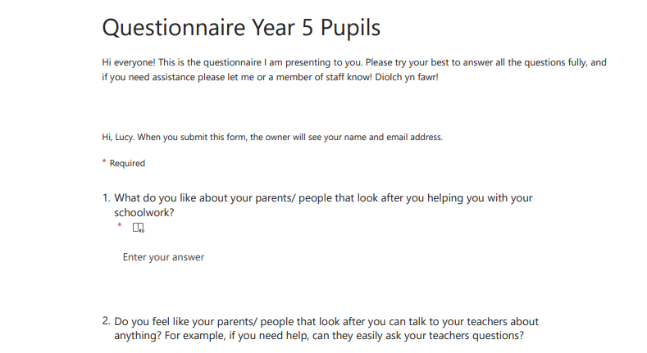
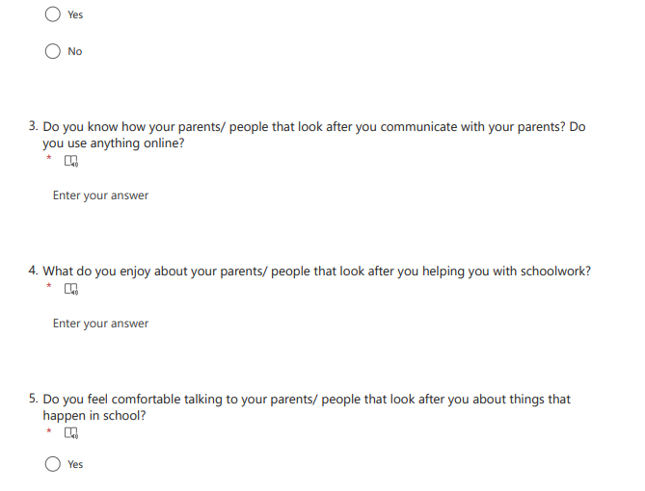
https://forms.office.com/Pages/ResponsePage.aspx?id=-REPTm4EBUWcuNshUjEeIf7PZM14xXNFjf7dMXV80tRUN1dYRFZCNUc1WU05NzFDSlFZQzNOOVQ1Vy4u

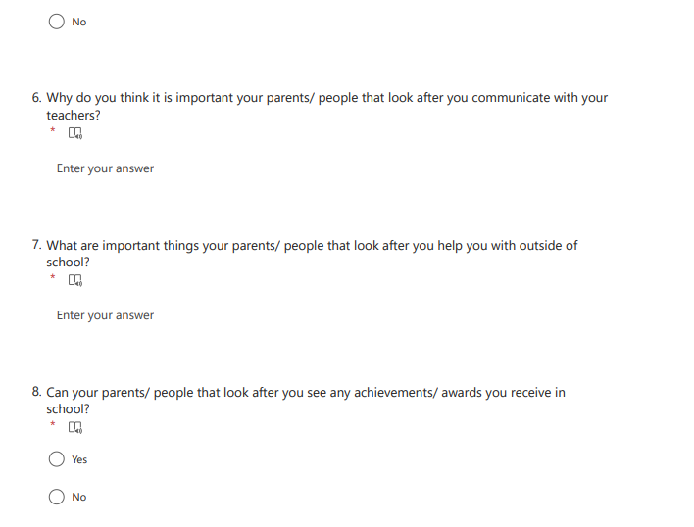
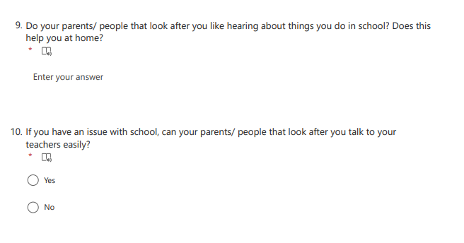

Interview Questions for Pupils
- How do your parents/ people that look after you help you outside of school? For example, do they help you with homework, do they ask you questions about the school day?
- How do your parents/ people who look after you communicate with your teachers?
- Why do you think it is important that your parents/ people that look after you help you with your schoolwork?
- Does your parents/ people that look after you ask you about the school day?
- What is your favourite part of your parents/ people that look after you helping you with your schoolwork?

Interview Questions for Staff
- What is the purpose of parental engagement as an aid to learning?
- what methods do you use to communicate with parents? For example, online platforms such as google classroom etc?
- what do you find are the positives in involving parents for learning?
- what do you believe are the negatives towards involving parents with learning?
- How do you think parents influence children in relation to the Four Purposes and the Curriculum for Wales?
- In relation to collaborative working, how do you find parental engagement linking from school to the children’s home?

