Module name: Financial Management for the Hotel Industry
Module code: BMIH5007
Lecturer`s name: Tristan Hawkins
Submission date: 29th February 2024
Wordcount: 2194
Report Case Study:
The Seacrest Lodge

Elena Luca
Student number: 2206171

Executive Summary

The Seacrest Lodge has been a popular destination among tourists seeking relaxation and luxury. In recent years the lodge has experienced a decline in revenue, occupancy rates, and customer satisfaction.
The coastal tourism market in the United Kingdom is continuously evolving, and tourists are looking for authentic experiences and hotels. The Seacrest Lodge experiences a decline in customer loyalty due to outdated amenities and declining service quality and this can be seen in the guest`s feedback as well.
By measuring the financial performance for the last three years, 2021, 2022, and 2023, a declining gross profit margin and a declining net profit margin have been noticed and this shows issues that need to be solved.
The key reasons behind the decline in profitability for The Seacrest Lodge are rising operational costs, declining revenue, seasonality and market conditions, and competitive pressures.
To revitalize the lodge`s financial health a turnaround strategy is needed and as strategies were listed: to conduct a comprehensive business assessment, enhance operational efficiency, revamp marketing and branding, improve guests' experience, diversify revenue streams, implement cost control measures, enhance online presence and booking experience and monitor performance and adjust strategies (created by the author).

Content Table

Executive Summary …………………………………………….….………………………...…. p. 1
1. Introduction ………………………………………………………………...….….…...... p. 3
2. Main Body ……………………………………………………………………….…….… p. 3
2.1. Market Analysis…………………………………….……………………………...….…. p. 3
2.2. Scope and Objectives………………………………………………………….……...... p. 5
2.2.1. Analyse the Seacrest Lodge's financial performance over the past three years.... p. 5
2.2.2. Identify the key reasons behind the decline in profitability………………………….. p. 7
2.2.3. A comprehensive turnaround strategy to revitalize the lodge's financial health and restore its reputation as a premier vacation destination…………………………….………. p. 9
3. Conclusions ………………………………………………….………………….……… p. 11
4. Recommendations …………………………………………………………………..… p. 11
5. References ……………………………………………………………………..………. p. 12
6. Appendices ……………………………………….……………………………………. p. 14

- Introduction
The Seacrest Lodge, positioned along a beautiful coastline, has long been a popular destination for vacationers seeking relaxation and luxury. With its restaurant, bar, and event facilities, the resort has offered a unique experience for the guests. However, in recent years, the Seacrest Lodge has experienced a decline in revenue, occupancy rates, and customer satisfaction. To salvage the business and ensure its future success, a turnaround strategy must be implemented. This report will explore potential solutions to revitalize the Seacrest Lodge and restore it to its former glory (created by the author).

- Main Body
  - Market Analysis
The coastal tourism market in the United Kingdom is undergoing continuous evolution, driven by changing consumer preferences, technological advancements, and sustainability concerns. As tourists seek authentic experiences, digital connectivity, and eco-friendly options, coastal destinations are adapting to meet these evolving demands (OECD iLibrary, 2022).
One good example of an adapting hotel is Budock Vean Hotel. Situated on the banks of Helford River in Falmouth, Budock Vean Hotel is a hidden gem that offers a luxurious retreat for those seeking a peaceful and tranquil escape. One of the standout features that make this hotel one of the bigger competitors of Seacrest Lode is its award-winning spa, which offers a range of indulgent treatments and therapies designed to help guests relax and rejuvenate. In addition to its spa, Budock Vean Hotel also offers a range of activities and facilities to keep guests entertained during their stay. From golf and tennis to kayaking and hiking, there is something for everyone to enjoy. The hotel also boasts a renowned restaurant that serves delicious and innovative cuisine made from locally sourced ingredients, ensuring that guests enjoy a truly memorable dining experience (Budock Vean, 2024).
In recent times, there has been a noticeable shift in the way travelers approach their vacation choices, moving away from traditional offerings towards more experiential and personalized options. One of the key drivers of the shift in customer preferences is the growing demand for experiential travel. Modern guests are increasingly seeking unique and immersive experiences that allow them to connect with the local culture and environment. This led to a rise in adventure tourism, eco-tourism, and cultural tourism, with people looking for authentic and meaningful experiences that go beyond traditional tourist attractions (LinkedIn, 2023). Another important factor influencing customer preferences is the desire for personalized and tailor-made experiences. Travelers today are looking for customized itineraries that cater to their specific interests and preferences. This has led to the rise of boutique hotels, personalized tours, and curated experiences that allow people to design their own travel experiences (Deputy, 2019). The shift towards sustainable tourism practices has also had a significant impact on customer preferences. Customers are increasingly conscious of the environmental and social impact of their travel choices and are seeking destinations and businesses that prioritize sustainability and responsible tourism practices. This has led to a rise in eco-friendly accommodation, carbon-neutral travel options, and community-based tourism initiatives that support local communities and protect the environment. A study made by the National Coastal Tourism Academy, in 2022 shows that 78% of the people visiting England`s Coast think is very important to reduce their carbon footprint and they are making more sustainable choices on holiday (See appendix 1).
Customer reviews are a valuable source of information for businesses to gauge customer satisfaction levels and identify areas of improvement. However, a common theme that has emerged from customer feedback is the indication of declining service quality and outdated amenities for The Seacrest Lodge. One of the main reasons behind declining service quality and outdated amenities is the lack of investment in staff training and interior upgrades. Businesses that fail to prioritize these aspects often struggle to meet the evolving needs and expectations of their customers (Sterns, 2023). Another contributing factor to declining service quality is the lack of employee engagement and motivation. When employees are not properly trained, supported, or incentivized, they may become disengaged and provide low service to customers. This can result in negative reviews highlighting issues such as slow service or unprofessionalism. Furthermore, the rise of online review platforms has made it easier for customers to share their experiences and opinions with a wider audience. This increased transparency has put pressure on businesses to maintain high service standards and address any shortcomings promptly. Failure to do so can lead as seen in The Seacrest Lodge case to a decline in customer loyalty and negative publicity, ultimately impacting the business`s bottom line (Tomic, Tesic, Kuzmanovic, and Tomic, 2018, p. 829).
  - Scope and Objectives.
    - Analyse the Seacrest Lodge's financial performance over the past three years.
Measuring financial performance is a critical aspect of evaluating the health and success of The Seacrest Lodge. It involves assessing various financial metrics and ratios to determine how well the company is performing in terms of revenue generation, profitability, efficiency, and liquidity.
For a better understanding of The Seacrest Lodge's performance over the past three years is important to conduct a financial statement analysis. This process includes investigating two of the financial statements in a business (created by the author).
The first statement is the Balance Sheet, analysed to determine the operational efficiency of a business.
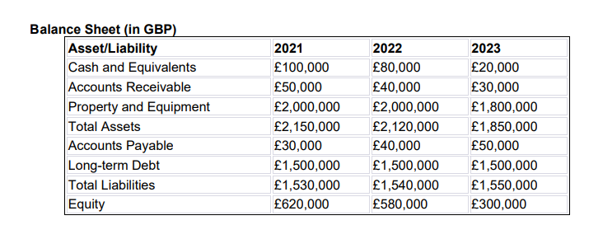
The second statement is the Income Statement, which is investigated to determine overall present and future profitability.
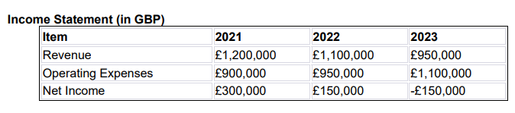
One of the primary reasons for measuring financial performance is to assess the profitability of the business. Profitability ratios such as gross profit margin, and net profit margin, provide insights into how effectively the hotel is generating profits from its operations.
Gross profit margin shows the remaining amount of revenue left after deducting the cost of sales (Corporate Finance Institute, 2024).
Year 2021
$\frac{(Revenue-Operating Expenses)}{Revenue}$ $x$ 100 = $\frac{\left(1,200,000-£900,000\right)}{1,200,000} x 100=99, 925$
Year 2022
$\frac{(Revenue-Operating Expenses)}{Revenue}$ x 100 = $\frac{\left(1,100,000-£950,000\right)}{1,100,000} x 100=13,637$
Year 2023
$\frac{(Revenue-Operating Expenses)}{Revenue}$ x 100 = $\frac{\left(950,000-£1,100,000\right)}{950,000} x 100=-15, 790$
Net profit margin shows the percentage of profit the company produces from its total revenue (Corporate Finance Institute, 2024).
Year 2021
$\frac{Net profit}{Revenue} x 100$= $\frac{300,000}{1,200,000}$ x 100 = 25 %
Year 2022
$\frac{Net profit}{Revenue} x 100$=$\frac{150,000}{1,100,00}x100=13,637 \%$
Year 2023
$\frac{Net profit}{Revenue}$ x 100= $\frac{-150,000}{950,000}x100= -15,79 \%$
As can be seen for the last three years has been a declining gross profit margin and a declining net profit margin and this is a signal of underlying issues that need to be solved to ensure the long-term sustainability of the business (created by the author).

Leverage
Equity multiplier, the leverage shows how much is being used to buy assets. If debts are used to purchase assets the leverage multiplier begins to increase (Corporate Finance Institute, 2024).
Year 2021
$\frac{Total Assets}{Total Equity}$= $\frac{2,150,000}{620,000}=3, 468$
Year 2022
$\frac{Total Assets}{Total Equity}= \frac{2,120,000}{580,000}=3,656$
Year 2023
$$\frac{Total Assets}{Total Equity}= \frac{1,850,000}{300,000}=6,167$$
Leverage, often measured as the debt-to-equity ratio, is an important indicator of a company`s capital structure and financial health. As seen above, for the last three years The Seacrest Lodge`s leverage was getting higher and a higher leverage ratio indicates that a business relies more on debt financing that equity, which can increase financial risk and impact the company`s ability to meet its financial obligations (Corporate Finance Institute, 2024).
    - Identify the key reasons behind the decline in profitability.
Profitability is a key metric that reflects a hotel`s ability to generate income and manage expenses effectively. A decline in profitability can stem from various internal and external factors that impact the hotel`s financial performance. Understanding the root causes of the decline in profitability is essential for The Seacrest Lodge to implement targeted strategies to improve financial results and ensure long-term success (Investopedia, 2024).
The key reasons behind the decline in profitability are:
Rising Operating Cost. One of the primary reasons behind the decline in profitability for The Seacrest Lodge is an increase in operating costs. As can be seen in the hotel`s income statement in 2021 the operating expenses were £900, 000, in 2022 were £950,000, and then in 2023 were £1,100,000. Rising costs of goods and services, labor expenses, utility bills, and maintenance costs put pressure on the hotel`s financial performance. Inflation, minimum wage increases, and regulatory changes can also contribute to higher operating expenses, reducing profitability (created by the author).
Declining revenue. A decrease in revenue significantly impacts The Seacrest Lodge`s profitability. Factors such as lower occupancy rates, reduced average daily rates (ADR), or a drop in demand due to economic downturns or competitive pressures lead to a decline in revenue. The Seacrest Lodge`s occupancy rate for 2021 was 65%, in 2022 was 60%, and in 2023 was 50% factor influenced the decline in revenue but also influenced the decline of average room rate (ARR) as this was lowered from £260 in 2021, to £240 in 2022 and in 2023 was lowered to £210 (created by the author).
Seasonality and Market Conditions. The seasonality of the hotel industry and fluctuations in market conditions had an impact in The Seacrest Lodge`s profitability. The hotel experience peak and off-peak seasons, with revenue and profitability varying throughout the year. Changes in tourist preferences, such as a growing interest in sustainable travel, unique experiences, and wellness offerings have influenced the profitability of The Seacrest Lodge. External factors such as Covid-19 had a huge impact as well on the Seacrest Lodge profitability. The hospitality sector was one of the most affected sectors because of the lockdowns and government restrictions and even if in 2021 the number of the tourist started to increase comparing to 2019 and 2020 it remained less than 70% of pre-pandemic levels (Office for National Statistics, 2021).
Competitive pressures. Intense competition in the hospitality industry can put pressure on the hotel`s profitability. The presence of new market entrants, online travel agencies, driving price competition, or the emergence of alternative accommodation options has impacted The Seacrest Lodge`s ability to maintain pricing power and profitability (created by the author)

    - A comprehensive turnaround strategy to revitalize the lodge's financial health and restore its reputation as a premier vacation destination.
Revitalising The Seacrest Lodge`s financial health and restoring its reputation as a premier vacation destination requires a comprehensive turnaround strategy that addresses various aspects of the business, from operations and marketing to guest experience and financial management (created by the author)
- Conduct a Comprehensive business assessment.
By conducting a thorough assessment of the hotel`s current financial situation, operational challenges, competitive landscape, and guest feedback can be identified the key areas of improvement and clear objectives can be set for the turnaround strategy.
- Enhance Operational Efficiency.
Streamline operations to improve efficiency and reduce costs. Evaluate staffing levels, implement training programs to enhance employee skills, and identify opportunities to increase productivity without compromising on service quality.
- Revamp Marketing and Branding.
Develop a targeted marketing strategy to showcase The Seacrest Lodge`s unique offerings and attract new guests. By using digital marketing channels, social media platforms, and partnerships with travel agencies the lodge can reach a wider audience. By enhancing its branding, the lodge can reflect its unique value proposition and position it as a premier vacation destination.
- Improve Guests Experience.
Focus on enhancing the guest experience to drive customer satisfaction and loyalty. Invest in staff training to deliver exceptional service, presonalised guest interaction, and create memorable experiences. By gathering feedback from the guests can be identified areas that needs improvement and changes can be implemented to meet the guests’ expectations.
- Diversify Revenue Streams.
Explore opportunities to diversify revenue streams and maximize income. By offering new services or amenities, partnering with local businesses for package deals, or expanding into niche markets to attract a broader range of guests and increase revenue.
- Implement Cost Control Measures.
Implement cost control measures to manage expenses and improve profitability. Evaluate suppliers’ contracts, negotiate for better pricing, invest in energy-efficient technologies to reduce utility costs, and identify areas where expenses can be reduced without compromising on quality.
- Enhance Online Presence and Booking Experience.
Optimize the lodge`s online presence, website, and booking process to make it easy for guests to discover and book accommodation. Utilise online booking platforms, showcase high-quality visuals, and provide transparent pricing and booking policies to enhance the overall guest experience and drive direct bookings.
- Monitor Performance and Adjust Strategies.
Regularly monitor key performance indicators, guest feedback, and financial metrics to track progress and make data-driven decisions. Continuously evaluate the effectiveness of the turnaround strategies, adjust its needs, and stay agile in responding to market dynamics and guest preferences (LinkedIn, 2024).

- Conclusions
In conclusion, The Seacrest Lodge can be salvaged through a comprehensive turnaround strategy that focuses on marketing, customer service, and facility improvements. By implementing these solutions, the resort can attract new customers, increase revenue, and ensure its future success. With dedication and hard work, The Seacrest Lodge can once again become a thriving destination for vacationers seeking relaxation and luxury (created by the author)
- Recommendations
Because The Seacrest Lodge financial health needs to be restored and a turnaround strategy was needed, as recommendations will be considered the same aspects from the turnaround strategy as by implementing these strategies and focusing on operational excellence, guests satisfaction, and revenue growth, The Seacrest Lodge can position itself for success, attract new guests, and regain its status as a top vacation destination in the competitive hospitality industry (created by the author).

- References:
Budock Vean (2024) Budock Vean the Hotel by the River. Available at: https://www.budockvean.co.uk/our-place/ (Accessed: 25 February 2024).
Corporate Finance Institute (2024) Financial Performance. Available at: https://corporatefinanceinstitute.com/resources/accounting/financial-performance/ (Accessed: 26 February 2024).
Corporate Finance Institute (2024) Net Profit Margin. Available at: https://corporatefinanceinstitute.com/resources/accounting/net-profit-margin-formula/ (Accessed: 26 February 2024).
Deputy (2019) 3 Ways Personalization is Changing the Hospitality Industry. Available at: https://www.deputy.com/blog/personalization-changing-hospitality-industry (Accessed: 25 February 2024).
Inestopedia (2024) Profitability Ratios: What They Are, Common Types, and How Businesses Use Them. Available at: https://www.investopedia.com/terms/p/profitabilityratios.asp (Accessed: 26 February 2024).
LinkedIn (2023) Experiential Travel: Embracing Authenticity and Meaningful Connections. Available at: https://www.linkedin.com/pulse/experiential-travel-embracing-authenticity-meaningful-connections-pc9fc/ (Accessed: 25 February 2024).
LinkedIn (2024) 10 key items to address in a business turnaround strategy. Available at: https://www.linkedin.com/pulse/10-key-items-address-business-turnaround-strategy-andre-draayer-lnk0c/ (Accessed: 28 February 2024).
National Coastal Tourism Academy (2022) England’s Coast Consumer survey. Available at: https://coastaltourismacademy.co.uk/resource-hub/resource/englands-coast-consumer-survey-results-2022 (Accessed: 25 February 2024).
OECD iLibrary (2022) Tourism in the economy and outlook for recovery. Available at: https://www.oecd-ilibrary.org/sites/bb0a99ef-en/index.html?itemId=/content/component/bb0a99ef-en (Accessed: 25 February 2024).
Office for National Statistics (2021) Coronavirus and its impact on UK hospitality: January 2020 to June 2021. Available at: https://www.ons.gov.uk/businessindustryandtrade/business/activitysizeandlocation/articles/coronavirusanditsimpactonukhospitality/january2020tojune2021 (Accessed: 27 February 2024).
Sterns, J. (2023) Why the recent decline in customer satisfaction matters. Available at: https://www.linkedin.com/pulse/why-recent-decline-customer-satisfaction-matters-jason-sterns/ (Accessed: 26 February 2024).
Tomic, I., Tesic, Z., Kuzmanovic, B., Tomic, M. (2018) `An empirical study of employee loyalty, service quality, cost reduction, and company performance`, Economic research-ekonomska istrazivanja, 31(1), pp. 827-846. Available at: https://www.tandfonline.com/doi/epdf/10.1080/1331677X.2018.1456346?needAccess=true (Accessed: 24 February 2024).

- Appendices
Appendix 1
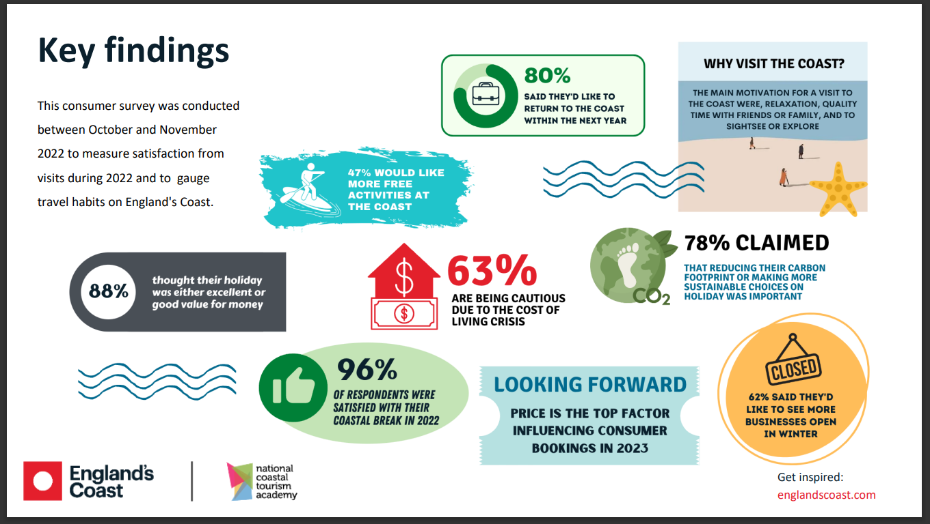
(National Coastal Tourism Academy, 2022).

