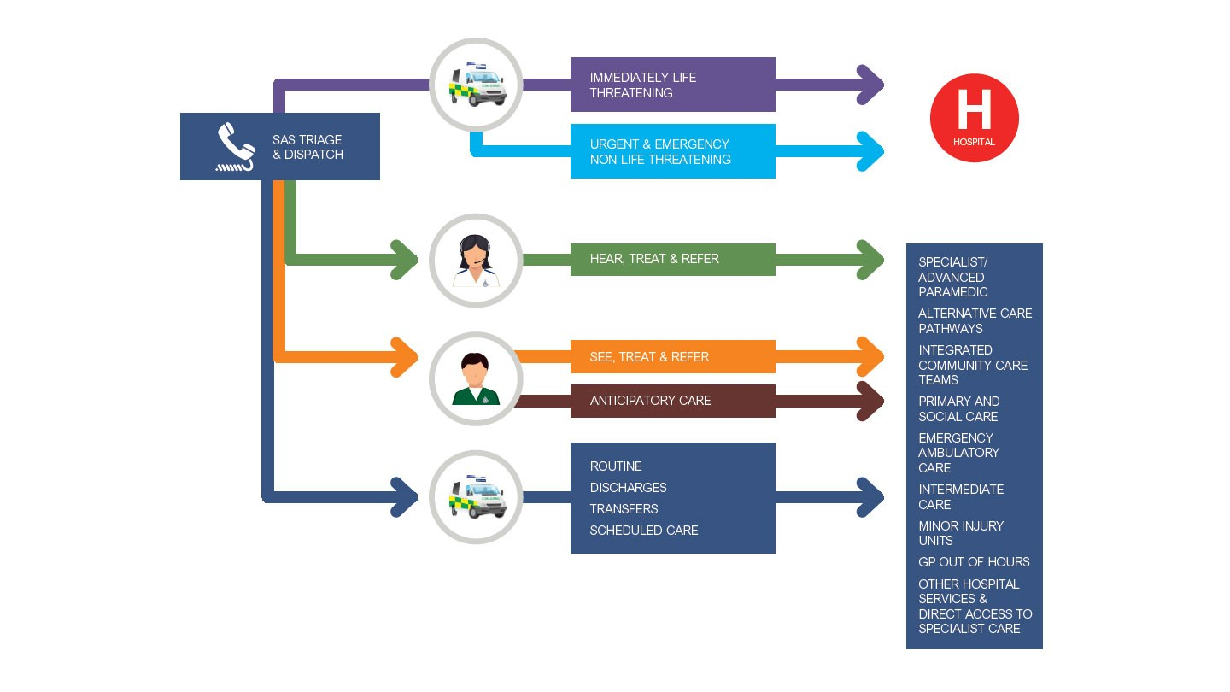
References
- The Statistical Yearbook 2011
Royal College of Paramedics (2023) Professional Standards for Paramedics. London. RCoP.
- The King’s Fund (2024) Pressure in Emergency and Ambulance Services. Available at: https://www.kingsfund.org.uk [Accessed 7 Nov 2025
- World Health Organization (2023) Emergency Medical Systems and Pre-Hospital Care. Geneva: World Health Organization.
- London: HMSO. Department of Health and Social Care (2024) About the NHS.

Challenges Faced by Ambulance Services
Challenge 1 - Response Times and Workload- A key concern is living up to national targets with respect to emergency response times. High demand, traffic congestion, and hand-off delays from hospitals result in ambulances waiting outside emergency departments to offload patients for prolonged periods of time. This fixes the cars and the personnel, causing delays in responding to other calls (The King’s Fund, 2024). In wintertime and during health emergencies, there tends to be intense pressure due to higher demand.
Challenge 2 - Staff Wellbeing and Retention- Emergency medical work is physically and psychologically taxing. They are continually presented with traumatic incidents as well as undertaking prolonged night shifts. Stress factors include fatigue, lack of exposure to distressing situations, and burnout. Many paramedics feel that the work that they do is undervalued due to its importance (Royal College of Paramedics, 2023). Better mental health resources and decent salaries are also essential to retain qualified employees within the service. (Apart from other difficulties such as hospital handover delays and shortages of personnel within the UK, there are other challenges that the United Kingdom's ambulance trusts face. These include sourcing money to buy more ambulances and how rural areas impact travel time.)
Current Functioning of Ambulance Services
In England there are ten regional trusts that provide the NHS ambulance service to each large area (NHS England, 2024). They operate 24 hours a day and 365 days a year. When a call is made to 999, it rings through to an Emergency Operations Centre (EOC), where trained operators use computer software to prioritize calls according to urgency. Life-threatening emergencies, such as heart attack, receive the shortest possible response time category, while other types might be advised to call other services such as the NHS 111. Typical frontline cars include: •Emergency ambulances with capabilities to provide higher •Rapid response cars/motor bikes to be used in congested areas. • Air ambulances; these are charity organizations that cooperate with the NHS. •Transport vans for patients on planned outings. The paramedic crews are also equipped with medical expertise that lends to transporting patients to aid in medical procedures such as oxygenation and defibrillation.
Conclusion
The provision of ambulances is integral to the commitment that the NHS offers to provide urgent care to all. They began with voluntolders in their early days and are now operating with state of-the-art technology. Though difficulties such as waiting times, staff stress, and finances are still critical concerns, the commitment of paramedics keeps the whole process operational. If resources are poured in and innovations are made, there will be more lives saved and confidence maintained in the health sector within the NHs. (“I believe that emergency medical staff receive less accolades because often this is the first difference between death and life that these people make.”)

A Brief History of Ambulance Services
The history of ambulance services within the UK has its roots in the nineteenth century. The initial structured service was formed in St. John’s Ambulance Brigade in 1877 to provide aid in public gatherings and to convey injured people to the hospital. In World War One and World War Two, civilian drivers and medics assisted the troops and civilians too; that shows how important the work in an ambulance might be. At the time that the NHS began in 1948, there had been separate departments within the councils that corresponded to the area In the 1970s, these services became integrated to form regional NHS trusts with more standardized training. Paramedicine was established as a profession in the 1990s and is now registered as an allied healthcare practitioner with the Health and Care Professions Council (HCPC) (Royal College of Paramedics, 2023).
Introduction to ambulance service
The ambulance service includes emergency care and non-emergency care. In cases such as heart attack, road accident, stroke, crew respond immediately to the 999 call. Each one of these ambulance is manned by trained personnel like paramedics, emergency medical technicians, and emergency care assistants. They can provide advance life support before the patient even gets to the hospital. Non-emergency transportation, “patient transport,” services transport those who are unable to travel on their own to appointments. The staff in the ambulances also work hand in hand with the police and fire rescue services, among other departments within the NHS. (Contemporary ambulances are mini-hospital transporters. They are designed to accommodate modern devices such as ECG monitors, defibrillators, oxygen supplementers, and breathing vents. This allows paramedics to revitalize the heart function of patients to breathe again before hospital arrival.)
Ambulance service
Nazia Riaz
Student ID- 2438254
Lecturer- Jolly Nwonkwo

Assignment 2 - The Background and Formulation of the NHS
Introduction
The National Health Service, commonly referred to as the NHS, has been one of the most significant aspects of living in the UK. The National Health Service was founded in 1948 to ensure that everyone received medical attention whenever they needed it regardless of how much money was in their pockets. The National Health Service was much welcome since previously people had to either hire doctors to come and attend to them or visit the charity hospitals if they had the privilege to get free medical services. Many people could not afford to hire doctors (NHS England, 2024).
(Our Community: The NHS is essential to our community as it ensures that people receive good healthcare irrespective of their financial backgrounds. Members within our area are dependent on the NHs to provide them with medical care. The existence of the best health providers within our area ensures that the whole community remains strong.)
1. Origins and Background
But before the establishment of the NHS, there was no uniform health care system in the U.K. Some hospitals functioned with the aid of charity organizations and others functioned as private concerns. Working-class people also had the option to contribute money to small-scale health care initiatives that covered the fees for consultations with doctors.
During and after the Second World War, there was a feeling that a new and more fair way was needed to look after the health of the whole population. The Beveridge Report (1942) recommended that a welfare state should be established to look after people ‘from the cradle to the grave’.
The then Minister of Health, Aneurin Bevan, was one of those who made it possible. The National Health Service Act (1946) ensured that health care was free to all and was funded through taxation. The National Health Service began operational on 5 July 1948 (Bevan, 1948). The service integrated all hospitals, doctors, nurses, and dentists (Bevan, 1948). For the first time in history, citizens had access to medical services with no concern about money.
(This was a massive difference to working-class areas. Those who might not normally see a doctor due to financial costs were then able to receive medical treatment and mothers had safer deliveries in hospital with medical care.)
2. Principles that Govern the NHS
The NHS was founded upon three key principles that remain to this day:
1.It fulfills the demands of all.
2.It is free at the point of use.
3.It is need-based and doesn't rely upon the means to pay (Department of Health and Social Care, 2024).
These principles ensured equal treatment was delivered in the healthcare sector. Whoever wanted to visit any medical practitioner would receive free entry. In fact, these principles over the years are mainly responsible for making British society understand that health is a right and a privilege. (I deeply agree with these values since they ensure that all people are treated equally. Nobody should be concerned about finances while sick, and that’s what makes the NHS such a unique institution even in contemporary times.)
4. The Current Functioning of the NHS The NHS has undergone significant changes since 1948. The NHS operates in each area of the UK differently; each area has its own structure since there are different health services in England, Scotland, Wales, and Northern Ireland. In England, there is the Department of Health and Social Care that provides national health policies; most health services are administered by NHS England. The healthcare sector is classified into three tiers:
•Community health services - initial contact centers such as family doctors, chemists, dentists, and opticians .
•Secondary care - hospital care or consultants that people are referred to by their family doctor.
•Tertiary care - Extremely specialized care; e.g. cancer treatment and heart transplants. The NHS is largely funded through taxation; therefore, everyone contributes to it depending on how much money one earns. The NHs employs over 1.3 million people; these include doctors, nurses, and other medical staff (NHS Digital, 2024). It is one of the world's biggest employers. (My trust controls the hospital and the ambulances in the area; therefore, there is rapid sharing of information among them, resulting in shortened waiting times.)
4. Strengths and Problems in the NHS The NHS has gained much since its establishment. The health service delivers excellent care to millions every day. In fact, it symbolizes equity. Citizens take pride in the health service. Additionally, they trust the professionals who run the NHs (King’s Fund 2024). But it also has significant challenges .
•Funding- The demand keeps increasing, and the government has to spend more to be able to meet that demand with new drugs, technology, and equipment.
•Staffing shortages: Many physicians and hospital staff are quitting due to stress and higher salaries elsewhere.
•Waiting times: As a result of such shortages, waiting times are normally long to get hospital appointments or undergo operations.
•Ageing population - The escalating demand from an aging population for long term care puts strain on hospital and GP practices. The National Health Services Long-Term Plan (2019) is attempting to improve this by prioritizing prevention and community health as well as incorporating technology to improve the efficiency of services. However, many believe that more investment and more personnel are required to bring about change.
(It’s important to look after the staff within the NHS just as much as improving technology because if the staff are taken care of, they are able to look after patients.)
5. Conclusion
The reason why the NHS was formed was that there was an unequal way of accessing health care, and people demanded that there be an equal opportunity to receive care whenever one needs it. Since 1948, the NHS has expanded to be one among the world’s biggest and best health services. The values that brought about the inception of the whole health service still stand tall today. Though there are challenges such as cuts in budgets and waiting lists, the NHS still remains one of the most integral components of British society.
References (UWTSD Harvard System)
Bevan, A. (1948) In Place of Fear. London: Heinemann Beveridge W. (1942) Social Insurance and Allied Services.
London: HMSO. Department of Health and Social Care (2024) About the NHS.
London: DHSC. NHS Digital (2024) NHS Workforce Statistics. Available at https://digital.nhs.uk [Accessed 7 Nov 2025 The King’s Fund (2024) The NHS at 75: Challenges and Priorities.
Available at https://www.kingsfund.org.uk [Accessed 7 Nov 2025 NHS England (2024) About the NHS. https://www.england.nhs.uk [Accessed 7 Nov 2025

