BA (Hons) International Hotel Management

Student Name: Rekha Begum
Student ID:2125644

Module Title: Sustainable Hospitality & Tourism Management
Module Code: BMIH5006
Assignment 2 – Report
Lecturer: Kathryn Roberts

Submission Date: 12 June 2025
Word Count: 2000

AI Declaration
I acknowledge that I have used Generative AI tools to assist with structuring, research summarisation, and proofreading during the preparation of this report, in accordance with university guidelines. All content is my own, supported by properly cited references.

Executive Summary
The report explores the reasons why hotels must focus on sustainability and circular business models as a result of rising environmental challenges, evolving consumer preferences and new regulations. It relies on key theories such as the Triple Bottom Line, the Circular Economy and Corporate Social Responsibility, to look at how running hotels sustainably is being planned into daily procedures. Marriott’s Serve360, Hilton’s Travel with Purpose and The Scarlet Cornwall provide examples of both large, statistics-based plans and natural, value-driven approaches to sustainability. It appears that sustainability is a positive branding asset and good business practise for large groups, but boutique hotels take it to heart as an essential part of how they operate. It points out reasons in favour, for example, cutting costs, gaining acceptance among stakeholders and caring for the environment, but it also notes the problem of greenwashing, barriers to money and limited ways to expand. Its solutions include special advice for hotels of every size, focusing on the roles of leaders, team members, honesty and long-term goals. For the hospitality sector to strongly influence sustainable progress, sustainability needs to become a key focus in strategic decision-making.
.

Contents
1. Introduction 4
2. Theoretical Frameworks 5
3. Industry Examples and Application 6
4. Benefits & Challenges of Adopting Circular/Sustainable Models 8
5. Recommendations for Future Strategic Development 10
6. Conclusion 11
Reference List 12
Appendices 14

1. Introduction
In hospitality, sustainability involves including care for the environment, society and the economy into business routines to save resources for future generations and meet today’s needs. Another important concept is the circular economy which works to reduce waste and increase how effectively resources are used, making production and consumption more sustainable (Contipelli, 2023). Given that climate change, resource shortages and caring consumers play a larger role, these frameworks are now more important than ever. There is great pressure on hotel companies from stakeholders, authorities and eco-friendly travellers to prove they are truly concerned about sustainability. Individuals and organisations are motivated by both their values and a desire to compete over much longer periods, thanks to benefits of sustainable practises like good routine, an enhanced reputation and loyal consumers. Because global tourism is expanding, how hotels function should be reassessed more urgently. This report analyses what makes it essential for hotels to adopt sustainable and circular business practises. It discusses leading theories, examines actual cases and delivers strategy advice. The aim is to see if companies are really dedicated to sustainability or just using it as a way to grow their business.

2. Theoretical Frameworks
2.1 Triple Bottom Line (TBL)
The Triple Bottom Line (TBL) approach measures a company’s success by looking at people, the environment and profit (Marco, 2024). In addition to financial performance, this model encourages businesses to evaluate how they influence society and the environment (Sloan, Legrand and Chen, 2017). This meets the hotel industry’s needs by providing secure jobs, using energy more efficiently and taking part in community development. International hotel brands have often adopted this model to meet the needs of both stakeholders and the government.
2.2 Circular Economy (CE)
The Circular Economy (CE) chooses a way that breaks with the traditional system of making, using and then throwing products away. Rather, it concentrates on reusing, recycling and regenerating materials to minimise what goes to waste and increase how efficiently the system runs (Veloz, Olea and Novilo, 2025). Ways to use circular methods in hospitality include repairing furniture, recycling food and using modular structures to keep assets intact for longer (Puig-Denia, Fernández-Yáñez and Forés Julián, 2025). Circle business models are most important for hotel carbon emissions, as they help limit waste in the supply chain and better plan logistics (Serio et al. 2025).
2.3 Corporate Social Responsibility (CSR)
CSR is when a company tries to act ethically, promote economic growth and improve the lives of employees, their local communities and everyone in society (Management Association, 2018). In the hospitality industry, CSR covers working with nearby suppliers, building local infrastructure and helping youth employment and conservation programmes.

Table 1: Summary of Key Sustainability Frameworks in Hospitality
Framework | Key Focus Areas | Hotel Industry Applications
Triple Bottom Line | Social, Environmental, Economic balance | Staff welfare, energy use, profit reinvestment
Circular Economy | Resource efficiency, waste minimisation | Linen reuse, upcycled furniture, local sourcing (Sustainable Tourism, 2019)
Corporate Social Responsibility | Ethics, community engagement, long-term value | Community projects, diversity initiatives, ethical supply chains

Besides being theories, these frameworks are now routinely used to shape the business strategies of hotels worldwide (Su et al., 2025). To understand if hotels are trying to be sustainable from the heart or for business reasons, we must understand how their factors are related.

3. Industry Examples and Application
The section shows how leading hotel brands and small, exclusive properties put sustainability and circularity into practise. The report examines whether Marriott’s Serve360, Hilton’s Travel with Purpose and The Scarlet Cornwall are true strategies aimed at preserving the environment or if they serve primarily to boost the companies’ image and sales.
3.1 Marriott – Serve360: "Doing Good in Every Direction"
To be sustainable, Marriott uses a structured plan called Serve360, setting targets to cut carbon emissions by 30% and send just half of its waste to landfills by the year 2025. The company’s actions match the UN SDGs which shows Marriott is acting as a responsible global firm (Costa and Costa, 2022). Rualis reports strong annual improvements which suggests the company wants to be responsible and to provide investors with confidence. Making sure employees train in sustainability and partnering with NGOs indicates a way that Marriott considers CSR.
3.2 Hilton – Travel with Purpose: Scaling Sustainability
The goal of Hilton’s “Travel with Purpose” initiative is to reduce its impact on the environment while increasing its social impact by 2030. These programmes consist of using managerial approaches for energy, water-saving tools and buying environmentally friendly supplies in all its buildings (Marco, 2024). Increased LEED certifications for the company prove that it can bring sustainable practises to all parts of the globe (Haski-Leventhal, 2018). However, some argue that these targets focus more on marketing and complying with environmental rules, rather than truly protecting the environment (Cooper, 2021). Yet, by participating in things like disaster response and youth programmes, Hilton has genuinely helped society.
3.3 The Scarlet Cornwall: Boutique, Regenerative Model
Sustainability forms the foundation of how The Scarlet is designed and run. All construction materials in the hotel are from the area, the hotel uses renewable energy and the company seeks to reduce wastes, encourage biodiversity and hire locally (Hansen, 2025). While major chains emphasise sustainability to grow their businesses, The Scarlet values sustainability from the beginning. While the model is admired for its authenticity, not being able to scale widely may limit how much it affects larger systems (Contipelli, 2023). Even so, it provides a standard for new sustainable and experiential tourism.
Motivation vs. Impact: A Critical Perspective
Every case focuses on unique reasons behind sustainability. Both companies, Marriott and Hilton, have models that connect sustainability with their brand strength and stability (Jauhari, 2021). By contrast, The Scarlet gives more importance to ecological values than to increasing sales which attracts some ethical buyers. The researchers Su et al., stated in 2025 that achieving real sustainability requires a leader motivated by purpose and decisions that benefit the local community.
Boutique operators are often more creative than large resorts—they use sourcing nearby, reuse products and choose green energy which are principles typical in circular systems (Inkson and Minnaert, 2018; New Governance and Management in Touristic Destinations, 2022).
Table 1: Hotel Sustainability Strategy Comparison
Hotel Brand | Sustainability Goals | Key Actions | Outcomes | Motivation Analysis
Marriott (Serve360) | Cut carbon intensity by 30%, 50% reduction in landfill waste by 2025 | Water/energy conservation, ethical sourcing, female empowerment initiatives | Strong ESG ratings, SDG alignment, positive media and investor attention | Balanced: CSR-driven, with strong commercial and reputational aims
Hilton (Travel with Purpose) | Halve environmental footprint, double social investment by 2030 | LEED certifications, youth training, disaster relief | Certified properties, stakeholder trust, compliance with global standards | Strategic branding with genuine community outreach
The Scarlet Cornwall | Minimal environmental footprint; regenerative tourism principles | Zero-waste kitchens, solar energy, local partnerships | Acclaimed for authenticity, model for eco-luxury, limited scalability | Purpose-led, non-commercially driven sustainability ethos

4. Benefits & Challenges of Adopting Circular/Sustainable Models
Introducing sustainable and circular models in the hotel and tourism industry leads to many economic, environmental and social improvements. However, there are still major obstacles to overcome such as cost factors and fake green marketing which often decide how genuine these strategies are.

Benefits
Following sustainable practises allows businesses to reduce their running costs as time goes on. For example, improving energy efficiency or working to decrease waste usually reduces expenses over time (Sloan, Legrand and Chen, 2017). The circular approach encourages hotels to lessen their carbon, water and waste output by switching from the old take-then-discard system to using materials more than once (Puig-Denia, Fernández-Yáñez and Forés Julián, 2025). Good environmental practises in the travel industry benefit the brand’s reputation and attract more ethically minded guests. Taking steps to hire locally, ensure diversity and sponsor projects that benefit the community help a hotel keep its social approval (Wickham, Donnelly and French, 2021). Strategic actions that meet UN SDGs set a standard and give investors and stakeholders greater trust in the industry.
Challenges
Still, there are some issues that keep blockchain from being used more widely. Small and medium-sized enterprises are mainly bothered by cost (Sustainable Tourism, 2019). Investing in retrofitting, green installations or sustainable supplies may be too difficult for most, as the return is not immediate (Serio et al., 2025). Greenwashing which means acting as if a company cares about the environment when it doesn’t, is a significant concern. Because eco-tourism is growing in popularity, a number of hotels just focus on looking sustainable, while actually making less significant changes and harming trust (Su et al., 2025). With scalability, there are additional challenges. While boutique hotels like The Scarlet do well when focusing on sustainability in their own regions, it is difficult to copy their model in different parts of the world because of cultural, legal and infrastructure differences (Veloz, Olea and Novilo, 2025).

Chart 1: Summary of Key Benefits vs. Challenges
Benefits | Challenges
Reduced long-term operating costs | High upfront investment costs
Lower environmental footprint | Risk of greenwashing
Enhanced guest loyalty and branding | Difficulty scaling across markets
Improved community relations | Limited technical knowledge/capacity
Investor and stakeholder appeal | Varied global regulatory environments

5. Recommendations for Future Strategic Development
Hotel companies should create their own strategies that are suited to their organisation, competitive landscape and business environment to help sustainability last.
- It is necessary for larger hotel groups to make circular thinking a key part of their overall strategy. As described by Sloan, Legrand and Chen (2017), introducing energy-efficient design, responsible sourcing and reuse of resources into long-term strategies improves a company’s ability to perform well and its brand reputation. Common and standard global programmes, followed by information shared with investors, is required to demonstrate real dedication.
- Meanwhile, boutique hotels benefit from being able to move quickly and support the local community more closely. They should, instead, use area-specific options like solar power and circular food approaches. In their 2021 study, Wickham, Donnelly and French found that smaller companies can earn greater trust from the community and deliver a stronger social impact by innovating and really involving people.
- In both segments, keeping staff engaged is very important. When sustainability training and feedback are built into HR activities, hotels help their staff learn and practise these values on their own. Their study points out that involving local people is essential for incorporating a circular approach into businesses.

- When it comes to fighting greenwashing, organisations must ensure they are transparent. Having outside organisations certify your progress and posting these reports also improves your reputation and opens your actions up to review by others, just as Serio et al. (2025) suggest. Also, Su et al. (2025) advise that both numerical aims and community welfare and staff representation should be taken into account.
For hospitality to truly benefit the environment, economies and humans, it needs to become an essential business value, not just a requirement companies have to meet.

6. Conclusion
The evidence presented here suggests that sustainable and circular approaches are vital to the hospitality industry’s long-term success. I have discovered through the theoretical analysis of the Triple Bottom Line, Corporate Social Responsibility and Circular Economy that sustainability is now being applied within the sector. The analysis of Marriott, Hilton and The Scarlet Cornwall showed that hotels can operate with large strategies or base their work on deeply held values. All these firms have made meaningful improvements, although how deeply they care often depends on their company model and size. The analysis pointed out that being sustainable helps organisations save money, improve their brand and build stronger ties with local communities. At the same time, it noted that challenges exist such as the need for a big investment, the problem of companies claiming to be green but not actually being so and difficulties expanding initiatives to many regional markets. To be truly effective, sustainability cannot be limited to small programmes or just met with compliance. Practising sustainability should be central to how hotels run their business for all team members. The hospitality sector can meet both its present and future obligations with strong and future-oriented sustainability plans.

Reference List
Batabyal, A.A. (2018). Managing Sustainable Tourism Resources. IGI Global.
Contipelli, E. (2023). Introduction to Circular Economy, London: SAGE.
Cooper, C. (2021). Essentials of Tourism. 3rd edn. London: SAGE.
Costa, C. and Costa, C. (eds.) (2022). Sustainability and Competitiveness in the Hospitality Industry. Business Science Reference.
Edgell, D.L. (2020). Managing Sustainable Tourism: A Legacy for the Future. 3rd edn. London: Routledge.
Hansen, B. (2025). Sustainable Tourism and Hospitality Management: Business Practices, Global Platforms and Reporting. Kogan Page
Haski-Leventhal, D. (2018). Strategic Corporate Social Responsibility: Tools and Theories for Responsible Management. London: SAGE.
Inkson, C. and Minnaert, L. (2018). Tourism Management: An Introduction. 2nd edn. London: SAGE.
Jauhari, V. (2021). Managing Sustainability in the Hospitality and Tourism Industry: Paradigms and Directions for the Future. 9th edn. Oakville: Apple Academic Press, Inc.
Korstanje, G.B. and Nedelea, A. (2020). Strategies for Promoting Sustainable Hospitality and Tourism Services. IGI Global.
Management Association. (2018). Sustainable Tourism. IGI Global.
Marco, B. (2024). Sustainable Sourcing and Waste Management in Hospitality: Strategies for a Greener Future. Journal of Tourism Research & Hospitality, 13(4). https://www.scitechnol.com/peer-review/sustainable-sourcing-and-waste-management-in-hospitality-strategies-for-a-greener-future-04td.php?article_id=26540
New Governance and Management in Touristic Destinations. (2022). IGI Global.
Puig-Denia, A., Fernández-Yáñez, J. M., & Forés Julián, B. (2025). Circular Economy in the Tourism Sector from a Family Business Perspective: The Case of Iberostar. Sustainable Futures, 7, 100123. https://doi.org/10.1016/j.sftr.2025.100617
Serio, R.G., Giuliani, D., Dickson, M.M. and Espa, G. (2025). Going green across boundaries: Spatial effects of environmental policies on tourism flows. Preprint. Available at: https://doi.org/10.48550/arXiv.2504.03608
Sloan, P., Legrand, W. and Chen, J.S. (2017). Sustainability in the Hospitality Industry: Principles of Sustainable Operations. 3rd edn. London: Butterworth-Heinemann.
Su, L., Li, M., Wen, J. and He, X. (2025). How do tourism activities and induced awe affect tourists’ pro-environmental behavior? Tourism Management, 106, 105002. https://doi.org/10.1016/j.tourman.2024.105002
Sustainable Tourism: Breakthroughs in Research and Practice. (2019). IGI Global.
Veloz, H. L. P., Olea, F. E. P., & Novilo, O. E. L. (2025). Circular Economy in the Hotel Industry: A General Mapping through Bibliometric Analysis. Journal of Posthumanism, 5(5), 750–769. DOI:10.63332/joph.v5i5.1403
Wickham, T., Donnelly, T. and French, L. (2021). ‘Strategic Sustainability Management in the Event Sector’, Event Management, 25(3), pp. 279–296.
Wisnawa, I. M. B. (2024). Integrating Sustainability Practices in Hospitality Management and Operations: An Analysis of Leadership Approaches, Green Certification, and Hotel Classification. Jurnal Manajemen Pelayanan Hotel, 8(2), 38–50. https://mapindo.ejurnal.info/index.php/manajemen_pelayanan_hotel/article/view/303

Appendices
Marriott Serve360 – Sustainability and Climate Action Snapshot
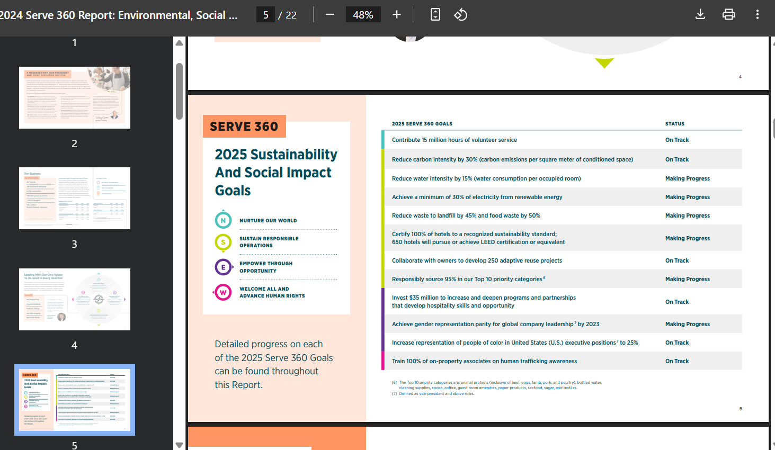
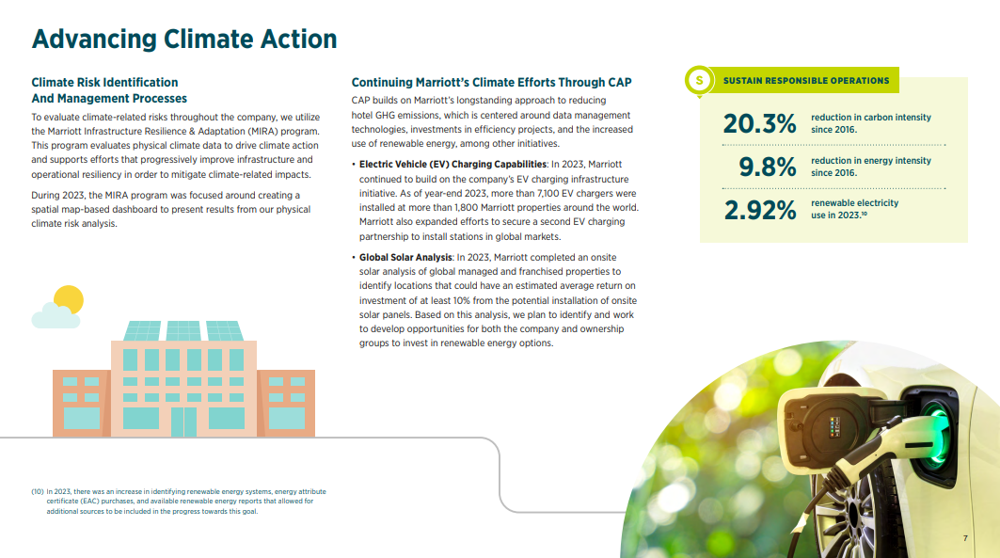

Source: https://serve360.marriott.com/wp-content/uploads/2024/07/2024ESGProgress.pdf

