Section 1: Report
1.Introduction (AC1.1)
Waite, et al. (2021) describes EBP as a “process where evidence from reliable sources is used to develop knowledge and understanding to inform practice”. EBP is important for people professionals as they experience a range of decisions as part of everyday practice. The concept is that it helps make better, more effective decisions by choosing reliable, trustworthy solutions (CIPD, 2023) and informing decisions on HR strategies, innovations, and practices with the best available evidence (Armstrong and Taylor, 2020).
According to Briner (2024), people do not always like being guided by structure and the CIPD (2023) argues that we tend to ‘cherry pick’ research that backs up our perspective or opinion. Individual opinion could be risky as can also be prone to bias. Evidence-based decisions will help reduce errors caused by ill-founded judgments (Taylor and Woodhams, 2022). The consequences of poor decisions can be substantial for an organisation with a monetary impact as well as affecting morale and poor performance.
People Professionals should consider evidence that will provide insight from 4 sources when making decisions; supporting scientific literature (e.g. what does research tell us?), Experiential (what do people in organisation tell us), organisational data (HR systems/analytics), and stakeholders (people with interest) (CIPD, 2023). Briner (2024) highlights examples of the types of evidence in Fig. 1 below.
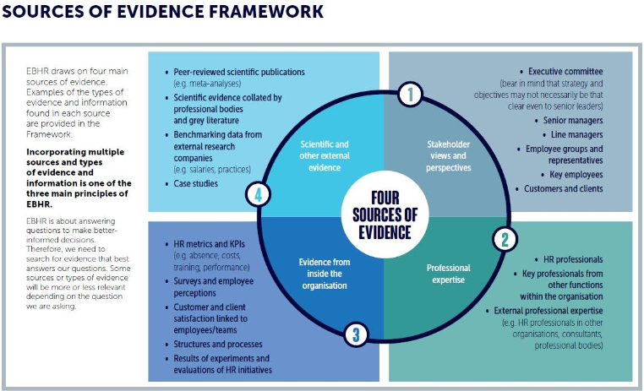
Figure 1. Sources of Evidence Framework
Another thing to remember is that we ensure the evidence considered is factual not opinion. According to Taylor & Woodhams (2022), evidence, especially on the internet is presented as neutral but often driven by personal or political agenda. Briner (2023) suggests that HR professionals look for solutions from the latest ‘fads’ that are the ‘new best thing’. The way to ensure that introducing this ‘fad’ will add value, and support the organisational objective is to ensure the decision has been made using EBP. Johny Gifford, Research Advisor , CIPD (2023) also states that EBP is a move away from making decisions guided by ‘what’s in favour’.
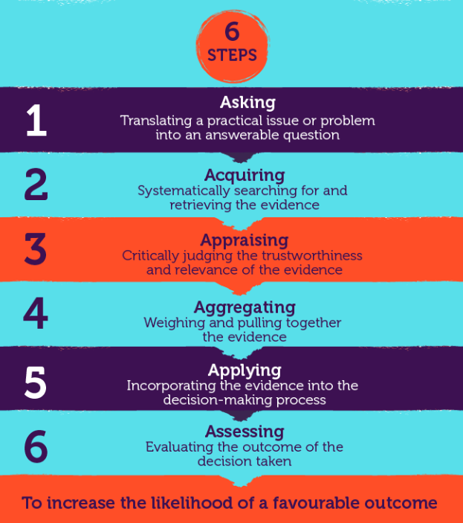
While evidence is all around us, it can be difficult to sort value from waste, requiring the use of critical thinking. Today, problems require more thought and are more complex, EBP is about asking good questions and keeping an open mind. By adopting a structured process of gathering and using evidence such as the 6 step model by Briner (2019) (see fig. 2) we can use facts and analyse information to reach a decision. The three areas of focus in EBP are systematic reading, understanding the organisation, and the ability to ask critical questions (how things work and why).
Figure 2. Six Steps to Evidence Based decision-making

Barends & Rousseau (2018) highlight 6 misconceptions, one being that it ignores the knowledge and expertise of professionals and argues that they are a major barrier to its implementation. No one source of evidence is more valid than another, misconceptions should be challenged and corrected according to Badens and Rousseau (2018).
The CIPD Profession Map (2024) set of standards defines the knowledge and behaviours that people professionals need. One of the core values of the professional map is that we should be Principles-led, evidence-based, and outcomes-driven, this will ensure that decisions can be made using the best insights possible.
2. (AC 1.2)
Several tools could be used to identify an issue or challenge, and it is important to recognise that different methods of analysis, will be appropriate in different situations. Taylor & Woodhams (2022) identify some commonly known tools, such as.
- SWOT Analysis (strengths, weaknesses, opportunities, threats)
- PESTLE
- Porter’s Five Forces analysis.
The PESTLE analysis tool audits the external environment considering factors such as political, economic, social, technological, legal, and environmental. It requires detailed analysis (Taylor & Woodhams, 2022) and is described by Armstrong and Taylor (2020) as an environmental scanning tool. CIPD (2024) suggests that it is worth collaborating as well as using expertise within the organisation when using this framework. It is useful to support business planning activities and is simple to use. It can enable a wider strategic vision identifying opportunities and potential threats. As an example, when developing a strategy for flexible working (CIPD 2024), consideration of political factors would identify that there is legislation and a statutory right for employees under the Employment Rights Act 1996 which needs considering. This would ensure that the risks are mitigated, and the strategy has been developed using EBP.
CIPD (2024) does argue, however, that a disadvantage of this tool is that the pace of change can make it difficult to predict developments in the future as well as having too much data which becomes an overload. In addition, some assumptions made may be unfounded. However, worth noting is that the PESTLE tool (and SWOT tool) is encouraged to be repeated at regular intervals to be most effective (Taylor & Woodhams, 2022).
Some commonly used methods for diagnosing challenges and issues are:
- focus groups with staff,
- Speaking to Trade Union representatives
- Interviews/observations,
- People analytics
It could also be beneficial to start with one method and then add further methods to gather additional evidence. Specifically, holding focus groups, a form of qualitative data collection, will gain deeper insights and can be more efficient and cost-effective than holding interviews. Notably, Taylor and Woodhams (2022) state that focus groups promote discussion and allow researchers to find out about a range of attitudes and opinions on a given topic. Barends and Rousseau (2018) maintain that focus groups are one of the most widely used methods to gather evidence from stakeholders. An example may be where an organisation is attempting to gauge reactions to an organisational change proposal. It can also promote that employee feedback is valued. Whilst there are benefits, it can sometimes prove difficult to get people together and can be challenging if you have one or two dominant people, so it is important to ensure all participants have a voice and that the information gathered is representative of the whole group. In conclusion, whilst people practice now has a more strategic role, using focus groups or qualitative methods as best practice ensures that organisations do not lose the human element when it comes to strategic decision-making.

3. (AC 1.3)
Critical thinking is the process of analysing and evaluating the quality of ideas, theories, and concepts to establish the degree to which they are valid and supported by the evidence and the extent to which they are biased. It involves reflecting on and interpreting data, drawing warranted conclusions, and recognising ill-defined assumptions. (Armstrong and Taylor, 2017). When making decisions in people practice, there should be a structured approach ensuring decisions are well informed, rational, and fair. It is a key skill for people professionals enabling them to navigate challenges, make decisions and contribute to organisational success (CIPD, 2019).
This is an approach that requires critical thinking to sources, and evidence and considers the wellbeing of the employees and the organisation. People professionals need to be critical about data – is it dependable, is it from a credible source, are we comparing like for like? It is essential that there is rational debate, free from emotion, no bias or preconceived notion and weigh up positive aspects but also question the information we have. Armstrong and Taylor (2020) states that ‘critical’ in this context does not mean disapproval or being negative as there are many positive uses of critical thinking.
Chadfield, T (2022) describes critical thinking as the ability to think twice about the information before your eyes and ask what is going on. Can this evidence be trusted?
As an example, within my workplace, it's essential to have the ability to critically think when considering a problem within the team. The next step is to define or formulate the question/problem, what else has influenced this? Understanding the opinions of others who have been involved, the staff – is the situation a result of group polarisation (where the groups beliefs have become more extreme than individuals (Sieber and Ziegler, 2019)), listening carefully and being open-minded to ensure there is no bias or manipulation. Ensuring that we use information that is factual and relevant with a focus on involving those involved in the situation and being open to other suggestions, will provide an opportunity to weigh up and reflect on the information gathered. Keeping others informed, communicating findings, and updating on the next steps will ensure those involved feel engaged. It is my opinion that critical thinking skills are a key skill for all people professionals. Critical thinking subjects all available options to scrutiny and scepticism (Ted-Ed, 2016).
To conclude, to assist objective and rational debate, critical thinking clarifies goals, examines assumptions, discerns hidden value, evaluates evidence, accomplishes actions, and assesses conclusions (Armstrong and Taylor. 2020).

4. (AC 1.4)
Decision-making is about making choices, often in conditions of uncertainty according to Armstrong and Taylor (2020). Adair (2016) highlights a rational approach for decision-making using six steps; defining problem, collect information, generating options, make decisions and then evaluate. This particularly highlights when there is a need to seek input from others. Being able to understand the implications of your decisions including its impact on the department and organisational objectives will help avoid costly mistakes and add value to your business (CMI, 2020).
De Bono six thinking hats, and Kepner and Tregoe’s model enable us to look at decisions from several different perspectives and are particularly effective in avoiding biases and assumptions. The drawbacks identified by CMI (2016) are that it allows very little regard to intuition or previous lessons learned. The Kepner and Tregoe model is a problem and risk analysis tool with four basic steps.
- Situation appraisal
- Problem analysis
- Decision analysis
- Potential problem analysis

The Six Thinking Hats requires people professionals to use a variety of thinking styles and perspectives when analysing a challenge/issue and considering solutions and decisions. Hats represent a colour for each of the areas listed.
- process driven (blue)
- creativity (green)
- feelings/emotions (red)
- benefits/values (yellow)
- risk assessing (black)
- information gathering (white)
One person can take on multiple hats, but this approach does work well within a team decision situation.

In contrast, a future pacing approach allows the decision to be made by the individual. The individual must make the decision considering and visualising the effect of the decision from different perspectives. This approach can lead to decisions prompted by a complex array of factors influenced by our background or experiences as well as impairing our judgement and decision by bias or tunnel vision (CMI, 2024). Having said that, Adair (2016) emphasises that behind our everyday thinking is our human mind which also requires knowledge about a subject to be able to decide during unforeseen circumstances.

There may be occasions where situation may require intuitive or heuristic decision- making, reacting to information at hand without the ability to gather more. The extent to which you can apply intuition may depend on your organisation or role (CMI, 2016). The result of poor decision-making in people practice can have a major impact on the wellbeing, performance, quality of service. It is therefore essential that decision- making in people practice is determined using a balanced approach free from bias and ensuring that different perspectives are considered. This balanced approach can be an individual using an approach such as the Six Thinking Hats or deliberating as a group.

- (AC 1.5)
Armstrong and Taylor (2020) define Ethics as a concept of making judgements and decisions on the right course of action. As people professionals, we are responsible for systems and processes that underpin the effective delivery of an organisations ethics message (CIPD, 2023).
As individuals, we should want to do what’s right without causing harm to ourselves or others when making decisions, being fair and acting honestly. Notably, there are different ethical frameworks that can be used to inform and influence decision-making and can have a big impact on the management and leadership and wider organisational culture;
Utilitarianism is the belief that the highest principle of morality is to maximise happiness (Armstrong and Taylor, 2020). An example may be introducing a policy or using this framework to resolve conflict that will maximise wellbeing of a large group of employees or the majority. Unfortunately, this framework may sometimes be subjective and requires careful measurement of quantifying happiness. It can also be criticised for neglecting the minority and not predicting the consequences of decisions.
Altruism on the other hand refers to the enduring tendency to think about the welfare and rights of other people, to feel concern and empathy for them, and to act in a way that beneﬁts them (Emmerik et al. 2005). As an example, using this framework when making recruitment decisions, ensuring adverts are free from biased language and inclusive can help attract a diverse range of candidates. There could be a risk that altruistic recruitment could lead to an overemphasis on a cultural fit or misalignment with business goals.
Deontological theory is an approach that forbids and follows certain sets of rules regardless of consequences. This is a structured approach, however, lacks flexibility and does not allow for personal autonomy according to Armstrong and Taylor (2020). People professionals, however, make decisions with a focus on treating everyone fairly, equally and legally. A good example would be using this framework in performance reviews setting out objectives, applying same standards for each employee, providing honest feedback and having a mechanism for employees to ask for clarity or dispute their review where appropriate.

While there is no right or wrong way in making ethical decisions, the CIPD (2015) has introduced 8 ethical lenses to consider, understanding these will ensure moral decision making that are legal and aligned with organisational values with transparency ensuring the organisation is sustainable for the future. These are; fairness, merits, markets, democracy, wellbeing, right and duties, character, handing down. There are, however, certain challenges with following the lenses framework. As an example, wellbeing initiatives can be quite costly so it is essential to assess the return on investment, whereas fairness may not always allow for dealing with unique situations.

To operate ethically, an organisation needs an ethics program, this could be formal or informal and should include a code of ethics (CIPD, 2023). This code should be regularly reviewed and discussed with staff to ensure they act ethically and decisions are not made due to their own personal beliefs e.g. religion. There are numerous challenges to ethical practices today and safeguarding these often falls to the people practice function (O’Higgins, et al. 2005). An ethical decision-making model provides a framework for assessing the potential consequences of each choice, analysing which option best aligns with personal values and organizational principles, and then acting on those conclusions.

- (AC 3.1)
Measuring performance is an important step and some sectors require very detailed performance measures (CIPD, 2024). With a better understanding of how organisations measure performance, we can take additional steps to provide additional value in daily activities (HBS, 2020). The type of sector can also influence how and what measures are used to monitor performance.
Notably in the private sector, they may use financial performance measures. The financial KPI’s measure the financial health of an organisation (HBC Online). An article by Eads, (2022) states that financial measures involve assessing an organisations asset, liabilities, revenue and profitability. Having clear quantifiable financial performance measures compared over time and against competitors to determine trajectory can help determine areas for improvement to increase profitability (Eads, 2022).
By contrast, Ittner and Larcker (2024) suggest that financial data have limitations as a measure of a company's performance. They do not capture the full picture and can sometimes encourage short term focus rather than longer term objectives. By placing too much emphasis on financial measures, it takes little account on drivers of value such as customer and employee satisfaction, innovation and quality (Ittner and Larcker 2024).
The public sector often focusses on non-financial value performance measures. One of their advantages, is that they link to longer term organisational objectives (Ittner and Larcker 2024). According to Welsh Value in Health Centre (2024), a key aspect is the capture (of customer (e.g. patients)) and commonly codified non-financial performance indicators as they report the symptom and quality of life of an individual on a given day and to involve those in decisions about their care. These are qualitative measures providing a holistic comprehensive view beyond finance. It can help demonstrate compliance, transparency and accountability to stakeholders including public bodies and government. They are often linked to wider priorities and frameworks, Welsh Government (2023) demonstrates this in its performance framework as it aligns to Ministerial priorities and core support functions in the Planning Framework. As an example, Welsh Government (2023) performance framework maps to the ‘A Healthier Wales’ Strategy (Hywel Dda University Health Board, 2024).
The Balanced Scorecard was developed to include financial measures to inform results of what has happened, and it complements with non-financial operational measures such as customer satisfaction, innovation, improvement placing strategy and vision, not control, at the centre (Kaplan and Norton, 1992).
For the organisation to make informed decisions, it is important to choose metrics that align with the organisational objectives and provide the most value. A balanced presentation of financial and non-financial measures would be preferred and advantageous to managers and is noted by Kaplan and Norton in HBR (1992
7. (AC 3.2)
There has been a significant shift in the focus of people's practices. Significantly, the rise of Human Resources management (HRM) has brought with it a new emphasis on the role of practitioners in improving the performance of the organisation (Bennett, et al, 2020, p.4). People practices play a crucial role in shaping culture, employee behaviour and performance. According to CIPD (2022), people professionals have stepped up through recent crises to support their organisations, yet the perceived value of the profession remains under constant challenge. Waite, et al. (2021) highlights that there are numerous debates about how human resources management (HRM) can assist value creation and high performance.

Practices such as supporting the maintenance practice (ensuring employees are paid), recruitment process, a systematic induction process, providing advice, promoting social responsibility, ensuring compliance, gathering employees’ views can be used to foster value creation by an organisation (Waite, et al. 2021).

Taylor & Woodhams (2022) state that managers are not just concerned with achieving tasks; they are also integral to organisations longer-term strategic objectives whilst keeping an eye on the future in an increasingly volatile, unpredictable, competitive and highlight regulated global environment. For instance, employee development through continuous learning will lead to improved organisational effectiveness, increased morale, improved retention levels.

One method to measure the impact would be looking at the return on investment on learning and development which can often be more time-consuming to measure, this would evaluate the effectiveness of training delivered and how it has affected employee performance/wellbeing and if it has contributed to achieving organisational objectives (Kearns, 2006).
Another method would be measuring employee satisfaction and engagement through staff feedback and/or exit interview feedback. Carefully managed, people practices can be used to foster value creation for the organisation by ‘gathering employee views and opinions on work matters’ according to Waite, et al (2021).

In an article, Codrington (2017) reports that Boston Consulting Group have measured the value of investing in people practice and it found that improved recruiting practices result in 3 x revenue growth and 2 x profit margins.

In conclusion, to quote from Taylor & Woodhams, (2022) ‘Organisational values’ has much in common with thinking about ‘organisational culture’. People practice activities add value to an organisation through employee engagement, productivity and overall organisational performance.

Section 2 (AC2.1, AC2.2, AC2.3)
Table 1: (AC 2.1)
- The pie chart in Chart 1 shows percentage by gender. This is quantitative data and demonstrates a fairly balanced gender workforce (53.85% male, 45.38% female, 0.77% non-binary).
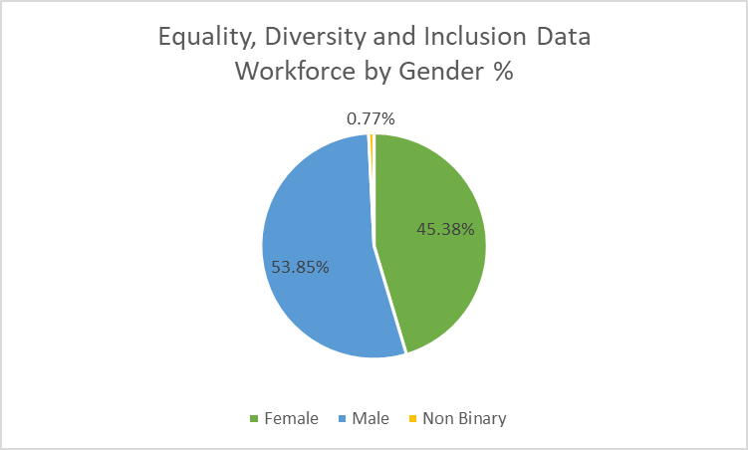

Chart 1

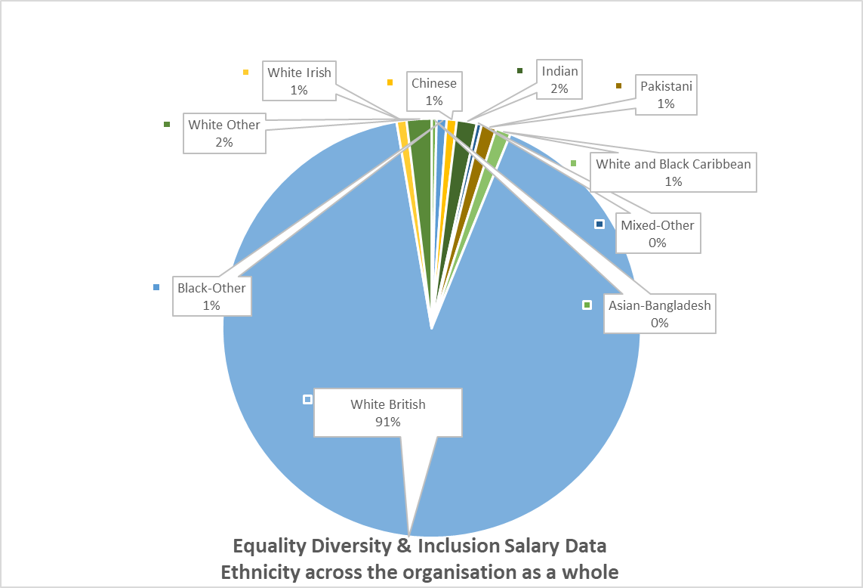
b) Illustrated in chart 2, 91% of the whole workforce are white British. ACAS (2024) defines Diversity as the range of people with different characteristics, ethnicity being one of them.
Chart 2
The stacked column (Chart 3) illustrates ethnicity. Facilities, Lettings, Marketing and regeneration’s workforce are white British, meaning there is no diversity within those teams. The team with the most diversity is Community Engagement and Partnerships, with 14.29% Indian, 14.29% Mixed Other, 14.29% white/black Caribbean and 57.14% white British. | Chart 3

c) 8.08% of the workforce are disabled, (Chart 4).
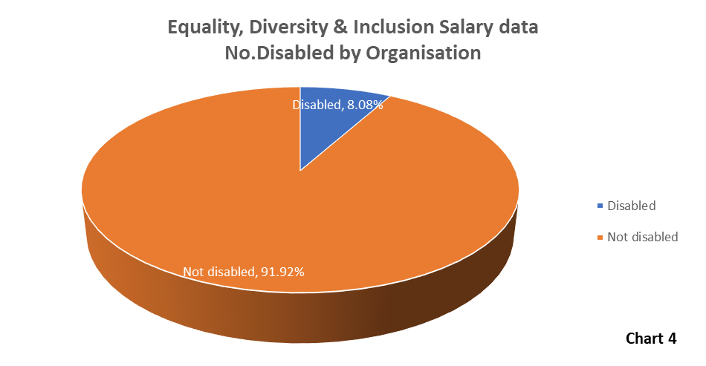
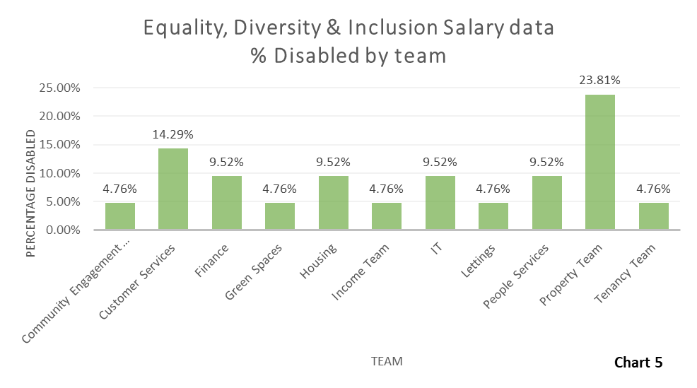
Chart 5 is a bar chart displaying the percentage of disabled employees per team. The property team has the highest disabled employees with 23.81%. Business Services, Directors, Facilities, Governance, Marketing, Regeneration, Supported Housing have no disabled employees.
d) 95.38% of the workforce earn a salary from £17.5k to £50k, 56.66% are female. To note, males are the most dominant gender with £22-£50k salary bracket.
When comparing the top 10 paid females to top 10 paid males – average female pay is £77,280 compared to males at £48,934.50.
The Chief Executive, Director of People and Finance are highest-paid roles, all females. Director of Customer Services is male providing an equal 50/50 split for those earning between £90k to £100k. In the Business Services Team, there are 2 employees (1 male/1 female), it is concerning that the female is being paid £10k more than the male.
e) The overall average organisational salary paid is £31,757.46. £31,900.03 is the average salary across the organisation for female with £31,812.18 for males and £19,500 for non-binary. To note, is that there are roles such as Development Manager, where two employees (in property and development), both female, are being paid a different salary. The Head of Service and Directors role appears to have a significant range of salary, it would be interesting to understand the job evaluation process and market pricing. The Trades Operatives have a significant variation between trades, difference in 4k. A market pricing exercise could be undertaken to compare rates. (CIPD, 2023) Pay rates for the same job role cannot be different based on gender alone. There can, however, be legitimate reasons such as experience, responsibilities, or market forces.
Table 2: AC 2.2 & AC2.3
Qualitative data has been gathered from a recent survey. This is cheaper and faster to administer than interviews and convenient as responders can complete in their own time (Taylor and Woodhams, 2022). However, one disadvantage is that it doesn’t allow any deeper insights in certain areas.
Below is a graph (chart 6) showing results of the survey.

Findings
- 56.3% of employees enjoy working from home for some days with 82.3% agreeing it supports work-life balance and wellbeing.
- There appears a differing opinion accessing resources from home with 147 stating they agree and 147 stating they disagree. 6 employees were not sure.
- Balanced response with 148 respondents stating hybrid working makes them more productive, and 147 stating they disagree.
- The Working from Home option has a higher proportion of negative responses, 66% stating that they disagree that this option allows them to meet their targets.
- Employees are reporting that they disagree that being away from the office gives less stress and they do not miss engaging with their colleagues – 83% disagree with the statement in the survey.
- 14% surveyed agreed they were fully supported when working at home.
- 101 employees were ‘not sure’ if working remotely was a challenge.
- Hybrid working appears to be connecting employees to the company culture; 62% stating they agree.

2. Recommendations
1: Improve Equity, Diversity and Inclusion (EDI)
Consultation with employees and representatives to develop an Inclusive Workplace Policy and action plan to ensure EDI is embedded within everyday workplace practices. Consider Positive Action strategies to promote equality of opportunity (Taylor and Woodhams, 2022). To be competitive, organisations need everyone who works for them to make their best contribution. Increasingly, employers recognise the importance of inclusion and diversity in recruiting and retaining the skills and talent they need (CIPD, 2022). Some UK politicians criticise EDI as ‘wasteful expenditure’, however, a global survey conducted revealed that 76% of employees believe diverse, equitable, and inclusive workplaces are important. To improve diversity will mitigate risk of reputational damage, arbitration, and financial implications of claims against the employer. The direct cost of developing this policy can be for expert consultants, policy development as well as indirect costs such as on going support, monitoring and evaluation as well as staff training.
2: Gender Pay Gap
Due to over 250 staff, undertaking a gender pay gap evaluation (CIPD, 2024) as it will provide a clear picture of the status and follow up actions required. This, if published, can provide the public with an understanding of gender pay situation but should be provided along with a narrative (CIPD, 2017). There will be direct costs e.g Consultancy fees for expert advice, HR hours for undertaking evaluation, data analysis and providing reports. Failure to comply amounts to a breach of the Equality Act 2010 and would therefore open an organisation up to action by the Equality and Human Rights Commission (EHRC). The EHRC have a series of actions and penalties that they can impose on organisations depending on the type of business and nature of the breach (CIPD, 2024)
3: Address the provision of resources and ongoing communication and monitoring to ensure wellbeing of all employees working away from the office
Hybrid Working Policy review and further engagement and mechanism to continuously measure experience as well as audit of resources available to staff. This would include follow-up interviews to gather deeper insights and how they can ensure its approach to hybrid working is effective in areas of feeling supported, engaged and improved communication. Structured communication plan to ensure no gap in knowledge and to avoid employees feeling excluded. Having appropriate resources ensure employees are supported, safe systems and accessible, maximising productivity (CIPD, 2024). CIPD (2024) identifies benefits to employees of hybrid working e.g. commute time, better work life balance, improved productivity. Organisations can be more agile and change ready (Taylor & Woodhams, 2022)
Risk assessments required (CIPD, 2024). Managers need to focus on assessing performance through outcomes, contribution, and value and can benefit from training and development to support hybrid management and leadership (CIPD, 2024). Employees not supported may lead to decline in wellbeing and lead to absenteeism. There could be costs of investment for resources however, this could be offset against potential claims for unfair treatment and discrimination leading to financial and reputational loss (CIPD, 2024). Employees terminating employment leading to loss of skill, expertise, retention as well as financial implication leading from recruitment costs.

Bibliography
ACAS (2024) Equality Diversity and Inclusion. Available at : If employees feel excluded - Equality, diversity and inclusion - Acas (Accessed: 22 May 2024)
Adair, John. (2016) Develop your Leadership Skills. 1st. London: Kogan Page.
Armstrong, M. and Taylor, S. (2020) Armstrong’s Handbook of Human Resource Management Practice. 15th edn. London: Kogan Page
Barends, E. and Rousseau, D. (2018) Evidence-Based Management. 1st edition. London: Kogan Page Limited.
Bennett, T, Saundry, R, Fisher, V (2020) Managing Employment Relations. London: Kogan Page.

Briner. (2023) Personnel Today. Available at: HR fads: How to recognise and avoid them (personneltoday.com) (Accessed: 24 May 2023).

Briner, R. (2024) What is Evidence Based Practice 2024. Available at https://www.youtube.com/watch?v=tSfo2XhEWkE (Accessed : 24 April 2024).
Briner, R (2024) Evidence-Based HR does NOT mean science-based HR. Available at: https://www.linkedin.com/posts/rob-briner_%3F%3F%3F%3F%3F%3F%3F%3F-%3F%3F%3F%3F%3F-%3F%3F-%3F%3F%3F%3F-activity-7204880439914704896-qBSG?utm_source=share&utm_medium=member_ios (Accessed: 7 June 2024).
Chartered Management Institute (2020) Decision Making. Available at: Decision Making - CMI (managers.org.uk) (Accessed: 13 May 2024).
Chartered Management Institute (2020) Rational Decision Making. Available at: Rational_decision_making.pdf (futurelearn.com) (Accessed: 15 May 2024).
CIPD (2017) Evidence Based Practice : an introduction. Available at: Evidence-based practice: an introduction (youtube.com) (Accessed : 24 May 2024)
CIPD (2018) People Analytics: driving business performance with people data. Available at: people-analytics-report_tcm18-43755.pdf (cipd.org) (Accessed : 20 May 2024).
CIPD. (2019) Critical Thinking [Podcast]. 5 November 2019. Available at: Critical thinking | Podcast | CIPD (Accessed : 22 May 2024).
CIPD (2020) When the going gets tough, the tough gets evidence. Available at : When the going gets tough, the tough get evidence | CIPD (Accessed : 15 May 2024).
CIPD (2021) Evidence-based L&D - ‘Why does evidence matter’ [Podcast]. 2 March 2021. Available at: Evidence-based L&D - ‘Why does evidence matter?’ | Podcast | CIPD (Accessed : 14 May 2024).
CIPD. (2022) What value does HR bring to today's organisations [Podcast]. 12 July 2022. Available at: What value does HR bring to today's organisations? | Podcast | CIPD (Accessed: 20 May 2024).
CIPD (2023) Evidence-based practice for effective decision-making. Available at: Evidence-based practice for effective decision-making | Factsheets | CIPD (Accessed: 14 May 2024).
CIPD. (2023) Strategic Human Resource Management. Available at: Strategic human resource management | Factsheets | CIPD (Accessed: 20 May 2024).
CIPD. (2023) Ethical Practice and the role of people professionals. Available at: Ethical practice and the role of people professionals | Factsheets | CIPD (Accessed: 20 May 2024).
CIPD. (2023) Pay fairness and pay reporting. Available at: Pay Fairness & Pay Reporting | Factsheets | CIPD (Accessed: 23 May 2024).
CIPD. (2023) Job evaluation and market pricing. Available at: Job Evaluation & Market Pricing | CIPD (Accessed: 23 May 2024).
CIPD. (2024) Ethics at work: An employers guide. Available at: Ethics at work: An employer’s guide | CIPD (Accessed: 20 May 2024).
CIPD (2024) Performance Management: an Introduction. Available at: Performance Management | Factsheets | CIPD (Accessed : 13 May 2024)
CIPD (2024). Available at: Gender pay gap reporting: Understand what it is, if you need to report and why | CIPD [Accessed: 21 May 2024]
CIPD. (2024) 'HR leaders can address the backlash against EDR - this is how', People Management, May-July 2024, Page 27.
CIPD (2024) Race Inclusion in the workplace. Available at : Race inclusion in the workplace | CIPD (Accessed : 22 May 2024).
CIPD (2024) How to use the profession map. Available at : How to use the Profession Map | CIPD (Accessed : 31 May 2024). (Accessed : 31 May 2024).
CIPD (2024) Flexible Working Practices. Available at : Flexible Working Practices | Factsheets | CIPD (Accessed : 31 May 2024).
CIPD (2024) Hybrid Working: Guidance for People Professionals. Available at : Hybrid working: Guidance for people professionals | CIPD
Codrington, M. (2017) ‘The ROI of people and culture’ [LinkedIn] 26 July. Available at: The ROI of people & culture: measurement, challenges and opportunities (linkedin.com) (Accessed: 20 May 2024).
Eads, A. (2022) ‘Financial Performance Analysis’ [Indeed] 22 December. Available at: Financial performance analysis (with techniques and metrics) | Indeed.com UK (Accessed: 18 May 2024).
Harvard Business Review (2007) Maximising your return on people. Available at: Maximizing Your Return on People (hbr.org) (Accessed: 20 Menabeay 2024).
Harvard Business School (2020) 13 financial performance measures managers should monitor. Available at: 13 Financial Performance Measures Managers Should Monitor (hbs.edu) (Accessed: 18 May 2024).
Horn, R. (2009) The Business Skills Handbook. London: CIPD. For information on Teams, Project Planning and more.
Hywel Dda University Health Board (2024) Healthier Mid and West Wales. Available at: Healthier mid and west Wales - Hywel Dda University Health Board (nhs.wales) (Accessed: 18 May 2024).
Ittner, C. and Larcker, D. (2024) 'Non-financial performance measures: what works and what doesn't' [podcast]. 6 December. Available at : Non-financial Performance Measures: What Works and What Doesn't - Knowledge at Wharton (upenn.edu) (Accessed : 18 May 2024)
Kaplan, R. and Norton, D. (1992) ‘The Balanced Scorecard’ [Harvard Business Review] January 1992. Available at: The Balanced Scorecard—Measures that Drive Performance (hbr.org) (Accessed: 18 May 2024).
Kearns, P. (2006). “Evaluating the ROI from Learning: How to Develop Value-based Training” Human Resource Management International Digest, 14(1)
Mullins, L, J. (2013) Management & Organisational Behaviour, 10th ed, Harlow: Pearson Education Limited.
Office for National Statistics (2022) Gender pay gap in the UK. Available at: Gender pay gap in the UK - Office for National Statistics (ons.gov.uk) (Accessed: 21 May 2024).
O'Higgins, E. et al (2005) C'omparative Perspectives on the Ethical Orientations of Human Resources, Marketing and Finance Functional Managers''Journal of Business Ethics, Issue 56, 275-288.
Sieber, J and Ziegler, R. (2019) ‘Personality and Social Psychology Bulletin’. Personality and Social Psychology Bulletin.
Stobierski, T. (2019) 'How to do a cost-benefit analysis and why it's importamt', Havard Business School, 5 September. Available at: Cost-Benefit Analysis: What It Is & How to Do It (hbs.edu) (Accessed: 20 May 2024).
Taylor, S. & Woodhams, C. (2022) Studying Human Resource Management. London: Kogan Page.
Ted-Ed (2016) [You Tube] 13 May.
Van Emmerik, I. H., Jawahar, I. M., & Stone, T. H. (2005). Associations among altruism, burnout dimensions, and organizational citizenship behaviour. Work & Stress, 19(1), 93–100.

Waite, K. et al. (2021) People Practice. 1st. London: Kogan Page Limited.
Welsh Government (2023) NHS Wales performance Framework 2023-2024. Available at: nhs-wales-performance-framework-2023-2024.pdf (gov.wales) (Accessed: 18 May 2024).
Welsh Value in Health Centre (2024) Health Informatics. Available at: https://www.vbhc.nhs.wales/value-based-healthcare-for-wales/health-informatics/ (Accessed: 17 May 2024)

