

Alimah Akter
Student Number: 2601739

Lecturer: Paul Darby

Early Years Education and Care

The learning journey: Developing skills for academic success.

ECEY4012

Content page :
Content page – Page 1
Part 1 – Study Timetable – page 2 – 3
Part 2 – Introduction and AI activity – Page 4 – 6
Academic writing, conclusion and reflection on the use of AI for academic study – Page 7 – 9
Part 3 – Poster and reference list Page – 10
Part 4 – Link to the oral presentation also shared with lecture team – Page 10
Reference list – Page 11
Part 1 – Study Timetable
08:00 - 08:59 | Travel & prepare for the day. | Travel & prepare for the day. | Travel & prepare for the day. | Travel & prepare for the day. | Travel & prepare for the day. | Sleep | Sleep
09:00 - 09:59 | Work | Work | Work | Work | Work | Wake up & get ready | Sleep
10:00 - 10:59 | Work | Work | Work | Work | Work | House shopping | Wake up & get ready
11:00 - 11:59 | Work | Work | Work | Work | Work | Laundry | Fold laundry
12:00 - 12:59 | Lunch break | Lunch break | Lunch break | Lunch break | Lunch break | Go to the gym | Relax (TV, read etc.)
13:00 - 13:59 | Work | Work | Work | Work | Work | Lunch | Lunch
14:00 - 14:59 | Work | Work | Work | Work | Work | Reading & researching | Prep for the week ahead
15:00 - 15:59 | Work | Work | Work | Work | Work | Review & practising Harvard referencing | Review notes for the second half of the assignment
16:00 - 16:59 | Travel home | Travel home | Travel home & get ready for the gym | Travel home | Travel home | Review lectures notes | Look over lectures slideshow
17:00 - 17:59 | Light snack & check emails | Relax (TV, read etc.) | Gym session & shower | Light snack & check emails | Relax (TV, read etc.) | Deep dive into completing half the assignment | Light note taking for lecture on Monday
18:00 - 18:59 | University Lecture | Review lectures notes | Gather research | Complete part of assignment | Review assignment. Add to turnitin draft | Free time (hobbies/ friends) | Prep for work (lunch/ uniform)
19:00 - 19:59 | University Lecture | Start assignment | Gather reference list | Practice Harvard referencing | Free time (hobbies/ family) | Free time (hobbies/ friends) | Free time (hobbies/friends)
20:00 - 20:59 | Dinner | Dinner | Dinner | Dinner | Dinner | Dinner | Dinner
21:00 - 21:59 | Relax (TV, read etc.) | Review assignment | Lc2 spa session | Relax (TV, read etc.) | Free time (hobbies/ family) | Free time (hobbies/ friends) | Relax (TV, read etc.)
22:00 - 22:59 | Skincare & get ready for bed | Skincare & get ready for bed | Skincare & get ready for bed | Skincare & get ready for bed | Skincare & get ready for bed | Free time (hobbies/ friends) | Skincare and get ready for bed
23:00 - 23:59 | Sleep | Sleep | Sleep | Sleep | Relax (TV, read etc.) | Free time (hobbies/ friends) | Sleep

Introduction:
This assessment will discuss two study techniques suggesting how they can support students in using their study time more effectively. The first technique is managing time by making a to-do list and the second technique is bullet-point note-taking. Microsoft 365 Copilot is an artificial intelligence (AI) tool that generates information when asking a prompt. This AI generator will be used to identify if making a to-do list and bullet-point note-taking can be effective for students while studying. The reason why study skills is extremely important for any student is because it supports students to divide their workload into sections which will help them manage time efficiently and organise their assignment tasks. Gaining study skills as a university student will boost your confidence and train you to become more independent and confident in you’re a work.

AI acknowledgment:
I acknowledge the use of Microsoft 365 Copilot app on 14th September 2026 to see whether two study techniques can support students in using their study time more effectively. I uses two prompts;
- I am a undergraduate university student studying early years education and care in my first year, how can making a to-do list improve time management skills
- Present me key points on how using a to-do list is an effective time management strategy.
I can confirm that I have not presented any AI generated text as my own work. I confirm I have copies of my drafts, notes and other resources I used before, and after the use of AI tools which I maybe asked to provide evidence.
AI activity:
AI prompt 1 –
Q: I am a undergraduate university student studying early years education and care in my first year, how can making a to-do list improve time management skills
Copilot said:
As a first-year Early Years Education and Care student, making a to-do list can significantly improve your time management by helping you stay organised and focused on your studies and personal responsibilities.
How a To-Do List Improves Time Management
1. Helps you prioritise tasks A to-do list allows you to identify which tasks are most important and need to be completed first. For example, an assignment due this week should take priority over reading that is not needed until later.
2. Reduces stress and anxiety Writing tasks down means you do not have to rely on memory. This can make your workload feel more manageable and reduce the worry of forgetting important deadlines.
3. Improves organisation As a university student, you may have lectures, seminars, placements, coursework, and personal commitments. A to-do list helps you keep track of all these responsibilities in one place.
4. Increases productivity When you have a clear list of tasks, you can focus on completing one activity at a time rather than wondering what to do next. This helps you use your study time more effectively.
5. Encourages goal setting Breaking large tasks, such as writing an essay, into smaller steps makes them easier to achieve. For example:
- Research articles
- Create an essay plan
- Write the introduction
- Complete the first draft
- Proofread and edit
6. Provides motivation Ticking off completed tasks gives a sense of achievement and can motivate you to continue working through your list.
7. Helps meet deadlines By recording assignment due dates and important university events, you are less likely to miss deadlines and can plan your work in advance.
Example
A daily to-do list for an Early Years Education and Care student might include:
- Attend Child Development lecture
- Complete seminar reading
- Research for safeguarding assignment
- Review lecture notes
- Submit reflective journal
- Prepare for tomorrow's class

AI Prompt 2 – Refining the question
Q: Present me key points on how using a to-do list is an effective time management strategy.
Copilot said:
Here are some key points you can use in an assignment or reflection on why a to-do list is an effective time management strategy:
- Helps prioritise tasks by identifying what needs to be completed first and what can be done later.
- Improves organisation by keeping all tasks, deadlines, and responsibilities in one place.
- Reduces stress because important tasks are written down and less likely to be forgotten.
- Increases productivity by providing a clear plan of what needs to be accomplished each day.
- Encourages goal setting through breaking large tasks into smaller, manageable steps.
- Helps meet deadlines by keeping track of assignment due dates and other commitments.
- Improves focus by allowing individuals to concentrate on one task at a time.
- Provides motivation and satisfaction when tasks are completed and ticked off the list.
- Supports effective planning by helping individuals allocate time appropriately to different activities.
- Promotes responsibility and self-discipline through regular monitoring of progress and workload.

Firstly, the to-do list technique is used every day in people’s lives. It can be used as a study technique that helps with time management. This technique helps students prioritise important tasks and meet deadlines in a time-efficient manner. (Wolters & Brady, 2021) According to the university of York (2025) the benefits of a to-do list are helping to organise thoughts and priorities. It also states having clear tasks can make them more manageable, reducing the tendency to procrastinate. It can also help with progression and marking off task while being completed, this results in increasing motivation and feeling the sense of achievement. (University of York, 2025)This technique helps students stay organised and reduces students feeling stressed or overwhelmed. For example in a university assessment there is word count students have to reach and numerous task they also have to complete, bare in mind students also have to complete several assessments before a deadline. This is why using a to-do list lets students separate the assessment into smaller parts for instance making a draft research page gathering information about the topic. The second part can be making a brief plan on how to present the assessment, alongside with adding an introduction. Once the plan and researched information is completed the student can imbed this into the main body of you assessment, ensure there is a reference list and the assignment is proofread before submitting the assessment. Student may find separating the assessment in to smaller parts more manageable as it allows students to understand the learning outcome of the assessment. Creating a to-do list lets students be more organised creates a balanced study schedule and gives direct instructions on which task need to be completed first and which ones are more urgent than others. A to-do list is beneficial as it stops students from falling behind on completing assessment and leaving it too last minute, it also helps students to work on completing assessment slowly to develop and progress on understanding the topic for future assessments. While using this technique on a day to day basis it will help students better their organisation and time-management skills. (De Jesus & Garcia, 2023). This skill can be used in students future assessments or future lives. In the future students can plan workload, manage deadlines and complete tasks in a structured way.
Secondly, the bullet-point note-taking technique is a simpler way of storing large amount of information but shortening the information into points storing the main key facts or ideas. According to the University of Reading (2026), bullet point note taking allows students read, understand and find the information easily. Universities in united states indicate bullet point note taking is a helpful method to improve study skills. According to Cornell university Learning Strategies Center (n.d.) taking notes during lectures supports students to stay productive and focused and stores important information that will help with their studies. They also state that students hand writing bullet-point information enhances their memory and understanding. This technique can be used in students future assessments or future lives. This way of method helps students manage large information and narrowing it down the key factors making it easier to review when writing up assessments. This technique also supports students activity and independently learn and not overload themselves with too much information.
Conclusion
In conclusion, using a to-do list and bullet-point note taking are both study skills techniques that can support students’ academic success in two different ways. A do list is a helpful technique that can not only help students during studies it can also support them in their everyday lives. This technique helps reduce time, manage workload, prioritise urgent task such as meeting deadlines. bullet-point note-taking technique is a simpler way of storing large amount of information but shortening the information into points storing the main key facts or ideas. This technique allows students to understand and review the topic and complete assessments. Students using both of these techniques can help them become confident dependant and develop organisation skills. Both of these study techniques can be used in everyday life and develop skills that can be used in future assessments or study research. The two techniques can work effectively together. Students can first use a to-do list to plan and prioritise their academic workload. They can then use bullet-point notes to organise important information while researching and studying. This creates a structured approach: plan, organise, learn, review and achieve.

Reflection on the Use of AI for Academic Study
This refection is my experience on using Microsoft 365 Copilot to support my academic work. I will discuss what went well and the difficulties I faced while using Microsoft 365 Copilot. I will also disclose what benefited me while using the artificial intelligence (AI), Any limitations or concerns about accuracy, reliability, or academic integrity and finally how I might use AI tools responsibly in the future. The part that worked well for me when using AI was how easy it was to ask a prompt and how fast the prompt was answered. Using AI is useful tool for when you want a quick and brief information about a topic which you can later on do a deep dive research on a topic. Having information generated quickly allowed me to have a understanding how a to-do list and bullet- point note taking is effective for students. When asking my first prompt in to Copilol the information was accurate and exactly what I was looking for. However Copilot was giving me too much information to briefly read and take in information. In my second prompt I refined my first prompt which gave me a more simplified answer which showed key information in bullet point format however the information was not as brief and specific as I wanted it to be. I noticed after I asked my two prompts I still did further reassure into the topic to ensure the information I was receiving was genuine and reliable. I believe asking a prompt in to AI you need to specify exactly what you want in your answer to get a more clear and detailed response from AI. When using artificial intelligence while studying it can be beneficial if you use it appropriately as it can minimise research time and guide you to understand the assignment on a level of your own understanding. For instance using AI to find definition of words or simplifying information to understand the topic more is a very useful tool to use while studying. However I do believe AI creates a barrier for you to use your own ideas and to think with your own mind which does not allow you to fully present work of your own. From my own personal experience and researches I do not believe using AI is appropriate to use academically as some information may not be accurate or reliable sources. However I do support using AI for some study tools in the future as it helps students to correct spelling, grammar and finding definitions for words. It also supports students to make a study timetable generate notes into flash cards or revision poster. During my experience of using AI it had taught me I should use my own brain to think rather than letting AI do the thinking for me. In the future I will be only using AI to support me with understand topics I’m not familiar with or task in not sure of. I will also be using AI to better my grammar and spelling as I have dyslexia and struggle to ensure my assessment is presented appropriable. Having my own notes and research is crucial as I believe not everything the AI presents is accurate or a reliable source. I like to ensure what I present in my assessment shows my own work, understanding and ideas a rather than taking parts of AI generated information and displaying it as my own work. Having evidence of my own research and notes from lectures will show I used my own critical thinking and to use AI responsibly to display my academic work.

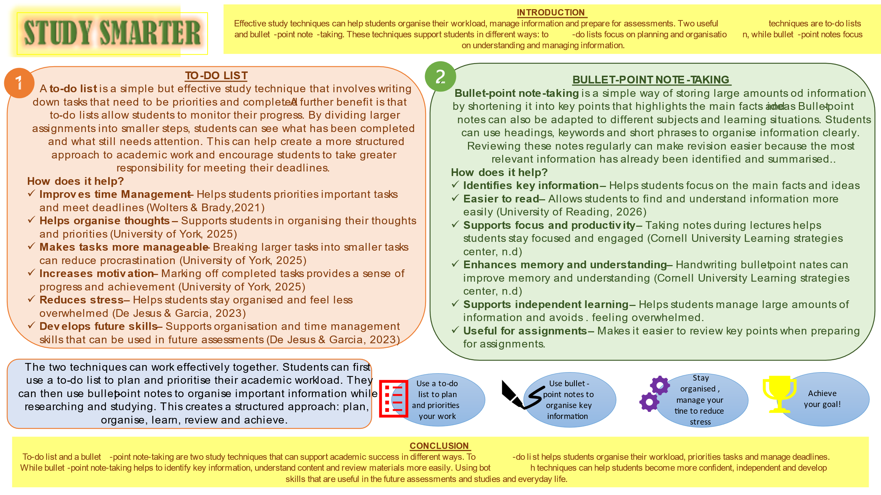
The poster above has a word count of 556
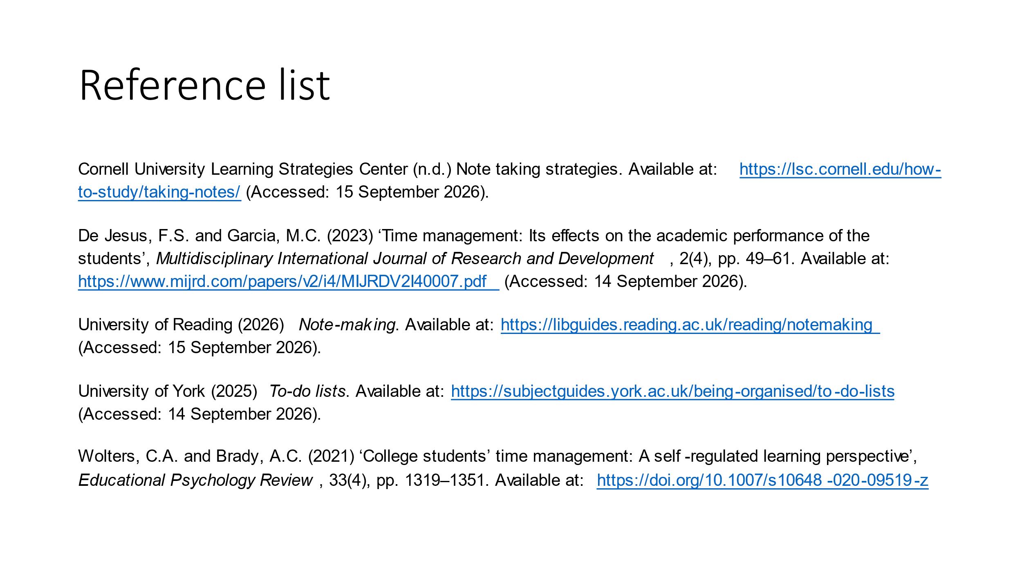

Reference list:
Cornell University Learning Strategies Center (n.d.) Note taking strategies. Available at: https://lsc.cornell.edu/how-to-study/taking-notes/ (Accessed: 15 September 2026).
De Jesus, F.S. and Garcia, M.C. (2023) ‘Time management: Its effects on the academic performance of the students’, Multidisciplinary International Journal of Research and Development, 2(4), pp. 49–61. Available at: https://www.mijrd.com/papers/v2/i4/MIJRDV2I40007.pdf (Accessed: 14 September 2026).
University of Reading (2026) Note-making. Available at: https://libguides.reading.ac.uk/reading/notemaking (Accessed: 15 September 2026).
University of York (2025) To-do lists. Available at: https://subjectguides.york.ac.uk/being-organised/to-do-lists (Accessed: 14 September 2026).
Wolters, C.A. and Brady, A.C. (2021) ‘College students’ time management: A self-regulated learning perspective’, Educational Psychology Review, 33(4), pp. 1319–1351. Available at: https://doi.org/10.1007/s10648-020-09519-z (Accessed: 14 September 2026).

