BUBBLES CAR WASH

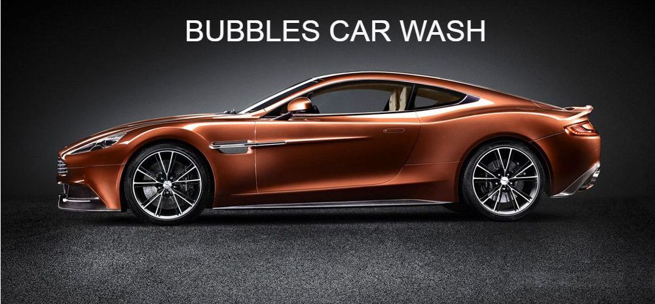

INTRODUCTION
In this presentation I will describe the website I created. As a fully insured valeting and detailing company, we employ the latest techniques and very best products to get exceptional results, safely, every time! Cleanliness is very important, especially that of vehicles because we spend more and more time every day being an indispensable thing.
ABOUT
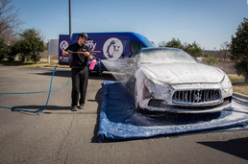

BUBBLES CAR WASH is Bristol's premier mobile car valeting / vehicle valet company, offering a range of services for cleaning your car or commercial vehicle. We offer a cost effective, professional car and commercial vehicle valeting service throughout Bristol area and beyond. We do not operate from a premises but we are fully mobile and can carry out work at your place of work home. We offer a wide range of diversified plans to suit everyone.
We at BUBBLE CAR WASH Care pride ourselves on the service we offer our clients. A prompt reliable service, no job is too big or small; from cleaning spilt milk to the complete restoration of a motor home. We are trustworthy and reliable, which is so important when entrusting such an important part of your life to us.
NOW OFFERING FOG-IT - Fog-It is an odour and bacterial removal system for your car – price of £30 must be carried out with an interior valet.
Fog-It is a unique form of sanitising and deodorising that totally destroys all foul odours including tobacco, smoke damage, milk spills, urine, vomit, mould, mildew, sweat, pet smells etc. At the same time Fogit attacks and destroys all germs and bacteria such as the Norovirus (Winter Vomiting Disease), E-coli, MRSA, and replaces them with a long lasting freshness. It leaves your vehicle smelling much nicer and germ free. Using a pre-wash and pressure washer or hose allows the bulk of the grit stuck to the bodywork to be removed without the risk of dragging it across a panel, damaging the paint. All products make foam and clean, so we focused on those among our rivals that left the least water to be dried off with a chamois or microfibre cloth. We also looked at the cost of the products, because the price of a bucket of wash can vary significantly.
NOW OFFERING RUG CLEANING FROM £25 - (10%) FOR STUDENTS AND OLDER PEOPLE.
LOCATION
The location is most important aspect in predicting a car wash success. Ideally, a car wash should be situated on a thoroughfare which possesss a heavy volume of traffic often referred to as traffic count .We are located near the mall in Cribbs Causeway this offering customers a diverse range of recreation and shopping.
LOGIN DETAILS:
ID: 1912870@gmail.com
Passoword:dob21.10.89

