

Programme: Master of Business Administration
Module: LCMB7003 Strategic Management
Assignment Title: Individual Report
Strategic analysis of Toyota (GB) PLC with regard to the United Kingdom market.
Student Name: Omkar Shinde
Student ID: 2526513
Group:3
Lecturer: Amare Desta/ Ghulam Mujtaba

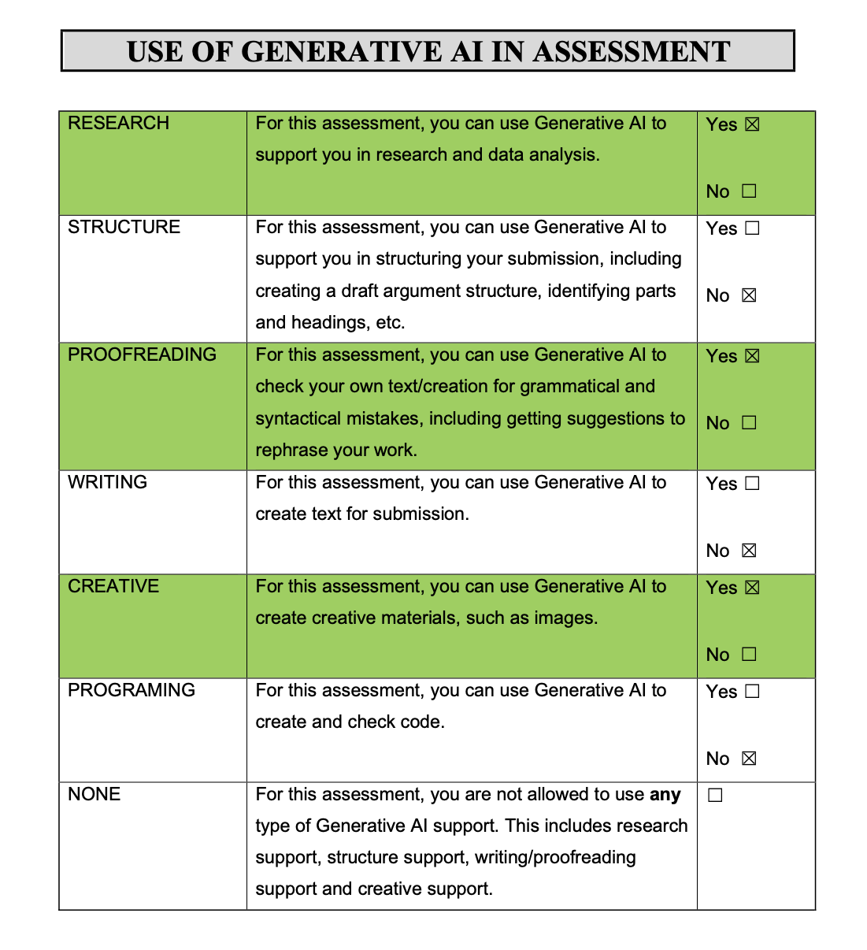
Generative AI Use Acknowledgement
I confirm that Generative AI was applied during this assessment to aid in research and data analysis, proofreading and enhancing grammar, and production of some visuals. The assignment was not developed using AI. All sources have been individually checked, and the analysis, arguments and written product are my own. I also I used for the image generation for Gemini and ChatGPT.
Table of Contents
Introduction 4
Organisational context and overview. 4
2. External and Internal Analysis 6
2.1 PESTEL Analysis 6
2.2 Internal Environment Analysis (VRIO Framework) 12
2.3 SWOT Analysis 15
3. Comprehensive and Holistic View of the Organisation 17
3.1 Corporate Social Responsibility (CSR) Strategy and Alignment with Business Objectives 17
3.2 Balanced Scorecard Analysis 18
4. Strategic Choices and Implementation 21
4.1 Business-Level Strategic Choices 21
4.2 Porter's Five Forces Analysis 21
4.3 Ansoff Matrix Analysis 23
4.4 SAFe Framework Evaluation 25
4.5 Strategy Implementation, Challenges and Recommendations 27
Conclusion 28
Reflective Account (Gibbs' Reflective Cycle) 29
References 31

Introduction

The report offers a strategic analysis of Toyota (GB) PLC with regard to the United Kingdom market. With its focus on quality, innovation, and sustainable mobility, Toyota has made a strong impression in the UK as one of the world's leading automotive manufacturers. This report, in the role of a strategic management consultant, will analyse Toyota UK's external and internal business environment, competitive advantage, corporate social responsibility and strategic performance to assess the current strategic position of Toyota UK. It also offers recommendations to enhance the company's future competitiveness and finishes with a Gibbs reflective account of the research, analysis and report preparation process.

Organisational context and overview.

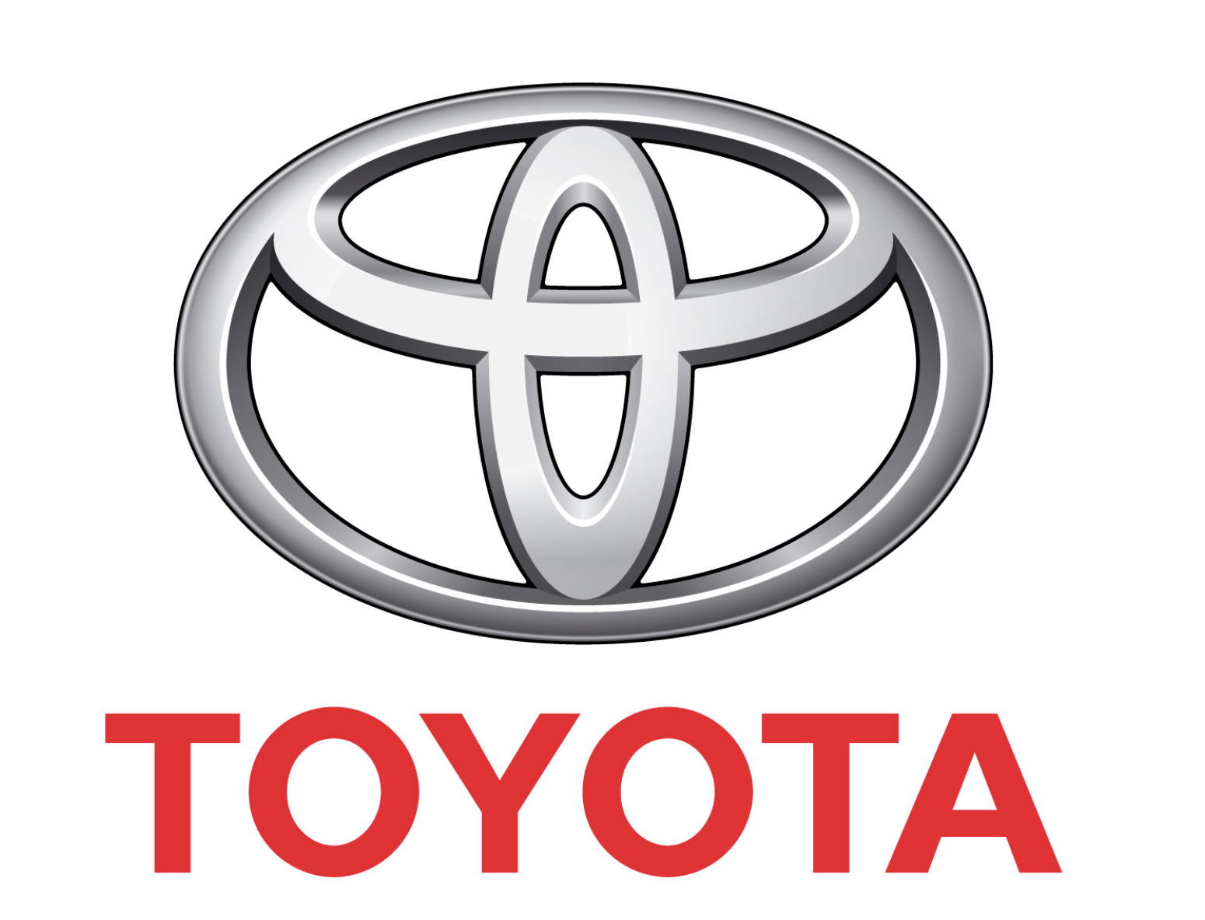
Source:https://media.toyota.co.uk/toyota-gb-plc-pr-and-social-media-team-and-the-general-data-protection-regulations/

Toyota Motor Corporation was founded by Kiichiro Toyoda in 1937 in Japan and is today one of the world's leading and most reputable automotive companies. The company is known throughout the world for its quality, Continuous Improvement (Kaizen) philosophy, innovation and environmental responsibility. Toyota came to the UK in the 1960s and built on its market strength with manufacturing plants at Burnaston, Derbyshire and Deeside, North Wales, in the early 1990s. Today, Toyota (GB) PLC sells, markets and distributes Toyota and Lexus vehicles throughout the UK, with a network of dealers and major investments in hybrid and electrified vehicle technologies (Toyota, 2025).

Toyota's vision is to deliver safe, reliable, innovative mobility solutions to improve the quality of life for customers and create long-term value for society. It has a vision of realizing carbon neutrality, fostering sustainable mobility and providing "Mobility for All" with technological innovation and responsible business (Toyota Motor Corporation, 2025). Toyota UK's strategic goals are embodied in its continued investment in hybrid, plug-in hybrid, battery electric and hydrogen fuel-cell technology, which is helping the UK move towards low emission transport.

Toyota UK's business model is customer-centric with revenue coming from the sale of new and approved used cars, after-sales services, vehicle parts, vehicle finance, insurance products and fleet management. The company generates value through its advanced manufacturing, ongoing innovation, lean supply chain and outstanding customer service. Toyota's strong relationships with suppliers, dealerships and technology providers further strengthen the company's capability to provide high-quality products and maintain operational efficiency.

The organisation is located in a highly competitive UK automotive sector, which is undergoing a massive transformation as the vehicle industry becomes increasingly electric, digitalised, consumer-driven and environmentally regulated. Toyota rivals such as traditional car makers as Volkswagen, Ford, Nissan, Hyundai, BMW, and Mercedes-Benz, as well as new electric vehicle makers like Tesla. Toyota holds a strong competitive position in the UK despite the fierce competition, owing to its reputation for reliability, product quality, technological leadership in hybrid cars, and its strong commitment to sustainability. The strengths offer a strong strategic base to remain competitive and to adjust to the fast evolving automotive market.

2. External and Internal Analysis

2.1 PESTEL Analysis

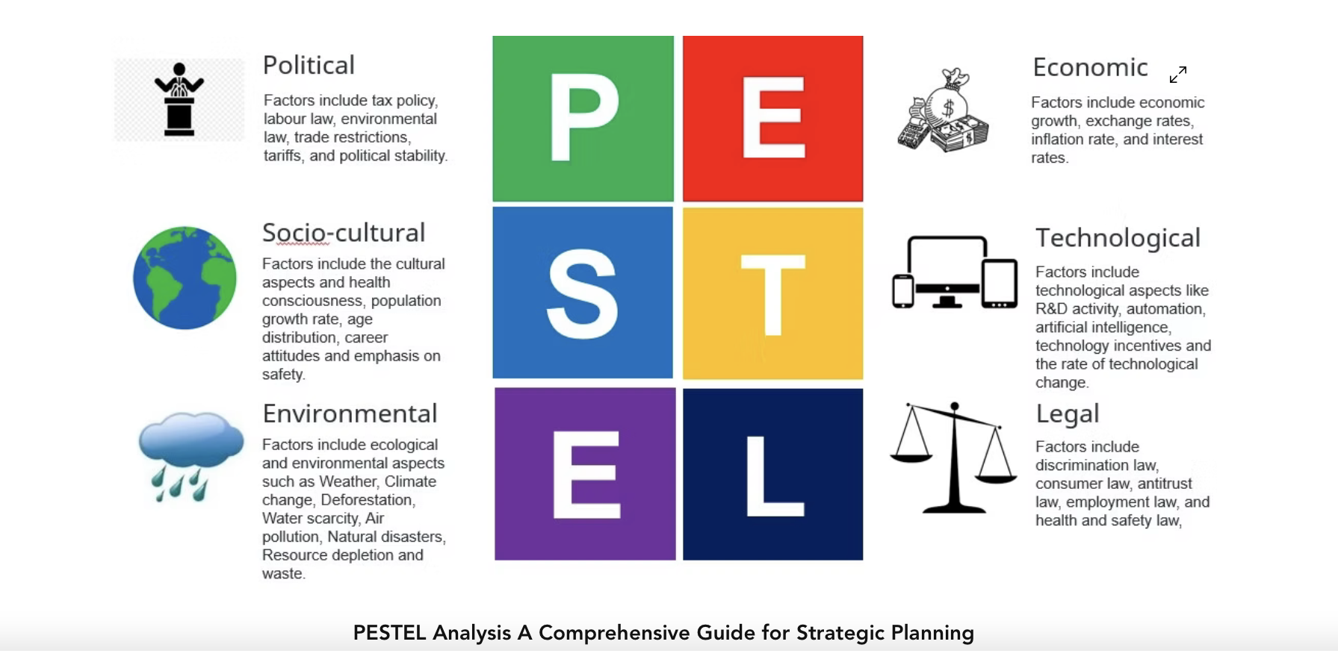
Source: https://www.projectmanagertemplate.com/post/pestel-analysis-a-comprehensive-guide-for-strategic-planning

Political Factors
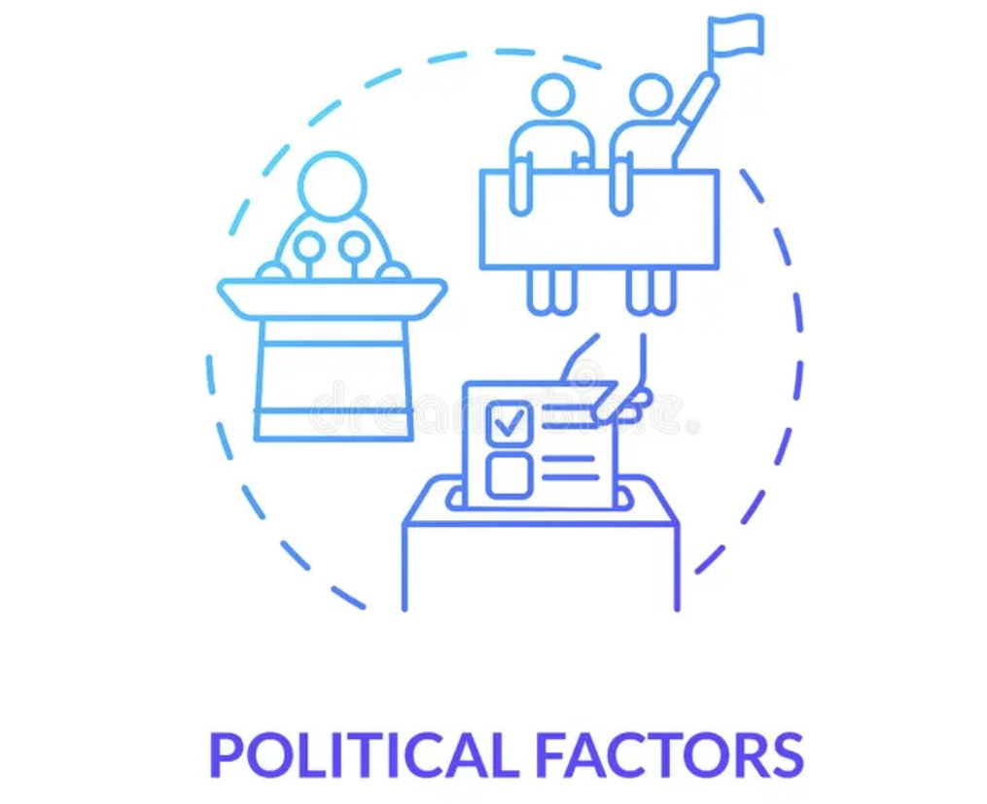
Source:https://www.dreamstime.com/political-factors-concept-icon-political-factors-concept-icon-pestel-analysis-plan-election-program-choosing-business-troubles-image196518110

Political and regulatory changes have a significant impact on Toyota UK's strategic context. The UK Government's goal of becoming net zero in greenhouse gas emissions by 2050 and the Zero Emission Vehicle (ZEV) Mandate is driving the shift towards electric mobility (Department for Transport, 2025).
Toyota has a strong level of knowledge in hybrid technology, which gives them an advantage; but with the growing demand for battery electric vehicles (BEVs) more investment is needed to stay competitive. Brexit has also posed a challenge due to the new UK-EU trade agreements and the added complexity and costs to manufacturers who use European parts in their supply chains (House of Commons Library, 2024).
To counter this, Toyota has worked to enhance the resilience of their supply chains by bolstering supplier ties and diversifying sourcing. In addition, the government's investment in charging infrastructure and promotion of low-emission vehicles provide opportunities for Toyota to grow its EV business. In summary, Toyota's long-term competitiveness will rely on its capacity to adjust to changing regulations and persist in investing in sustainable and innovative mobility solutions.

2.2 Economic Factors
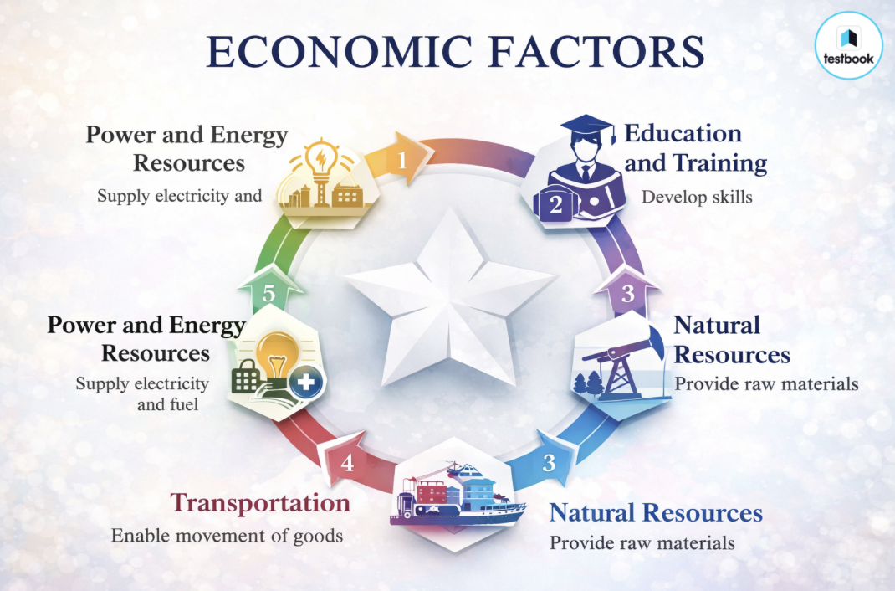
Source:https://testbook.com/ugc-net-commerce/economic-factors-can-be-converted-into-a-business-opportunity

The economy has a strong impact on consumer buying habits and the UK automotive industry. Consumers have less purchasing power due to high inflation and interest rates, driving up demand for low cost and low fuel consumption cars and making vehicle financing more expensive (Bank of England, 2025).
This poses challenges and opportunities to Toyota UK. With its reputation for reliability, fuel efficiency, and low ownership costs, the hybrid vehicles are an attractive option for consumers who are looking for long-term savings. The fact that Toyota is a global supply chain also means that the firm's production costs and profitability can be impacted by exchange rate movements. To mitigate these risks, Toyota has enhanced its manufacturing processes at both the Burnaston and Deeside facilities and diversified its supply chain (Toyota Motor Corporation, 2025).
In addition, with the increased demand for hybrid and electric cars, and government investment in sustainable transport, there are also good growth opportunities (SMMT, 2025).
Toyota, however, will need to continue to balance out these factors of affordability, innovation and operational efficiency in order to stay competitive in the face of inflationary pressures and economic uncertainty.

2.3 Social Factors
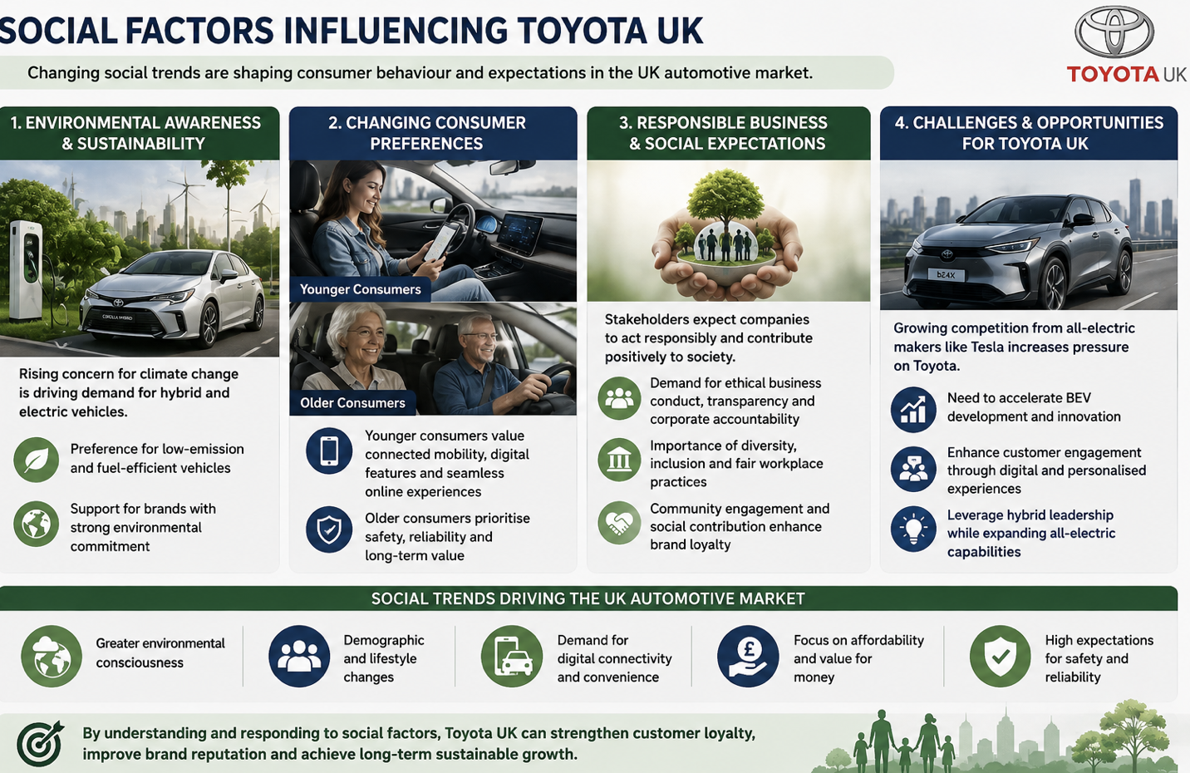
Source: Created by own

The automotive sector in the UK is undergoing a transformation, as social trends drive consumers to value environmental sustainability, digital connectivity, affordability, and vehicle reliability. As climate change becomes more of a concern, there has been a rise in demand for hybrid and electric cars, which provides an opportunity for Toyota UK to leverage its expertise in hybrid technology and its reputation for manufacturing fuel-efficient, reliable vehicles (Department for Transport, 2024).
Additionally, demographic shifts have an impact on consumer preferences, with younger consumers looking for connected mobility and digital purchasing experiences, while older consumers remain focused on safety and reliability (Toyota Motor Corporation, 2025).
Also, the increasing demands for corporate social responsibility, ethical business conduct and workplace diversity have made sustainability a factor to consider when it comes to customer loyalty. The company's efforts to reduce carbon footprint, engage with the community and make sustainable manufacturing practices underscore its corporate reputation (Toyota (GB) PLC, 2025).
But, as competition from all-electric car makers like Tesla grows, Toyota needs to speed up the development of BEVs, and continue innovating and improving customer engagement.

2.4 Technological Factors
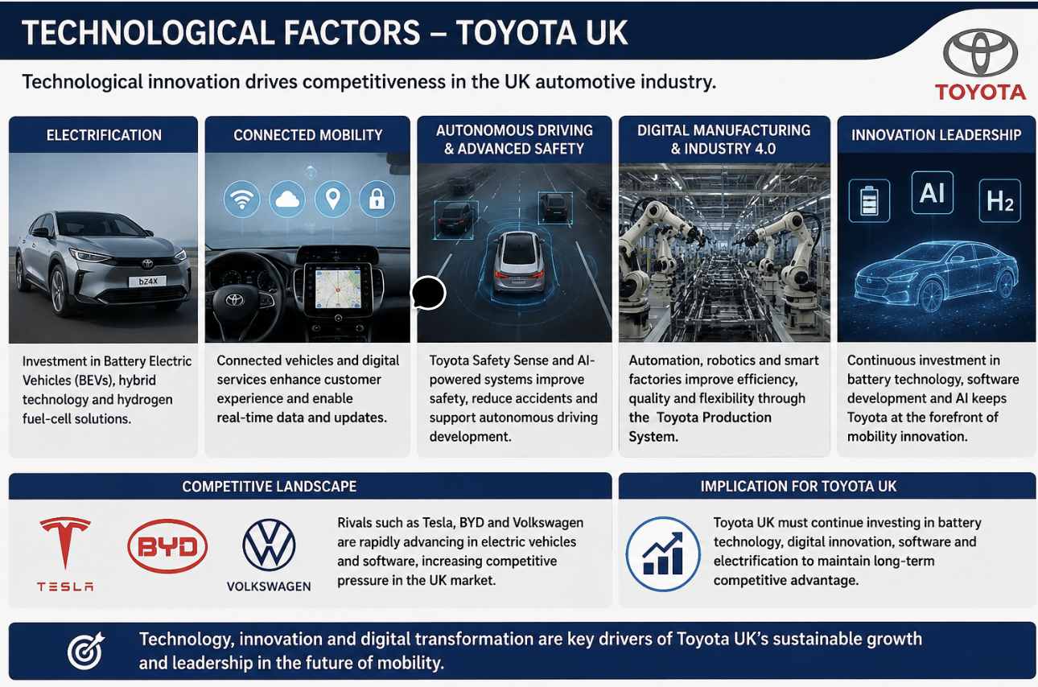
Source: created by own

Technological innovation plays a crucial role in the competitive advantage of the UK automotive industry. The automotive sector is undergoing a transformation – driven by innovations in electrification, artificial intelligence (AI), connected vehicles, autonomous driving, and digital manufacturing – vehicle production and customer expectations are changing. Toyota UK's long-term sustainability goals have been bolstered by its leadership in hybrid technology and sustained investment in battery electric vehicles (BEVs), hydrogen fuel-cell technology, connected mobility services, and advanced safety systems, which provide a competitive edge (Toyota Motor Corporation, 2025).
Automation, robotics, predictive maintenance, and Industry 4.0 technologies have further enhanced operational efficiency, cutting costs, boosting quality, and bolstering manufacturing performance via the Toyota Production System (Toyota Motor Corporation, 2025). But other rivals including Tesla, BYD and Volkswagen are quickly closing the gap on the electric vehicle and software side, adding pressure (International Energy Agency, 2025). So Toyota UK needs to keep investing in battery technology, digital innovation and software development to stay competitive in the long term.

2.5 Environmental Factors
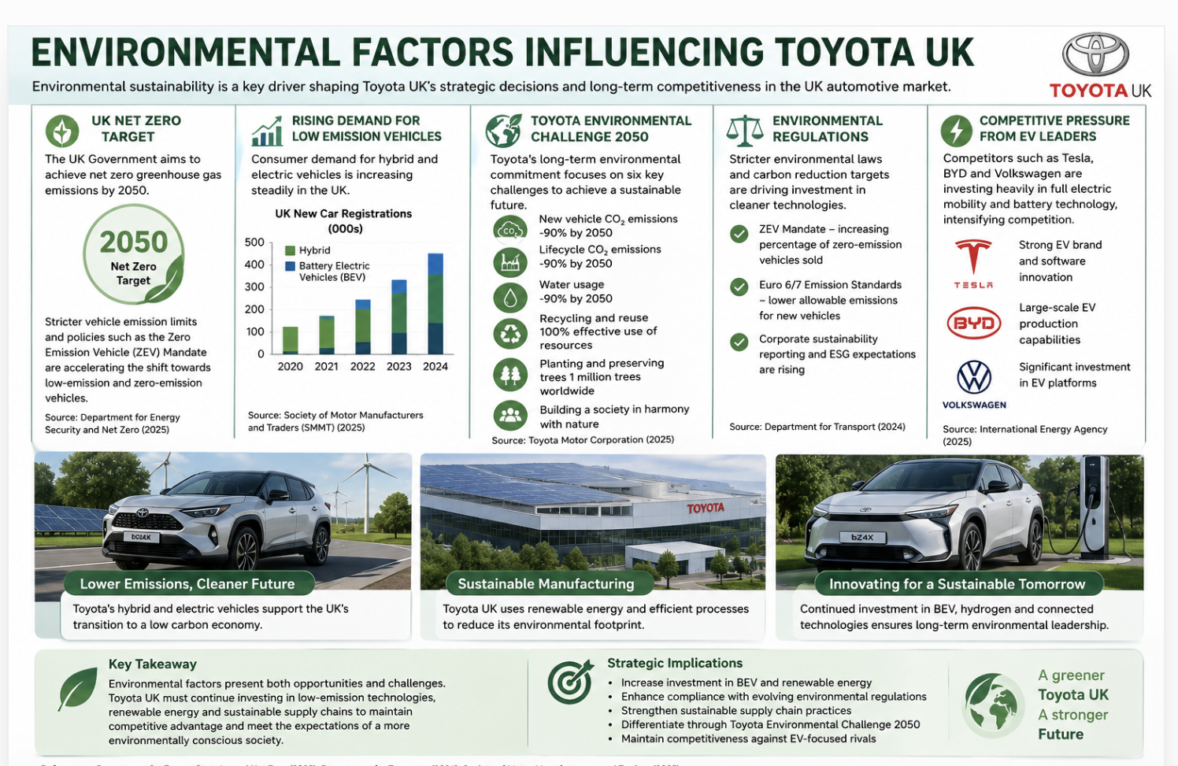
Source: Created by Own
The environment has a profound influence on the strategic decisions of Toyota UK in its transition towards sustainable mobility in the UK car industry. The UK's ambition of becoming net zero for GHGs by 2050 and tougher vehicle emission limits have helped spur demand for LZEV, providing growth opportunities for Toyota UK (Department for Energy Security and Net Zero, 2025). Toyota backs these goals with its Toyota Environmental Challenge 2050, which focuses on hybrid, plug-in hybrid, battery electric, and hydrogen technologies and the company's energy efficiency in its UK manufacturing process (Toyota Motor Corporation, 2025).
But with the growing share of battery electric vehicles and stricter environmental laws, competition from Tesla, BYD and other carmakers, who have poured considerable resources into the full electric mobility sector, is rising (International Energy Agency, 2025). To ensure their long-term competitiveness and reinforce their environmental leadership, Toyota UK is therefore continuing to develop their battery electric technologies, renewable energy initiatives and sustainable supply chain practices.

2.6 Legal Factors

The UK automotive sector is subject to a wide range of laws and regulations across various areas, including vehicle safety, environmental protection, employment, consumer rights, and data privacy. These regulations have a big impact on Toyota UK's strategy and operating procedures. One of the major legal advancements is the Zero Emission Vehicle (ZEV) Mandate, which obligates manufacturers to increase the sales of ZEVs annually or incur financial penalties (Department for Transport, 2025).
Toyota's know-how in hybrid technology gives them a competitive edge, but further investment in battery electric vehicles is necessary to meet future regulations. As connected vehicles gather more and more customer data, Toyota UK is also required to adhere to the UK General Data Protection Regulation (UK GDPR) and the Data Protection Act 2018. Thus, robust data governance and cybersecurity are essential to keep customers' trust (Information Commissioner's Office, 2025).
Toyota's strong governance, quality management practices, and adherence to regulations are likely to enable the company to adjust to future legal shifts and maintain its competitive edge (Toyota Motor Corporation, 2025).

2.2 Internal Environment Analysis (VRIO Framework)
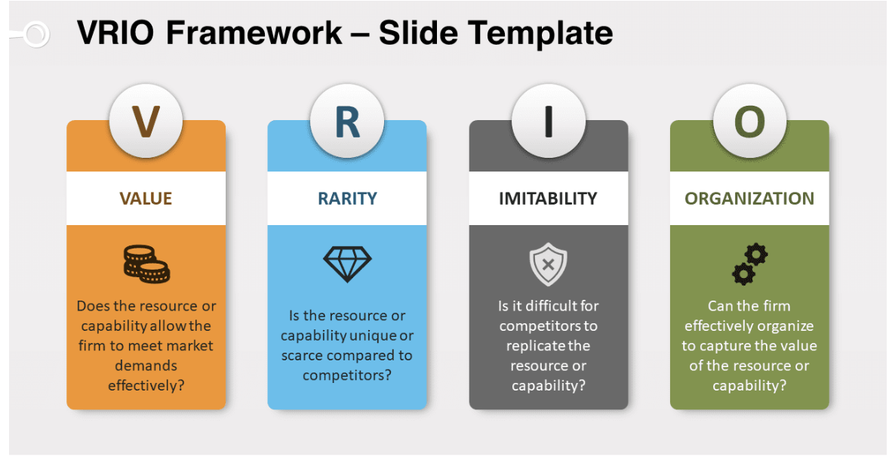
Source: https://www.presentationgo.com/presentation/vrio-framework-powerpoint-google-slides/

Barney (1991) developed an evaluation tool called VRIO to determine if an organisation's resources and capabilities can create a sustainable competitive advantage. The framework evaluates resources according to four criteria: Value, Rarity, Imitability and Organisation. Resources that meet all four criteria are likely to lead to long-term competitive advantage and superior organisational performance. Toyota UK's market position in the UK automotive market is strong, due to a number of strategic resources.

Toyota UK's most important asset is its brand reputation. The Toyota brand has been built over decades of providing customers with high quality, reliable, and fuel efficient vehicles, and has created trust and loyalty. This reputation can generate a lot of value by mitigating the perceived risk of customers who want to buy the product, while also allowing for premium prices and repeat sales. Other car companies have excellent and reputable brands, but Toyota's brand of reliability and quality is relatively scarce and hard to emulate as it has been built through the steady consistency of operational excellence and lasting customer satisfaction. The organisation further builds on this strength by marketing well, having dealership networks and providing after sales services, thus showing that the resource is well supported by capabilities within the organisation.

Another important ability is the Toyota Production System (TPS), which is a manufacturing system that is considered one of the most influential manufacturing systems in the world. Lean Manufacturing concepts, including continuous improvement (Kaizen), Just in Time production and waste minimisation, are applied throughout TPS to ensure that operations are as efficient as possible with a focus on exceptional product quality. While many competitors have embraced some aspects of lean manufacturing, it is very difficult to duplicate Toyota's employee engagement, organisational culture and decades of accumulated operational knowledge. Therefore, TPS remains a competitive advantage to Toyota UK as it increases productivity, decreases the cost, and enhances flexibility in manufacturing (Liker, 2021).

Toyota's strong research and development (R&D) investment and hybrid vehicle technology are also valuable assets. Toyota has a long history of research and development in the commercial hybrid vehicle market, and gained considerable expertise, patents and engineering knowledge that has made Toyota a leader in low emission mobility. But the rise of battery electric vehicle producers like Tesla and BYD has made hybrid technology less of a rarity, and Toyota is betting more on both battery electric and hydrogen technologies to ensure its continued technological dominance. However, Toyota's financial strength, international research and development facilities and innovation capabilities are well-equipped to thrive in the future of technological advancements (Toyota Motor Corporation, 2025).

Toyota UK's own human resources and culture also reinforce their internal capabilities. This culture of operational excellence, based on continuous learning, empowering employees, team spirit and problem solving, enables the company to innovate and continuously improve. It has been created in many decades and is ingrained in Toyota's operations around the world. These skills, when coupled with lean organisation and effective leadership, helps Toyota UK to make good use of its valuable assets and meet the external changes to the business environment.

The VRIO analysis overall suggests that the most significant sustainable competitive advantage that Toyota UK has is its reputation of being a well-known brand internationally, its Toyota Production System, its organisational culture and its ability to innovate. The company has a good competitive position as these resources meet most or all of the VRIO criteria and this helps the company to stay competitive in the UK automotive sector, which is becoming more technologically disrupted and competitive.

2.3 SWOT Analysis
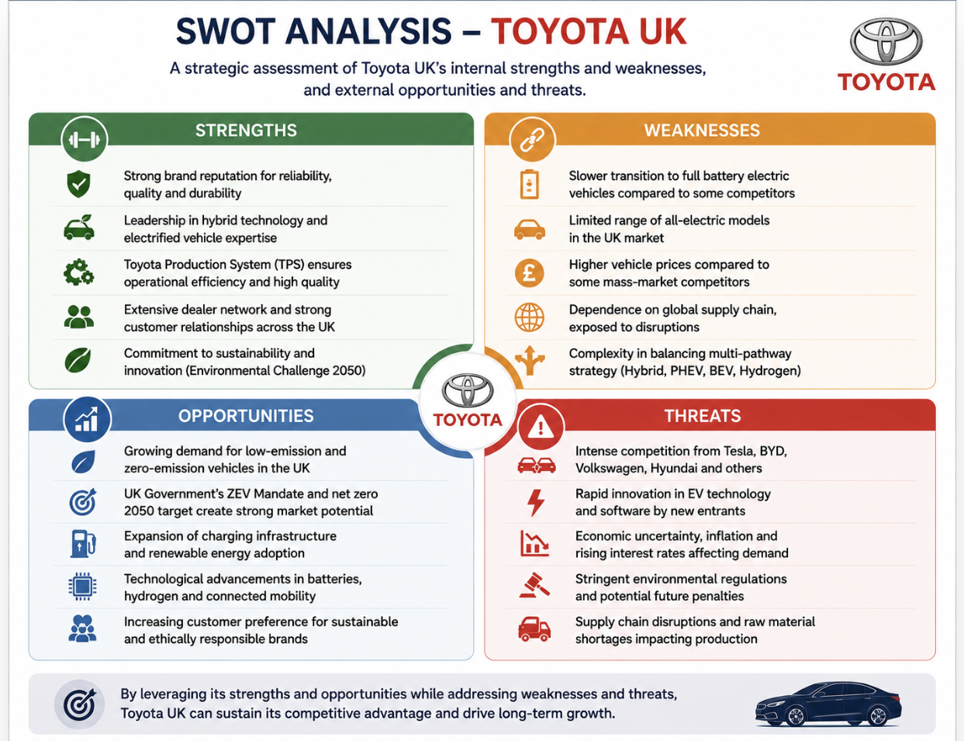
Source: Created by own

The SWOT framework brings together the results of the external (PESTEL) and internal (VRIO) analyses to give a full picture of Toyota UK's strategic position. It highlights the organisation's strengths and weaknesses, and external opportunities and threats that will affect the organisation's ability to be competitive in the long-term. The analysis indicates that Toyota UK has a number of sustainable competitive advantages, such as its global brand recognition, operational excellence and the fact that it is a leader in the field of hybrid technology (Barney, 1991; Toyota Motor Corporation, 2025). But the organisation is also under mounting pressure due to the fast pace of EV technologies, growing consumer expectations, and the growing competition in the automotive market (IEA, 2024; Gürel and Tat, 2017). Thus, Toyota's future will hinge on the ability to use its own strengths and react to new market opportunities and threats.

Strengths | Weaknesses
Globally recognised and trusted brand with a strong reputation for quality and reliability (Toyota Motor Corporation, 2025). | Slower adoption of battery electric vehicles (BEVs) compared with competitors such as Tesla and BYD (IEA, 2024).
Toyota Production System (TPS) delivers high operational efficiency, cost control, and product quality (Barney, 1991). | Heavy historical dependence on hybrid technology while consumer demand increasingly shifts towards fully electric vehicles (McKinsey & Company, 2023).
Strong financial position supporting investment in research, innovation, and sustainability initiatives (Toyota Motor Corporation, 2025). | Higher research and development costs associated with multi-pathway strategy (hybrid, hydrogen, BEVs) (Deloitte, 2024).
Advanced manufacturing capabilities and efficient global supply chain (Barney, 1991). | Limited presence in the premium electric vehicle segment compared with competitors (IEA, 2024).
Long-standing expertise in hybrid technology and low-emission mobility solutions (Toyota Motor Corporation, 2025). | Supply chain complexity and exposure to semiconductor shortages and geopolitical risks (World Economic Forum, 2023).
Table 1: SWOT Analysis of Toyota UK

Opportunities | Threats
Increasing UK demand for electric and low-emission vehicles driven by environmental awareness (UK Government, 2023). | Intense competition from established manufacturers and EV disruptors such as Tesla, BYD, Hyundai, and Volkswagen (IEA, 2024).
Government incentives and investment supporting zero-emission vehicle adoption and charging infrastructure (UK Department for Transport, 2024). | Rapid technological change requiring continuous investment in innovation and digital transformation (Deloitte, 2024).
Expansion of connected mobility services, digital customer experiences, and autonomous vehicle technologies (McKinsey & Company, 2023). | Increasingly stringent environmental regulations and Zero Emission Vehicle (ZEV) mandates increasing compliance costs (UK Government, 2023).
Growing consumer preference for sustainable and environmentally responsible brands (NielsenIQ, 2022). | Inflation, supply chain disruptions, and fluctuating exchange rates affecting production costs and profitability (World Bank, 2024).
Opportunities to strengthen partnerships in renewable energy, battery technology, and hydrogen mobility (IEA, 2024). | Global economic uncertainty and changing consumer purchasing behaviour reducing demand for new vehicles (Deloitte, 2024).

According to the SWOT analysis, Toyota UK has a high level of brand equity, operational excellence, and reputation for innovation (Barney, 1991; Toyota Motor Corporation, 2025), which puts the company in a strategic position. However, maintaining this competitive position will need to rely on new opportunities in the fast-expanding EV market and weaknesses in battery electric vehicle development (BEVD) (IEA, 2024). At the same time, Toyota needs to proactively respond to external challenges by leveraging technological innovation, supply chain agility, and sustainable mobility investments (McKinsey & Company, 2023). These results offer a solid basis for the Toyota UK's strategic overall performance in the following section, which briefly covers Toyota UK's corporate social responsibility strategy and Balanced Scorecard.

3. Comprehensive and Holistic View of the Organisation

3.1 Corporate Social Responsibility (CSR) Strategy and Alignment with Business Objectives
Corporate Social Responsibility (CSR) is a key pillar of Toyota UK's strategic management and is not seen as a separate philanthropic activity, but as a fundamental part of the Company's long-term business goals and sustainability. Toyota's CSR strategy supports its vision to become carbon neutral, enhance mobility, and drive sustainable value for society, thereby reinforcing its competitive edge and fulfilling the expectations of customers, regulators, investors, and the local community (Toyota Motor Corporation, 2025).
Toyota UK's CSR efforts are based on the Toyota Environmental Challenge 2050, which includes carbon emissions reduction, resource efficiency, circular economy and the development of hybrid, battery electric and hydrogen vehicle technologies. The company has also enhanced manufacturing efficiency by cutting energy consumption, water usage and waste from manufacturing at its Burnaston and Deeside factories (Toyota (GB) PLC, 2025). These programs are all indicative of sustainability being part of Toyota's business approach instead of as CSR programs.
In addition to environmental programs, Toyota supports employee development, diversity, health and safety and community partnerships. The Toyota Production System and Kaizen philosophy encourage learning and working with educational institutions to develop future engineering talent. These initiatives increase employee engagement, innovation and stakeholder relationships, which help to increase long-term organisational performance (Porter and Kramer, 2011).
From a strategic perspective, Toyota's CSR efforts align with its business goals of operational excellence, technological innovation, product quality, and customer confidence, as well as to boost brand reputation and regulatory compliance (Eccles, Ioannou and Serafeim, 2014). The company however has been criticized for a slower rate of growth in its BEV portfolio compared to other competitors like Tesla and BYD, which is putting pressure on the company to speed up electrification (International Energy Agency, 2024). Overall, Toyota UK's CSR strategy is effective in supporting sustainable competitive advantage, but further investments in battery electric technologies will be key to ensuring long-term market leadership.

3.2 Balanced Scorecard Analysis
Balanced Scorecard (BSC) was developed by Kaplan and Norton (1992) and is a strategic performance management system which conveys an organisation's vision into measurable goals, across four perspectives, Financial, Customer, Internal Business Processes and Learning and Growth. Recent research emphasizes that the BSC is still a good instrument to link sustainability, innovation, and long-term value creation with the organisation's strategy (Kumar et al., 2024; Madsen, 2025). The BSC is a tool that helps Toyota UK to achieve strategic alignment, as it balances financial performance, operational excellence, customer satisfaction, innovation, and employee development to achieve sustainable mobility and a long-term competitive advantage (Liker, 2021; Toyota Motor Corporation, 2025).

Table 2: Proposed Balanced Scorecard for Toyota UK
Perspective | Strategic Objectives | Key Performance Indicators (KPIs) | Strategic Targets | Key Initiatives
Financial | Improve profitability and revenue growth while maintaining cost efficiency. | Revenue growth, operating profit margin, return on investment (ROI), manufacturing cost per vehicle. | Increase annual revenue, improve operating margins, reduce production costs through lean manufacturing. | Expand electrified vehicle sales, strengthen cost management, improve manufacturing efficiency through the Toyota Production System (TPS).
Customer | Increase customer satisfaction, loyalty, and brand trust while expanding market share in electrified vehicles. | Customer Satisfaction Index (CSI), Net Promoter Score (NPS), customer retention rate, market share. | Improve customer satisfaction scores, increase hybrid and electric vehicle sales, strengthen customer loyalty. | Enhance digital customer experience, improve after-sales services, expand connected mobility solutions and customer engagement programmes.
Internal Business Processes | Improve operational excellence, innovation, quality, and supply chain resilience. | Production efficiency, defect rate, delivery lead time, inventory turnover, carbon emissions per vehicle produced. | Reduce production defects, improve delivery performance, lower operational emissions, strengthen supply chain resilience. | Invest in Industry 4.0 technologies, predictive maintenance, automation, digital supply chain management, and continuous improvement (Kaizen).
Learning and Growth | Develop employee capabilities, encourage innovation, and strengthen organisational culture. | Employee engagement score, training hours, innovation projects, staff retention rate. | Increase employee training, improve engagement, develop digital and sustainability skills, strengthen leadership capability. | Leadership development programmes, digital skills training, diversity and inclusion initiatives, continuous learning through Kaizen culture.

The Financial Perspective is about increasing the profitability of the company while keeping the operations efficient, with a strategic investment in electrified mobility and lean manufacturing. Toyota UK's vision is to sustain its revenue growth through an increase in hybrid and battery electric vehicle offerings and by enhancing production efficiency via the Toyota Production System (Toyota Motor Corporation, 2025). Those programs help to improve financial resilience in the face of growing competition and market uncertainty.
The Customer Perspective is focused on customer satisfaction, customer loyalty and customer relationship management. Toyota is known for its reliability, product quality, and customer service, which helps to retain customers and foster brand loyalty. The company remains committed to investing in digital customer experience and technologies that enable low-emission vehicles to satisfy the rising demand for connected and environmentally friendly mobility solutions (Toyota Motor Corporation, 2025; Liker, 2021).
The Internal Business Process Perspective focuses on Toyota's operational excellence based on the Toyota Production System (TPS), Continuous Improvement (Kaizen), Just in Time (JIT), automation and digital manufacturing technologies. All of these practices not only help to produce a better product and less waste, but they also help to strengthen the supply chain and lower production costs, thereby providing Toyota with a long-term competitive advantage (Liker, 2021; Toyota Motor Corporation, 2025).
The Learning and Growth Perspective acknowledges that the company's long-term success is driven by the people, culture and innovation of Toyota UK. Ongoing learning, leadership programs, digital skills, and knowledge sharing contribute to the adaptability of the organisation and innovation. Toyota's culture of continuous improvement is based on having employees participate in problem solving and organisational learning (Liker, 2021). In summary, the Balanced Scorecard illustrates how Toyota UK's strategic goals, activities, and metrics are interconnected, contributing to sustainable growth and long-term value creation for customers, employees, shareholders, and society (Toyota Motor Corporation, 2025).

4. Strategic Choices and Implementation

4.1 Business-Level Strategic Choices
Business-level strategy provides the answer to the question of how the organisation will compete for competitive advantage. According to Porter (1985), the three generic competitive strategies are: cost leadership, differentiation and focus. Toyota UK's main approach is a differentiation strategy which is underpinned by TPS. The company's strategy is to out-compete using high quality vehicles, reliability, fuel efficiency, innovation and strong after-sales service, not just on price alone (Liker, 2021; Toyota Motor Corporation, 2025). Yet, as the demand for battery electric vehicles and digital mobility continues to rise, and with growing competition from companies such as Tesla and BYD, there is a need for Toyota UK to reinforce its electrification strategy, while maintaining its operational excellence and brand reputation (International Energy Agency, 2024).

4.2 Porter's Five Forces Analysis
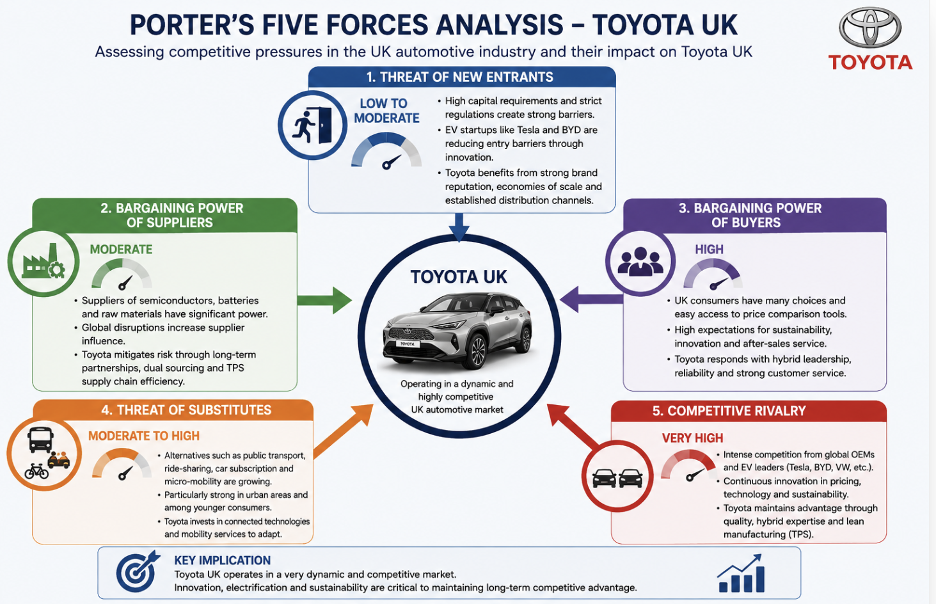
Source: Created by own

To analyse the competitive pressures in the UK automotive industry and its effects on Toyota UK's strategic position the Porter's Five Forces framework (Porter, 1980) is used. The study reveals a dynamic and competitive market driven by technological advancements and evolving consumer demands, with sustainability concerns playing a significant role.

Threat of New Entrants – Low to Moderate: There are high capital costs, strict regulations and strong brand requirements. But, with software and battery innovations, EV companies like Tesla and BYD have reduced the barriers to entry. Toyota enjoys a good brand reputation, has economies of scale, and has well-established distribution channels in the UK (Toyota Motor Corporation, 2025).

Bargaining Power of Suppliers – Moderate: The reliance on semiconductors, batteries, and raw materials heightens supplier power, particularly given the recent global disruptions (Deloitte, 2024). Toyota mitigates this risk by having long-term partnerships, dual sourcing, and Toyota Production System (TPS) that improves the efficiency of the supply chain (Liker, 2021).

Bargaining Power of Buyers – High: UK consumers have a lot of choice and can use price comparison websites to increase their bargaining power. The demand for EVs also comes with the expectations of sustainability and innovation (McKinsey & Company, 2023). In response, Toyota offers a hybrid leadership, reliability and robust after-sales service.

Threat of Substitutes – Moderate to High: Car ownership is becoming less desirable due to other modes of transport, like public transport, ride-sharing and micro-mobility, especially in cities (PwC, 2024). Toyota is making investments in connected technologies and mobility services to accommodate.

Competitive Rivalry – Very High: The intense competition from global manufacturers and EV leaders drives innovation in pricing, technology and sustainability (IEA 2024). Rapid EV expansion is crucial but Toyota retains its advantages in quality, hybrids and lean manufacturing.

In summary, Toyota UK is in a very dynamic market where innovation and electric vehicles are key.

4.3 Ansoff Matrix Analysis
Ansoff matrix (Ansoff, 1957) is a strategic planning matrix which can be used to identify the growth opportunities available to the organisation by considering existing products and markets, as well as new ones. It encompasses four strategies which are market penetration, market development, product development and diversification. For Toyota UK, it offers a valuable framework to deal with technological change, increased competition and the move towards sustainable mobility.
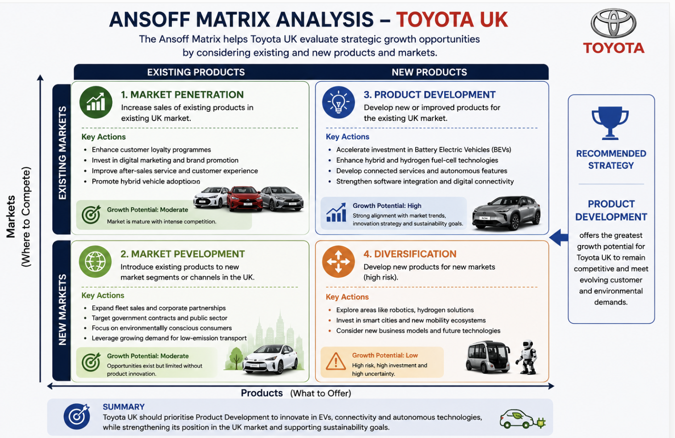
Source: Created by own

Market Penetration is to improve the sale of the same product in the same market. Toyota UK can fortify their position by making their customer loyalty programs better, investing more in digital marketing, enhancing after-sales services, and promoting hybrid vehicle adoption. This is because of its high reliability and efficiency. In the UK automotive market, however, this is not the only way to achieve long-term growth as the market is very mature (Toyota Motor Corporation, 2025).

Market Development is the introduction of a product into a new market or market segment. In the UK market, Toyota has the potential to grow fleet sales, corporate partnerships and government contracts, especially with the rising demand for low emission transport. There are opportunities for targeting environmentally aware consumers and organisations looking to cut carbon emissions (SMMT, 2025). But with no product innovation, this approach can only be moderately growth.

Product Development Toyota UK would be best suited by implementing. It is about developing new products or improved products for the existing market. As the demand for battery electric vehicles (BEVs), connected services, and autonomous technologies continues to grow, Toyota needs to speed up full EV investment and improve hybrid and hydrogen technologies. Digital connectivity and software integration will enable Toyota to stay competitive against Tesla, BYD and Volkswagen (IEA 2024; McKinsey 2023). This is in line with Toyota's innovation strategy.

Diversification is a high-risk strategy that entails new products and markets. While Toyota looks at topics like robotics, hydrogen, and smart cities with projects like Woven City, diversification in large-scale is not a priority given the costs and uncertainties (Toyota, 2025).

Overall, Product Development has the greatest growth potential, which will help Toyota UK stay competitive in the market and meet customer and environmental needs.

4.4 SAFe Framework Evaluation
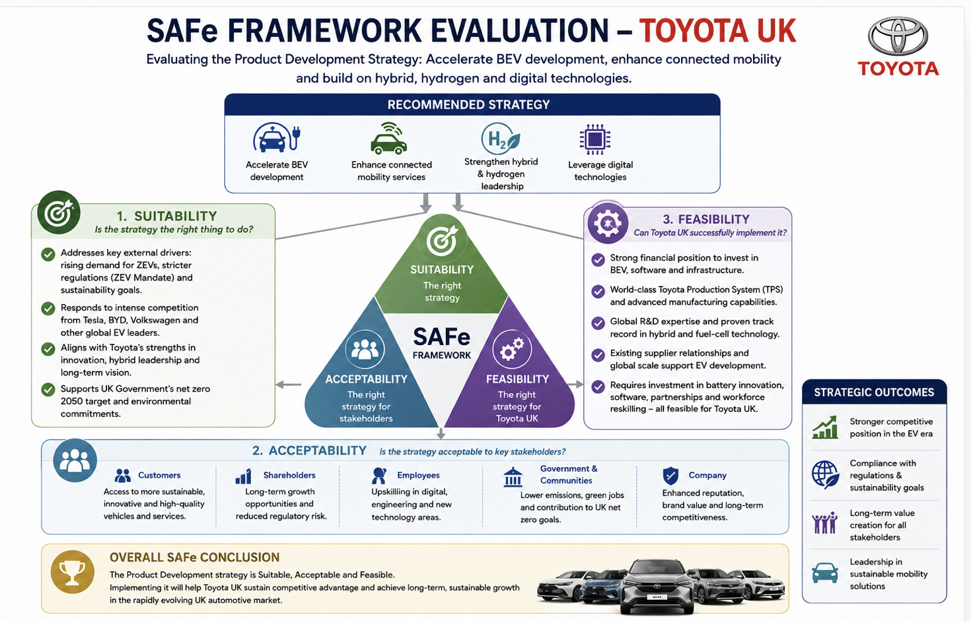
Source: Created by own

After analysing the external environment of Toyota UK, internal capabilities and strategic growth options, Product Development is identified as the most suitable strategy for the Toyota UK to sustain long-term competitive advantage. In particular, Toyota UK should speed up the development and commercialisation of battery electric vehicles (BEVs), boost connected mobility services, and continue to build on its existing leadership in hybrid and hydrogen vehicles and digital technologies. As developed by Johnson, Scholes and Whittington (2020), the SAFe framework offers a process to consider this recommendation by exploring Suitability, Acceptability and Feasibility.

Suitability

The strategy is very appropriate because it is a direct response to the key findings from the PESTEL, VRIO, SWOT, Porter's Five Forces and Ansoff analysis. Consumer demand for ZEVs is now accelerating in the UK and Government measures like the Zero Emission Vehicle (ZEV) Mandate are putting greater pressure on vehicle manufacturers to sell ZEVs (Department for Transport, 2025). Meanwhile, other manufacturers, such as Tesla, BYD, and Volkswagen, are pushing their EV lines with vigor (International Energy Agency, 2024). As a result, Toyota UK's increase of investment in BEVs and digital mobility solutions is consistent with market trends, regulatory requirements, and sustainability efforts, which will help maintain its competitiveness in an increasingly electric vehicle industry.

Acceptability

The strategy is agreed by the relevant stakeholders. Customers benefit from access to more sustainable, and technologically advanced vehicles, while shareholders see long-term growth prospects and decreased regulatory risk (Toyota Motor Corporation, 2025). Staff are upskilled in digital and engineering functions, and governments and communities benefit from reduced emissions. Although short-term R&D costs are high, long-term financial, environmental, and reputational gains outweigh these investments.

Feasibility

Toyota UK is well equipped to carry out this strategy, with financial strength, state-of-the-art manufacturing systems, global R&D capabilities and Toyota Production System (Liker, 2021). It also has a strong track record with hybrid technology and global supply chains, which will help develop EVs. Further investments in battery innovation, software, infrastructure partnerships, and workforce reskilling, however, will be needed. These requirements are feasible at Toyota, with their resources and culture of innovation.

The SAFe analysis overall suggests that the strategy is appropriate, acceptable, and feasible, which will help Toyota UK to maintain their competitive advantage and sustainable growth.

4.5 Strategy Implementation, Challenges and Recommendations

If Toyota UK are to implement their product development strategy successfully, it is important that there be a structured and phased approach which is in line with the innovations, the organisational capability and the long term goals. The Zero Emission Vehicle (ZEV) Mandate (Department for Transport, 2025) will be supported by accelerating the development of battery electric vehicles (BEVs), connected mobility services and digital technologies as identified in the SAFe evaluation, which will improve competitiveness and contribute towards compliance with the ZEV Mandate. It requires good leadership, investment, collaboration, and performance monitoring.

For the short term, Toyota UK should invest more in BEV research; further partnerships with battery and charging suppliers; and enhance software for connected vehicles. It should also incorporate Industry 4.0 technologies such as automation, AI, and predictive maintenance, which all enhance and optimize the manufacturing process (Toyota Motor Corporation, 2025).

Workforce development is key in the medium term. To adapt to the transition to electrified and software-driven cars, Toyota needs to invest in digital skills training, leadership development, and reskilling programmes. Kaizen gives a solid platform for the handling of this change (Liker, 2021).

The main difficulties are the need for significant capital investment, disruptions in the battery and semiconductor supply chain (Deloitte, 2024), the rapid pace of technological change and resistance from employees to change. To meet these, Toyota needs to establish long-term supplier relationships, partner with universities, improve change management and apply Balanced Scorecard monitoring for performance tracking (Kaplan and Norton, 1992).

Overall, a phased approach to BEV and digital innovation will help to increase Toyota UK's competitiveness, sustainability and market leadership.

Conclusion
This report has appraised Toyota UK's strategic position through an analysis of their external environment, internal capabilities, CSR, operations and strategic options. The results indicate that Toyota UK is highly competitive in the UK automotive sector, as a result of its worldwide brand reputation, Toyota Production System, innovation capability, and its quality and sustainability focus. It is also grappling with the challenges of rapid technological change, growing competition from both conventional manufacturers and new electric vehicle entrants, and more stringent environmental regulations, and changing consumer demand.
Product development, particularly for battery electric vehicles (BEVs) and connected mobility, was found to be the most appropriate strategy for long-term growth through the PESTEL, VRIO, SWOT, porter's five forces and SAFe frameworks. Although significant investment and capability development is required, Toyota UK has good resources and operational excellence to ensure implementation is successful. Its emphasis on innovation and sustainability will further solidify its market standing and competitive edge in the changing UK automotive landscape.

Reflective Account (Gibbs' Reflective Cycle)
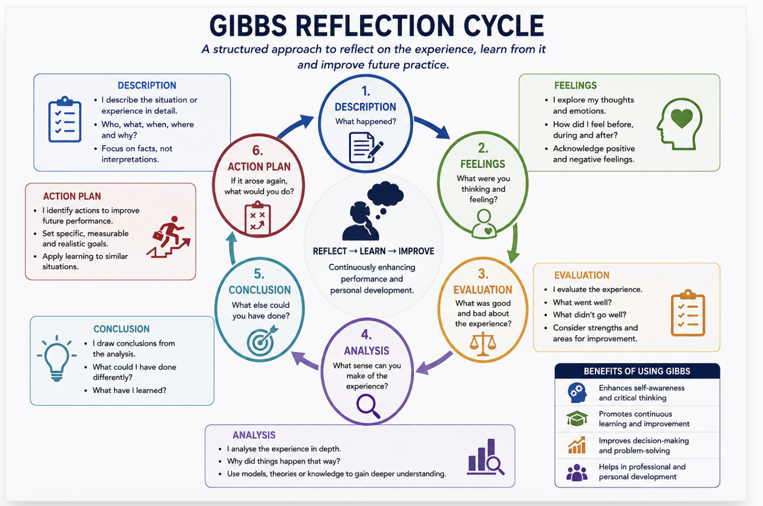
Source: Created by own

Description
As part of this assignment, I have analysed Toyota UK's strategic position using strategic management frameworks such as PESTEL, VRIO, SWOT, Porter's Five Forces, Ansoff Matrix, SAFe and the Balanced Scorecard. In addition, I looked through company reports and industry publications to assess Toyota UK's competitive landscape and provide strategic recommendations (Toyota Motor Corporation, 2025). Also, I used external market information to gain insight into the trends and sustainability pressures of the UK automotive industry, as well as on the manufacturers themselves (Deloitte, 2024).

Feelings
The assignment was difficult to start with as I had to interpret a lot of information and also relate the theoretical concepts with a real organisation. I didn't feel confident enough to go beyond descriptive writing to critical analysis. As I became more involved in the academic literature, however, I grew in confidence to connect theory with practice.
Evaluation
Through the research process, I gained a better understanding of strategic management and enhanced my systematic approach to assessing business problems. It took a long time, however, to choose the evidence that was relevant and to combine various strategic frameworks. I also knew that I had to get better at critically comparing sources, and not just describing them.

Analysis
The use of more than one framework helped me to grasp how external and internal factors affect the performance of an organisation and decision making. By reading academic papers and Toyota's Integrated Report, I gained a deeper insight into linking theory with practice and formulating evidence-based suggestions (Toyota Motor Corporation, 2025). I also noted how sustainability and innovation play a crucial role in Toyota's long-term planning and its efforts in developing electric vehicles and competing globally (Deloitte, 2024).

Conclusion
This assignment helped me develop my critical thinking, academic writing and Harvard referencing skills. It also boosted my confidence in analysing complex business situations and offering hands-on recommendations. Moreover, I now realize that it is essential to use several reliable sources to back up arguments in academic writing.
Action Plan
Future assignments will involve applying more recent peer reviewed research, better time management and enhancing critical evaluation skills. I will also try to obtain more academic and industrial sources to support my analysis and make my writing more critical. These enhancements will assist in my academic development and in making informed strategic decisions in my future management career.

References

Toyota (GB) PLC (2025) Sustainability reporting. Available at: Toyota UK Sustainability Reporting (Accessed: 25 July 2026).
Toyota Motor Corporation (2025) Integrated Report 2025. Available at: Toyota Integrated Report 2025 (Accessed: 25 July 2026).
Toyota Motor Corporation (2025) Mission, Vision and Corporate Philosophy. Available at: Toyota corporate reporting and philosophy (Accessed: 25 July 2026).
Department for Transport (2025) The UK Zero Emission Vehicle (ZEV) Mandate. London: Department for Transport. Available at: https://www.gov.uk/government/publications/the-zero-emission-vehicle-mandate (Accessed: 28 July 2026).
House of Commons Library (2024) The automotive industry and Brexit. Available at: https://commonslibrary.parliament.uk/ (Accessed: 28 July 2026).
Bank of England (2025) Monetary Policy Report – February 2025. London: Bank of England. Available at: https://www.bankofengland.co.uk/monetary-policy-report/2025/february-2025 (Accessed: 28 July 2026).
Society of Motor Manufacturers and Traders (SMMT) (2025) UK Automotive Performance Report 2025. London: SMMT. Available at: https://www.smmt.co.uk/reports/ (Accessed: 28 July 2026).
Toyota Motor Corporation (2025) Integrated Report 2025. Available at: https://global.toyota/en/ir/library/annual/(Accessed: 28 July 2026).
Department for Transport (2024) Transport Decarbonisation Plan: Annual Progress Report. London: Department for Transport. Available at: https://www.gov.uk/government/publications/transport-decarbonisation-plan (Accessed: 28 July 2026).
Toyota (GB) PLC (2025) Sustainability Reporting. Available at: https://www.toyota.co.uk/discover-toyota/sustainability/governance/reporting (Accessed: 28 July 2026).
Toyota Motor Corporation (2025) Integrated Report 2025. Available at: https://global.toyota/en/ir/library/annual/(Accessed: 28 July 2026).
International Energy Agency (IEA) (2025) Global EV Outlook 2025. Paris: International Energy Agency. Available at: https://www.iea.org/reports/global-ev-outlook-2025 (Accessed: 29 July 2026).
Toyota Motor Corporation (2025) Integrated Report 2025. Available at: https://global.toyota/en/ir/library/annual/(Accessed: 29 July 2026).
Toyota Motor Corporation (2025) Sustainability Data Book 2025. Available at: https://global.toyota/en/sustainability/report/ (Accessed: 29 July 2026).
Department for Energy Security and Net Zero (2025) Net Zero Strategy: Build Back Greener. London: HM Government. Available at: https://www.gov.uk/government/publications/net-zero-strategy (Accessed: 29 July 2026).
International Energy Agency (IEA) (2025) Global EV Outlook 2025. Paris: International Energy Agency. Available at: https://www.iea.org/reports/global-ev-outlook-2025 (Accessed: 29 July 2026).
Toyota Motor Corporation (2025) Sustainability Data Book 2025. Available at: https://global.toyota/en/sustainability/report/ (Accessed: 29 July 2026).
Toyota Motor Corporation (2025) Integrated Report 2025. Available at: https://global.toyota/en/ir/library/annual/(Accessed: 29 July 2026).
Department for Transport (2025) The UK Zero Emission Vehicle (ZEV) Mandate. London: Department for Transport. Available at: https://www.gov.uk/government/publications/the-zero-emission-vehicle-mandate (Accessed: 29 July 2026).
Information Commissioner's Office (ICO) (2025) Guide to UK GDPR. Available at: https://ico.org.uk/for-organisations/uk-gdpr-guidance-and-resources/ (Accessed: 29 July 2026).
Toyota Motor Corporation (2025) Integrated Report 2025. Available at: https://global.toyota/en/ir/library/annual/(Accessed: 29 July 2026).
Barney, J. (1991) 'Firm resources and sustained competitive advantage', Journal of Management, 17(1), pp. 99–120.
Liker, J.K. (2021) The Toyota Way: 14 Management Principles from the World's Greatest Manufacturer. 2nd edn. New York: McGraw-Hill.
Toyota Motor Corporation (2025) Integrated Report 2025. Available at: https://global.toyota/en/ir/library/annual/(Accessed: 30 July 2026).
Barney, J. (1991) 'Firm resources and sustained competitive advantage', Journal of Management, 17(1), pp. 99–120.
Gürel, E. and Tat, M. (2017) 'SWOT analysis: A theoretical review', The Journal of International Social Research, 10(51), pp. 994–1006.
Toyota Motor Corporation (2025) Integrated Report 2025. Available at: https://global.toyota/en/ir/library/annual/(Accessed: 30 July 2026).
Eccles, R.G., Ioannou, I. and Serafeim, G. (2014) ‘The impact of corporate sustainability on organizational processes and performance’, Management Science, 60(11), pp. 2835–2857.
International Energy Agency (IEA) (2024) Global EV Outlook 2024. Paris: International Energy Agency. Available at: https://www.iea.org/reports/global-ev-outlook-2024 (Accessed: 01August 2026).
Porter, M.E. and Kramer, M.R. (2011) ‘Creating Shared Value’, Harvard Business Review, 89(1–2), pp. 62–77.
Toyota (GB) PLC (2025) Sustainability Reporting. Available at: https://www.toyota.co.uk/discover-toyota/sustainability/governance/reporting (Accessed: 01August 2026).
Toyota Motor Corporation (2025) Integrated Report 2025. Available at: https://global.toyota/en/ir/library/annual/(Accessed: 01August 2026).
Kaplan, R.S. and Norton, D.P. (1992) ‘The Balanced Scorecard—Measures that Drive Performance’, Harvard Business Review, 70(1), pp. 71–79.
Kumar, S., Lim, W.M., Sureka, R. et al. (2024) ‘Balanced scorecard: Trends, developments and future directions’, Review of Managerial Science, 18, pp. 2397–2439.
Liker, J.K. (2021) The Toyota Way: 14 Management Principles from the World's Greatest Manufacturer. 2nd edn. New York: McGraw-Hill.
Madsen, D.Ø. (2025) ‘Balanced Scorecard: History, Implementation, and Impact’, Encyclopedia, 5(1), Article 39.
Toyota Motor Corporation (2025) Integrated Report 2025. Available from Toyota's investor relations library.
International Energy Agency (IEA) (2024) Global EV Outlook 2024. Paris: International Energy Agency. Available at: https://www.iea.org/reports/global-ev-outlook-2024 (Accessed: 10 August 2026).
Liker, J.K. (2021) The Toyota Way: 14 Management Principles from the World's Greatest Manufacturer. 2nd edn. New York: McGraw-Hill.
Porter, M.E. (1985) Competitive Advantage: Creating and Sustaining Superior Performance. New York: Free Press.
Toyota Motor Corporation (2025) Integrated Report 2025. Available at: https://global.toyota/en/ir/library/annual/(Accessed: 02 August 2026).
Deloitte (2024) Global Automotive Outlook 2024. Available at: https://www2.deloitte.com (Accessed: 02 August 2026).
International Energy Agency (IEA) (2024) Global EV Outlook 2024. Paris: International Energy Agency. Available at: https://www.iea.org/reports/global-ev-outlook-2024 (Accessed: 02 August 2026).
Johnson, G., Scholes, K. and Whittington, R. (2020) Exploring Strategy. 12th edn. Harlow: Pearson.
Liker, J.K. (2021) The Toyota Way: 14 Management Principles from the World's Greatest Manufacturer. 2nd edn. New York: McGraw-Hill.
McKinsey & Company (2023) The future of electric vehicles and mobility transformation. Available at: https://www.mckinsey.com (Accessed: 02 August 2026).
Porter, M.E. (1980) Competitive Strategy: Techniques for Analysing Industries and Competitors. New York: Free Press.
PwC (2024) The Future of Mobility. Available at: https://www.pwc.com (Accessed: 02 August 2026).
Toyota Motor Corporation (2025) Integrated Report 2025. Available at: https://global.toyota/en/ir/library/annual/(Accessed: 02 August 2026).
Ansoff, H.I. (1957) ‘Strategies for Diversification’, Harvard Business Review, 35(5), pp. 113–124.
International Energy Agency (IEA) (2024) Global EV Outlook 2024. Paris: International Energy Agency. Available at: https://www.iea.org/reports/global-ev-outlook-2024 (Accessed: 03 August 2026).
McKinsey & Company (2023) The future of electric vehicles and mobility transformation. Available at: https://www.mckinsey.com (Accessed: 03 August 2026).
Society of Motor Manufacturers and Traders (SMMT) (2025) UK Automotive Performance Report 2025. Available at: https://www.smmt.co.uk/reports/ (Accessed: 03 August 2026).
Toyota Motor Corporation (2025) Integrated Report 2025. Available at: https://global.toyota/en/ir/library/annual/(Accessed: 03 August 2026).
Department for Transport (2025) The UK Zero Emission Vehicle (ZEV) Mandate. Available at: https://www.gov.uk/government/publications/the-zero-emission-vehicle-mandate (Accessed: 03 August 2026).
International Energy Agency (IEA) (2024) Global EV Outlook 2024. Paris: International Energy Agency. Available at: https://www.iea.org/reports/global-ev-outlook-2024 (Accessed: 03 August 2026).
Johnson, G., Scholes, K. and Whittington, R. (2020) Exploring Strategy. 12th edn. Harlow: Pearson.
Liker, J.K. (2021) The Toyota Way: 14 Management Principles from the World's Greatest Manufacturer. 2nd edn. New York: McGraw-Hill.
Toyota Motor Corporation (2025) Integrated Report 2025. Available at: https://global.toyota/en/ir/library/annual/(Accessed: 03 August 2026).
International Energy Agency (IEA) (2024) Global EV Outlook 2024. Paris: International Energy Agency. Available at: https://www.iea.org/reports/global-ev-outlook-2024 (Accessed: 03 August 2026).
Johnson, G., Scholes, K. and Whittington, R. (2020) Exploring Strategy. 12th edn. Harlow: Pearson.
Liker, J.K. (2021) The Toyota Way: 14 Management Principles from the World's Greatest Manufacturer. 2nd edn. New York: McGraw-Hill.
Toyota Motor Corporation (2025) Integrated Report 2025. Available at: https://global.toyota/en/ir/library/annual/(Accessed: 03 August 2026).
Department for Transport (2025) The UK Zero Emission Vehicle (ZEV) Mandate. Available at: https://www.gov.uk/government/publications/the-zero-emission-vehicle-mandate (Accessed: 06 August 2026).
Deloitte (2024) Global Automotive Outlook 2024. Available at: https://www2.deloitte.com (Accessed: 06 August 2026).
Kaplan, R.S. and Norton, D.P. (1992) ‘The Balanced Scorecard—Measures that Drive Performance’, Harvard Business Review, 70(1), pp. 71–79.
Liker, J.K. (2021) The Toyota Way: 14 Management Principles from the World's Greatest Manufacturer. 2nd edn. New York: McGraw-Hill.
Toyota Motor Corporation (2025) Integrated Report 2025. Available at: https://global.toyota/en/ir/library/annual/(Accessed: 06 August 2026).
Gibbs, G. (1988) Learning by Doing: A Guide to Teaching and Learning Methods. Oxford: Oxford Polytechnic.
Johnson, G., Scholes, K. and Whittington, R. (2020) Exploring Strategy. 12th edn. Harlow: Pearson.
Toyota Motor Corporation (2025) Integrated Report 2025. Available at: https://global.toyota/en/ir/library/annual/(Accessed:08 August 2026).

