Choose either the beach or the woods to plan a visit for a group of children. Describe how visiting this location can support learning.

This essay will highlight the importance of educational visits on a child’s learning. I will be outlining a visit that I have planned which will take place in Penllergaer Woods and also Penllergaer Waterfall which is close by (See diagram 1) Within the plan, I will discuss what will happen before the visit, during the visit and also after the visit. This includes the documents that will be required for the visit to ensure all aspects are covered.
Diagram 1
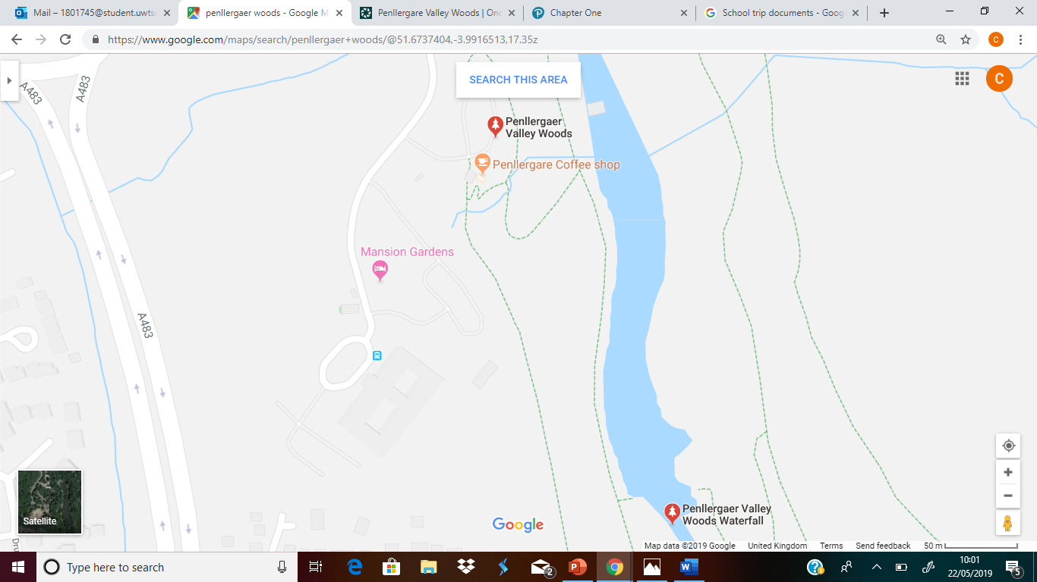
‘The term learning environment encompasses learning resources and technology, means of teaching, modes of learning, and connections to societal and global contexts.’ (Educause, 2019). A safe and interactive learning environment is beneficial for the holistic development of children and their skills. In order for a learning environment to be effective, it must consist of activities which support the children’s learning, assessment strategies which aim to both drive and measure learning, the environment has to be accessible and also inclusive to all pupils. The learning environment must also be a positive environment which meets the needs of all pupils. If the learning environment is effective, the pupils and teacher will feel comfortable within the environment and the children will get the best learning experience possible. A learning environment that promotes independence for the children is seen as effective as the children are able to lead their own learning and make discoveries for themselves.
The use of the outdoors is often neglected by teachers as they may see it as too much hassle or they may not want to take the children out because they are afraid of them misbehaving. This only deprives the children of the opportunity to develop their sensory skills alongside their cognitive and emotional skills. Through the outdoors, children are able to make the most of their surroundings and use their natural instincts to explore and discovery new environments. Children must also experience the aspect of danger in a controlled way, this is shown through the educational visits as the children can explore trees, waterfalls and rivers that they may not get the opportunity to do so at home. This type of exploration can create endless questions and new teaching opportunities to take back to the classroom.
Educational visits are used for the children to relate their indoor learning to the outdoors. Through educational visits, children have the opportunity to have hands-on experiences and develop their independence throughout their learning. There is also the opportunity to bring their learning to a close, they are able to link their knowledge with their experiences.
The location that I have chosen for the educational visit is Penllergaer Woods and Penllergaer Waterfall. The children will spend half of the day in the woods and the second half of the day at the waterfall. This gives the children the opportunity to explore more than one environment and gain develop different skills in each location.
The children will lead their activities themselves with the close supervision of the adult leading their group. this gives the children the opportunity to work together as a team to solve problems using both natural and man-made resources which will develop their skills both socially and cognitively. Children's development and learning is complex which is why we take a holistic view and highlight the importance of their physical, social, cognitive, creative and emotional skills and how these complement and interact with one another (LEGO, 2018).
The school I am taking on the visit is St Andrew’s Catholic School which is situated in Gorseinon, Swansea. The age that I have chosen for the visit is a Year 5 class, which makes the children ages 9 and 10, there are 30 children in this class. Within the class there are a wide range of abilities, there are a small proportion with learning difficulties and also behavioural difficulties. I have chosen to visit this woodland area as there are lots of opportunities for the holistic development of skills. It is also an easy location to visit with parking for the four minibuses that we will be taking. Fortunately, the buses belong to the school and enough drivers are available. Also, close by there is a café, this is where the children will be able to use the toilet facilities and also have a picnic in the outdoor seating area. The theme of the educational visit is ‘The Great Outdoors’, within this theme, the children are able to explore and discover endless possibilities from minibeasts and their habitats to water flow in the river and what affects that. The children will have the opportunity to explore and discover new things throughout all of their activities and also develop their social skills.
Within the visit, the children will be developing a wide range of skills covering all areas of learning. The children will be developing their physical education during the visit, they will have the opportunity to ‘develop, consolidate, and then apply, the basic actions of travelling, balancing and stillness, jumping and landing and rotation. Actions should be developed using the floor and apparatus, as appropriate’ (Welsh Government, 2015). The children will also be able develop their skills in an adventurous way, they will have the opportunity to overcome challenges and solve problems whilst being in small groups. Also, the children can identify why they have to be mindful as to why they have to be safe and keep each other safe whilst respecting the environment. Throughout the course of the day, children will also, ‘plan and evaluate their individual or group responses to challenges using key words related to their activity.’ (Welsh Government, 2019). Children have the opportunity to develop their geographical skills through this educational visit and they are able to carry out investigations to assist with their learning. They also have the opportunity to ‘identify and describe natural and human features’ (Welsh Government, 2015). (See appendix)
The children also learn to develop their problem solving skills through small team games. Within these games the children will have the opportunity to develop their ‘trial and error’ strategies and reflect on the strategies in order to improve. The use of games to assist skill development is a great way to engage the children and let them become independent. This ties in with Rod Thorpe and David Bunker’s work which was developed in the late 1970’s to the 1980’s. They developed a model which focuses on developing understanding through games as relevant techniques are being used and reflected upon. Developing an alternative approach to games helps the learners to develop their strategies and skills alongside developing their techniques (Bunker and Thorpe, 1982). The Teaching Games for Understanding model can be seen below.
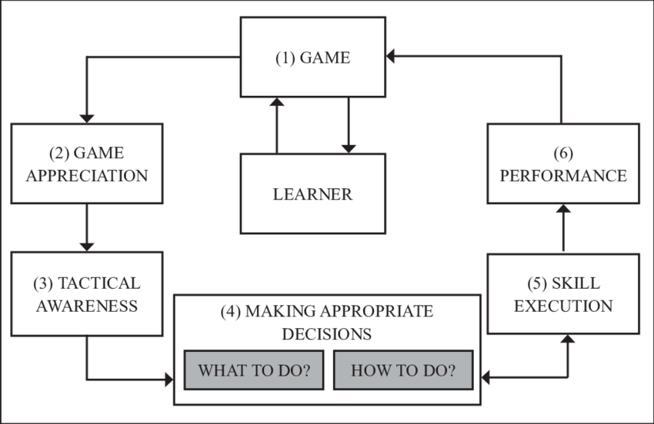

It is important that prior to the visit, there is a clear indication of staff members that will be attending the visit. This is important as there must be enough staff to cover the children to adult ratio of 1:6. In order to meet the requirements, I will need to have four other adults present to cover small groups of children and also two adults to support those children with additional learning needs. This makes six adults in total excluding myself. Additional adults are an effective resource when used to their full potential, they are extra eyes to watch over small groups of children and they improve the efficiency of an educational visit as a whole. Additional adults are effective as it is impossible for teachers themselves to keep track of 30 pupils all together in a big open space such as the woods. Having additional adults present, this helps to keep all pupils safe at all times.
Before attending the visit, there is a lot of information that must be known about the children. This includes any allergies, physical disabilities that may be impacted on the visit, medical information and also emergency contact details in the case that parents need to be called. This information will be collected via parental consent and emergency contact forms that will be sent out in advance. Without this consent, the children are not allowed to attend the visit and will have to come into school on that day and spend the day with another class. The additional adults also must be informed of the itinerary for the day and also be made aware of any medical issues within the class as they then know what to look out for and what to do in an emergency. Each member of staff will have a checklist to work from, specific to their group of children to ensure the day runs smoothly.
An important activity to undertake before the visit is the teacher must visit the location. This is to ensure it is an appropriate location for all pupils and the development of their learning. It is also important that the teacher is aware of any out of bounds areas and also toilet facilities for the children to use. The teacher will then also be able to collect relevant information required to complete a risk assessment. (See appendix)
It is essential that the children are aware of the location of the visit and also why they are going on the visit. This will ensure the children are engaged with the visit and they get the most out of the visit. The children will be working towards the visit during their lessons in school. This will include planning activities that they would like to do on the trip, I will give them a choice of activities and they will then vote on which ones they would prefer to do. By doing this the children feel that they have control over their learning and they will be excited to carry out the tasks that they have planned. It is beneficial for the children to know where they are going and what they are doing as they will be able to relax and enjoy the experience.
The children will all have the same activities to take part in, but that does not necessarily mean that the children will all reach the same end result. This is due to all children having a unique way to solve problems and their own learning path. Children all learn different ways, there are four main learning styles; visual which involves the use of images to assist learning, auditory, which involves listening and speaking, read and write which children learn through words and also kinaesthetic which is where children learn through being tactile. (Teach.com, 2019).
As previously mentioned, the staff will each have a checklist for their small group which will include the itinerary for the day and the specific times that the activities will be done. The staff will also have a list of children they have in their groups and their emergency contact details. All children should be made aware of their group leader before leaving the school and the children must be reminded to stay with their group at all times. When grouping the children it is essential to do this in an effective way. The teacher will be aware of which pupils do and do not work well together and this will help with grouping. Each group being made up of mixed ability pupils will be effective for each pupil in that group. They can then use each other as a more knowledgeable other and assist each other’s learning. This links in to Vygotsky’s theory of the zone of proximal development where children use their class mates or an adult to scaffold their learning. (McLeod, 2018)
Upon arrival, the teacher must assess the surroundings again, to ensure nothing has changed since the pre-visit. Once this is complete, the children will then need to be informed of the plans for the day and also be shown toilet facilities. It is important that the children are aware of who to go to in an emergency, then the relevant member of staff will be able to deal with the issue. The teacher must have appropriate resources brought onto the trip, this will include, the children’s consent forms, any medication for the children, contact details for the children, a first aid kit, wet wipes and also a bucket. The children’s parents will be informed that the children will need a change of clothes as they will get wet and muddy.
In the case that any pupil is misbehaving on the visit, there must be suitable consequences for this bad behaviour. If there is a serious behavioural incident which causes harm or danger to the pupil themselves or another pupil it will be appropriate to contact parents. Children will be aware of the behaviour that is expected of them whilst on an educational visit and they will also model their behaviour from the members of staff. This relates to Bandura’s (1925) Social Learning Theory in which he states that people learn from others. (David, 2019)
The activities that the children will take part in within the woods area are building a shelter, where they will have a short period of time to collect materials from around the area and they are also able to use the resources that were brought onto the visit from school. Another activity that the children will be taking part in is a search and discover activity. They have pre-planned a list of minibeasts, habitats and greenery that they would like to find and they will then record what they see, including observations using their senses.
The children will have brought packed lunch from home or school which will be kept safe on the bus near to the woodland area, then the children will sit in the outdoor seating area next to the Penllergare Café which is situated next to the entrance to the woods. After lunch, everyone will then walk over to the waterfall to take part in the next activities. The activities at the waterfall and the river area focus more on team work to solve problems. The children have the task of working in their groups to cross the river one at a time but they cannot get wet. They will be able to use any resources they find around them and also resources they brought from the school such as ropes, planks and waterproof materials. The other activity that the children will do involves the team retrieving an item in a bucket from the middle of the river. For this activity it will be a whole-class effort, this will identify ways that the children will solve problems and also which children will come out as strong leaders for the activity to help them overcome difficulties. They will have only long lengths of rope to do so and they will have to figure out the process for themselves. (see appendix for lesson plans). Ohio State University (1940s) conducted a study where they discovered that there are four main areas that will outline behaviour within group activities. They are, initiating, organising, clarifying and information gathering. The children in each group will show at least one member for each area which will in turn lead to a successful solution. The last activity for the waterfall area involves a long tube with various holes in it, a ping pong ball, rope and natural resources. The ball will be inserted into the tube and the children have to fill the tube with water from the river to try and raise the ball out of the tube. They have to find a way to plug the holes to prevent spillage. There will be extra tubing available if the children want to challenge themselves.
There are specific protocols set out for schools to follow whilst on an educational visit. The Government design them, the schools then follow the protocol which will ensure all staff and children stay safe and get the best experience possible. (Appendix)
After the educational visit the children will be reflecting on their visit and bringing all of their information and findings into the classroom. The children will work towards developing their instructional writing, they will each choose one activity that they took part in and write a detailed set of instructions which another individual will be able to follow clearly. The children will also collectively work on a display within the classroom, it will be designed and produced by the children themselves. The display will show evidence from the visit, pieces of writing that the children have produced following their activities at the woods and also will include a reflection from the children regarding their experiences. In accordance to The Children’s Act 2004, it is essential to empower children and also their choices. This can be done through the use of child-led displays within the classroom, this helps the children to feel involved with their learning environment and it will also help them to feel ownership of their work. The children will complete their tasks on J2E on the Hwb. They will create charts to support their observations and also produce writing pieces.
It is important to conclude the visit back in the classroom over the course of a week, as the experience is still fresh in the children’s mind and it is still an event that they are interested in. The children will be able to reflect on what they have learned and the skills that they have developed which will make the reason for the educational visit more clear.
To conclude, educational visits are beneficial for the holistic development of children’s skills. The children are able to engage with ‘hands on’ experiences and really engage with the learning experiences. Educational visits are also beneficial for the children as some children may not get the opportunity to visit outdoor areas with their families. Using educational visits is an effective way for the children to apply what they have learned in the classroom to a real life situation and to guide their own learning through discovery. The outdoors is a great way for children to experience new surroundings whilst being kept safe by adults.

References
David L, "Social Learning Theory (Bandura)," in Learning Theories, February 7, 2019, https://www.learning-theories.com/social-learning-theory-bandura.html.
Kirk D. and McPhail A., (2002) Teaching Games for Understanding and Situated Learning: Rethinking the Bunker and Thorpe Model. Journal of Teaching in Physical Education. Vol 21. P.p. 177-192.
Leadership-Central.com. (2019). Behavioral Theories of Leadership. [online] Available at: https://www.leadership-central.com/behavioral-theories.html [Accessed 17 May 2019]
Legislation.gov.uk. (2004). Children Act 2004. [online] Available at: https://www.legislation.gov.uk/ukpga/2004/31/contents [Accessed 7 May 2019].
Mcleod, S. (2015). Vygotsky | Simply Psychology. [online] Simplypsychology.org. Available at: https://www.simplypsychology.org/vygotsky.html [Accessed 15 May 2019].
S3-eu-west-1.amazonaws.com. (2008). [online] Available at: https://s3-eu-west-1.amazonaws.com/hwb-live-storage/48/69/a0/be/fea54ae8bf819f0664bb129e/geography-in-the-national-curriculum.pdf [Accessed 15 May 2019].
S3-eu-west-1.amazonaws.com. (2008). [online] Available at: https://s3-eu-west-1.amazonaws.com/hwb-live-storage/af/1f/4d/7a/f5184776ac77e1e9b94dc48f/physical-education-inthe-national-curriculum.pdf [Accessed 8 May 2019].
Teach.com. (2019). Learning Styles. [online] Available at: https://teach.com/what/teachers-know/learning-styles/ [Accessed 19 May 2019].
The LEGO Foundation. (2018). Skills for holistic development. [online] Available at: https://www.legofoundation.com/en/why-play/skills-for-holistic-development/ [Accessed 14 May 2019].

