

BA (HONS) Leadership and Management Skills in the Workplace
Project Management
Reopening of Highway 5 following the 2022 British Columbia Floods

Module code: LCLM_5003
Lecturer Name: Dr Xavier Matieni
Student Name: Luiza Florentina Pascu
Student Number: 2246735

Table of Contents
Part A – Poster Proposal 3
Part B – Reflection on Feedback 4
Improvements Made in the Final Project Plan 5
Conclusion 5
Part C – Project Management Plan 5
Introduction 6
Project Description 6
Project Scope 7
In-Scope 7
Out-of-Scope 7
Assumptions 8
Constraints 8
Work Breakdown Structure (WBS) 8
Quad Chart Analysis 10
Project Schedule (Gantt Chart) 12
Stakeholders’ Involvement 13
Allocation of Resources 15
Risk Analysis 15
Conclusion 17
References 19

Part A – Poster Proposal
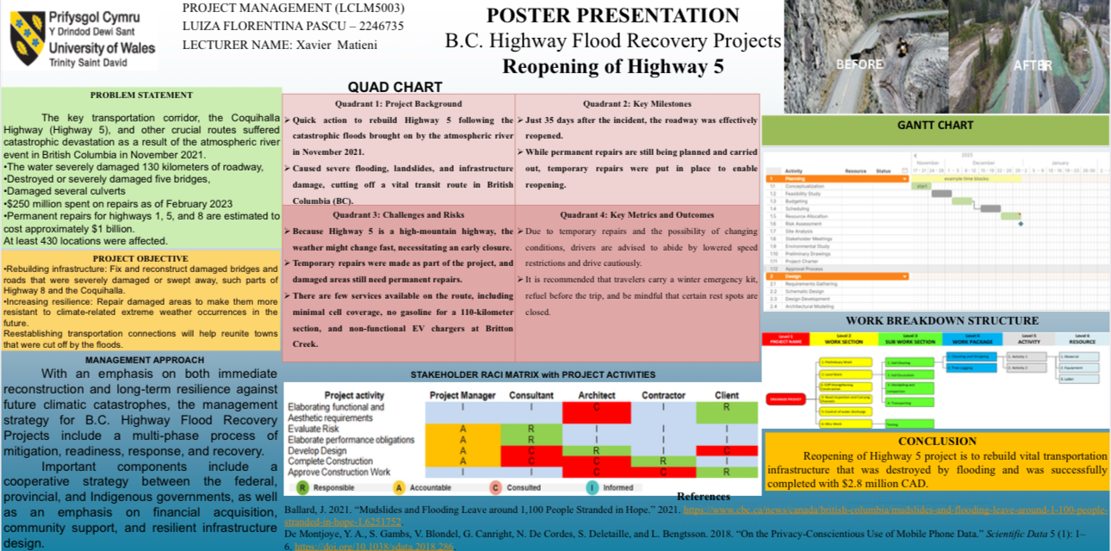

This poster was presented as part of the module assessment and received formative feedback.

Part B – Reflection on Feedback
The feedback received on the poster presentation was both positive and constructive, provding valuable guidance for the development of the final project management plan. Overall, the poster was considered clear, well-structured and relevant to a real-world infrastructure project.
Positive feedback highlighted the effective visual presentation of the project and the appropriate use of project management tools. The inclusion of a Work Breakdown Structure, Gantt chart, Quad Chart and RACI matrix was recognised as a key strength, as these tools demonstrated an understanding of planning, scheduling and responsibility allocation. In addition, the project topic, focusing on the reopening of Highway 5 following the British Columbia floods, was viewed as realistic and highly relevant to disaster recovery and infrastructure management
Constructive feedback indicated that several areas required further development. In particular, it was suggested that stakeholder involvement should be analysed in greater depth, including clearer identification of stakeholder interests and engagement strategies. Feedback also noted that the risk analysis was presented at a high level and would benefit from a more structured assessment of risks, probabilities and mitigation measures. Furthermore, the allocation of resources required additional detail to better justify how financial, human and material resources would be managed throughout the project lifecycle.

Improvements Made in the Final Project Plan
The feedback received from the poster presentation was carefully considered and used to strengthen the final project management plan. One of the main improvements relates to stakeholder involvement. While stakeholders were initially identified in the poster, the final plan expands this section by providing a more detailed analysis of stakeholder roles, levels of influence and interests. Engagement strategies were further developed to demonstrate how effective communication and collaboration can support project success.
Another significant improvement was made in relation to risk management. The poster presented risks at a high-level; however, in the final project plan these risks have been developed into a structured risk analysis. This includes the identification of key environmental, operational and financial risks associated with reopening Highway 5, as well as an assessment of their potential impact and likelihood. Appropriate mitigation strategies were also introduced to demonstrate proactive risk management.
In addition, the allocation of resources was expanded in response to feedback. The final plan now provides clearer justification for the use of human, financial and material resources across different phases of the project. This improvement enhances the realism and feasibility of the proposed project and demonstrates stronger alignment with project management principles.

Conclusion
In conclusion, the feedback received on the poster presentation played an important role in improving the quality of the final project management plan. By addressing the identified gaps and expanding key areas such as stakeholder involvement, risk analysis and resource allocation, the final plan provides a more comprehensive and structured approach to the reopening of Highway 5. This process highlights the value of formative feedback in project management and its contribution to developing effective and well-informed project plans.

Part C – Project Management Plan

Introduction
In November 2021, British Columbia experienced severe flooding caused by an atmospheric river event, which resulted in widespread damage to critical infrastructure. One of the most significantly affected routes was Highway 5, also known as the Coquihalla Highway, a key transportation corridor linking the Lower Mainland with the interior of the province. The damage to this highway disrupted supply chains, emergency services and community connectivity, highlighting the importance of rapid and well-managed infrastructure recovery.
The reopening of Highway 5 represents a complex infrastructure project that involves both temporary emergency repairs and long-term reconstruction to ensure safety and resilience against future climate-related events. Effective project management is essential in such circumstances to coordinate multiple stakeholders, manage risks and allocate resources efficiently within strict time and budget constraints.

The purpose of this project management plan is to provide a structured approach to the reopening of Highway 5 following the 2022 British Columbia floods. The plan outlines the project scope, schedule, stakeholder involvement, resource allocation and risk management strategies required to support the successful delivery of the project. By applying established project management tools and principles, this plan aims to demonstrate how a systematic and well-coordinated approach can contribute to the recovery and long-term resilience of critical transportation infrastructure (Project Management Institute, 2021).

Project Description
The Reopening of Highway 5 project focuses on the recovery and restoration of a critical transportation route that was severely damaged during the British Columbia flooding events. Highway 5, commonly known as the Coquihalla Highway, plays a vital role in connecting major regions of the province and supporting economic activity, emergency response and community mobility. The extensive damage caused by flooding and landslides necessitated a coordinated and structured approach to reopening the highway in a safe and timely manner.
The project involves both short-term emergency interventions and long-term reconstruction activities. Temporary works include debris removal, stabilisation of slopes, temporary bridge structures and safety inspections to allow the controlled reopening of the highway. In parallel, permanent reconstruction works are planned to restore and strengthen damaged bridges, road surfaces and drainage systems. These permanent measures aim to improve the resilience of the highway against future extreme weather events and reduce the likelihood of similar disruptions.
Key project deliverables include the safe reopening of Highway 5 to traffic, the completion of permanent infrastructure repairs, compliance with safety and environmental standards, and the implementation of resilient design solutions. The project requires coordination between government authorities, engineering teams, contractors and local communities, making effective project management essential to ensure successful delivery within defined time, cost and quality constraints (Chang, 2010).

Project Scope
The scope of the Reopening of Highway 5 project defines the boundaries of the work required to restore the highway following the British Columbia flooding events. Clearly establishing the project scope is essential to ensure effective planning, resource allocation and control throughout the project lifecycle (Kerzner, 2022).

In-Scope
The scope of the project includes activities directly related to the reopening and restoration of Highway 5. These activities involve damage assessment, debris removal, slope stabilisation and repair of damaged road sections. The project also includes temporary emergency repairs to enable the safe reopening of the highway, as well as permanent reconstruction works such as bridge repairs, road resurfacing and improvements to drainage systems. Safety inspections, environmental compliance measures and final testing prior to full reopening are also included within the project scope.

Out-of-Scope
Activities not directly related to the recovery of Highway 5 are considered out-of-scope. This includes the construction of new transportation routes, commercial developments along the highway corridor and infrastructure upgrades unrelated to flood damage. Long-term regional transport planning beyond the restoration of Highway 5 is also excluded from this project.

Assumptions
The project assumes that funding will be made available by relevant government authorities and that key stakeholders will cooperate throughout the project. It is also assumed that weather conditions will allow construction activities to proceed according to the planned schedule and that required materials and skilled labour will be accessible when needed.

Constraints
Key project constraints include time pressures to restore critical transport links, budget limitations and challenging environmental conditions. Seasonal weather patterns, remote location factors and safety regulations may further restrict construction activities and influence project scheduling.

Work Breakdown Structure (WBS)
The Work Breakdown Structure (WBS) provides a systematic breakdown of the Reopening of Highway 5 project into manageable components. By decomposing the project into clearly defined phases and tasks, the WBS supports effective planning, monitoring and control throughout the project lifecycle.
The WBS for this project is structured into several key phases. The initial phase focuses on assessment and planning, including damage inspections, risk evaluations and the development of detailed work plans. This is followed by debris removal and site preparation, which involves clearing landslides, stabilising affected areas and preparing sites for reconstruction. The next phase includes structural repairs, such as the repair and reconstruction of damaged bridges, road surfaces and drainage systems. Safety testing and inspections are then conducted to ensure that all repaired sections meet regulatory and operational standards. The final phase involves the controlled reopening of Highway 5 and ongoing monitoring to identify any emerging issues.
Figure 1 illustrates the Work Breakdown Structure for the Reopening of Highway 5 project. The WBS enhances project control by clarifying responsibilities, improving resource allocation and enabling accurate scheduling and cost estimation. This structured approach supports the effective coordination of project activities and contributes to the successful delivery of the project objectives (Project Management Institute, 2021).
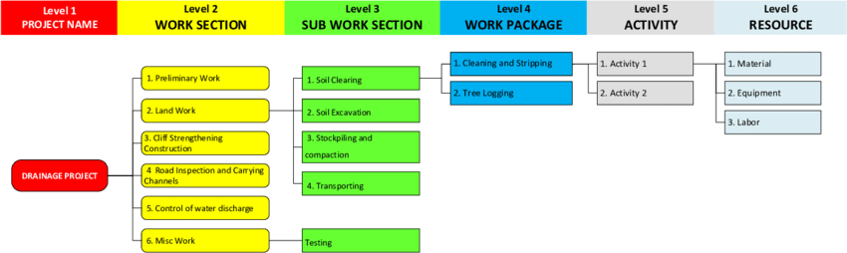

Quad Chart Analysis
The quad chart provides a high-level overview of the Reopening of Highway 5 project by summarising key project information in a clear and structured format. This visual tool supports decision-making by presenting the project background, milestones, risks and outcomes in a concise manner.
The first quadrant outlines the project background, highlighting the severe damage caused by flooding and landslides and the urgent need to restore a critical transportation corridor. This section emphasises the importance of rapid response to minimise disruption to communities, emergency services and supply chains.
The second quadrant focuses on key milestones achieved during the project. These include the implementation of temporary emergency repairs and the reopening of Highway 5 within a short timeframe following the flooding event. The achievement of these milestones demonstrates effective coordination and prioritisation under challenging conditions.
The third quadrant identifies the main challenges and risks associated with the project. These include unpredictable weather conditions, the need for ongoing permanent repairs and safety concerns linked to the highway’s mountainous location. Recognising these risks supports proactive planning and risk mitigation.
The fourth quadrant presents key outcomes and performance considerations, including safety measures, traffic management and guidance provided to road users. Figure 2 illustrates the quad chart for the Reopening of Highway 5 project and demonstrates how this tool contributes to effective project planning and communication (Turner, 2014).

- Quad Chart for the Reopening of Highway 5 Project
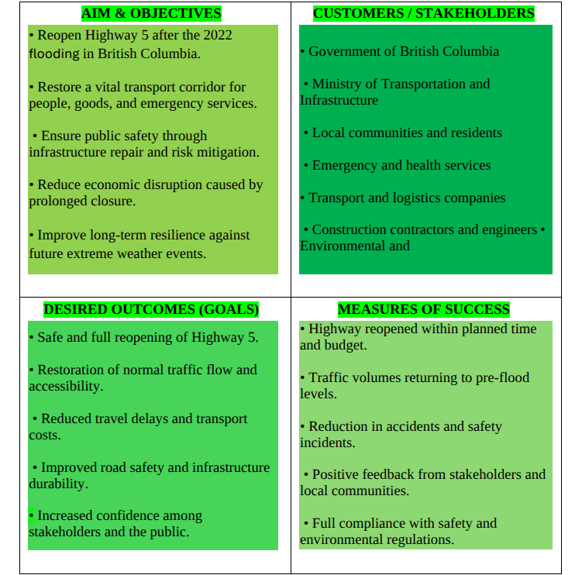

Project Schedule (Gantt Chart)
The project schedule outlines the sequence, duration and dependencies of key activities involved in the Reopening of Highway 5 project. A Gantt chart is used to provide a clear visual representation of the project timeline and to support effective time management.
The schedule begins with damage assessment and planning activities, which are critical for identifying priorities and allocating resources effectively. This is followed by debris removal and site preparation, allowing reconstruction activities to commence safely. Structural repairs and reconstruction works are then carried out, including bridge repairs, road resurfacing and drainage improvements. These activities represent the most time-intensive phase of the project and require close coordination between multiple teams.
Subsequent activities include safety inspections, testing and quality assurance to ensure that all repaired sections meet regulatory standards before reopening. Key milestones within the schedule include the completion of temporary emergency works, the controlled reopening of Highway 5 and the finalisation of permanent reconstruction works. Figure 3 illustrates the Gantt chart for the project and demonstrates how dependencies and milestones are managed to support timely project delivery.
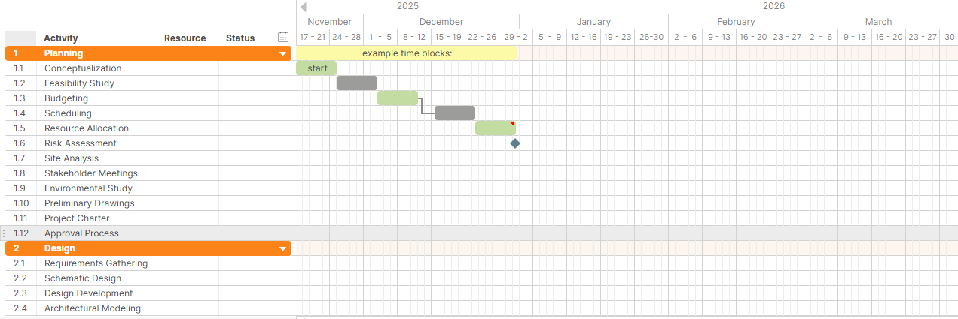
- Gantt Chart for the Reopening of Highway 5 Project

Stakeholders’ Involvement
Effective stakeholder involvement is critical to the successful delivery of the Reopening of Highway 5 project due to the number of parties affected by and involved in the recovery process. Stakeholders play a key role in decision-making, resource provision and the overall coordination of project activities, particularly in complex infrastructure projects following natural disasters.
Key stakeholders in this project include the British Columbia Ministry of Transportation, federal and provincial government authorities, engineering consultants, construction contractors and emergency services. Local communities and road users are also significant stakeholders, as the highway is essential for regional mobility, economic activity and access to essential services. In addition, environmental agencies and Indigenous groups have an important role in ensuring that reconstruction activities comply with environmental regulations and respect local land considerations (Freeman, 1984).
Stakeholder analysis is used to assess the level of influence and interest of each group. Government authorities and project sponsors have high power ad high interest, as they are responsible for funding, approvals and strategic decisions. Contractors and engineering teams also hold high influence due to their technical expertise and responsibility for delivering project outcomes. Local communities and road users typically have high interest but lower decision-making power, requiring effective communication and engagement strategies to manage expectations and maintain public trust (Mitchell, Agle and Wood, 1997).
To support effective stakeholder management, clear communication and engagement strategies are applied throughout the project lifecycle. Regular progress updates, coordination meetings and reporting mechanisms are used to align stakeholder expectations and address emerging concerns. The RACI matrix included in the project identifies responsibilities for key activities, ensuring clarity in roles and accountability. By actively involving stakeholders and managing their interests and influence, the project is better positioned to achieve its objectives and deliver a safe and resilient reopening of Highway 5.

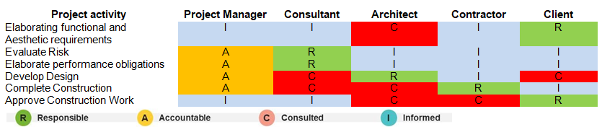
- RACI Matrix

Allocation of Resources
The allocation of resources is a critical component of the Reopening of Highway 5 project, as effective use of human, financial and material resources is essential to achieve project objectives within time and budget constraints. Careful resource planning supports efficiency, coordination, and overall project control (Kerzner, 2022).
Human resources for the project include project managers, civil and structural engineers, environmental specialists, safety officers and construction workers. These roles are essential across different phases of the project, from planning and assessment to reconstruction and final inspections. Clear allocation of responsibilities ensures that tasks are completed efficiently and in accordance with safety and quality standards.
Financial resources are primarily provided by government authorities and are allocated across emergency response activities, temporary repairs and permanent reconstruction works. Budget planning focuses on prioritising critical activities, managing cost risks and ensuring that funds are used transparently and effectively. Monitoring and control mechanisms are applied to track expenditure and support informed decision-making throughout the project lifecycle.
Material and equipment resources include construction machinery, repair materials, temporary bridge components and safety equipment. The timely availability of these resources is essential to prevent delays and maintain project momentum. Effective coordination of resources contributes to the successful reopening of Highway 5 and supports the long-term resilience of the infrastructure.

Risk Analysis
Risk analysis is a vital element of the Reopening of Highway 5 project due to the complex and uncertain conditions associated with post-disaster infrastructure recovery. Identifying and managing risks effectively supports informed decision-making and reduces the likelihood of delays, cost overruns and safety incidents (Aven, 2016).
One of the most significant risks associated with the project is adverse weather conditions. Due to the mountainous location of Highway 5, sudden changes in weather, including heavy rainfall and snow, may disrupt construction activities and increase safety risks. This risk is mitigated through continuous weather monitoring, flexible scheduling and the implementation of strict safety procedures (IPCC, 2021).
Operational risks also present a major challenge. These include potential delays caused by limited site access, equipment failure or shortages of skilled labour. To reduce these risks, contingency plans are established, alternative supply arrangements are considered, and regular maintenance of equipment is conducted to ensure reliability.
Financial risks are another key concern, particularly the potential for cost overruns due to extended construction periods or unforeseen repair requirements. This risk is managed through careful budget planning, ongoing cost monitoring and the allocation of contingency funds to address unexpected expenses.
Environmental and safety risks must also be considered. Construction activities may impact surrounding ecosystems, while working in unstable terrain increases the risk of accidents. These risks are mitigated by complying with environmental regulations, conducting regular safety inspections and ensuring that all personnel are adequately trained.
Table 1 presents a summary of the key risks, their potential impact and corresponding mitigation strategies for the project.

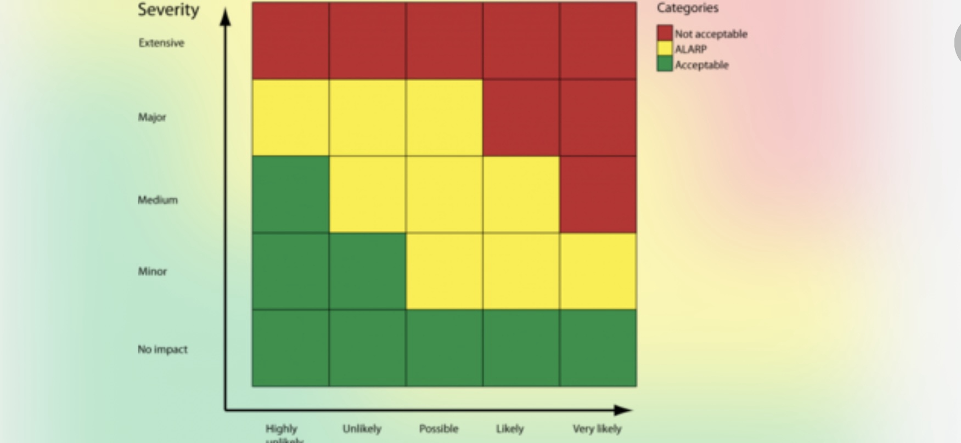
Risk Register for the Reopening of Highway 5 Project

Conclusion
The Reopening of Highway 5 project demonstrates the importance of structured project management in the recovery of critical infrastructure following natural disasters. The flooding events in British Columbia highlighted the vulnerability of key transportation corridors and the need for effective planning, coordination and risk management to restore connectivity safely and efficiently.
This project management plan has outlined a comprehensive approach to the reopening of Highway 5 by defining the project scope, schedule, stakeholder involvement, resource allocation and risk management strategies. The application of tools such as the Work Breakdown Structure, Gantt chart, Quad Chart and risk analysis supports informed decision-making and effective control throughout the project lifecycle.
By adopting a systematic and collaborative project management approach, the project supports not only the timely reopening of Highway 5 but also the long-term resilience of the infrastructure against future climate-related events. The plan demonstrates how effective project management practices can contribute to sustainable infrastructure recovery and provide valuable lessons for similar projects in the future.

References
Aaltonen, K. and Kujala, J. (2016) Towards an improved understanding of stakeholder dynamics. International Journal of Project Management, 34(8), pp. 1537–1552.
Aven, T. (2016) Risk assessment and risk management: Review of recent advances. Reliability Engineering and System Safety, 146, pp. 23–34.
CBC News (2021) Flooding and mudslides leave communities isolated in British Columbia. Available at: https://www.cbc.ca (Accessed: 10 December 2025).
Chang, S.E. (2010) Urban disaster recovery: A measurement framework and its application. Disasters, 34(3), pp. 577–600.
Freeman, R.E. (1984) Strategic Management: A Stakeholder Approach. Boston: Pitman.
Government of British Columbia (2022) B.C. Flood Recovery Projects. Available at: https://www2.gov.bc.ca (Accessed: 10 December 2025).
Hillson, D. (2009) Managing Risk in Projects. Aldershot: Gower.
IPCC (2021) Climate Change 2021: The Physical Science Basis. Cambridge: Cambridge University Press.
Kerzner, H. (2022) Project Management: A Systems Approach to Planning, Scheduling, and Controlling. 13th edn. Hoboken: Wiley.
Mitchell, R.K., Agle, B.R. and Wood, D.J. (1997) Toward a theory of stakeholder identification and salience. Academy of Management Review, 22(4), pp. 853–886.
Project Management Institute (PMI) (2021) A Guide to the Project Management Body of Knowledge (PMBOK® Guide). 7th edn. Newtown Square, PA: PMI.
Turner, J.R. (2014) The Handbook of Project-Based Management. 4th edn. New York: McGraw-Hill.

