Network Operating Systems and Services (ACCA5023)

VM Creation and Operating System Installations
To create two functioning ‘disconnected’ virtual networks, there must be servers and clients involved. For this to happen, there must be two servers and two clients. The servers have two network adapters, with the first one being a public network adapter. This is typically a machine that is linked to the internet. The second adapter in the servers is an Internal Network adapter, which is only linked to each of the relative clients. That being server 1 connecting to client 1 and server 2 connecting to client 2.

Creating Server1 and Server2
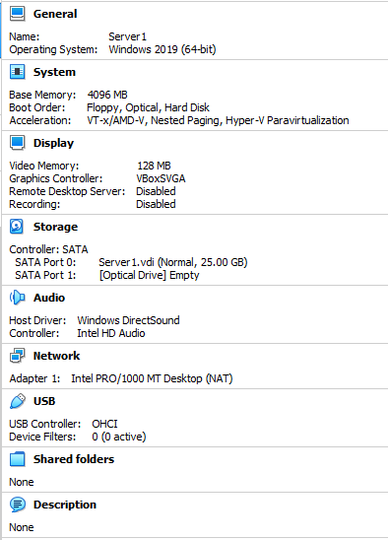
Server1 and Server2 have been created using a pre-installed windows server 2019 host, with the memory size increasing to 4096MB, and the RAM to 25GB, allowing plenty of space for Client1 and Client2 to connect successfully.

Creating Client1
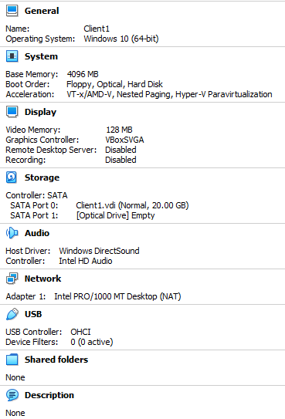
Client1 and Client2 have been created using a pre-installed Windows 10 OS, with the memory size increasing to 4096MB, allowing plenty of space for Client1 and Client2 to connect successfully. The RAM decreased to 20GB, to save physical hard drive space.

Operating Systems on Server1 and Server 2
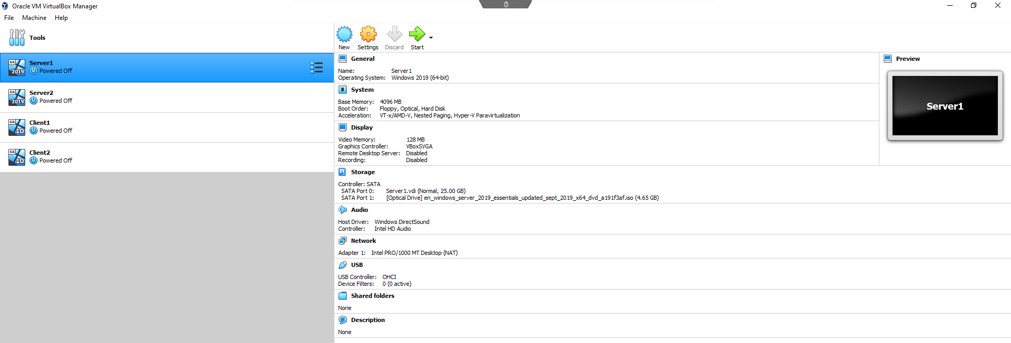
Adapting SATA port 1 in storage to include the Windows 10 ISO, so that the machine uses the essential OS.

Operating Systems on Client1 and Client2
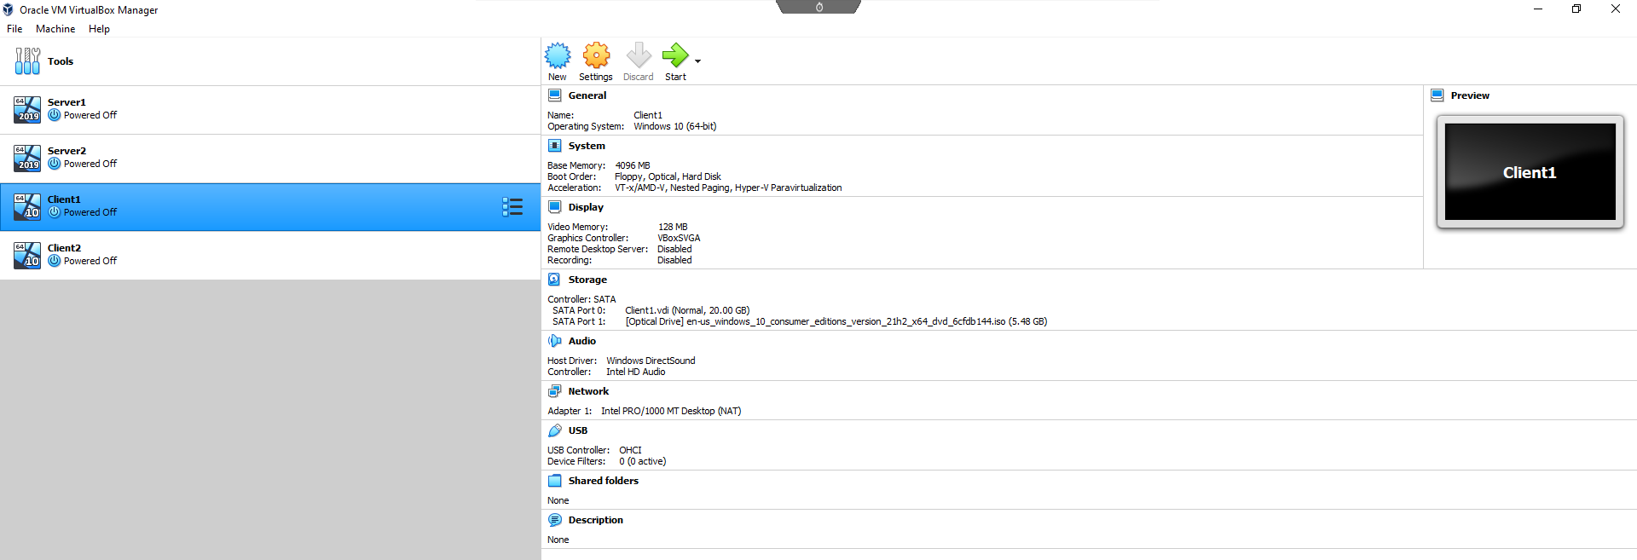
Adapting SATA port 1 in storage to include the Windows 10 ISO, so that the machine uses the essential OS.

Optimising the Type 2 Hypervisor Programs on Server1, Server2, Client1 and Client2
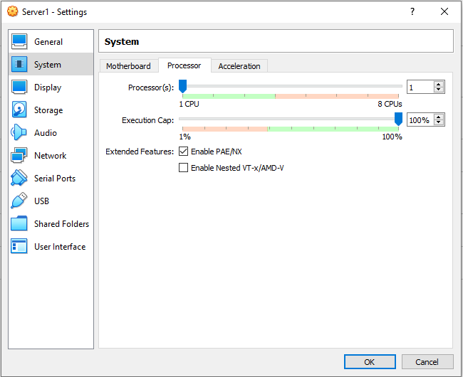
Ensuring that ‘Enable PAE/NX is checked on’, allows the physical address register of the Host system CPU to be more readily accessible to each VM.

Allocate more CPUs in VirtualBox
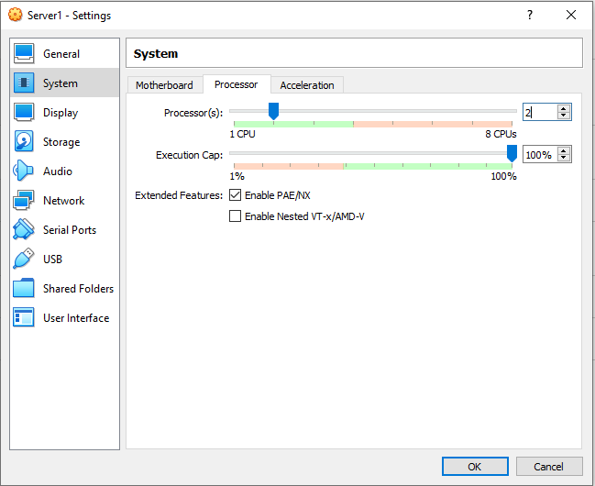
Allocating more CPUs to the servers and clients means that the processor will be much faster.

Installing the Operating System on Server1 and Server2
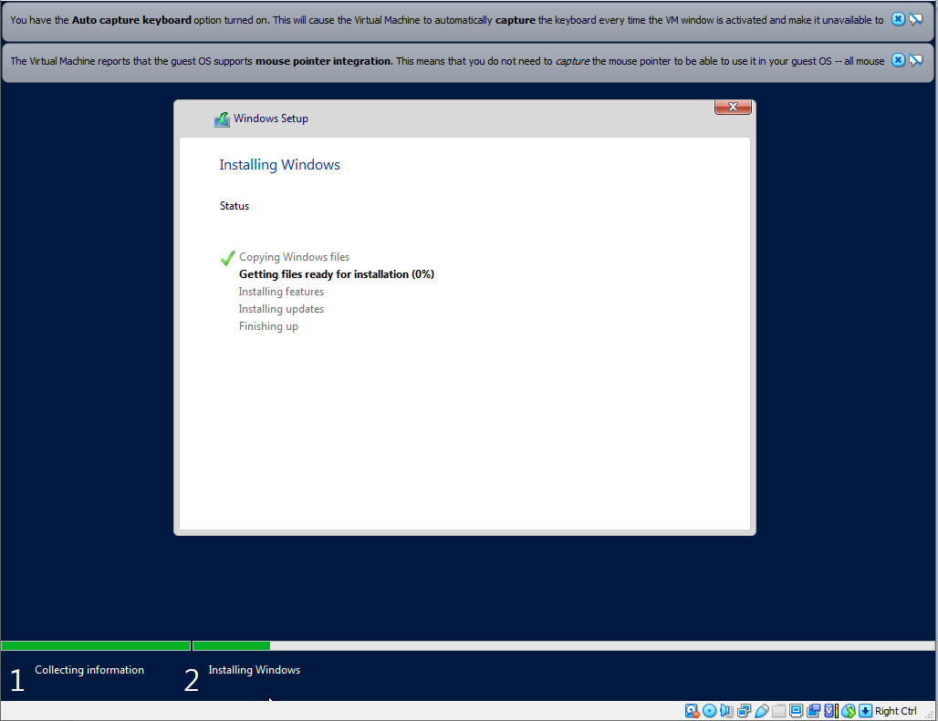
Server1 and Server2 have been installed with Windows Server 2019 and have been setup with no product key and custom install, so that it installs the basic version.

Installing the Operating System on Client1 and Client2
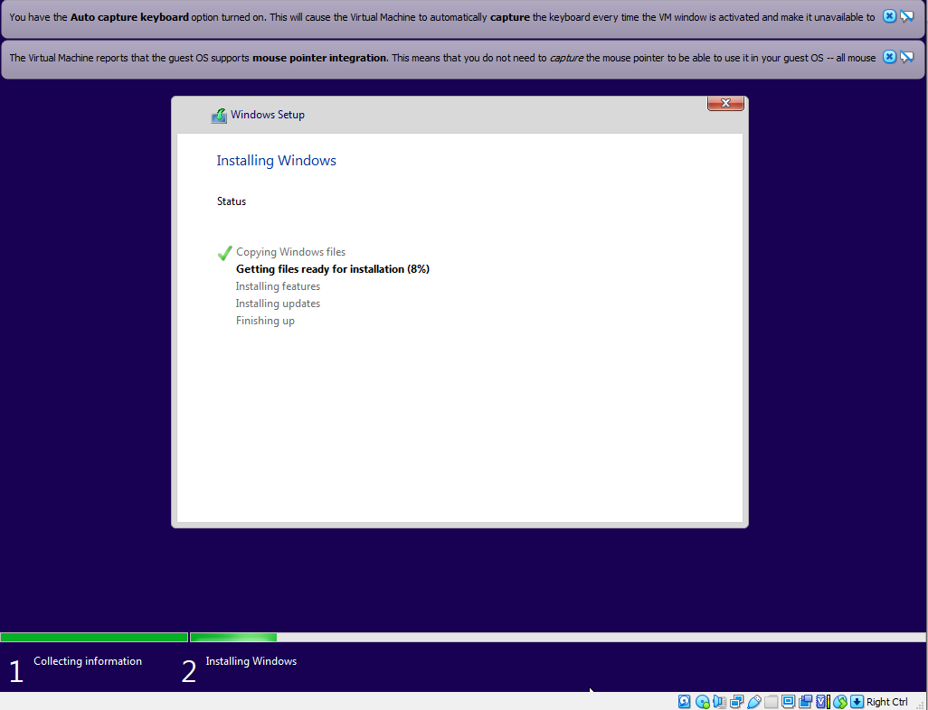
Client1 and Client2 have been setup with Windows Education 10 and have the relevant pre-programmed setting changes, similar to the servers.

Task 2

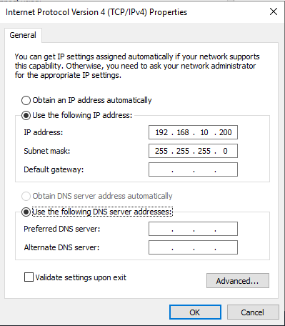
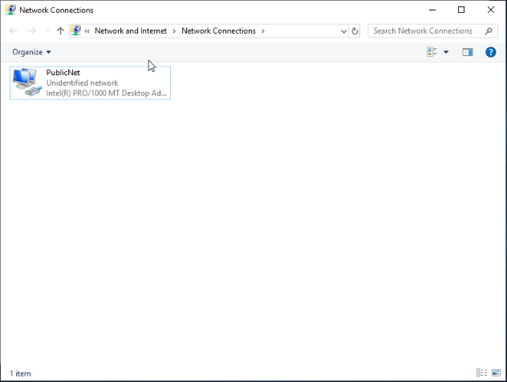
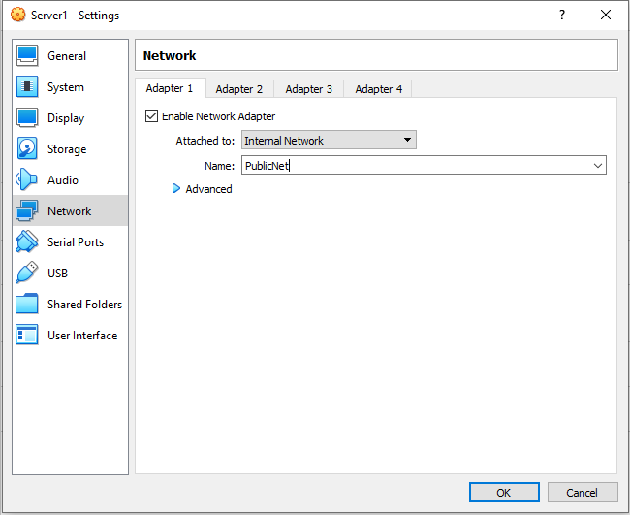
Change Network Name, Adapter Settings, and IP Address on Server1 and Server2 PublicNet

Changing these three things essentially means that a virtual switch has been created, and a LAN has been formed called PublicNet. This is so that each server can connect to the PublicNet.

Configuring a PrivateNet on Server1 and Server2
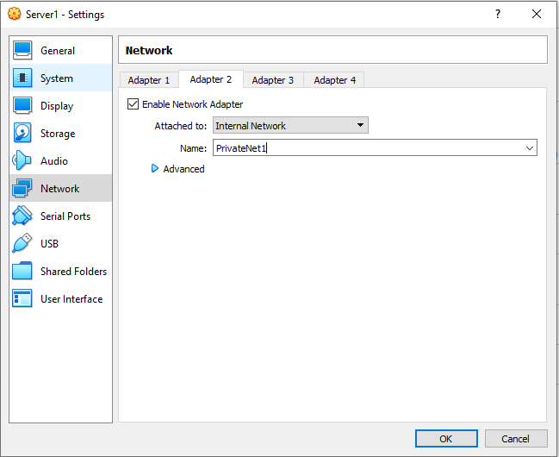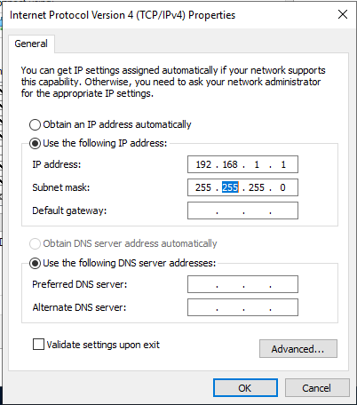
Creating a PrivateNet on Server1 and Server2 means that each client can connect to the relevant servers, e.g., Client1 to Server1, then Client2 to Server2.

Configuring Client1 and Client2 as PrivateNet
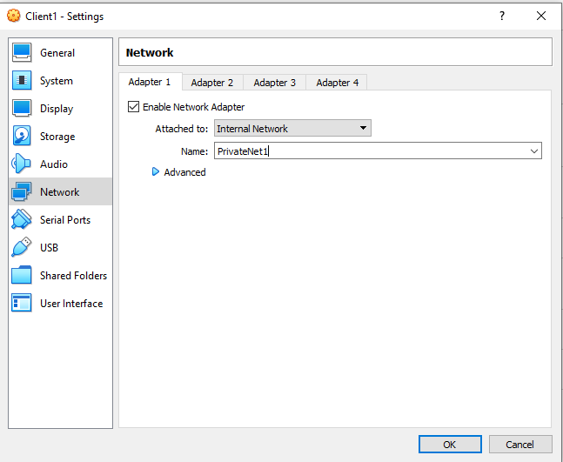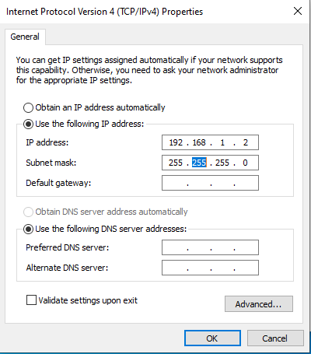
Creating a PrivateNet on Client1 and Client2, allows for them to connect to the relevant servers.

Turning off firewall for Client1 and Client2
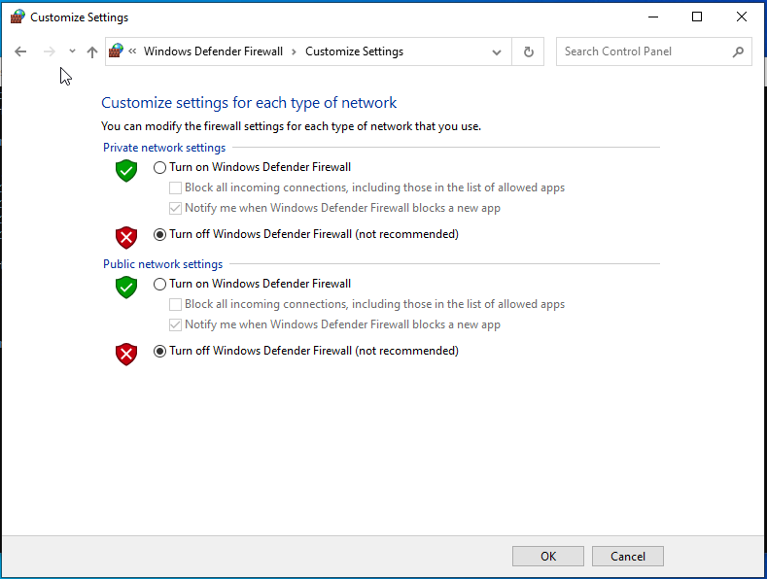
Turning off the firewalls on the clients allows the ICMP command to be used to check the connectivity and firewalls in OOBE environments will deny the ICMP protocol.

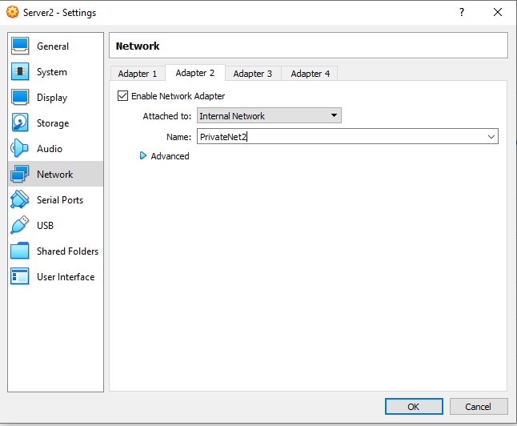
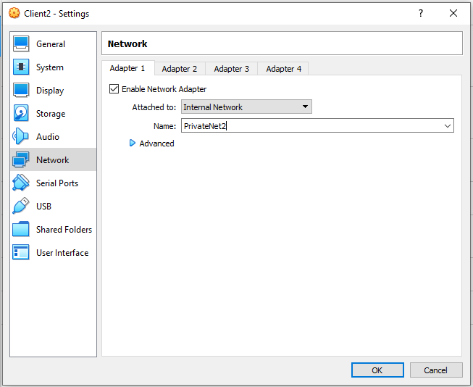
Enabling Adapter2 on server2 and Adapter1 on Client2

Enabling and naming adapter2 to PrivateNet2 means that Client2 will be able to connect to the server to communicate, and it will be on a private LAN connection.

Changing ethernet name and Ip address on server2
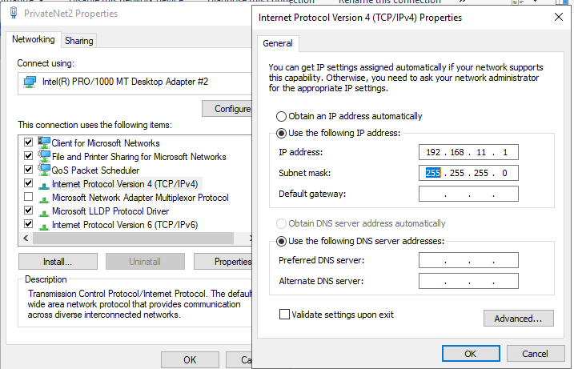
An IP address consists of two parts, the first being the network ID. And the second is the host ID. Therefore, ending in 1 means that client2 will be end in 2 as it is the second device on the host.

Changing ethernet name and changing Ip address on client2
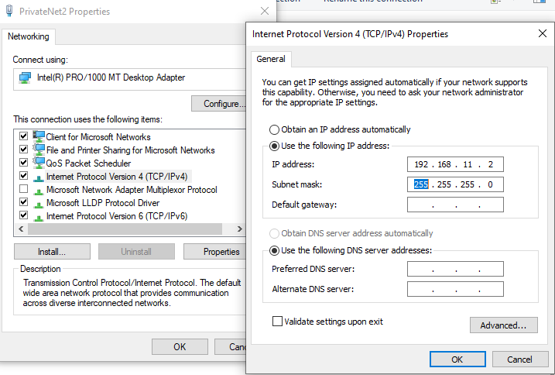
The change to the IP address allows the client to be on the same host as the server.

Checking that the firewall is turned off
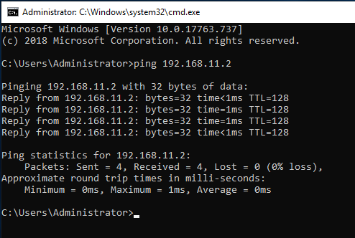
The firewall is successfully turned off, as the server and client had a successful ping to verify LAN connectivity.

Changing the computer name on server 1
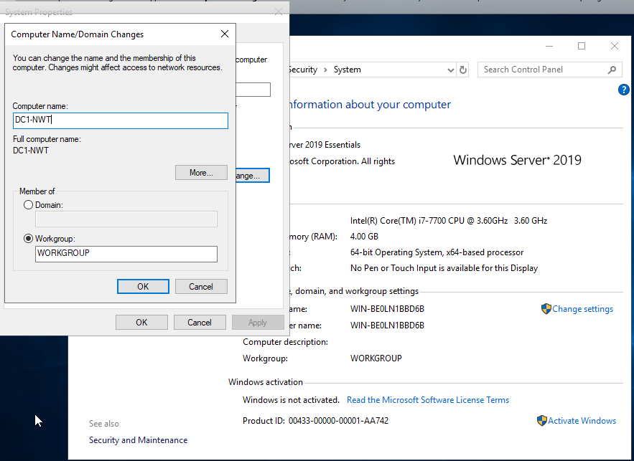
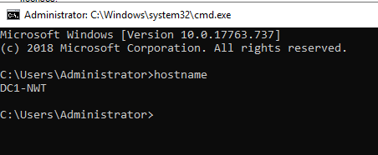
Verifying the computer name means that they are able to identify which resources/hosts provide each service in the network.

Add roles/features wizard in server manage 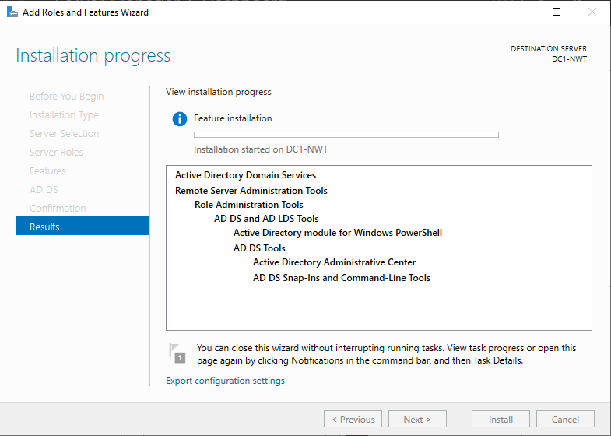
A network directory service is a method of simplifying the task of better managing the existence of specific items that may need catalogued on the network.

Adding a new forest in server manager
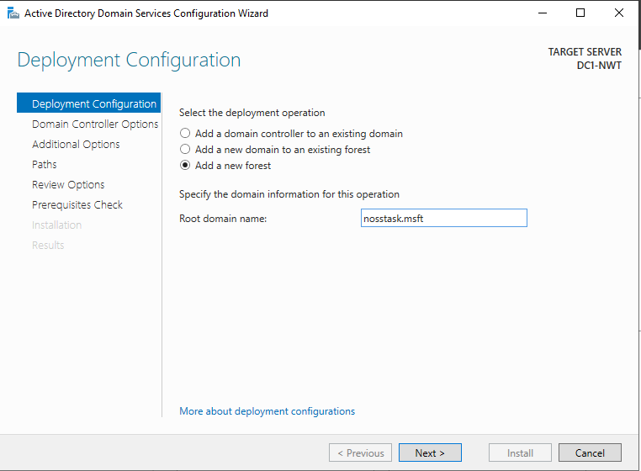
Adding a new forest allows then allows the user to set the domain functional level to a value that is higher than the forest functional level, e.g., admin rights. And therefore has a unique username and password.

Locations of the Database folder
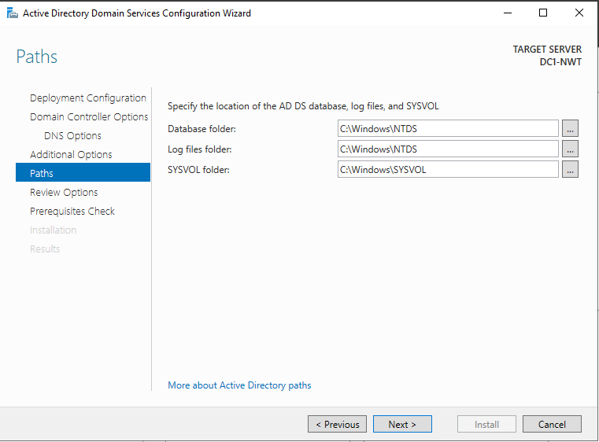
These show the path of the database directories.

Install
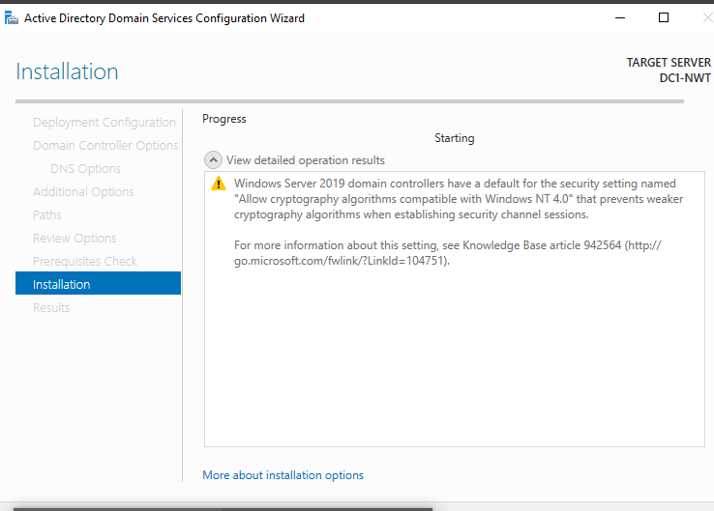

Successful build of the active directory
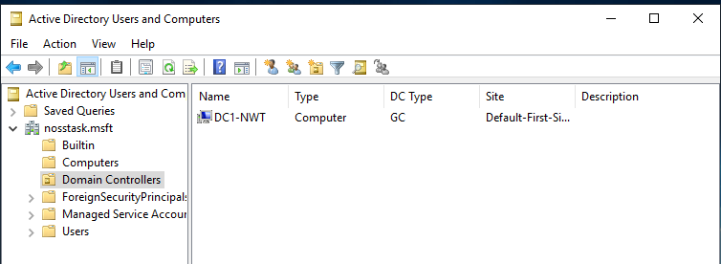

Checking Domain Admin users
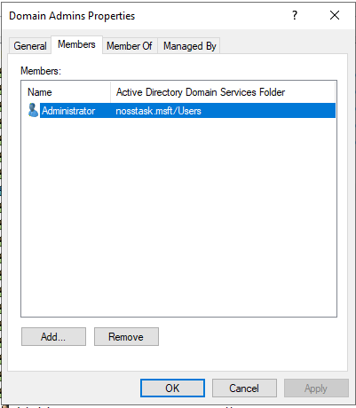
This is an active check on whether the creation of the forest was successful, showing that there are domain admin users.

Creating a new user
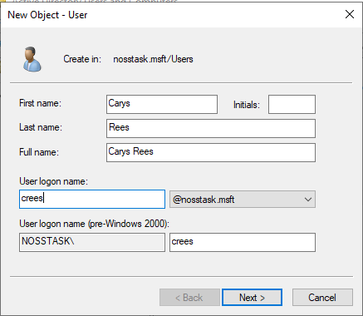

Not able to specify a poor password
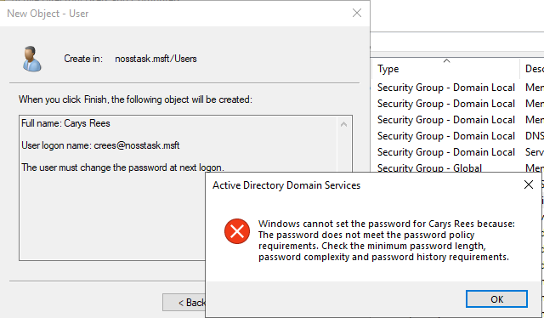
Creating a user on a standard level means that they will not have access to domain admin rights. Windows also doesn’t allow the password to be set as a poor one, and will ask for a more secure password.

Checking if new account is administrator
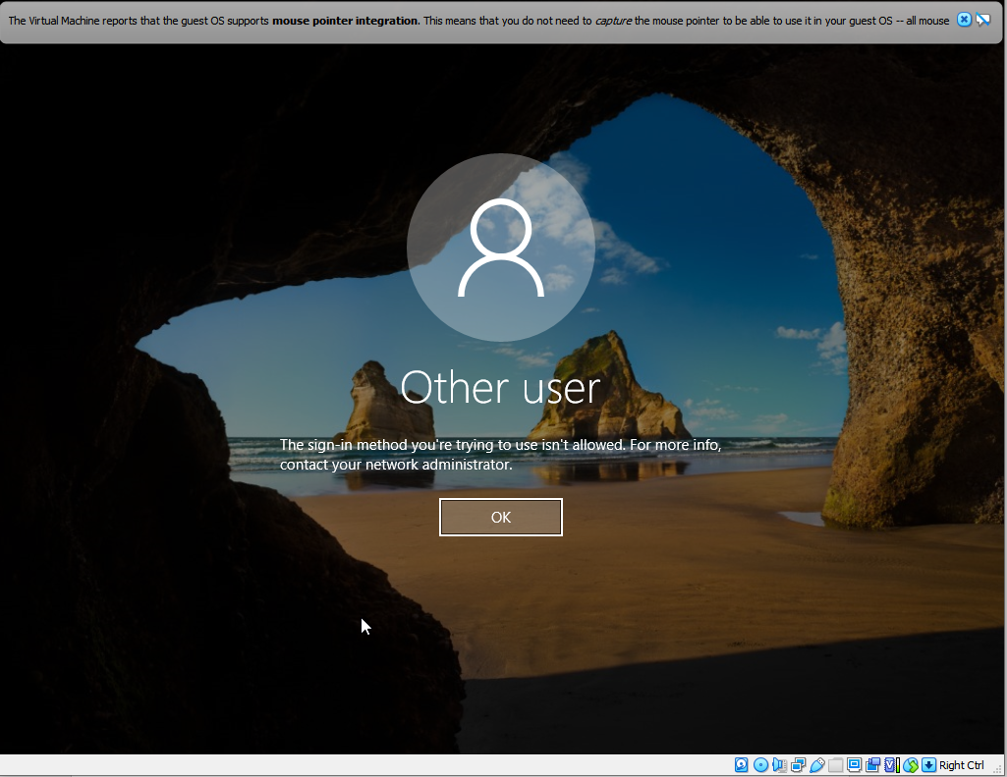
This shows that at user level they cannot access domain privileges.

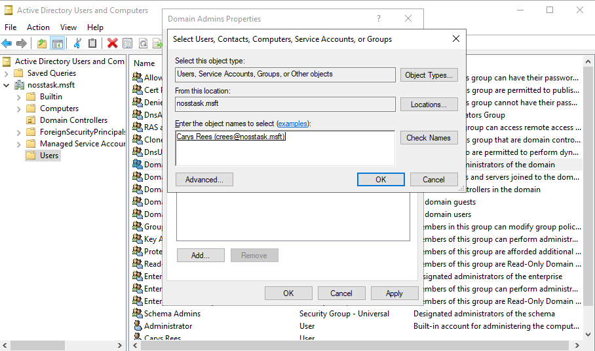
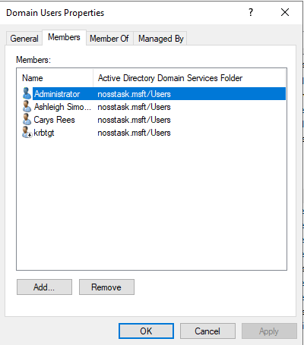
Setting new account as domain administrator

Setting another domain user is useful as it means that if there was a security risk on it, then there will be a backup.

Altering logon hours for the new user
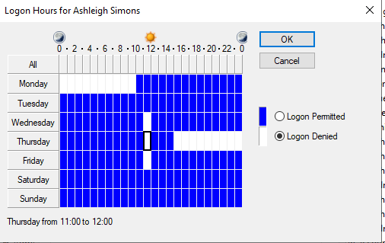
Changing logon hours allows the account to only be accessible at set hours, and essentially means that the network can be more secure and not work overtime.

User cannot change password
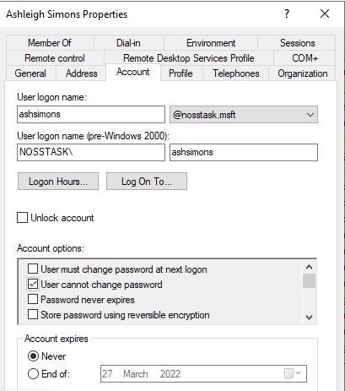
Changing a password at domain level and not base user level allows for less issues, and to be secure.

Creating a new computer
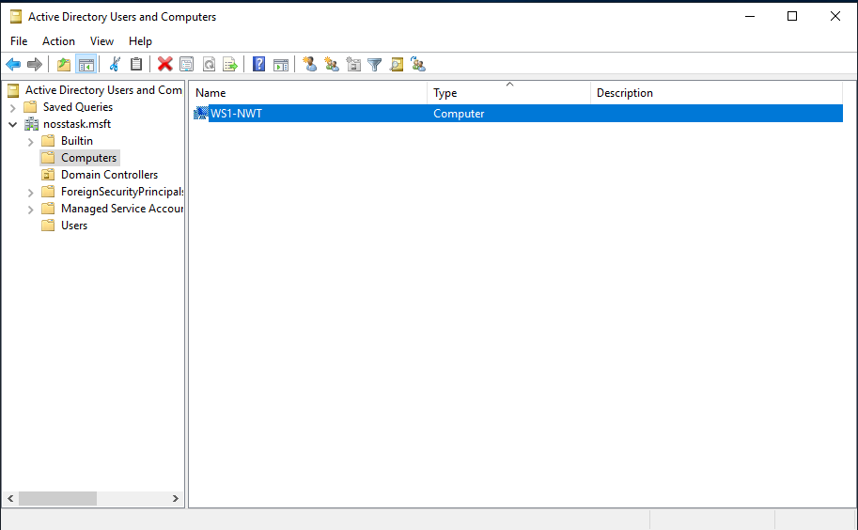
Creating a new computer allows the workstation to be added to the domain.

Setting a preferred DNS Server address
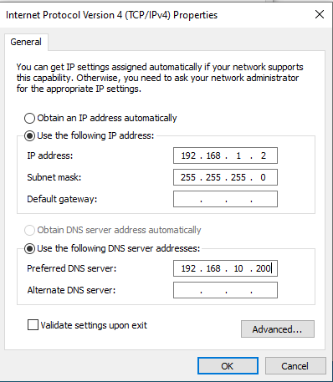
Setting a preferred DNS address means that the computer times out after the time limit defined by the OS is set.

Changing computer name
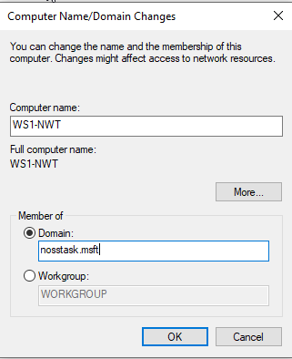
Changing a computer name allows them to be more identifiable.

Getting an error when setting a preferred DNS Server Address
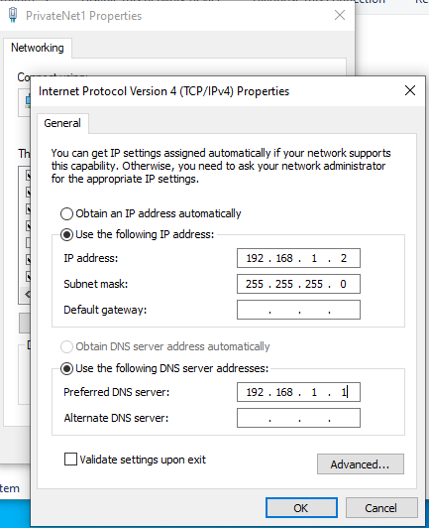
An error is given when changing a preferred DNS server as it is not on the same IP address. The first three sections of an IP address need to be the same. Therefore, the DNS server needed to be changed from 192.186.1.200 to 192.168.1.1 so that it is on the same private network. The last section was 2, meaning that there are only two directories available, so needed to set the preferred server to 1. Then it works.

Successfully changed computer name
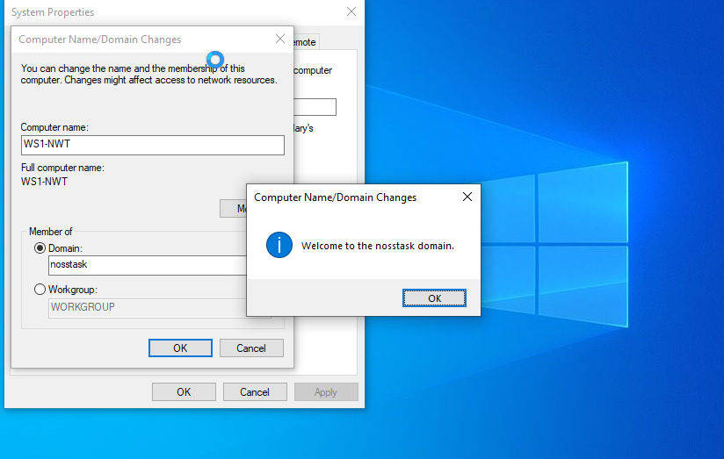
And that is how two ‘disconnected’ virtual networks are created.

Observational Task

Type 1 and Type 2 Hypervisors
Virtualisation is made possible by a piece of software known as a hypervisor. It hides the actual hardware from guest PCs and the operating systems they run. A host machine is the one on which a hypervisor is installed, as opposed to guest virtual machines that run on top of it. Hypervisors allow guest machines to access available resources by simulating them. Whatever operating system you use to start a virtual computer, it will believe it has access to physical hardware. [1].
A type 1 hypervisor runs on the physical hardware of the underlying machine, interfacing directly with the CPU, memory, and physical storage. Type 1 hypervisors are also known as bare-metal hypervisors because of this. The host operating system is replaced with a Type 1 hypervisor. [2].
The main difference between type 1 hypervisors and type 2 hypervisors is that type 2 is normally installed on an existing OS. Since it relies on the host machine’s OS for certain operations like managing CPU calls, network resources, memory, and storage, it’s referred to as a hosted hypervisor. Type 2 hypervisors can now support a wider range of hardware. [3].
An advantage of type 1 hypervisors is that they have direct access to physical hardware, therefore making them very efficient. This also improves their security since there is nothing in the way of an attacker gaining access to the CPU. However, the drawbacks to this are that to administrate different VMs and control the host hardware, a Type 1 hypervisor frequently requires a separate administration system. [2]. Examples of Type 1 hypervisors are AntsleOs, Xen, XCP-ng, Microsoft Hyper V, VMware ESX/ESXi, and Oracle VM server for x86, which is what was used for this worksheet.
The benefit to a type 2 hypervisor is that they effectively server as command centres. To administer virtual machines operating on a type 2 hypervisors, there is no need to install a separate software package. [4]. In addition to the primary guest OS operating on the host system, a Type 2 hypervisor allows rapid and easy access to an alternate guest OS. It is ideal for end-user productivity because of this. For example, a customer may utilise it to access their preferred Linux-based programming tools while utilising a Windows-only spoken dictation system. Yet, a type 2 hypervisor must use the host OS, which has primary access to the physical system, to access the physical machine, memory, and network resources. This causes latency concerns, which has an impact on performance. If the host OS is compromised, an attacker can alter any guest OS operating in the Type 2 hypervisor, posing a security concern. [5]. Examples of Type 2 hypervisors include VMware Workstation, VMware Player, VirtualBox, and Parallel Desktop for Mac.

Cloud computing
The delivery of various services through the internet is known as cloud computing. Cloud-based storage allows the user to store files to a distant database rather than maintaining them on a proprietary hard drive or local storage drive. For a variety of reasons, including cost savings, greater productivity, speed and efficiency, performance, and security, cloud computing is a popular choice among individuals and corporations. For corporations to utilise cloud hosting, the application or website is hosted by a network of connected virtual and physical cloud servers, allowing for greater flexibility and scalability. [6].
The benefits of cloud computing for businesses are endless, from cost saving, advanced security, improved flexibility, increased scalability, and so on. Security is a top priority for cloud providers and data centre operators in all the services and solutions they supply. Their security measures will be far more modern and advanced than a standard in-house security system used by a company. Unauthorised users will have greater difficulty accessing data housed in data centres and travelling through cloud networks since it is encrypted. [7].
There are not as many drawbacks to cloud computing for enterprises, however they can be critical when it happens. Cloud computing is constantly relying on an internet connection, so if it’s offline then it is critical to business productivity. Although this is quite critical, having their own physical server can also go down and therefore cease productivity. An example of this is Apple iCloud in 2015, had a seven-hour outage that affected email and various other cloud services, such as iCloud Drive and Documents. [8]. Examples of the best cloud hosting provides include, A2 Hosting, Cloudways, Kamatera, SiteGround, Hostwinds, and so on.

Domain Name System (DNS)
Domain names are converted to IP addresses by the Domain Name System (DNS), which are then used by browsers to load web pages. Every internet-connected device has its own IP address, which is used by other devices to find it. DNS servers allow individuals to type normal words into their browsers, such as Fortinet.com, without having to remember the IP address for each website. [9].
A DNS server is a computer that keeps a database of public IP addresses and the names of the websites that an IP address leads to. DNS serves as the internet’s phone book. The DNS finds the correct IP address whenever people type domain names like Yahoo.com into the address bar of their web browsers. The device is directed to the correct location to access the site’s data by the IP address of the site. DNS is used by the Active Directory Domain Services to locate domain controllers. Computes use DNS to locate Active Directory Domain controllers for performing any of the main Active Directory functions, such as authentication, updating or searching. [10].

Endpoints
An enterprise network consists of endpoints. This includes devices such as PC’s, laptops, mobile devices, servers, etc. [11]. A remote computing device known as an endpoint interacts back and forth with the network to which it is attached. To go along with this, it is important to have endpoint security, in which it refers to cybersecurity services for networking endpoints. Not only does it protect the business’ data, but it is also important that they protect the customer data, and without the endpoint protections, they could potentially lose access to their valuable data, risking the very survival of their business.

Communication Protocols
There are thousands of communication protocols used in a network, as they simply cannot work without them. There are implemented in hardware and software, essentially a network cannot exist without them. They are formal descriptions of digital message formats and rules, that are required to exchange messages in or between computing systems. Allowing two networks to communicate allows the user to send information and is happening in everyday life.

Ping
A ping is a packet of information that is sent to a network, and if the same packet is sent back then the networks are communicating, and that is has worked, however if nothing is sent back then it has not worked, and they are not communicating. For example, if a user was to send over 4 packets to the network, they should receive back 4, but if none are sent back then it has not worked. This is essential to any network as it verifies if a specific target IP address exists and can receive requests. This function was useful in the exercise above as we needed to establish communication between the servers and clients.

Server Management
IT server management is a method of overseeing and maintaining server so that they run at maximum performance. This includes hardware, software, security, and backup administration. Its major goal is to reduce server slowdowns and downtime, build safe environments, and guarantee that servers continue to satisfy an organisation needs as it expands. Server management was used to ensure that the maintenance of anything, is done. Whether that is the computers file systems, security, firewalls, etc.

Firewall
Firewalls are very important in a computer network as it is a network security device that monitors the incoming and outgoing traffic to ensure that they are allowed through, or whether they should be blocked. This is determined by a specific set of security rules that is determined by the company or organisation. [12]. In the activity above, the firewall was turned off on the two client machines as we needed it to ensure there was communication between the clients and servers. Turning off the firewall allowed us to ping the client from the server for them to connect.

PAE/NX
PAE/NX is enabled when the user is setting up a virtual machine with 32-bit OS, and they need more than 4GB of RAM. In simple terms, if the VM is created with 4GB but the machine it is run on has 8GB then it allows it to use the extra amount of memory to ensure the performance is utilised fully. [13].

OOBE (Windows Out of Box Experience)
The OOBE is the starting screen when setting up a computer. This is the screen that allows the user to set their language, date and time and preferences. This is used in the activity to ensure that the language is set to English and the date and time was set to United Kingdom.

Conclusion
In conclusion, creating the virtual machines was an interesting experience, to say the least. It was interesting to learn about how they are created, however it was challenging at times to understand the new terminology and what the next step was. The observational task was also a good way of showing our understanding of the work done, and to ensure that the practical work done had fully been absorbed and allows us to better understand what certain terminologies mean. In total, the assignment was interesting and allowed us to fully appreciate Network Operating Systems and Services.

References
- “What is a Hypervisor? Types of Hypervisors Explained (1 & 2),” Knowledge Base by phoenixNAP, Jan. 24, 2019. https://phoenixnap.com/kb/what-is-hypervisor-type-1-2 (accessed Mar. 04, 2022).
- IBM Cloud Education, “hypervisors,” Ibm.com, May 08, 2019. https://www.ibm.com/cloud/learn/hypervisors#:~:text=A%20Type%201%20hypervisor%20runs,of%20the%20host%20operating%20system. (Accessed Mar. 04, 2022).
- ResellerClub, “Type 1 and Type 2 Hypervisors: What Makes Them Different,” Medium, May 24, 2019. https://medium.com/teamresellerclub/type-1-and-type-2-hypervisors-what-makes-them-different-6a1755d6ae2c (accessed Mar. 04, 2022).
- Admin, “Type-1 and Type-2 Hypervisors explained,” vembu.com, Dec. 12, 2019. https://www.vembu.com/blog/type-1-and-type-2-hypervisor/ (accessed Mar. 04, 2022).
- wing, “Types of Virtualization Technology-Advantages vs. Disadvantages | securitywing,” Securitywing.com, 2014. https://securitywing.com/types-virtualization-technology/#:~:text=Disadvantage%20of%20type%202%3A%20they,VM%20will%20also%20be%20rebooted. (accessed Mar. 04, 2022).
- “What is cloud hosting?,” Ibm.com, 2020. https://www.ibm.com/uk-en/cloud/learn/what-is-cloud-hosting#:~:text=Cloud%20hosting%20makes%20applications%20and,ensuring%20greater%20flexibility%20and%20scalability. (accessed Mar. 04, 2022).
- “Benefits & Advantages of Cloud Computing for Business | Telehouse,” Telehouse, Nov. 23, 2021. https://www.telehouse.net/blog/the-benefits-and-advantages-of-cloud-computing-for-business/#:~:text=The%20benefits%20of%20cloud%20computing%20for%20business%20are%20clear&text=The%20cloud%20provides%20many%20benefits,range%20of%20cloud%20connectivity%20services. (accessed Mar. 04, 2022).
- https://www.facebook.com/thebalancecom, “Cloud Computing Isn’t Right for Every Business,” The Balance Small Business, 2016. https://www.thebalancesmb.com/disadvantages-of-cloud-computing-4067218 (accessed Mar. 04, 2022).
- “What Is DNS? Definition & How DNS Works | Fortinet,” Fortinet, 2022. https://www.fortinet.com/resources/cyberglossary/what-is-dns (accessed Mar. 04, 2022).
- JasonGerend, “Domain Name System (DNS),” Microsoft.com, Jan. 10, 2022. https://docs.microsoft.com/en-us/windows-server/networking/dns/dns-top#:~:text=Active%20Directory%20Domain%20Services%20(AD,locate%20Active%20Directory%20domain%20controllers. (accessed Mar. 04, 2022).
- N. Carklin, “Learn the fundamentals of an Enterprise Network,” Parallels Remote Application Server Blog - Application virtualization, mobility and VDI, Jul. 27, 2020. https://www.parallels.com/blogs/ras/enterprise-network/ (accessed Mar. 11, 2022).
- “What Is a Firewall?,” Cisco, Nov. 2021. https://www.cisco.com/c/en_uk/products/security/firewalls/what-is-a-firewall.html (accessed Mar. 11, 2022).
- “Chapter 3.Configuring Virtual Machines,” Virtualbox.org, 2019. https://www.virtualbox.org/manual/ch03.html (accessed Mar. 11, 2022).
‌

