
PROGRAMME: CERTIFICATE OF HIGHER EDUCATION SKILLS FOR THE WORKPLACE (HEALTH AND SOCIAL CARE)
MODULE: PROFESSIONAL DEVELOPMENT WITHIN HEALTH AND SOCIAL CARE
MODULE CODE: LCHS4009

ASSIGNMENT TITLE: PERSONAL DEVELOPMENT PORTFOLIO
LECTURER: OLUBUKOLA ADEGBITE

STUDENT ID:
STUDENT NAME: FARHANA RAHMAN LUCKY

WORD COUNT: 2036

Table of Contents
Task 1: Professional CV 3
Task 2: Personal statement 5
Task 3: SWOT and PDP 7
a) SWOT analysis 7
b) Personal Development Plan (PDP) 8
Task 4: Critical reflection 9
Description 10
Feelings 10
Evaluation 10
Analysis 10
Conclusion 11
Action Plan 11
References 12

Task 1: Professional CV
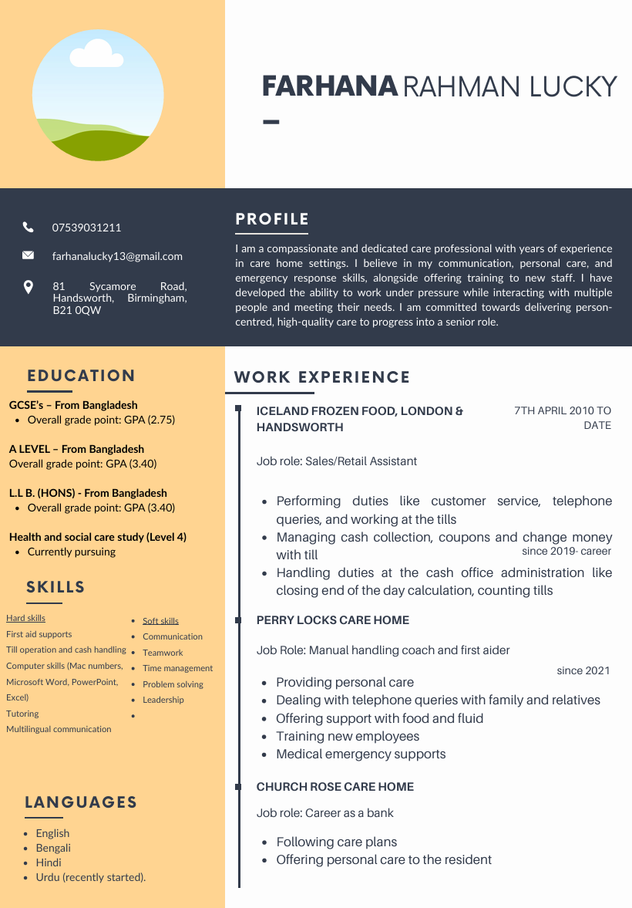
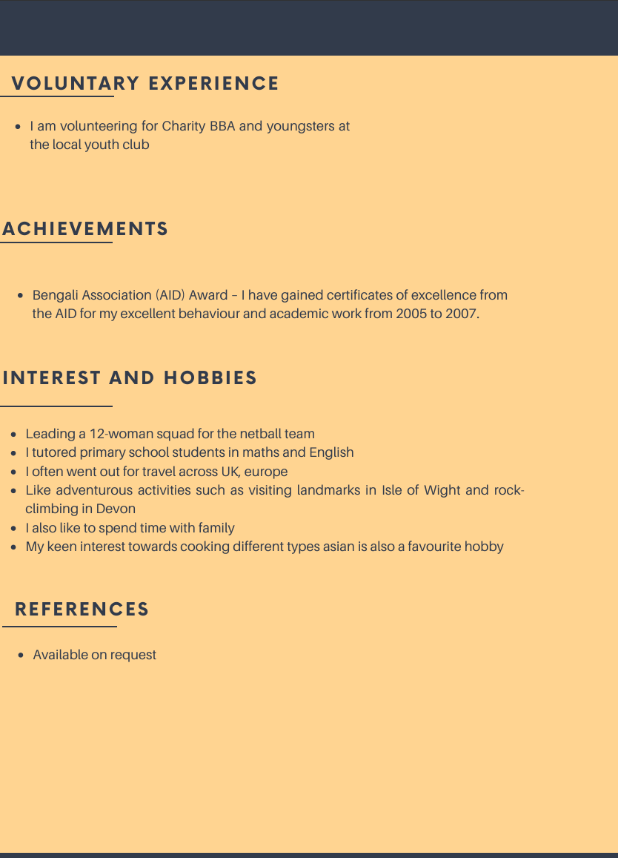

Task 2: Personal statement
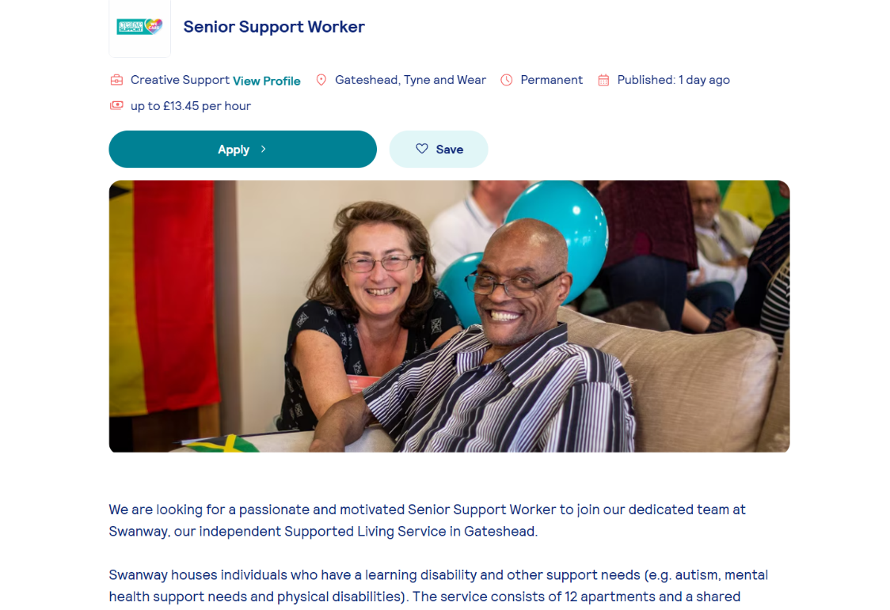
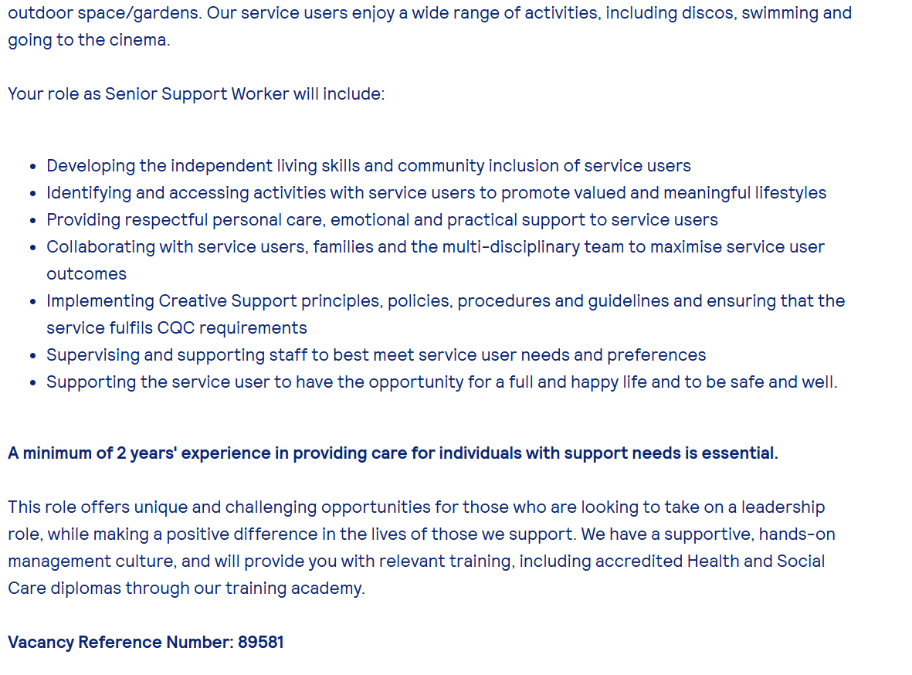
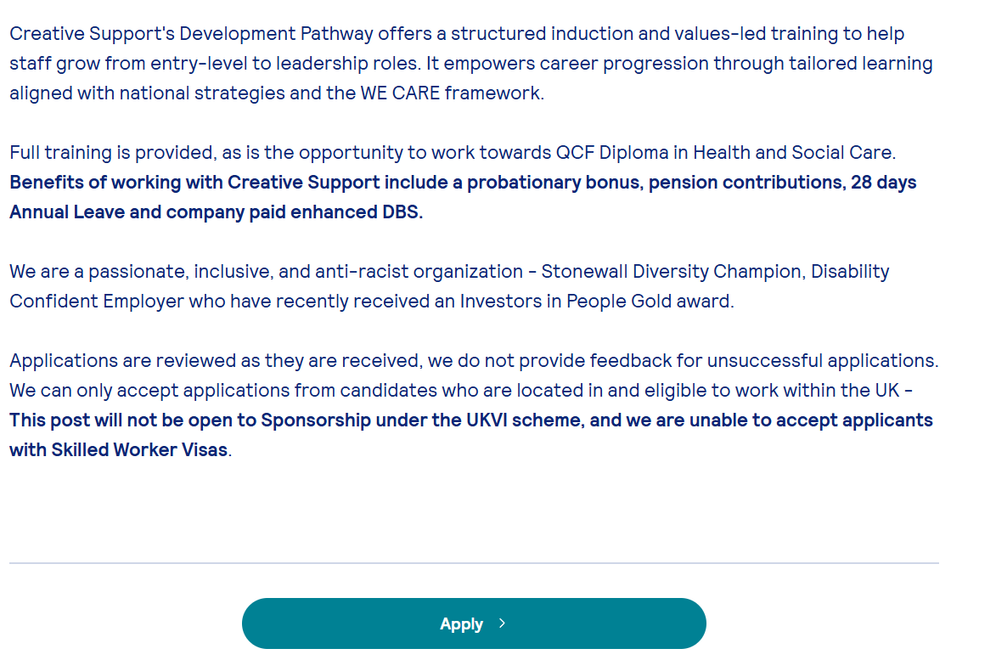
Figure 1: Job advertisement
(Source: Totaljobs, 2026)
I have decided to apply for the senior support worker job role to pursue my career goal of working in the health and social care industry. My previous experiences, dedication and personal strengths in personal care make me the best fit for the job role. I have mustered hands-on experience working in care home settings while working at Church Rose Care Home (since 2021) and Perry Locks Care Home (since 2019). The respective job position, responsibilities have supported me in developing practical skills like emergency support, professional values like confidentiality management to assist vulnerable people with compassion, dignity and respect.
My career aim is to make continuous progress in the health and social care sector, in which the senior support workers provide me the opportunity to fulfil my goal. I have experience in supporting individuals with daily living activities, fluid intake, food intake, and effective responding during medical emergencies. During this period, I have also fulfilled responsibilities like coaching, first aid support and teaching new joiners. These experiences not only improve my ability in communication and practical skills, but also help me learn about collaboration, teamwork, and safe care environments. Training and coaching experience particulars help me in sharing knowledge, promoting good practices which are advantageous for supportive work roles.
Additionally, I have strengthened my interpersonal and communication skills during my long-term employment in Iceland's frozen food. My experience over a decade in this job helps me learn how to work under pressure, manage customer queries, maintain professionalism, and handle cases in a busy environment. Likewise, I can transfer such skills in a supportive work role for efficiently dealing with families, external professionals, and relatives. As senior supportive work rules require attending to multiple aspects at the same time, experience of working in busy environments supports me to skilfully manage multitasking.
Alongside my academic qualifications in GCSE, A-level, and LLB, helps to apply analytical thinking as a crisis response or knowledge on policy for the betterment of ethical practices. I am currently pursuing academic qualifications in health and social care (level 4), that base my knowledge on caring for patients, across functional work, handover processes, and integrated care. Apart from this, my expertise in multiple languages such as English, Hindi, and Bengali enables me to effectively communicate with people from diverse backgrounds, which will promote culturally sensitive support.
I strongly believe that my professional experience and personal quality strictly resonate with the expectations of employers for the job position of senior support worker. Throughout the job activity, I have portrayed a genuine passion for supporting others by maintaining reliability and punctuality. I am quick to adapt to any new environment, handling situational pressure well, and have a vision for maintaining a high-quality standard of care. My experiences with problem-solving, mentoring, and personal care demonstrate my capability to take on the responsibility of a more senior role to better contribute to supporting staff, leading teams, and providing person-centred care. Thus, getting a senior support worker job position is a critical step in my career journey, in which commitment, expertise, and enthusiasm help me to positively contribute to your team.

Task 3: SWOT and PDP

a) SWOT analysis
Strengths | Weaknesses
- I have hands-on experience of care home setting, care planning from Church Rose Care Homes and Perry Locks  - Communication, customer service, emergency response and first aid support skills are another major strength  - My multilingual skills, such as Bengali and English, support me in serving individuals from diverse backgrounds | - Lack of health and social care qualification or related certificates  - I face challenges in managing multiple responsibilities and allocating time for additional training  - I do not possess much experience with medication administration
Opportunities | Threats
- A global healthcare shortage is expected to reach about 10 million by 2030 (McKinsey, 2025)  - I have the opportunity to take part in further training, such as medication training, NVQ level 3 or 4  - Technological advancement (LinkedIn) can support me in networking with care homes | - High competition and individuals with higher degrees might first prioritise the senior role  - Risk of burnout and poor stress management capability can negatively affect my work-life balance.
Table 1: Personal SWOT analysis
(Source: Created by author)
My previous job experience in a care home setting supported me to learn about how to assist a patient with daily living supports and understand practical challenges (managing families, stress). These experiences guide me to avoid mistakes like missing medication and empathically serving the people. Although ascending to a senior role requires academic qualification in which no certification in health and social care, which can be a barrier to achieving this job role. In addition, improper time management also reduces chances for consistently working on new skills. However, noting certification on medication or NVQ can open up opportunities to grab the huge chance in the health and social care sector. Although candidates with higher education degrees and inadequacy in stress management can hamper my mental well-being in the long term.

b) Personal Development Plan (PDP)
Goals | Strategic action | Monitoring and evaluation | Timeline
Goal 1: I want to complete my first health and social care degree from a recognised university as a formal qualification and improve my knowledge | - I will enrol for a level 3 diploma course in health and social care  - I will seek guidance from mentors and senior colleagues to choose the most compatible courses | - I will track feedback by completing units and taking feedback from the professor  - I will keep a reflective journal to note open improvement areas and daily progress | 12 months
Goal 2: I will improve time management and active listening skills to better address patients' requirements | - I will maintain daily task lists for effective workload management  - Making eye contact, questioning to family members for clarification to boost active listening skills | - Joining a supervision meeting with managers  - Assess based on missed tasks or response rate | 6 months
Goal 3: Improving medical awareness and safe administrative practice to improve medical knowledge | - Working under trained staff to learn medication usage safely  - Building knowledge on common medications and their side effects | - Keep a record of certificates  - Assisting the supervisor with the medication task | 6 months
Table 2: PDP
(Source: Created by author)

Task 4: Critical reflection
Gibbs reflective model
I will use six factors of Gibbs reflective model to structure my experiences on completing LCHS4009 component 1. This reflective model will explain my feelings, skills development, and areas of improvement that I experienced during the assignment.

Description
I have participated in Component 1 activity of presentation preparation on the professional skills required in the health and social care sector. This activity requires me to research the importance of skills, collect evidence-based information and present it in a concise format in front of peers and professors. My aim is to illustrate the importance of the chosen skills in real-life execution, like interacting with patients and their family members. During the process, looking for real case examples and connecting with theoretical aspects was the most challenging for me.

Feelings
At the initial stage, I felt nervous and excited due to my first time presenting in front of others. According to Mardiningrum and Ramadhani (2022, p.106), students might face nervousness and anxiety during a presentation while performing in front of the public. As English was not my first language, I felt concerned about properly clarifying my ideas on skills. Although a week-long rehearsal with peers, clear structures of presentation and maintaining eye contact slowly improved my confidence. I have noticed that the presentations have improved communication skillsets. However, I felt that my initial nervousness affected my time management capability, which negatively affected my delivery and coverage of all points.

Evaluation
Looking back, I understand that logical content structure, visual communication and idea flow between sections were major strengths of this presentation activity in component 1. I have used media coverage, peer review articles, and information from health and social care organisations to validate claims on the importance of skill. Professors and peers feedback on my body language and clarity of voice demonstrates successful competition of the presentation. Feedback educates students about where theory is currently going and next steps for improvement (NZ Day, Saab and Admiraal, 2022, p.183). However, a lack of active listening and continued speaking without many pauses prevented the audience from going through my ideas. Additionally, the lack of practical examples makes it challenging for audiences to relate the importance of the skill to real-life phenomena.

Analysis
Based on the experience from the component 1 presentation, I have learned that beforehand preparation boosts confidence and reduces anxiety, which leads to better academic scores. As per Mekonnen (2025, p.26), underconfident college and university students are reluctant to share their opinions in class, as they would in a presentation. This activity makes me realise areas of improvement in public speaking, time management and active listening. For example, the professor told me to distribute time effectively to cover all points in detail. Additionally, I feel that communication skills professor feedback on clear presentations can be transferable to professional aspects that will strengthen my employability.

Conclusion
In conclusion, I believe that component 1 activity is not only an academic activity but also a cornerstone for personal skill improvement. I have developed skills in researching, referencing, critical thinking, and communication while collecting information and delivering the presentation. I need to work on my time management and active listening skills to better engage with audiences in similar scenarios. Thus, I will work on the following action plan to improve my interpersonal skills and boost my employability skills for the future.

Action Plan
Objective | Strategic action | Timeframe
I want to improve my time management skills | Using time blocks and the Pomodoro technique for better time allocation | 3-4 months
I will boost my active listening skills | Using tech back methods and lighting others without interruptions | 2-3 months
Table 2: Action plan
(Source: Self-Developed)

References
Mardiningrum, A. and Ramadhani, D.R. (2022) ‘Classroom oral presentation: Students’ challenges and how they cope’, Eralingua: Jurnal Pendidikan Bahasa Asing dan Sastra, 6(1), pp.103-119. https://pdfs.semanticscholar.org/e2db/ff37842eec5ee7802b28c5a1b56302c7815f.pdf
McKinsey (2025) Heartbeat of health. Available at: https://www.mckinsey.com.br/mhi/our-insights/heartbeat-of-health-reimagining-the-healthcare-workforce-of-the-future (Accessed: 03 March 2026)
Mekonnen, L. (2025) ‘Improving Students' Self-Confidence in Learning Through Action Research: Presentation Skills in Focus Improving Students' Self confidence in Learning’, IJCAR: Indonesian Journal of Classroom Action Research, 3(1), pp.26-36. https://www.das-institute.com/journal/index.php/ijcar/article/download/753/670
NZ Day, I., Saab, N. and Admiraal, W. (2022) ‘Online peer feedback on video presentations: Type of feedback and improvement of presentation skills’, Assessment & Evaluation in Higher Education, 47(2), pp.183-197. https://doi.org/10.1080/02602938.2021.1904826
Totaljobs (2026) Health and social care jobs. Available at: https://www.totaljobs.com/job/senior-support-worker/creative-support-job106908914 (Accessed: 03 March 2026)

