

University of Wales Trinity Saint David
by
Atanas Maslev

Switching, Routing and Wireless (ACCA6022_LON)
Lector: Kwame Assa-Agyei

BSc (Hons) Computing (Cloud Computing)

August 2025

R1

R1#show run
Set up

Current configuration : 6965 bytes

Last configuration change at 09:10:57 UTC Wed Aug 20 2025

version 17.9
service timestamps debug datetime msec
service timestamps log datetime msec
service password-encryption
! Call-home is enabled by Smart-Licensing.
service call-home
platform qfp utilization monitor load 80
platform punt-keepalive disable-kernel-core

hostname R1

boot-start-marker
boot-end-marker

no aaa new-model

tells the router to stop interacting with any DNS servers entirely and give new name “swre-lab.com
no ip domain lookup
ip domain name swre-lab.com
to prevent the server from automatically assigning specific IP addresses to clients
ip dhcp excluded-address 192.168.20.1 192.168.20.244
ip dhcp excluded-address 192.168.30.1 192.168.30.244
used to enter DHCP pool configuration mode for a specific VLAN (VLAN7 in this case) within a network device like a switch or router
ip dhcp pool VLAN7
network 192.168.20.0 255.255.255.0
default-router 192.168.20.1
domain-name swre-lab.com

ip dhcp pool VLAN8
network 192.168.30.0 255.255.255.0
default-router 192.168.30.1
domain-name swre-lab.com

login on-success log

subscriber templating
vtp version 1
multilink bundle-name authenticated

crypto pki trustpoint TP-self-signed-1898109890
enrollment selfsigned
subject-name cn=IOS-Self-Signed-Certificate-1898109890
revocation-check none
rsakeypair TP-self-signed-1898109890

crypto pki trustpoint SLA-TrustPoint
enrollment pkcs12
revocation-check crl

crypto pki certificate chain TP-self-signed-1898109890
certificate self-signed 01
30820330 30820218 A0030201 02020101 300D0609 2A864886 F70D0101 05050030
31312F30 2D060355 04031326 494F532D 53656C66 2D536967 6E65642D 43657274
69666963 6174652D 31383938 31303938 3930301E 170D3235 30383230 30393030
31355A17 0D333530 38323030 39303031 355A3031 312F302D 06035504 03132649
4F532D53 656C662D 5369676E 65642D43 65727469 66696361 74652D31 38393831
30393839 30308201 22300D06 092A8648 86F70D01 01010500 0382010F 00308201
0A028201 0100B986 19FB703F 64116C01 826D9731 62A01BD9 8DE6CE06 B0C91CF4
AAAC55BF D87E58AE D940A866 A2880E15 14242E9B 03DF20A4 04F4878B 2D38AA72
CC22B834 673B58F6 6421F946 7F05009C DA30E944 944AD993 EB6A96FD F1345B1D
CBEFE80B C654E67C E60337A6 D0219967 1878FD41 1BF0E0E2 7375F337 7596392C
80C8E1F0 F2B6783A 8F3A0B13 551B994C F595DF38 EDBBFC7A D20FE6E5 BB84036A
8A5AEC2D 26C54751 C5F67D33 D2E56CCA DB03CE0A 7651FDC5 DC0FF978 01EF2F62
371AACB6 5967E9CB 8A443845 F6C47D01 E3D4BE5B D43379FD 4659D363 6324C548
0068F1FC 98481528 AC23BCC6 8612D83F B8FCBA14 5A5B3EB1 1AA824F1 2B7E36EF
6E62AD2D BD5D0203 010001A3 53305130 0F060355 1D130101 FF040530 030101FF
301F0603 551D2304 18301680 1485CCC2 970EC9CC 52C847DC B0544CF0 4893FC12
F2301D06 03551D0E 04160414 85CCC297 0EC9CC52 C847DCB0 544CF048 93FC12F2
300D0609 2A864886 F70D0101 05050003 82010100 4B03A828 DF0F8BDF 724D5221
5207A529 16E14856 AD659F80 F61F9DA6 982D558D 622971A9 3F796F64 752E1F12
61A49019 F0A7FBE7 6DC50AC1 2B2D92FE FEA460F6 0346661E F2396658 27F1F654
FA781AC9 96BCEB28 DE81B7E6 16E2758F 0ABD05E2 D6492F33 5862ACB9 8B58A247
BDFC8E02 00A3D61A BAE99878 2505E70A 23D61712 839503A5 D17FEBE0 CA1FC6A2
A0E8E189 A758EC5E 134AE32F 8B5204D2 20BA7B16 5520FC10 E2C6468F 4CE2B8B8
DCB8BF8E 49DF1C67 90232B5E EB6F8C2A 2659A1AB A6A0C9B3 0366821C 5D0DBC57
2C3B3033 01E4F9AD 3CF06484 BE96E62B 89A78F45 6AB4B8A7 5079BF1E 7BA478E0
90118D7A AA4BD72D 41C20E27 0B2AD8B4 725CC372
quit
crypto pki certificate chain SLA-TrustPoint
certificate ca 01
30820321 30820209 A0030201 02020101 300D0609 2A864886 F70D0101 0B050030
32310E30 0C060355 040A1305 43697363 6F312030 1E060355 04031317 43697363
6F204C69 63656E73 696E6720 526F6F74 20434130 1E170D31 33303533 30313934
3834375A 170D3338 30353330 31393438 34375A30 32310E30 0C060355 040A1305
43697363 6F312030 1E060355 04031317 43697363 6F204C69 63656E73 696E6720
526F6F74 20434130 82012230 0D06092A 864886F7 0D010101 05000382 010F0030
82010A02 82010100 A6BCBD96 131E05F7 145EA72C 2CD686E6 17222EA1 F1EFF64D
CBB4C798 212AA147 C655D8D7 9471380D 8711441E 1AAF071A 9CAE6388 8A38E520
1C394D78 462EF239 C659F715 B98C0A59 5BBB5CBD 0CFEBEA3 700A8BF7 D8F256EE
4AA4E80D DB6FD1C9 60B1FD18 FFC69C96 6FA68957 A2617DE7 104FDC5F EA2956AC
7390A3EB 2B5436AD C847A2C5 DAB553EB 69A9A535 58E9F3E3 C0BD23CF 58BD7188
68E69491 20F320E7 948E71D7 AE3BCC84 F10684C7 4BC8E00F 539BA42B 42C68BB7
C7479096 B4CB2D62 EA2F505D C7B062A4 6811D95B E8250FC4 5D5D5FB8 8F27D191
C55F0D76 61F9A4CD 3D992327 A8BB03BD 4E6D7069 7CBADF8B DF5F4368 95135E44
DFC7C6CF 04DD7FD1 02030100 01A34230 40300E06 03551D0F 0101FF04 04030201
06300F06 03551D13 0101FF04 05300301 01FF301D 0603551D 0E041604 1449DC85
4B3D31E5 1B3E6A17 606AF333 3D3B4C73 E8300D06 092A8648 86F70D01 010B0500
03820101 00507F24 D3932A66 86025D9F E838AE5C 6D4DF6B0 49631C78 240DA905
604EDCDE FF4FED2B 77FC460E CD636FDB DD44681E 3A5673AB 9093D3B1 6C9E3D8B
D98987BF E40CBD9E 1AECA0C2 2189BB5C 8FA85686 CD98B646 5575B146 8DFC66A8
467A3DF4 4D565700 6ADF0F0D CF835015 3C04FF7C 21E878AC 11BA9CD2 55A9232C
7CA7B7E6 C1AF74F6 152E99B7 B1FCF9BB E973DE7F 5BDDEB86 C71E3B49 1765308B
5FB0DA06 B92AFE7F 494E8A9E 07B85737 F3A58BE1 1A48A229 C37C1E69 39F08678
80DDCD16 D6BACECA EEBC7CF9 8428787B 35202CDC 60E4616A B623CDBD 230E3AFB
418616A9 4093E049 4D10AB75 27E86F73 932E35B5 8862FDAE 0275156F 719BB2F0
D697DF7F 28
quit

license udi pid C8200L-1N-4T sn FCZ2818R0LX
memory free low-watermark processor 62972

diagnostic bootup level minimal

spanning-tree extend system-id

enable secret 9 $9$ixqY4h//bHE/LE$d9Di0Y9fLsioIibdBXZh5uDIg8NvLHQ0uIea5rMlE/.

username cisco secret 9 $9$Xa0nHhx5yZrfH.$tg4VFyiA3/XUY8bcxEzIjU6DolQnIgGRRuBdheIQSPk

redundancy
mode none

"interface Loopback0" refers to a logical, software-based network interface commonly used in networking devices like routers and switches
interface Loopback0
Set the interface ports
ip address 209.165.201.1 255.255.255.0

interface GigabitEthernet0/0/0
no ip address
negotiation auto

interface GigabitEthernet0/0/1
no ip address
negotiation auto

interface GigabitEthernet0/0/1.7
encapsulation dot1Q 7
ip address 192.168.20.1 255.255.255.0

interface GigabitEthernet0/0/1.8
encapsulation dot1Q 8
ip address 192.168.30.1 255.255.255.0

interface GigabitEthernet0/0/1.9
encapsulation dot1Q 9
ip address 192.168.40.1 255.255.255.0

interface GigabitEthernet0/0/1.11
encapsulation dot1Q 11 native

interface GigabitEthernet0/0/2
no ip address
negotiation auto

interface GigabitEthernet0/0/3
no ip address
negotiation auto

interface Serial0/1/0
no ip address

interface Serial0/1/1
no ip address

ip http server
ip http authentication local
ip http secure-server
ip forward-protocol nd
ip route 0.0.0.0 0.0.0.0 Loopback0

control-plane
line con 0
password 7 045802150C2E1D1C5A
login
stopbits 1
line aux 0
used to manage and configure remote access to network devices like routers and switches
line vty 0 4
authentication uses locally configured credentials using the username and password command
login local
limit the router to SSH connections only
transport input ssh
line vty 5 15
login local
transport input ssh

call-home
If contact email address in call-home is configured as sch-smart-licensing@cisco.com
the email address configured in Cisco Smart License Portal will be used as contact email address to send SCH notifications.
contact-email-addr sch-smart-licensing@cisco.com
profile "CiscoTAC-1"
active
destination transport-method http

end

Switch
S1
S1#show run
Set up

Current configuration : 3525 bytes

Last configuration change at 09:45:01 UTC Wed Aug 20 2025

version 15.2
no service pad
service timestamps debug datetime msec
service timestamps log datetime msec
service password-encryption

hostname S1

boot-start-marker
boot-end-marker

enable secret 9 $9$HHO1RejcXuuQtZ$0V9XEYPnUslKUUOxeK2HgZ6.eQNixKGGpAFkqHlUJGs

username cisco secret 9 $9$Q265fwwSoxkUtV$.77sGn6xnk4HG0U9HGwDQ.VEyGgX2lWMss483m0JBNI
no aaa new-model
switch 1 provision c1000-24t-4g-l
system mtu routing 1500
--More--
*Aug 20 09:45:12.873: %CDP-4-NATIVE_VLAN_MISMATCH: Native VLAN mismatch discovered on GigabitEthernet1/0/2 (11), with Switch GigabitEthernet! .

no ip domain-lookup
ip domain-name swre-lab.com

spanning-tree mode rapid-pvst
spanning-tree extend system-id

vlan internal allocation policy ascending

interface Port-channel1

interface GigabitEthernet1/0/1
switchport trunk native vlan 11
switchport mode trunk
channel-group 1 mode desirable

interface GigabitEthernet1/0/2
switchport trunk native vlan 11
switchport mode trunk
channel-group 1 mode desirable

interface GigabitEthernet1/0/3
switchport access vlan 10
switchport mode access
shutdown

interface GigabitEthernet1/0/4
switchport access vlan 10
switchport mode access
shutdown

interface GigabitEthernet1/0/5
switchport trunk native vlan 11
switchport mode trunk

interface GigabitEthernet1/0/6
switchport access vlan 7
switchport mode access
switchport port-security maximum 3
switchport port-security

interface GigabitEthernet1/0/7
switchport access vlan 10
switchport mode access
shutdown

interface GigabitEthernet1/0/8
switchport access vlan 10
switchport mode access
shutdown

interface GigabitEthernet1/0/9
switchport access vlan 10
switchport mode access
shutdown

interface GigabitEthernet1/0/10
switchport access vlan 10
switchport mode access
shutdown

interface GigabitEthernet1/0/11
switchport access vlan 10
switchport mode access
shutdown

interface GigabitEthernet1/0/12
switchport access vlan 10
switchport mode access
shutdown

interface GigabitEthernet1/0/13
switchport access vlan 10
switchport mode access
shutdown

interface GigabitEthernet1/0/14
switchport access vlan 10
switchport mode access
shutdown

interface GigabitEthernet1/0/15
switchport access vlan 10
switchport mode access
shutdown

interface GigabitEthernet1/0/16
switchport access vlan 10
switchport mode access
shutdown

interface GigabitEthernet1/0/17
switchport access vlan 10
switchport mode access
shutdown

interface GigabitEthernet1/0/18
switchport access vlan 10
switchport mode access
shutdown

interface GigabitEthernet1/0/19
switchport access vlan 10
switchport mode access
shutdown

interface GigabitEthernet1/0/20
switchport access vlan 10
switchport mode access
shutdown

interface GigabitEthernet1/0/21
switchport access vlan 10
switchport mode access
shutdown

interface GigabitEthernet1/0/22
switchport access vlan 10
switchport mode access
shutdown

interface GigabitEthernet1/0/23
switchport access vlan 10
switchport mode access
shutdown

interface GigabitEthernet1/0/24
switchport access vlan 10
switchport mode access
shutdown

interface GigabitEthernet1/0/25

interface GigabitEthernet1/0/26

interface GigabitEthernet1/0/27

interface GigabitEthernet1/0/28

interface Vlan1
no ip address

interface Vlan9
ip address 192.168.40.2 255.255.255.0

ip default-gateway 192.168.40.1
ip http server
ip http secure-server

line con 0
password 7 030752180500701E1D
login
line vty 0 4
login local
transport input ssh
line vty 5 15
login local
transport input ssh
end

S1#
*Aug 20 09:45:55.682: %CDP-4-NATIVE_VLAN_MISMATCH: Native VLAN mismatch discovered on GigabitEthernet1/0/1 (11), with Switch GigabitEthernet1/0/1 (1).
*Aug 20 09:46:03.293: %CDP-4-NATIVE_VLAN_MISMATCH: Native VLAN mismatch discovered on GigabitEthernet1/0/2 (11), with Switch GigabitEthernet1/0/2 (1).
*Aug 20 09:46:54.888: %CDP-4-NATIVE_VLAN_MISMATCH: Native VLAN mismatch discovered on GigabitEthernet1/0/1 (11), with Switch GigabitEthernet1/0/1 (1).
*Aug 20 09:46:59.495: %CDP-4-NATIVE_VLAN_MISMATCH: Native VLAN mismatch discovered on GigabitEthernet1/0/2 (11), with Switch GigabitEthernet1/0/2 (1).

S2

*Aug 20 10:09:53.116: %SYS-5-CONFIG_I: Configured from console by console[OK]
S2#show run
Building configuration...

Current configuration : 3586 bytes

Last configuration change at 10:09:53 UTC Wed Aug 20 2025

version 15.2
no service pad
service timestamps debug datetime msec
service timestamps log datetime msec
service password-encryption

hostname S2

boot-start-marker
boot-end-marker

enable secret 9 $9$HAz9QvITCjLHtZ$7quazsJt4Oa2yzUXPMdPC4fMweizmgfETWTPozzuw2I

username cisco secret 9 $9$KHQZREctXqHLso$fZ9ktA4jInWWpXkAfeohrk.73AuTW879Zuef7q7xyK6
no aaa new-model
switch 1 provision c1000-24t-4g-l
system mtu routing 1500

no ip domain-lookup
ip domain-name swre-lab.com

spanning-tree mode rapid-pvst
spanning-tree extend system-id

vlan internal allocation policy ascending

interface Port-channel1
switchport trunk native vlan 11
switchport mode trunk

interface GigabitEthernet1/0/1
switchport trunk native vlan 11
switchport mode trunk
channel-group 1 mode desirable

interface GigabitEthernet1/0/2
switchport trunk native vlan 11
switchport mode trunk
channel-group 1 mode desirable

interface GigabitEthernet1/0/3
switchport access vlan 10
switchport mode access
shutdown

interface GigabitEthernet1/0/4
switchport access vlan 10
switchport mode access
shutdown

interface GigabitEthernet1/0/5
switchport access vlan 10
switchport mode access
shutdown

interface GigabitEthernet1/0/6
switchport access vlan 10
switchport mode access
shutdown

interface GigabitEthernet1/0/7
switchport access vlan 10
switchport mode access
shutdown

interface GigabitEthernet1/0/8
switchport access vlan 10
switchport mode access
shutdown

interface GigabitEthernet1/0/9
switchport access vlan 10
switchport mode access
shutdown

interface GigabitEthernet1/0/10
switchport access vlan 10
switchport mode access
shutdown

interface GigabitEthernet1/0/11
switchport access vlan 10
switchport mode access
shutdown

interface GigabitEthernet1/0/12
switchport access vlan 10
switchport mode access
shutdown

interface GigabitEthernet1/0/13
switchport access vlan 10
switchport mode access
shutdown

interface GigabitEthernet1/0/14
switchport access vlan 10
switchport mode access
shutdown

interface GigabitEthernet1/0/15
switchport access vlan 10
switchport mode access
shutdown

interface GigabitEthernet1/0/16
switchport access vlan 10
switchport mode access
shutdown

interface GigabitEthernet1/0/17
switchport access vlan 10
switchport mode access
shutdown

interface GigabitEthernet1/0/18
switchport access vlan 8
switchport mode access
switchport port-security maximum 3
switchport port-security

interface GigabitEthernet1/0/19
switchport access vlan 10
switchport mode access
shutdown

interface GigabitEthernet1/0/20
switchport access vlan 10
switchport mode access
shutdown
!
interface GigabitEthernet1/0/21
switchport access vlan 10
switchport mode access
shutdown

interface GigabitEthernet1/0/22
switchport access vlan 10
switchport mode access
shutdown

interface GigabitEthernet1/0/23
switchport access vlan 10
switchport mode access
shutdown

interface GigabitEthernet1/0/24
switchport access vlan 10
switchport mode access
shutdown

interface GigabitEthernet1/0/25

interface GigabitEthernet1/0/26

interface GigabitEthernet1/0/27

interface GigabitEthernet1/0/28

interface Vlan1
no ip address

interface Vlan9
ip address 192.168.40.3 255.255.255.0

ip default-gateway 192.168.40.1
ip http server
ip http secure-server

line con 0
password 7 00071A1507545A545C
login
line vty 0 4
login local
transport input ssh
line vty 5 15
login local
transport input ssh

end

Ping to PC A

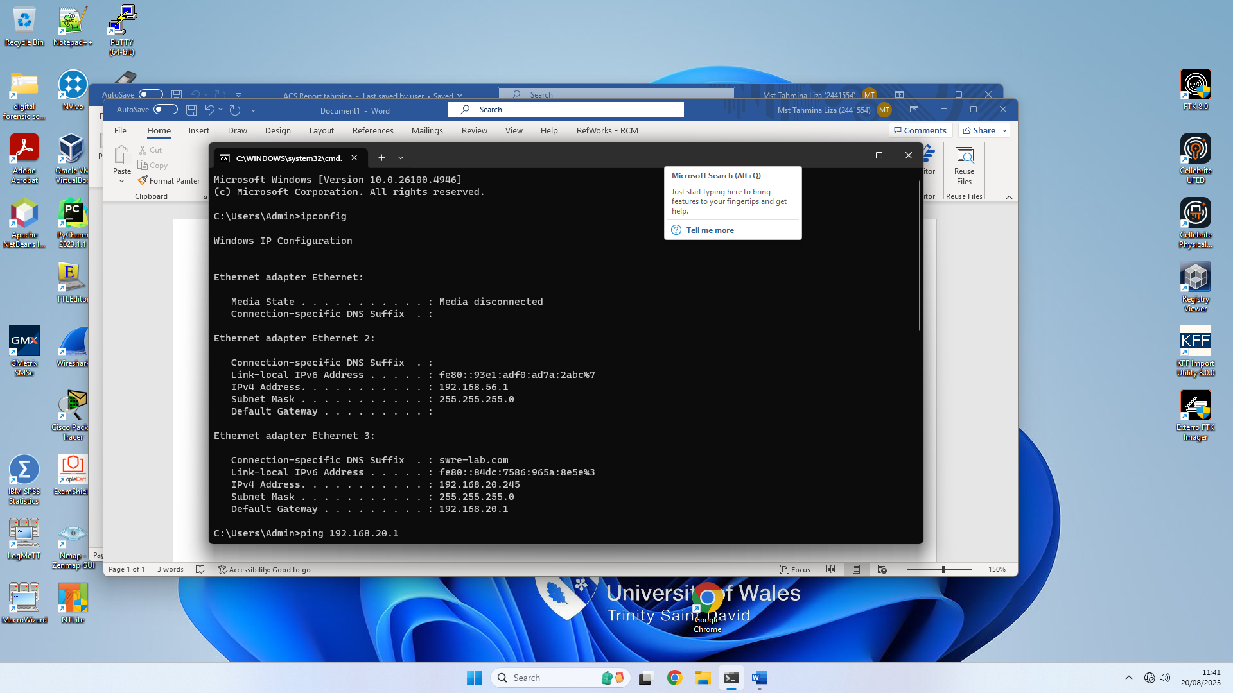
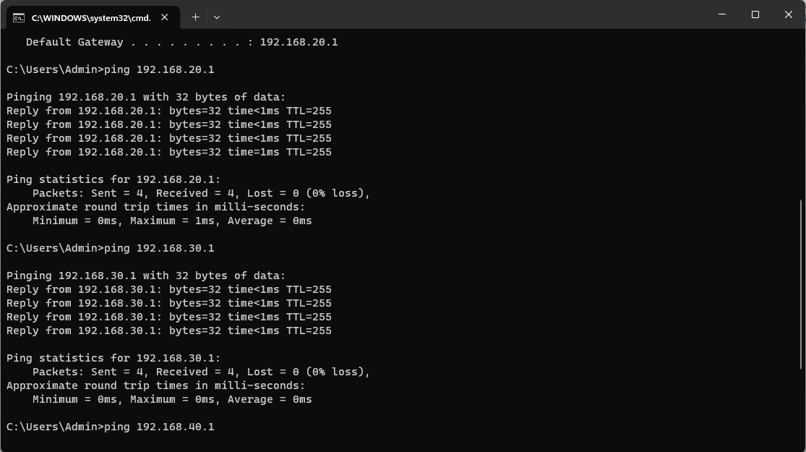

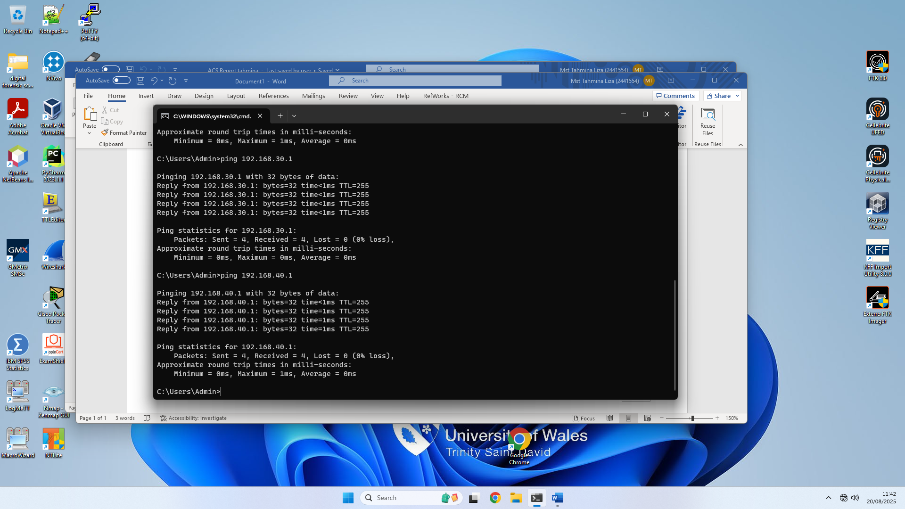

Ping to PC B


