

Managing Enterprise in the 21st Century

Business Plan

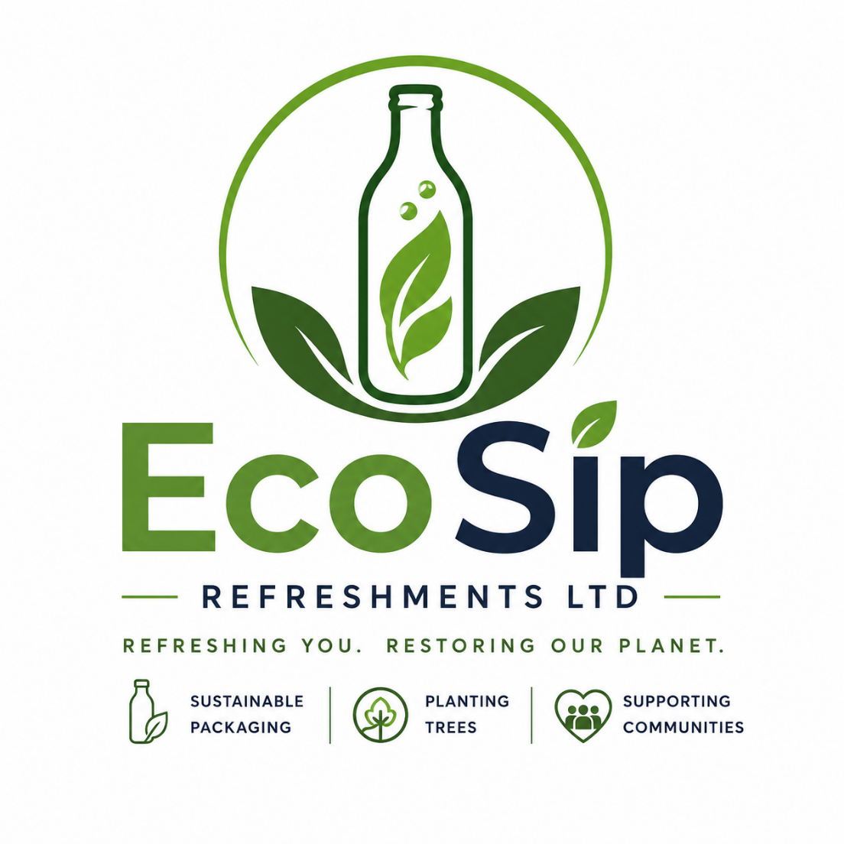

Submission Date:27.07.2026
Lecturer: Thomas Adeyemi
Student ID:2518291

Table of Contents
Group Information 2
Executive Summary 4
Business Concept 5
Business Description 5
Product Description 5
Business Objectives (SMART Objectives) 5
Short-Term Objectives (less than a year) 5
Long-Term Objectives (less than a year) 5
Market Analysis and Marketing Plan 6
Market Analysis (Competitors, Customers, Target Groups) 6
PESTEL Analysis 6
SWOT Analysis 6
Marketing Mix (4Ps) 6
Management Team 6
Management Team and Their Background 7
Organisational Chart 7
Key Milestones 7
Financial Plan (One Year) 7
Sources of Finance 7
Cash Flow Forecast 7
Sales Forecast 7
Cost of Production Forecast 7
Break Even Analysis 7
Operations and Management Plan 7
Production of Good and Service 7
Technology Plan 7
Human Resource Plan 7
Expansion Plan 8
Reference List 8
Appendices: 9

Executive Summary

EcoSip Refreshments Ltd is a start-up beverage company specializing in premium, naturally flavoured sparkling water and iced tea, packaged in environmentally sustainable materials. The company aims to meet the growing demand for healthier beverages while reducing environmental impact by using recyclable packaging and supporting community initiatives.
The business will operate as a private limited company based in London. An initial investment of £40,000 will support product development, branding, inventory, marketing, and operational expenses. EcoSip will distribute its products through cafés, restaurants, gyms, convenience stores, and online platforms.

Business Concept

Business Description

EcoSip Refreshments Ltd is a sustainable beverage company producing healthy drinks made from natural ingredients with reduced sugar and no artificial colours. The business focuses on delivering premium-quality refreshments while minimising environmental impact through recyclable packaging and responsible sourcing.
The company will initially distribute its products through hospitality businesses, convenience stores, and online sales before expanding into national supermarket chains.

Product Description

Products include:
- Sparkling water
- Natural iced tea
- Sugar-free fruit drinks
The beverages are made with natural ingredients, contain no artificial colours, and have reduced sugar content.
Unlike many competitors, EcoSip uses glass bottles and aluminium cans, both of which are fully recyclable.
For every 100 bottles sold, EcoSip will arrange for one tree to be planted in partnership with environmental charities.

Business Objectives (SMART Objectives)

EcoSip's objectives are Specific, Measurable, Achievable, Relevant and Time-bound.

Short-Term Objectives (less than a year)

- Register the business as a Private Limited Company.
- Secure funding of £40,000.
- Launch three beverage products.
- Acquire at least 50 business customers.
- Generate first-year sales of £120,000.
- Build a social media audience of 5,000 followers.

Long-Term Objectives (More than a year)

- Expand distribution across the UK.
- Enter major supermarket chains.
- Launch new seasonal flavours.
- Increase annual sales above £500,000.
- Employ more than 20 staff.
- Become carbon neutral by Year 5.

Market Analysis and Marketing Plan

Market Analysis (Competitors, Customers, Target Groups)

Customers
- Health-conscious adults
- Young professionals
- Gym members
- Families
- Environmentally aware consumers
Target Groups
Business customers include:
- Restaurants
- Cafés
- Hotels
- Gyms
- Independent retailers
- Corporate offices
Competitors
Main competitors include:
- Coca-Cola
- PepsiCo
- Dash Water
- Belu Water
- Innocent Drinks
EcoSip differentiates itself through premium positioning, sustainability, community engagement and recyclable packaging.

PESTEL Analysis

Political
Government initiatives encouraging recycling and reducing single-use plastics create opportunities for EcoSip.
Economic
Despite inflation, consumers continue to purchase premium healthy products.
Social
Customers increasingly seek healthier drinks and environmentally responsible brands.
Technological
Digital marketing, CRM software and e-commerce platforms enable efficient customer engagement.
Environmental
Consumers expect companies to reduce waste and carbon emissions.
Legal
EcoSip will comply with:
- Food Safety Act 1990
- Food Information Regulations
- GDPR
- Health and Safety legislation

SWOT Analysis
Strengths
- Sustainable packaging
- Premium ingredients
- Strong environmental mission
- Growing healthy lifestyle trend
Weaknesses
- Limited brand awareness
- High initial investment
- Strong competition
Opportunities
- Growing demand for healthier beverages
- Expansion into supermarkets
- Online sales growth
- Corporate partnerships
Threats
- Large multinational competitors
- Rising production costs
- Economic downturn
- Supply chain disruptions

Marketing Mix (4Ps)

Product
Premium natural beverages with recyclable packaging.
Price
Premium pricing strategy reflecting product quality and sustainability.
Place
Distribution through:
- Restaurants
- Cafés
- Hotels
- Retail stores
- Company website
- Amazon
- Wholesale distributors
Promotion
Marketing activities include:
- Social media advertising
- Influencer partnerships
- Product sampling
- Trade exhibitions
- Google Ads
- Email marketing
- Public relations
- Sustainability campaigns

Management Team

EcoSip will initially employ four full-time staff.

Management Team and Their Background

Managing Director
Responsible for business strategy, partnerships and investment.
Sales & Marketing Manager
Develops new business and marketing campaigns.
Operations Manager
Manages inventory, suppliers and logistics.
Finance & Administration Officer
Responsible for accounting, payroll and compliance.

Organisational Chart

Key Milestones

Month | Milestone

1 | Business registration

2 | Product development

3 | Branding completed

4 | Website launch

5 | Production begins

6 | First customer orders

9 | 50 customers secured

12 | £120,000 sales achieved

Financial Plan (One Year)

Startup Cost | Cost (£)
Company Registration & Legal Fees | 300
Branding & Logo Design | 1000
Website & E-commerce Development | 2000
Product Development & Testing | 5000
Initial Stock (Drinks & Ingredients) | 10000
Packaging (Glass Bottles & Cans) | 6000
Marketing & Product Launch | 5000
Warehouse Equipment | 4000
Office Equipment | 2000
Insurance | 700
Total Startup Cost | 36000

Fixed Costs | Per Month (£)
Warehouse Rent | 1500
Business Rates | 300
Electricity & Water | 250
Internet & Phone | 80
Accountant | 150
Insurance | 120
Salaries (2 Employees) | 4000
Marketing | 800
Software Subscriptions | 150
Delivery Vehicle Fuel | 500
Total Fixed Costs | 7850

Variable Costs | Jan | Feb | Mar | Apr | May | Jun
Ingredients (Fruit Extracts, Tea, Water) | £1200 | £1500 | £1800 | £2100 | £2300 | £2500
Packaging (Glass Bottles, Labels & Caps) | £800 | £1000 | £1200 | £1400 | 1600 | £1800
Delivery & Distribution | £400 | £500 | £600 | £700 | £800 | £900
Production Labour (Hourly Staff) | £500 | £600 | £700 | £800 | £900 | £1000
Utilities (Production Electricity & Water) | £300 | £350 | £400 | £450 | £500 | £550
Total Variable Costs | £3200 | £3950 | £4700 | £5450 | £6100 | £6750

 | Jan | Feb | Mar | Apr | May | Jun
Fixed Costs | £7850 | £7850 | £7850 | £7850 | £7850 | £7850
Variable Costs | £3200 | £3950 | £4700 | £5450 | £6100 | £6750
Total Costs | £11050 | £11800 | £12550 | £13300 | £13950 | £14600
Sales Revenue | £8000 | £10000 | £13000 | £16000 | £19000 | £22000
Profit / (Loss) | -£3050 | -£1800 | £450 | £2700 | £5050 | £7400

Sources of Finance

Source | Amount
Personal Savings | £10,000
Bank Loan | £15,000
Private Investor | £15,000
Total | £40,000

Cash Flow Forecast

Income | £
Sales Revenue | 120,000

Expenses | £
Stock | 42,000
Rent | 12,000
Salaries | 38,000
Marketing | 10,000
Utilities | 3,000
Insurance | 2,000
Miscellaneous | 5,000
Estimated Net Profit: £8,000

Sales Forecast

Quarter | Sales
Q1 | £20,000
Q2 | £25,000
Q3 | £35,000
Q4 | £40,000
Annual Sales Forecast: £120,000

Cost of Production Forecast

Item | Annual Cost
Ingredients | £20,000
Packaging | £12,000
Manufacturing | £10,000
Distribution | £8,000
Total Production Cost: £50,000

Break Even Analysis

Fixed Costs: £70,000
Average Contribution Margin: 40%
Break-even Sales Revenue:
£175,000
The business expects to achieve break-even during the second year of operation as brand awareness and sales increase.

Operations and Management Plan

Production of Good and Service

Production of Good and Service
Production will be outsourced to a certified beverage manufacturer in the UK to ensure quality control and food safety compliance. EcoSip will manage branding, sales, logistics and customer service internally.

Technology Plan

- Shopify e-commerce platform
- Microsoft 365
- Xero Accounting Software
- CRM system
- Inventory Management Software
- Social Media Management Tools

Human Resource Plan

Initial workforce:
- Managing Director
- Sales & Marketing Manager
- Operations Manager
- Finance Administrator
Additional sales representatives and warehouse staff will be recruited as sales increase.

Expansion Plan

During Years 2–5, EcoSip plans to:
- Expand nationwide.
- Supply major supermarket chains.
- Introduce organic product lines.
- Export products to European markets.
- Increase production capacity.
- Develop reusable bottle return programmes.

Reference List

Burns, P. (2022). Entrepreneurship and Small Business. 6th ed. London: Palgrave Macmillan.
Companies House (2024). Private Limited Companies.
Food Standards Agency (2024). Food Safety Guidance.
Kotler, P. and Keller, K. (2022). Marketing Management. 16th ed. Pearson.
Statista (2024). United Kingdom Soft Drinks Market.

