Technical Summary: Contributions to Group Presentation
advanced chemistry, acda6020
Luke Malcolm (2030773)
2026
Contents
1. Aim 3
2. Mechanical and In-Bore Considerations 3
3. Physical Performance-Influencing Characteristics 3
4. Service Considerations of Propellants 4
5. Binders 4
6. Flash Suppressants 5
7. Future of Propellants 6
References 7
Annex A: Presentation 8

Figure 1 - Propellant Perforation Natures 3
Figure 2 - Muzzle Flash - Credit - Author 5
Figure 3 - Cutaway CAD Model & 3D-Printed Grain [4] 6

1. Aim
This document explains the author’s contribution to a group presentation given on the 28th November 2025. The principal areas discussed are:
- In-bore considerations
- Burn rate and pressure relationship
- Grain geometry considerations
- Service requirements
- Binders & chemical concepts
- Flash suppressants & chemical concepts
- Future of propellant

2. Mechanical and In-Bore Considerations
Gun systems are simple mechanical devices; push too hard and they can fail spectacularly. Pressure time curves must be kept as flat as possible. Burn rate is dependent on pressure, so any problems will compound quickly and result in huge pressure spikes.
Chemical and physical modifications to the propellant can prevent this.

3. Physical Performance-Influencing Characteristics
Note: this presentation principally focussed on “big gun” propellants, so ball, flattened ball, and flake propellant will not be discussed.
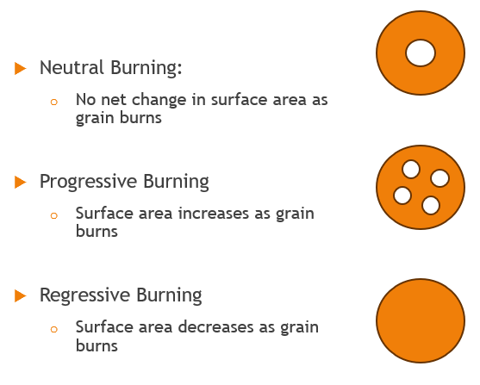
Propellant grains are available in several perforation configurations, changing the burn rate. An example of this is given in Figure 1.
Figure 1 - Propellant Perforation Natures
A greater surface area will result in a greater burn rate (as more surface is available for burning, which is itself a surface effect), therefore resulting in more pressure. It is possible to have a greater burn rate (comparatively) without overpressuring the gun when the projectile approaches the muzzle, as the internal volume in the gun system is greater at this point than when the shot started. This is why multi-perforation grains are most common in larger gun systems.

4. Service Considerations of Propellants
There are numerous service parameters to consider when designing or selecting a propellant:
- Propellant Life
  - Stabilisers govern the propellant life and environmental stability characteristics, often determining the safe service life of the overall round.

- Bore Wear
  - Even if a high-performing round has considerably better performance than its service predecessor, if the rate of bore wear is very high, there are knock-on effects. Soldiers cannot train as often, resulting in a less lethal force overall, despite having “better” ammunition. Burn rate modifiers, deterrent coatings, decoppering agents, and coolants all play a part in keeping bore wear to an acceptable level.

- Mechanical Properties
  - Binders hold the components of the propellant together and prevent the break-up of grains.

- Stealth
  - If you are not detected during firing, the chance of experiencing effective return fire is low. Flash suppressants aid in reducing visual signature.
Binders and flash suppressants will be covered in detail.

5. Binders
Binders hold together the chemical components of the propellant and give the grain its mechanical strength. Preventing breakup of the grains is important, as any breakup will result in an uncontrolled increase in surface area and therefore burn rate.
Ethyl Acetate [1]:
Ethyl acetate is a polar aprotic solvent which dissolves energetic polymers. This allows the solution to be cast or extruded in a slurry, aiding production consistency. It evaporates once the grain is “finished”, consequently it does not contribute any energy. Due to the polar ester group and nonpolar ethyl tail, it interacts with both polar (such as nitrate esters) and nonpolar functional groups (such as hydrocarbon chains).
Ethyl acetate is a volatile organic chemical, and propellant must be dried properly - not doing so can cause migration of other propellant additives, and reduce mechanical strength. This evaporate contributes to atmospheric pollution.
Poly-NIMMO [2]:
Poly-NIMMO is an energetic long-chain polymer, containing repeating oxetane units with nitrate ester groups. When it cures, a 3D network is formed that physically encapsulates other particles. It has excellent mechanical strength when cured. It contributes energy to the propellant, but also encounters the same problems as any other energetics – heat and moisture accelerate breakdown, and it requires a stabiliser in itself. Safe disposal is costly and difficult, again much like other energetics.

6. Flash Suppressants
Muzzle flash gives away your position and contributes to blast overpressure at the muzzle. Flash hiders can only do so much.
Both active and passive chemical mechanisms can be used to reduce flash. Active mechanisms include endothermic oxidation reactions or producing a cooling/inert gas during the reaction. Passive mechanisms focus on absorbing heat.

It must be noted that the overall flash is still mostly governed by barrel length and propellant choice – if propellant is still burning at muzzle exit, there is going to be flash regardless.
Figure 2 - Muzzle Flash - Credit - Author
Potassium Nitrate, potassium sulphate, potassium carbonate/bicarbonate, and carbon black are a variety of examples of flash suppressants.
Most propellants have a negative Ω, resulting in the formation of CO and H₂. Hot products react with atmospheric oxygen at the muzzle. Both reactions are highly exothermic, contributing to the flash.
2CO + O₂ = 2CO₂
H₂ + O₂ = H₂O
To reduce flash, oxidisers must be reduced, levels of CO and H₂ in decomposition products must be reduced, or the gas temperature lowered.
Passive: Potassium Sulphate [3]:
Sulphate ions are fully oxidized – they do not burn. The particles melt, then condense in the bore. As they do so, they absorb heat and lower the flame temperature.
From an environmental standpoint, potassium sulphate is not exceptionally hazardous but can contribute to mild acidification over time. It is even used as a fertilizer [4].
Active: Potassium Carbonate [3]:
K₂CO₃ –heat-> K₂O + CO₂
This decomposition is endothermic, consuming energy and lowering flame temperature. CO₂ is non-combustible and dilutes the flammable gas volume.
Potassium bicarbonate works in a similar way.
From an environmental perspective, potassium nitrate can cause eutrophication of water bodies, algae blooms, and oxygen depletion [5]. Nitrate runoff is a regulated pollutant in many areas.
Note that potassium salts have no effect on propellant chemical stability, but potassium carbonate decomposition products can harm gun barrels barrels long term. Potassium oxide – a decomposition product - turns to potassium hydroxide on contact with moisture, a strong alkaline, causing corrosion.

7. Future of Propellants
Novel Geometries [3]:
Through 3D printing, complex geometries that cannot be extruded can be produced. Carefully controlled internal voids can be designed into the propellant, allowing for an ultra-fast burn rate towards the end of shot travel. It is even possible that propellant formulations can be mixed within a single grain.
Through employing novel geometries, it is possible to get closer to the ideal “plateau” pressure-time curve in both gun and rocket propellants [4].

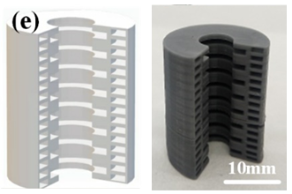
Figure 3 - Cutaway CAD Model & 3D-Printed Grain [4]

References

[1] | X. Zhang, M. Lei, J. Ren, Z. Li, X. Duan, J. Shen and C. Pei, “Influence of solvents on solubility, processability, thermostability, and mechanical properties of nitrocellulose gun propellants,” Cellulose, vol. 32, pp. 1539-1556, 2025.
[2] | T. Kemp, M. Barton and A. Cunliffe, “Mechanism of the thermal degradation of prepolymeric poly(3-nitratomethyl-3-methyloxetane),” Polymer, vol. 40, pp. 65-95, 1998.
[3] | J. Heimerl, “Proceedings of the Workshop on the Chemical Suppression of Rocket Afterburning and of Gun Muzzle Blast,” 1987.
[4] | Santos Energy, “EHS Support - POTASSIUM SULPHATE,” 2021.
[5] | Environment Agency, “Nitrates: challenges for the water environment,” 2025.
[6] | W. Yang, R. Hu, L. Zheng, G. Yan and W. Yan, “Fabrication and investigation of 3D-printed gun propellants,” Materials & Design, vol. 192, 2020.
[7] | Y. Chen, S. Ba and R. H, “Additive Manufacturing of a Special-Shaped Energetic Grain and Its Performance,” Micromachines, 2021.

Annex A: Presentation



