Jenna Wengler
2306090
Research in Practice
ADAD5004
Title
Three keywords – Narrative, Surface Pattern, Fantasy

Word count: 2,679 (including in-text citations)

This essay will explore three keywords I have chosen that will influence and reflect my practice going forward. The first keyword is narrative. To examine this, I will be looking at costume colour psychology in the TV series House of the Dragon.
My second keyword is surface pattern; I will examine the psychology behind the opulent and impoverished costumes from the TV series Game of Thrones.
The third keyword is fantasy. I will be looking at The Witcher series and how the costume design enhances the fantasy elements in the show.

The first keyword is Narrative, meaning ‘‘a story or a description of a series of events’’ or ‘’a particular way of explaining or understanding events’’ (Cambridge Dictionary, 2019).
Narratives are used to create or tell a story through written words and sounds such as music, imagery, or physical actions. Multiple narratives can be used simultaneously to create a story with a different perspective. Through a narrative, one is essentially creating a world and a point of view to look through.

To discuss this keyword, I will examine the work of costume designers Jany Temima and Caroline McCall in the TV series House of the Dragon. ‘‘Costumes are an important element for expressing characters and their relationships so that the audience will understand them.’’ (Taylorfrancis.com, 2025).

House of the Dragon is a TV series that was adapted from one of George R.R Martin’s fantasy books, Fire & Blood. The series is also a prequel to Game of Thrones, which is set in the far future after House of the Dragon takes place. The series revolves around House Targaryen, famous for their ethereal beauty, silver hair and dragon affiliation. The story follows them through events that lead to a civil war, known as the Dance of Dragons. The series explores themes of politics, plays for power, loyalty and betrayal.
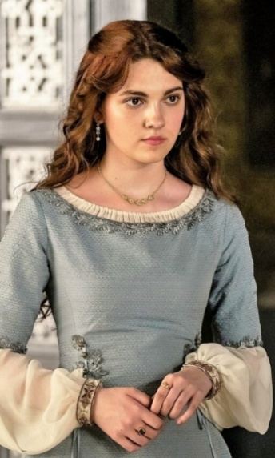
The wardrobe of Alicent Hightower, a vital character to the storyline and prevalent throughout the show, is a visual example of storytelling through the costume design. ‘’Color psychology is the study of how different colors affect human mood and behavior.’’ (Verywell Mind, n.d.). It can also be used to enhance the unspoken narrative and convey a deeper storyline. I will be using colour psychology to analyse Alicent’s costume design development throughout the series.

Figure 1
At the start of the series, fourteen-year-old Alicent Hightower appears in a loose-fitting pale blue and white cowl-neckline gown with wrist-length sleeves and simplistic jewellery. This attire is appropriate for her age and her high social standing.
White is associated with innocence and purity, and blue is often associated with trust, loyalty and dependability.
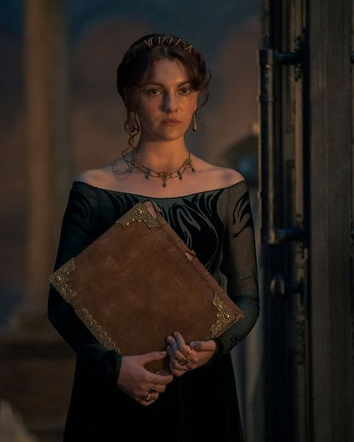
Alicent's costume and colours reflect the narrative of her naive innocence and help the viewer connect with pure intentions and her loyalty towards her friend.

Figure 2
In the same episode, later on, Alicent is seen in a black gown with see-through details and a much lower cut than her previous gown. She wears her hair up and has more opulent jewellery than before.
Before this scene takes place, her father guides her to comfort the Targaryen King after his wife's death. Her father also tells her to wear the gown, revealing it was one of her late mother's.
The colour black is associated with sophistication, formality, mourning and dramatics.
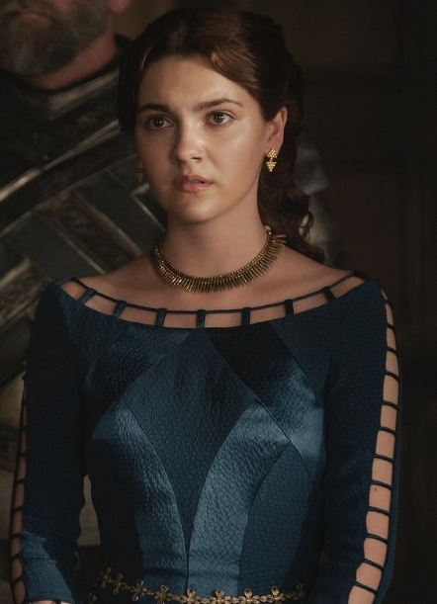
Within the context of this scene, she is clearly uncomfortable wearing the gown, as she hides behind a book when she visits the King. It is also clear that her father plans to use her to seduce the King. Her costume and body language in this scene are at odds with her feelings and her father's intentions.

Figure 3
In episode two, Alicent is wearing a tighter-fitting, alluring, darker blue gown with ladder cutouts down the sleeves and around the neckline. Her jewellery is more noticeable, and she has a waist-emphasising decorative gold chain with her hair away from her face.
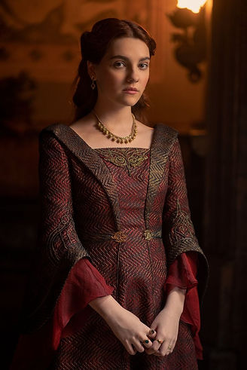
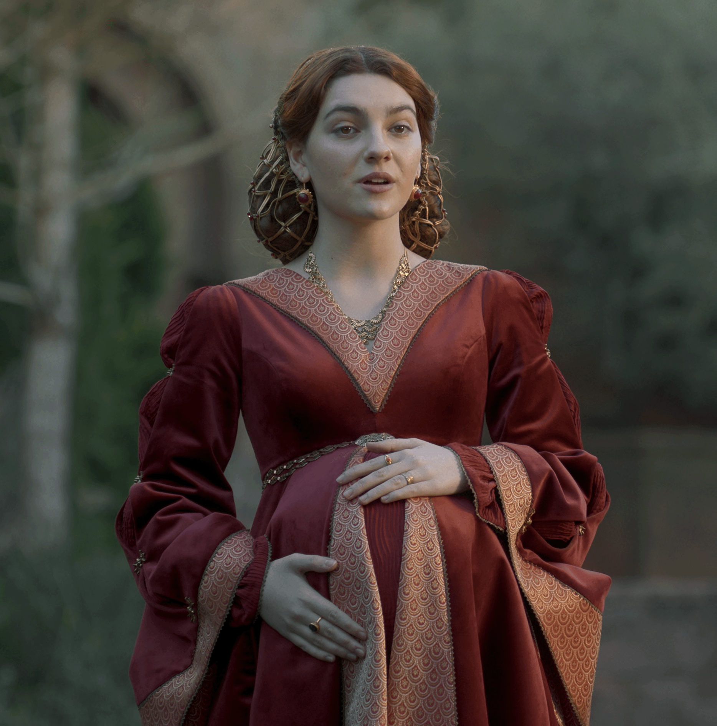
In the scenes where she’s wearing this gown, Alicent boldly tries to court the King. “Blue is the colour of trust, serenity, and peace. It suggests loyalty and integrity as well as conservatism and predictability’’ (London Image Institute , 2020).Alicent, by wearing this colour, is trying to appear more trustworthy and dependable to the King. Appealing to his desires and trying to prove her loyalty to him.

Figure 4, Figure 5
In episode three, she is already married and pregnant to the King. We see her wearing a soft red gown with a V-neckline, long sleeves and lighter-coloured patterned trim decorating the edges of her gown. She is wearing her hair up and in a decorative net, jewellery gold and notable, but slightly hidden by her gown. The style of the gown she is wearing both accommodates and draws attention to her pregnancy. While the neckline is sharp, it is very modest compared to her previous gowns.
In episode four, her attire changes; although still wearing red, she is now seen with gold patterning and black details. Her neckline is low like her previous gown, but her shoulders are covered, almost modest compared to her previous attire. While she wears this gown, she fits in with her husband’s family colours and appears to be one of them.
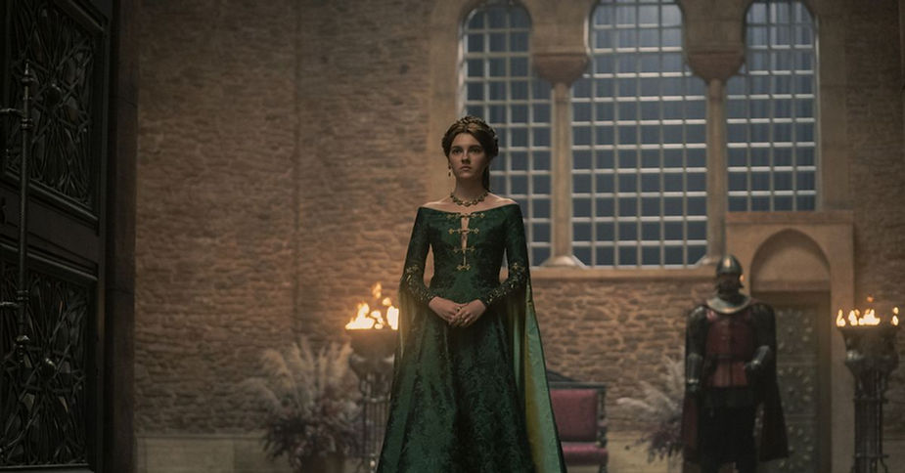
Red is the colour of passion, anger, power, and strength. Although she wears these colours to fit in with the King's family, she blends into the background and appears submissive and timid. This contradicts the colour psychology but inadvertently shows the narrative that she feels like she does not belong. Perhaps by wearing it, she is trying to gain more confidence in her position.

Figure 6
Later, Alicent learns her friend has lied and betrayed her. In an act of quiet retaliation and rebellion, she appears at her friend's wedding wearing a deep green gown with gold accents. The gown is off-shoulder and features a narrow V cut out down the chest, accompanied by tight sleeves and prominent, bold jewellery.
The colour green is associated with rebirth, new beginnings, and growth, so it is clear that Alicent is making a bold but verbally unspoken statement. She is rebelling, and by no longer wearing red, she is no longer the quiet wife of the King. Instead, she shows us the visual character development of her being ‘reborn’ as Queen Alicent. Green is also her birth family's colour, signifying a call to arms. She is declaring war on her friend by wearing green to her wedding.
The colour psychology in Alicent’s costume design shows an unspoken but clear narrative throughout the show. The progression from her blue gown and naive innocence to her green gown and subsequent rebirth into Queen Alicent has given the viewers a visual representation of the narrative and her character development.

The second keyword is Surface Pattern. Meaning patterns that are made, crafted, and applied to surfaces and textiles through various techniques and methods. The series Game of Thrones will be used to examine this keyword and how it portrays the difference between the opulent clothing of the wealthy and the impoverished clothes of the lower class.

The history of surface patterns dates back to the start of civilisation when people used the natural resources around them to create patterns on textiles, ceramics, and various structures. For example, the Mesopotamians “created intricate geometric patterns on ceramics using the potter’s wheel’’(Stefaniagil.com, 2024). Surface patterns have developed and followed the eras throughout history, like the Renaissance and Art Nouveau time periods. It has also played significant roles in religions, the wealthy classes, and royalty throughout history.
With the rise of more expensive materials, complicated techniques, and handmade processes, the royal and affluent classes have used surface pattern and ornamentation to show their social and financial status through various means. At the same time, the poorer and less wealthy could not afford such luxurious things.

Game of Thrones is a fantasy TV series based on George R.R. Martin’s novels, Song of Ice and Fire. The series takes place in the fictional continents of Essos and Westeros, and follows a large cast of characters, most of whom are of royal or noble origin. The story follows betrayal, politics, and alliances as the characters fight for more power and a chance at the Iron Throne and the Seven Kingdoms.
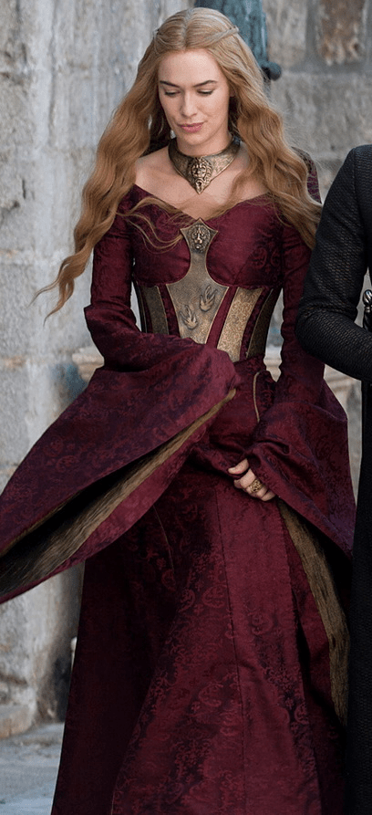
Game of Thrones is inspired by various time periods, but it draws heavily on inspiration from medieval, Roman, and early European cultures. Throughout the series, it is clear who the royal and opulent characters are compared to the lower class. This is shown through the use of expensive materials such as silk, fur, and jewels, as well as intricate detailing and symbolic patterns and elements. By analysing the surface patterns, it can be better understood how they reflect hierarchies and character development. Costume plays a vital role in establishing identities and status among the characters. The wealthy are immediately recognisable through the richness of their fabrics and the complex detail of their designs.

Figure 7
For example, the Lannister’s, a prominent Westeros family in the series, are known for their opulence, often decorating garments made of expensive materials like silk and velvet, with adornments of detailed gold embroidery.
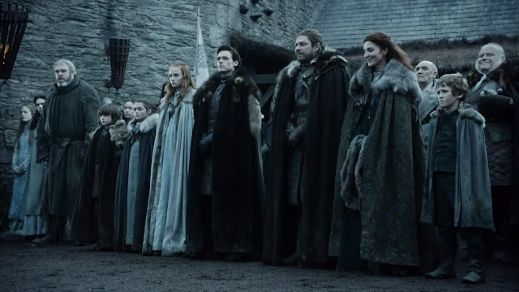
“The embroidery is a subliminal way to tell someone’s story,” says Michele Clapton”(Snead, 2014). Like the lion emblem, a symbol of the House Lannister, it is prominently displayed on their attire, a visual reinforcement of them being one of the wealthiest families in the show and in Westeros. This use of surface pattern and luxurious materials not only highlights their affluence and opulence but also serves to intimidate and assert dominance over the less wealthy houses and the more impoverished.

Figure 8
In comparison, the other characters from poorer houses, like House Stark, wore simpler, practical clothing that was made from stronger materials to suit the harsh environment of the North. Although their clothing was not noticeably embellished or had intricate detailing, they did wear fur, which was only a slight status distinction compared to the townsfolk. The Starks’ muted colour palette and minimalistic details reflected their social standing, in stark contrast to the Lannister’s ostentatious style.
Additionally, the use of colour in the series is a powerful tool for conveying wealth. The vibrant and bright reds and golds associated with House Lannister mirror their wealth and ambition, while the muted greys and blues of House Stark show the harsh realities of their environment.

The interaction between characters often highlights the difference in wealth and status, with surface pattern as a backdrop for these dynamics. The opulence of House Lannister’s banquets contrasts sharply with the rations of a soldier from House Stark, demonstrating the gap between the wealthy class and common townsfolk.
In conclusion, the Game of Thrones series artfully utilises surface patterns through costume design and colour symbolism to portray wealth and status throughout the show.“Costumes are the first impression that you have of the character before they open their mouth-it really does establish who they are. - Colleen Atwood” (BrainyQuote, 2025).
The visual element enriches the narrative by providing insight into the characters' identities and socio-political hierarchies that govern their world. Ultimately, the intricate interplay of wealth and surface pattern contributes significantly to the depth of the series.

The third keyword is fantasy, and focuses on how the costume design in the TV series The Witcher enhances the fantasy elements in the show.
I will be exploring how costume design in The Witcher enhances the fantasy elements, using semiotic theory to decode the visual language of clothing.

“Fantasy is a type of imaginative fiction featuring beings, places, and events that could never occur in real life.”(Britannica Kids, n.d.). It is a way to escape the real world and get lost in it, or to create a whole new world filled with unimaginable places and extraordinary creatures based on the individual's creativity and storytelling.
Semiotic theory in the context of art explores how meaning is generated and conveyed through signs, symbols, and visual elements. I will use semiotic theory to explore how visual elements enhance and elevate the fantasy world of The Witcher.

The Witcher is a fantasy-based TV series adapted from a series of short stories and novels by Polish author Andrzej Sapkowski. The story follows Geralt of Rivia, a man who has enhanced abilities and skills, who is a monster hunter known as a Witcher. It is set in a medieval fantasy world with monsters, magical creatures and sorceresses.
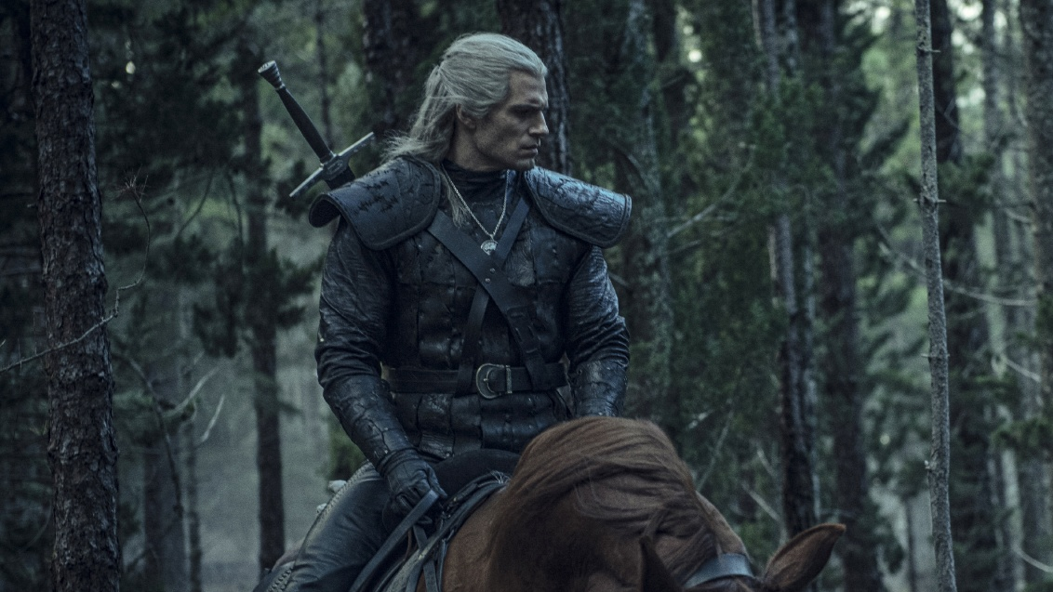
Figure 9
One of the most significant aspects of The Witcher series that enhances the fantasy element is the costume design. Through the selection of materials, colours, and styles, the costume design effectively utilises semiotic theories to convey deeper meanings, reinforce character identities, and immerse the viewers in a fantasy realm.

Geralt’s costume design, characterised by his dark leather armour, worn layered garments and silver sword, reflects both his identity and occupation as a monster hunter. The weathered armour and worn attire indicate towards his harsh environment and tough job. His dark, muted colour palette refers to his personal and professional life, dark muted colours so as not to be at a disadvantage whilst fighting a monster, keeping to the shadows and not drawing attention. The same could be said for his personal life as well. When he is around people, he tends to stick to the shadows out of sight, interacting as little as possible. His silver sword also plays an important role in his character design, as it is a symbol of his fight against monsters.
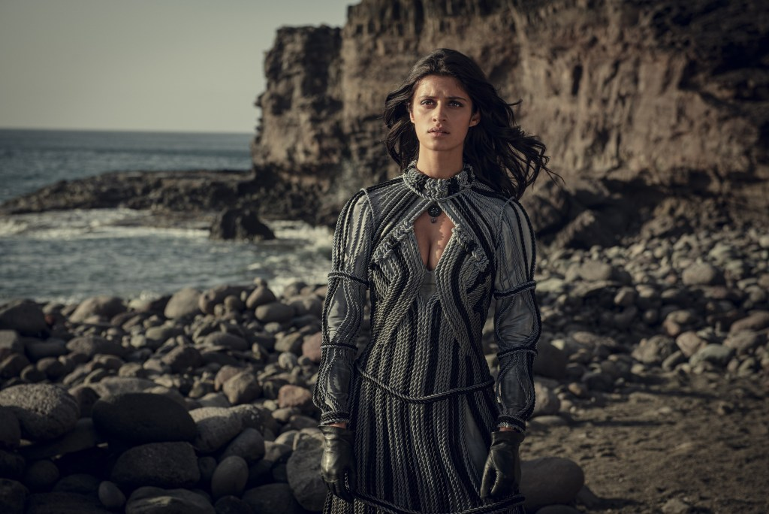
The semiotic analysis suggests that these visual aspects signify his complex character, as a ‘hero’ slaying monsters, as well as his isolation from others.

Figure 10
On the opposite end of Geralt, there is Yennefer of Vengberg, a sorceress. Her gowns are made with luxurious fabrics, intricate patterns, and dramatic silhouettes that accentuate her figure and highlight her status as a powerful sorceress. Although her colour palette is also made up of darker tones, they are richer and more polished than Geralt’s garments, with a few of her garments featuring off white colours. At the beginning of the series, she was only dressed in plain dirty clothes and was often discriminated against. However, after her transition into a powerful sorceress, her costume design symbolises her gaining confidence and independence while becoming seduced by the newfound power and magic. Almost completely separating herself from who she was before to who she is now.
The semiotic analysis reveals that her gowns and garments are more than just clothing or for decoration, it reveals her internal struggle. It also reflects her development externally and internally throughout the series.

Furthermore, the use of colour in costume design plays a vital role in enhancing the fantasy visuals. The vibrant hues of the elves' garments, for example, evoke a sense of otherworldly beauty, aligning with their portrayal as mystical beings. Whereas the muted tones of the monsters and darker, more sinister characters create a visual separation between the good and evil struggle. The use of colour as a semiotic tool in costume design improves the visual language and allows the viewers to engage with the characters through a different method.
In conclusion, the costume design in The Witcher is not only an aesthetic choice but also an important aspect that enhances the fantasy visuals and storytelling. Using semiotic theory reveals how costumes function as signs that convey a character's identity, themes and emotional depth. Design and colour contribute to the overall immersive experience.

When I reflect on my practice going forward, the elements that stand out and are important to my designs are narrative, surface pattern, and fantasy. Narrative is important to me because every piece should tell a story.
Surface pattern is essential because it is a way of visually communicating through design.
Fantasy is important to me as a form of unrestrained creativity where anything is possible and can happen.
This research has led me to a potential question to explore in the future: Costume Design in Fantasy, Weaving Narrative Through Visual Storytelling. Other areas of research could include the semiotics of costume design, clothing as a visual language, and fashion psychology.

Bibliography
List of figures
Figure 1
House of the Dragon, (Alison Hightower) Available at :
dariasandu (2024). Alicent’s Attires: How Clothing Reveals a Story of its Own. [online] The Nest - ISB. Available at: https://www.thenestisb.com/post/alicent-s-attires-how-clothing-reveals-a-story-of-its-own.
Figure 2
House of the Dragon, (Alison Hightower) Available at :
dariasandu (2024). Alicent’s Attires: How Clothing Reveals a Story of its Own. [online] The Nest - ISB. Available at: https://www.thenestisb.com/post/alicent-s-attires-how-clothing-reveals-a-story-of-its-own.
Figure 3
House of the Dragon, (Alison Hightower) Available at :
Tilda.ws. (2022). House of the dragon. [online] Available at: https://hotd.tilda.ws/.
Figure 4
House of the Dragon, (Alison Hightower) Available at :
Reddit.com. (2022). Reddit - The heart of the internet. [online] Available at: https://www.reddit.com/r/HouseOfTheDragon/comments/xipjt3/about_alicents_dresses_up_to_ep_5/?rdt=60861.
Figure 5
House of the Dragon, (Alison Hightower) Available at :
dariasandu (2024). Alicent’s Attires: How Clothing Reveals a Story of its Own. [online] The Nest - ISB. Available at: https://www.thenestisb.com/post/alicent-s-attires-how-clothing-reveals-a-story-of-its-own.
Figure 6
House of the Dragon, (Alison Hightower) Available at :
dariasandu (2024). Alicent’s Attires: How Clothing Reveals a Story of its Own. [online] The Nest - ISB. Available at: https://www.thenestisb.com/post/alicent-s-attires-how-clothing-reveals-a-story-of-its-own.
Figure 7
Game of Thrones, (Cersei Lannister) Available at :
Williams, S. (2021). The Costumes of Game of Thrones - The Iron Anniversary. [online] The Art of Costume. Available at: https://theartofcostume.com/2021/06/10/the-costumes-of-game-of-thrones-iron/.
Figure 8
Game of Thrones, (House Stark) Available at :
costumevault.blogspot.com. (n.d.). Creating the Seven Kingdoms. Part I: The North. [online] Available at: https://costumevault.blogspot.com/2016/08/creating-seven-kingdoms-part-i-north.html.
Figure 9
The Witcher, (Geralt of Rivia) Available at :
Kelly, A. (2019). The Witcher episode 1 recap: Geralt of Rivia’s Netflix debut is a violent delight. [online] PC Gamer. Available at: https://www.pcgamer.com/witcher-episode-1-recap/ [Accessed 14 May 2025].
Figure 10
The Witcher, (Yennefer of Vengerberg) Available at :
HeroOfRodden (2020). The Witcher’s costume designer on Nilfgaardian armor, Yennefer’s most iconic dress and more - Redanian Intelligence. [online] Redanian Intelligence. Available at: https://redanianintelligence.com/2020/01/26/costume-designer-on-nilfgaardian-armor/ [Accessed 14 May 2025].

Reference list
BrainyQuote. (2025). BrainyQuote.
[online] Available at: https://www.brainyquote.com/quotes/colleen_atwood_358076.
Accessed on the 17th of April 2025
Britannica Kids. (n.d.). fantasy.
[online] Available at: https://kids.britannica.com/students/article/fantasy/625314.
Accessed on the 22nd of April 2025
Cambridge Dictionary (2019). NARRATIVE | meaning in the Cambridge English Dictionary.
[online] Cambridge.org. Available at:https://dictionary.cambridge.org/dictionary/english/narrative.
Accessed on the 20th of March 2025
London Image Institute (2020). Color psychology: How Do Colors Affect Mood & emotions? [online] London Image Institute.
Available at:https://londonimageinstitute.com/how-to-empower-yourself-with-color-psychology/.
Accessed on the 25th of March 2025
Snead, E. (2014). ‘Game of Thrones’ Costume Designers Reveal the Secrets Stitched Into the Actresses’ Gowns. [online] The Hollywood Reporter.
Available at:https://www.hollywoodreporter.com/news/general-news/game-thrones-costume-designers-reveal-705873/.
Accessed on the 10th of April 2025
Stefaniagil.com. (2024). The evolution of surface design: a journey through history – Stefania Gil.
[online] Available at: https://stefaniagil.com/the-evolution-of-surface-design/.
Accessed on the 8th of April 2025
Taylorfrancis.com. (2025). e-Reader | Taylor & Francis Group eBooks, Reference Works and Collections.
[online] Available at: https://www.taylorfrancis.com/reader/download/9d863ade-69ce-47b0-83a8-dabadbe393f8/chapter/pdf?context=ubx
Accessed on the 20th of March 2025
Verywell Mind. (n.d.). Can Color Affect Your Mood and Behavior?
[online] Available at: https://www.verywellmind.com/color-psychology-2795824#toc-what-is-color-psychology.
Accessed on the 25th of March 2025

Additional reading list
Books
Barthes, R. (2013). Language of fashion. S.L.: Bloomsbury Academic.
Barthes, R. (1967). The Fashion System. London: Vintage Books.
Barthes, R., Carter, M., & Stafford, A. (2013). The language of fashion (Bloomsbury revelations edition.). Bloomsbury Academic.
Blumer, H. (1986). Symbolic Interactionism: Perspective and Method. Berkeley: University of California Press.
Chandler, D. (2022). Semiotics : the basics (Fourth edition.). Routledge. https://doi.org/10.4324/9781003155744
Ekman, S., & Taylor, A. I. (2021). Between World and Narrative: Fictional Epigraphs and Critical World-Building. Journal of the Fantastic in the Arts, 32(2 (111)), 244–265.
Forsyth, P. (2004). John Gage. Color and Meaning: Art, Science, and Symbolism . 320 pp., illus., index. Berkeley: University of California Press, 1999. $55 (cloth). Isis, 95(3), 473–474. https://doi.org/10.1086/428983
Paul Martin Lester (1995). Visual communication images with messages. Belmont, Calif. Wadsworth Publishing Company.

Alternative research sources
Barron, N. (2022). Rivia’s Riveting Wardrobe: A Look at The Witcher’s Season 2 Costumes. [online] Natania Barron. Available at: https://nataniabarron.com/2022/01/10/the-rivias-riveting-wardrobe-a-look-at-the-witchers-season-2-costumes/.
Bedewi, J. (2020). Wardrobe Secrets From Behind The Scenes Of ‘The Witcher’. [online] Ranker. Available at: https://www.ranker.com/list/netflix-witcher-wardrobe-secrets/jessica-bedewi [Accessed 14 May 2025].
Bell, A. (2021a). Daenerys Targaryen’s Style Evolution Through Game of Thrones. [online] TVGuide.com. Available at: https://www.tvguide.com/galleries/daenerys-targaryens-style-evolution-throughout-game-of-thrones/3/.
Bell, A. (2021b). Daenerys Targaryen’s Style Evolution Through Game of Thrones. [online] TVGuide.com. Available at: https://www.tvguide.com/galleries/daenerys-targaryens-style-evolution-throughout-game-of-thrones/20/.
Cherry, K. (2024). How White Impact Moods, Feelings, and Behaviors. [online] Verywell Mind. Available at: https://www.verywellmind.com/color-psychology-white-2795822.
Codarity (2024). The Role of Costumes in Character Portrayal - Loop Talent. [online] Loop Talent. Available at: https://looptalent.co.uk/role-of-costumes-in-character-portrayal/.
dariasandu (2024). Alicent’s Attires: How Clothing Reveals a Story of its Own. [online] The Nest - ISB. Available at: https://www.thenestisb.com/post/alicent-s-attires-how-clothing-reveals-a-story-of-its-own.
Eldridge, S. (2023). Game of Thrones | Television Series, Plot, Reception, & Facts | Britannica. [online] www.britannica.com. Available at: https://www.britannica.com/topic/Game-of-Thrones.
etsesvetements. (2020). dynasty and dictatorship: dressing daenerys targaryen. [online] Available at: https://etsesvetements.wordpress.com/2020/07/30/dynasty-and-dictatorship-dressing-daenerys-targaryen/.
Fashion is Psychology. (2021). The Psychology Behind costume Design. [online] Available at: https://fashionispsychology.com/the-psychology-behind-costume-design/.
Fashion Law Journal. (2023). Fashion in The Witcher: Exploring the Style of Geralt, Yennefer, and Ciri - Fashion Law Journal. [online] Available at: https://fashionlawjournal.com/fashion-in-the-witcher-exploring-the-style-of-geralt-yennefer-and-ciri/ [Accessed 14 May 2025].
Fiveable. (2018). Semiotics and the study of signs in art | History of Art Criticism Class Notes | Fiveable. [online] Available at: https://library.fiveable.me/history-of-art-criticism/unit-9/semiotics-study-signs-art/study-guide/wLPOyBP22w5c2ERg [Accessed 14 May 2025].
HeroOfRodden (2023). Anya Chalotra and The Witcher Costume Designer on Crafting Yennefer’s Season 3 Look. [online] Redanian Intelligence. Available at: https://redanianintelligence.com/2023/06/28/anya-chalotra-lucinda-wright-interviews-witcher-season-3/.
Hubpages.com. (2025). Blocked. [online] Available at: https://discover.hubpages.com/entertainment/The-Best-Costumes-of-Game-of-Throne-Season-4.
London Image Institute (2020). Color psychology: How Do Colors Affect Mood & emotions? [online] London Image Institute. Available at: https://londonimageinstitute.com/how-to-empower-yourself-with-color-psychology/.
Nast, C. (2019a). How the costumes on Game of Thrones evolved through the seasons. [online] Vogue India. Available at: https://www.vogue.in/content/game-of-thrones-daenerys-sansa-cersei-costume-evolution-hidden-meanings-clues-in-clothes.
Nast, C. (2019b). How the costumes on Game of Thrones evolved through the seasons. [online] Vogue India. Available at: https://www.vogue.in/content/game-of-thrones-daenerys-sansa-cersei-costume-evolution-hidden-meanings-clues-in-clothes.
Reddit.com. (2022). Reddit - The heart of the internet. [online] Available at: https://www.reddit.com/r/HouseOfTheDragon/comments/xipjt3/about_alicents_dresses_up_to_ep_5/?rdt=60861.
Rivera, J. (2019). What to Know About The Witcher If You Know Absolutely Nothing About The Witcher. [online] Vulture. Available at: https://www.vulture.com/article/what-is-the-witcher.html.
Sewn Modern Quilt Patterns by Amy Schelle. (2024). What is Surface Pattern Design? [online] Available at: https://sewnhandmade.com/blogs/sewn-handmade/what-is-surface-pattern-design?srsltid=AfmBOopGQ2ftN3zVeT3M_sNJqFz1Jgx5BzhalaNewsBsZAVo1tnPCakn.
Snead, E. (2014). ‘Game of Thrones’ Costume Designers Reveal the Secrets Stitched Into the Actresses’ Gowns. [online] The Hollywood Reporter. Available at: https://www.hollywoodreporter.com/news/general-news/game-thrones-costume-designers-reveal-705873/.
Stefaniagil.com. (2024). The evolution of surface design: a journey through history – Stefania Gil. [online] Available at: https://stefaniagil.com/the-evolution-of-surface-design/.
Thipphawong, L. (2021). Art Theory: Semiotics. [online] Arts Help. Available at: https://www.artshelp.com/art-theory-semiotics/.
Tilda.ws. (2022). House of the dragon. [online] Available at: https://hotd.tilda.ws/.
Time. (n.d.). See How Daenerys Targaryen Has Changed Over Six Seasons of ‘Game of Thrones’. [online] Available at: https://time.com/4818380/game-of-thrones-daenerys-targaryen-costume-hair/.
Unplugged (2024). Colour Psychology: How Colour Influences Your Brain. [online] unplugged.rest. Available at: https://unplugged.rest/blog/colour-psychology.
Williams, S. (2022). Armor and Monsters: Behind The Dark Fantasy Costumes of ‘The Witcher’ Season Two. [online] The Art of Costume. Available at: https://theartofcostume.com/2022/08/12/armor-and-monsters-behind-the-dark-fantasy-costumes-of-the-witcher-season-two/.
Witcher Wiki. (n.d.). The Witcher (TV series). [online] Available at: https://witcher.fandom.com/wiki/The_Witcher_(TV_series).
www.makethedot.com. (n.d.). A designer’s guide to what is surface pattern design. [online] Available at: https://www.makethedot.com/blog/a-designers-guide-to-what-is-surface-pattern-design.

