ROUTING AND PACKET FILTERING WITHIN CORE TCP/IP SERVICES AND CRITICAL FAILOVER/REDUNDANCY PRACTICES

Network Operating Systems and Services (NOSS) (ACCA5023)

Student Name: Brian Morris
Student ID: 1809130

Contents
Routing and remote access install 4
Configurations of Routing and Remote Access Services 5
Test routing is working successfully. 7
Physical network identification 9
Routing Tables 10
Task 4 11
Applyng filters to the network interfaces 11
Filter 1 : Stopping ‘anyone’ in PrivateNet1 from pinging the router firewall service. 11
Filter 2: Restrict Access to FTP Service running on Server 2 to only host on PrivateNet2. 13
Filter 3 : Only allow specific hosts in Privatnet1 to access the FTP Service running on Server 2. 16
Problem solving failure. 21
Failover Clusters 25
High Availability clusters 25
Very basic active/passive cluster. 26
Active/Active Cluster 27
Fault Tolerance and Single Point of Failures 28
Stretched clusters. 28
Cluster Shared Volumes 28
Hyperconverged Clusters 29
Building a Cluster within Virtual Box. 29
Two server nodes are prepared to host the cluster 34
Using the Failover Cluster Manager 36
Failing over resources 47
Cluster resource placement planning, failover and failback 48
Quorum 50
Cluster Aware updates. 51
Organizational IT Security Policy 52
Risk Management 52
System Availability 52
Group Policy Standards 52
Access to resource 52
Password Policy 52
Patching Policy 53
Backup Policy 53
Lifecycle of solution 53
ICT Security Service 53
Bibliography 54

Routing and remote access install

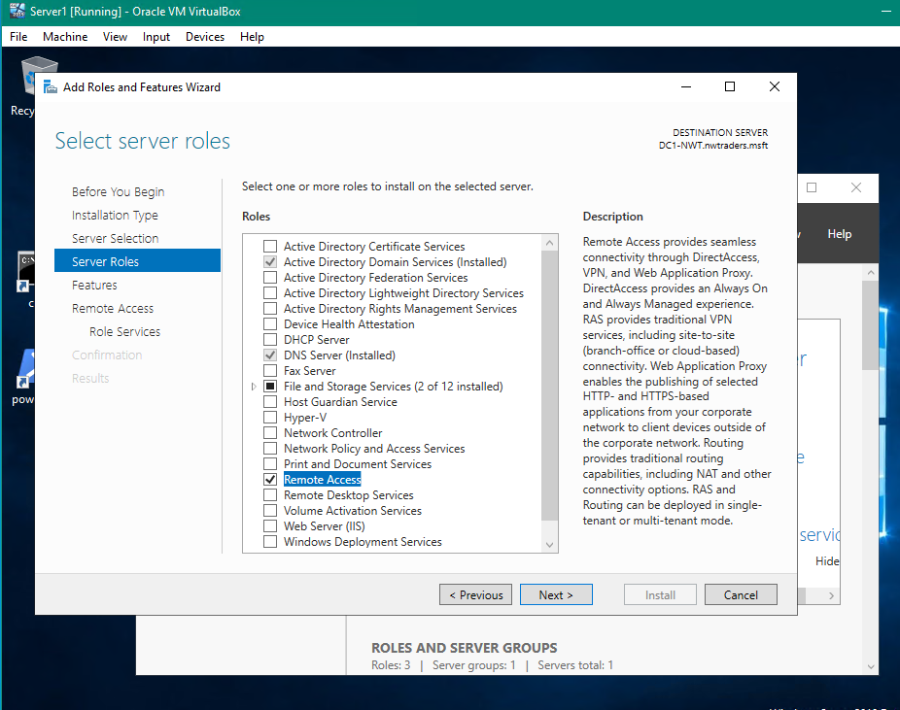
Figure 1- Install Remote Access role
Adding the Routing and Remote access role to the sever via the add Roles and feature Wizard.

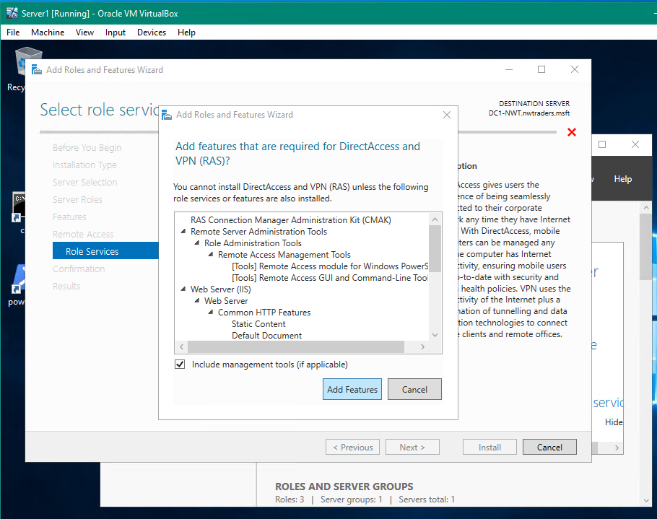
Figure 2- Additional Features to meet application requirements
Adding additional features to meet the application requirements
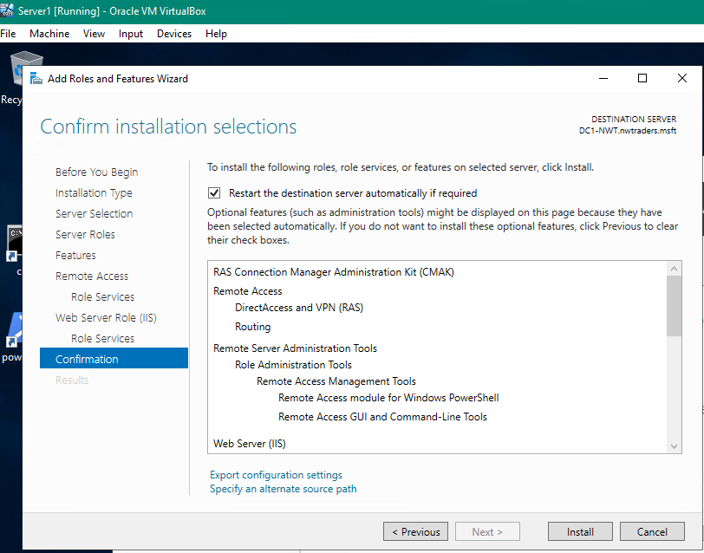
Figure 3- Confirmation of features installed
Confirmation of selection

Configurations of Routing and Remote Access Services

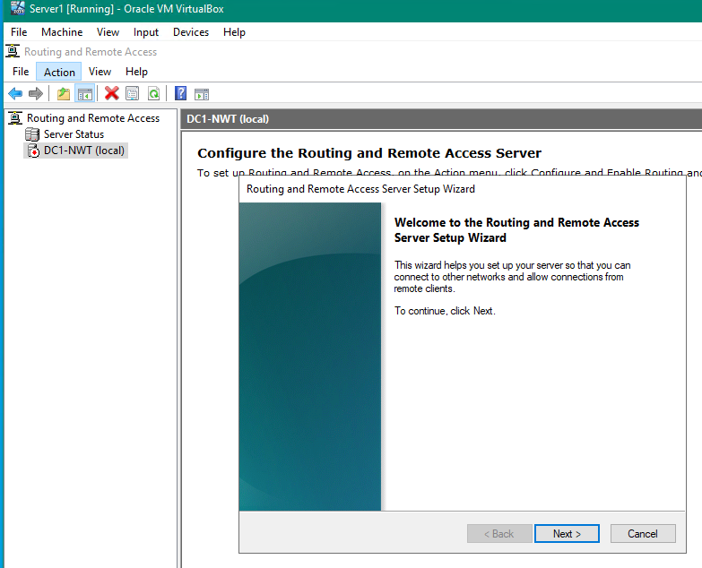
Figure 4- Routing and Remote access. Getting started wizard
Configuring the Routing service
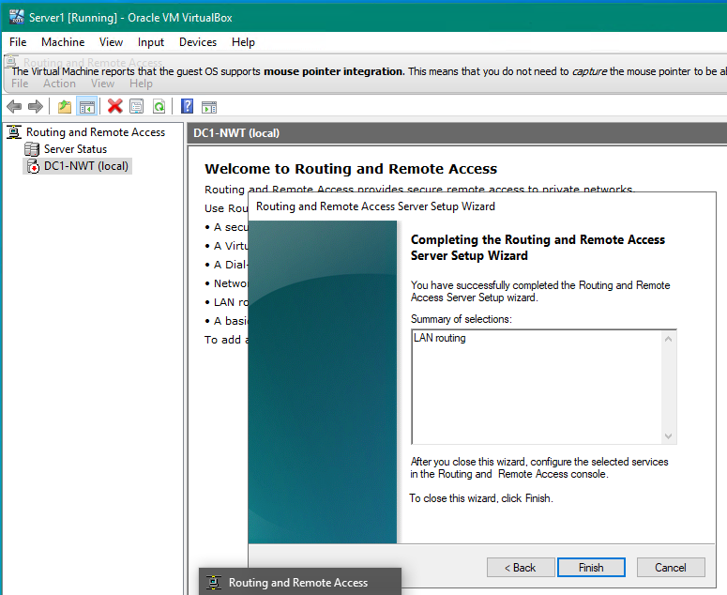
Figure 5- Routing and Remote Access- Selecting LAN routing
Select the type of routing needed for the role.

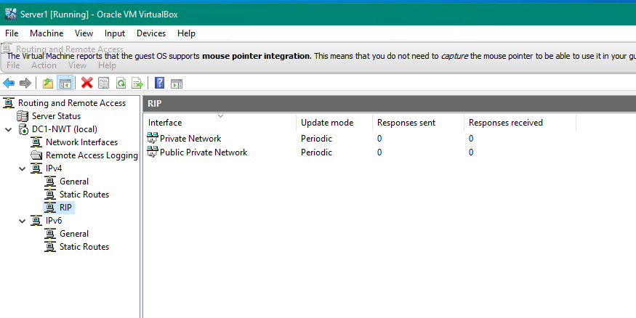
Figure 6- routing and remote access - enable both NIC for LAN routing
Select which network interface requires the routing in this instance it is the ‘Public’ network. Please note all work is being carried out on the IPV4 network
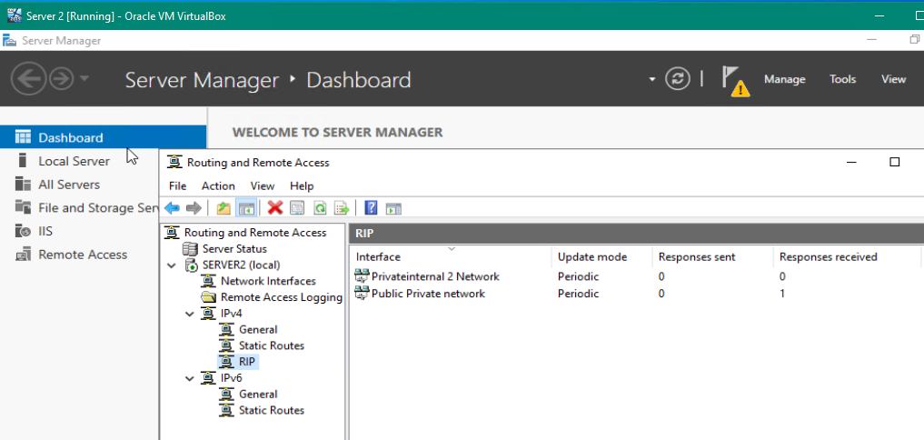
Figure 7 routing and remote access - enable both NIC for LAN routing on Server2
Repeat the same procedure on ‘Server2’ as for DC1-NWT

Test routing is working successfully.

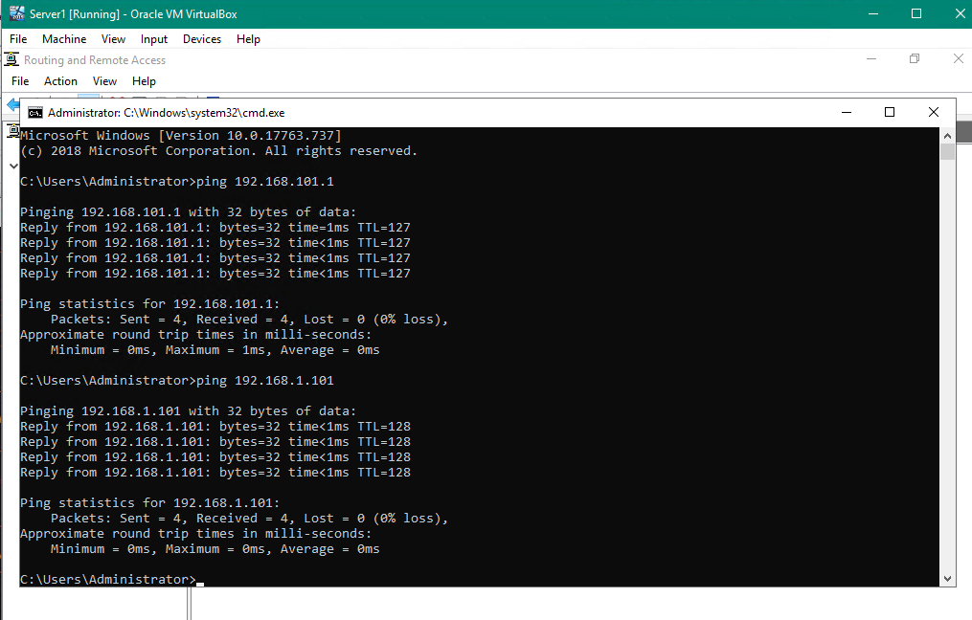
Figure 8 Server1 pinging both of Server2's IP addresses
DC1-NWT is now able to ping both the public and private addresses of Server2
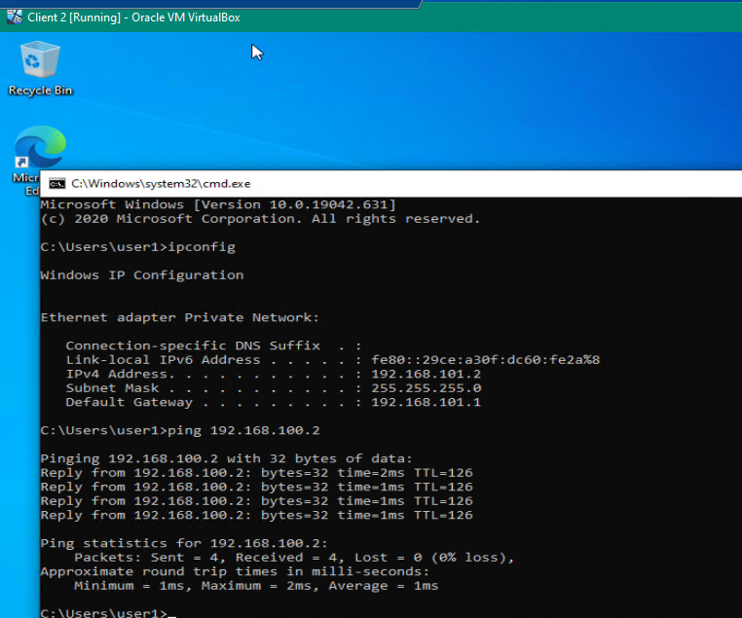
Figure 9- Client2 pinging Client1
Client2 on one network is now able to ping Client1 within a different subnet
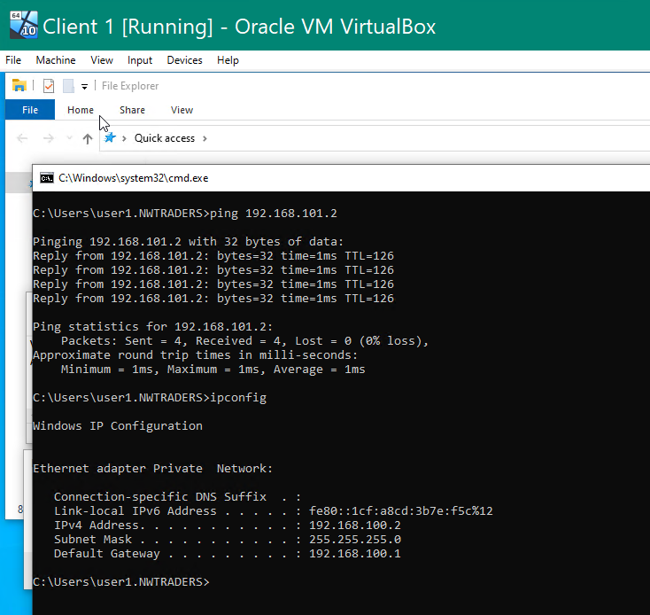
Figure 10 - Client1 pinging Client2
Client1 can ping Client2 demonstrating traffic is able to flow in both directions.

Physical network identification

It should be noted that to identify the network that the routers are referencing, the name given to the Network Interface Card is used to reference the network as detailed in the screen shot below.

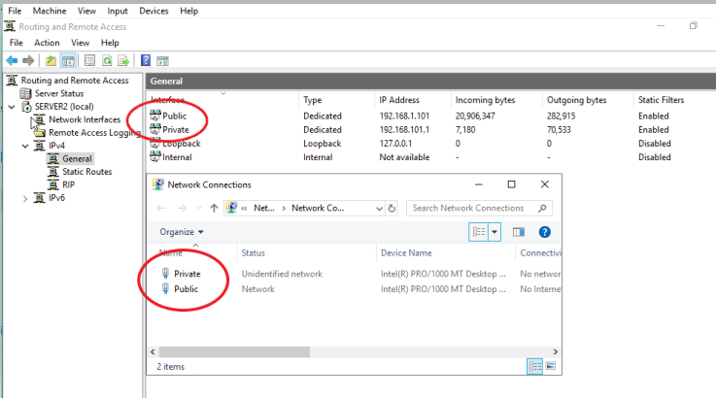
Figure 11 Labels applied to route interfaces and NICs.

Routing Tables

When routers make decisions on where to direct packets they refer to their routing table. The routing table will hold information regarding routes its directly connected to . They also conatin routes to remote routes that they have either been statically configured to use of have learned through dynamic routing protocols [1]. The routing table will also contian next hop information enabling a router to efficently route the trafic to next appropriate and availible router.
Acces to the routing table information on a windows client can be achived through the cmd prompt using the following command

- Route Print

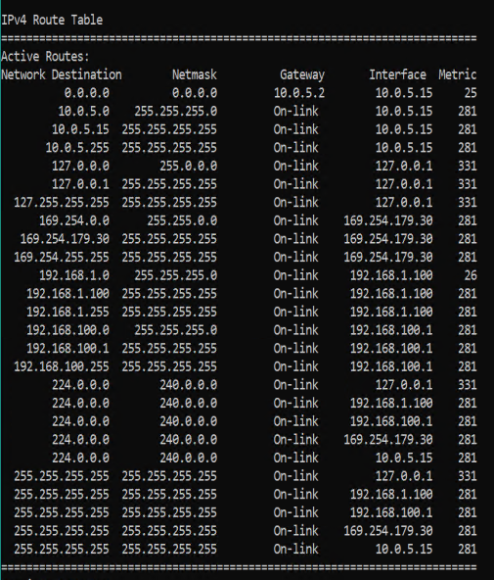
Figure 12 Extract of routing table on Server1

The above table split in to 5 columns Network Destination Netmask, Gateway, Interface, Metric.

Network Destination ,list all the networks that the device is connected to.
Netmask, shows the subnet of the network the device is attached to.
Gateway, once the device knows which network (Network Destination + Netmask) to send the packet it decides on the gateway to send the packet to.
Interface, the IP address of the network card the packet should be passed to.
Metric, a measure of the optimal route for the packet the lower the better.

Task 4

Applyng filters to the network interfaces

Filter 1 : Stopping ‘anyone’ in PrivateNet1 from pinging the router firewall service.

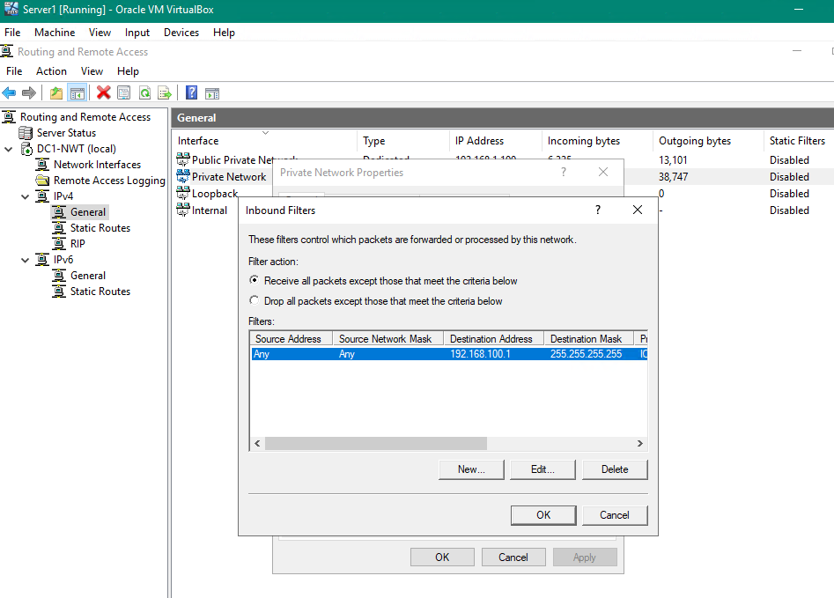
Figure 13 Inbound packet filter rule applied to Private interface
The above filter will ‘drop’ any packet that meets the above criteria. In this instance the criteria are for any source address to the destination address of 192.168.100.1
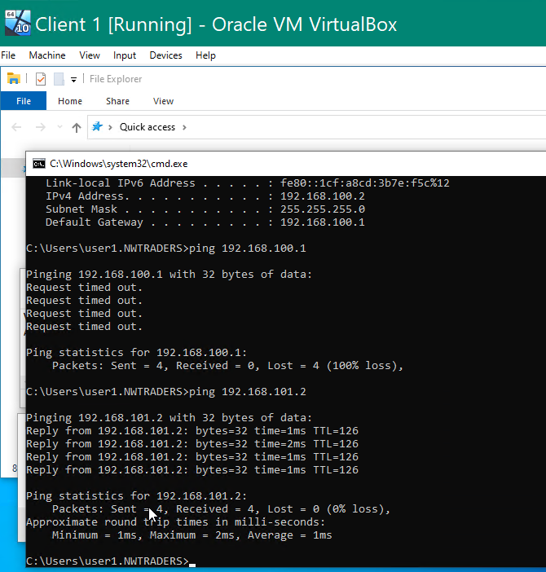
Figure 14 Client1 unable to ping Server1 but able to ping Client2
The above screen shot demonstrates that Client1 is unable to ping Server 1 but can ping Client2.

Filter 2: Restrict Access to FTP Service running on Server 2 to only host on PrivateNet2.

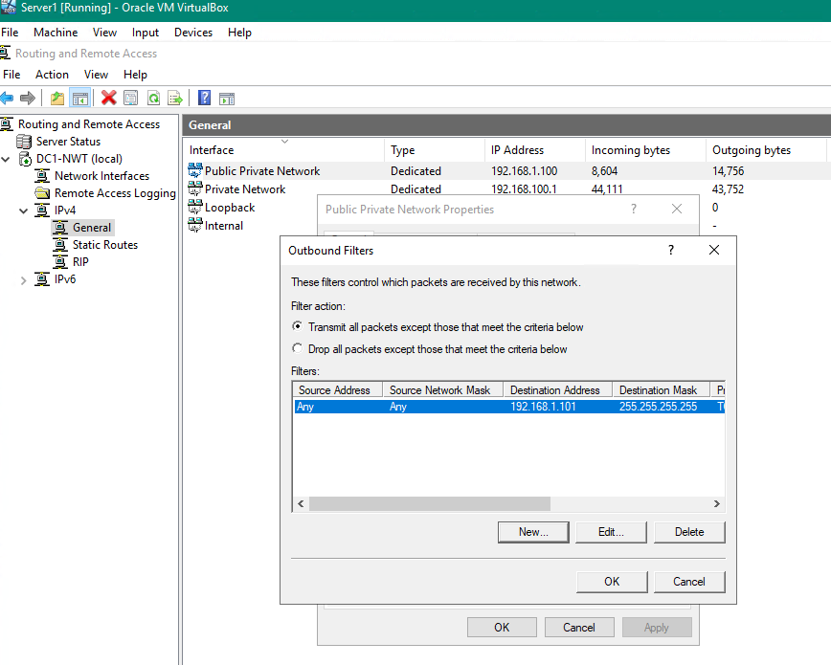
Figure 15 Server1 outbound filter on Public Network to prevent FTP traffic
A filter was applied on DC1-NWT to prevent FTP traffic over its public network. Clients on the subnets routed by this server would be unable to use FTP services on Server2
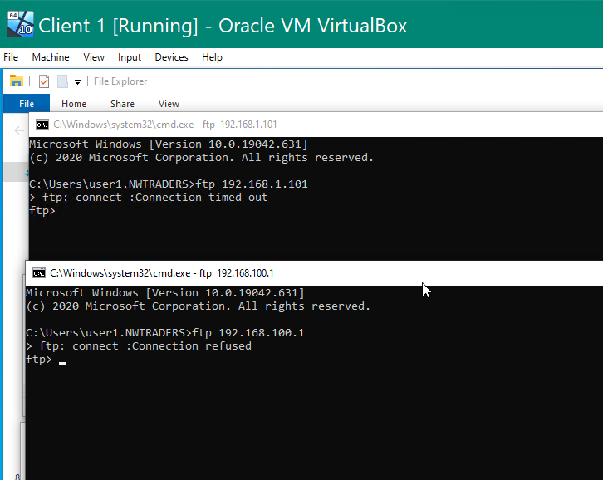
Figure 16 Client1 unable to FTP Server2 using either of its addresses
Client1 in the subnet managed by DC1-NWT is unable to initiate any FTP to Server1 on either its Public or Private IPV4 address
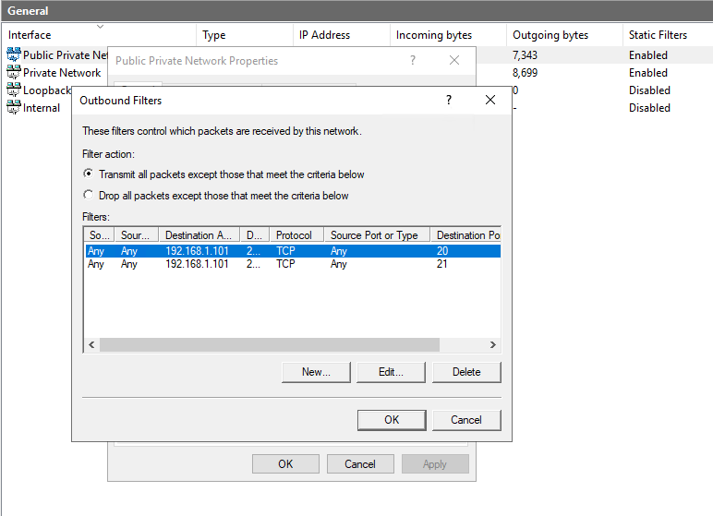
Figure 17 Both ports 20 and 21 (Control and Data) are blocked
The filtering was limited to two ports. Port 20 FTP control and port 21 FTP data. To the private IPV4 address on Server2

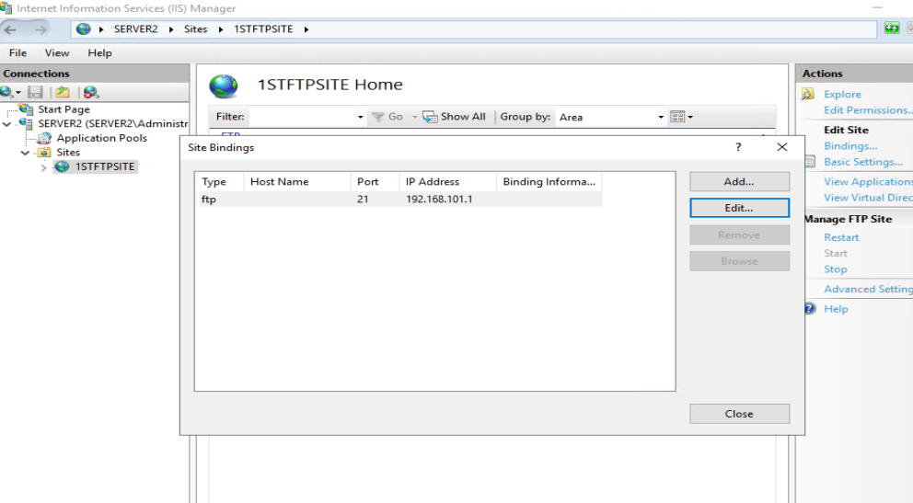
Figure 18- Set binding of FTP service to just the private address within IIS
The FTP service on Server2 was also bound to only use the private IPV4 address and not to respond to any of the other addresses this server was configured to use.
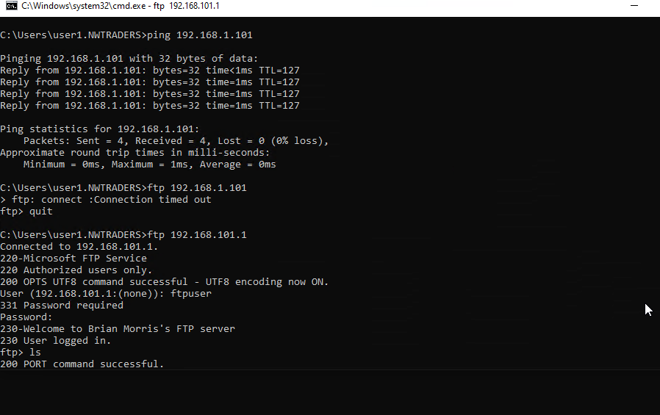
Figure 19 Ping works to public IP but not FTP. FTP works on private address
Ping requests were routed to without an issue however we can see that the FTP requests to 192.168.1.101 was dropped however requests to 192.168.101.1 were successful

Filter 3 : Only allow specific hosts in Privatnet1 to access the FTP Service running on Server 2.

All previous filters were removed from the configuration and ping tests were carried out prior to this configuration to ensure access was successful. Following the confirmation of a stable platform two rules were applied to an outbound filter to drop all traffic unless it was to 192.168.100.2 and used port 20 and 21.
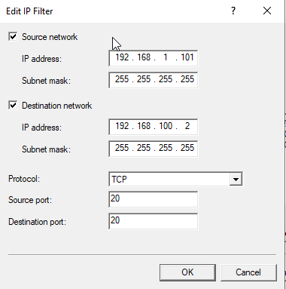
Figure 20 Port 20 rule applied
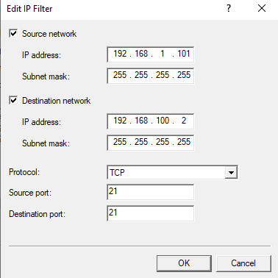
Figure 21Port 21 rule applied
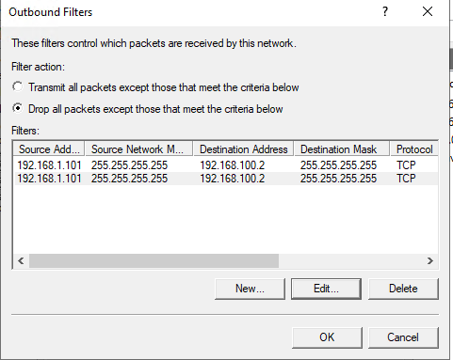
Figure 22 Both rules applied

Following application of the rule ftp process were started on the clients Server1 Client2 and Client 1

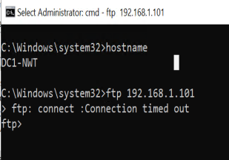
Figure 23 hostname FTP connection attempt
An FTP connection attempt was tried from Sever1 to Server2 and is successfully failed.

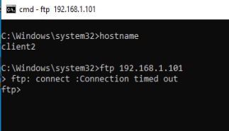
Figure 24 hostname and ftp connection attempt
An FTP connection attempt was tried from Client2 to server 2 and it successfully failed
Unfortunately, it also successfully failed on client1 which meant the rule set was invalid. Despite repeated attempts within the filtering options the author was unable to get a successful rule set to work practically.

To protect the servers FTP role a filter was applied at the FTP server to block all traffic except traffic from source IP 192.168.100.2

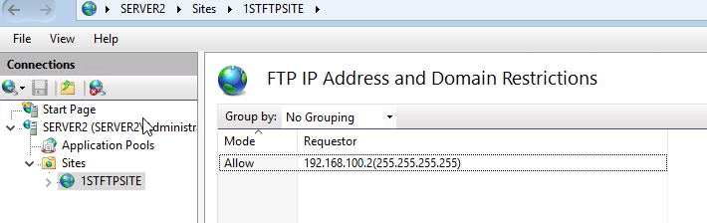

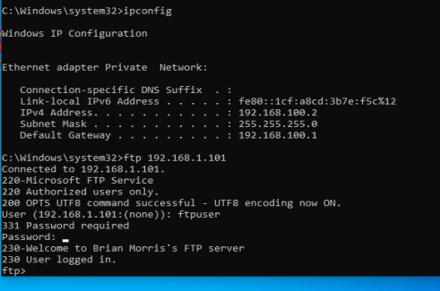
Figure 25 Client 1 FTP access
The above screen shot demonstrates a successful FTP connection from Client1 into Server2

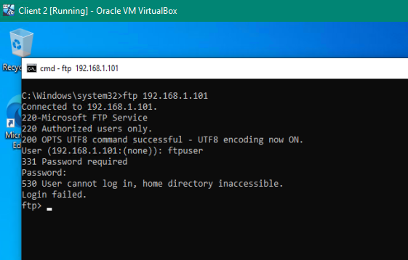
Figure 26 Client 2 FTP access rejected.

The above screen shot demonstrates a successful failure event on client2 when attempting to access the FTP server. Whilst it does not prevent the device establishing an FTP link to the server it demonstrates that other clients cannot access the FTP site .

Problem solving failure.
Further testing was undertaken to try and understand the system failing the way it did and all rules were removed from the IP filter and an FTP process was monitored using Wireshark.
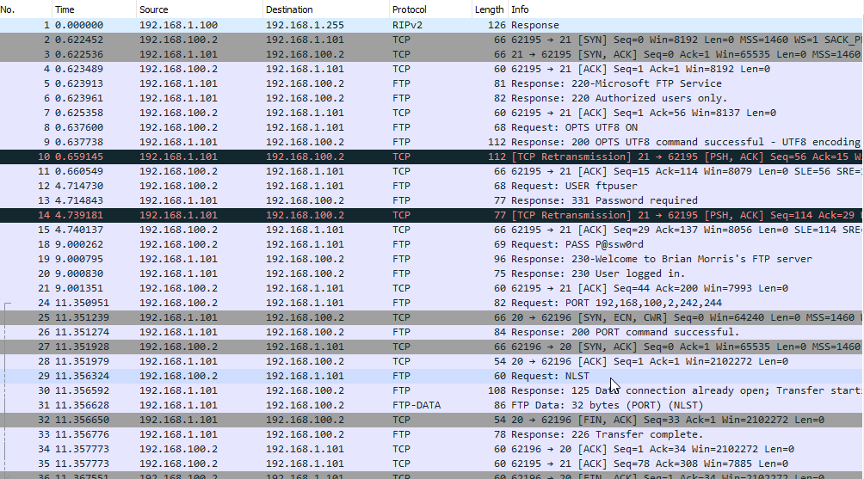

The output of Wireshark showed the successful login (line 19) and the transfer of data when a listing was requested (line 31).
We can also see that the source ports used by the FTP service are not restricted to ports 20 21 as the system was also using but not limited to port 62195 62196 in the above example.
So, the source and destination rules were amended for the subnet.
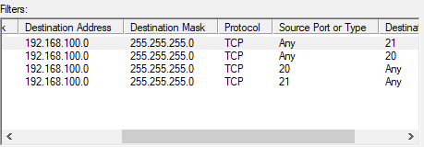
Figure 27 Additional source and destination port rules added.

This configuration proved successful, and an FTP connection was able to be established by client1.
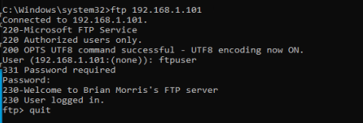
Figure 28 Successful FTP connection
However, the specification stipulated that only Client1 192.160.100.2 should access the FTP service, so the rules were amended to the specific host.
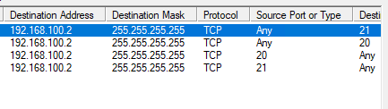
Figure 29 - Locking the subnet to the IP of the client device.
This again process proved successful but there were too many rules to be secure, so the extra rules were removed.
Using the command netsh routing ip dump > filename the configuration was extracted for reference.

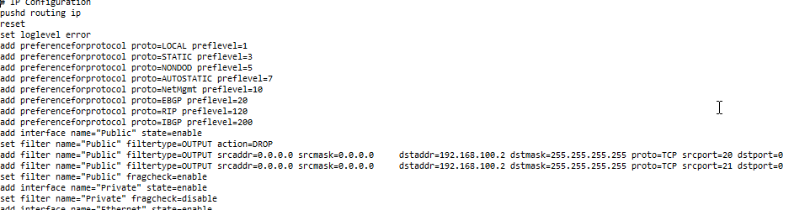

The final outbound rules applied are as follows : -
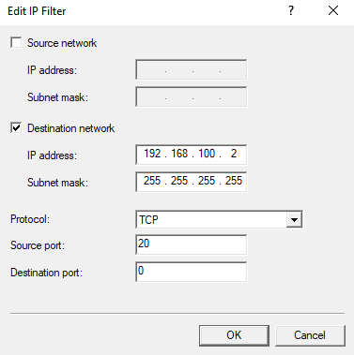
Figure 30 Source port 20 rule
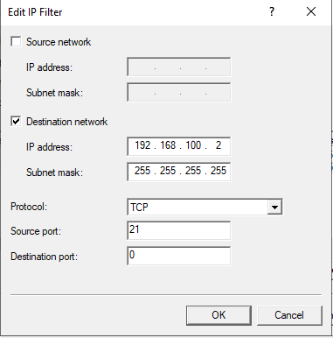
Figure 31 Source port 21 rule

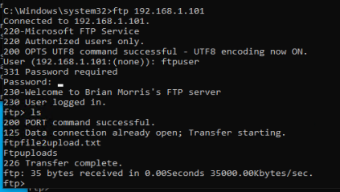
Figure 32 FTP connection established with applied rules.
To summarise we can see that FTP is not restricted to just ports 20 and 21 and the ports needed to be more open to allow the system to successfully establish an FTP connection. We must also acknowledge that by implementing the rule set as above directly effects other services and further rules would need to be created to allow the system to function fully.

Failover Clusters
A failover cluster being a set of similarly specified physical or virtual computers that provide a highly available or continuously available service. Clusters are typically deployed where a service is critical and cannot afford to be offline for a protracted length of time or where the demands of the service cannot be met economically by a single server solution. A cluster can consist of one or more nodes. A single node known as a ‘lone wolf cluster’ (derived from the ‘wolf pack’ moniker that Microsoft original introduced with its clustering technology) fails to meet any of the HA and CA requirements but can be useful when testing solutions. Windows 2019 Datacentre or Standard can scale to 64 nodes [2] in a single cluster. This scope provides an administrator plenty of range to scale a cluster to meet the demands of a service for typical day to day workloads outside of a high-performance computing scenario.

High Availability clusters
HA clusters can be either Active/Passive or Active/Active. The author has in the past created both types of clusters typically for a file serving role. A single server that must serve terabytes of data to thousands of users can often struggle to meet the demands and provide a poor end users experience. Creating a single monolithic cluster group with all IPs disks and shares within the one cluster group to sit on only one active server in the cluster whilst the other nodes sit there passively is wasteful of resources and again can provide a poor end users experience.
Splitting out the requirements into smaller more manageable resource groups enabling the duties to be carried out by multiple nodes within the cluster so no single server is overloaded provides several benefits to the service users and administrators.
No single server is overloaded with competing resources.
Resource Groups can be easily moved to alternative nodes.
Nodes can undergo maintenance tasks without unduly impacting the overall cluster performance.
Failover/failback events take less time to occur limiting outages.
Cluster nodes can be smaller as performance is gained by scaling out the solution (adding more nodes) not scaling up the solution (adding more CPU and RAM). This can affect the overall cost of the solution.

Active/Passive cluster where not all the nodes in the cluster are active, do provide a level of resilience to a cluster and become useful when licensing a solution for example enterprise versions of database servers become prohibitively expensive if the cluster was Active/Active. They offer a level of performance resilience where workloads can be moved to a node that has readily available resources.

Very basic active/passive cluster.

Below is a very simple cluster. The basic concepts behind this cluster include a shared storage component that makes storage available to the nodes that need to access the data. Also included is a network that connects the nodes to each other and the outside environments. Also illustrated are published resources that in this instance reside on one active node of the cluster.
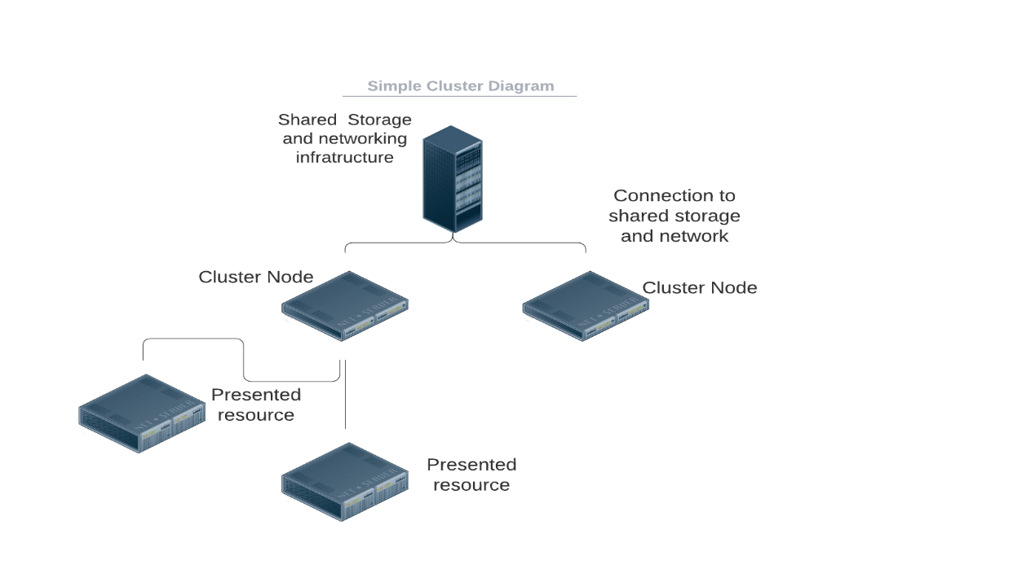
Figure 33 - Simple Active/Passive Cluster Diagram

Active/Active Cluster

Extending the above concept, we can share he workloads across multiple nodes so that each node takes an active role within the cluster.

g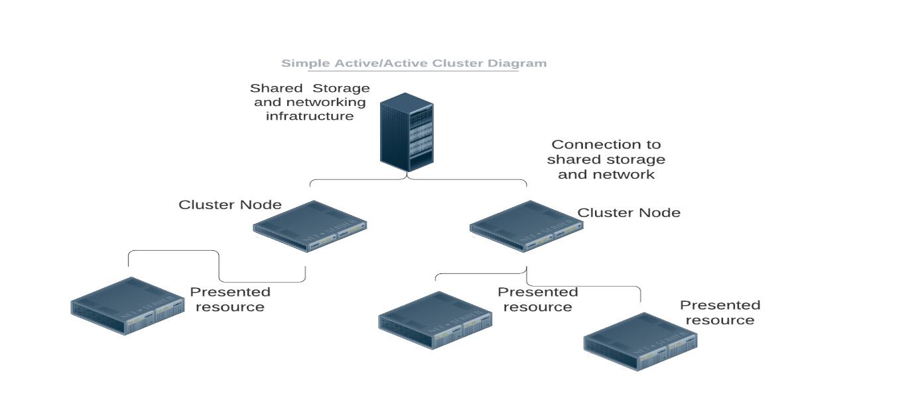
Figure 34Simple Active/Active Cluster Diagram

There are drawbacks in running an active/active cluster. The servers themselves are a finite resource and are only capable of processing data at a specific rate. To make effective use of the resources the servers should not be running idle. For example, if the presented resources on each node was running at 60% capacity this may be an acceptable level but in the event of a failure event or a patching cycle the presented resources would need to move from node to node. This would put undue strain on the cluster nodes that need to handle the additional workload. That could provide a poor end user experience due to poor performance or take the whole system offline compounding the issues for the end users.
For a service to maintain improved uptime within a cluster the clusters itself should be able to suffer the loss at least one node adding more nodes decreases the overall demand on individual nodes to provide a more robust and resilient platform.
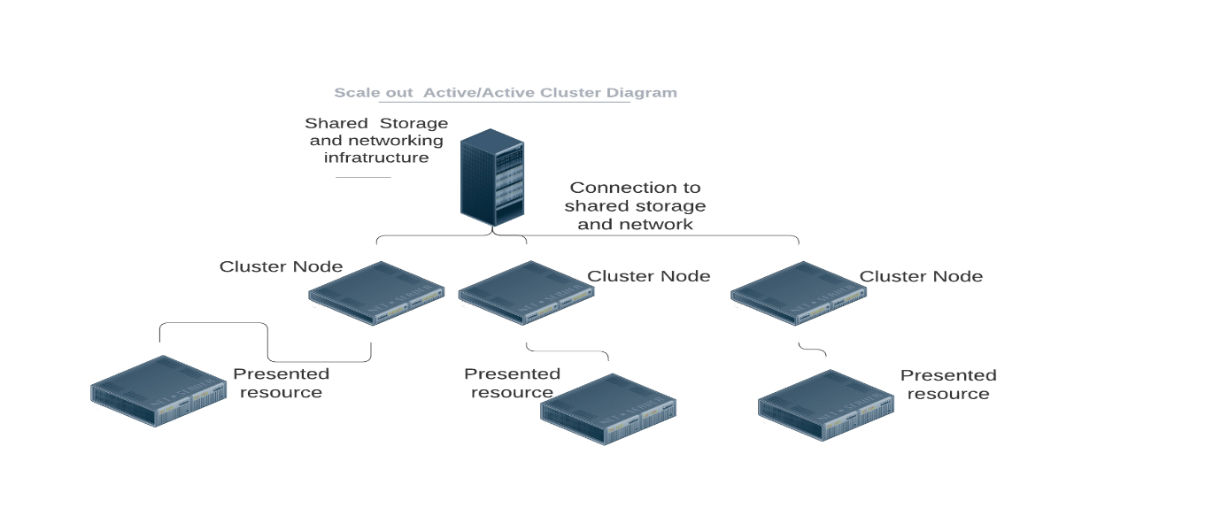
Figure 35 Scaled out Active/Active cluster

Fault Tolerance and Single Point of Failures
Placing so many services within a cluster must provide additional benefits beyond performance, so by utilising hardware that can provides additional layers of fault tolerances solutions can attain a greater uptime. To achieve this a solutions designer or infrastructure architect would look to eliminate single point of failures. Storage Area Networks devices typically have multiple power supplies, multiple storage controllers and multiple connections into multiple storage switches coupled with fault tolerant configuration within the storage arrays themselves to mitigate drive failures.
The nodes or physical hosts of the cluster are also typically provisioned with multiple network cards power supplies and connections to the backend storage. These all help to eliminate potential outages be removing individual points of failure.
Ideally the support infrastructure would also be protected by a supplementary power system (UPS, Diesel Generator, Secondary Utility Provider) to protect the service in the event of a power failure specified to either run until normal power is restored or to provide enough time to gracefully power down the systems.

Stretched clusters.
The unexpected loss of a site can have a detrimental effect on an organization. If key services hosted at the affected within the cluster are lost it can take a protracted length of time to recover the services. It is possible to “stretch” the cluster beyond the physical limits of a geographic site. A stretched cluster can also be used to ensure a constant service is presented to end users at a site with appropriate network performance. There are additional considerations that need to be considered such as network addressing name resolution services storage replication etc.

Cluster Shared Volumes
The above Windows cluster operates on a shared nothing principle. Where the cluster resources Disks IP etc could only be accessed directly by one host at a time. This configuration has its draw backs especially when operating a large cluster of nodes hosting Virtual Machines. If only one node can access the presented LUN that hosts the Virtual Machine disk images this would dramatically reduce the benefit of operating in clusters. With Windows 2008r2 Microsoft introduced Clustered Shared Volumes. CSVs permits multiple nodes in the cluster simultaneous access to the same disks. For example, a LUN on shared storage presented to multiple nodes hosting many VHDs servers in a cluster can each read and write to the same LUN without impacting the overall performance of the storage.

Hyperconverged Clusters
Separate cluster components in an enterprise include shared storage of some kind, possibly a SAN, storage networking, compute nodes (CPU and RAM) plus the additional associated networking infrastructure. For an organization to provision this type of infrastructure requires a significant investment in both technologies, skills, and finance. This method can lead to certain components being over or under specified. Either too much storage not enough compute etc which can result in over or under investment in infrastructure.
Hyper Converged take the above components storage, networking, and compute to integrate them into a standard commodity chassis and layer a management software on top. Whereas the above clusters have separate component that could be scaled independently each node contains the required CPU, RAM, networking, and storage required to participate in a cluster. The perceived benefit to this solution is the capacity of the solution scales at a liner level as nodes are added into the cluster. More CPU/RAM/Storage/Networking ensure that the growth is consistent. However, some hyper converged solutions vendors do have nodes configured that can be added into the cluster that are more storage or CPU focused if the requirements of the solution demand it.

Building a Cluster within Virtual Box.

Lab resources on the test host are limited so the service will consist of three servers. The storage for the cluster was added to the domain controller. In this instance the DC is going to hold a centralised storage controller role similar to a shared storage array.
A 2GB disk was carved to and added to the DC.
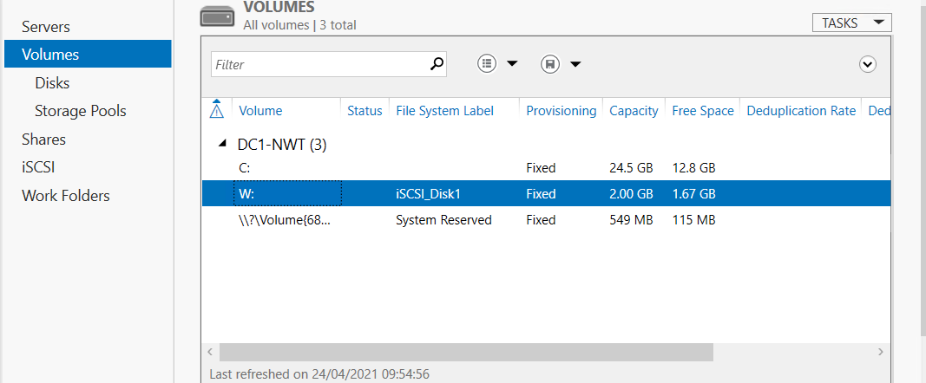
Figure 36 Thin provisioned 2Gb drive added to DC.
Several disks were then created as ISCSI targets to present to the cluster nodes.
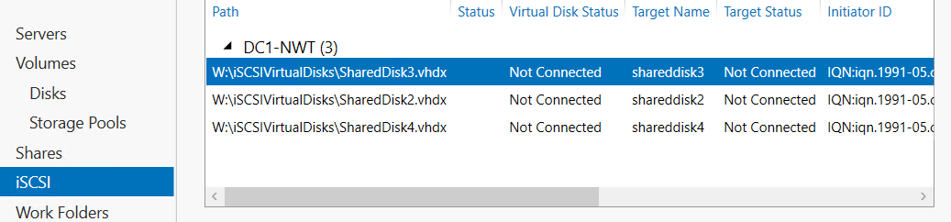
Figure 37Disk on the LUN presented to clients.
The process is driven by interactive Wizards to guide the user adding additional disks is relatively straight forward.
Select where the disk will be stored on the server.
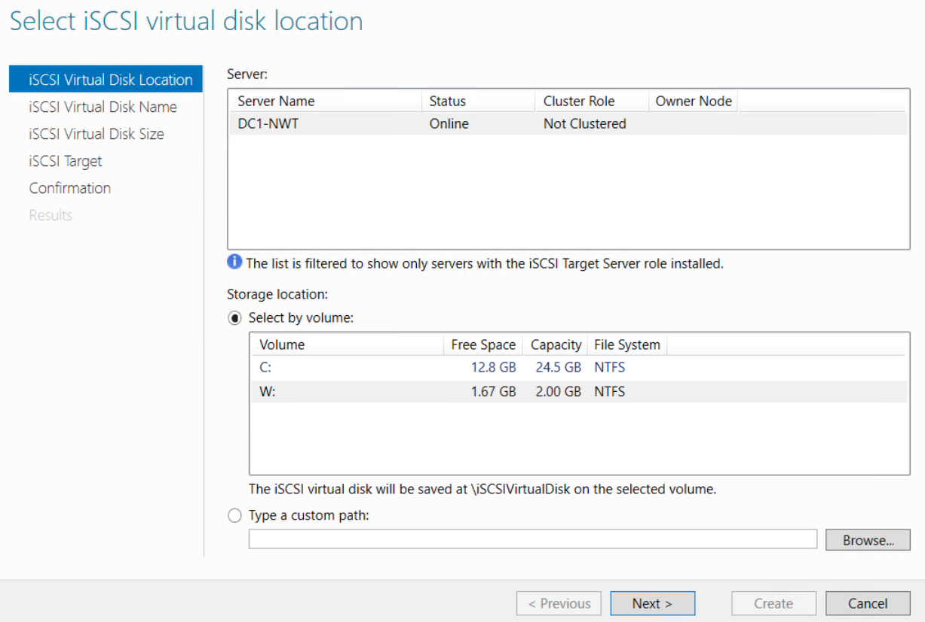
Figure 38 Select Volume where the new disk will reside

Provide a unique name to the disk.
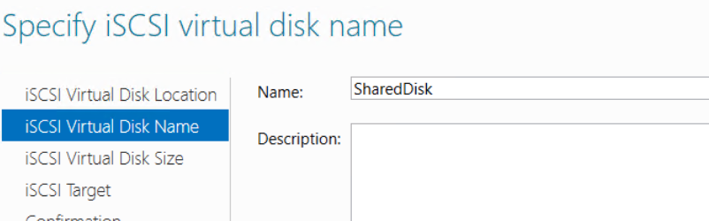
Figure 39 Disk naming dialog options

Disk size and parameters. In this instance a small disk was being created and the option for Dynamically expanding thinly provisioned disk was used
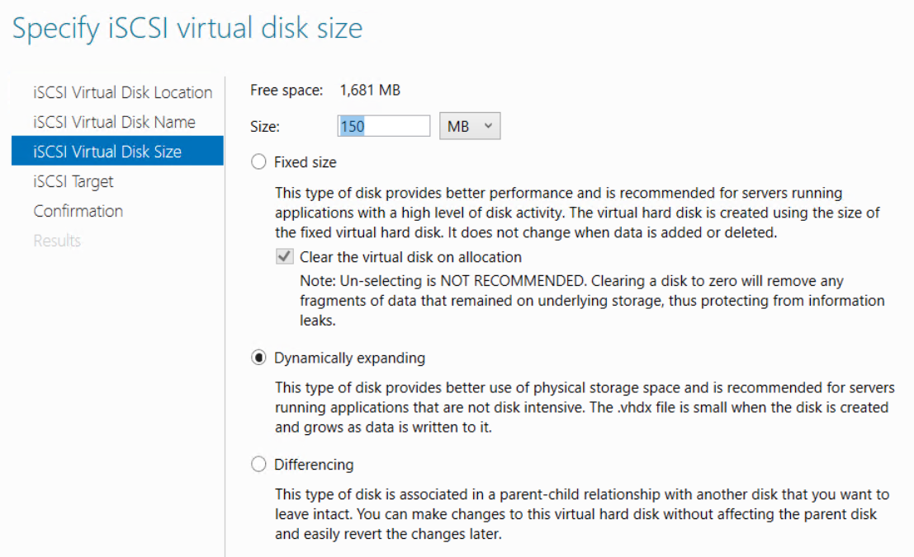

A new iSCSI target was created for the disk.
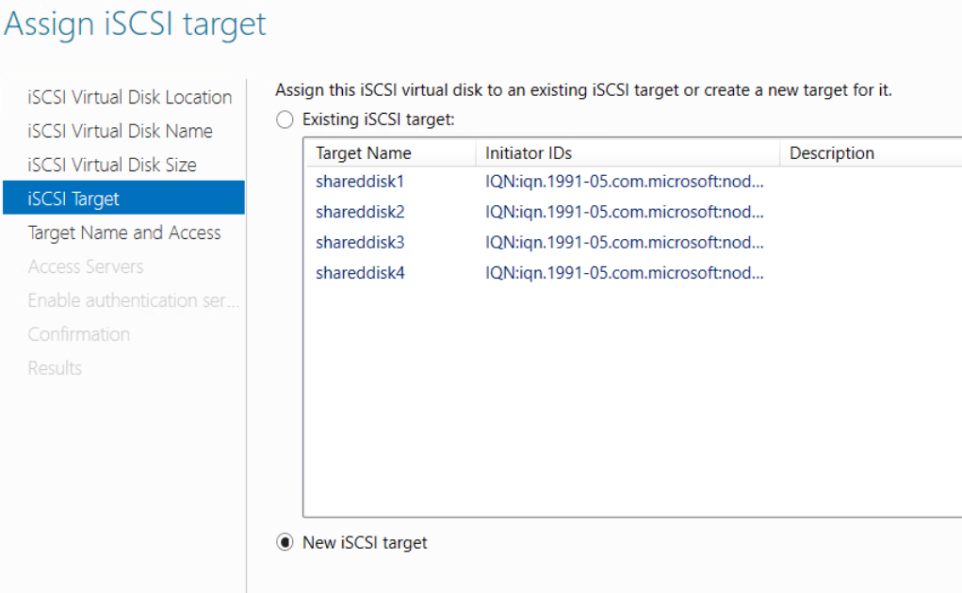

A name was given to the target.
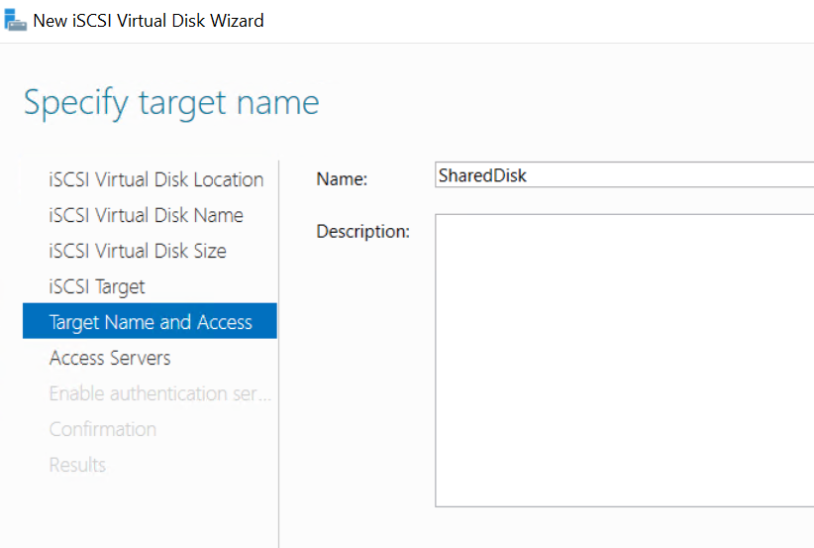

The active directory name of the clients was used to identify the initiator of the connections.

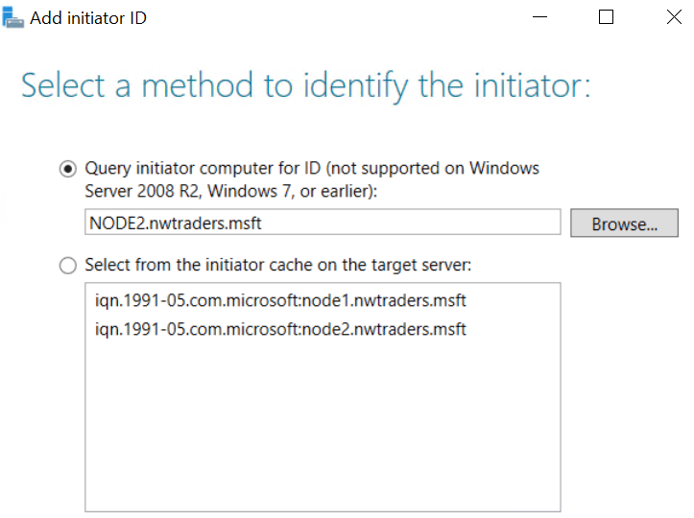

All nodes of the cluster are being assigned access to the disk.
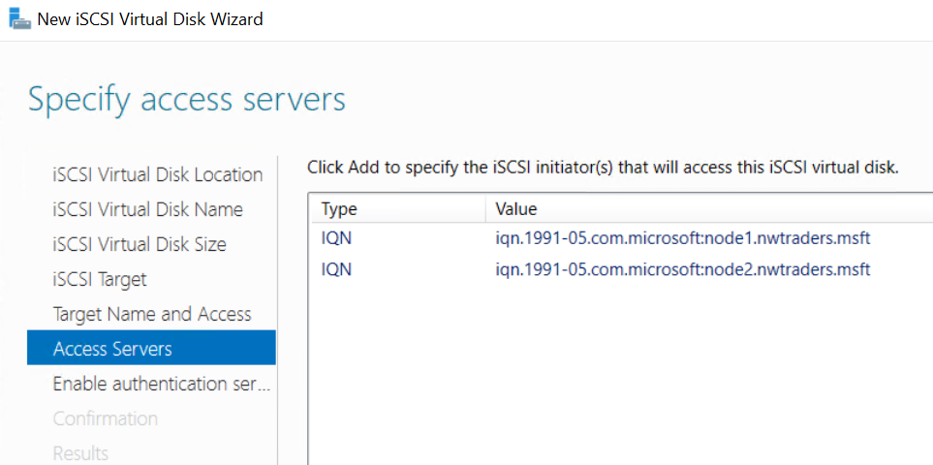

Additional security can be used to prevent unauthorised access to the resources if required.
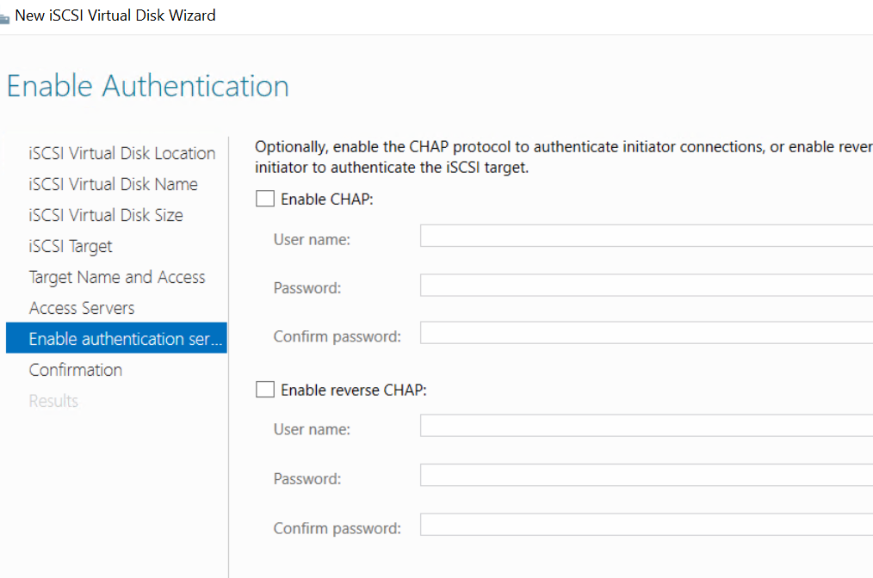

Disk presentation summary screen
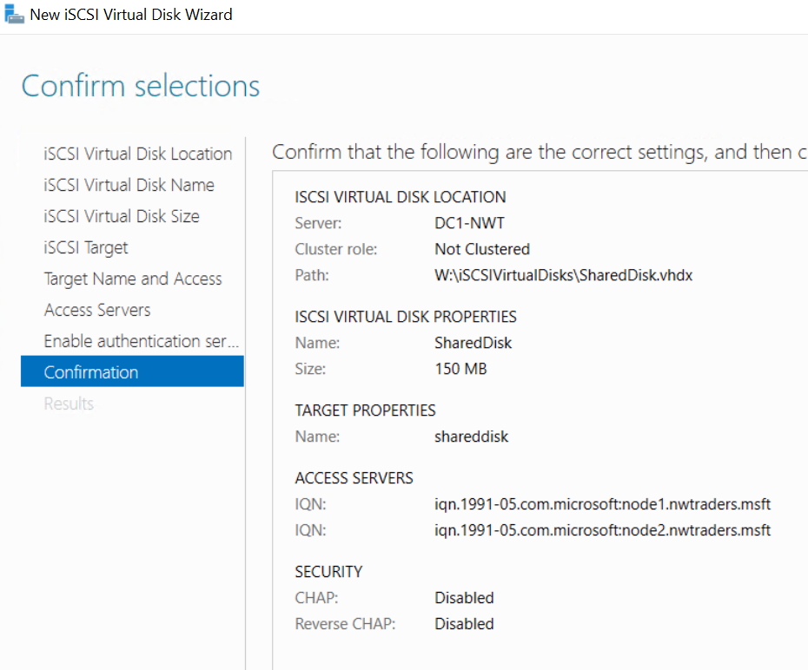

Successful deployment
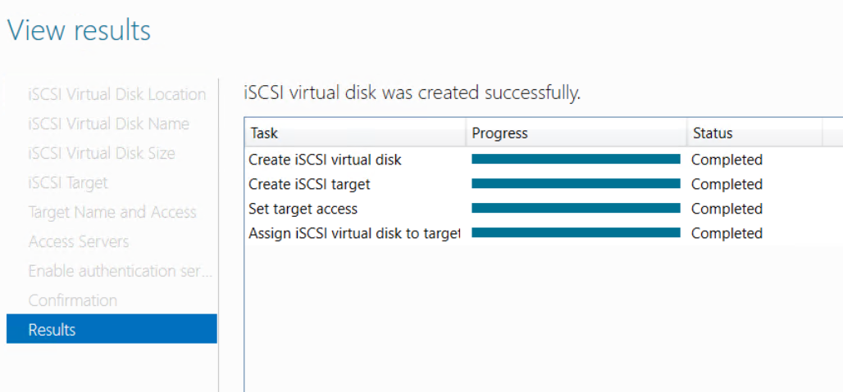

Two server nodes are prepared to host the cluster.
A production cluster would have a public network for general traffic, a private network for node heartbeat communication and in this case as the solution relies on iSCSI a network dedicated for storage traffic, the server could also have a dedicated network for backup traffic. However, clusters can operate with minimal network interface cards.
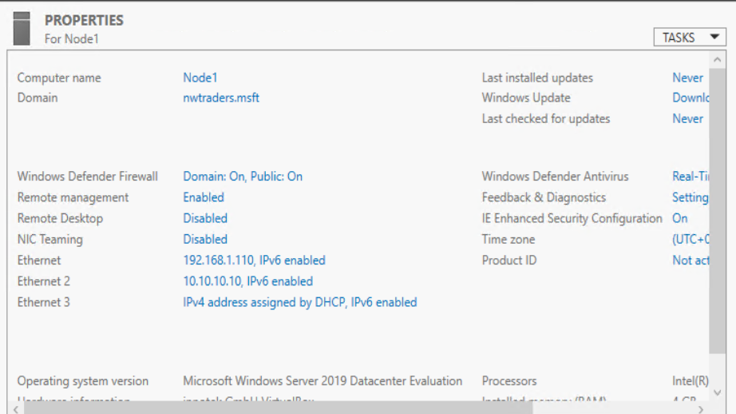

The cluster is going to host a file serving role, so the file server role and failover cluster feature was added to each node. The feature was also added to the Domain Controller, so the administrative tools were accessible from that host as well if required.

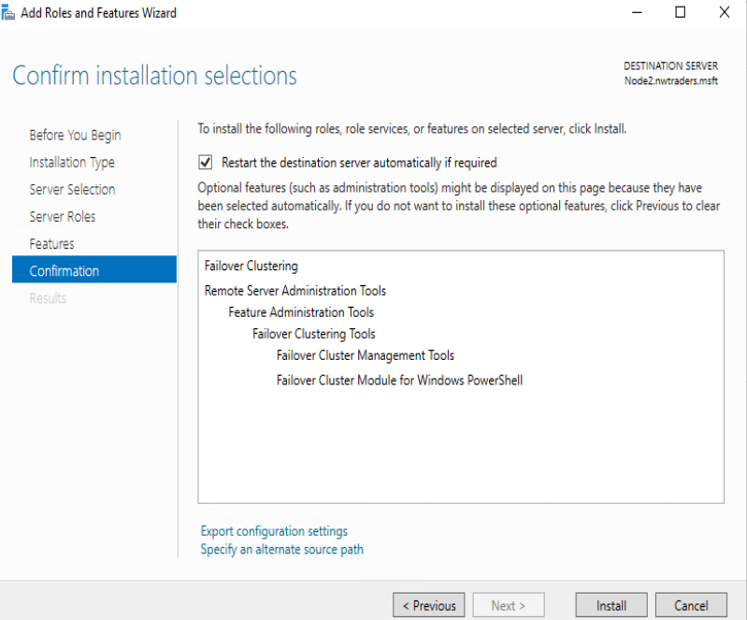
Figure 40 Installing Roles and Features

Using the Failover Cluster Manager

Prior to the cluster being built the nodes must be validated against an approved configuration. Following the Validate configuration wizard the nodes are tested. This test ensures that the cluster has resources that are supported i.e., part of the Hardware Compatibility List and that the hardware is configured in way to support a cluster.
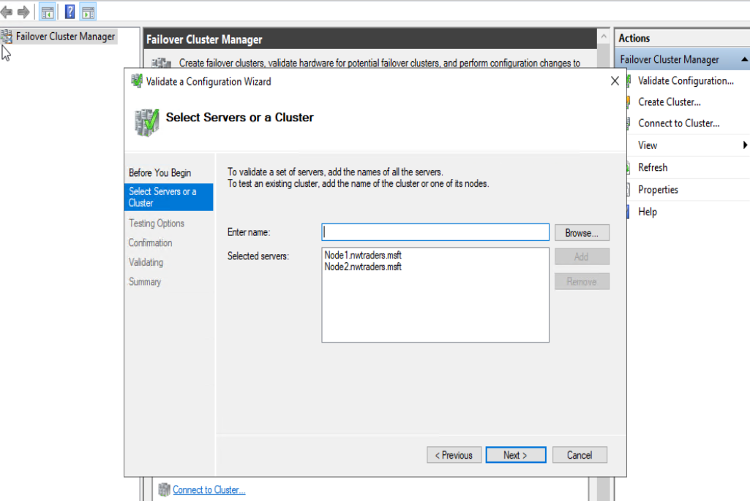
Figure 41 Nodes of the proposed cluster

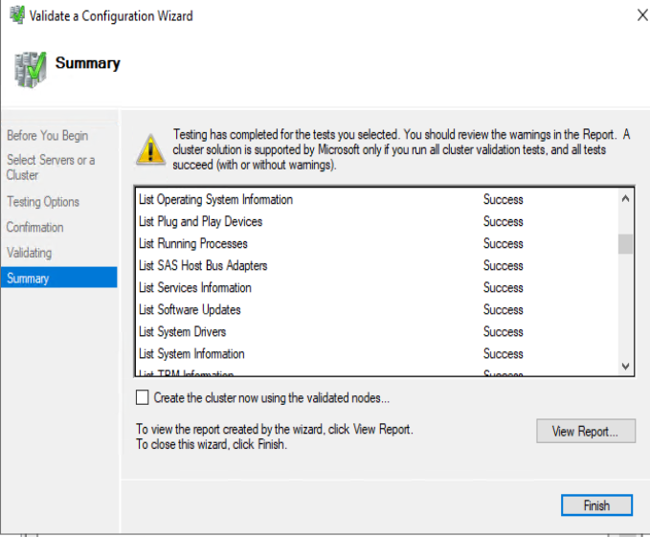
Figure 42:- Cluster Validation Results

The wizard runs server tests against the cluster to ensure it meets the minimum recommended hardware requirements to support a cluster service.
Once the validation has proved successful a cluster can now be created add in both the nodes.
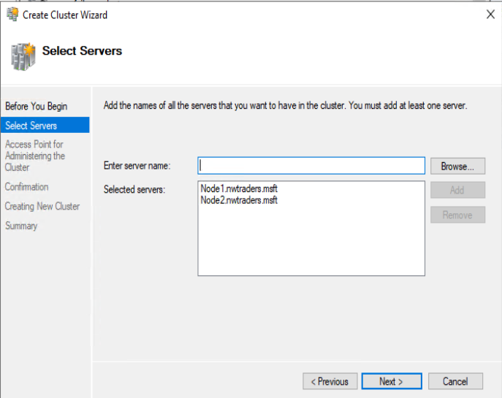
Figure 43 Creating the cluster wizard adding the nodes.
Part of the configurations requires the cluster to have its own Network name and IP-address the process then creates a computer account in the active directory for the cluster. This account can then be used to delegate access to the nodes within the cluster and the OU the cluster resources reside in within the active directory.
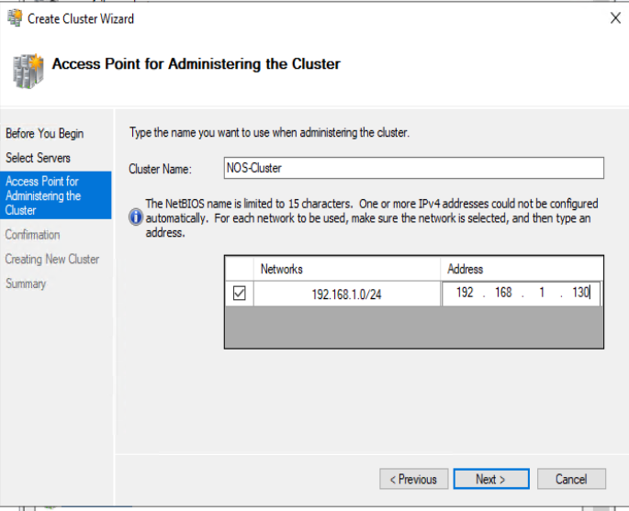
Figure 44 Specify Cluster Name and IP address

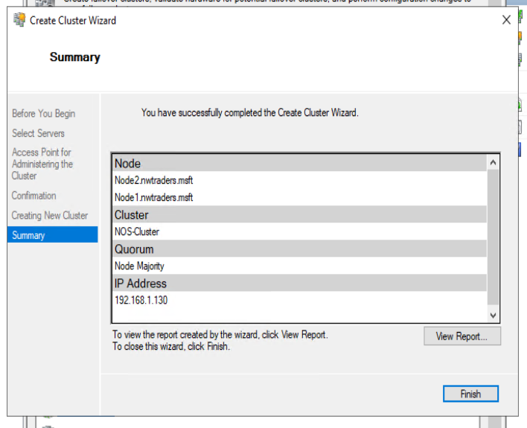
Figure 45 Cluster Created.
The cluster is currently built but has no roles assigned to it.

Cluster was granted Full Control to the Organizational Unit that the cluster resources reside within. This permits the cluster rights to add new objects with Active Directory as new cluster resources are created.
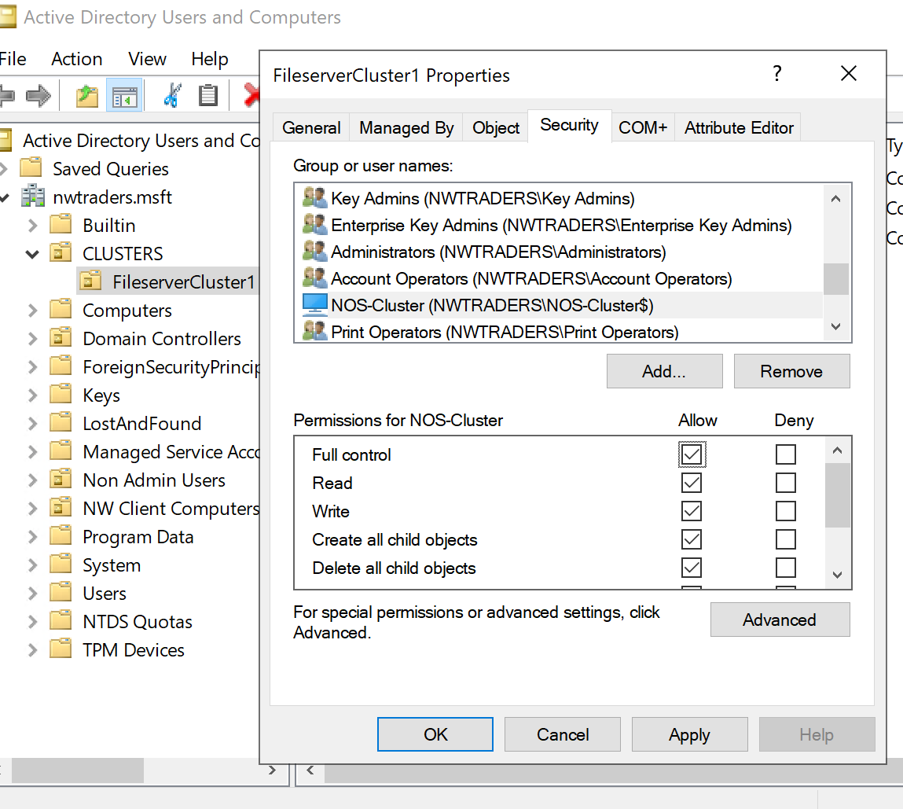
Figure 46 Delegating permissions within Active Directory to the cluster resource

Ensure the node support the features that you plan to use. For example, the cluster is going to be a file serving cluster but the file serving role was not installed on the nodes, so the feature was added.

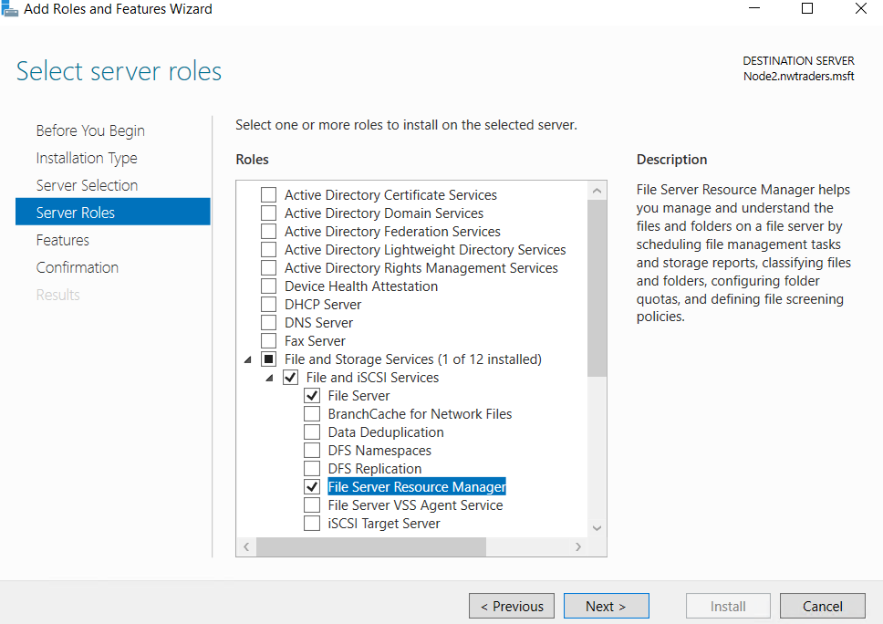
Figure 47 Add additional roles and features that the cluster resources require

The nodes are then connected to the central storage in this instance residing on the DC, presented out as iSCSI targets. In this instance there is very little redundancy in the connectivity however in a production environment each node would have multiple paths to central storage, to mitigate a failure of a component. Either via an ethernet connection or a dedicated fibre connection.
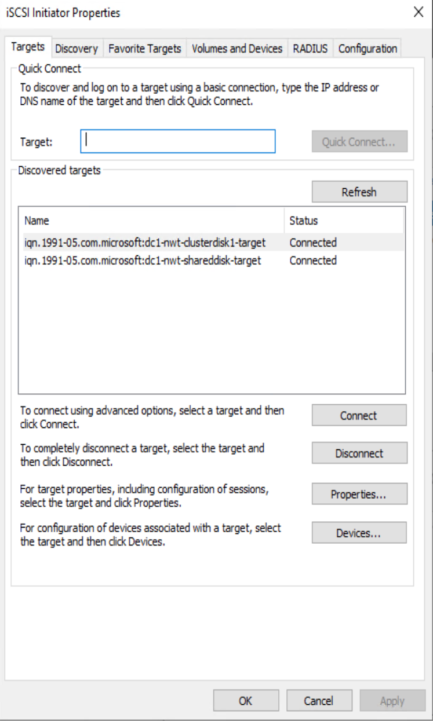

Figure 48Connect to central storage iSCSI targets.
Presented disks are added to each node via the disk management system to ensure the cluster nodes have visibility of the disks.
MPIO (Multi Path Input Output) is a feature that is employed to aid in presenting disks to hosts and nodes. If a host has multiple ways to connect to a storage its possible a single drive can show up multiple times within disk manager. MPIO detects and manages the paths to present the node with a single drive within the disk management interface.
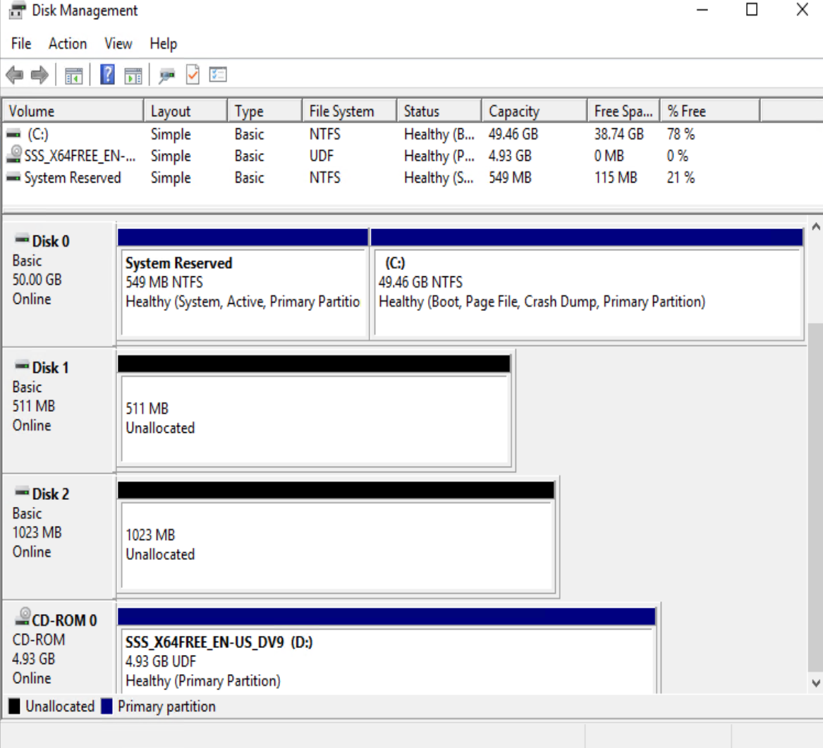
Figure 49 Disk manager
Disks are initialised and formatted on one of the nodes as required prior to being made available to the cluster.

Disks are added to the cluster resource via the Failover cluster manager.
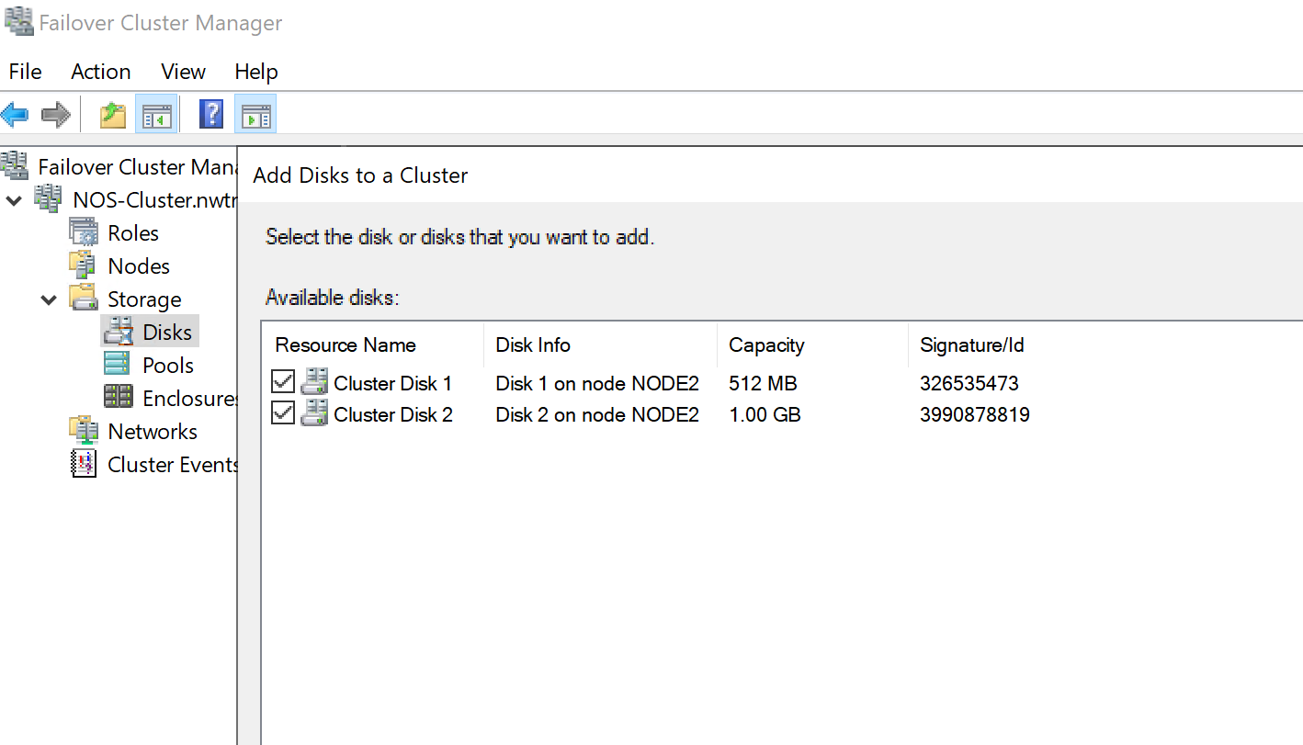

Follow the wizard to install the desired roles. There are many roles available in this instance a file server is being configured.
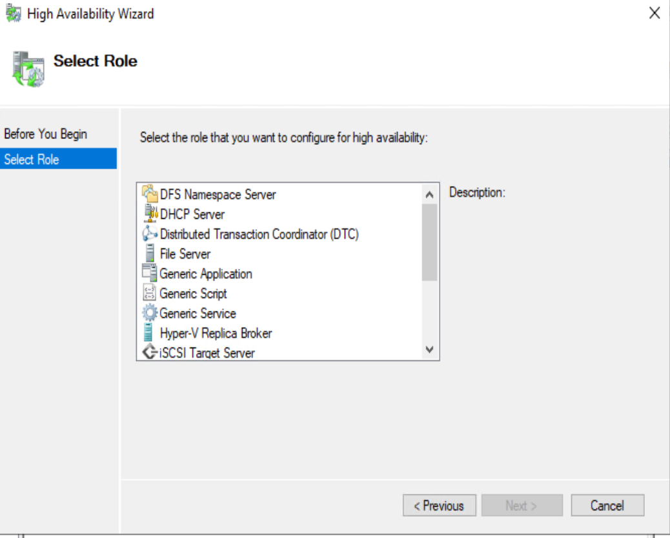
Figure 50 Selecting the File Server role

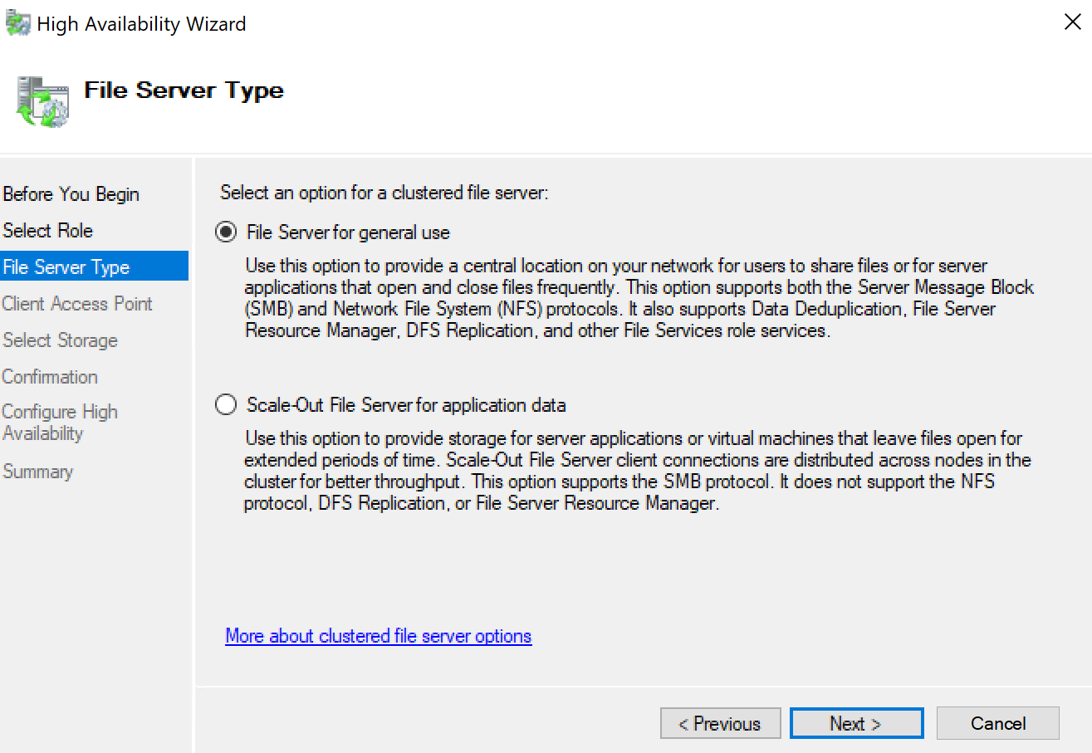
Figure 51 Selecting the file serving option.
Files serving functions have progressed to help reduce downtime during cluster fail over events coupled with SMB3 performance improvements have also been introduced. If the clusters are to host virtual machines, then as advised within the wizard use the scale out file server option. However, for general user access it not necessarily an advisable configuration option [3]

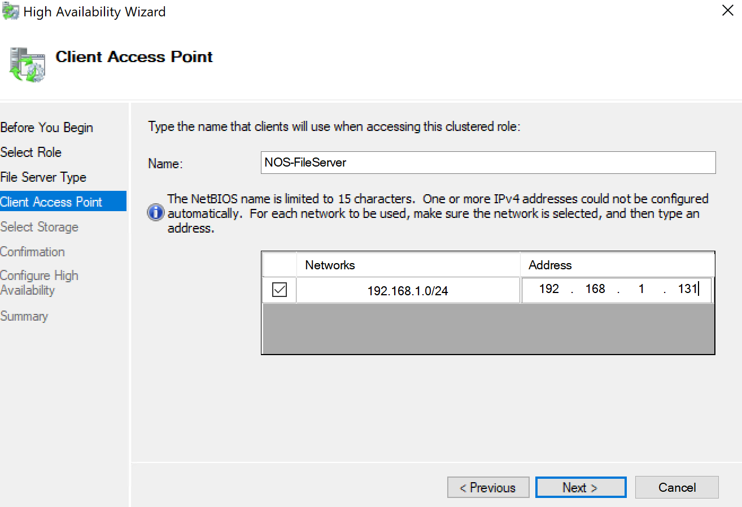
Figure 52Provide cluster resource Name and IP address

The file server resource has its own IP address and network name for clients to connect to as required.

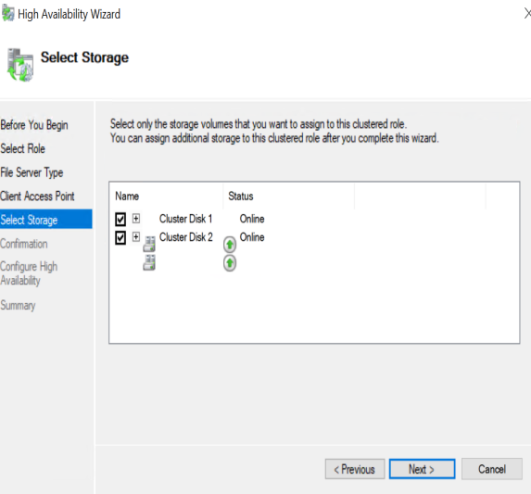

Figure 53 Selecting storage to add to the resource.

Disk that has been presented to the cluster can be individually selected for the resource or added all together as required.
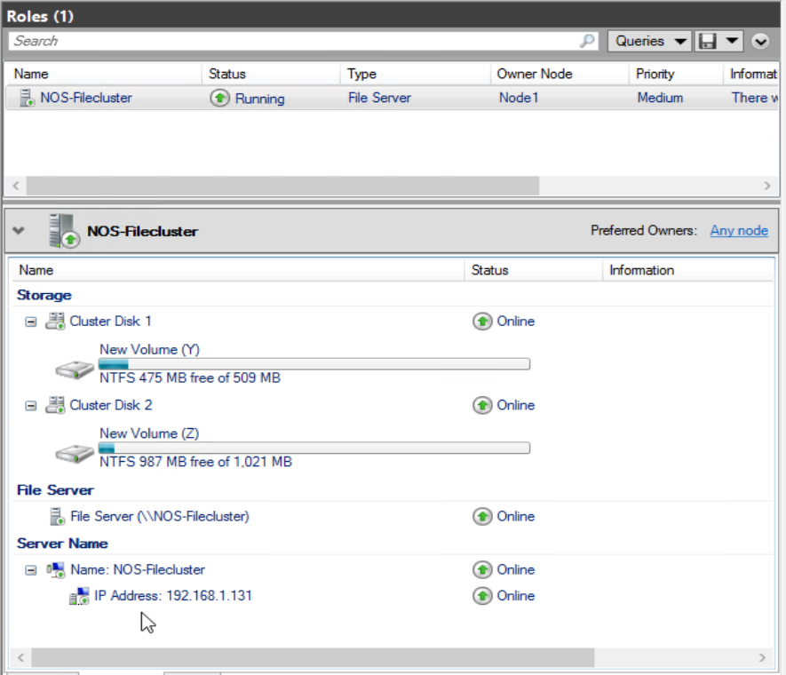

A file share can be added to the cluster following the same procedures as if the file was being presented via a single server using the file sharing wizard adding the features of a share that is considered appropriate.
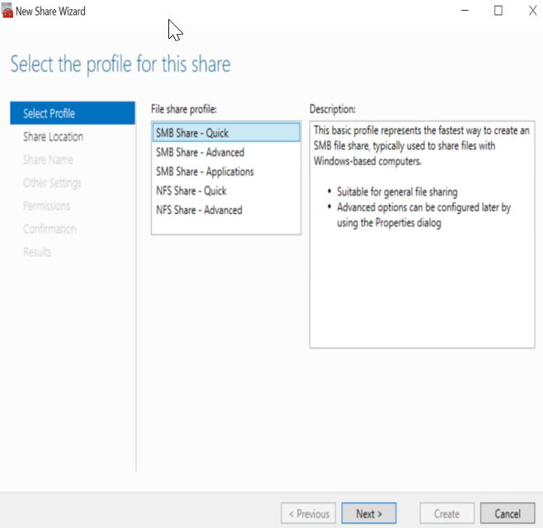
Figure 54 Share creation Wizard

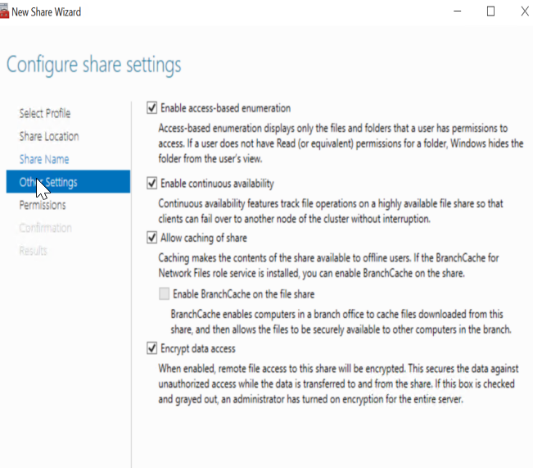
Figure 55 clustered share features

Confirmation of the shares being created.
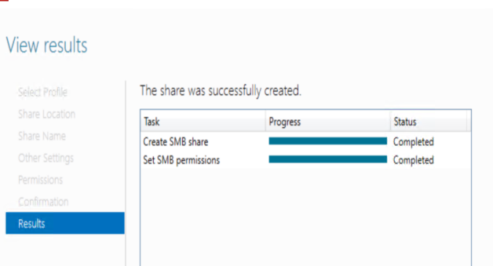
Figure 56 Confirmation Share creation

Below we can see the two shares as planned.
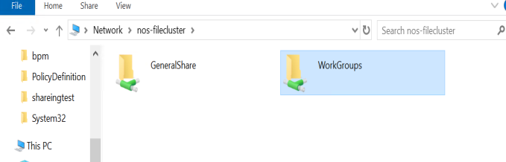
Figure 57 Presented shares

Failing over resources.
A simple fail over test of a simple file share cluster demonstrates that a cluster resource can drop out even when there is a very minimal resources usage. Pinging the NOS-Filecluster that resided on Node1.
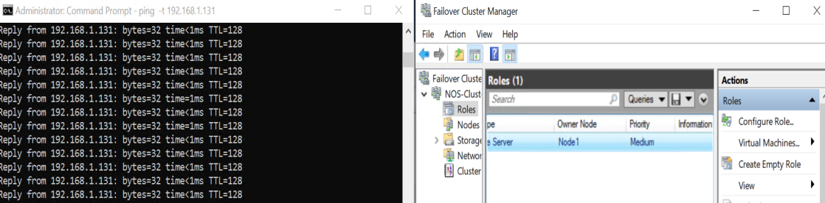
Figure 58 Active node - Node1

Using the move cluster role tool, the file server role was moved from Node1 to Node 2.

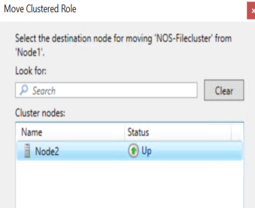
Figure 59 - Move role from node 1 to 2

As demonstrated below there was a brief period when the resource became unavailable as it moved from one node to the other. This situation is not ideal especially if the systems are mission critical and cannot tolerate such outages. This outage example is minimal however if this server was serving large numbers of users with thousands of connections the resource could take longer to fail over cleanly.

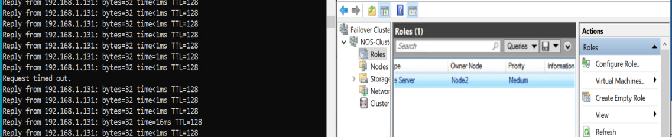
Figure 60 intermittent drop in service while resource moves two node2

Cluster resource placement planning, failover, and failback

If the resources required are known, it is possible to manually balance out the resources within the cluster to fit equally across all the nodes. By selecting the preferred node an administrator can help maintain a balance of resources.
Inevitably at some point a resource run into trouble and fail, the cluster will attempt to move a failing resource over to another node in case the node itself is struggling. If this is continuing to happen its possible an underlying issue needs to be resolved by forcing a fail an administrator may be alerted to the issue sooner than if the resource was just bouncing across nodes.
If a failing resource issue has been resolved the active resources may reside on a limited amount of cluster nodes. This unbalanced workload can cause further issues if the node is overworked serving too many clients with limited resources. To re-balance the workloads it is advisable to configure the fail back options where the failed resource restarts on its configured preferred host. This can be scheduled to happen immediately or within a specified time frame if an immediate failback is not suitable.

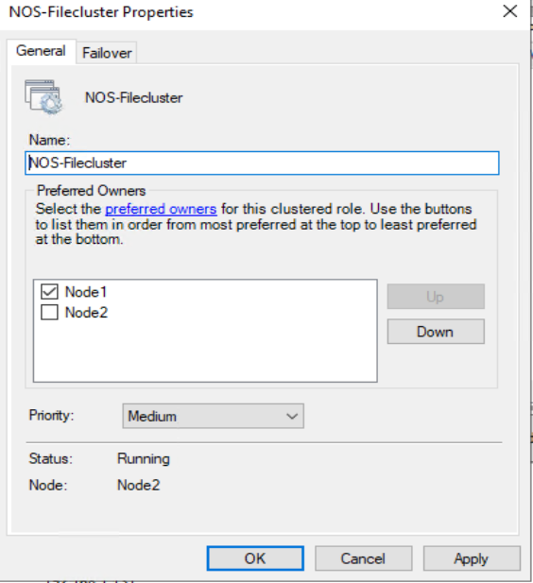
Figure 61 Setting the preferred owner of a resources to help balance resources

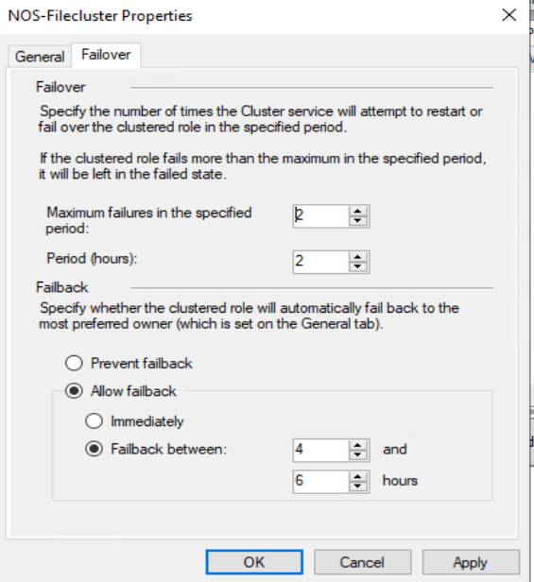
Figure 62 Fail over and fail back parameters

Quorum
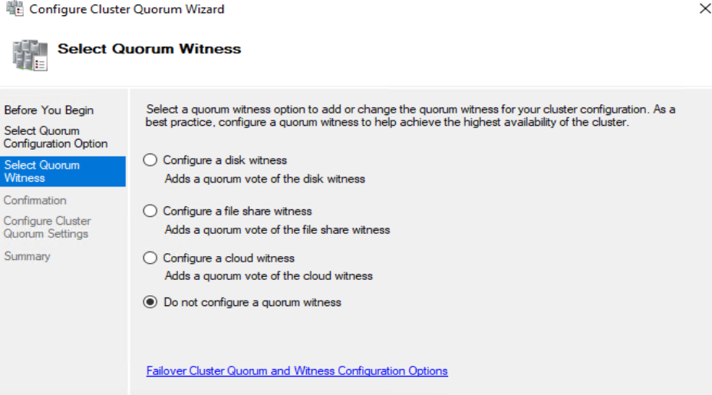

The quorum function determines how the cluster will behave in the event of an error that can affect the stability of the cluster, the majority node quorum prevents the cluster suffering a split brian. Where one node loses communication with another node and multiple nodes think they are the owner of the cluster. In the cluster each server and a witness (if configured) are given a ‘vote’ however in an even node cluster (without a witness) one of the servers is not permitted to have a vote to prevent there being an equal outcome on the vote there by ensuring a majority vote [4].
As stated, clusters require an odd number of votes to ensure a majority, cluster should employ a witness technology either a witness disk presented to the cluster nodes only, a witness file share hosted on a file server outside of the cluster or a cloud hosted witness. If a node is unable to communicate to the rest of the cluster and the quorum than it will fail its resources, so the resources can fail over to an active node within the cluster.

Cluster Aware updates.
A secure enterprise should ensure its hosts are running with the latest approved patches and security updates. Patching large clusters without impacting the resources can be an administrative overhead that was cumbersome to implement well. Updates to the technology have automated the process so failover cluster nodes are automatically placed in maintenance mode, active resources are resources are moved off the node to an alternative active node, updates are applied and the node rebooted if required, the node is brought out of maintenance mode, the cluster resources are moved back to the updated node, then the whole process moves onto the next node within the cluster . [5]

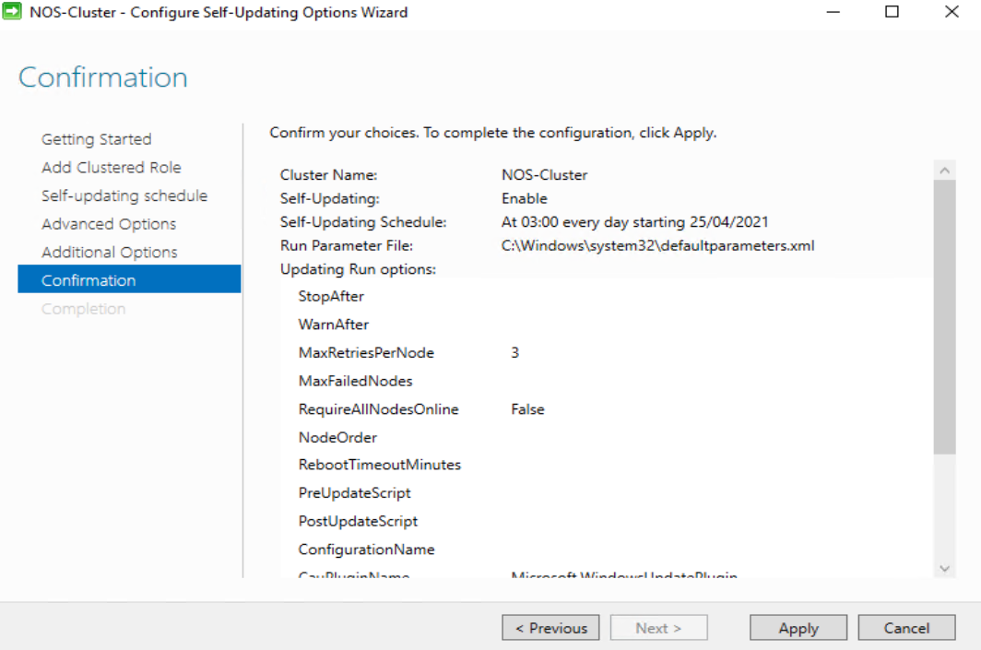

Organizational IT Security Policy.
ICT services delivered by this organization are vital to our staff and customers. Systems should adhere to the following principles policies and procedures where possible to maintain security accreditation and ISO 27001 standards. Failure to follow any of these could lead to severe circumstances including service disruption, loss of revenue, disciplinary action, possible legal actions against the individual and the organization up .

Risk Management
A risk management exercise should be undertaken of solutions and new solutions, to Identify risks to the system under the planned deployment and to identify consequences of the risks. The services users and the budget holders will need to determine the overall levels of risk the solution is willing to accept without compromising the integrity of the overall ICT service.

System Availability
Where possible the solutions should be deployed on services that are highly available employing such technologies as clusters, load balancers, system redundancies, if required geographic split site redundancy is also an option either in our own data centres where computational and environmental services exist with established redundant and backup technologies or utilizing cloud hosted solutions. What is to be avoided is the introduction of solution with no levels of redundancy.

Group Policy Standards
Across the estate Group Policy Object and utilised to ensure good practice is followed and systems have a strong security posture. They restrict but are not limited to the following examples :-
The use of removable media is actively discouraged, and the sharing of data is via auditable cloud hosted data sharing tools such as “OneDrive”, “SharePoint” or “ShareFile”.
AppLocker policies are deployed to prevent the running of unauthorised or malicious software.
Restricted groups are deployed to remove users inadvertently added into elevated security groups on devices.
Periodically group policy guidance is issued via the NCSC and Microsoft this organization will evaluate and apply these polices to the estate as it deems fit to ensure security compliance it maintains to an agreed standard.

Access to resource
Access to resources can only be permitted via the agreed change control process no user should request access to a resource for themselves manager approval must be sought. The rights given will follow the principle of just enough administration where access will be managed to reduce the need to elevate privileges or need to run with elevated rights for a protracted length of time.

Password Policy
Following guidelines new passwords should be a minimum of at least 12 characters but no longer need to meet complexity but it is advisable to still mix the cases and add special characters and numbers. A password block list is also employed to prevent the use of know hacked passwords or easily guessed passwords. To help reduce password fatigue systems must either integrate with existing active directory accounts for on premises single sign on or employ federated services with multi-factor authentication when using cloud based services.

Patching Policy
All systems are periodically reviewed for missing patches and updates are deployed on a regular cycle. Planned solutions should be designed to tolerate a patching schedule that may require the active system be taken offline for a period, either automatically or through a regular manual maintenance window.
Planned maintenance windows and patching schedules may need to be revised in the event of a zero day exploit requiring emergency patches.

Backup Policy
All systems will be covered under an agreed backup policy the policy is dependent on the service and the agreed Recovery Point Objective (How often the system is backed up) and Recovery Time Object (How quickly the system can be recovered ) also included is the back retention period (how long we retain the backups)

Lifecycle of solution
The service unit, vendor and budget holders are responsible to ensure the service is operating is at a supported level including middleware applications, runtimes, and operating system. Failure to do so may result in mitigating action including the removal of the system from service. ICT security polices will also be reviewed as part of its’ lifecycle the results may impact on the lifecycle management of the solution.

ICT Security Service
The ICT Security service will undertake the management of the following services to actively protect the overall estate: -
Hardware and software based firewalls to limit traffic to defined parameters. Also utilising Intrusion Detection and Prevention systems that monitor the network for unauthorised or malicious traffic, to protect public facing and internal systems.
Implementation and management of Virtual Private Networks wherever organization network traffic needs to utilise public networks. Including the configuration of reverse proxy and remote desktop solutions.
The management and renewal of Public Key Infrastructure certificates used to encrypt data, protect data, provide identification services, and protect internal and external services including websites.
The deployment and update of endpoint protection systems and rapid regular deployment of updated Anti-Virus and IPS/IDS signatures.
Regular vulnerability assessment will be run against systems using tools such as Nessus and NMAP to highlight vulnerabilities in systems that have yet to be addressed or are only recently known. Newley commissioned system will also be reviewed and tested prior to the system going live.
Splunk will be our primary Security Information and Event Management tool utilised to provide real-time analysis of security alerts generated by applications and network hardware. For example, adding a user to the domain admins group. Bull RC will be used to protect file servers from ransom ware.

Bibliography

[1] | Cisco Press, “Routing Concepts,” Cisco Press, 1 Jan 2018. [Online]. Available: https://www.ciscopress.com/articles/article.asp?p=2756479&seqNum=6. [Accessed 26 April 21].
[2] | E. Christensen, “Planning Failover Cluster Node Sizing,” [Online]. Available: https://techcommunity.microsoft.com/t5/failover-clustering/planning-failover-cluster-node-sizing/ba-p/371981. [Accessed 12 4 2021].
[3] | “Scale-Out File Server for application data overview,” Microsoft, 29 9 20. [Online]. Available: https://docs.microsoft.com/en-us/windows-server/failover-clustering/sofs-overview. [Accessed 25 April 21].
[4] | “Understanding cluster and pool quorum,” Microsoft, 18 1 2019. [Online]. Available: https://docs.microsoft.com/en-us/windows-server/storage/storage-spaces/understand-quorum. [Accessed 25 4 2021].
[5] | “Cluster-Aware Updating overview,” Microsoft, 08 06 2018. [Online]. Available: https://docs.microsoft.com/en-us/windows-server/failover-clustering/cluster-aware-updating. [Accessed 25 April 2021].

