Marine Litter: Problems and Recommendations
David Rowe (151646)
Introduction
According to the Marine Strategy Framework Directive, the term 'marine litter' refers to, "any persistent, manufactured or processed solid material discarded, disposed of or abandoned in the marine and coastal environment" (Surfers Against Sewage, 2014). Estimates of the amounts of marine litter that enters the world's oceans each year range from 6 million to 12 million tonnes, with the materials including paper, metal, rubber, glass, and most prominently, plastic (Casson, 2017; Surfers Against Sewage, 2014). Plastic can be defined as "any of a group of synthetic or natural organic materials that may be shaped when soft and then hardened ...for making many articles" (Le Guern, 2009). In combination with it's over consumption due to it being versatile, cheap, lightweight and strong, it also takes a very long time to degrade. According to the Marine Conservancy, a plastic bottle and a piece of fishing line is estimated to take around 450 and 600 years to decompose respectively (Le Guern, 2009). This has led to plastics making up the bulk of the world's marine litter, and with it have come many environmental, societal and economical impacts. This report will delve into the issue of marine litter, with a focus on plastics, by first investigating how they find their way into our oceans and where they accumulate. Then the most significant issues that these marine plastics create globally will be identified. Finally, examples of management techniques will be provided to help make recommendations for solutions to this widespread issue.
How do Plastics End up in the Ocean?
Marine debris can originate from both the land and the sea. For instance, according to Surfers Against Sewage (2014), land based sources may include discarded litter from beach users and holiday makers, waste being blown over from landfills, debris contained within untreated sewage deposited at the coast, and lastly domestic, industrial and agricultural waste that has made its way into rivers that lead to the ocean. Ocean based sources include waste deposited from fishing, merchant, recreational, military and research vessels, the offshore industry and fish farm installations (Surfers Against Sewage, 2014). With that being said, most marine litter originates from the land, accounting for around 80% of it, and in particular it is the world's major rivers that act as the main transport mechanism for this by carrying approximately 1.15 to 2.41 million tonnes of plastic into the sea each year (Le Guern, 2009). This makes a lot of sense when one considers that around 50% of the world's human population lives within 50 miles of the coastline, coupled with the fact that oceans are downhill and thus downstream from these locations making it very easy for litter to make its way in to the sea (Harse, 2011). Jambeck et al (2015) conducted research into the inputs of plastic waste from the land into the ocean. They this did by linking global data on solid waste, population density and economic status, and from it they were able to calculate that around 275 million metric tonnes of plastic waste was generated in 2010 from a total of 192 countries. From this they found that 4.8 to 12.7 million metric tonnes of it was entering the ocean in the same year (Jambeck et al, 2015). They came to the conclusion that it is the population size and the quality of the waste management systems in place within a country that largely determines it's contribution of marine plastics. This is supported by Winn (2016) who states in his article that according to the Ocean Conservancy, up to 60% of the world's marine plastic originates from just five countries; China, Indonesia, the Philippines, Thailand and Vietnam. These countries have consistently growing populations and economies, with more money to spend on consumables and thus produce large amounts of plastic waste. The report goes on to state that only around 40% of this waste is collected properly, with the remainder either ending up in communal dumps or being dumped at roadside. Even with litter scavenging occurring in these countries, not much of this illegitimately dumped plastic waste is recycled and thus easily finds its way into the ocean (Winn, 2016).
Where Do Marine Plastics End Up?
Once plastics end up in the ocean, they are carried by its vast network of currents and may end up in multiple locations, where around 70% of marine litter sinks to the sea bed, 15% continues to drift and float in the water column, and 15% finds its way on to beaches (Surfers Against Sewage, 2014). Large quantities of marine litter end up in one of five garbage patches. These occur in massive circular features where ocean currents meet known as gyres. For instance, the 'North Pacific Gyre' has led to the formation of both the 'Western and Eastern Pacific Garbage Patches', known collectively as the 'Great Pacific Garbage Patch', which was discovered in 1997 by Captain Charles Moore (Le Guern, 2009). This has occurred as the North Pacific Gyre is made up four currents, including the North Pacific, the California, the North Equatorial, and the Kuroshio current. These currents are created by the huge amounts of air heated at the equator which descends in a clockwise rotation as it reaches the North Pole, carrying debris from the east coast of Asia and the Western US to the centre of the patch in less than one year and 5 years respectively (Harse, 2011; Le Guern, 2009). The other additional Gyres include the South Pacific, the North and South Atlantic, and the Indian Ocean Subtropical Gyres.
To help visualise the effects of these gyres on marine debris, Erik Van Sebille, an Oceanographer from Imperial College in London and Utrecht University in the Netherlands, has created a model known as 'Plastic Adrift', to see where much of the plastics caught up in these massive currents ends up.
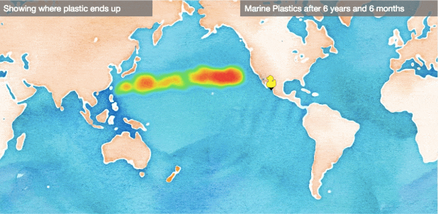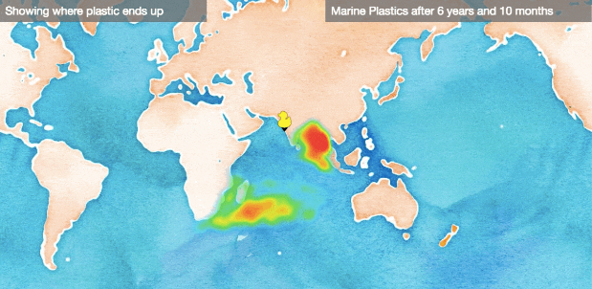
Fig. 1. Left: Screenshot of model illustrating where plastic ends up when dropped off the coast of China; Right: Where plastic ends up when dropped off the coast of Mumbai (Evan, 2017).
For instance, in figure 1, the image on the left shows that when a bottle is dropped off the coast of China near Shanghai it is likely to be carried by the North Pacific Gyre towards the east where it will end up a few hundred miles off the coast of the US. The image on the right demonstrates that when plastic is dumped in the ocean around the coast of Mumbai it is likely to be carried close to Madagascar or swept east to the Bay of Bengal by the Indian Ocean Gyre (Evans, 2017).
Massive accumulations of marine plastics also occur in Hawaii thanks to the 6000 mile marine litter corridor known as the 'North Pacific Subtropical Convergence Zone' (Le Guern, 2009). Pichel et al (2007) found evidence of this when conducting aerial surveys north of Hawaii in March and April of 2005, where they observed more than 1800 pieces of debris including 122 derelict fishing nets. Furthermore, they state that between 1996 and 2006 the NOAA recovered around 511 metric tons of fishing gear from the reefs of the Northwest Hawaiian Island Marine National Monument. A report by Eriksen et al (2014) highlighted the true global scale of these sort of mass accumulations of marine plastics by estimating the total number of plastic particles and their weight floating in the world's oceans. By using an oceanographic model of floating debris dispersal which was corrected for wind-driven vertical mixing they were able to estimate a minimum of 5.25 trillion particles weighing 268,940 tons (Eriksen et al, 2014).
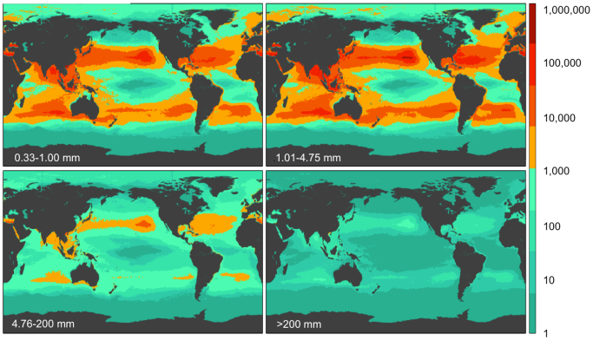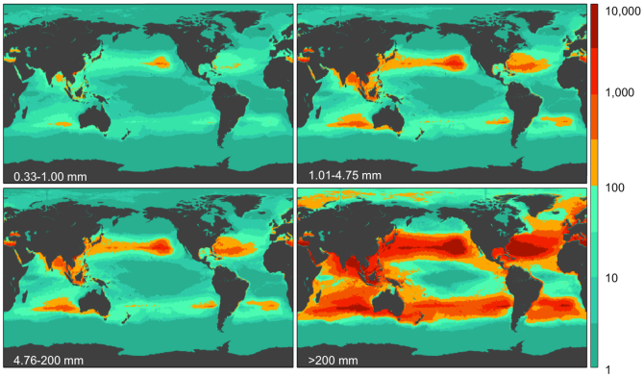
Fig. 2. Left: Global count density of the four size classes of marine plastics from the report; Right: Global weight density of the four size classes of marine plastics (Eriksen et al, 2014).
Interestingly, based on these models, what the report also found was that the total plastic debris originating from Southern Hemisphere oceans are similar to those from the Northern Hemisphere ones. Eriksen et al (2014) go on to state that this is surprising given that inputs of plastics are higher in the northern hemisphere, suggesting that plastic pollution may move more easily between gyres and hemispheres, there may be more sources in the southern hemisphere than previously thought, and there may be additional losses in the northern hemisphere from sinking and degradation of debris. Either way, this report along with the previous examples show the unprecedented levels that marine plastics have reached and that they are accumulating and ruining large portions of the world's oceans.
What issues have marine plastics caused?
As a result of their widespread accumulation and physical properties, marine plastics are the cause of many environmental, social and economical issues. Environmentally, they have significant impacts on marine life and the marine environment. Discarded fishing gear, also known as ghost gear, is a big culprit for entanglement and suffocation of marine animals, with more than 640,000 tons being left in oceans globally each year (Surfers Against Sewage, 2014). Additionally, ingestion of plastic debris is also a big killer for marine life, with both plastic bags and fragments being confused for food which can cause suffocation by blocking windpipes, and starvation by blocking the digestive tract and filling the stomach (Le Guern, 2009). In total, at least 267 different animal species have suffered from entanglement and ingestion of plastic debris, where according to the website 'Clean Water Action' 86% of all sea turtle species, 44% of all sea bird species, and 43% of all marine mammal species have been impacted in some way (Le Guern, 2009). For instance, Copello and Qunitana (2003) evaluated the presence of marine debris in the diet of Southern Giant Petrels along the Patagonian Coast. They found that around 73% of the food samples contained marine debris, with plastics being the most frequent item at around 66%. They determined these plastics in their diet were highly likely to come from the fishing activities in the area as there is spatio-temporal overlap with said activities and the range in which these birds travel over the Patagonian shelf during breeding season.
When consumed, plastics also have the capability to introduce the chemical additives present in them into the marine food web. This is particularly worrying as these chemicals can bio-magnify, increasing the further up the food chain they get. According to a report by Katsuhiko Saido at the 238th National Meeting of the American Chemical Society, marine plastics are actually able to decompose at lower temperatures than what was once thought, causing the release of their toxic substances into the water, including Biphenyl A and PS Oligomer (Le Guern, 2009). This environmental impact can also effect society as some of these substances are endocrine disrupting chemicals (EDCs), which are believed to block endogenous steroid hormones from binding to receptors whilst also altering their metabolism (Harse, 2011). Harse (2011) goes on to state that EDCs can alter gene expression in cells, contribute to the development of cancer, reduce human sperm counts, cause periodic increases in the frequency of developmental normalities in the male reproductive tract and also cause the onset of puberty in females prematurely.
Marine plastics also have aesthetic consequences to the environment, particularly when washed ashore. One example of this would be the increasing levels of mermaids tears that find their way back to our shores. These are essentially tiny plastic particles, which can be thinner than the diameter of human hair, that result from the fragmentation of larger pieces with the effect of U.V. degradation and weathering processes (Le Guern, 2009). Recently, large volumes of these plastic nurdles have ended up washing ashore on the beach of Freshwater West in Pembrokeshire, Wales. These were observed by a National Trust employee, Rhian Sula who had to organise a mass clean-up of them that took place on the 7th of January. Figure 3 shows another example of the impacts that marine litter has on a coastal area; the Bay of Bengal, which is one of the most polluted locations on the planet. The photograph on the left shows a rubbish dump in Chennai contaminated with chemicals from the plastics left there. This toxic water finds its way into Buckingham Canal where it is discharged into the Bay of Bengal, affecting the fish that is then caught and sold in the markets in the area. The photograph on the right shows the extent to which litter is both washed ashore and dumped intentionally in the Bay of Bengal, and thus either finds its way back out to sea or remains there uncollected. Plastic debris such as this not only acts as an eyesore, but also has severe economic implications both in the form of the costs associated with cleaning it up and the loss of revenue for the tourism industry. For instance, according to Pichel et al (2007), the economic loss of commercial fish caught in ghost nets, the amount of money and time it takes to rescue vessels damaged by marine litter, the loss of endangered species and rare coral, along with the cost of cutting nets by hand from reefs equates to millions of dollars a year in the United States alone.
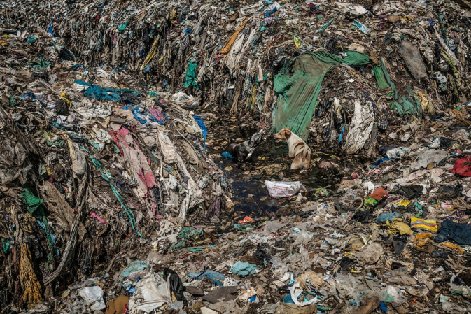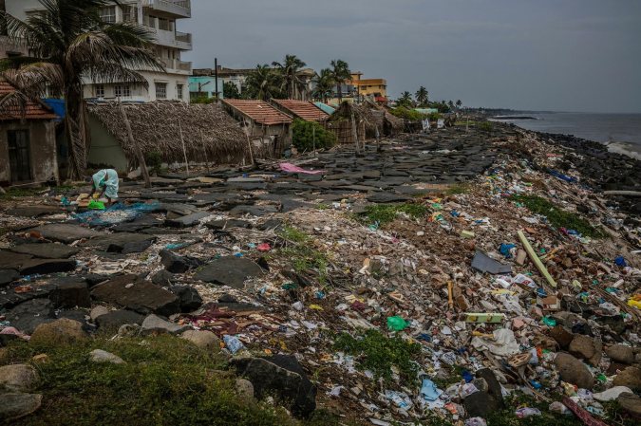
Fig. 3. Photographs by Jacques de Lannoy depicting the extent of marine litter and pollution that has accumulated in the Bay of Bengal, India. Left: Picture of contaminated water in a rubbish dump which has been polluted by chemicals from plastics; Right: Masses of uncollected rubbish along the coastline (The Guardian, 2017).
How Can the Problem be Solved?
Therefore, with so many detrimental impacts, this is an issue that needs to be solved. However, that is far easier said than done, and will require radical measures to be taken by individuals, businesses, and governments to combat it. The Surfers Against Sewage report (2014) calls for a 50% reduction in UK beach and coastal litter by 2020 and suggests some personal, industrial, and legislative measures that can be taken to remedy the problem. For instance, they aim to promote personal responsibility and action. They intend to do this through their view that the 'surfer' is someone who can influence the masses to adopt the sustainable 'surfer' lifestyle. By utilising the diverse mix of people and occupations present in the surfing community they believe they can push this change in attitude. The report states that this process begins with the 'innovators', which are hardcore surfers that start to spread the message that then reaches the 'connectors', who deliver the message of sustainability in a more digestible form. The 'early majority' will then start to adopt the anti-littering message, then be followed by the 'late majority' who participate when the message is cemented in the mainstream. The charity also does a lot of beach clean work, with the aims of mobilising 25,000 volunteers and to deliver at least 1000 beach cleans annually by 2020 (Surfers Against Sewage, 2014). It is through litter picking and mass beach clean ups such as these that are some of the most accessible management methods available to the individual person.
Industry has a main role to play in reducing the level of marine litter, where at each part of the production cycle, businesses should be held accountable for their impacts on the environment and that they should be working towards cutting down their waste drastically to close the loop on litter (Surfers Against Sewage, 2014). This philosophy is known as 'Extended Producer Responsibility' and will help to limit the level of waste entering the environment from its true source (Le Guern, 2009). Recently, the supermarket 'Iceland' has become the first of its kind to go 'plastic-free' and is a prime example of this policy. The company has decided to implement this strategy on its own-brand products, with the hopes of eliminating plastic-packaging on all of them by 2023 (Beament, 2018; BBC News, 2018). Iceland has so far removed all plastic straws from its own label ranges and new food ranges introduced from this year onwards will use paper-based food trays (Beament, 2018). Hopefully, bold moves made by companies like this will have a big influence on the way industry will operate with regard to their waste management in the future.
Legislation is another key factor in addressing this difficult issue and can be used to guide the practices of both individuals and companies through both incentives and penalties. There are many examples of somewhat effective previous legislation that has been implemented to limit the levels of litter and plastics entering our oceans. Perhaps one of the biggest and most important ones is the 'International Convention for the Prevention of Pollution from Ships (MARPOL 73/78) which came into effect on October 2nd, 1983. Annex V of the convention deals with the different varieties of waste, particularly with regards to how they should be disposed of. What makes this piece of legislation so important is the fact that it completely bans any forms of plastic from being dumped into the ocean by vessels (Harse, 2011). However, Harse (2011) goes onto state that there are some limitations with it though, including the fact that it is difficult to determine which nation has jurisdiction to prosecute any violators of the act, which comes down to three potential parties; the flag state, the port state, and the coastal state. This along with the fact that there are large differences among individual nations abilities to enforce the requirements of MARPOL 73/78, mean that it is often hindered.
One of the main issues that has been identified for previous legislation is that it often has a focus on the dumping of waste at sea as opposed to the land, which is host to the most significant sources of marine pollutants (Harse, 2011). In the UK, there are hopes to address this, particularly with the recently announced long-term strategy to eradicate all avoidable plastic by 2042. The strategy, which was introduced by Theresa May this year, involves the encouragement of supermarkets to introduce 'plastic-free' isles, looking into taxes on single-use items, extending the 5p charge on plastic carrier bags, funding plastic innovations, and committing to helping developing nations tackle pollution (BBC News, 2018; Walker, 2018). However, this plan has been met with scepticism by green experts and opposing groups including Greenpeace, The Wildlife Trusts, and the Labour Party due to its lengthy timescale, vague aims and lack of legal underpinning (Gabbatiss, 2018). These concerns have been exacerbated due to the fact that less than a week later, government budget cuts to the Waste and Resources Action Program (WRAP), who were put in charge of exploring the idea of plastic-free supermarket isles, has led to them making 25 redundancies, which in turn has put the proposal in jeopardy (Vaughan, 2018). This demonstrates that when using legislation to tackle marine litter, strategies need to be ambitious whilst also having significant funding and backing behind them to be effective.
Conclusion
To conclude, marine litter is truly one of the most prominent global issues today, with seemingly never-ending sources, spreading harmful plastics across great distances to all corners of the earth. The issues associated with it are not only harmful to the environment, but also to both society and the economy. Each of these factors make it an issue that requires urgent attention, where individuals, businesses, and the world's governing bodies will need to make radical changes to the way they operate in order to have any effect. Provided that individual people lead their lives with sustainability in mind, businesses take responsibility for the materials they use and the items they make, and the world's governments introduce ambitious legislation, putting the environment at the forefront of their future policies with dedicated financial backing, the scourge of marine plastics is an issue that can be overcome.

References
BBC News (2018). Iceland aims to be plastic free by 2023. [online] BBC News. Available at: http://www.bbc.co.uk/news/business-42692642 [Accessed 20 Jan. 2018].
BBC News (2018). May defends 'long-term' green plan. [online] BBC News. Available at: http://www.bbc.co.uk/news/science-environment-42651480 [Accessed 20 Jan. 2018].
BBC News (2018). 'Mermaids' tears' washed up in storm. [online] BBC News. Available at: http://www.bbc.co.uk/news/uk-wales-south-west-wales-42586220 [Accessed 18 Jan. 2018].
Beament, E. (2018). Iceland becomes first supermarket to go 'plastic-free' for own brand products in landmark announcement. [online] The Independent. Available at: http://www.independent.co.uk/news/business/news/iceland-plastic-free-packaging-own-brand-products-recycling-pollution-environment-a8161081.html [Accessed 20 Jan. 2018].
Casson, L. (2017). How does plastic end up in the ocean? | Greenpeace UK. [online] Greenpeace UK. Available at: https://www.greenpeace.org.uk/plastic-end-ocean/ [Accessed 8 Jan. 2018].
Clean Water Action (2018). The Problem of Marine Plastic Pollution. [online] Clean Water Action. Available at: https://www.cleanwater.org/problem-marine-plastic-pollution [Accessed 16 Jan. 2018].
Copello, S. (2003). Marine debris ingestion by Southern Giant Petrels and its potential relationships with fisheries in the Southern Atlantic Ocean. Marine Pollution Bulletin, 46(11), pp.1513-1515 [Accessed 18 Jan. 2018].
Eriksen, M., Lebreton, L., Carson, H., Thiel, M., Moore, C., Borerro, J., Galgani, F., Ryan, P. and Reisser, J. (2014). Plastic Pollution in the World's Oceans: More than 5 Trillion Plastic Pieces Weighing over 250,000 Tons Afloat at Sea. PLoS ONE, 9(12), p.e111913.
Evans, A. (2017). If you drop plastic in the ocean, where does it end up?. [online] the Guardian. Available at: https://www.theguardian.com/environment/2017/jun/29/if-you-drop-plastic-in-the-ocean-where-does-it-end-up [Accessed 8 Jan. 2018].
Harse, G. (2011). Plastic, the Great Pacific Garbage Patch, and International Misfires at a Cure. UCLA Journal of Environmental Law and Policy, [online] 2(29). Available at: https://cloudfront.escholarship.org/dist/prd/content/qt4pp84809/qt4pp84809.pdf [Accessed 14 Jan. 2018].
Jambeck, J., Geyer, R., Wilcox, C., Siegler, T., Perryman, M., Andrady, A., Narayan, R. and Law, K. (2015). Plastic waste inputs from land into the ocean. Science, 347(6223), pp.768-771 [Accessed 17 Jan. 2018].
Le Guern, C. (2009). Plastic Pollution | Coastal Care. [online] Coastalcare.org. Available at: http://coastalcare.org/2009/11/plastic-pollution/ [Accessed 10 Jan. 2018].
Pichel, W., Churnside, J., Veenstra, T., Foley, D., Friedman, K., Brainard, R., Nicoll, J., Zheng, Q. and Clemente-Colón, P. (2007). Marine debris collects within the North Pacific Subtropical Convergence Zone. Marine Pollution Bulletin, 54(8), pp.1207-1211 [Accessed 17 Jan. 2018].
Surfers Against Sewage (2014). Marine Litter Report. [ebook] Cornwall: Surfers Against Sewage. Available at: https://www.sas.org.uk/wp-content/uploads/SAS-Marine-Litter-Report-Med.pdf [Accessed 10 Jan. 2018].
The Guardian (2017). Plastic pollution blights Bay of Bengal – in pictures. [online] the Guardian. Available at: https://www.theguardian.com/global-development/gallery/2017/mar/02/plastic-pollution-blights-bay-of-bengal-in-pictures [Accessed 10 Jan. 2018].
Vaughan, A. (2018). 25 staff laid off at agency key to May's plastic reduction pledge. [online] the Guardian. Available at: https://www.theguardian.com/environment/2018/jan/17/25-staff-laid-off-at-agency-key-to-mays-plastic-reduction-pledge [Accessed 20 Jan. 2018].
Walker, P. (2018). Theresa May proposes plastic-free supermarket aisles in green strategy. [online] the Guardian. Available at: https://www.theguardian.com/environment/2018/jan/10/theresa-may-proposes-plastic-free-supermarket-aisles-in-green-strategy [Accessed 20 Jan. 2018].
Western Telegraph (2018). 'Mermaid's tears' blight Pembrokeshire beach. [online] Western Telegraph. Available at: http://www.westerntelegraph.co.uk/news/15810976.mermaids-tears-blight-pembrokeshire-beach/ [Accessed 18 Jan. 2018].
Winn, P. (2016). 5 countries dump more plastic into the oceans than the rest of the world combined. [online] Public Radio International. Available at: https://www.pri.org/stories/2016-01-13/5-countries-dump-more-plastic-oceans-rest-world-combined [Accessed 17 Jan. 2018].

