
Name: Milena Mirek
Student ID: 2505642
Module Code: BMHP5016
Module: Principles of Health and Social Care Practice
Lecturer: Robert Nartowski
Assignment title : Written Assignment (Reflective Report)
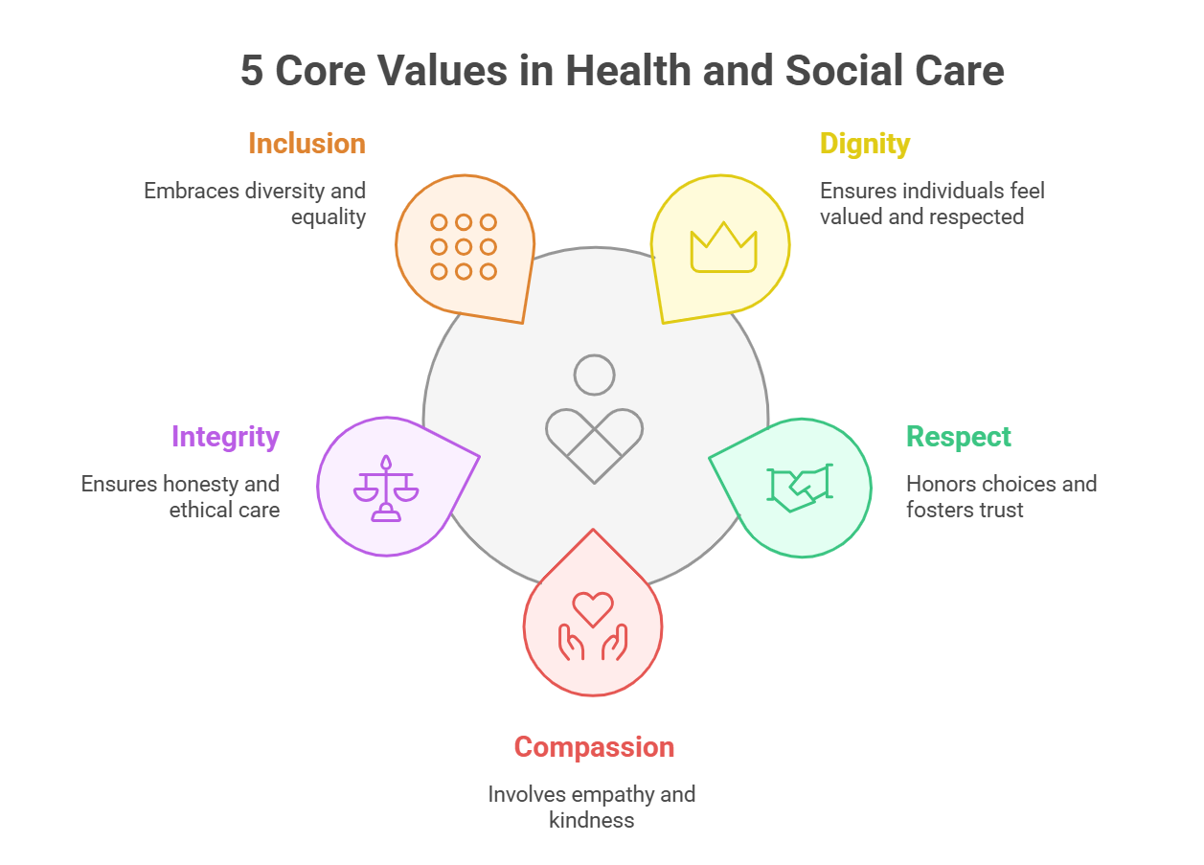

TABLE OF CONTENTS
1.Tatle Page………………………………………………………1
2.Table of contents…………………………………………………………2
3. Introduction/ TASK 1: REFLECTION ON THE IMPORTANCE OF PRINCIPLES OF HEALTH AND SOCIAL CARE…………………………………….3
4. TASK 1: REFLECTION ON THE IMPORTANCE OF PRINCIPLES OF HEALTH AND SOCIAL CARE………………………………………………………………………..4
5.Partnership working/Ethical/ TASK 1: REFLECTION ON THE IMPORTANCE OF PRINCIPLES OF HEALTH AND SOCIAL CARE………………………………………………………5
6. TASK 1: REFLECTION ON THE IMPORTANCE OF PRINCIPLES OF HEALTH AND SOCIAL CARE…………………………………………………………………………..6
7. TASK 3: SELF REFLECTION AS A HEALTH AND SOCIAL CARE PROFESSIONAL…………………………………………………………………………..7
8.Task 3/ Conclusion……………………………………………………………………………….8
9. Reference List………………………………………………………………..9

Principles of Health and Social Care: Person Centred Care, Partnership Working and Ethics.

Introduction
Health and social care practice in the UK is based on principles that promote dignity, wellbeing, safety and respect for individual rights, and independence , there are three important principles which are person centred care , partnership and ethical practice, these are connected because effective care requires professionals to understand individual’s needs. Help people in decision making and communicate with other professionals and making decisions that respect rights and wellbeing.
The care act 2014 places individual wellbeing at the centre of adult care. Wellbeing includes personal dignity, physical and mental health, protection from abuse and neglect, control from day-to-day life, relationships and participation in work and as well education and training needing, (care act, 2014). Person centre care is also regulation 9 of the health and social care act 2008. Which care and treatment meets people needs and reflect their preferences. This assignment will show the importance of person centred cared, partnership working and ethical practice, this will be applied to Joans case to consider their importance and development in health and social care.

TASK 1: REFLECTION ON THE IMPORTANCE OF PRINCIPLES OF HEALTH AND SOCIAL CARE,
Person-Centred care
Person-centred care teach to treat each individual as a unique person rather than focusing only on a medical condition or care requirement, to consider a person needs usually that involves professional, preferences, values, circumstances and individual goal when delivering care, this kind of approach can help in improving the quality of care because support is treated individual rather than based on a standard approach. The Care Quality Commission states the person centre care should be appropriate, meets people needs and reflect on the preferences, A people should always be involved and have access in the planning and management of review of their care and treatment.
CQC, 2025 (Care Quality Commission) this shows that individuals should never be treated as passive instead they should be always involved in decision making. The Care Act 2014 also supports person centred approach by establishing a duty to promote individuals wellbeing. The Act states that the individuals are better with judge their own wellbeing, wishes, and feelings. Person centre care can be linked with Maslow Hierarchy of needs. Maslow (1943) propose that human needs, Maslow’s shows that humans’ needs are big part of physiological needs, safety, love, and belonging, esteem and self-actualisation. Maslow’s theory demonstrates how important it is to consider the different of people aspects of life, for example a person treated for physical condition may also feel loneliness, anxiety or stop being energetic. It’s better to address wider emotional and social needs to improve person wellbeing, as Maslow’s develop the theory in the mid-20th century to explain human motivation, he also explains in his pyramid of needs that physiological needs are only fundamental survival requirements such as food, water, shelter and sleep, in the Safety needs, things like Security, stability health and protection from harm, in the Love and belonging he explains that we need social connection such as family, friends, and being accept by the group, for Esteem needs : Self-respect , confidence, recognition and sense of achievement.
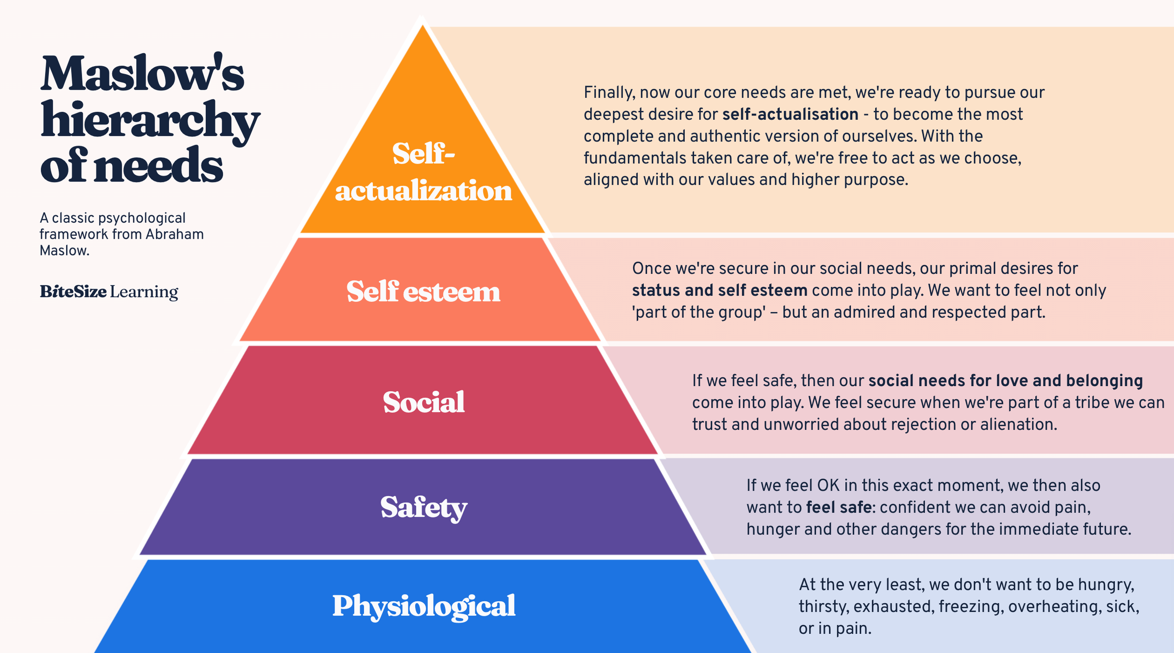


PARTNERSHIP WORKING
Partnership working involves individuals, health professionals, social care, Organisations, Families and carers working together where appropriate to achieve positive outcomes, Health and social care requirements are often complex, so no single professional has all the knowledge or resources needed to deliver full support.so for example, one person could receive help from a GP, Nurse, social worker, or therapist and some other specialist. The communication between all of them are very important and have big impact to understand correctly and care is well-co-ordinated.

ETHICAL PRACTICE
Ethical practice allowed making decisions that respect people rights, dignity, choices and wellbeing, the most important ethical principles include autonomy, beneficent, non-maleficence and justice. Autonomy shows to respect a person right to make a decision about their own life and care when they can do so, Beneficence involves acting to promote wellbeing. While non involves avoiding unnecessary harm. Justice concerns fairness and ensuring that individuals are treated equitably. Consent is an important part of ethical practice. Regulation 11 of the Health and Social care act 2008 (regulated activity) Regulations 2014 shows that people who receiving treatment should place and provide consent before care or treatment is provide, it is relevant to legal exceptions (CQC,2025).

TASK 1: REFLECTION ON THE IMPORTANCE OF PRINCIPLES OF HEALTH AND SOCIAL CARE Joan’s Story
Joans case shows a clear example of how person centre care, partnership working and ethical practice can be applied within the health and social care settings. Joan has Chronic Obstructive Pulmonary Disease (COPD), which is basically stopping her to manage her symptoms and stopping her from doing the activities she enjoys and would like to do, she have difficulties to attend appointments, harder with following professional advice and managing her condition, she also attend many emergency hospital admission, NHS England case study explains that Joans initial patient activation measure showed an activation level of one , including a very low confidence and ability to manage her own health (NHS England,n.d).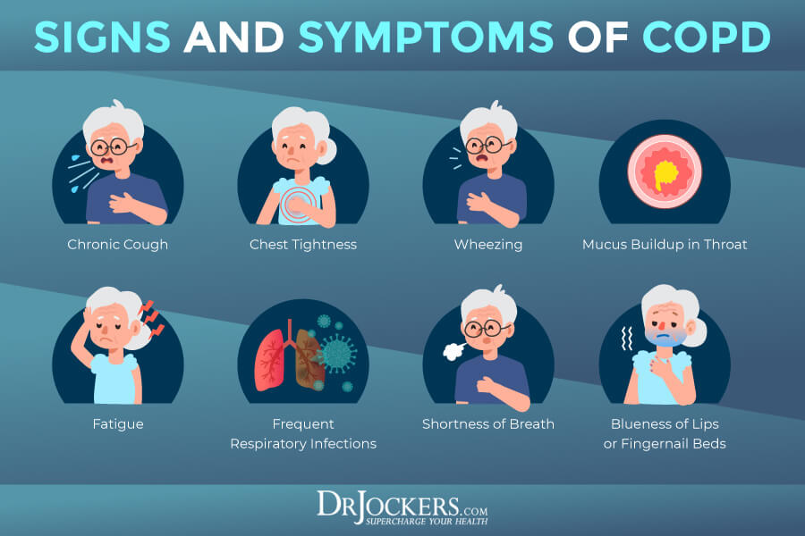
Person-centred care was put into practice when staff identified barriers stopping Joan from engaging with healthcare. Instead of only assuming Joan was simply unwilling to follow advice, the therapy team explain the reason behind her health condition. Weekly review session gave Joan space to discuss issues affecting her health and appointment attendance. Those conversations show that uncontrolled Joan disease was one key barrier and mostly bowel related symptoms made Joan feel unable to leave her home. This marks the importance of assessing the individual rather than focusing only on their primary condition, Joan’s physical health, self-confidence, daily routines and circumstances all affected how well she could engage with treatment. This approach was especially with person cared principles, as care plans was made on her individual needs. Regulation 9 of the CQC requirements states that care must be tailored to individual needs and preferences, and that people should be always included in panning and reviving their own support (CQC,2025). This case also shows how strong is the partnership working in action. Joan joined weekly meetings with the therapy team, so professionals could focus on her identify barriers and create an action plan. Big part was playing also her GP as he was also helping manage the disease, this all show how well all the sectors within health and social care collaborate when it comes to person care. Partnership working was essential here, because focusing only on COPD would not have solve Joan’s difficulties. Better management and communication resolve the key barriers of her symptoms that stopped her from leaving home and attending appointments. The Ethical principle of autonomy is also visible in how Joan contributed to her action plan. She was given space to explain her difficulties and challenges to help get the right solution instead of professionals telling her what to do. Respecting autonomy means recognising an individual’s right to take part in decisions about their care provided they have the capacity to do so. This way of treating Joan respected her dignity. Instead of judging and saying she was not following advice on purpose, staff looked at why she had missed appointments and struggled with her care. This matters because if people feel judged, they may lose confidence and stop asking for help.

TASK 3: SELF REFLECTION AS A HEALTH AND SOCIAL CARE PROFESSIONAL
Person-Centred care, partnership working and ethical practice are important foundations for professionals developing within health and social care, the professionals need to understand that effective practice involves more than completing practical tasks. It also requires effective communication, respect for individual rights, responsibility, teamwork and keep learning. One of the most important key for care works is good communication. When the communication is well, people are most likely to trust us and tell us what they need, what they prefer, what are their worries and what kind of solution they would like to achieve, we need to change how we speak to suit every different person to understand their situation, for example, hard to use medical words can confuse people who do not know much about health , so we should explain the information simply, so people can understand what choices they have, Listening is another important skill. Care that focused on the person means we try to understand what matters most to them, instead of guessing what is wrong, Joan’s story shows this clearly, when staff asked why she was missing so many appointments they found out about her Crohn’s disease was a big problem for her. If they haven’t spoke to her or listen to her they might never find out about this issue. We also need to respect people dignity and help them stay independent as possible, we should support people to do things for themselves where we can, we should only step in when we really have to, and avoid stepping in things they can still manage, making people feel independent helps them being more confident and keep control over their daily life. The care act 2014 says being able to control your day-to-day life is part of people’s wellbeing. This means care work is not just about finishing task quickly. We also need to let people have their own chances to make decisions and be a part of their care plan. Working with people is another skill for care workers. Health and social care teams have many different professionals, who need to share useful information in the right way. For example, if someone mood change or the health we need to inform other team to get the right help. Working together is very important, and it is a big part with working with patient who receiving the care and their family, but we can not share private information with anybody unless we have to do it by law or with the person agreement. The Health and Care Act 2022 shows how important it is for health and social services to work together. Different groups of the care try to find out what local people need and plan how to help them. Which shows the care is much better when working in teams. Another key of the job is making good, fair choices, care workers think about four main things: letting people chose for themselves, doing good, avoiding problems and harms, and being fair. For example, if someone refuse the treatment we offer instead of thinking they are making a mistake, we need to make sure they have all the fact they need and help them to make a choice they understand. Getting permission for care is very important too. The CQC says we must have people’s agreement before we give them care or treatment, and workers must follow the law (CQC, 2025). Workers also need to know about mental capacity act 2005, which helps when people find it hard to make certain decision for themselves. Keeping people safe is another big part of care work. Care workers need to be very careful as they have to spot when someone is hurt, neglected or taken advantage of, and follow the right steps to help them. The Care Act 2014 says being safe from harm is part of people wellbeing. People learning to work in health and social care need to keep learning see where to get better, follow rules and lows, its never to only relay on what we learn in UNI. To learn and improve the training should be provided, meetings with supervisor, asking for feedback from others, think about the work, reading as much as possible new information’s, also confidence will help when dealing with difficult things happen. Care workers face sometimes strong disagreements, hard choices to make, worried about people safety or people who are upset. While talking with supervisor and following good guidance help us deal with these situations safely. It is also important to understand and respect different cultures and treat everyone equally. Many people come from different backgrounds and may have different ideas about health and care. We should never judge and follow any stereotypes and only focus on providing the care the person needs. Care work should be respectful welcoming and fair to everyone. We should see the person first and their needs not the illness only. Overall care workers need to keep learning and thinking about their work. Care that shapes how we talk to people and how we let them join decisions.

CONCLUSION
In UK health and social care, person centred care, teamwork and good ethical practice are key. Workers must treat everyone as an individual, support joint working between services, and respect people’s right and choices. Joan’s case shows how this work, finding what stopped her using service, planning support together and team work improved her confidence and attendance, Laws such as the Care Act 2014 and health and care act 2022 guide this work, good care means listening, collaborating and keeping learning to support people well.

REFERENCE LIST
1.Care Act 2014 (c.23)/London: The Stationery office. Available at: Legislation.gov.uk-Care Act 2014 (Accessed: 8 October 2026).
2. Care Quality Commission (CQC) (2025) Regulation 9: Person-centred care. Available at: CQC- Regulation 9 (Accessed: 8 October 2026).
3.Department of health and social care (DHSC) (2025) care and support statutory guidance. Available at: GOV.UK-Care and support statutory guidance (Accessed 8 October 2026).
4. Equality Act 2010 (c.15). London: the stationery office. Available at: Legislation.gov.uk-Equality Act 2010 (accessed 10 October 2026).
5. Mental Capacity Act 2005 (c.9). London: The Stationary Office. Available at: Legislation.gov.uk-Mental Capacity Act 2005 (Accessed 10 October 2026).
6. Maslow, A.H. (1943) ‘A theory of human motivation’ Psychological Review, 50(4),pp.370-396.
7. National institute for health and care excellence (nice) (2021) Patient experience in adult NHS services: improving the experience of care for people using adult NHS services (CG138). Available at: NICE-Patient experience in adult NHS services (accessed 21 October 2026).
8. NHS England (n.d.) About shared decision making. Available at NHS England -shared decision making (Accessed 21 October 2026).
9. NHS England (n.d.) Joan’s story. Available at: NHS England -Joan’s Story (Accessed 21 October 2026).
10. Department of health and social care (DHSC) (2023) The NHS Constitution for England. Available at: GOV.UK – NHS Constitution for England (Accessed 21 October 2026).
11. Bitesize Learning (n.d.) Maslow’s hierarchy of needs theory. Available at: https://www.bitesizelearning.co.uk/resources/maslows-hierarchy-of-needs-theory (accessed: 21 October 2026).
12. Celestine, N. (2025) Abraham Maslow, his theory and contribution to psychology. PositivePsychology.com. Available at: https://positivepsychology.com/abraham-maslow/ (accessed at 21 October 2026).
13. Jockers, D. (n.d.) COPD: Symptoms, Causes and Support Strategies. DrJockers.com. Available at: Https://drjockers.com/copd/ (accessed: 21 October 2026).

