
Applied Leadership and Management in the Workplace
Module Assignment Submission
Student Name: | Jonathon Forshaw
Student Number: | 2238303
Module No: | BMSK5012
Module Title: | Understanding & Engaging in the Customer Experience

Statement of Confirmation of Authenticity
By the act of making this submission, the student declares that this is the work of the student named above. The work has not, in whole or in part, been knowingly presented elsewhere for assessment, or where assessment has been built on a previous assessment, this has been identified. Where materials have been used from other sources it has been properly acknowledged. If this statement is untrue, the student acknowledges that an assessment offence has been committed.
Attention is drawn to the plagiarism and unfair practice policies of both the University and of ILM.

Table of Contents
Introduction 4
Main Findings 5
Quality Management Processes 7
Provide a framework for establishing a knowledge management culture 9
Conclusion 11
Quality Management and Customer Experience 11
Impact on Customer Relationships 12
Continuous Improvement and Its Role in CX 13
Building a Customer-Centric Culture 13
Long-Term Benefits of Quality Management 13
Conclusion 14
References 14
Appendices 16

Introduction

Delivering an outstanding customer experience (CX) has become a vital factor for organisations in today's fiercely competitive marketplace. Meeting and surpassing client expectations not only leads to customer happiness but also cultivates loyalty and advocacy, ultimately adding to a company's enduring prosperity. To attain such a high degree of customer satisfaction, one must possess a profound comprehension of consumer requirements and a steadfast dedication to excellence at every interaction.
In this paper I will analyse the crucial correlation between quality management procedures and customer experience. Through an analysis of prominent models and ideas such as Six Sigma, Total Quality Management (TQM), and Deming's principles, we will demonstrate how these frameworks can improve the customer experience (CX). In addition, we will explore the complexities of customer relationship management, with a specific focus on the customer lifecycle, customer value, and the significance of expectation management. The purpose of this analysis is to offer practical insights and suggestions for organisations who want to use quality management to enhance their customer experience and gain a competitive advantage in their industry.

Main Findings
Relationships with Customers
Establishing strong ties with one's clientele is absolutely necessary in order to achieve success in business in today's sector, which is marked by intense competition. A comprehensive understanding of the customer lifetime, the provision of exceptional value, the management of expectations, the cultivation of loyalty, and the prioritisation of customer centrality are all necessary components of effective client connection management. According to Kotler and Keller (2016), businesses that prioritise these elements can increase customer satisfaction and create long-term loyalty from their clientele. The purpose of this section is to investigate each of these components and provide insights into the ways in which they contribute to an exceptional customer experience (CX) and overall business performance (Gronroos, 1990).
Lifecycle of the Customer
When it comes to recognising and maintaining client connections, it is essential to take into account the stages that a customer goes through during their engagement with a firm, beginning with the initial contact and continuing through the post-purchase conversations. Continuous engagement and the provision of value can be ensured by gaining an understanding of the client lifetime and properly supervising it. This includes the stages of client acquisition through client retention. The phases of the consumer lifetime that are most important are the phases of awareness and acquisition, engagement and retention, and loyalty and advocacy.
According to Kotler and Keller (2016), during the awareness and acquisition stage, firms employ tactics such as targeted marketing and superior value propositions in order to attract prospective clients. According to Lemon and Verhoef (2016), the engagement and retention stage is characterised by the fact that continuous relationships are maintained through the provision of personalised experiences and the maintenance of consistent quality. Customers who are pleased with the company's products or services become brand advocates at the final stage, which is known as the loyalty and advocacy stage (Reichheld, 2003). These customers actively represent the company to others. In order to achieve organic growth and long-term success, it is essential to transform delighted customers into champions for the brand.
Profitability for the Consumer
For the purpose of maintaining a competitive advantage, it is vital to guarantee exceptional value. Specifically, this requires successfully communicating to customers the benefits and distinguishing characteristics of the items and services that are being offered (Porter, 1985). By consistently gathering feedback and changing offerings to suit the expectations of consumers, it is possible to ensure that the value proposition continues to be relevant and appealing (Parasuraman, Zeithaml, & Berry, 1988). To increase customer satisfaction and loyalty, businesses should consistently provide items or services that are of high value to their customers. In a market that is constantly changing, businesses may ensure that they continue to be relevant and appealing by ensuring that their products and services are in line with the ever-changing requirements and preferences of their clients.

Management of the Expectations of Customers
In order to effectively manage the expectations of consumers, it is necessary to communicate honestly about the capabilities and limitations of the product, to fulfil promises on a consistent basis, and to engage in active interaction with customers (Gronroos, 1990). According to Berry, Parasuraman, and Zeithaml (1988), effective communication makes it easier to develop practical expectations, and maintaining consistency in achieving those expectations makes it easier to build trust and dependability. According to Gustavsson, Johnson, and Roos (2005), developing a relationship with customers can be improved by actively connecting with them, anticipating their needs, and addressing issues before they become more challenging. Businesses are able to lessen the likelihood of their customers becoming dissatisfied and to develop connections that are more robust and trustworthy if they effectively manage their customers' expectations.
Retention of Customers
The implementation of a combination of rewards programmes, targeted interactions, and continuing enhancement is a strategy that may be utilised to foster customer loyalty. According to Sharp and Sharp (1997), businesses have the ability to encourage customers to make repeat purchases and cultivate long-term commitment by creating loyalty programmes that offer tangible benefits to customers. For Peppers and Rogers (1993), a deeper and more substantial link between the customer and the brand may be established through the use of customised interactions. These interactions are specifically built to match the unique preferences and requirements of each individual consumer. An ongoing commitment to incorporate feedback from customers into the development of new products and services ensures that the offerings will continue to be valuable and relevant (Oliver, 1999). This continual conversation with consumers helps to guarantee that the company continues to be sensitive to the requirements of its clients and is able to provide the amount of value that is required.
Putting the Customer First
Integration of the customer into business goals necessitates coordination across a large number of departments and the cultivation of a culture that places the customer at the forefront of priorities. Working together across functional lines makes it easier to integrate all of the departments in order to provide the best possible experience for the consumer (Day, 1994). According to Shah, Rust, Parasuraman, Staelin, and Day (2006), a culture that is customer-centric emphasises the satisfaction of customers as the highest priority and encourages employees at all levels to focus on giving exceptional service. Businesses are able to develop a competitive advantage that will remain for a long time if they incorporate a focus on the requirements and preferences of their customers into the fundamental structure of the organisation. The implementation of this strategy guarantees that every facet of the company is in accordance with the objective of providing excellent client experiences, which in turn contributes to customer pleasure, loyalty, and advocacy.

Quality Management Processes
Quality management processes are crucial for ensuring the consistent delivery of high-quality services by our SEO (Search Engine Optimisation) business to our clients. We improve operational efficiency, service delivery, and customer satisfaction by implementing established quality management frameworks. This section examines prominent quality management models and theories, including Six Sigma, Total Quality Management (TQM), and Deming's concepts, and their potential application in our SEO business, to enhance service quality and enhance the entire client experience.
Iterative Enhancement refers to a software development approach that involves repeatedly refining and improving a system across multiple iterations or cycles (Larman & Basili, 2003).
Models and theories related to quality in SEO
Six Sigma
Six Sigma is a methodology that relies on data analysis to enhance the quality of a process by finding and eliminating flaws and minimising variability (Pande, Neuman, & Cavanagh, 2000). Implementing Six Sigma for us entails:
- Definition: The act of setting unambiguous project objectives and client anticipations.
- Measure: Gathering data on existing performance indicators, such as keyword ranks, website traffic, and conversion rates.
- Perform analysis: To identify the underlying reasons of performance difficulties and pinpoint areas that can be improved.
- Enhance: Creating and executing strategies to resolve identified problems.
- Control: Continuously monitoring the enhancements to guarantee consistent performance over an extended period (Harry & Schroeder, 2000).
Total Quality Management (TQM)
Total Quality Management (TQM) is a comprehensive strategy aimed at achieving long-term success by prioritising customer happiness. The concept highlights the importance of ongoing enhancement, active participation of employees, and a culture centred around satisfying customer needs (Evans & Lindsay, 2014). Within the framework of our SEO company, Total Quality Management (TQM) encompasses:
- Customer Focus: Comprehending and fulfilling customer requirements and anticipations.
- Continuous Improvement: Consistently evaluating and enhancing SEO strategy and techniques.
- Employee Involvement: Promoting the active participation of all team members in quality improvement projects.
- The process approach: This involves optimising SEO procedures to improve efficiency and effectiveness (Oakland, 2014).
Deming's Principles
W. Edwards Deming's ideas promote a methodical approach to enhancing quality and highlight the significance of management in cultivating a quality-oriented culture (Deming, 1986). Key factors that are pertinent to our SEO company encompass:
- Consistency of Purpose: Sustaining a continuous commitment to enhancing quality throughout the long term.
- Adopting a new philosophy: Embracing a proactive approach to ensuring quality and continuously improving.
- Process Enhancement: Consistently assessing and refining SEO methods to minimise fluctuations and enhance results.
- Training and Education: Investing in staff development through training and education is essential for enhancing their skills and knowledge (Deming, 1986).
The Impact of Quality on Customer Experience
Quality management processes have a direct and significant influence on customer experience (CX) in multiple ways:
- Consistency and reliability are achieved by the implementation of high-quality processes, which in turn guarantee the consistent provision of SEO services. This fosters confidence and happiness among clients (Parasuraman, Zeithaml, & Berry, 1988).
- Efficiency and responsiveness are improved by streamlined processes, resulting in faster response times and enhanced client service. This ultimately enhances the overall client experience (Berry, Parasuraman, & Zeithaml, 1988).
- To minimise faults and errors in SEO techniques is to reduce client complaints and enhance satisfaction (Crosby, 1979).
- Quality management facilitates the creation of customised SEO solutions that fulfil individual client requirements, hence improving client contentment and allegiance (Peppers & Rogers, 1993).

Provide a framework for establishing a knowledge management culture
The way in which customers perceive and engage with our organisation is highly influenced by quality management systems, which have a substantial impact on customer experience (CX). Through the establishment of stringent quality standards and the ongoing pursuit of improvement, we are able to increase the quality of the customer experience in a variety of different areas. The execution of this strategy results in improved levels of satisfaction, loyalty, and advocacy. There are a number of different ways in which the quality of our services has a significant impact on the overall experience that our customers have.
Reliability and conformity to standards
The delivery of outstanding services is guaranteed to be consistent and reliable when robust processes are in place. In the context of our search engine optimisation (SEO) company, this implies continuously attaining the intended results, which may include improved search ranks, greater website traffic, and enhanced conversion efficiency. According to Parasuraman, Zeithaml, and Berry (1988), maintaining consistency in service delivery helps to foster client trust by ensuring that we consistently meet the expectations of our customers. When it comes to providing a great experience for customers, trust is an essential component since it guarantees that their requirements will be addressed in a dependable manner.
Efficient and expeditious operation
The use of quality management systems that are streamlined results in improvements to our responsiveness and efficiency. In order to accomplish this, it is necessary to rapidly respond to requests from customers, to provide timely updates, and to promptly execute changes to SEO tactics based on data analysis and input from customers. According to Berry, Parasuraman, and Zeithaml (1988), efficient procedures cut down on waiting times and guarantee that customers receive fast service, which in turn increases the overall happiness of the consumers. We are in a position to provide an amazing experience for our customers because of our capacity to quickly adjust to changes in the algorithms used by search engines or in the requirements of our clients.
Efficient Error Reduction
A better customer experience can be achieved by the effective use of robust quality management practices, which reduces the number of errors and faults. Among the faults that might occur in search engine optimisation are inaccurate keyword targeting, broken hyperlinks, and insufficient content optimisation. Through the mitigation of these flaws, we not only improve the efficiency of SEO efforts, but we also reduce the number of complaints and dissatisfactions that our customers have. Outstanding service is ensured by giving priority to the reduction of errors through continuous improvement and extensive quality checks (Crosby, 1979). This results in an experience that is more positive and smoother.
Individualization and Adjustment of Specifics
The implementation of quality management systems enables the creation of individualised solutions that are suited to the specific requirements of our customers. As part of this process, search engine optimisation tactics are tailored to coincide with the specific goals, industry, and target audience of each individual customer. In accordance with Peppers and Rogers (1993), personalisation improves the relevance and efficiency of search engine optimisation (SEO) activities, hence providing customers with a sense of value and comprehension. By implementing efficient quality management systems, we are able to enhance our capacity to collect and assess client data, which in turn enables us to provide services that are more precisely and significantly customised to address specific needs.
Ongoing and Constant Improvement
The adoption of a mindset that is focused on continuous improvement is critical to the achievement of success in quality management and has a substantial influence on the experience that customers have. According to Evans and Lindsay (2014), continuous improvement is the practice of routinely analysing and altering processes, strategies, and services in order to improve performance and ensure that customers are as satisfied as possible. In the context of our SEO company, this entails maintaining a current awareness of the most recent developments in SEO, honing our keyword tactics, and consistently enhancing the websites of our clients. By implementing ongoing improvements, we guarantee the delivery of first-rate service on a constant basis, which ultimately results in an exceptional experience for our customers.
Establishing a Culture That Is Focused on the Customer
As part of our efforts to integrate quality management methods into our business operations, we must also cultivate a culture that places a premium on the fulfilment of customer requirements and expectations. In order to meet this objective, it is necessary to place the customer at the centre of all strategic choices and to encourage collaboration among all departments in order to enhance the overall customer experience. According to Shah, Rust, Parasuraman, Staelin, and Day (2006), one definition of a customer-centric culture is one that prioritises the satisfaction of customers as the highest priority and encourages employees at all levels to concentrate on providing exceptional service.
Our search engine optimisation company needs to have cross-functional collaboration in order to build a culture that is focused on the customer. This means that teams such as content production, technical SEO, and client management need to work together in order to give services that are seamless and integrated. The cultivation of such a culture enables us to ensure that each and every interaction with the customer is optimised for the purpose of providing a positive experience.
The Advantages of Quality Management Over the Long Term
It is important to highlight that, in the long run, combining strategies for quality management with approaches for conducting interactions with customers can result in significant benefits. We are able to improve both our reputation and the image of our brand if we consistently deliver products and services of the highest quality. When customers are pleased with our services, they are more likely to become passionate advocates for our company, recommending our company to others and contributing to word-of-mouth marketing practices. It is impossible to overstate the importance of organic growth in terms of establishing long-term success and sustainability (Oakland, 2014).
In addition, we are able to keep our competitive edge in a market that is always shifting because we place a strong emphasis on quality control. According to Evans and Lindsay (2014), businesses that place a higher priority on quality and ongoing development are better equipped to successfully meet the ever-increasing expectations of their customers and differentiate themselves from their rivals.

Conclusion

Integrating quality management processes with customer relationship strategies is crucial for enhancing customer experience (CX) in my business. By adopting models like Six Sigma, Total Quality Management (TQM), and Deming's principles, we can improve operational efficiency, reduce errors, and deliver superior value to our customers. These quality management processes ensure consistency, reliability, and continuous improvement, which are vital for meeting and exceeding customer expectations. This approach leads to increased customer satisfaction, loyalty, and advocacy.

Quality Management and Customer Experience
Quality management frameworks such as Six Sigma, TQM, and Deming’s principles provide a structured approach to continuous improvement and customer satisfaction. Six Sigma, with its rigorous, data-driven focus on reducing variability and eliminating defects, helps streamline our processes and achieve higher quality outputs. By defining, measuring, analysing, improving, and controlling processes (DMAIC), we can ensure that our products and services consistently meet customer expectations (Pande, Neuman, & Cavanagh, 2000).
TQM emphasizes a comprehensive approach to quality, involving all employees in continuous improvement efforts and focusing on long-term success through customer satisfaction. TQM principles encourage us to be customer-focused, involve all employees in quality initiatives, and use a process approach to manage and improve operations (Evans & Lindsay, 2014). By fostering a culture of quality and continuous improvement, we can enhance our ability to deliver exceptional customer experiences.
Deming's principles advocate for a systematic approach to quality improvement, emphasizing the importance of management's role in fostering a culture of quality. Deming’s focus on constancy of purpose, adoption of a new philosophy, and continuous improvement of processes is particularly relevant for enhancing CX (Deming, 1986). By adopting these principles, we can create a more consistent, reliable, and customer-focused operation.

Impact on Customer Relationships
Quality management processes directly impact various aspects of customer relationships. Consistency and reliability, driven by robust quality management, build customer trust and satisfaction. When we consistently deliver high-quality products and services, customers develop confidence in our brand, leading to long-term loyalty and advocacy (Parasuraman, Zeithaml, & Berry, 1988). This trust is essential for maintaining strong customer relationships and fostering repeat business.
Efficiency and responsiveness, achieved through streamlined quality management processes, enhance the overall customer experience. In our SEO business, efficient processes mean quicker response times to client inquiries, timely updates on campaign progress, and rapid implementation of strategy adjustments based on data analysis and client feedback. These factors contribute to a positive client experience, as clients feel valued and well-supported (Berry, Parasuraman, & Zeithaml, 1988).
Error reduction is another critical aspect where quality management influences CX. Minimizing defects and errors through robust quality checks and continuous improvement ensures that customers receive products and services that meet or exceed their expectations. In the SEO industry, reducing errors such as incorrect keyword targeting or poor content optimization directly improves campaign outcomes and client satisfaction (Crosby, 1979). A focus on error reduction not only enhances the effectiveness of SEO efforts but also minimizes client complaints, contributing to a smoother, more positive experience.
Customization and personalization, enabled by quality management processes, are vital for delivering tailored solutions that meet specific client needs. In our SEO business, this means customizing SEO strategies to align with each client’s unique goals, industry, and target audience. Personalization enhances the relevance and effectiveness of SEO efforts, making clients feel understood and valued (Peppers & Rogers, 1993). By leveraging quality management frameworks, we can better gather and analyse client data, allowing for more precise and impactful customization of services.

Continuous Improvement and Its Role in CX
Continuous improvement is a cornerstone of quality management that significantly impacts CX. It involves regularly reviewing and refining processes, strategies, and services to enhance performance and client satisfaction. For our SEO business, this could mean staying updated with the latest SEO trends, refining keyword strategies, and continuously optimizing client websites (Evans & Lindsay, 2014). By committing to ongoing enhancements, we ensure that we are always offering the best possible service, which translates into a superior CX.
A commitment to continuous improvement demonstrates to clients that we are dedicated to maintaining high standards and are proactive in adapting to changes and new challenges. This proactive stance helps in building long-term trust and loyalty, as clients recognize our efforts to stay at the forefront of the industry and deliver exceptional results.

Building a Customer-Centric Culture
Integrating quality management processes into our business operations also involves fostering a customer-centric culture. This means placing the customer at the core of all strategic decisions and ensuring that every department within the organization works together to enhance CX. A customer-centric culture prioritizes customer satisfaction and encourages employees at all levels to focus on delivering exceptional service (Shah, Rust, Parasuraman, Staelin, & Day, 2006).
In our SEO business, building a customer-centric culture involves cross-functional collaboration, where teams such as content creation, technical SEO, and client management work together to deliver seamless and cohesive services. By fostering such a culture, we can ensure that every touchpoint with the client is optimized for a positive experience.

Long-Term Benefits of Quality Management
The long-term benefits of integrating quality management processes with customer relationship strategies are significant. By consistently delivering high-quality products and services, we can enhance our reputation and brand image. Satisfied customers are more likely to become loyal advocates, recommending our business to others and contributing to word-of-mouth marketing. This organic growth is invaluable for long-term success and sustainability.
Moreover, a strong focus on quality management helps us stay competitive in an ever-evolving market. As customer expectations continue to rise, companies that prioritize quality and continuous improvement are better equipped to meet these demands and differentiate themselves from competitors.

Conclusion
Incorporating quality management processes into our business operations is essential for delivering an exceptional customer experience. For our SEO company, this means adopting frameworks like Six Sigma, Total Quality Management (TQM), and Deming's principles to ensure consistency, reliability, efficiency, error reduction, customization, and continuous improvement. By focusing on quality, we can build trust, enhance satisfaction, and foster long-term loyalty among our clients, ultimately achieving a sustainable competitive advantage.
The integration of quality management with customer relationship strategies leads to a more customer-centric approach, where every aspect of the business is aligned to deliver superior value to customers. This holistic focus on quality and customer satisfaction not only drives business success but also contributes to a positive and memorable customer experience. In conclusion, quality management is a vital component of our customer experience strategy. By prioritizing quality, we can achieve sustained success, foster loyalty, and maintain a strong reputation in the industry.

References
Berry, L. L., Parasuraman, A., & Zeithaml, V. A. (1988). The Service-Quality Puzzle. Business Horizons, 31(5), 35-43.
Day, G. S. (1994). The Capabilities of Market-Driven Organizations. Journal of Marketing, 58(4), 37-52.
Grönroos, C. (1990). Service Management and Marketing: Managing the Moments of Truth in Service Competition. Lexington Books.
Gustafsson, A., Johnson, M. D., & Roos, I. (2005). The Effects of Customer Satisfaction, Relationship Commitment Dimensions, and Triggers on Customer Retention. Journal of Marketing, 69(4), 210-218.
Kotler, P., & Keller, K. L. (2016). Marketing Management (15th ed.). Pearson.
Lemon, K. N., & Verhoef, P. C. (2016). Understanding Customer Experience Throughout the Customer Journey. Journal of Marketing, 80(6), 69-96.
Oliver, R. L. (1999). Whence Consumer Loyalty? Journal of Marketing, 63, 33-44.
Parasuraman, A., Zeithaml, V. A., & Berry, L. L. (1988). SERVQUAL: A Multiple-Item Scale for Measuring Consumer Perceptions of Service Quality. Journal of Retailing, 64(1), 12-40.
Peppers, D., & Rogers, M. (1993). The One to One Future: Building Relationships One Customer at a Time. Currency Doubleday.
Porter, M. E. (1985). Competitive Advantage: Creating and Sustaining Superior Performance. Free Press.
Reichheld, F. F. (2003). The One Number You Need to Grow. Harvard Business Review, 81(12), 46-54.
Shah, D., Rust, R. T., Parasuraman, A., Staelin, R., & Day, G. S. (2006). The Path to Customer Centricity. Journal of Service Research, 9(2), 113-124.
Sharp, B., & Sharp, A. (1997). Loyalty Programs and Their Impact on Repeat-Purchase Loyalty Patterns. International Journal of Research in Marketing, 14(5), 473-486
Berry, L. L., Parasuraman, A., & Zeithaml, V. A. (1988). The Service-Quality Puzzle. Business Horizons, 31(5), 35-43.
Crosby, P. B. (1979). Quality is Free: The Art of Making Quality Certain. McGraw-Hill.
Deming, W. E. (1986). Out of the Crisis. MIT Press.
Evans, J. R., & Lindsay, W. M. (2014). Managing for Quality and Performance Excellence (9th ed.). Cengage Learning.
Harry, M., & Schroeder, R. (2000). Six Sigma: The Breakthrough Management Strategy Revolutionizing the World's Top Corporations. Currency.
Oakland, J. S. (2014). Total Quality Management and Operational Excellence: Text with Cases. Routledge.
Pande, P. S., Neuman, R. P., & Cavanagh, R. R. (2000). The Six Sigma Way: How GE, Motorola, and Other Top Companies are Honing Their Performance. McGraw-Hill.
Day, G. S. (1994). The Capabilities of Market-Driven Organizations. Journal of Marketing, 58(4), 37-52.
Grönroos, C. (1990). Service Management and Marketing: Managing the Moments of Truth in Service Competition. Lexington Books.
Harry, M., & Schroeder, R. (2000). Six Sigma: The Breakthrough Management Strategy Revolutionizing the World's Top Corporations. New York: Currency.
Evans, J. R., & Lindsay, W. M. (2014). Managing for Quality and Performance Excellence.

Appendices
Customer Value
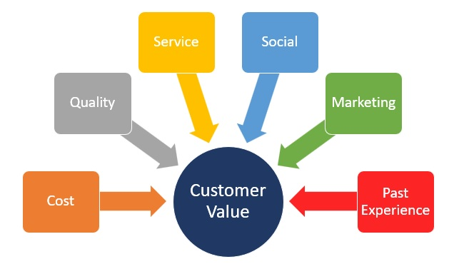
Customer Lifecycle 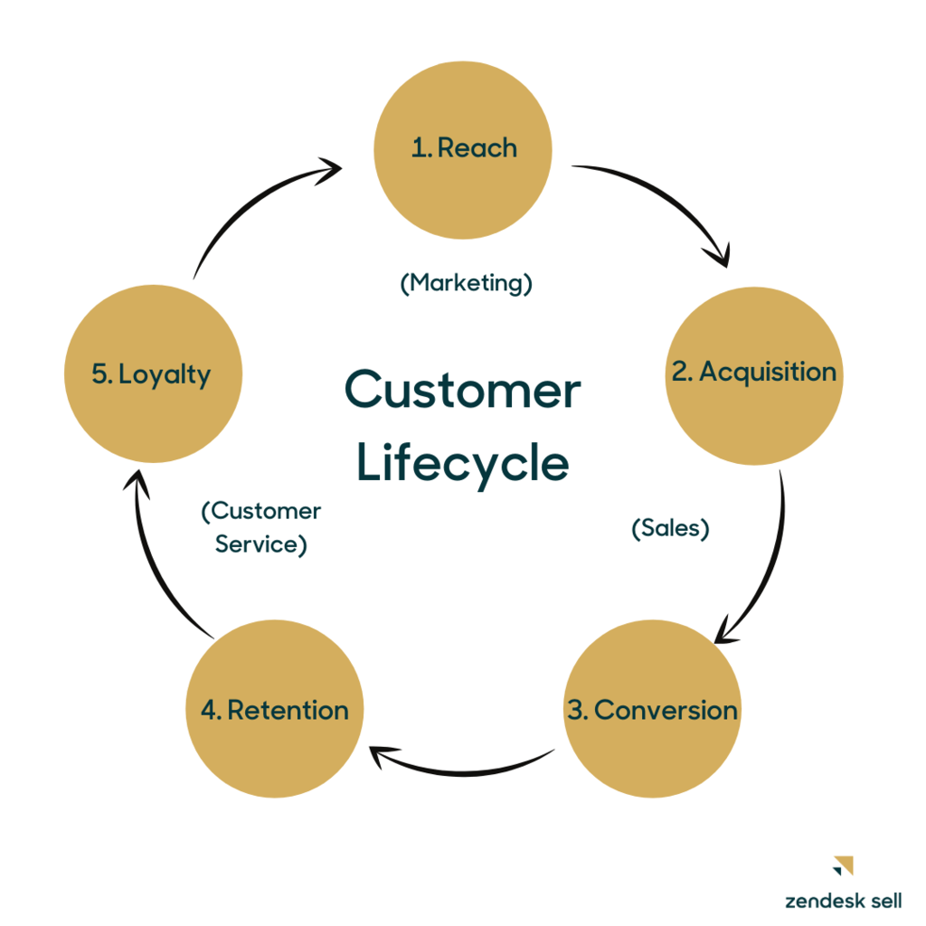
Customer Lifecycle within a CRM Process 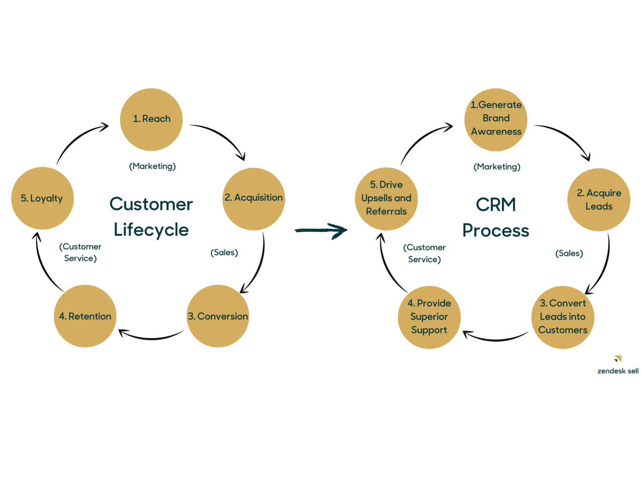
Customer Loyalty

