

LOCATION: Swansea | LLEOLIAD: abertawe
LEVEL 5 | LEFEL 5
EXAMINATION PERIOD | CYFNOD ARHOLIADAU
may 2018 | mai 2018

MODULE CODE: M5X00372
Electrical Principles Theory
TIME: 2 HOURS
answer THREE quESTIONs out of FOUR

Equipment or materials required – Calculator, Ruler, Protractor
Adnoddau neu ddefnyddiau sydd eu hangen - Cyfrifiannell, Ruler, Onglydd

ANSWER THREE QUESTIONS FROM FOUR

- For the circuit shown in Fig Q1, calculate V out, given:
  - C1 = 10µF
C2 = 100µF
V1 = 230V, 50 Hz
[3 Marks]

  - C1 = 10µF
C2 = 100µF
V1 = 230V, 100Hz
[3 Marks]

  - The capacitor C1 has now been replaced with a 100mH inductor. Calculate Vout given:
C2 = 22µF
V1 = 120V 60Hz
[6 Marks]

  - A 10Ω resistor is connected across V out. Calculate the current flowing in the capacitor C2 given:
C1 = 33µF
C2 = 47µF
V1 = 230V, 50Hz
[5 Marks]

Answers should be given in polar form.
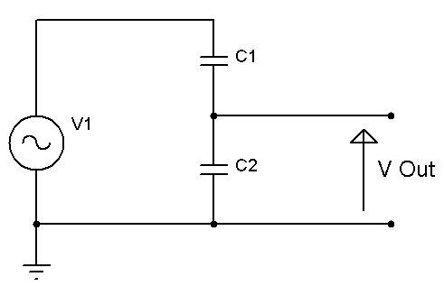
Fig Q1

  - Calculate the power dissipated by the 10Ω resistor connected across V out given:
C1 = 10µF
C2 = 68µF
V1 = 120V, 100Hz
[8 Marks]

  - When a single phase 230V 50Hz motor is running, its DC resistance is 1.2Ω and an inductance of 120mH. Calculate the required shunt capacitance required to correct its power factor to 0.95 lagging.
[8 Marks]

  - For the unbalanced 3 phase load shown in Fig Q2, calculate the current flowing in the neutral conductor given:
$$V_{L1-N}=230 V∠0°$$
$$V_{L2-N}=230 V∠120°$$
$$V_{L3-N}=230 V∠240°$$
$$Z_{1}=8+j10 Ω$$
$$Z_{2}=10+j12 Ω$$
$$Z_{3}=12+j8 Ω$$

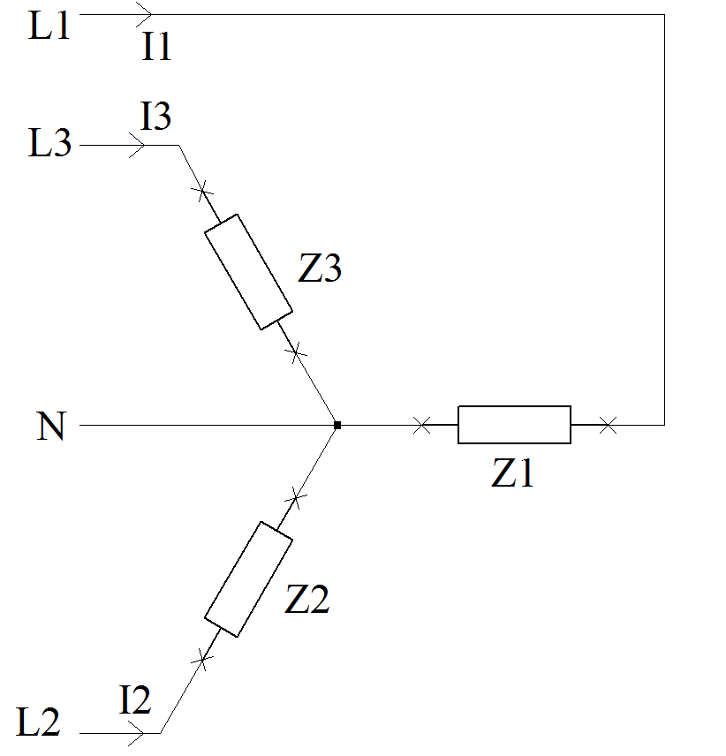
Fig Q2
[11 Marks]

  - For the circuit shown above, calculate the power dissipated by each load and their respective power factors.
[6 Marks]

  - For the circuit shown in Fig Q3, given R = 150Ω, L = 10mH, C=86µF, V=120V, f=100Hz. Calculate:
    - The circuit current and phase angle
[2 Marks]
    - The individual component voltages
[3 Marks]
    - The power dissipated by the resistor
[1 Mark]
    - The total power supplied to the circuit
[1 Mark]

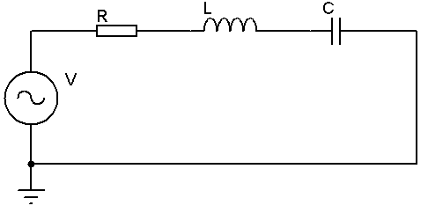
Fig Q3
  - Draw a phasor diagram showing the component voltages and the circuit current.
[4 Marks]

  - Calculate the resonant frequency of the circuit using the component values above.
[1 Mark]

  - Draw a phasor diagram for the circuit at resonance showing the component voltages and the circuit current.
[4 Marks]

  - At resonance, explain:
    - What happens to the individual component voltages and why?
[3 Marks]
    - How is energy stored, converted and transferred within the circuit?
[4 Marks]
    - What functions does the resistor have in this circuit?
[2 Marks]

  - For the transformer shown in Fig Q4, the silicon steel core has a uniform cross section area of 20mm X 30mm and mean length of 400mm. The primary coil has 1000 turns, if 10A flows through the primary windings, calculate the magnetic flux density in the core.
[6 Marks]

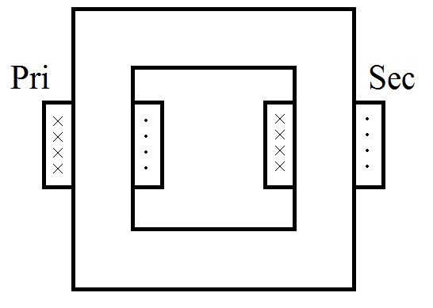
Fig Q4

  - For the transformer in part a, calculate the primary current required to magnetically saturate the core given that silicon steel saturates at 1.72T
[6 Marks]

  - If the primary coil had an impedance of 1.3Ω, calculate the required primary voltage to achieve this current.
[2 Marks]

  - With the aid of diagrams, describe what the secondary voltage and currents will appear to be like from a saturated transformer. Explain why this happens.
[4 Marks]

  - The changing magnetic field in the core of a transformer induces a voltage within the core, this voltage causes a current to flow in the core material. Describe how this affects the efficiency of a transformer and what can be done to improve it.
[4 Marks]

  - Describe magnetostriction and the affects it has on transformer operation
[3 Marks]

Diwedd/End

Magnetism | AC Power
$$B=\frac{Φ}{A}$$ | $$pf=\cos{ϕ}$$
$$mmf=N.I$$ | $$S=\sqrt{P^{2}+Q^{2}}$$
$$mmf=H.l$$ | $$P=I^{2}R$$
$$H=\frac{N.I}{l}$$ | $$Q=I^{2}X$$
$$B=µH$$ | $$S=IV$$

