Jack Piper (1702137)
Research In Context ADAD5003
Advertising and Brand Design
Timi O’neill
Question 4: Explore the mediated form of narrative and critically show how it is used to promote political, ideological, religious or socially constructed perspectives within your discipline area.
Word count: 2296

Introduction
In this essay I will be discussing the use of narrative in advertising and how it can be used to boost the effectiveness of political, perspectives. Narrative is a very huge part of advertising and in the modern day it exists in each and every form of advertising. Many creatives believe that a narrative will exist in anything, whether by design or just by the basic human need to create stories. Stories allow humans to process and retain information in a way that no other medium will let them. Stories exist on our screens, in our books and in our heads, we simply can’t get enough of them. This is why advertisers find narratives to be so useful, as they are simply more effective than anything else they can create. But why is the use of narrative so effective? Firstly, we will look at what a narrative really is.
Narrative
Narrative is defined as “a spoken or written account of connected events; a story.” [1]. But that doesn’t quite explain the four main sections of a narrative. According to Matthew Luhn, a writer known for movies such as Toy Story 2, Finding Nemo and Up, a narrative needs four main points. A hero, a goal, obstacles and a transformation. [2] The “hero” of the story is very often the part that has the most time and thought given to it. This is because the hero needs to feel empowering and relatable, which means while they need to be great in many aspects of their life, they also need to be flawed in some ways, that the audiences can relate to them and hopefully see them overcome these flaws. Every good story starts with a good main character, Harry Potter and Frodo Baggins are not without their flaws, but it is the journey that the audience takes with them to overcome these flaws that makes them so popular. A good narrative must always have clear goals too. Whether this is in the form of an antagonist that needs to be overcome, or just a simple A to B path that needs to be taken. However, the audience must always know what the desired goal is, lest they become lost and disinterested. However, while a clear goal is needed, there must be clear obstacles as well. A story without struggle is no story at all. The audience must be presented with challenges for the hero to overcome, this is where the audience really gets sucked into the narrative. If you learn about and grow interest in a character, you will truly start to care for them once they have to experience hardships and strain. When the character feels emotion, the audience can feel it too, this is when an advertiser like myself has the audience right where I want them. The final step, transformation. This is what brings the whole story to a close, where the moral of the story is revealed and where some people may change their entire outlook on life. Great resolutions include great transformations. Seeing your hero thrive in the face of adversity – or fail for that matter – can teach lessons that no lecture or class could ever teach. Which is exactly how humans learned to grow so effectively. 
“Is this cave painting humanities oldest story?” [3]
Narratives can be traced back to the very beginning of human history, it is believed to be a big part of why humans were able to learn and adapt so well compared to other species. Being simply told “don’t go near snakes!” is much less memorable than being told of a close encounter a family member had with a snake. This is still true even in the modern day, where people don’t like to be told “Buy this product, it’s good!” but instead like to see stories from people they know or can relate to. This is true in all adverts, not just film ads. Modern day advertising requires characters of all kinds, be it an animal or a person. Some characters have become more recognisable than the product or brand that they are representing. This is due to them being so easily recognisable through imagery or speech, such as catchphrases. Without me needing to describe them at all, you the reader will instantly know the look of the characters behind “Simples” and “Go Compare!”.

Heroes
First and foremost, in the modern-day narrative advert is the importance of a main character, which is most important when it comes to political adverts. Modern day politics has been very much muddied by social media and modern journalism. The 2019 election to many people is not Labour vs Conservative, but instead Jeremy Corbyn vs Boris Johnson. This is due to the fact that everyone will know who the prime minister is and what they are doing, but they do not follow politics very closely outside of that. However, this is simply something that these political parties need to take advantage of, rather than try to change. Current political advertising from the two major parties are solely focused on the party leaders, rather than the party and the policies that they plan to focus on if they were to come into power. This has proven to be very effective, as now both Boris Johnson and Jeremy Corbyn are household names, but the other major party leaders, Jo Swinson and Nicola Sturgeon are much less well known and will undoubtably receive less votes due to this. However, while both these parties have their main protagonist, no story is complete without a true antagonist.
Obstacles
What makes the stories of both of these parties interesting is how much they seem to despise one another. Boris Johnson’s party has framed the story to be that they are the last line of defence to save the country from Jeremy Corbyn. They are using his anti-defence and immigration policies against him to strike fear into members of the public, to paint him as untrustworthy and naïve. Conversely, the Labour party are using the same policies to inspire the public to have complete faith in them to restore safety and stability. These are both completely different narratives but told using the same information, but it still creates debate and splits opinion. This is caused by something called “Selection Bias”. Selection Bias is when someone will receive information but will only acknowledge the parts that agree with their internal narrative. Most people that you can speak to will have a preference between the Labour Party or the Conservative party. This is often referred to as being “left wing” or “right wing”. If one were to take a purely impartial look at both parties, one would find that they both have their upsides and downsides. However, due to selection bias which is created due to a person’s experiences in life, each side seems to despise the other, leading to huge amounts of arguing and resentment. One aspect of these narratives that is particularly interesting however is the difference in the way that these messages are being delivered. The conservative party has chosen to very cleverly and very carefully monitor exactly what each of their party members is saying. By making sure that each interview that a party member takes is favourable to them at the onset and each answer is meticulously planned out well in advance. Whether it be through their own medias or through select press conferences, the choice of wording and the emphasized policies have been well thought out and restricted to only the information they are prepared to deliver. This has backfired on several occasions however, as refusal to comment can very often be seen as ignorant and dismissive.

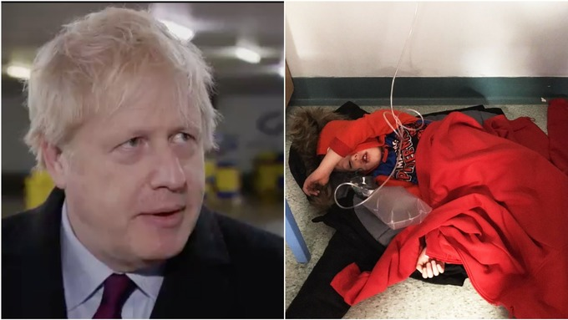

“Boris Johnson takes ITV reporter's phone after refusing to look at photo of boy on hospital floor” [4]

One example of this is when Boris Johnson was suddenly shown a picture on a journalist’s phone that he had no planned response to. The picture in question was of a four-year-old boy who was admitted to hospital with suspected Pneumonia. Due to the fact that he was taken to a hospital in the centre of Manchester during their busiest day of the year, he was unfortunately unable to be given a bed and needed to remain in a chair with his mother. When he was tired however, the mother was forced to lay him on the floor of the hospital and supply him with whatever protection she had on him. Outraged, the mother shared her story on social media, which very quickly picked up steam and was shared throughout the country. While the Conservative party was busy writing their response to this story however, a journalist doing a pre-planned interview with Boris Johnson went off script, pulled out his phone and brought up a picture of the young boy on the floor. Boris, clearly sticking to the rules of his party to not comment without prior consultation, refused to comment on the image, even going so far as to take the journalists phone away. This played right into the hands of the Labour party, who could then spin the narrative – which has a perfectly reasonable explanation – and use it to paint Boris Johnson as the antagonist of the people. That’s just how politics works. Next I will describe how the Labour party presents its narrative: Memes.
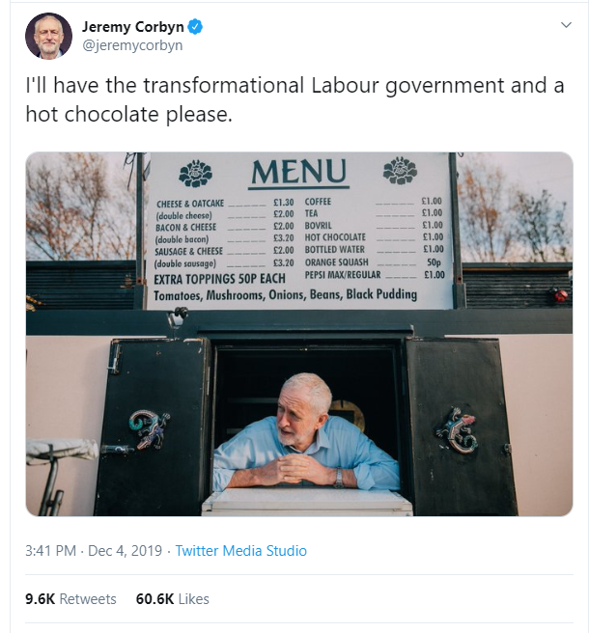[5]
The labour party and the left wing in general have always been more closely associated with the younger generations. The younger generations in the modern day will spend at least 6 hours a day using the internet, mainly social media. A very old pastime of social media is the use of memes. Memes are when a person will create a post with a specific format. This varies in a huge amount of ways; however proper meme technique is very difficult to master. Each meme is unique in its own way and very often does not make sense if it is seen on its own. One must see multiple versions of the meme to understand the format used, then it is possible to see how the meme is entertaining. Just in case you still don’t understand how memes work, I will explain it using the well-known joke format: the knock knock joke. A knock knock joke is a very early version of meme, in that the words being said do not form a joke on their own, but it is the format of the joke that breeds creativity. The simplicity of memes speaks to the younger generation in a way that no manifesto or press conference could, which is precisely why it has proven so effective for the current labour party. This however also has its downsides. Much of the older generations, while tech savvy enough to use the internet just as much - if not more - than the younger generations, do not keep up with the latest popular memes. This means that a large portion of the media produced by the labour party is simple illegible to them and instead appears childish and unprofessional, which are two things that the older generations tend to avoid.
Transformation
So we’ve seen the heroes, their goals and their obstacles. But where does the transformation stage fit in when it comes to political narratives? It is very unique, in that the transformation stage during the build-up to an election is actually entirely within the audiences head. That’s right, while political parties can show you their vision of what they intend to happen after the election, each individual person has their own ideas of what they would like to see. Each person picks their expected outcome, then decides on which party to vote for based on what they envisage will happen. This has been especially true of the 2019 election as so much of the future is extremely uncertain currently. Not only does one have to factor in how the parties will employ their chosen policies, but the audience also has to decide which news stories they have read are actually true, further muddying the waters of what the expected outcome will be. This is what makes political narrative advertising so difficult. No matter how many messages or stories you tell to the audience, in the end they will still need to draw their own conclusions and make their own decisions.
Conclusion
So, what does this tell us about the impact of narrative? It’s simple. A narrative is only effective if it targets the correct audience. If narratives are to be used to promote specific ideas or push certain agendas, then they must be very well planned out. One major flaw in a narrative and it can very quickly backfire and give an entirely different message than the one intended. However, when it comes to modern day political advertising, narratives are currently the only way forward. Once again, all you need for a good narrative is 1), a hero that has been well thought out, 2), clear goals that the hero will wish to accomplish, 3), obstacles for the hero to overcome and 4), a final transformation to leave a clear message in the head of the audience. If all of these points are well planned out and the story is pertinent to the target audience, then there is the chance that a narrative that will be remembered for a lifetime will be created. As this is being written before December 12^{th,} I will unfortunately not be able to comment on how this particularly interesting battle of narratives will conclude. I am sure that the transformation of the narratives that we have all dreamt up will all be incorrect, we will all be surprised by what comes next. One thing is for certain though, once December 12th has passed, a narrative will begin anew.

Bibliography
[1] https://dictionary.cambridge.org/dictionary/english/narrative
[2] https://www.forbes.com/sites/kimberlywhitler/2019/01/27/5-ads-that-tell-great-stories-insight-from-a-pixar-movie-writer/#58a522db4241
[3] https://www.nature.com/articles/d41586-019-03826-4
[4] https://www.itv.com/news/calendar/2019-12-09/boris-johnson-takes-itv-reporter-s-phone-after-refusing-to-look-at-photo-of-boy-on-hospital-floor/
[5] https://twitter.com/jeremycorbyn/status/1202251590834540545

