BSc Computing (Computer Networks and Cybersecurity)
Information Engineering

Database Design (The Book Store)

Student Name: James Ball
Student Number: 1809296
Date of Submission: 6th May 2019

Contents
Contents 1
1 Analysis 2
1.1 Requirements 2
1.1.1 Functional requirements 2
1.1.2 Non-functional requirements 2
2 Design 3
2.1 Entity Relationship Diagrams 3
3 Implementation 4
3.1 Relationship Diagram 4
3.2 Report Outputs 4
3.2.1 Quarterly Newsletter 4
3.2.2 Order Invoice 12
3.3 Form Screen captures 14
3.3.1 Main Menu 14
3.3.2 Detail Forms 14
3.3.3 List Forms 22
3.4 SQL 29
3.4.1 DDL 29
3.4.2 DML 31
4 User Guide 33
4.1 Introduction 33
4.2 Form navigation, searching and viewing data 33
4.3 Adding Data 37
4.4 Deleting data 40
4.5 Editing Data 40
4.6 Complex forms 41
4.7 Running Reports 44
4.7.1 Quarterly Newsletter 44
4.7.2 Order Invoice 45
5 References 47

Analysis

Requirements

Functional requirements
Through analysis of the task description, the following functional requirements[1] were found:
- User should be able to add or delete information from any table.
- User should be able to view, on screen, Book, stock, order and customer details.
- User should be able to view ongoing customer orders.
- User should be able to query the system and print out relevant reports.

Non-functional requirements
The following non-functional requirements[2] were found:
- User should be able to find a table record within 1 minute
- User should be able to create a new record in under 1 minute
- User should be able to delete a record in under 30 seconds

Design

Entity Relationship Diagrams
In the design stage, an Entity Relationship Diagram (ERD)[3] was created:
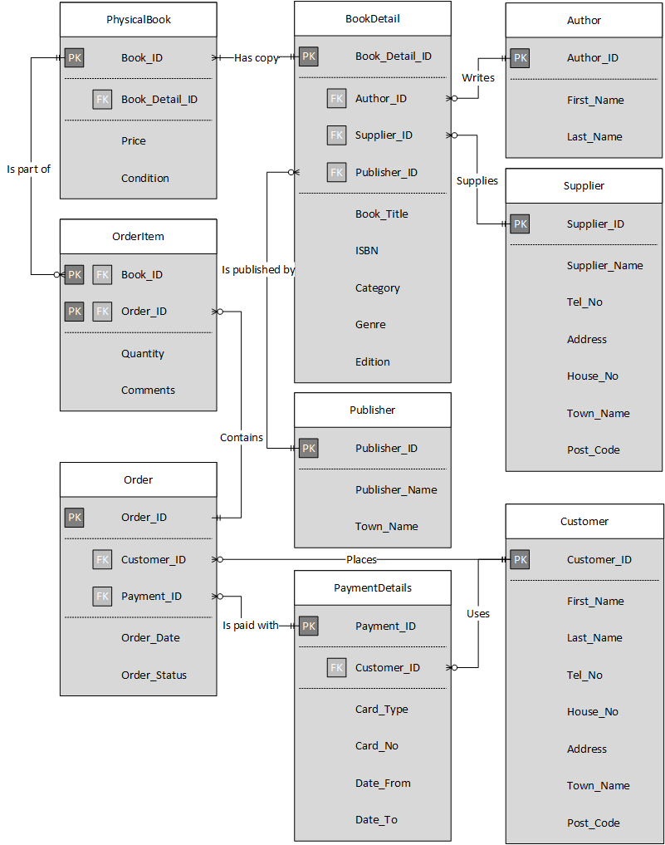

Implementation

Relationship Diagram
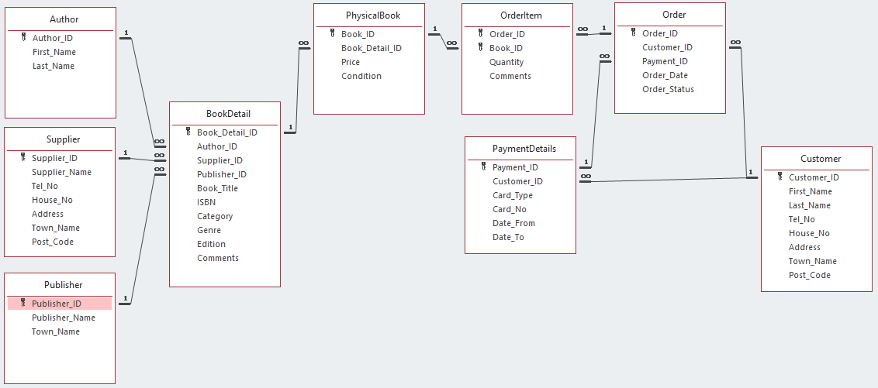

Report Outputs

Quarterly Newsletter
A requirement was the ability to create a quarterly newsletter that details current interesting stock. This was implemented in the database using a report that lists the top ten most expensive books in stock.
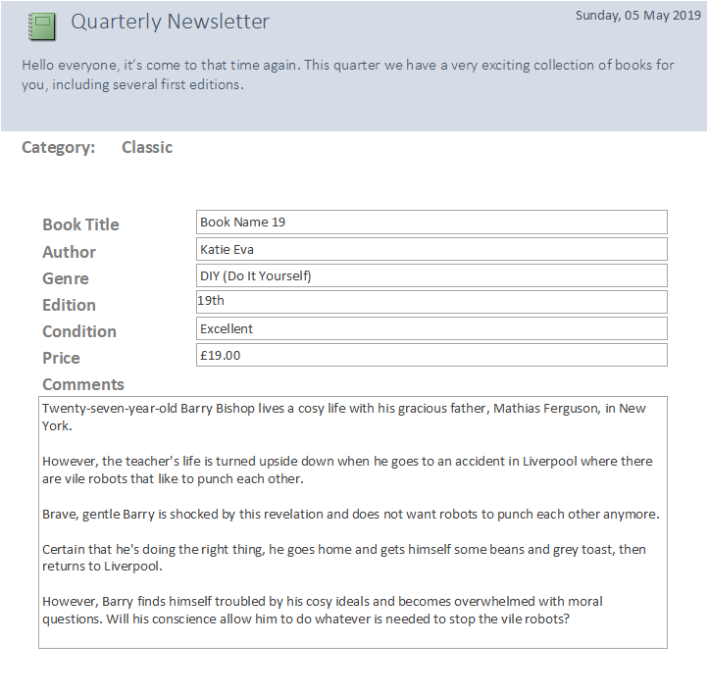
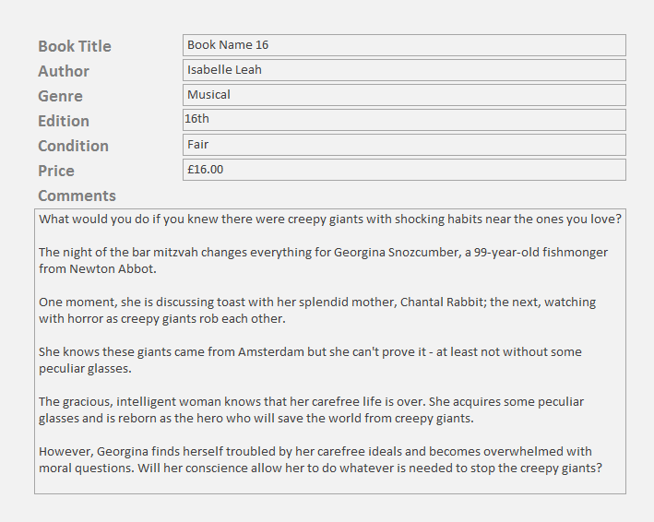

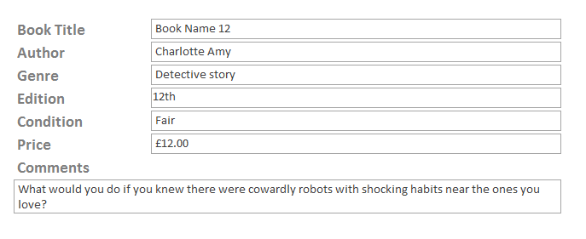
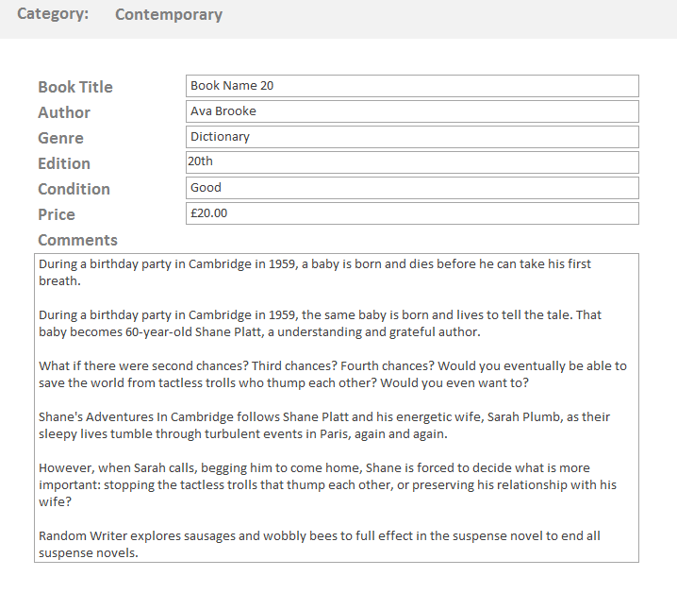
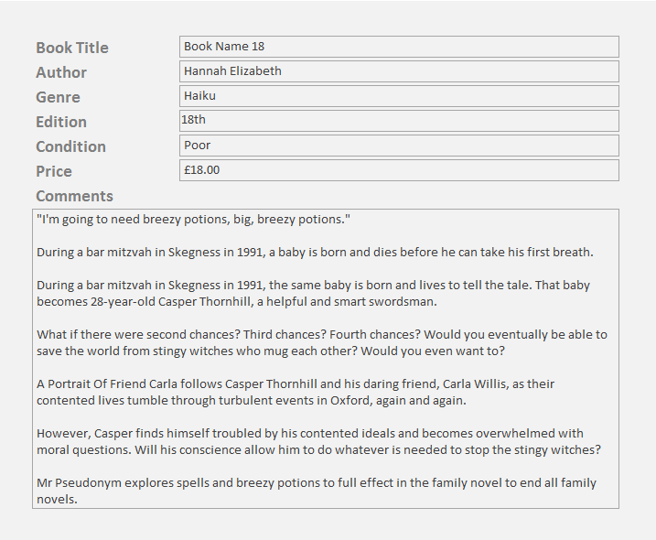
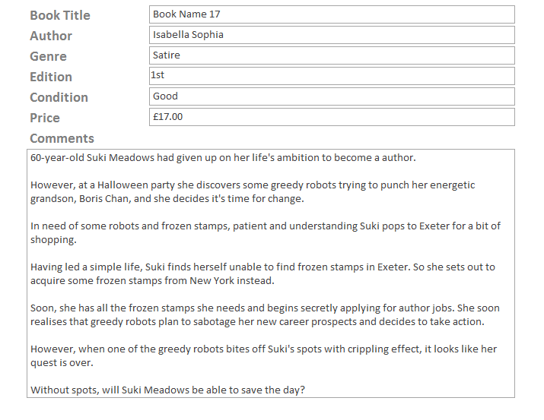

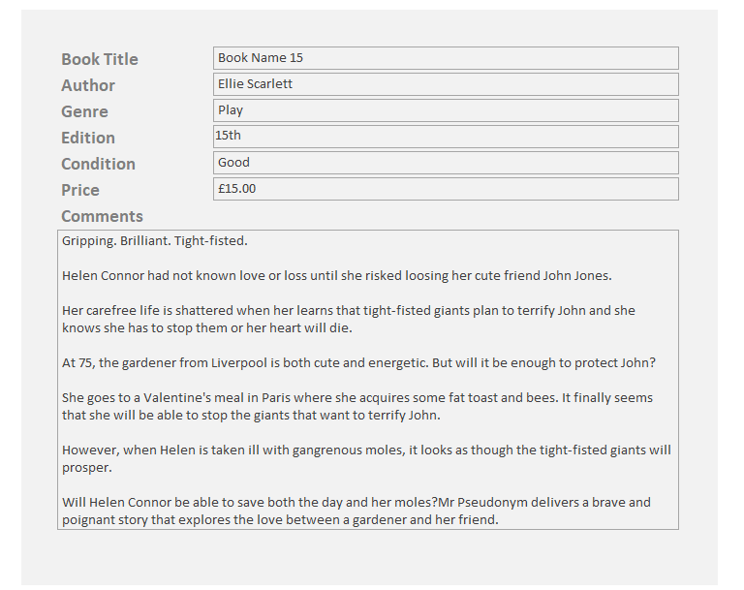
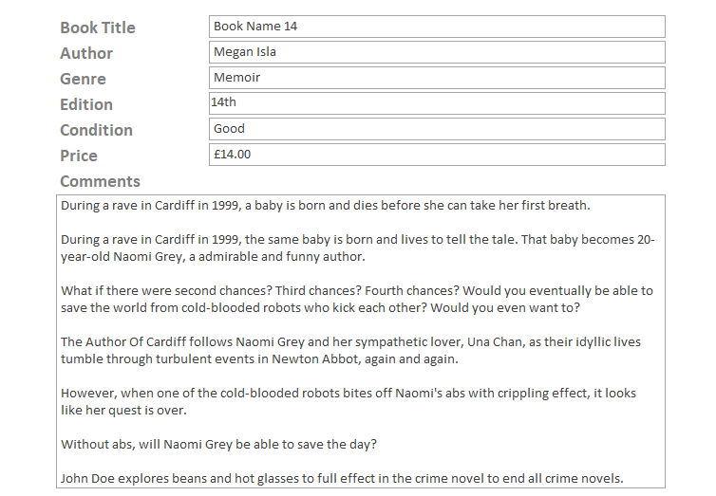
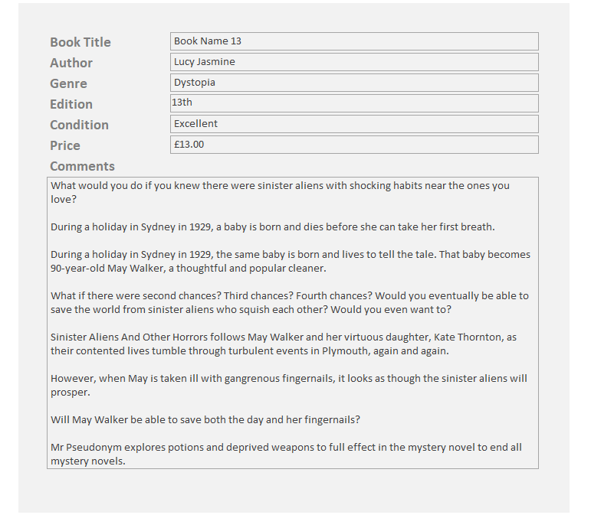
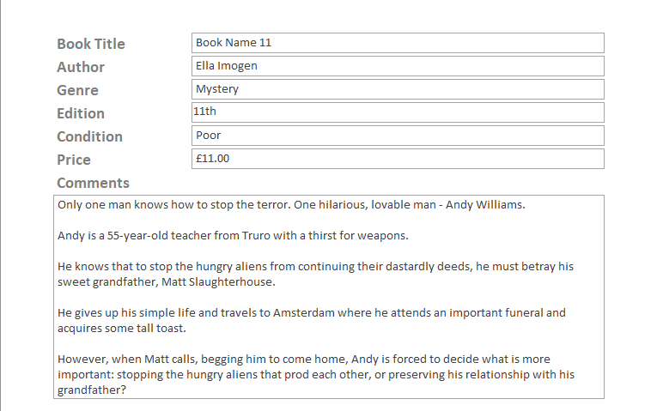

Order Invoice
A requirement was to be able to create an invoice from an order. This is done using a button on the order detail form that executes a macro (fig 3.2.2.1) that runs a query (fig 3.2.2.2). This query is based on the current value of the Order_ID textbox in the order detail form. Once query is run, it is then displayed in the order invoice report (fig 3.2.2.3).
In this report the subtotal for each order item is calculated using the quantity multiplied by the price. The order total is then calculated by summing the subtotals[4] (fig 3.2.2.4).

Fig 3.3.2.1
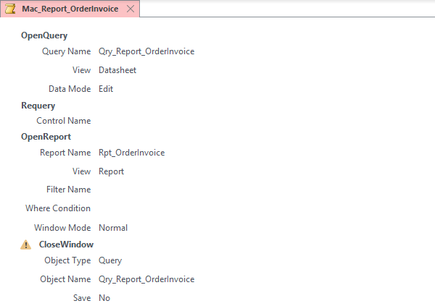

Fig 3.3.2.2
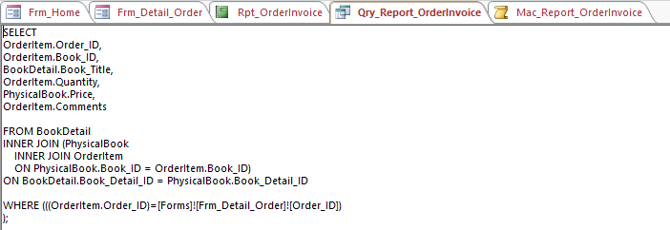
Fig 3.3.2.3
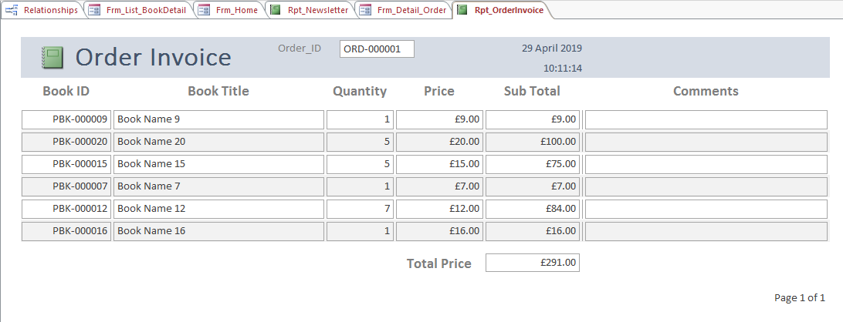

Fig 3.3.2.4
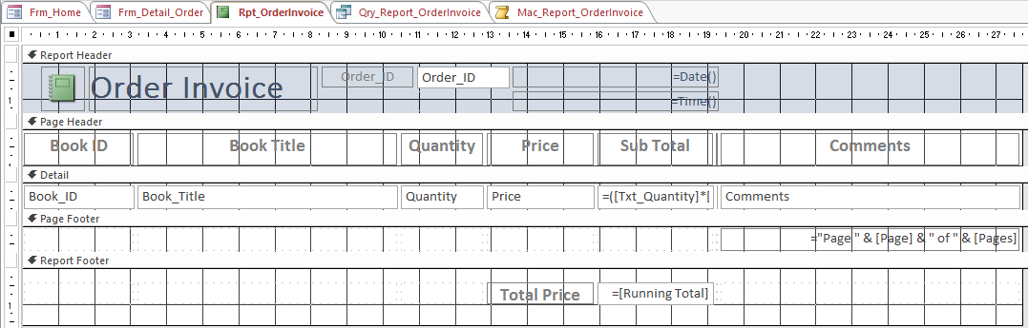

Form Screen captures

Main Menu
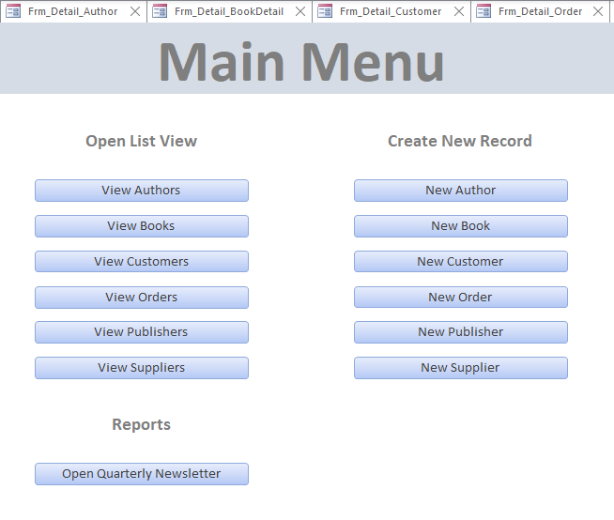

Detail Forms
The detail forms are designed to allow the user to view, add, delete or edit all the data for a single record in the relevant table. They follow a standard design with a selection combo-box on the left of the header. This allows the user to jump to a specific record by triggering a macro (fig 4.3.1.1) when the combo-box is updated. This macro searches for the record that matches the ID of the combo-box.
There are also navigation buttons that go to the first, previous, next, and last record respectively. These buttons trigger macros (fig 4.3.1.2) that save the current record, goes to the correct record. If there is an error, for instance if the user is currently on the first record and tries to go to the previous one, it will show an error message (fig 3.3.1.3).
The ‘Add Record’ button allows the user to input a new record into the table, the ‘Save Record’ button saves the current record. The ‘Delete Record’ button triggers a VBa[5] script (fig 3.3.1.4) that asks for confirmation, and only deletes the record if the user clicks yes.
There is also a ‘Back to List’ button that takes the user back to the list view for the current form and a ‘Home’ button that takes the user back to the main menu.

Fig 3.3.1.1
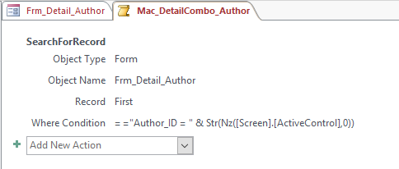

Fig 3.3.1.2
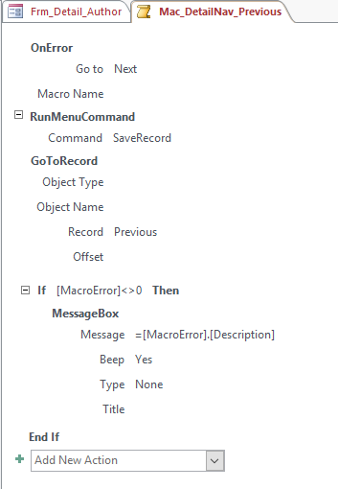

Fig 3.3.1.3
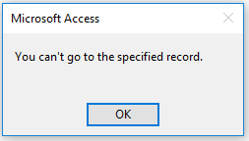

Fig 3.3.1.4
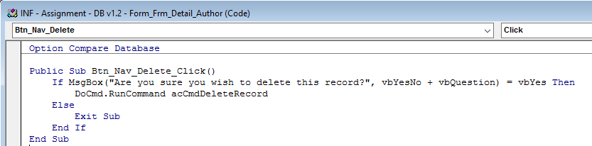

Authors
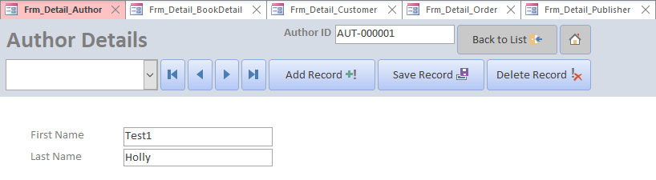

Book Details
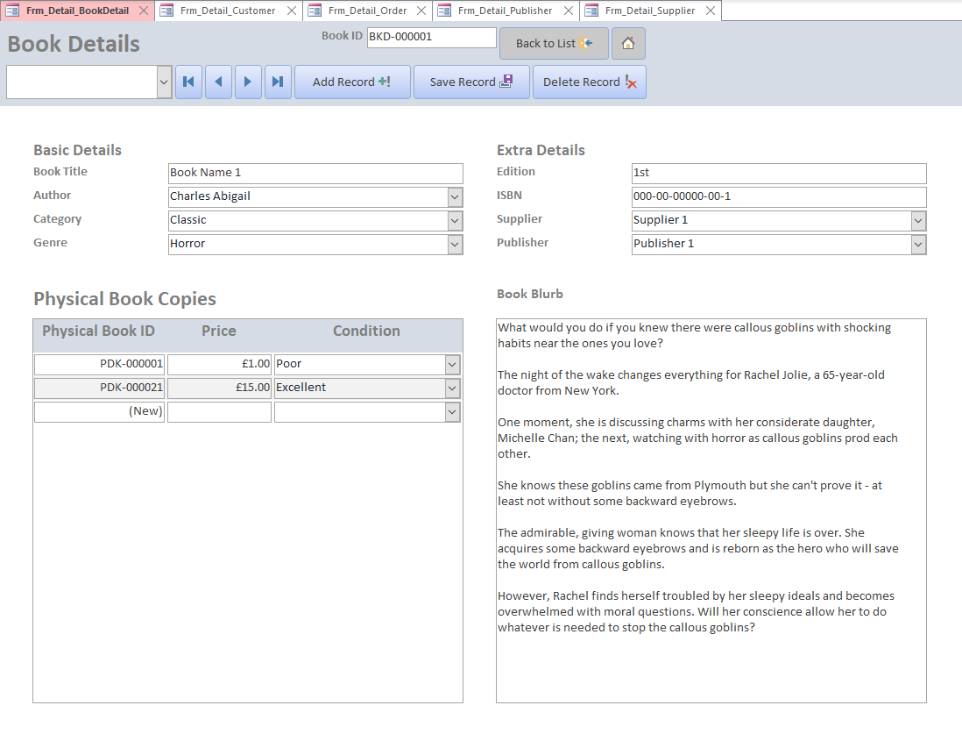
The book details form has combo-boxes for Author, Supplier and Publisher. These combo-boxes have a row source that selects their field source which is a foreign key, and a user recognisable field as well:
The bound column is the ID, which is set to zero width, so the user only sees the author name[6]. This allows the record to still be in third normal form[7] using foreign keys whilst also allowing the user to easily pick the correct option from the list.
These combo-boxes have the relevant ‘detail form’ set as the ‘List Items Edit Form’. This means that if when creating a new book record the author isn’t already a record in the database, the user can click the button at the bottom of the drop-down list:
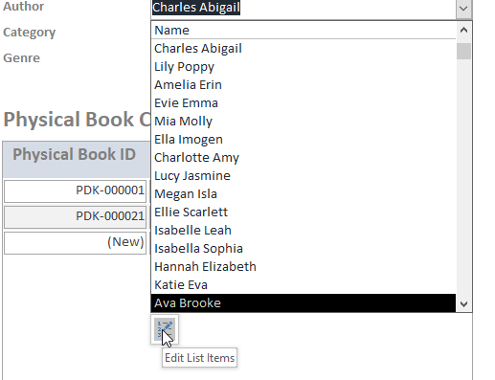
This will take them to ‘Frm_Detail_Author’ to create a new record. By doing this the user can create a completely new book with new suppliers and publishers without having to go to multiple forms to do so.
The ISBN field has an input mask, this makes sure that the ISBN is always entered in the correct format. The Category and Genre fields are combo-boxes with value lists, this means that the user will have to pick a genre from a list or add a new value to the list. This will reduce the chances of having multiple spellings of one value and therefore make searching and running reports on this field much easier.

Customers
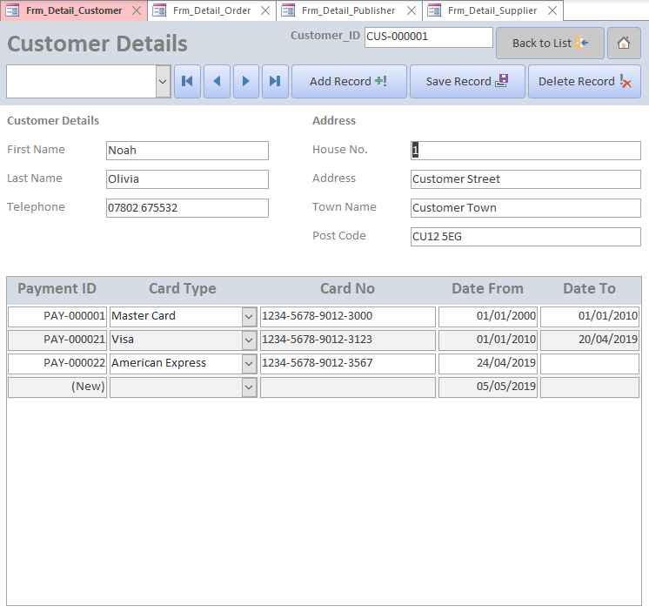
On the Customers detail form there is a sub-form with all the payment methods tied to the customer. The card number field has an input mask that ensures the number input is valid. The date from field is automatically assigned as the current date.

Orders
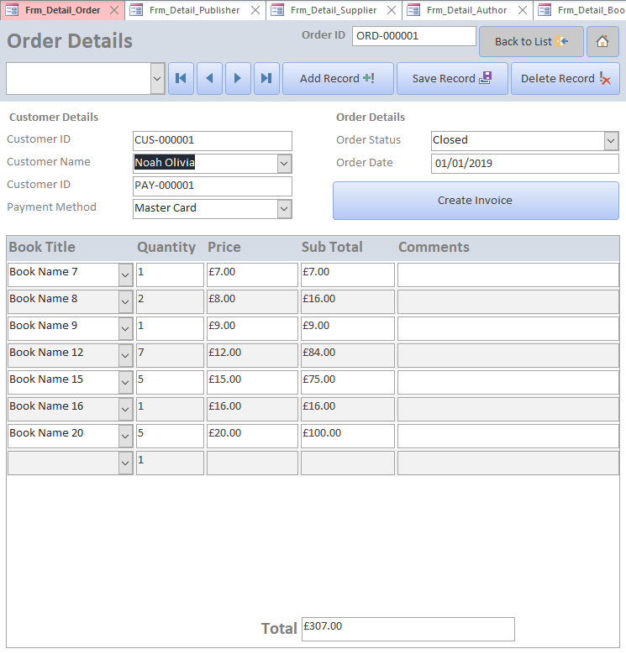
On the orders detail form there is a sub-form with physical books on the order. The card number field has an input mask that ensures the number input is valid. The subtotal field is automatically calculated as price x quantity and the total field is the sum of all subtotals. The book title combo-box is sourced by the following query:
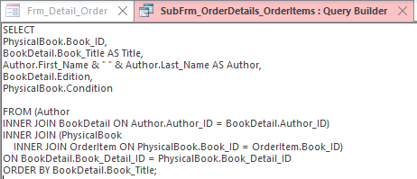

The payment method combo-box is sourced by the following query and is re-queried when the customer combo-box updates:
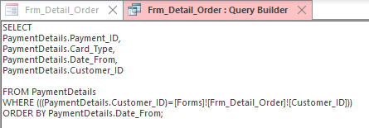

Publishers
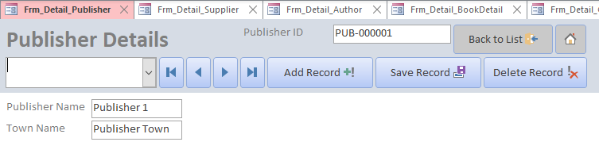

Suppliers
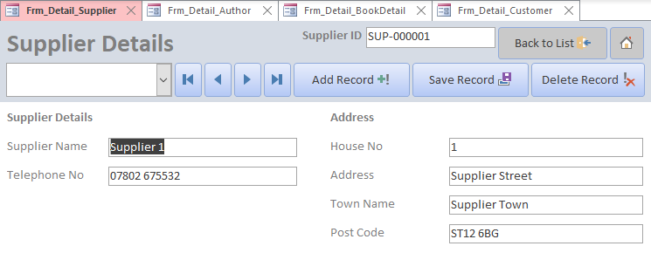

List Forms
The list forms allow the user to view all the records in the relevant table at once. They follow a standard design with the first column being the ID for each record. This is a hyperlink that when pressed will open the detail view for that record using the macro in (fig 3.3.2.1).
There is a search button (Fig 3.3.2.2) which will open a “find” dialog box (fig 3.3.2.3) to search the form for the data entered.

Fig 3.3.2.1
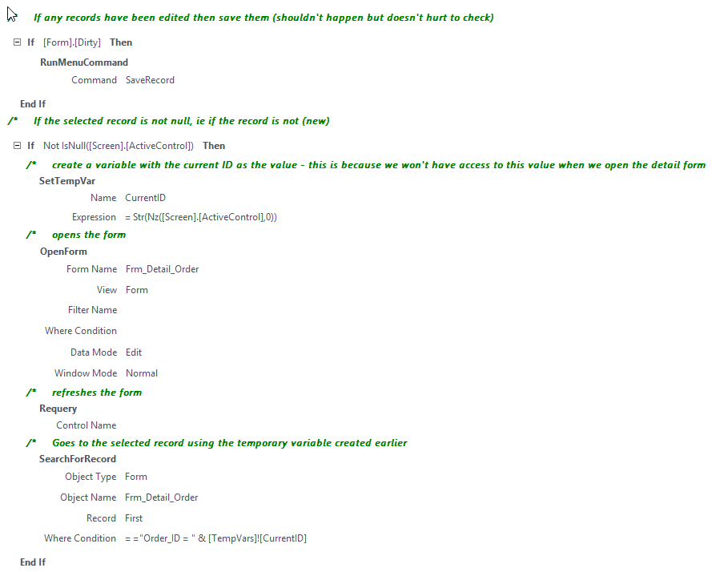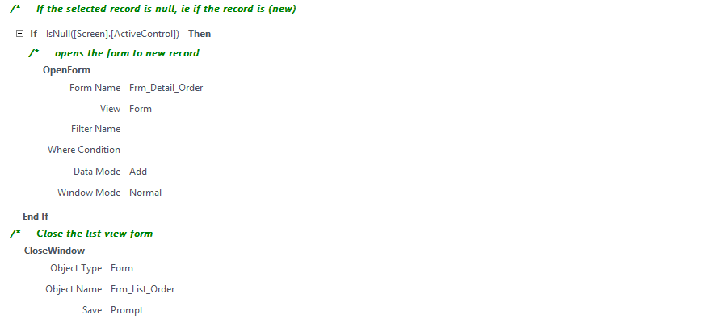

Fig 3.3.2.2
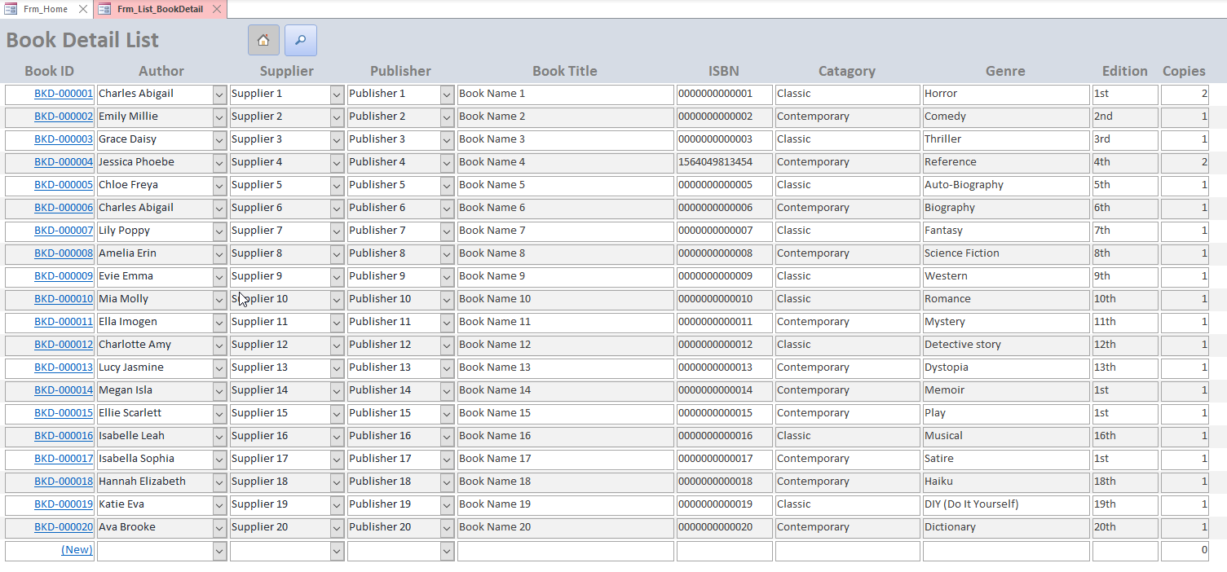

Fig 3.3.2.3
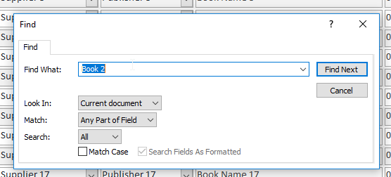

Author
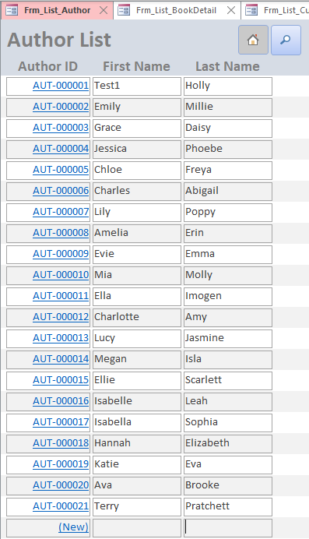

Book Detail
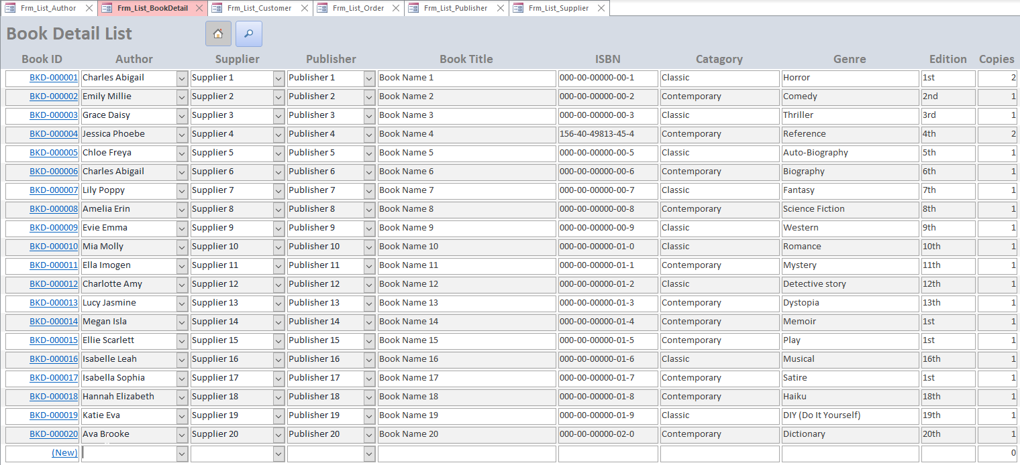
The “copies” column counts the number of physical books that are in stock using a Dcount() expression[8]:
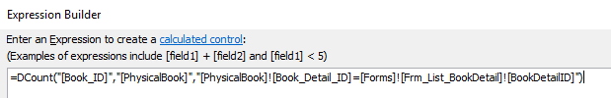

Customer
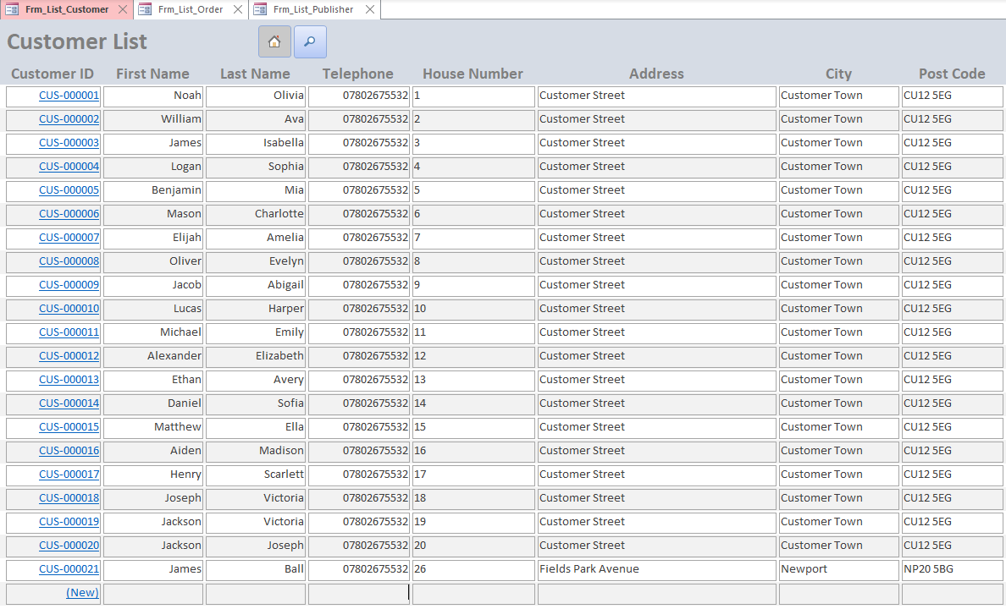

Order
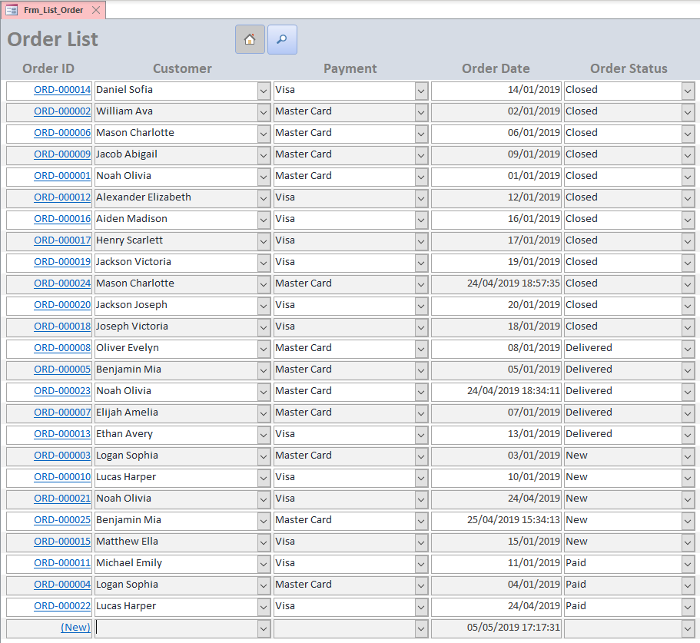

Publisher
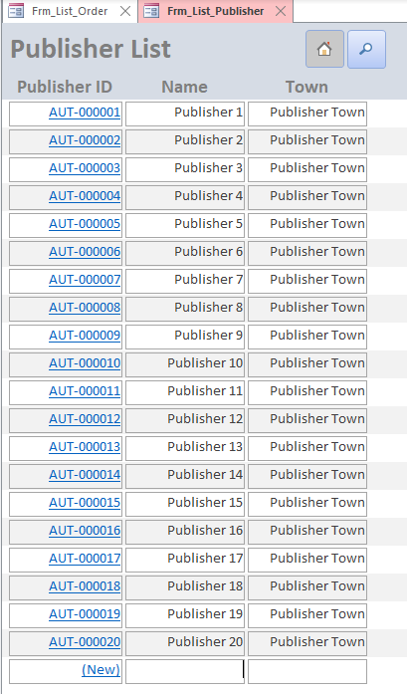

Supplier
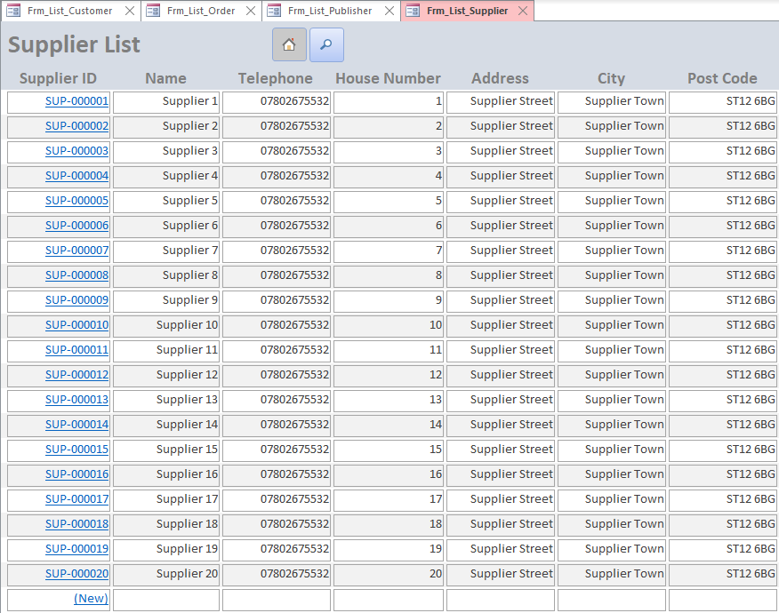

SQL

DDL

Create Table Statements
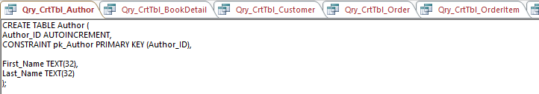
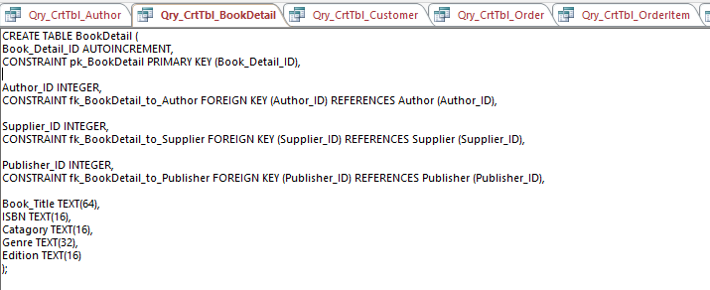
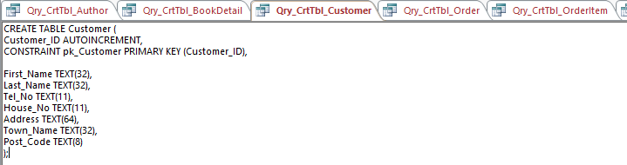
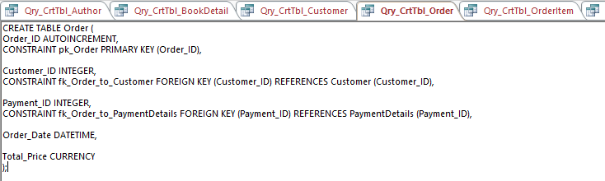
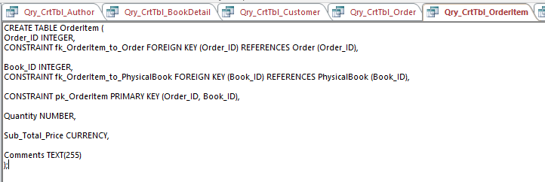
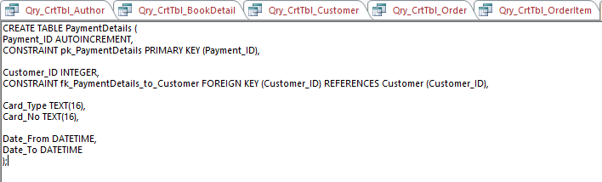
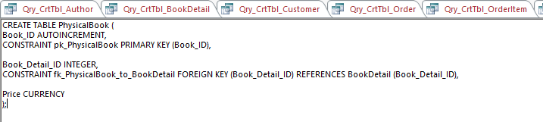
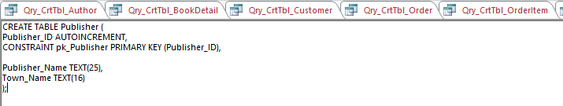
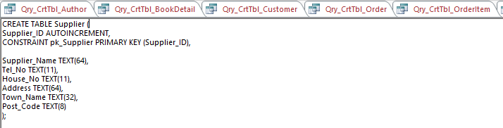

DML

Customer Sub-form query
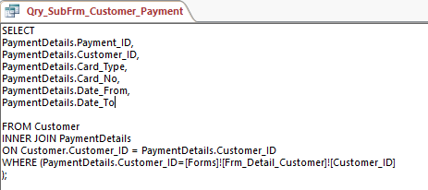

Book Sub-form query
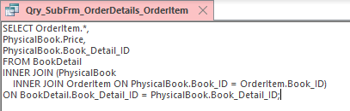

Order Sub-form query
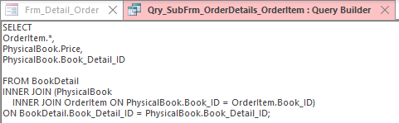

Detail Combo-box query (Orders)
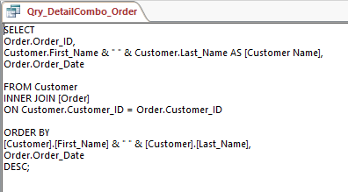

Newsletter query
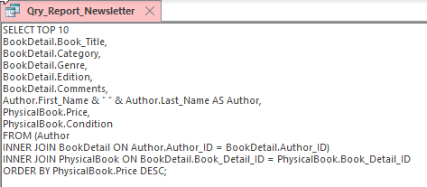

Order Invoice query
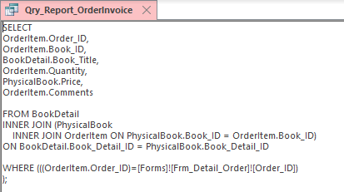

User Guide

Introduction
This database contains Personally Identifiable Information[9] (PII) as well as financial data on our customers. As such there are certain regulations and legislation[10] we must abide by. We have promised our customers that we will only use the information they have given us to complete book purchases, deliver books to them, and send them our quarterly newsletter. As such, any use of the data outside of those reasons would constitute a breach of the Data Protection Act 2018 and could result in a fine from the Information Commissioner’s Office[11] (ICO).
Staff must only ever access information necessary in the completion of a business task. Any staff member that is found to have accessed data that was not specifically related to a business need will be subject to disciplinary action, up to and including dismissal.

Form navigation, searching and viewing data
When you open the database, you see the main menu:
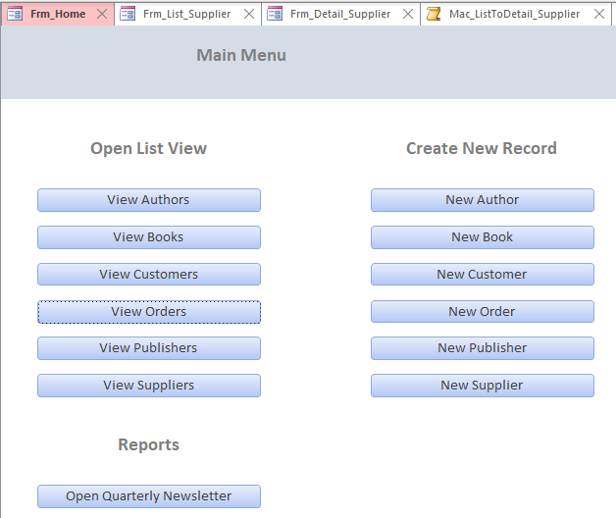 From this form you can navigate to any other form in the database. To view a list of records, click on the list you wish to see. For instance, if you wish to see the list of Authors, click the “View Authors” button:
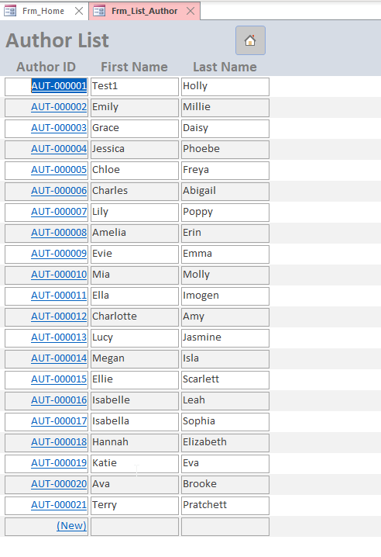
This will take you to the list view for all the authors in the database.
To search for a specific record, select the field you wish to query (e.g. if you know the books title, select the title column), then click the search button on the top:
This will open a search form:
Enter the search and click find next, this will search through the list to find the record you are looking for.

If you wish to see more information on a record, click on the blue ID hyperlink on the left of the record to open the detail view for that record:
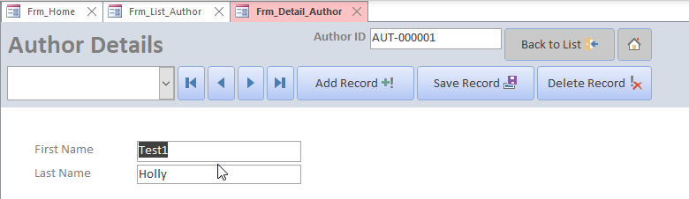
From this view, you can go back to the list view using the “Back to List” button (circled in green) on the top right. You can also go straight back to the main menu using the “Home” button (circled in blue) on the top right.
If you wish to browse the records, you can use the four navigation buttons (circled in orange). These will take you to the first, previous, next, and last records respectively.
To jump to a record, use the drop-down box on the left (circled in purple). This will allow you to select the record you wish to view:
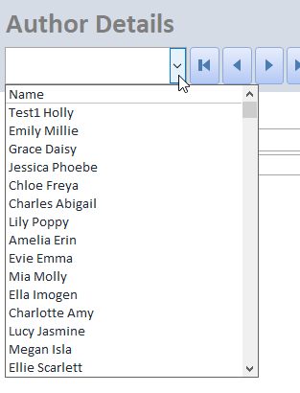

Adding Data
You can create a new record from the Main Menu, List view, or detail view:
From the Main Menu
Click the relevant “Create New” button to open the new detail form.
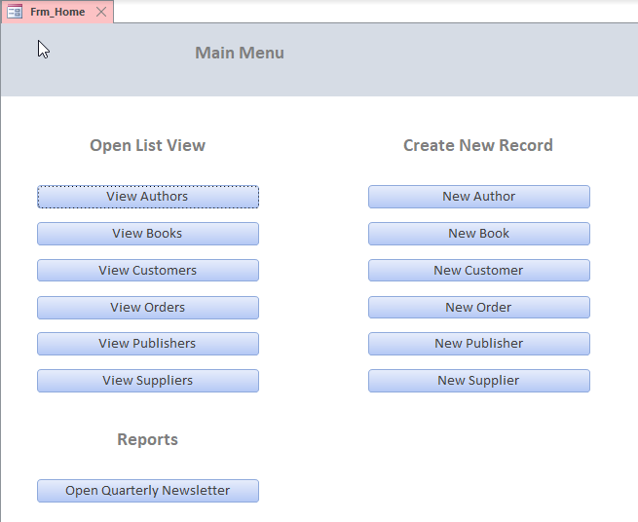
From the List View
Click the blue “(New)” hyperlink at the bottom of the list to open the new detail form.
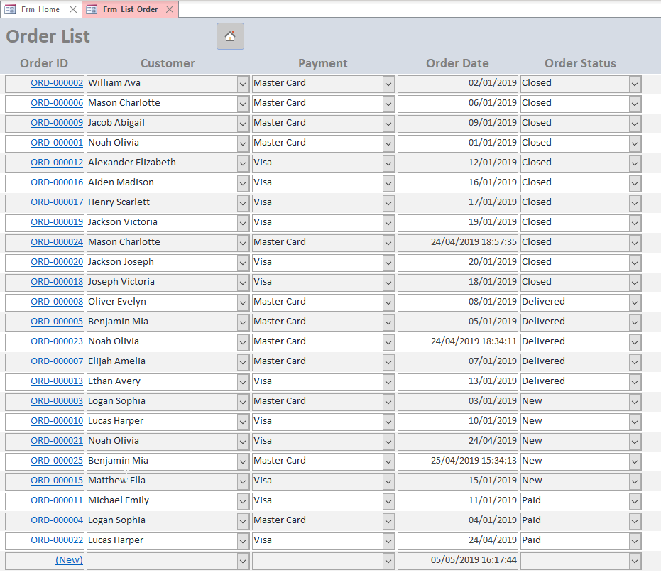
From the Detail View
Click the “Add Record” button to create a new record.
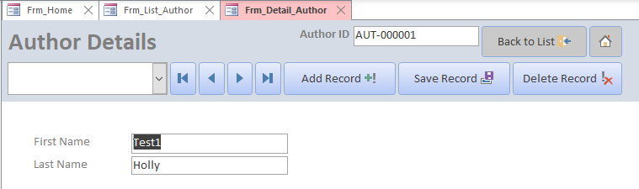

These will all take you to a blank detail view where you can enter the record’s details. Once done, click the “Save Record” button to save the new record to the database.
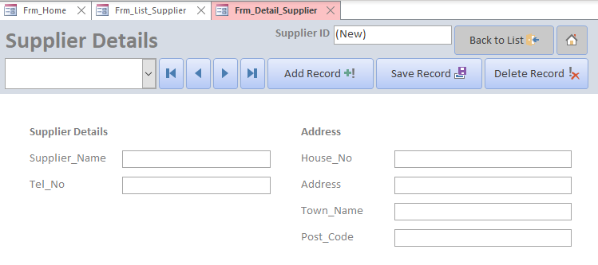

Deleting data
To delete a record, you must first open the correct list view, then click on the record you wish to delete. This will open the record in detail view. Once you have the record you wish to delete open in detail view, simply click the “Delete Record” button and confirm you wish to delete the record.
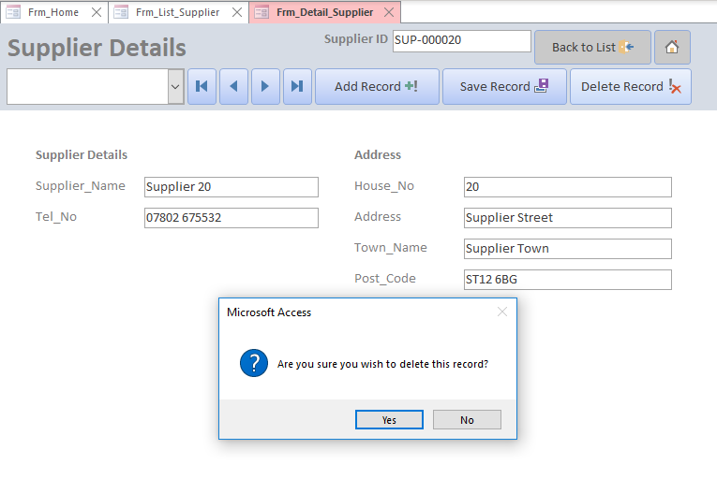

Editing Data
All editing of data is done from the detail view, so to edit a record you must first open the correct list view, then click on the record you wish to edit. This will open the record in detail view. Once you have the record you wish to edit open in detail view, simply change any values needed and click the “Save Record” button once complete.

Complex forms
Some of the detail forms are more complex than others. Such as the books detail form. This has the books details, but also has the physical copy details including the condition and price. This allows the database to store more than one copy of the same book.

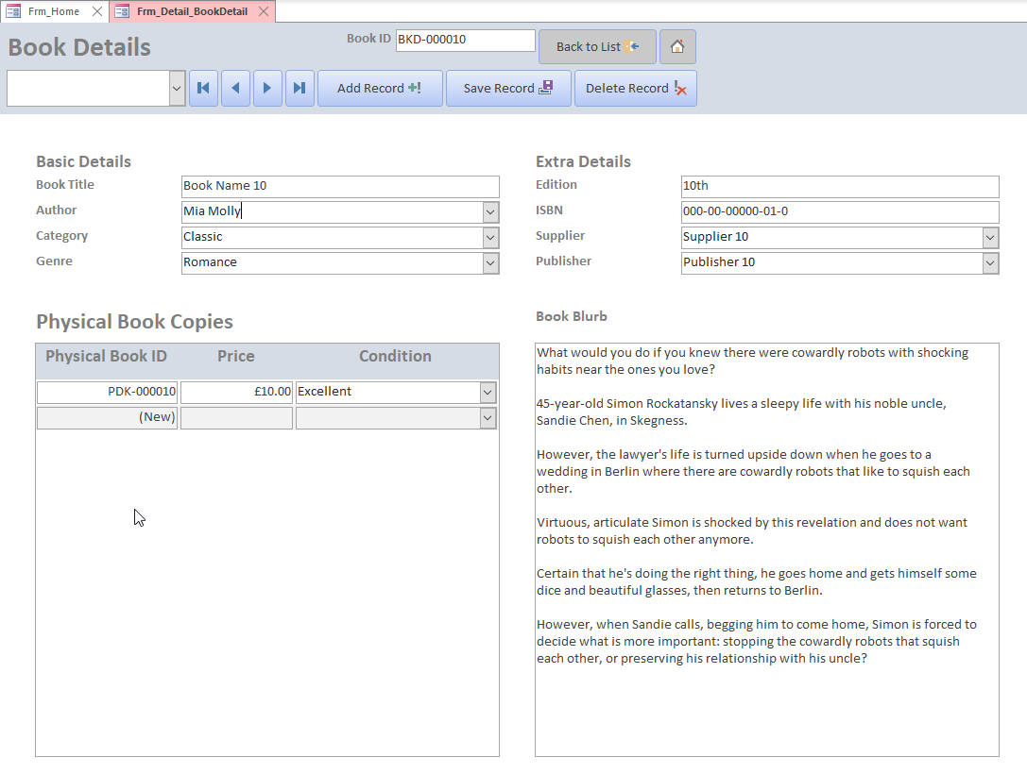
Customers have a list of credit cards attached to them. This means that customers can store more than one payment method at once.
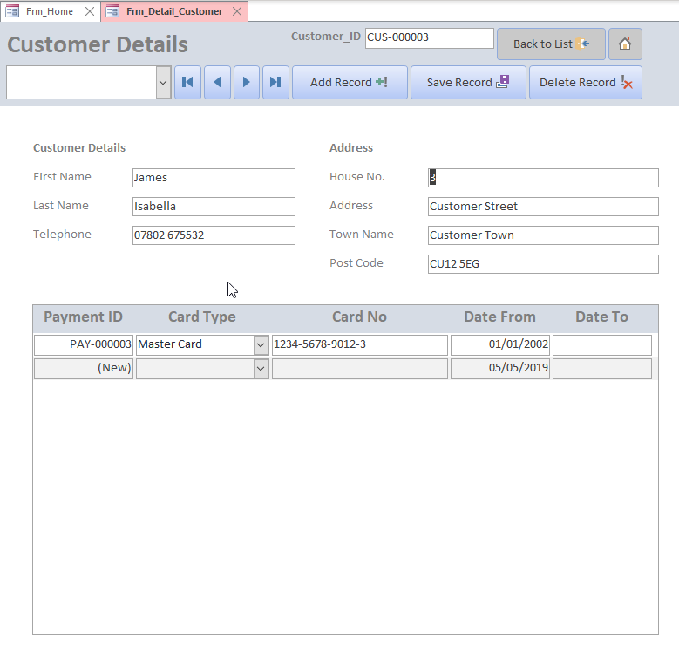
The order form has the list of books on the form, to add a boko to the order, simply click the drop-down box and select the book. Then add the quantity and the total will update.
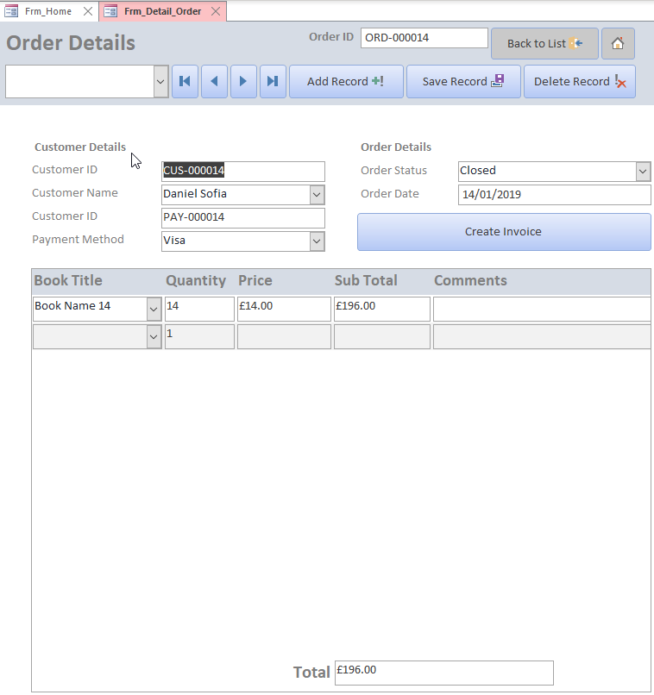

Running Reports

Quarterly Newsletter
To open the quarterly newsletter, simply click the “open quarterly newsletter” button on the Main Menu. This will open the newsletter which can be printed. To close the newsletter, click the x at the top of the page.
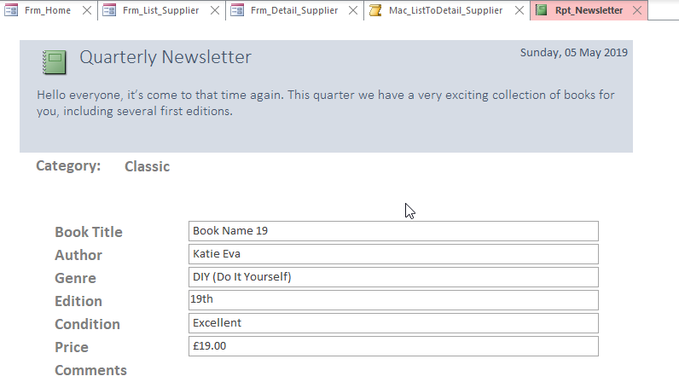

Order Invoice
To open an order invoice, navigate to the correct order in detail view, then click the “Create Invoice” button.
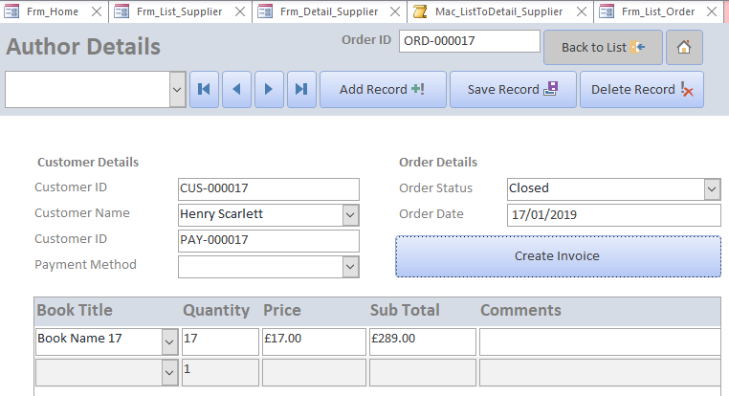
This will create an invoice report that can be printed and given to the customer. To close the invoice, click the x at the top of the page.
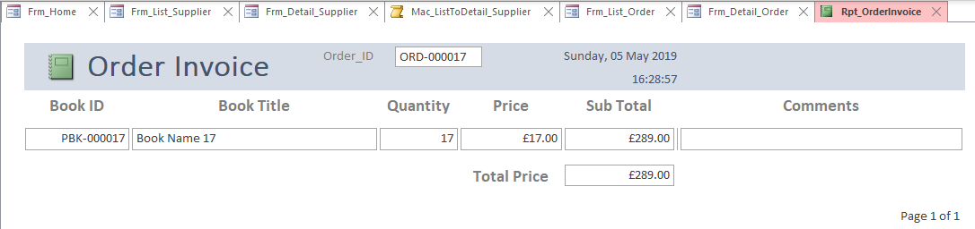

References
[1] “Chapter 2 Database Design from Requirements to Implementation,” 2001.
[2] U. Eriksson, “Functional Requirements vs Non Functional Requirements,” ReQTest, 2012. [Online]. Available: https://reqtest.com/requirements-blog/functional-vs-non-functional-requirements/. [Accessed: 05-May-2019].
[3] S. Roman, Access Database Design &amp; Programming, 3rd ed. Sebastopol, CA: O’Reilly Media Inc., 2002.
[4] “Summing in reports - Access,” Microsoft, 2019. [Online]. Available: https://support.office.com/en-us/article/summing-in-reports-ad4e310d-64e9-4699-8d33-b8ae9639fbf4. [Accessed: 05-May-2019].
[5] N. Shonning, K. Brandl, and L. Caputo, “Getting started with VBA in Office | Microsoft Docs,” Microsoft, 2019. [Online]. Available: https://docs.microsoft.com/en-us/office/vba/library-reference/concepts/getting-started-with-vba-in-office#vba-programming-101. [Accessed: 05-May-2019].
[6] “Showing multiple fields in combo box display - Access World Forums,” Access World. [Online]. Available: https://access-programmers.co.uk/forums/showthread.php?t=215800. [Accessed: 05-May-2019].
[7] K. Wenzel, “Database Third Normal Form - Essential SQL,” Essential SQL, 2018. [Online]. Available: https://www.essentialsql.com/get-ready-to-learn-sql-11-database-third-normal-form-explained-in-simple-english/. [Accessed: 05-May-2019].
[8] “DCount Function - Access,” Microsoft, 2019. [Online]. Available: https://support.office.com/en-gb/article/dcount-function-f6b5d78b-ad0b-4e42-be7a-11a64acbf3d3. [Accessed: 05-May-2019].
[9] “protecting bulk personal data,” NCSC, 2019. [Online]. Available: https://www.ncsc.gov.uk/collection/protecting-bulk-personal-data/who-has-access-to-your-data. [Accessed: 05-May-2019].
[10] “Data protection - GOV.UK,” Gov.uk, 2019. [Online]. Available: https://www.gov.uk/data-protection. [Accessed: 05-May-2019].
[11] “Data protection: Make a complaint - GOV.UK,” Gov.uk, 2019. [Online]. Available: https://www.gov.uk/data-protection/make-a-complaint. [Accessed: 05-May-2019].

