First Assignment Component 1
Student Name: Stacilee Hamilton
Student Number :2436469
Module Number LCHS4003
Module Title: Introduction To Health And Social Care
Lecturer’s Name: Mumtaz Goolam
Assignment Title: Portfolio Two Task

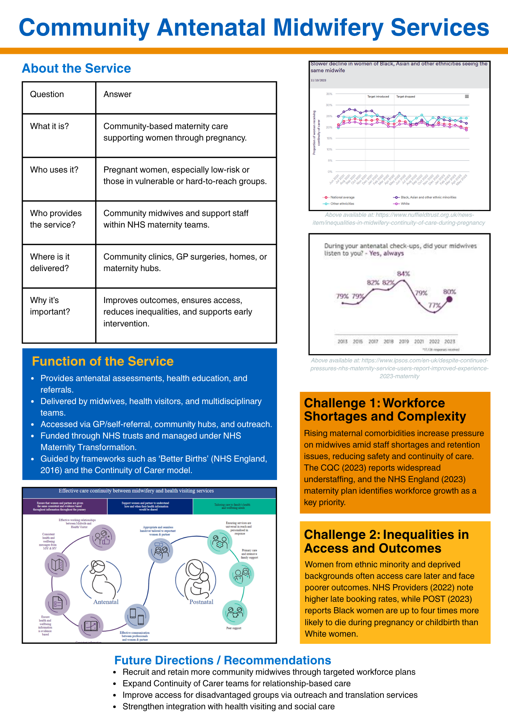
The National Health Service (NHS) is one of if not the UK most defining public institutions, symbolising universal access to healthcare. Established in 1948, it changed the UK’s approach to healthcare by providing it with public funding and allowing it to be free at the point of use. This essay will examine and discuss the NHS’ historical foundations while outlining its core principles and critically evaluating its structure and functioning today, highlighting its strengths and challenges.
Before the NHS’ establishment in 1948, the healthcare system was fragmented and unequal. Access depended on employment, charity or personal wealth, leaving many members of the public without the access to essential care. The impact of the Great Depression and the Second World War highlighted these inequalities, creating momentum for a change in the UK’s healthcare system. The Beveridge Report (1942) provided a blueprint for the government to eliminate “want, disease, ignorance, squalor and idleness,” advocating for all members of the public to gain access to comprehensive public services (King’s Fund, 2025; Reflecting 75 years, 2025).
After the Labour Party’s victory in the 1945 general election, the Health Minister at the time, Aneurin Bevan introduced legislation that would unify all hospitals, local authorities and general practitioners (GPs) into a single system. The National Health Service Act 1946 established this new framework, which began being used on the 5 July 1948 (UK Parliament National Archives). Funded by taxation, the newly founded NHS aimed to ensure that medical care was available to everyone, regardless of income (Nuffield Trust)
The NHS’ founding was a major turning point in social policy in the UK. Even though, Aneurin Bevan faced some resistance from some medical professionals and Labour’s political opposition, the public support for the NHS was overwhelming. Within weeks of its launch, millions of citizens registered with doctors, symbolising a collective commitment to social equity and national wellbeing. (UK Parliament National Archives)
The NHS was built on three key principles: universality, comprehensiveness and free access at the point of delivery (PMC Founding Principles, 2008; Nuffield Trust) and was designed to meet every member of the public’s needs and provide a range of services. These principles ensured that healthcare would be a right for all citizens rather than a privilege of wealth.
The NHS was a departure from the insurance-based systems seen in other parts of the world; this embodied the idea of solidarity through shared contributions (PMC Founding Principles, 2008). Policy reviews and public debates have reaffirmed these ideas over time making them the moral compass of the NHS (King’s Fund, 2025; Nuffield Trust).
However, there have been challenges in maintaining these principles amid growing financial pressures. Increasing demand linked to an ageing population and rising costs continue to test the NHS’s ability to provide equitable and timely care to all (King’s Fund, 2025; Charlesworth, 2025).
In England the overall responsibility for the NHS lies with the Department of Health and Social Care; they oversee policy and allocate resources. Regional Integrated Care Systems (ICSs) coordinate services between individual hospitals, GPs and mental health care centres with the aim to deliver more preventive and wholistic healthcare (King’s Fund, 2025; Nuffield Trust)
Many argue that the NHS faces underfunding. Demand has risen faster than spending growth which has contributed to staff shortages, long waiting times and pressures on service quality. (Charlesworth, 2025; Anderson, 2025; Al-Janabi, Smith and Parker, 2023)
Despite these challenges, the NHS still has remarkable public trust and international notoriety for providing universal coverage at relatively low administrative costs (Khan et al, 2023). Sustaining the NHS’s founding values will require innovation and sustained political commitment (Warner, 2025).

References
Poster:
Care Quality Commission (2023) Maternity services 2022–2024: Staffing and safety. Available at: https://www.cqc.org.uk/publications/maternity-services-2022-2024/staffing [Accessed: October 2025].
Dodsworth, E. (2023). Inequalities in midwifery continuity of care during pregnancy. [online] Nuffield Trust. Available at: https://www.nuffieldtrust.org.uk/news-item/inequalities-in-midwifery-continuity-of-care-during-pregnancy. [Accessed: October 2025]
Jeffreson, A. and Brown, H. (2024). Despite continued pressures on the NHS, maternity service users report an improved experience in the 2023 Maternity Survey. [online] Ipsos. Available at: https://www.ipsos.com/en-uk/despite-continued-pressures-nhs-maternity-service-users-report-improved-experience-2023-maternity. [Accessed: October 2025]
NHS England (2016) Better births: Improving outcomes of maternity services in England – A five year forward view for maternity care. London: NHS England. Available at: https://www.england.nhs.uk/publication/better-births [Accessed: October 2025].
NHS England (2023) Three-year delivery plan for maternity and neonatal services. London: NHS England. Available at: https://www.england.nhs.uk/long-read/three-year-delivery-plan-for-maternity-and-neonatal-services [Accessed: October 2025].
NHS Providers (2022) Bold action: Tackling inequalities in maternity care. London: NHS Providers. Available at: https://nhsproviders.org/resources/bold-action-tackling-inequalities-in-maternity-care [Accessed: October 2025].
Parliamentary Office of Science and Technology (2023) Maternal, newborn and infant health: Priorities for improved outcomes (POSTnote 689). London: UK Parliament. Available at: https://post.parliament.uk/maternal-newborn-and-infant-health-priorities-for-improved-outcomes [Accessed: October 2025].
Essay:
Al-Janabi, H., Smith, R. & Parker, M., 2023. Is the NHS underfunded? Three approaches to answering this question. Journal of the Royal Society of Medicine, [online]. Available at: https://journals.sagepub.com/doi/10.1177/01410768231214340 [Accessed Oct. 2025].
Anderson, M., 2025. Addressing the fiscal and sustainability challenges for the NHS. RCS Bulletin, [online]. Available at: https://publishing.rcseng.ac.uk/doi/full/10.1308/rcsbull.2025.38 [Accessed Oct. 2025].
Charlesworth, A., 2025. Affording the NHS: estimating demand pressures and the future of funding. Oxford Review, [online]. Available at: https://academic.oup.com/oxrep/article/41/1/195/8157941 [Accessed Oct. 2025].
Khan, Z., et al., 2023. The Emerging Challenges and Strengths of the NHS. PMC, [online]. Available at: https://pmc.ncbi.nlm.nih.gov/articles/PMC10240167/ [Accessed Oct. 2025].
King’s Fund, 2025. Tight Budgets and Tough Decisions: the impact of NHS financial pressures. [online]. Available at: https://www.kingsfund.org.uk/insight-and-analysis/long-reads/tight-budgets-tough-choices [Accessed Oct. 2025].
Maynard, A., 2017. Shrinking the state: The fate of the NHS and social care. PMC, [online]. Available at: https://pmc.ncbi.nlm.nih.gov/articles/PMC5305011/ [Accessed Oct. 2025].
Nuffield Trust, n.d. The history of the NHS. [online]. Available at: https://www.nuffieldtrust.org.uk/health-and-social-care-explained/the-history-of-the-nhs [Accessed Oct. 2025].
PMC Founding Principles, 2008. Founding principles of Britain’s NHS. PMC, [online]. Available at: https://pmc.ncbi.nlm.nih.gov/articles/PMC2405823/ [Accessed Oct. 2025].
Reflecting 75 Years, 2025. Reflecting on 75 years of the NHS. King’s Fund, [online]. Available at: https://www.kingsfund.org.uk/insight-and-analysis/projects/reflecting-75-years-nhs [Accessed Oct. 2025].
The National Archives, n.d. The foundation of the NHS. [online]. Available at: https://www.nationalarchives.gov.uk/explore-the-collection/stories/the-foundation-of-the-nhs/ [Accessed Oct. 2025].
UK Parliament, n.d. National Health Service Act 1946. [online]. Available at: https://www.parliament.uk/about/living-heritage/transformingsociety/livinglearning/coll-9-health1/health-01/ [Accessed Oct. 2025].
Warner, M., 2025. Future challenges for health and social care provision in the UK. Oxford Review, [online]. Available at: https://academic.oup.com/oxrep/article/41/1/179/8157937 [Accessed Oct. 2025].
Wharton, G., 2018. Funding the NHS: past, present and future. LSE, [online]. Available at: https://eprints.lse.ac.uk/90197/1/Wharton__funding-the-NHS.pdf [Accessed Oct. 2025].

