Part C
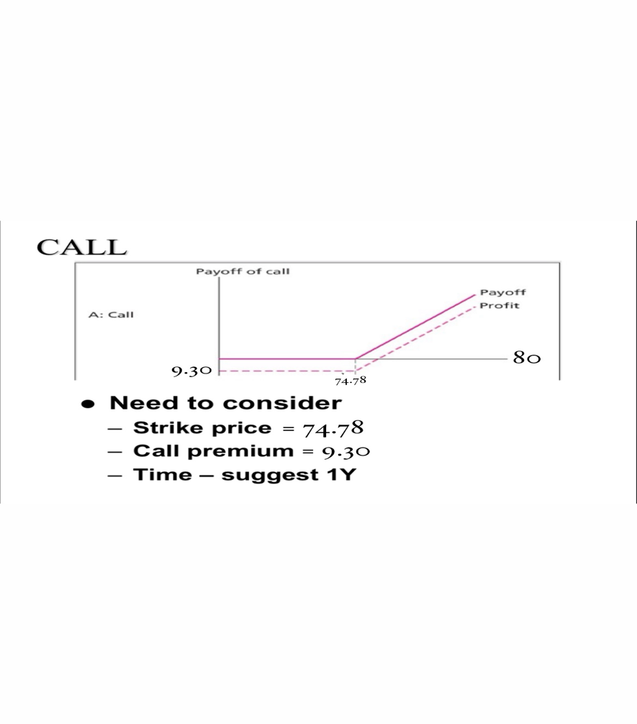
Description
- Above mentioned diagram shows the Call option contract pay off. In which the Expiry selected is January 17, 2025.
- The initial X shows the Strike Price which is 74.78.
- The initial C shows CallPremium which is 9.30.
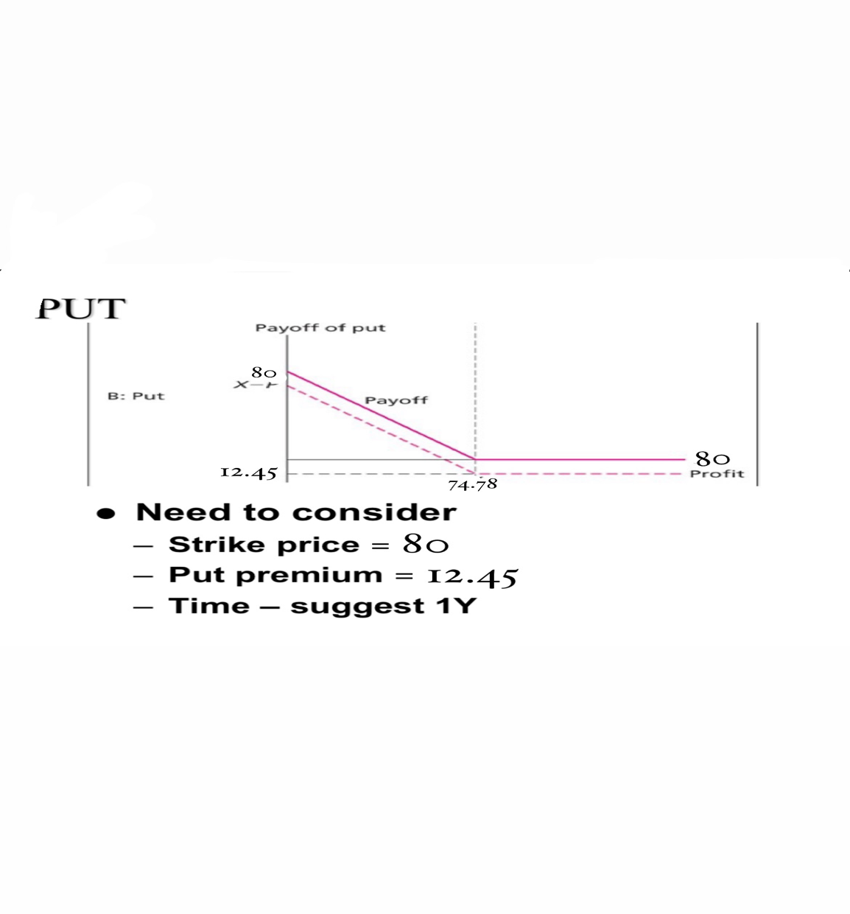
Description
- Above mentioned diagram shows the Put option contract pay off. In which the Expiry selected is January 17, 2025.
- In which the initial X shows the Strike price Which is 80.
- Initial P shows the putpremium which is 12.45.
- And ST shiws the selected stike which is 80.

