
Analyze the operation status of Accor Hotel under the impact of the pandemic

18 March 2022

Zhenghao Zhang (2103114)

A report submitted in fulfilment of the requirements for Course BMBM6016, Strategic Marketing, University of Wales Trinity Saint David.

Executive Summary

Economic development is closely related to everyone's life. Under this consensus, developing the world economic system can be conducive to the sustainable development and cultural exchanges of the whole society, which also makes the development of Commerce, education and technology more prosperous, but it is also fragile. The impact of covid-19 pandemic on the economic system at the end of 2019 has delayed and declined the development of Commerce, trade, infrastructure and stock market. All countries have paid high attention to this impact and taken appropriate measures in order to maintain their social stability and development. In this context, the report will take Accor hotel as a research case to analyze the development of Accor hotel under the pandemic situation, understand the impact of the pandemic on the hotel industry, and provide some appropriate suggestions for the development of Accor hotel according to the analysis content.

Table of Contents

Executive Summary 1
1.0 Introduction 3
2.0 Backgrounds 3
3.0 Main Findings 4
3.1 The PESTEL Model 4
3.1.1 Political Factors 4
3.1.2 Economic Factors 5
3.2 The SWOT Model 6
3.3 The Porter's five force Model 8
3.4 McKinsey’s 7s Model 9
4.0 Recommendations 11
5.0 Conclusion 12
Reference 13

1.0 Introduction

A stable social environment is the foundation of development. It is on this premise that many developing and developed countries can achieve social progress. Under this consensus, most countries are committed to peaceful development. (Galtung, 2005). Igbuzor (2011) also pointed out that many developed and developing countries have officially prospered because they have a sufficient stable and long-term development space. The long-term peace and social development have also jointly promoted exchanges and cooperation between different cultures and countries, thus promoting the development trend of regional cooperation and economic globalization. However, covid-19 virus broke out at the end of 2019. Due to its high transmission rate and mortality, the pandemic has had a great impact on global social stability. In particular, some countries have taken strict traffic restrictions, which has had a great impact on tourism and offline physical stores, the chain reaction brought by this impact also has an impact on other industries (wachyuni & kusumaningrum, 2020). In this case, AccorHotels group is used as a reference to analyze the impact of the pandemic on the hotel industry.

2.0 Background

AccorHotels (2022) group is a large French multinational enterprise,which operating in nearly 100 countries. Accor's hotel is the overlord of the European hotel industry, with 40 brands and 5200 hotels around the world. The hotel brand covers the most luxurious hotels to the most economical hotels. And Accor's services are also highly regarded in the global corporate service industry. On June 1, 2015, Accor (2022) announced its name change to AccorHotels. However, the impact of the pandemic on the hotel industry will inevitably affect the operation of AccorHotels. In this context, this report will take AccorHotels as a research case, analyze the operation status of AccorHotels under the pandemic situation through SWOT model, PESTEL model, McKinsey 7S model and Porter's five forces model, and provide reasonable development suggestions according to the analysis results.

3.0 Main Findings

3.1 The PESTEL Model
PESTEL model is a theory to analyze the macro external environment of enterprises. It includes political, economic, social, technological, legal and environmental factors. Although these factors are not under the control of the enterprise, these macro factors may have an impact on the development of the enterprise (Professional Academy, 2022).The impact of the pandemic on the macro environment is an important factor that AccorHotels needs to pay attention to. For example, the entry-exit restrictions of the United States, China and other countries will inevitably have an important impact on the tourism and hotel industry. In addition to this policy factor, there are also the effects of rising prices and political conflicts between different countries (Jordan Martin et.al, 2020). This report will deeply analyze the impact of political factors and economic factors on the Accor Hotel through this model

3.1.1 Political Factors
Political participation is an important means to maintain social stability. Therefore, in the context of the pandemic, political participation will be frequent and influential. In this context, it will be valuable to analyze the impact of political factors on the hotel industry.
Among the countries responding to the pandemic crisis, the Chinese government should be the country with the earliest and most stringent response to the crisis (Wu, Benjamin & Macmahon, 2016). During the epidemic period, restricting population mobility has become the main direction of policy-making. The main policies include restrictions on personnel entry and exit country and regional closure. However, such policies are related to the situation of the epidemic and will be implemented when the government believes that the epidemic can not be controlled. Therefore, such policies are difficult to predict. At the same time, the stagnation of population flow has seriously affected China's physical industry and economic development(Zhang & Qian, 2020). The report of Radio France International (2020) points out that China closed 460000 enterprises in the first quarter of 2020, while the tourism industry, the hotel industry and other service industries have become the most seriously affected areas in the pandemic. Alcántara-Ayala, et.al, (2021) also pointed out that with the development of the pandemic, most countries in the world have also begun to formulate some policies to limit population mobility. Moreover, Alcántara-Ayala. et.al, also pointed out that the complexity of the virus makes it difficult for the society to predict when the pandemic will end. This means that in this environment, policies related to restricting population mobility may exist for a long time, the restriction of population mobility will inevitably reduce the number of customers in the hotel industry, which will have an unpredictable long-term negative impact on the operation of AccorHotels.

3.1.2 Economic Factors
Economic factors have a significant impact on the way organizations conduct business and their profitability. It includes interest rate, economic growth, inflation, exchange rate,disposable income of consumers and enterprises and other factors. These social factors will directly affect how marketers understand customers and the factors driving them (Baron & Baron, 2003). During the pandemic period, the delay and recession of economic development is the most obvious social sign (Adhan & prabheesh, 2021). Assaf, et.al (2017) believed that the change of exchange rates was related to the development of the hotel industry. Because under the influence of the epidemic, the global trade supply chain is seriously affected, and the trade balance between different countries may be broken, which will directly affect the exchange rate trend between the two countries (Asahi.et.al, 2021). In this context, most industries are facing finance crisis.

Table 1. 2020 Exchange Rates data (ACCOR,2021).
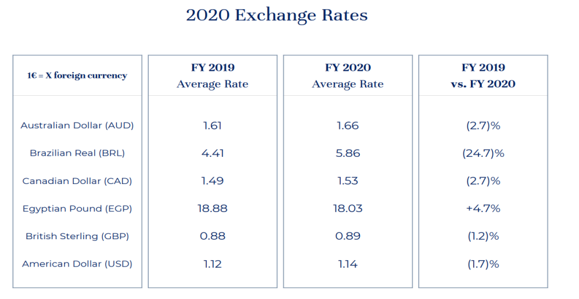
Source from:ACCOR,(2021),Ful-Year 2020 Results presentation

As a multinational group, the sharp fluctuation of exchange rate may cause financial losses. Table 1 compares the exchange rate relationship between the euro and different currencies in 2019 and 2020. Although most exchange rate fluctuations tend to be stable, there are also large exchange rate fluctuations of a few currencies. For example, the exchange rate of the euro against Brazilian real (BRL) increased by 24.7%, which means that the BRL depreciated by 24.7% relative to the euro, This means that Accor's income operating in BRL currency area has a higher risk of exchange rate loss. Since Accor hotels operates in nearly 100 countries around the world, it will have to face the financial risk caused by exchange rate fluctuations，And financial risks caused by exchange rate fluctuations, and exchange rate fluctuations may also put pressure on overseas investors and suppliers, which will affect the relationship between Accor hotels and them.

3.2 The SWOT Model
SWOT model is a strategic planning and management technology. Its analysis scope includes the strengths, weaknesses, opportunities and threats of the organization (Kenton, 2021). AccorHotels, as a global chain of large hotel groups, must have industry advantages and capabilities. Analyzing the advantages of AccorHotels is not only an important symbol to distinguish it from its competitors, but also a source for enterprises to enhance their confidence in coping with the crisis.

Compared with Marriott, IHL and other hotel groups, AccorHotels has a hotel management advantage. As of 2019, AccorHotels has 4892 hotels and 40 brands, which 2974 are located in the European region, which makes AccorHotels occupy 47% of the number of rooms in Europe. But this is a huge challenge for the management of AccorHotels (Damnjanović, Lončarić & Dlačić, 2020). Because in the epidemic environment, the management mode will determine the efficiency of enterprises to deal with the crisis and the ability to maintain the normal operation of enterprises.

AccorHotels owns more than 4000 hotels, 75% of which are directly operated by the group, which is quite different from the main authorized Marriott hotels. The biggest advantage of the direct management model is that it can quickly implement the group's new plans(TravelDaily, 2016). This will facilitate the flexibility and efficiency of the hotel in managing its multiple brands during the pandemic. Meanwhile, AccorHotels adopts a digital management system. Hudson and Hudson (2017) pointed out that digital tools enable enterprises to have low-cost marketing and personalized publicity capabilities. In addition, Parvez, S. J., et.al (2018) also pointed out that hotels' optimization of digital platforms can improve hotel performance. Amalia and Alexandru (2014) believes that the reason why AccorHotels has become the overlord of European hotels is that it has realized through the management mode. The advantages enable AccorHotels to obtain a huge European market share and influence. Therefore, in the context of the pandemic，this digital direct management mode will enable Accor hotels to save a lot of time and cost and improve the unity of overall management in response to the crisis. At the same time, the digital system also helps enterprises collect and share the latest market data in real time, which will further improve the management ability of enterprises.

3.3 The Porter's five force Model
Porter's five forces model understands the current organization's competitiveness by analyzing the organization's 5 competitive forces in its industry (Scott, 2020). The five forces include 1.the competition in the industry, 2.the potential of new entrants in the industry, 3.the power of suppliers, 4.the power of customers and 5.the leads of alternative products.

After analyzing the internal and external environmental factors and competitive factors of AccorHotels enterprises, industry analysis is also an important factor for enterprises to make decisions. Under the influence of the pandemic, the hotel industry is in recession. In this special period, through Porter's five forces model analyzes the influence of the power of customers on AccorHotels.

Table 2. International Tourism and covid-19. UNWTO (2022).
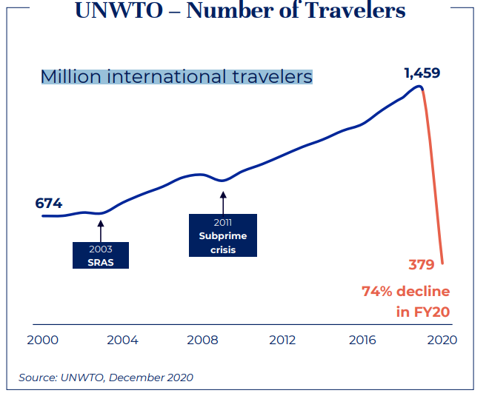

Table 2 shows that due to the rapid decline of tourism and the implementation of restrictive measures, the number of international tourists has decreased from the highest 1459 million before the pandemic to the lowest 379 million in 2020. The number of international tourists has decreased by 74%. The sharp decline in the number of customers has made the hotel industry in a state of over saturation, which means that the hotel industry is facing a serious industry crisis, For example, according to the data of IBIS world (2021), the number of hotels in the United States decreased from 94619 in 2019 to 77870 in 2020, which means that a large number of hotels are facing serious problems such as poor management, reducing the number of operators in the whole hotel industry, and all operators in the hotel industry have to take measures to maintain the operation of hotels. For example, selling some hotels or lowering (Arabadzhyan, Figini & Zirulia, 2021). Although the number of hotels is decreasing rapidly, the hotel industry is still in a state of over saturation relative to the reduction of the number of customers, this trend will intensify the competition level of the whole industry.

Table 3. AccorHotels’ Revenue Per Available Room data (ACCOR,2021).
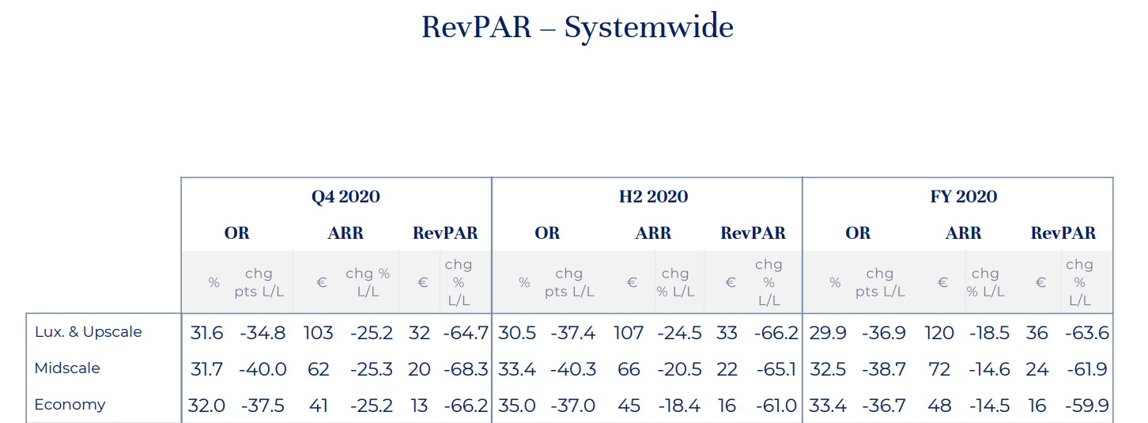
Source from:ACCOR,(2021),ReVPAR as of December 31,2020.

For AccorHotels, the sharp decline in the number of customers in the market will directly affect the revenue of the hotel. The data in Table 3 shows the revenue per available room data (RevPAR) of luxury, medium and economy hotels under AccorHotels group in 2020. The RevPAR data of luxury brand hotels in fiscal year 2020 is -63.6%, that of mid-scale brand hotels is -61.9%, and that of economy brand hotels is -59.9%. Therefore, in the industry, the drastic change in the number of customers will directly affect the development of the whole industry, and AccorHotels with a large number of hotels may face operating losses caused by reduced revenue.

3.4 McKinsey’s 7s Model
McKinsey 7S model points out that there are 7 important factors for business development, that including structure, system, style, staff, skill, strategy and shared values (Kenton, 2021). Strategy is an important factor affecting the long-term development of an enterprise. In particular, AccorHotels group is currently facing economic recession and pandemic crisis. How to adjust the strategy will be one of the important means for the hotel to deal with the current crisis and stabilize the development of the enterprise. Therefore, the report will focus on analyzing the impact of the pandemic on the strategic factors of AccorHotels through this model.

AccorHotels adopted the brand diversification strategy before the pandemic. The strategic combination of digital marketing strategy and loyalty program has made AccorHotels global hotel market a great success. AccorHotels Group has not only obtained a large market share, but also brought great benefits to Accor Hotel's brand reputation and Finance (Demirçiftçi & Kizilirmak,2016). However, the outbreak of the pandemic has forced the global market environment to change rapidly, and strategy is closely related to the internal and external environment of the organization. The analysis of the above three models shows that Accor's internal environment is facing pressures from its declining financial capabilities. At the same time, the external environment of the organization is facing changes in factors such as reduced customers, intensified industry competition, exchange fluctuation and Policy factors. This means that the change of the internal and external environment of the organization has greatly reduced the value of Accor's strategic portfolio. At the same time, the hotel industry is also facing the changes in customer expectations.

Table 4. The Customer expectations Survey (ACCOR,2021).

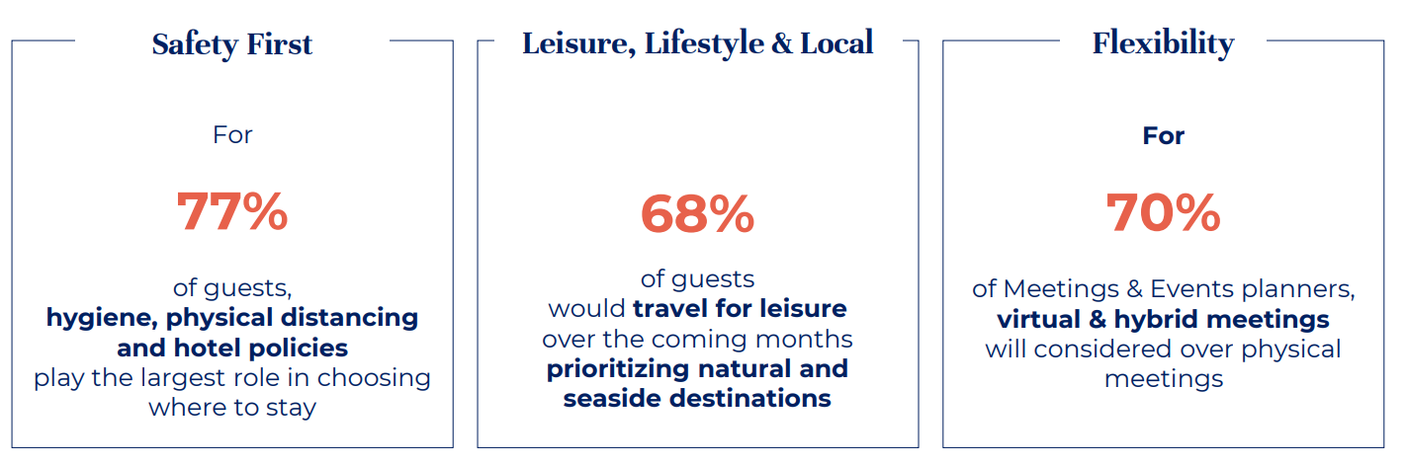
Source from:ACCOR,(2021),Ful-Year 2020 Results presentation

Table 4 shows that in Accor's market survey, customers pay more attention to safety, flexibility and give priority to hotels located in natural and seaside. In addition, according to the World Tourism and Tourism Council's assessment (Faus, 2020), the recovery time for tourism is about 10-35 months. Under the background of great changes in the internal and external environment of the organization, AccorHotels needs to adapt to the current environment and make appropriate strategic adjustments.

4.0 Recommendations

The impact of the pandemic on the hotel industry is extensive and unified. The depression of the industry is a common challenge to all hotel operators. Under the background of this special period, the current main goal of AccorHotels group should be to maintain the overall business state and win the trust of investors. In this regard, this report will provide three suggestions based on the above analysis. Under the background of economic depression and the reduction of the number of customers, the advantage of economy hotel business will be an important competitive advantage for enterprises to obtain stable income. Therefore, AccorHotels can improve the market competitiveness of different brands of AccorHotels through price strategy. In addition, the development of the pandemic also makes it difficult for some competitors in the industry to operate or withdraw from the market. For the long-term development of AccorHotels, AccorHotels can consider markets outside Europe and increase market share by purchasing some brands or hotels at a low price. Reducing operating costs is an effective way for the hotel industry to improve the operating capacity of enterprises in the pandemic environment. Therefore, hotels can consider temporarily closing some low yield hotels to reduce unnecessary costs.

5.0 Conclusion

The global impact of the pandemic is huge. The overall economic recession makes most industries in a recession cycle. In this context, AccorHotels group, as one of the excellent operators in the hotel industry, is also facing great challenges. The change of the external environment has led to a sharp decline in the number of customers of the hotel industry and exchange rate fluctuations. In the analysis of the internal environment of the enterprise, AccorHotels relies on the strategic combination in the pre pandemic period, Brand image and management make AccorHotels still maintain a certain market competitive advantage in the hotel industry, which makes the hotel still get enough income guarantee during the pandemic. However, the analysis of McKinsey 7S model shows that AccorHotels’ strategic factors are affected by the pandemic and face difficulties, which requires AccorHotels to re-examine its corporate strategy in the pandemic environment. At the same time, the hotel industry is also facing industry pressure from suppliers and price competition. These analysis conclusions show that although AccorHotels is an excellent operator in the hotel industry, it also has to face great challenges in the environment of the overall market depression.

Word count 2650

Reference

- ACCOR (2022).Historical data. [Online] Available at: https://group.accor.com/en/finance/accor-share/historical-data [Accessed: 7 March 2022]
- ACCOR,(2021), Ful-Year 2020 Results presentation. [Online] Available at: https://group.accor.com/en/finance/events-and-announcements/annual-and-half-yearly-information [Accessed: 8 March 2022]
- ACCOR,(2021), ReVPAR as of December 31,2020. [Online] Available at: https://group.accor.com/en/finance/events-and-announcements/annual-and-half-yearly-information [Accessed: 7 March 2022]
- Accor (2022) Our history. [Online] Available at: https://group.accor.com/en/group/who-we-are/our-history [Accessed: 11 March 2022].
- Accor (2019). Accor-H1-19 Results-vDef. [Online] Available at: https://group.accor.com/en/finance/events-and-announcements/annual-and-half-yearly-information [Accessed: 9 March 2022]
- Accor (2022)Accor Overview. [Online] Available at: https://group.accor.com/en/group/who-we-are/accor-in-brief [Accessed: 11 March 2022].
- Alcántara-Ayala, I., et.al (2021). Root causes and policy dilemmas of the COVID-19 pandemic global disaster. International Journal of Disaster Risk Reduction, 52, 101892.
- Amalia, G., & Alexandru, G. (2014). Current State of European Hotel Chains. Ovidius University Annals, Series Economic Sciences, 14(2).
- Arabadzhyan, A., Figini, P., & Zirulia, L. (2021). Hotels, prices and risk premium in exceptional times: The case of Milan hotels during the first COVID-19 outbreak. Annals of Tourism Research Empirical Insights, 2(2), 100023.
- Assaf, A. G., et.al (2017). Destination characteristics that drive hotel performance: A state-of-the-art global analysis. Tourism Management, 60, 270-279.
- Asahi, K. et.al (2021). The effect of COVID-19 on the economy: Evidence from an early adopter of localized lockdowns. Journal of global health, 11.
- Baron, D. P., & Baron, D. P. (2003). Business and its environment (p. 2). Upper Saddle River, NJ: Prentice Hall.
- Damnjanović, V., Lončarić, D., & Dlačić, J. (2020). TEACHING CASE STUDY: Digital marketing strategy of AccorHotels: shaping the future of hospitality. Tourism and hospitality management, 26(1), P.236
- Faus, J., (2020). This is how coronavirus could affect the travel and tourism industry. [Online] Avialble: https://www.weforum.org/:https://www.weforum.org/agenda/2020/03/world-travel-coronavirus-covid19-jobspandemic-tourism-aviation [Accessed: 9 March 2022]
- Demirçiftçi, T., & Kizilirmak, İ. (2016). Strategic branding in hospitality: Case of AccorHotels. Journal of Tourismology, 2(1), 50-64.
- Galtung, J. (2005). Meeting basic needs: peace and development. The science of well-being, 475-502.
- Hudson, S., & Hudson, L., (2017). Marketing for tourism, hospitality & events: a global & digital approach. Sage.
- IBIS World (2021). Hotels & Motels in the US - Number of Businesses 2005–2027. [Online] Available at: https://www.ibisworld.com/industry-statistics/number-of-businesses/hotels-motels-united-states/ [Accessed: 9 March 2022].
- Igbuzor, O. (2011). Peace and security education: A critical factor for sustainable peace and national development. International journal of peace and development studies, 2(1), 1-7.
- Jordan-Martin, N. C., et.al (2020). Isolation hotels: a community-based intervention to mitigate the spread of the COVID-19 pandemic. Health security, 18(5), 377-382.
- Kenton. W., (2021). How SWOT (Strength, Weakness, Opportunity, and Threat) Analysis Works. Investopedia. [Online] Available at: https://www.investopedia.com/terms/s/swot.asp [Accessed: 11 March 2022].
- Kenton, W., (2021) Understanding the McKinsey 7S Model. Investopedia. [Online] Available at: https://www.investopedia.com/terms/m/mckinsey-7s-model.asp [Accessed: 10 March 2022].
- Parvez, S. J., et.al (2018). Digital marketing in hotel industry. International Journal of Engineering & Technology, 7(2.21), 288-290.
- Padhan, R., & Prabheesh, K. P. (2021). The economics of COVID-19 pandemic: A survey. Economic analysis and policy, 70, 220-237.
- Professional Academy (2022) Marketing Theories – PESTEL Analysis. [Online] Available at: https://www.professionalacademy.com/blogs/marketing-theories-pestel-analysis/ [Accessed: 10 March 2022].
- RFI (2020). China closed 460,000 companies in the first quarter - Radio France International. [Online] Available at: https://www.rfi.fr/cn/%E4%B8%AD%E5%9B%BD/20200406-%E5%8F%97%E6%96%B0%E5%86%A0%E7%96%AB%E6%83%85%E5%86%B2%E5%87%BB-%E4%B8%AD%E5%9B%BD%E9%A6%96%E5%AD%A3%E5%BA%A646%E4%B8%87%E5%AE%B6%E5%85%AC%E5%8F%B8%E5%80%92%E9%97%AD [Accessed: 11 March 2022].
- Scott, G., (2020) Porter’s 5 Forces. Investopedia. Available at: https://www.investopedia.com/terms/p/porter.asp [Accessed: 8 March 2022].
- TravelDaily (2016). Accor CEO of Hotel Group describes its investment and business strategy. [Online] Available at: https://www.traveldaily.cn/article/105740 [Accessed: 9 March 2022].
- UNWTO (2022). International Tourism and covid-19. [Online] Available at: https://www.unwto.org/international-tourism-and-covid-19 [Accessed: 8 March 2022].
- Wachyuni, S. S., & Kusumaningrum, D. A. (2020). The effect of COVID-19 pandemic: How are the future tourist behavior. Journal of Education, Society and Behavioural Science, 33(4), 67-76.
- Wu, Y., Benjamin, E. J., & MacMahon, S. (2016). Prevention and control of cardiovascular disease in the rapidly changing economy of China. Circulation, 133(24), 2545-2560.
- Zhang. K., & Qian. Q., (2020). The impact of COVID-19 on China's economy and policy discussion. Tropical Geography, 40(3), 396-407.

