LCCB4005: The Global Business Environment
Assessment 1

Name: Mihaela Madalina Calugaru
Student ID: 2013036
Module Title: LCBB4005 The Global Business Environment
Module Lecture’s Name: Dr. Jhon-Paul Okeke

Table of Contents
Introduction 3
Analysing the impact of the pandemic in the fashion industry 4
Explain the major forces that have shaped the business environment of the fashion industry. 4
Assessing the opportunities and challenges that these forces have presented to the key players in the fashion industry 5
Explaining why and how some firms have been able to adapt better than others to this changing business environment. 5
Conclusion’ 6
References 7

Introduction
Businesses are vulnerable to their surrounding environments if the organisation continues to ignore the influence of the external environment (Bruijl, 2018). The fashion industry is one of the most contributing industries of the economy but now the industry is affected severely by the global pandemic (Akpoviroro and Owotutu, 2018). The Major environmental forces that shape the industry include macro and micro forces of the business environment. The macro forces include economic recession, mandatory lockdowns, and closed national borders, a ban on social gatherings and festivals, a production halt, and legal regulations that are affecting the industry and influencing its consumer behaviours to shift. On the other hand, the micro forces of the business environment are changing the landscape of doing business for the fashion industry as pandemic has created tension, lack of supplies and halt in international markets (Doh et al., 2019). Though having so much struggle and uncertainty within the industry, the changes that occurred within the fashion industry are reshaping with new growth opportunities, for example, the expanding online market of the Fashion industry. In addition to this, the firm is offering competitive prices with proper execution of the business plan with examining the trends in external environmental forces are having better adaptability with pandemic affected economy.

Analysing the impact of the pandemic in the fashion industry
The Fashion industry in the United Kingdom is one of the major sectors that nourish the economy with employment and great exporting opportunities (Epure, 2017). According to recent statistics, the fashion industry contributes £26 billion to the national economy and responsible for around 800,000 employment opportunities. Fashion includes products that range from makeup, clothing, footwear, lifestyles, etc (Fozer et al., 2017). Though being one of the strongest industries and contributors to the economy, COVID 19- The global pandemic has severely damaged the fashion industry impacting the lives of several million people. After the occurring worldwide pandemic, the production line and export of fashion apparel has come to halt and the whole industry has shifted to tackling the challenges of uncertain production lines. With the emergence of COVID 19, the consumers' behaviours have certainly changed their patterns and most of the garments factories and organisations related to apparel products have to be a great loss. (Ghicajanu, 2019) But only the matter of hope is seen by the e-commerce fashion companies with their online sales. Moreover, the customer has changed their feelings for products as they have significantly reduced their spending on luxurious clothes and shifted to way cheaper items to satisfy their clothing needs.

Explain the major forces that have shaped the business environment of the fashion industry.
The business environment has a great influence on shaping the future of the fashion industry around the globe. The industry has major involvement in the life of common people through employment and serving them with quality fashion apparel. But recently, the industry has been badly affected by pandemics and for continuing the future pathway of growth, the industry must have a proper understanding of the external environmental forces (Hamilton and Webster, 2018). Usually, the external environmental forces refer to the elements of the business environment which has deep influence though uncontrollable for the business organisations. In such conditions, the business organisation must keep its eye close to the external environmental forces and design its strategies according to environmental impact and situations around them. The external environment is comprised of two forces: Macro environmental forces and Microenvironmental forces (Hynes et al., 2020). To gather insights regarding the macro-environmental forces of the fashion industry, the pestle framework will be a good option to consider as pestle include the major national-level forces that have a profound impact on the businesses. On the other business side of the business environment comes with micro-level forces. The micro lever forces are the external environmental elements that have a direct impact on the operational activities of the business organisation (Macchion et al., 2017). The subsequent secti0n will uphold both of the external environment:
Major Macro environmental forces of Fashion Industry:
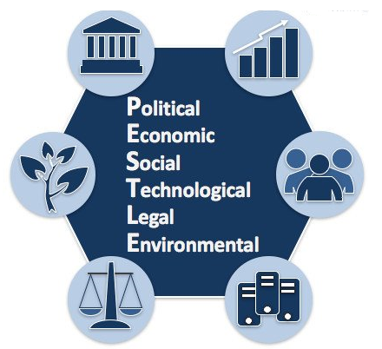
Figure 1: Macro environmental forces of Fashion Industry (Achinas et al., 2019)
Political forces: The political impact of the pandemic has brought the political leaders to pose an emergency production half. With the increasing spread of COVID 19, the fashion industry has come to uncertain futures. Again, the BREXIT has put pressure on the fashion industry of the country regarding the trade policies and regulations. In contrast, the Government of the United Kingdom has a positive attitude towards the growth of the fashion industry and provides tax incentives in fashion cloth wear exports
Economic forces: After the global pandemic along with the world economy, the economy of the United Kingdom is undergoing a recessionary period (Peng et al., 2017). For this reason, the fashion products have seen great drops in their export quantities, as well as the production units of the country, are shifted to countries with cheaper production costs (Perera, 2017). The economy of the fashion industry is now moving from retail stores to online e-commerce sites and the global brands adopting online business practices to sustain their ventures.
Social forces: Social practices have influenced the clothing sectors as the United Kingdom is one of the rich countries in fashion and designing universities and destination of world’s popular brands (Peng et al., 2017). Moreover, United Kingdom is well-known for its vivid and colorful fashion weeks and encourages millions of fashion enthusiasts to join. Though after the exposure of COVID, this has shifted to online
Technological forces: With the adoption of Technological efficiency, the online market of the fashion industry has tremendously growing overtimes. The well-established brands of the United Kingdom for example Next, Debenhams, and Primark are now available for online shopping (Sharma et al., 2020). As COVID has posed uncertain lockdowns in the cities of the United Kingdom, customers are showing interest and trust in e-commerce platforms.
Environmental forces: The environmental impact of the fashion and clothing industry is huge as the section is highly dependent on energy and water consumption. According to statistics, the production of 1-kilometer cotton takes more the 10000-liter waters as well as people wastes their purchased clothes which contributed to increasing environmental degradation (Shtal et al., 2018). For this reason, the climate experts have claimed that the fashion section is one of the most challenging in terms of environmental sustainability.
Legal forces: The fashion industry of the United Kingdom is dependent on the supply of raw materials and production plants in foreign countries which has come up with a challenge for the organisation (Singh and Sonwaney, 2020). if the countries attribute a higher level of tax burden and tariffs on these key raw materials supply, the profitability of the companies significantly suffers.

Microenvironmental forces of the fashion industry:

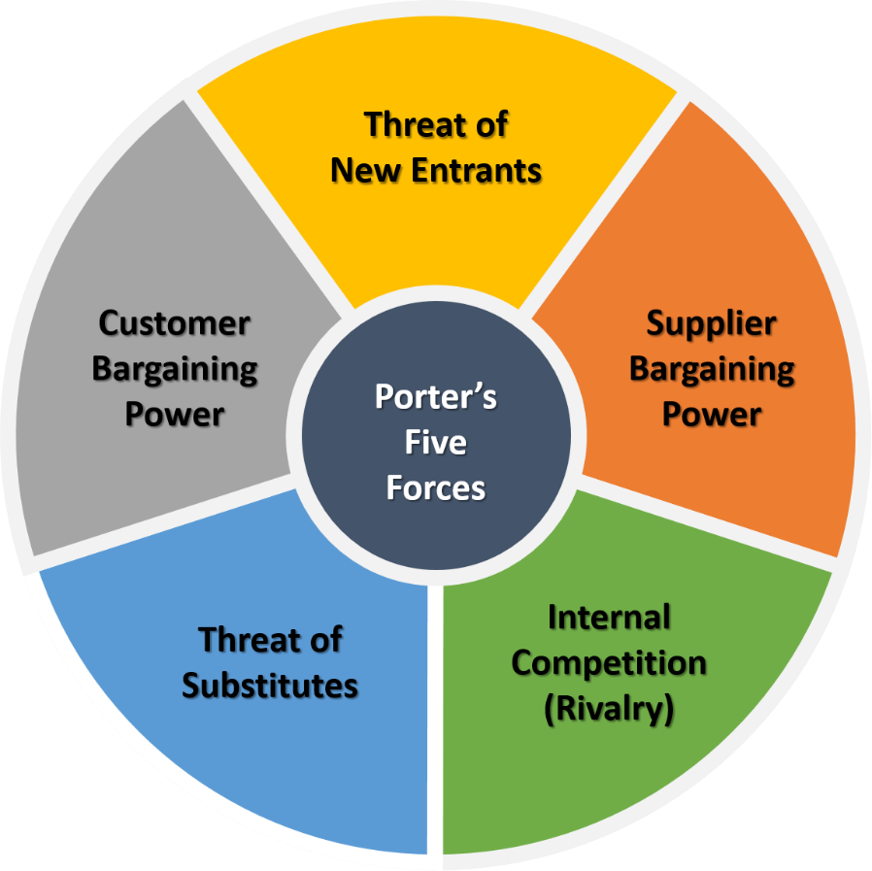
Figure 2: Microenvironmental analysis of Fashion industry (Ghicajanu, 2019)
The threat of new entries: Setting new factories in fashion is quite an easy task though the organisation suffers in creating loyal customers and brand values as the market is already undergoing extensive competition. The fashion industry has little chance of getting threats from new entrants.
The threat of suppliers: The shortage in supplies has temporarily increased the supplier power and they are increasing the prices of raw material. In general, the raw material is purchased from developing nations and the suppliers have low concentration with themselves which made the task easy for the fashion brands to attain raw material at low cost.
The threat of buyers: The ability of buyers' powers decreases as they have to undergo a sheer drop in income due to the exposure of the global pandemic. Though having switching powers to many fashion brands at low cost, the customers have low buying concentration to actively dominate the markets as well as to pose any significant threats (Tashanova et al., 2020).
The threat of substitutes: The number of substitutes in this industry is close to zero and the industry is enjoying its superiority against others.
The threat of existing rivalry: The fashion industry in the United Kingdom is dominated by a large series of competing brands and they include Next, Primark, Tesco, Debenhams, etc. To survive in the fierce markets, the major players in the fashion industry take strategies of cost leadership, product differentiation, and customer loyalty, etc (Varelas and Georgopoulos, 2017).

Assessing the opportunities and challenges that these forces have presented to the key players in the fashion industry
The fashion industry has seen a dramatic change in the behaviours of the consumers and the policy of the industry has been shifted with the global pandemic. Form this, the organisations will likely face new challenges and opportunities to overcome their loss (Tashanova et al., 2020). The key player of the fashion industry in the UK includes ASDA, Primark, Next, Tesco, Marks, and Spencer, etc. With global changes around the economic, political and social factors of the world, the potential challenges for the key player of the industry include the following:
Political Instability and insecurity: With the inclusion of BREXIT, the political environment for the United kingdom is certainly having hard times. The organisation must keep them ready to adapt to the changing scenarios.
High Competition from Existing brands: The competition for getting a higher market share among the existing brands has created challenges for the organisation to obtain cost leadership maintaining product quality.
Increasing Labour costs: Though the production houses are shifted to low labor cost intensive countries, the organisation will likely face higher costs due to the surge of labour unions and human rights groups (Singh and Sonwaney, 2020).
Pressure from environmental groups: The environmental cost of the fashion industry is comparatively high and the environmental groups are against investing more in this industry (Varelas and Georgopoulos, 2017). Moreover, the organisation needs to maintain green policies in their factories which is augmenting the total costs of production.
The need for a specialised labour force: The need for a skilled labour force is taking rapid shape and the industry must generate skilled labour to balance the future production requirements and efficiency.
The upcoming opportunities for the Fashion industry
- Expanding online Markets
- Attractive fashion brands
- Increasing market audience
- High profitability and growth opportunities

Explaining why and how some firms have been able to adapt better than others to this changing business environment.
The business environment constantly evolves with time and the organisation operating in an industry must keep its close eyes on the changing trends. The organisation that can keep itself adaptable and quickly aligned with such changes gets superiority in attaining high-profit margin and sustainability in the business in comparison to those business organisations that can’t (Macchion et al., 2017). The subsequent section will analyse the key reason for better adaptability of organisation with changing business environment:
Comprehensive Business plan: Comprehensive business plan is the way organisation carefully plan their future activities and design their goals considering key elements of the business environment. With the help of a comprehensive business plan, the organisation attains flexibility in their operation and quickly manage the risks arising from their surroundings (Peng et al., 2017). For this reason, organisations that have comprehensive plans and preparation can easily adapt and tackle the uncertain changes in the environment.
Competitive pricing strategies and product leadership: With COVID19, the income of general people has significantly reduced and they are looking for a cheaper option with quality products (Sharma et al., 2020). Here, the strategy of competitive pricing with good product leadership helps the organisation to quickly adjust the sales volume that is declining due to the recessionary period of the industry.
Examining the influence of Environmental factors: As the business organisations are very impactful with the changes in the environment. The organisation must timely check the influence and trends of the surroundings and draw the pathways to get a quick recovery in an uncertain situation like a pandemic.

Conclusion
Businesses must prepare themselves before uncertainties and unwelcomed events hamper their business performance (Hynes et al., 2020). For this reason, the organisation must map out their surroundings as well as keep track of the changing events. From the analysis of the fashion industry of the United Kingdom, the COVID pandemic has seriously threatened the existing market structure and business of the industry. In this aspect, the role of external factors such as competition, economic recession, and BREXIT, and global lockdowns has played a major role. Though most of the companies are looking to recover their financial position by taking online business approaches and opening a new dimension of the fashion industry(Macchion et al., 2017). The industry has many opportunities and challenges to overcome and the organisation that has better preparation will get an advantage in quick adaptability.

References
Achinas, S., Horjus, J., Achinas, V. and Euverink, G.J.W., 2019. A PESTLE analysis of biofuels energy industry in Europe. Sustainability, 11(21), p.5981.
Akpoviroro, K.S. and Owotutu, S.O., 2018. Impact of external business environment on organizational Performance. IJARIIE, 4(3), pp.498-506.
Bruijl, G.H.T., 2018. The relevance of Porter's five forces in today's innovative and changing business environment. Available at SSRN 3192207.
Doh, J.P., Tashman, P. and Benischke, M.H., 2019. Adapting to grand environmental challenges through collective entrepreneurship. Academy of Management Perspectives, 33(4), pp.450-468.
Epure, M., 2017, July. University-business cooperation: adapting the curriculum and educational package to labor market requirements. In Proceedings of the International Conference on Business Excellence (Vol. 11, No. 1, pp. 339-349). Sciendo.
Fozer, D., Sziraky, F.Z., Racz, L., Nagy, T., Tarjani, A.J., Toth, A.J., Haaz, E., Benko, T. and Mizsey, P., 2017. Life cycle, PESTLE and multi-criteria decision analysis of CCS process alternatives. Journal of cleaner production, 147, pp.75-85.
Ghicajanu, M., 2019. Analysis of factors from the external environment in changing business processes. In MATEC Web of Conferences (Vol. 290, p. 07008). EDP Sciences.
Hamilton, L. and Webster, P., 2018. The international business environment. Oxford University Press.
Hynes, W., Trump, B., Love, P. and Linkov, I., 2020. Bouncing forward: a resilience approach to dealing with COVID-19 and future systemic shocks. Environment Systems and Decisions, 40, pp.174-184.
Macchion, L., Moretto, A.M., Caniato, F., Caridi, M., Danese, P. and Vinelli, A., 2017. International e-commerce for fashion products: what is the relationship with performance?. International Journal of Retail & Distribution Management.
Meyer, A.D., 2019. Adapting to environmental jolts. Administrative science quarterly, pp.515-537.
Peng, F., An, N. and Vecchi, A., 2017. Cross-Cultural Study of Online User Behavior in Fashion E-Commerce: A Comparison of Britain and China. In Advanced Fashion Technology and Operations Management (pp. 277-293). IGI Global.
Perera, R., 2017. The PESTLE analysis. Nerdynaut.
Sharma, P., Leung, T.Y., Kingshott, R.P., Davcik, N.S. and Cardinali, S., 2020. Managing uncertainty during a global pandemic: An international business perspective. Journal of business research, 116, pp.188-192.
Shtal, T., Buriak, M., Ukubassova, G., Amirbekuly, Y., Toiboldinova, Z. and Tlegen, T., 2018. Methods of analysis of the external environment of business activities.
Singh, S. and Sonwaney, V., 2020. Changing Consumer behavior Dynamic-Impact of COVID-19 in India on Elderly People Adaptability. Psychology and Education Journal, 57(9), pp.4727-4741.
Tashanova, D., Sekerbay, A., Chen, D., Luo, Y., Zhao, S. and Zhang, T., 2020. Investment opportunities and strategies in an era of Coronavirus pandemic. Available at SSRN 3567445.
Varelas, S. and Georgopoulos, N., 2017. Porter’s competitive forces in the modern globalized hospitality sector–the case of a Greek tourism destination. J Tour Res, 18, pp.121-131.
Zwijgers, H., 2020. Adapting to a changing environment in the Mekong Delta: Analysis of socio-economic farm and commune characteristics.

