Assignment Title
Academic and employability skill
Student Name: Adriana Octavia Bostina
Student Number: 1711810
Moodle Name: Academic and employability skills
Moodle Tutor: Peter Allen

Table of contain:
INTRODUCTION_______________________________________________________________________2
CONFIDENCE SKILLS____________________________________________________________________3-4
COMMUNICATION SKILLS_______________________________________________________________4-5
TEAM WORK_________________________________________________________________________ 6-7
TECHNOLOGY SKILLS___________________________________________________________________7-8
REFLECTIVE SKILLS____________________________________________________________________8-9
CONCLUSION _________________________________________________________________________9
APPENDIX___________________________________________________________________________10
REFERENCES_________________________________________________________________________11

Introduction:
The purpose of this reflective report is to analyse the developments of my first year of studies, explaining what skills I have achieve in this time of learning and how I have improved myself overall. The objective of this report is to understand how important are employability and academic skills to obtain a better job. My knowledge was really limited compared to what it is at the moment. In my class I have learned how to speak in an academic term and also it will be really helpful in future for any job interview and how to write a CURICULUM VITAE. Studying at school and at home has made me discover myself better and to improve my skills that I did not have before.
By the time I started my first lectures my main worries were to adjust on different environments of the lectures. In order to adjust I had to understand typology of every teacher that I had for my different lectures.
I would like to show my skills that I have achieved by learning, and they are: Confidence, communication skills, teamwork and technology skills.

Confidence skills:
Self confidence is the belief in your own ability when doing anything by viewing yourself positively and realistically about yourself and your environment. (Densky 2006)
To be honest when I started studying my first think was to improve the confidence, because I was so shy to speak in front of people or maybe for example to have an interview for a job could be a very hard experience for me but I realised that if I learn about what I want to speak to the public it would not be so bad as I thought. For example in my presentation I was for the first time confident and I believed in myself that I can be strong and this thing has happened because I learned and I practiced. Now I am more confident and I feel more certain about myself.my action, my decision and my opinion. I can take and expand more words in order to write an essay and to have more sense. Everywhere I go and everything I do, the confidence helps me to think much more easy about what I want to do and also to achieve my goals and fulfil wishes.
I learned how to be more optimistic, loving, independent, assertive, happier, selfrespect and selfcontrol person and I believe and I know my own abilities. I look more like a confident person with positive body language and good posture. Yes, I learned how to be confident and I am really happy to say that because I wished so much to have this skill and now I got it. And because I have done this task I also learned to trust in myself and to say in my mind that I can do it. When I talk, I walk, I think and feel the confidence is shown.
The first thing that I learned is that is much more easy to be confident when I am thinking positively. I am optimistic and I am powerful with hope, I am more happy.I know the confidence is not a guaranteed success but is my driver to my dreams of success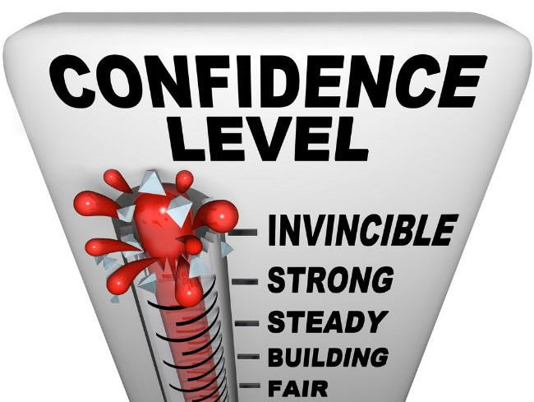Source(https://www.tes.com/teaching-resource/confidence-rating-for-poetry-exams-11612627)

Communication skills
My second skill that I want to discuss about is the communication and I know I am that kind of person that is communicative, very friendly, I make friends very easily. This skill is the most important because I think it can help me in everything I want to do and wherever I go I have to be communicative.
In this module I had the opportunity to develop my communication skills not just theoretically but also practically, facing a reallife environment. My placement made me aware of the importance of interpersonal and communication skills which are very important in delivery of care. Throughout my career, I will be encouraged to develop a reflective practice skill and become a reflective practitioner. In order to effectively communicate with the others you have to know how to communicate with yourself at first, this thing I learned in my class. Within all of our communication activities, listening and responding is perhaps the one we use the most amount of our interpersonal communication skill in our daily life.
Like a parent I believe communication helped me to make me understood by my children and also to have a good relationship with my family. In this module I also learned how to present myself when I have an interview for a job and how to have the ability to communicate effectively with employers.
My communication skills improving my communication has been a work in progress stating back in the semesters of my school. I have always been my worse critic usually beating myself down through interpersonal communication, but it is odd how my feelings about myself changed day by day.
I engaged quite often in interpersonal conversation questioning my motives and encouraging myself to move forward. Also conveyed a strong confidence in my ability to perform my job at a high level. Selfmotivation is one of the traits that I put at the very top of any list of positive attributes. I understand now, in detail, the step to solving a conflict, starting the problem analysing the problem, brainstorming solution and choosing the best one. My listening and communication skills have also greatly improved over the semester. But now I know how to use the listening skills even better, nonverbal communication, feedback and many more strategies to communicate appropriately with people. An di also learned how to registrate a feedback and make changes in the way I am communicated to me. Having good communication skills in your life, to know the successful communication with the others and also I learned that exists too many ways to communicate: verbal, non verbal communication and body language.
Communication skills like listening assertiveness helps information to be processed and more transparent. ( Andrew, M. , Michaela, S. & Paul, K. T 2017)
As a result to analyse my current communication skills I am very happy to say I learned the most of the things from this topic and I think this is the main key to have success in my future because just with communication you can change the world.
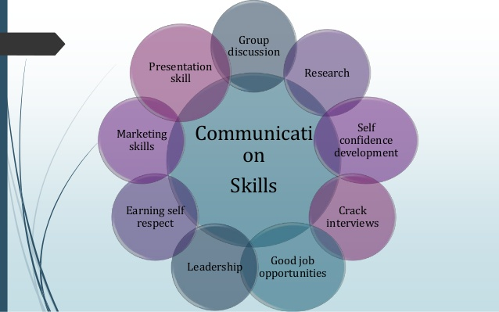
Source:(https://www.slideshare.net/AbhijitJadhav9/communication-skills-for-engineers-69559719)

Team work
About team work I can say too many things because I learned everything about it in all this semester. I learned why it is the best way to work in a team and that is because just together you can achieve more.
I learned that the most good way to be an effective team mate, you must have:
- Good communication
- Social skills
- Positive interdependence (meaning we instead of me)
- Individual accountability and personal responsibility
- Shared goals
- Processes for conflict resolution
Bruce Tuckman offered a model compromising four stages in 1965 advocating this as the ideal group-decision making processes. The stage is:
- Forming
- Storming
- Norming
- Performing (Adair 2004)
Purpose it to be a problem solving toolkit.
Most organisations are concerned with effective teamworking and it is accepted that factors affects team performance are multi-faceted. Empirical studies suggests the validity of belbin’s self-perception inventory (SPI) (ARIZETA et al , 2005) Belbin (1981)
Developed the SPI to identify the behaviour characteristics of individual within a team, thus enabling the creation of effectively functioning team through a creative and appropriate mix (BROUCEK & RANDELL, 1996). An observers further increased validity (BELIBIN ,1994).
I learned as a team that we can have success when communicate effectively with others, appreciating the contribution you are expected to make and when recognizing and understanding their viewpoint.
I the semester I understood the most important and essential to have a good work in a team and relationship is the communication, also the quality of the team to have success is to know how to communicate well with each other, to focus on goals and results, everyone to contribute their fair share, to offer each other support and to be organised and why not to have fun. In life team work can help me achieve my goal much more easy when my team has the same goal.
I think this is the main key to be getting ahead in life.

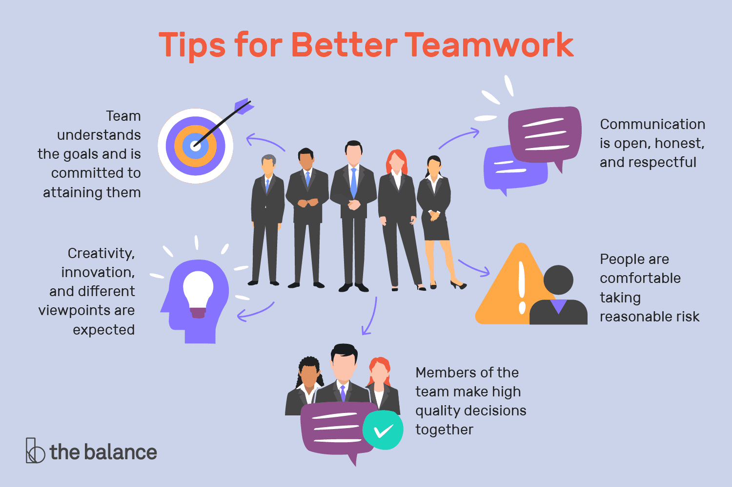
Source:(https://www.thebalancecareers.com/tips-for-better-teamwork-1919225)
Technology Skills:
It is the ability to perform and knowledge the specific task.
Source:(https://www.thebalancecareers.com/technical-skills-list-2063775)
My personal observation has showed me that technology is a positive tool in the class room. It brings advantages in the teaching process both for educators and for learners. Technology can also be a gateway to the vast realism of creativity for us, student, allowing them to participate in activities that they never would have dreamed possible. Despite the shortcomings, technology has a tremendous impact upon education today in the era we are currently in. The technology helps me to have access to information via the internet that before involved trips to libraries. In addition, this access to information can be free for me as a student, by utilizing resources such Wikipedia in a responsible fashion. Technology will be a great asset in my class room, as a motivational aid and teaching tool to help me succeed for example, instead of merely creating a power point presentation. This course had given me more knowledge of the various tools that I was not aware of such as creating my own website/ blogs doing quizzes online, creating rubrics and interactive presentations among other than that I can now proudly say I can master this course has also taught me the skills and concept needed to plan effective lessons that cater for all of us because we have different learning styles.
The use of a teaching platform using technology in educational environment provides chat room, emails, messages, boards or voice recordings which facilitate the communication between us and the people.Since communication is the primary goal inside and outside the class room and are very useful maintain contact with the world.
During this course I also learned that the technology is really important in life to progress and give use possibilities to know new things, brings advantage to learn and I believe the technology can change the world.

Source:(https://blog.beautheme.com/7-hottest-information-technology-skills-in-2016/)
Reflective Skills
In this semester I learned about reflective skills and that this type of skills can be used to driscoll model. This model was developed by JOHN BRISCOLL in 1994,2000 and 2007 with 3 steps question:
‘’What’’?, ‘’So what?’’, ‘’Now what?’’
This type of question helped me to complete the circle and also to remember the questions. This model is ideal for me to develop my reflective writing skills for the first time. Reflection is not to focus on one specific experience, but is to reflect on what I learned and developed in individual and that is what made me achieve in this semester.

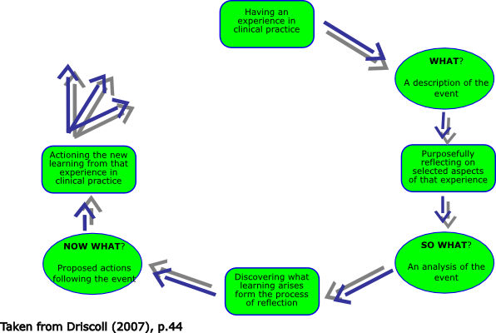
Source:(https://www.pinterest.ca/pin/380483868498818546/)
Conclusion:
This reflective report tried to review and understand this semester of academic studies at university. It reflected upon my expectations and what was delivered in classes, skills that were developed and how to increase my employability, over coming my weaknesses and working on my strength. During this semester my expectations were to learn about academic system to develop my academic writing and skills and to learn the course models subjects and topics. I also learned that engagement is necessary to completely experience my underground year and in order to develop my employability skills. I was able to find out more about my weaknesses and strength and how overcome and develop them. This semester gave me a good base in order to success in my university, a good plan to success in my future, but what was learned needs to be developed in order to graduate in honors.

Appendix:
Curriculum Vitae
Adriana Bostina
Waltham Cross, United Kingdom
07459513783 • adrianabostina4@gmail.com

Personal statement

I am the kind of person that does not give up easily, when I want to achieve something I first assume that is gonna be hard but I know if I work hard I can achieve it.
I have enough experience in work and I am not afraid to try new things.

Work Experience
Quality Control, Abbey View
01/2015 - 05/2017
Responsibilities & Achievements
I worked 2 years ago in a warehouse as a packer. It was a really hard job and my responsibility was to make sure the production is in good condition. I left this job as the timetable of it wasn't good enough for my time. And now in present I found another job at the Reynolds Company that I curently work for.

Cleaner, ReynoldsClick or tap here to enter text.
06/2017 - Present
Responsibilities & Achievements
I was having the task to clean all the offices in the night time and make sure everything is clean in the company.
￼
Qualifications

High School 1 May Ploiesti Romania
1997 - 2001Click or tap here to enter text.
● Romanian - 7
● Maths - 5
● Science – 6

References:
DENSKY, A.B.(2006), Self-Confidence, What Is It And How Do I Get It? Neuro-Vision, Retrieved: October 27, 2007 from http://WWW.neuro-vision.us/Article/Self-Confidence-what-is-it.html
ANDREW M, MICHAELA, S. & PAUL, K.T(2017) (Certificate in Higher Education: Skills for the Workplace, Student Yearbook p.p(51) London: Sahe Publication LTD.
ADAIR, J.(2004), The Concise Adair on Leadership, London: Throughout Good
ARITZETA. A , SWAILES.S &SENIOR. B.(2005) Research Memorandum. Team Roles: Psychometric Evidence, Construct Validity and Team Building. Centre Management & Organizational Learning: Business School: University of Hull.
BELBIN. M.(1981) Management Teams: Why They Succeed or Fail. London: Heinemann
Broucek. W & RANDELL.G.(1996) An Assignment of the Construct Validity of the Belbin Self-Perception Inventory & Observer’s Assesment from the Perspective of the Five factor model. Journal of Ocupational & Organizational Psychology December 1st 1996
Belbin. M. (1994) Team Roles at Work Oxford: London: Heinemann
CLAIRE.A.(MAY 2017) Confidence Rating for Poetry Exams ,
Available from:<https://www.tes.com/teaching-resource/confidence-rating-for-poetry-exams-11612627> (Viewed 24th august)
ABHIJIT.H.J(NOV 2017) Importance of Communication Skills in Engineers Life,
Available from:<https://www.slideshare.net/AbhijitJadhav9/communication-skills-for-engineers-69559719>(Viewed 24th august)
SUSAN.M.H(AUG 2018) Ten Tips for Better Team Work,
Available from:<https://www.thebalancecareers.com/tips-for-better-teamwork-1919225>(Viewed 24th august)
ALISON.D(DEC 2017) Technical Skills List and Examples,
Available from:<https://www.thebalancecareers.com/technical-skills-list-2063775>(Viewed 24th august)
BEAU (2016) 7 Hottest Information Technology Skills in 2016,
Available from:<https://blog.beautheme.com/7-hottest-information-technology-skills-in-2016/>(Viewed 25th august)
PINTEREST(2007) Diagram of Dristoll’s Model of Reflection,
Available from:<https://www.pinterest.ca/pin/380483868498818546/>(Viewed 25th august)

