Component 2 - Research Report
Student Name: Cito Ruhana
Student Number:2219829
Lecturer Name: Zeno Leung
LCHS4002_BIRM
Digital Skills and Research Methods.

Contents
1. Introduction 3
2. Research design 3
2.1. Research Question 3
2.2. Method 3
2.3. Ethical Considerations 3
3. Results 3
4. Discussion 3
5. Conclusion 3
6. Reference List 3
7. Appendix A – A blank copy questionnaire. 3

Introduction
Digital skills and research methods are two key components in gaining new knowledge.
I got opportunity to learn more about this topic that is why in the following lines I will be describing in detail the important of such topic nowadays. Before we go into the depth of our subjects let us look at the meaning of components.
Digital skills is a range of abilities to use devices, communication, applications and manage information. It is an ability to find evaluate, to use, share and create content using digital devices such as computers and smart phones.
Research methods is a process to discover or search out new knowledge. That means the main objective of research is to gain knowledge. Research is a scientific inquiry that investigates or test hypotheses, suggesting new interpretations of data or texts and poses new questions for future research to explore. They are strategies, processes or techniques utilized in the collection of data or evidence for analysis in order to uncover new information or create better understanding of topic.

Research design
In this research I learn how good is to prepare a report by using a design data, it helped me how to solve and addresses problems to creates a logical model for data analysis. With this research I understand how is important for me to use some technique for frame work of research methods to conduct a study and better sign to allows the research methods to be suitable for the student of UWRSD. By learning this research topic is helping me to have more experience on how to do good design, research problem, and have a good review. By learning about the organization help me to determine which tools to use and how are used so I can be able to full filed my everyday task.
This process of research design is very important and useful for all the student and for future generation. This research teaches me how to do case study, survey and questions.

Research Question
For this research I choose my question regarding digital tools is most used by students of UWTSD.
My first question was: Do you think that using digital skills is important to the students of UWTSD?
For this I question I have good number of response and every one of them answers in their opinion.
Second question asked was: Do you think using One Drive is the most important digital skills? For the following question I did do same survey for asking students and by individual response all give different answers. The third question ask was: Do you think using MS Word is the most important digital skills? I did get more answer from the students and it all comes as different answers compere to each other. I did ask more questions regarding digital skills and this is question number four: Do think that using Moodle is the most important digital skills? I have more response to the students, and I keep on getting difference answers to each end everyone who did agree to do my survey.
The following question is number five which I ask the about digital skills : Do you think using WhatsApp is most important digital skills? By asking this question I have received quiet good number of response and it help me for my studies and it also help other students to be able to know how to do research in the future, My methods of research was email to the UWTSD students and it was quiet challenging because when you send email sometimes you get few response and you will need to wait until the number reached how many people you need for your survey to be much successful.

Method
In my research I use few methods to complete my work including questionnaire to the students of UWTSD and read some books on library to understand the full meaning of research. In this research I did recruiting fellow students to do my survey through students email, I have to look at UWTSD website to search for the student number and once I have the they number I started sending emails and if I can not find the student number I will need to work around the university and talk to them asking for they student number so I can send them email for my survey. Before asking for their student number I will present my self first to let them know who am I so they can trust me as their fellow student for them to trust me and agree to give me their number or student email direct.
I did ask some few questions regarding digital skills if is important for students of UWTSD and I did get some few good results among the students. The question asks about digital skills was: MS Teams, One Drive, MS Word, WhatsApp and Moodle. Which are most important digital skills do university of UWTSD think is more important compere to others? I did get the result and it will be share in this work according to the structure as planed.

0

Ethical Considerations
In this work we find out about ethical considerations which we use by allowing members of the university community to make their own decision by answering the questions given for the good research. We also respect everyone opinion for what they think is good for they research given.
I learn how to respect other people work, I listen to other people opinion and I learn how to work as team at university, in class and in work place. I learn how to respect dignity and maintain professionalism of conduct from the research participants so their can feel free to do my research with good heart and good intention without forcing them. In relation to the online or email, I give my participant information asked to read and answer the consent form which details that could read and understand research information that they where taking part voluntarily; that confidentiality was explained. I handled data gathered from participants confidentially in conformity with Data protection Act 1998.

- Results
The result of quantitative data was facilitated by use of graphs chart facilitated transcription of the record questions taking at the email address of students who take place by completing our survey. About 80% of the participants agreed with the statement that Digital skill is more useful at the university of UETSD and 96% agree that majority of students are now using all sort of digital including Moodle, MS Word, WhatsApp, Excel and all sort of technology need.
This work show how important it is for using digital skills from all over the World because now you can be anywhere and you still participate to the university by using all material or using all facility to access the to the class by online course, and this I s possible just because of digital skills and internet with help the World to come together as one place,
In this result I will use my graphs to show the important of using digital skills and how the survey say about it.
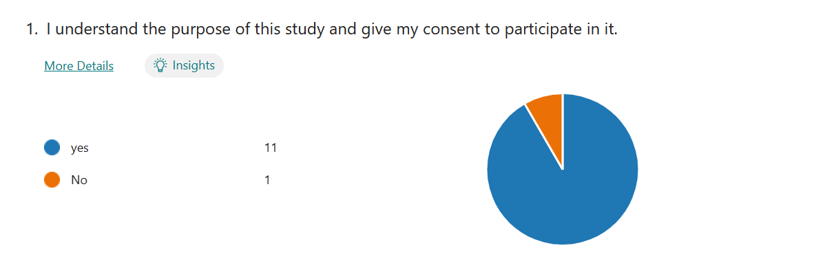

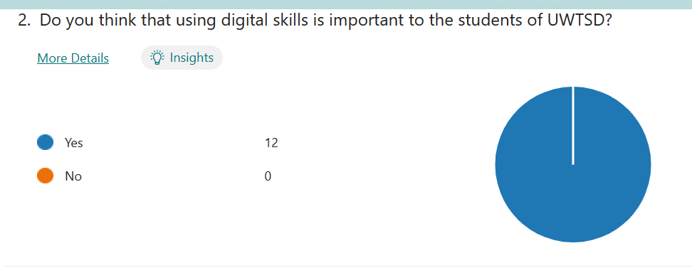
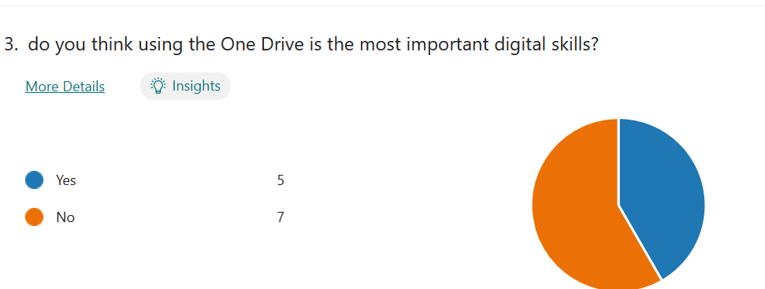
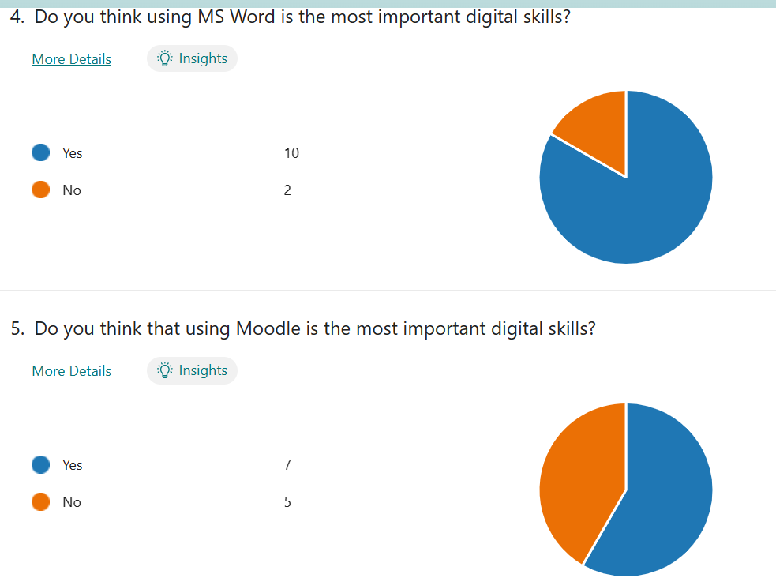

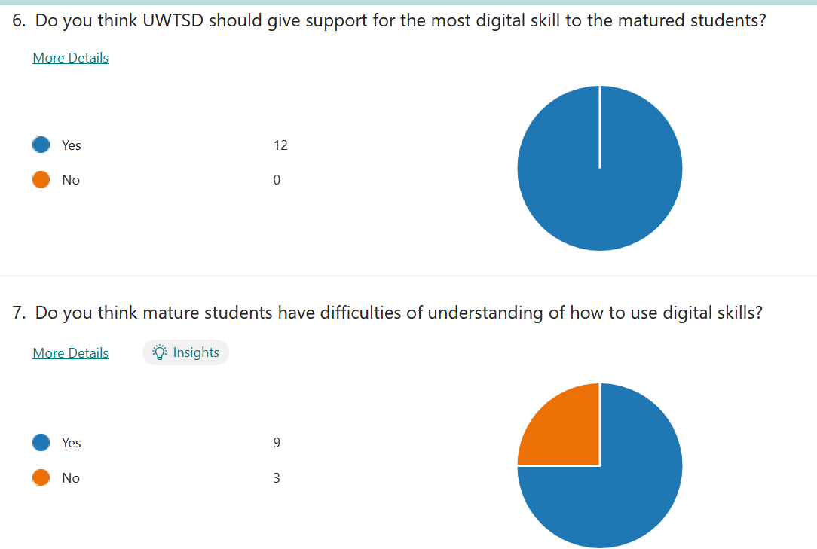
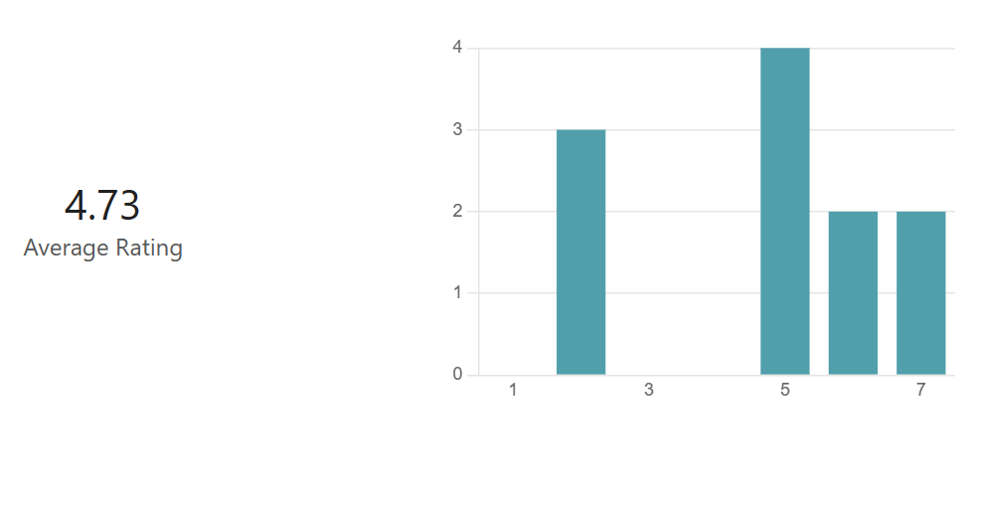

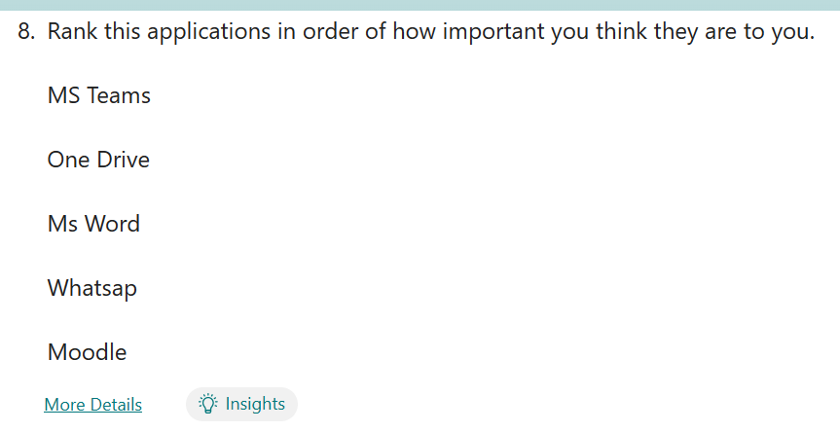

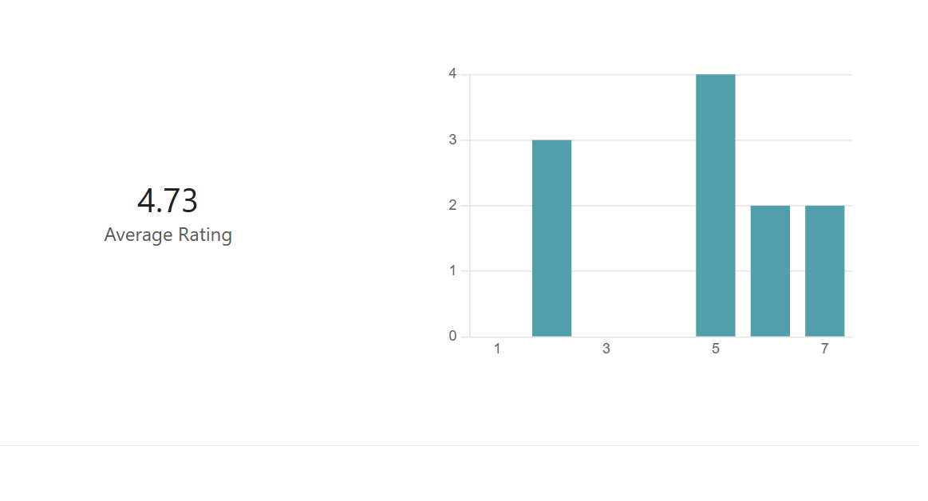

Discussion

In this part I discus mor about digital skills and how it is important for the students now days to use digital skills as bring the all World together. The results has been reported in this section show that majority of people about 96% all have agree about using digital skills and how help full it is for students and to the teaching of this generation. By looking at my introduction I can see that all result including my research are both meet hypothesis need to this work and I can confirm it look at good standard of asking questions and answer I was given by the people who take survey to this work

- Conclusion
I conclude by showing the impotent of digital skills and haw it is so useful for students trying to achieved their education in a range of good technology and to be able to gain better understanding of the skills they need to fulfil their dream. Am very satisfied for the answer given by the participant who took place in this survey by own decision to make this work come to the good opinion and to reach the best conclusion for this survey. I also understand how important it is to learn mor about digital skills and to be able to use it in all platforms all over the world so we can compute with technology in working place once finish my studies.

- Reference List
Corporate author: UNESCO Institute for Statistics (662)
Person as author: Law, Nancy. (6), Wood, David (1), Torre, Jimmy de la (1), Wong, Gary. (1)
Document code: UIS/2018/ICT/IP/51
Collation; 146 pages; maps
Language: English
Year of publication; 2018
Licence type: CC BY-SA 3.0 IGO (11476)
Anjum, N, A., & Rehmani, M. H. (2022). Non-fungible tokens in business and management-a review. ArXiv preprint ArXiv:2208,04836.
Ante, L. (2022). Non-fungible token (NFT) markets on the Ethereum blockchain: Temporal development, cointegration and interrelations. Economics of Innovation and New Technology, 1-19. doi:10.1080/10438599.2022.2119564
Brown, R., Shin, S., & Kim, J. B. (2022). Will NFTs be the best digital asset for the metaverse? SAIS 2022 Proceedings, 16.
Htt//aisle.aisnet.org/sais2022/16
Butcher, M. (2021, May 6). Could NFT auctions be moving away from Ethereum? One new group is betting they will.

- Appendix A – A blank copy questionnaire.
We are group of UWTSD students taking the module ‘ Digital skills and Research Methods ‘ under the programme of CertHE Health and social care. We are conducting a mini research relating to the use of digital skills among UWTSD students. You are invited to participate in this research.
This survey aims to investigate which digital skills do UETSD students think is most important. Result obtain will be used for suggesting further support to be provided by University in this area.
It will take you only two minutes to complete the questionnaire. All data collected will confidential and destroyed two months after completion of this study.

Thank you for your kind help.

1. I understand the purpose of this study and give my consent to participate in it.
2. Do you think using the One Drive is most important digital skills?
3. Do you think using digital skills is important to the student of UWTSD?
4. Do you think using MS Word is most important digital skills?
5. Do you think that Moodle is the most important digital skills?
6. Do you think UTSD should give more support to the matured student?
7. Do you think mature student have difficulties of understanding how to use digital skills?
8. Rank this application in order of how important you think they are too you.
- MS teams
- One Drive
- WhatsApp
- MS Word
- Moodle

