Samuel Szwediuk

Micro Peripherals and Interfaces

GOEE4000

Contents
Introduction 3
Arduino uno build 4
Bill of materials (BOM) 8
Blink test 10
Coding 12
Conclusion 19

Introduction

The project was to design a car park and program this using C++ in the Arduino software. The first task involved in this was to create a design for the car park both physically and on paper, to complete this I first read through the brief of the project set out to us which listed some of the aspects vital to the project. These included a maximum number of available spaces, a barrier to restrict entry, push button for entry, traffic light system (stop, go and full), sensor to detect a car at the barrier and the ability for the operator to check the state of the car park.
After reading through this I created a physical design on paper which allowed me to list all of the components I would need for this. Once all of the components had been selected I created a bill of materials (BOM) which I have included later on in this report and I could start building. I physically assembled the car park using the pins stated in the project brief and once assembled could begin coding.
To interface between the code of the car park and the physical system I used an Arduino uno (orange pip). This came as a kit which I assembled and integrated into the car park.

Arduino uno build

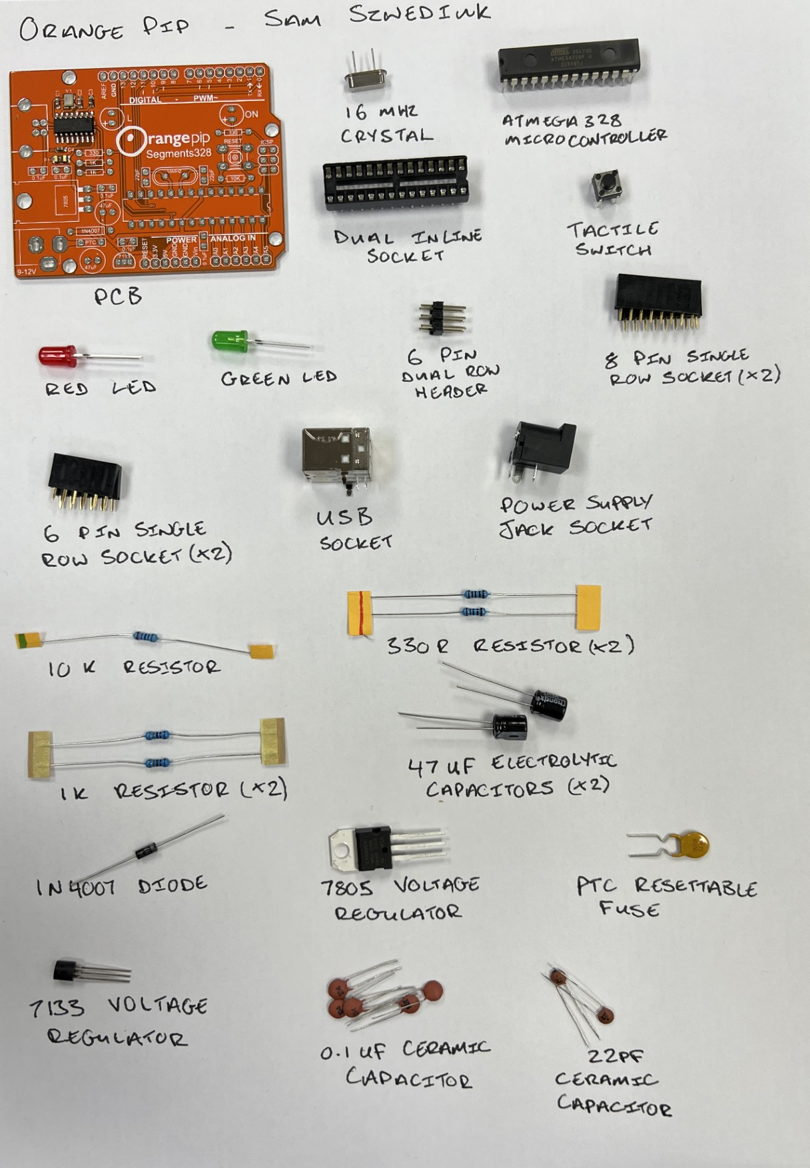
This kit came as all of the separate components and I used a guide to build it, the steps taken are listed below and I have written a small paragraph on each component.
PCB – The main component which all other parts are to be connected to.
16 MHz crystal – This is used to create an oscillating signal at a set value, this signal is used as a system clock to keep track of time. This was pushed through the respective holes in the PCB and soldered.
Atmega 328 controller – This is the main chip for the microcontroller. This is polarity sensitive and the correct orientation can be easily checked by the notched area of the chip which lines up with the notched area of the socket and the PCB, once correct this can be pushed into place in the socket.
Dual inline socket – A socket to be mounted and soldered to the PCB to allow the microcontroller chip to be mounted into. This socket had multiple connections close together on the board all of which needed to be soldered, as this was the case once I checked each connection as I went along to ensure no bridging of connections. This socket also has a notch to indicate which way it is to be placed onto the PCB to ensure the microcontroller is correctly placed.
Tactile switch – A switch to be mounted to the PCB to allow the operator to reset the system as and when needed. The 4 legs of this were pushed through the relevant holes in the PCB and soldered in place.
Red LED – LED to show power of the board. This component is polarity sensitive and the correct orientation can be found by a longer positive leg which lines up with the + mark on the PCB, the legs were then placed through the holes in the PCB and soldered in place.
Green LED – LED to show system function. This component is polarity sensitive and the correct orientation can be found by a longer positive leg which lines up with the + mark on the PCB, the legs were then placed through the holes in the PCB and soldered in place.
6 pin dual header – To be mounted and soldered to the PCB to allow connections from an external source. The legs of the 2 of these were placed through the PCB and soldered in place.
8 pin single socket – To be mounted and soldered to the PCB to allow connections from an external source. The legs of the 2 of these were placed through the PCB and soldered in place.
6 pin single socket – To be mounted and soldered to the PCB to allow connections from an external source. The legs of the 2 of these were placed through the PCB and soldered in place.
USB socket – To be mounted and soldered to the PCB to allow connections from an external source. The legs of this were placed through the PCB and soldered in place.
Power supply jack socket – To be mounted and soldered to the PCB to allow a power connection from an external source. The legs of this were placed through the PCB and soldered in place.
10k resistor – This allows the source current to be reduced to an appropriate level for the component it will be connected to. The legs of these were bent to 90 degrees, pushed through the associated holes in the board and soldered to give a solid connection.
330k resistor – This allows the source current to be reduced to an appropriate level for the component it will be connected to. The legs of these were bent to 90 degrees, pushed through the associated holes in the board and soldered to give a solid connection.
1k resistor – This allows the source current to be reduced to an appropriate level for the component it will be connected to. The legs of these were bent to 90 degrees, pushed through the associated holes in the board and soldered to give a solid connection.
47 µf electrolytic capacitors – These allows electrical energy to be stored and released quickly into the circuit. These components are polarity sensitive and the correct orientation can be found by a longer leg on the positive, these were inserted through the respective holes in the PCB and soldered.
1n4007 diode – Used as a rectifier to the allow the conversion of AC voltage to DC voltage. This component is polarity sensitive meaning that it must be placed on the board in the correct orientation, the correct orientation is marked on the board and is crucial as current can only flow one way through a diode.
7805 voltage regulator – This allows the output voltage into the system to be a constant regardless of fluctuations in the input voltage. This component is polarity sensitive due to each pin being assigned to a different function, the legs were placed through the PCB and soldered in place, I then checked each leg for any bridging of solder. This component was then folded flat to stay close to the PCB.
PTC resettable fuse – This is used to protect the system against any overcurrent faults which may occur. The legs of this were placed through the board and soldered.
7133 voltage regulator – This allows the output voltage into the system to be a constant regardless of fluctuations in the input voltage. This component is polarity sensitive due to each pin being assigned to a different function and can be easily check for orientation with the image on the PCB, the legs were placed through the PCB and soldered in place, I then checked each leg for any bridging of solder.
0.1 µf ceramic capacitors – This allows electrical energy to be stored and released quickly into the circuit. This was inserted through the respective holes in the PCB and soldered.
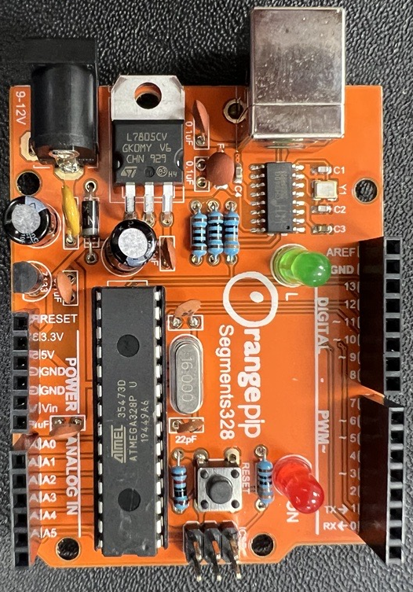
22 pf capacitors – This allows electrical energy to be stored and released quickly into the circuit. This was inserted through the respective holes in the PCB and soldered.

Bill of materials (BOM)

Component | Identification | Function
Arduino (orange pip) | Rapid electronics P/No: 75-0550 | Microcontroller – this will control / set all input and output, executes code for the defined functionality
Operator terminal | Printed circuit board (GCS manufactured) | Allows the operator to interface with the Arduino to execute commands such as reset or settings, this gives the opportunity to expand functionality of the unit
Light emitting diodes | Red / Green | Indicates entry and states how many spaces are used / available
LED wiring loom | Colour code3d wires (GCS stock / ultimate starter kit MS32) | Interface with the microcontroller
Power source | Battery / standalone PSU | To provide power
Barrier | GCS | Restricts / allows access to the car park
Stepper motor | Ultimate starter kit MS32 | Activates the barrier movement (open / closed)
LCD – Liquid crystal display | Ultimate starter kit MS32 | LCD will display a variety of messages for the functionality of the car park
Push button (entry) | Ultimate starter kit MS32 | Push to make switch – this will allow an input low on the Arduino, the code will then recognise a change of state and send an output signal to enable the barrier to be raised
Push button loom | Colour coded wires (GCS stock / ultimate starter kit MS32) | Connection to Arduino, colour coded for installation / fault finding purposes
Sensor 1: (entry) infra-red beam | Ultimate starter kit MS32 | This will be used as an infra-red source and detector, opto electronics reduces the need for a physical connection / contact although a filter may be required to avoid nuisance operations. This change of state is fed back to the Arduino to run messages on LCD display etc.
Sensor 2 (exit) infra-red beam | Ultimate starter kit MS32 | This will be used as an infra-red source and detector, opto electronics reduces the need for a physical connection / contact although a filter may be required to avoid nuisance operations. This change of state is fed back to the Arduino to run messages on LCD display etc.
License plate recognition | Ultimate starter kit MS32 | This will need to be positioned to focus on the plate, for a function test we could use a license plate that is recognised as an analogue reading and passed through an ADC to the Arduino. It may also be possible to use an RFID reader and indicator to achieve similar functionality
Board | B&Q | Allows all components to be mounted in one place
3D printing material | GCS | Allows additional parts required to be manufactured to accommodate build

Blink test

To first test the functionality of my Arduino I used a pre made code within the Arduino software to perform a blink test. The premade code would display the red LED as solid to show that the system was on and functioning, it would then blink the green LED at a rate defined in the code. With the premade code this blink was set with a wait between blinks of 1000 milliseconds, I uploaded this code to my Arduino uno and ran the test which was successful. I then changed the rate by adjusting the wait time to 100 milliseconds which allowed the system to blink faster.
All of this was successful and proved that the components I had installed onto the Arduino were installed successfully, with this checked I could move onto writing the code for my car park.
I have included a copy of the blink test code below:
/*
Blink

Turns an LED on for one second, then off for one second, repeatedly.

Most Arduinos have an on-board LED you can control. On the UNO, MEGA and ZERO
it is attached to digital pin 13, on MKR1000 on pin 6. LED_BUILTIN is set to
the correct LED pin independent of which board is used.
If you want to know what pin the on-board LED is connected to on your Arduino
model, check the Technical Specs of your board at:
https://www.arduino.cc/en/Main/Products

modified 8 May 2014
by Scott Fitzgerald
modified 2 Sep 2016
by Arturo Guadalupi
modified 8 Sep 2016
by Colby Newman

This example code is in the public domain.

https://www.arduino.cc/en/Tutorial/BuiltInExamples/Blink
*/

// the setup function runs once when you press reset or power the board
void setup() {
// initialize digital pin LED_BUILTIN as an output.
pinMode(LED_BUILTIN, OUTPUT);
}

// the loop function runs over and over again forever
void loop() {
digitalWrite(LED_BUILTIN, HIGH); // turn the LED on (HIGH is the voltage level)
delay(1000); // wait for a second
digitalWrite(LED_BUILTIN, LOW); // turn the LED off by making the voltage LOW
delay(1000); // wait for a second

Coding

My first task when coding was to outline what I wanted the system to do, I achieved this using flowcharts which allowed me to visual the outcome better.
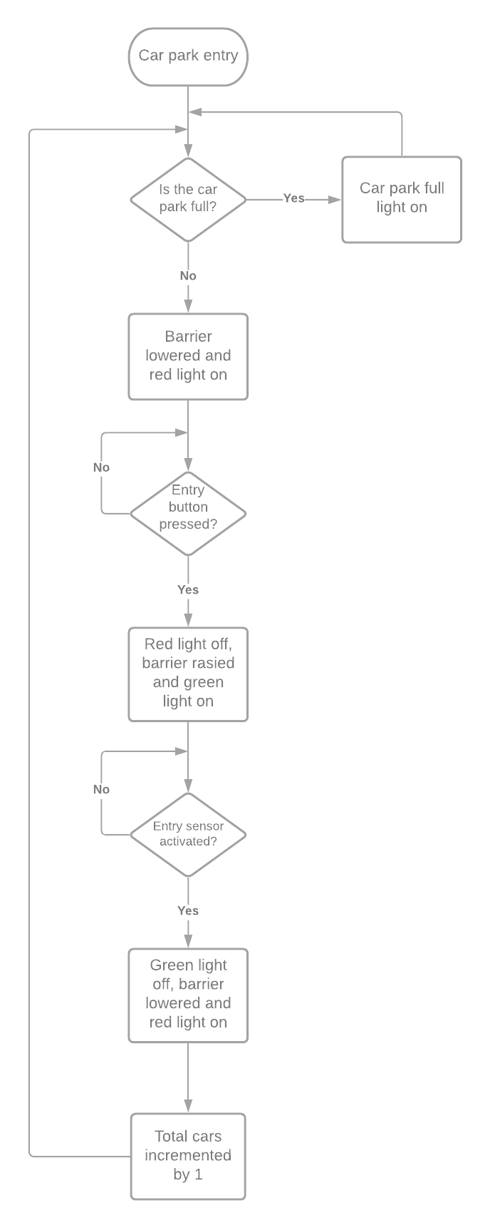

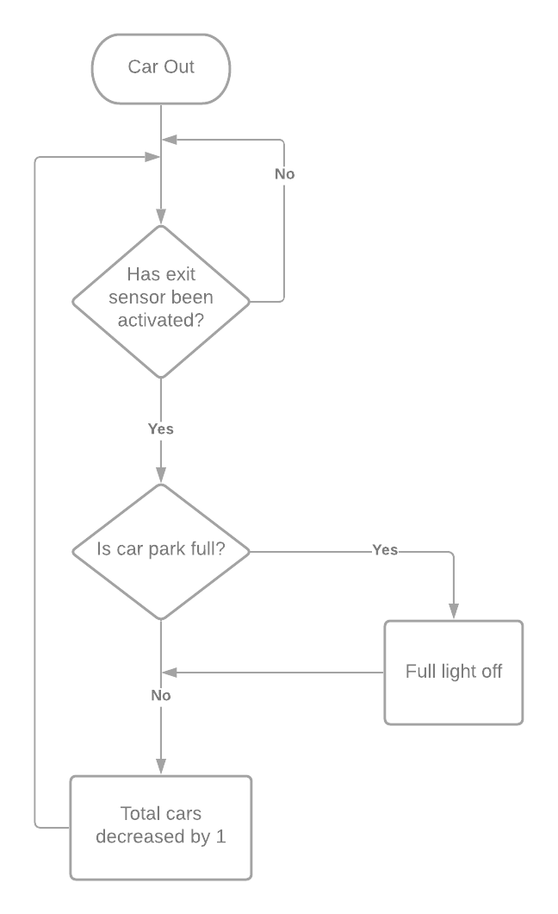

Requirements from brief:
Red Lamp - A digital output on Pin 6 Logic level 1 = Lamp ON
Green Lamp - A digital output on Pin 5 Logic level 1 = Lamp ON
Full Lamp - A digital output on Pin 7 Logic level 1 = Full Lamp ON
Barrier control - An interface to a stepper motor connected on pins 8,9,10,11 The stepper has 200 steps per revolution. 90 deg clockwise raises the barrier,
Sensor 1 - A logic input on Pin 3 Logic level 1 = car present
Sensor 2 - A logic input on Pin 4 Logic level 1 = car present
Push Button - A logic input on Pin 2 (derived from a mechanical switch) Logic level 1 = pressed

Once this was achieved I began to code my car park. When explaining my coding the bulk of this is done within the code as I have explained each line as I have gone along, this allows the process to be followed more easily than a separate explanation. The code however is broken up into 3 main sections:
Initial inclusion – this section includes any library inclusions as well as all of my definitions such as which pin is aligned with which component.
Setup – this is where the initial conditions of the system are set up such as which LEDs to turn on, motor speed and different pin modes.
Loop – this is where the repeatable lines of code such as the sensors and the barrier operation is contained. The section will allow the system to run continuously until stopped by the operator.
A copy of my code is below:

#include <Stepper.h> // Initialize the library with the numbers of the interface pins

const int button = 2; // Assigns logic pin 2 to the push button
const int sensor1 = A0; // Assigns analog pin 0 to a sensor
const int sensor2 = A1; // Assigns analog pin 1 to a sensor
const int green = 5; // Assigns logic pin 5 to the green LED
const int red = 6; // Assigns logic pin 6 to the red LED
const int blue = 7; // Assigns logic pin 7 to the blue LED
int redOn = HIGH; // Switch on red LED
int greenOn = LOW; // Switch off green LED
int blueOn = LOW; // Switch off blue LED
const int stepsPerRevolution = 512; // The number of steps per revolution for chosen motor
unsigned int fullpark = 10; // Maximum amount of cars
int cars = 0; // Holds number of cars in car park
int x = 0; // Assigns sensor 1 (entry) as a variable
int outsense = 0; // Assigns sensor 2 (exit) as a variable

Stepper myStepper (stepsPerRevolution, 8, 10, 9, 11); // Initialize the stepper library on pins 8 through 11

void setup() { // Code to run once on start up
myStepper.setSpeed(60); // Set the speed at 60RPM
Serial.begin(9600); // Initialized the serial monitor

pinMode(button, INPUT); // States this pin is an input
pinMode(red, OUTPUT); // States this pin is an output
pinMode(sensor1, INPUT); // States this pin is an input
pinMode(sensor2, INPUT); // States this pin is an input
pinMode(green, OUTPUT); // States this pin is an output
pinMode(blue, OUTPUT); // States this pin is an output

digitalWrite(red, redOn); // Switch on red LED
digitalWrite(green, greenOn); // Switch on green LED
digitalWrite(blue, blueOn); // Switch on blue LED

}

void loop() { // Code to run repeatedly

if (cars < fullpark) // If the number of cars is less than the full value

{
if(digitalRead(button)==1) // If the push button is pressed
{
myStepper.step(stepsPerRevolution); // Initiate motor
digitalWrite(red, LOW); // Switch off red LED
digitalWrite(green, HIGH); // Switch on green LED

do

{
delay(500); // Waits for the signal from the sensor
x = analogRead(sensor1); // Checking sensor
}
while (x < 750); // States analog value needed from entry LDR
delay(1000); // 1 second delay
myStepper.step(-stepsPerRevolution); // Initiate the motor
digitalWrite(green, LOW); // Switch off green LED
digitalWrite(red, HIGH); // Switch on red LED
cars ++; // Adds a car to the count
Serial.println(cars); // Initialises the serial monitor
delay(1000); // 1 second delay
}

}
{
outsense = analogRead(sensor2); // If outgoing sensor is triggered

if(outsense <=600 && cars >=1) // States analog value needed from exit LDR
{
delay(1000); // 1 second delay
cars--; // Removes a car from the count
Serial.println(cars); // Initialises the serial monitor
digitalWrite(blue, LOW);} // Switch off blue LED

if (cars == fullpark){ // If the number of cars is the maximum
delay(300); // 0.3 second delay
digitalWrite(blue, HIGH); // Switch on blue LED
digitalWrite(red, HIGH); // Switch on red LED
delay(2000); // 2 second delay

delay(300); // 0.3 second delay
}
}
}

One challenge when coding this system was the LDRs which I had used as sensors, these needed calibration to work in the environment in which I was using then. I completed this by first using a pre made code along with the serial monitor to determine the values that my sensors were reading for both covered and uncovered as shown below.
A copy of this code is below:

int ldr;
void setup() {
// put your setup code here, to run once:
pinMode(A1, INPUT);
Serial.begin(9600);

}

void loop() {
// put your main code here, to run repeatedly:
ldr = analogRead(A1);
Serial.println(ldr);
delay(300);
}

Uncovered:
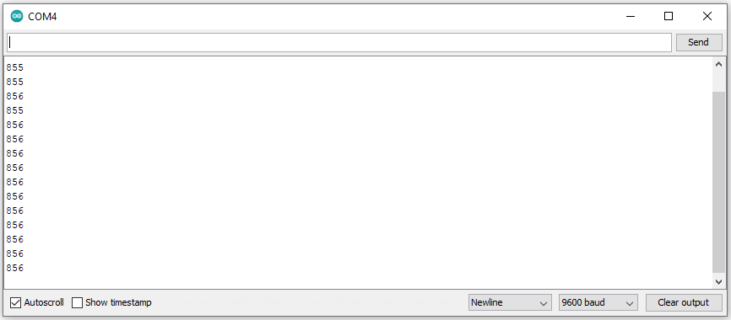
Covered:
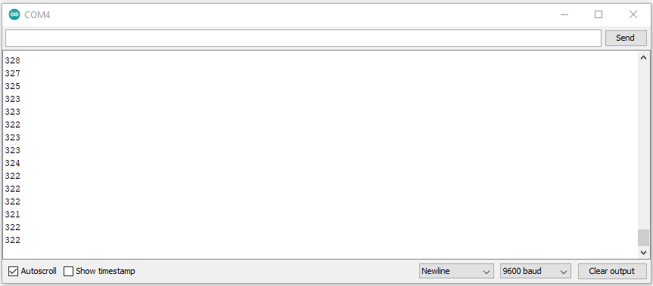
Once this was complete I could enter the values obtained here into my code to ensure that the sensors installed would work correctly in the environment I was in.

As for the physical build of my car park I mounted all components to a piece of wood to give a solid base for everything, I first mounted the bread board, the orange pip, the small pcb to interface with the motor and the motor itself. I then moved onto drilling through the board to allow the motor to be recessed in and sit flush to ensure the barrier was level when closed. Once I had mounted all of this I connected everything together using the pins required in the brief along side components such as resistors to ensure the safe operation of the equipment.
The resistor size used varied dependant upon the component it was interfacing with and the value was selected using various guides from the Arduino website which also showed how to connect the components together.

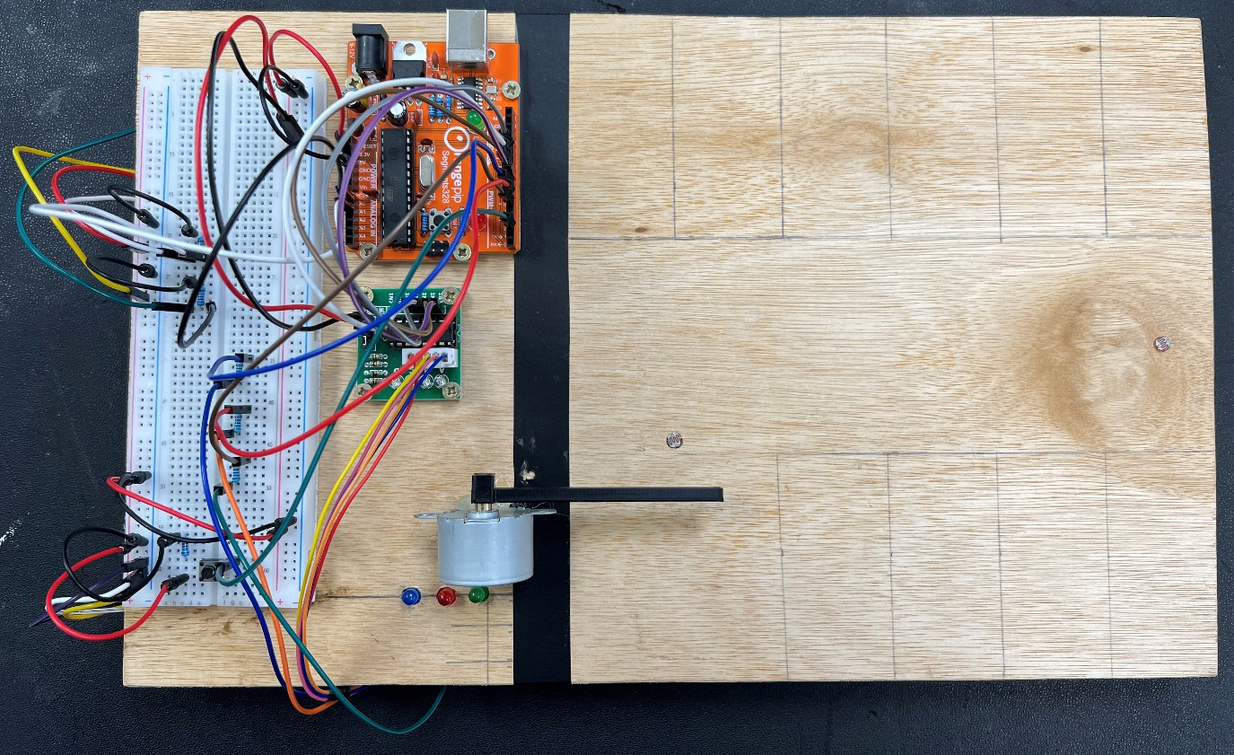

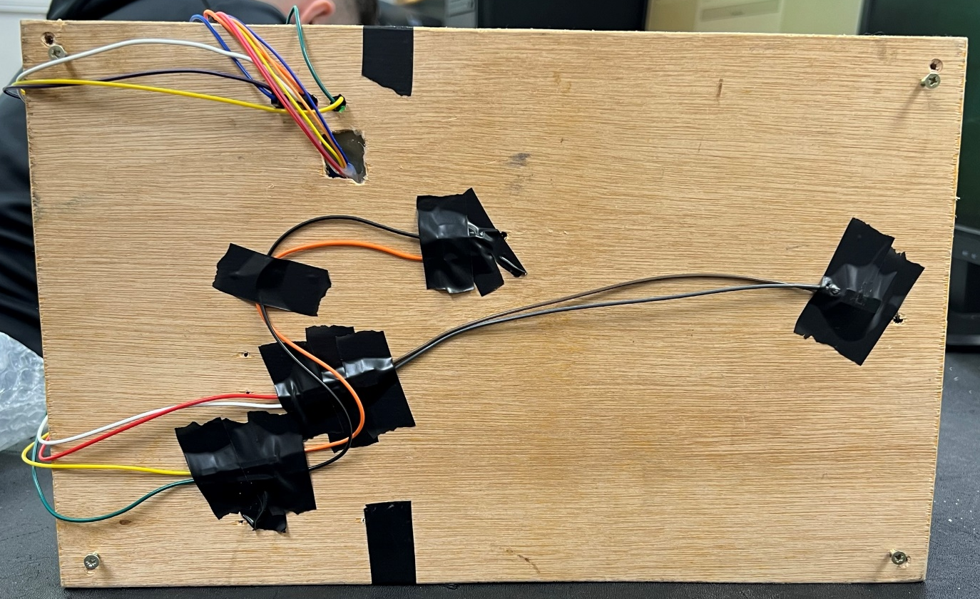

Conclusion

In conclusion this project was a success although were a couple of differences between my original plan and my finished project which I have outlined below.
Originally I had planned on using a screen to give a written message for things such as “enter” and “car park full” however my limited knowledge of coding prevented me from achieving this. I had researched how to code this and how to integrate it into the Arduino uno but decided against using it in the end to ensure the finished project would run smoothly with no errors. If I returned to this project in the future this is something I would look to add.
In the assignment brief it was stated that the two sensors (entry and exit) were to be connected to logic pins 3 and 4 respectively, I had originally planned to build it this was but things changed. Due to me using LDRs which give an analogue signal as oppose to a digital signal I was required to connect these to the analogue pins of the Arduino. This did not impact functionality but meant that the brief could not be fully complied with.
One slight functional issue which can be seen in the video of the car park was trying to calibrate the LDRs, this was challenging to get the perfect value for operation. This can be seen in the video as sometimes the car would not register on the outgoing sensor and sometimes it would register twice.
Apart from these three issues all other aspects of the brief were met and the project was a success.

