The impact of product recalls on businesses and projects
Darren Thomas
Student ID 2117577
MSc Engineering Project Management, University of Wales Trinity of Saint David
ACEA 7012: Quality Management in an Operational Environment
Lecturer: Andrew Thorn
29th November 2022

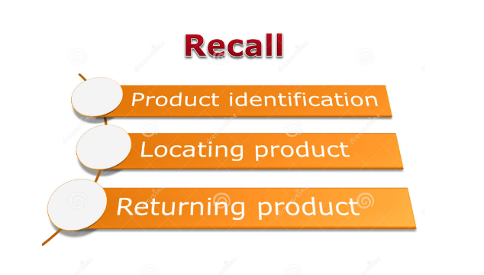

Contents page

Contents page 2
Introduction 3
Product recall process 4
The Product Recall Process 5
Classification of Recall: 6
Class I: 6
Class II: 6
Class III: 6
Justifications for recalls Examples 6
Lack of testing 6
Manufacturing mistakes 6
Substitutions 6
Product recall procedure: 7
Costs associated with product recalls and controls 8
Cost implications of product recall 8
Damage limitation 8
Regulatory Recalls 9
Ascertain the Scale of the Fault/Defect 9
Decide the Suitable Reaction 9
Product Return 9
Repair option 9
Notification 9
Inform The Insurer 9
Stakeholders and Customers Communication 10
Restoring customer confidence 11
Consequence of poor quality 12
Ethical Product Manufacture 12
Failure Mode Effect Analysis (FMEA) 13
Supply Chain Complexities 13
Conclusion 13
References 14

Figure 1. Product Recall Flow Diagram 4
Figure 2. United States Vehicle Recalls 8

Introduction

A product recall is a process a company should follow if a product is faulty, the product may be faulty due to manufacturing issues, quality, contamination, or safety concerns. The customers and consumers who have purchased the item should be contacted and informed of the recall and the item taken off the market.

Companies will usually compensate or convince the customers to trade in their products to ensure the safety of the customers, usually recalls are at the company’s discretion undertaken for customer satisfaction and to ensure repeat sales and to build and keep trust in the company, on the other hand the Government bodies or HSE may intervene and issue a mandatory recall to protect the consumers depending on the severity of the issues.

Companies are aware that recalls should be managed properly as not to effect brand and customer health. The quick communication and recall process is essential to ensure customer and product safety. For example a washing machine company has recalled up to 21 models due to issues with the door mechanism and heating element on their machines which may pose a risk of fire, no serious injuries reported. Since the recall in early 2020 over 210,000 customers have registered their appliances for the recall (over 40% of affected customers, above industry average for a recall) (Whirlpool Corporation, 2020)

Product recall process

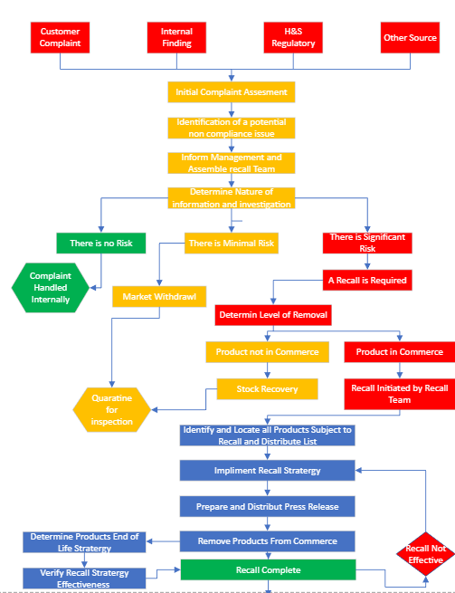

Figure 1. Product Recall Flow Diagram

The Product Recall Flow Diagram Fig 1. appropriate for the recall of dispatched products, if believed to be defective or that they have been detected that the products are defective.

The Product Recall Process

The Quality Assurance Manager (Q.A.) is to initiate the recall process, monitor the process and close out the recall on completion. These actions can only be initiated after a team of people called the Product recall team has made the final decision to implement the process of a recall. (PharmaBlog, 2022)

The Technical Head role within the company is responsible for investigating the Complaint, including the examination of all documents, and after discussion with the Q.A. and the recall team, proposals are given to the management board for the recall process of the product to commence.

A Recall is defined as the removal or return of specific batch or batches of a product in circulation and a Withdrawal is the removal of the product from the consumer and customer market. (PharmaBlog, 2022)

The recall of sold products will be started in following circumstances.

- If a product is expected or recognized to be faulty based on consumer and customer complaints, and an assessment of risk of the hazard is seen to be true.

- If the local Health / Regulatory authorities have issued a complaint or notice.

- If recommended by the Key customer for which the product is produced.

From the initial complaint a Product Recall Team should be formed. (ASQ.ORG, 2022)

The Product recall team should consist of following members or similar depending on the company management set up.

Director
Technical Head
Quality Assurance Head
Quality Control Head
Production Head

The Q.A shall initiate the product recall, tailored to suit depending on the nature of the complaint and the analysis of the fault.

Classification of Recall:

There are several types of Product recall:

Class I:
The most critical of recalls, consequences to health are serious harm or likely hood of Death to the user and customer. The recall would be initiated within a short period of time after the recall team put forward its recommendations.
Examples are: wrong product, wrong strength, chemical contamination all with serious health consequences.

Class II:
Product recalls are for defective or poor-quality products but do not present a danger or serious health risk. The recall is initiated within 1 week from the recommendation of product recall team.
Examples are incorrect labelling or mis information, contamination of products, wrong product or out of spec.

Class III:
Is for product recalls that are unlikely to cause health issues but are below manufacturing regulations and compliance.
Example would be Faulty packaging, contamination, missing leaflets, or information on the product etc.

Justifications for recalls Examples
Companies would normally recall a product to make sure the safety of their customers and the integrity of their brand. There are numerous reasons why a product would be recalled, including:

Lack of testing
If a product is on the market without having thorough tests and inspections, there may be defects or side effects that have been missed. Including stress tests to measure their strength and ductility to simulate the life cycle of the product where premature failure may be the result. For example, a company might recall a car with seat belt issues if they didn't test their effectiveness enough in a crash or hard breaking simulation. For example. 2022 Hyundai recall 239,000 vehicles with serious seat belt issues. (Wile, 2022)

Manufacturing mistakes
A common cause for companies to recall a item is manufacturing errors. This can involve errors in production such as missing an ingredient or tainting a product with another ingredient. For examples, a cat food product accidentally didn't include the chicken in the formula, (Indeed, 2022)

Substitutions
Substitutions are an additional mistake that can prompt a product recall. If a manufacturer substitutes ingredients for costs or availability. When companies haven’t approved these substitutes, a product recall may be issued.
For example, if a product that normally uses organically obtained ingredients and a manufacturer substituted for artificial ingredient, the recall process may be followed to protect the integrity of their brand name. (Indeed, 2022)

Product recall procedure:

Recall commencement: warning is given to the storage warehouse, outlet departments and the executives of the company, to inform them that a recall of a product is to commence within a specific time period as previous classifications.

On receipt of the recall notification all concerned distributors and stockists are to be contacted by phone or mail, requesting them to cease sales of product and remove items from the marketplace.
Q.A. and the Directors will collate all documents, Quantities affected, costs, and customers concerned, all information will be reviewed before initialising the Recall.

A Product recall Team meeting should be called to evaluate the risk associated with the complaints and how to minimise customer dissatisfaction.

All returned goods to be marked as Recalled goods and quarantined, the local regulatory body should be notified regarding the recall plan.

The Director or equivalent will provide a product recall email where the product has been delivered abroad and inform to the customer of the type of recall and its likely hood to cause harm or its hazards. A request to return the product back at the earliest opportunity or the arrangement to destroy the product in the country if unable to ship. The development of the recall process will be closely monitored by the Q.A. Head.
On completion of the recall, the warehouse team and Q.A. to perform a stock take and document all findings to cross reference outgoings with returns, including any certifications for destroyed stock. All stock to be kept separate and under lock and key until final decisions by the product recall team.

The Q.A. will end the Product recall when completed, recording the Recall and collating all relevant data for future reference.

Q.A. and director to complete a root cause analysis and communicate with the teams to prevent reoccurrence.

Management and recall team to complete a product recall report and to be approved by the Director.

Conclusion to be documented and stock either destroyed in the presence of the management team or appropriate steps taken for stock to be re-entered into the supply chain with the modifications required.

Evaluation of all recall incidents should be completed annually and documented for future reference.

Costs associated with product recalls and controls

Modern manufacturers over the past 10 years have seen a jump in product recalls with significant costs to their companies. An OMEP article (Kelly, 2022) highlights the best way to protect their customers and reduce risk is to initiate a product recall.
In the United States over the past 20 years this is evident and in 2016 the market was seeing up to 1000 vehicle recalls and on average over 3 vehicles per 1 sold where being recalled. Figure 2 shows this steady climb up to 2017. (Adriana Aragon, 2019)

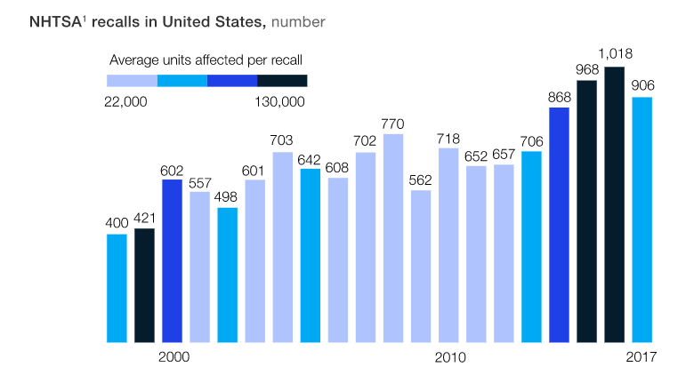

Figure 2. United States Vehicle Recalls

Cost implications of product recall
Obvious Costs for a product recall are the inspection costs, repair costs, replacement, and disposal costs, as well as personnel to deal with the recall, the reduction in sales due to loss of customer purchases and loss of trust in the company and products.

Damage limitation
The first thing to do in every recall process is to confirm the presence of a defect. For example, the fault may be due to damage or tampering in this case there would be no requirement for a recall. Initiating a recall too soon places the company in unwarranted risk with unnecessary costs and loss of customer trust. Customers may choose to claim damage and compensation even if there are no issues if a recall has been authorized. On the other hand, if there is an issue or fault with the product and a recall is not raised, legal and regulatory enforcement and exposure may cost the company a great deal more.

Regulatory Recalls
Some Industry recalls are regulated by government bodies and departments. These departments have specific recall requirements and should be consulted with directly if a product defect is found. Failure to follow protocol with regulatory requirements can cause an organization to have imposed civil, or even criminal, consequences.

Ascertain the Scale of the Fault/Defect
If a fault exists, detecting the faulty part of the product, or situations that generate the fault, may remove, or lower the scale of the recall. E.g., if something has been changed recently, suppliers, materials, manufacturers, and the issues have only been seen since, only the products within this time period need to be recalled, or if the issue is only with certain batch or serial numbers the issue can be narrowed down and only recall the specific serial numbers of the batch. Lessoning the costs needed to be outlaid by the company and decrease the loss of trust to the customers, largely reducing the bulk of the recall.

Decide the Suitable Reaction
Every recall is different and must be customised to the defect. There are a few types of recall that may be suitable under different situations:

Product Return
where the customers are asked to return the product with certain serial numbers, generally the costliest, but is regularly essential if the defect is not simply fixable.

Repair option
If the defect can be simply fixed and completed in a cost-effective way, the company will request the customers to return the merchandise for repair. Large items, the company may send personnel to the customers site to complete the repairs.

Notification
Notification of the defect to Customers can be an effective response In certain circumstances, This option can be successful if the problem arises under certain conditions for example high temperature or when used incorrectly. Reducing or negating a recall action.

Inform The Insurer
Prior to starting a recall, the company insurer should be contacted to understand what your company’s insurance policy covers. Costs of a recall are often omitted from general policies.so it will be worth a company adding recall insurance to existing policies in case this event arises. This would pay for the inspection costs, repairs, and replacement costs.

Stakeholders and Customers Communication
Communication is required to be given to all key stakeholders regarding the recall, involving the customers, end-users, employees, sales partners, and suppliers. All communications must be consistent – misunderstandings regarding the defect can hurt consumer confidence and trust.

Having a mock recall plan in place and rehearsing it will help the company and team understand the roles required and what is required to protect customers whilst minimising the risks and costs to the company. A good communication strategy is key to the success of a product recall.

As well as a recall plan, the company can review contracts with clients and suppliers to establish how recall costs can be distributed. Improving product tracking systems can assist with locating specific products for the recall process, having the correct policies and procedures in place will reduce disruption caused by the recall process.

Restoring customer confidence

The company must react quickly if there is an issue with a product which could potentially affect the health and safety of the customer or to cause displeasure, it's essential to react swiftly. Quick reaction shows the consumer that the company is committed to their responsibilities and proactive into dealing with any safety issues that arise, building trust.

After the initial investigation and the company understands the fault with the product the appropriate authorities should be notified, this is a legal requirement, as they may well have a specific recall procedure to follow to be compliant.

Customers will be expecting an explanation for the recall. An option is to share this information in a press release and or on social media accounts, brief and truthful description for the recall safeguards the customers understand of the issue. This will again help to build trust and have an advantage towards the customers to accept a product swap or full reimbursement at a later date. Limiting the damage to the company’s relationship is then to offer refunds and or an exchange for similar product. Taking responsibility for the fault will increase customer satisfaction. (Indeed, 2022)

After declaring a product recall, ensure communication pathways are open for customer concerns and questions. Open dialog and customer complaints contact details should be made readily available, Transparency is one of the 13 high trust behaviours (Covey, 2008) and can improve reputation of the company.

Using Product recall insurance can protect companies from the recall costs, these costs can include shipping, disposal and advertising.

Consequence of poor quality
Quality is crucial in business, poor quality leads to damaging outcomes such as lost customers, operational issues, diminished profits, and even shutting down of the company.

Substandard quality manufactured goods or services can lead to displeased customers, causing lost profits and reduced consumer loyalty. As well as customers taking their interest elsewhere, causing job losses and a reduction in company throughput.

The operational associated concerns of bad quality can contain lost time, wasted resources, and reduced productivity. Leading to increased production costs and higher repair costs of the faulty products.

Poor quality also leads to product insurance claims. In some cases, poor quality can also lead to legal action against the manufacturer or supplier.

Some other outcomes of poor quality contain:

- Insurance costs rising
- Higher legal fees
- Negative effect on reputation
- Loss of goodwill
- Product Insurance claims
- Greater Product recalls
- Higher warranty payments

Quality is important part of the business. It is vital to have a quality management system to guarantee that all products and services are of the highest standard.

Ethical Product Manufacture
Ethics plays a big part in obligations to the consumer.
The contract view, Due care view and the social cost’s view are examples by Manuel Velaquez. (Velasquez, 1992)
- The contract is the duty to provide the customer safe products and is a contract held by to manufacturer and the purchaser.
- The Due care view a Manufacturer has a duty to exercise due care to prevent others from being injured by the product.
- Social view is that the manufacturer should pay the costs of any injury sustained through defects in the design and manufacture of the of the product. Even when the manufacturer has taken all reasonable precautions to warn users of every foreseen danger.

All the above are good reason to implement a recall process and act with haste when identified.

Failure Mode Effect Analysis (FMEA)
Generally speaking, an FMEA should be completed at the design stage of a new product, when a change in the use of a product or process is to be implemented, when a goal is to improve quality or when we need to understand and improve the failures of a process. The desired outcome would be to improve the quality, reliability, and performance of a product. (Quality One, 2022).
Understanding the issues from a product recall by implementing an FMEA and tackling the recommended actions from the process can avoid future costs to the company. (Durivage, 2017).

Supply Chain Complexities
In the modern day supply chain complexities are challenging with customers and consumers expecting faster lead times, expanded products and services, as well as internal complexities, specialist suppliers can often restrict, slow down and make the process less responsive. (O'Handley, 2017) A recall would require returns, repairs, re deliveries, all need to be taken into account.
Having Product Quality to meet the user’s standards is essential. (Business.com, 2022).

Conclusion
In conclusion over recent years there has been a sharp rise in product recalls, companies are required to act quickly and decisively on ethical grounds as well for customer and consumer health and wellbeing, including in the interest of the company’s profits, customer relations, brand name and the company’s future. Product quality is essential to reduce recalls, there is always room for improvement on quality whether it is through manufacturing, supply chain or the tracking of products to the end user to enable quick communications to the relative parties concerned.

References

Adriana Aragon, U. H. T. M. H. N., 2019. Resolving the automotive-recall resurgence. [Online]
Available at: https://www.mckinsey.com/industries/automotive-and-assembly/our-insights/return-to-sender-resolving-the-automotive-recall-resurgence
[Accessed 19 November 2022].
ASQ.ORG, 2022. WHAT IS A PRODUCT RECALL?. [Online]
Available at: https://asq.org/quality-resources/recalls
[Accessed 26 November 2022].
Business.com, 2022. Elevating Expectations: 6 Ways Product Quality Affects Your Brand. [Online]
Available at: https://www.business.com/articles/5-reasons-why-product-quality-matters/
[Accessed 26 November 2022].
Covey, S. M. R., 2008. The Speed of Trust: The One Thing that Changes Everything. United Kingdom: Simon & Schuster UK..
Durivage, M. A., 2017. The Certified Reliability Engineer Handbook.. United States: ASQ Quality Press..
Indeed, 2022. How To Manage a Successful Product Recall Procedure. [Online]
Available at: https://www.indeed.com/career-advice/career-development/product-recall-procedure#
[Accessed 27 November 2022].
Kelly, K. E. E., 2022. Product Recall: A Quick Guide for Manufacturers. [Online]
Available at: https://www.omep.org/product-recall-a-quick-guide-for-manufacturers/#:~:text=In%202015%2C%20almost%20three%20times%20more%20vehicles%20were,have%20doubled%20since%202002%2C%20according%20to%20the%20article.
[Accessed 19 November 2022].
O'Handley, C., 2017. 3 Main Sources of Supply Chain Complexity. [Online]
Available at: https://www.inboundlogistics.com/articles/main-sources-of-supply-chain-complexity/
[Accessed 26 November 2022].
PharmaBlog, 2022. Product Recall SOP. [Online]
Available at: https://pharmablog.in/product-recall-sop/
[Accessed 26 Novemeber 2022].
Quality One, 2022. Failure Mode and Effects Analysis (FMEA). [Online]
Available at: https://quality-one.com/fmea/
[Accessed 26 November 2022].
Velasquez, M., 1992. Buisness Ethics: Concepts and Cases. 3rd ed. Englewood Cliffs: Prentice Hall.
Whirlpool Corporation, 2020. Washing machine Recall. [Online]
Available at: https://washingmachinerecall.whirlpool.co.uk/about_issue.jsp?lang=en
[Accessed 12 November 2022].
Wile, R., 2022. NBC News Hyundai recalls 239,000 cars over exploding seat belt parts. [Online]
Available at: https://www.nbcnews.com/business/consumer/hyundai-recalls-cars-exploding-seat-belt-parts-rcna30361
[Accessed 26 November 2022].

