Certificate of Higher Education Skills for the Workplace (Health & Social Care)
Student: Dominique Heath Student Number: 2505637

Module: LCHS4003 - Introduction to Health and Social Care
Lecturer: Dr Daniel Hanura
Assignment Title: Portfolio – Two Tasks
Task 1: Create a poster (900 words Equivalent) that explains one social care service from the table below
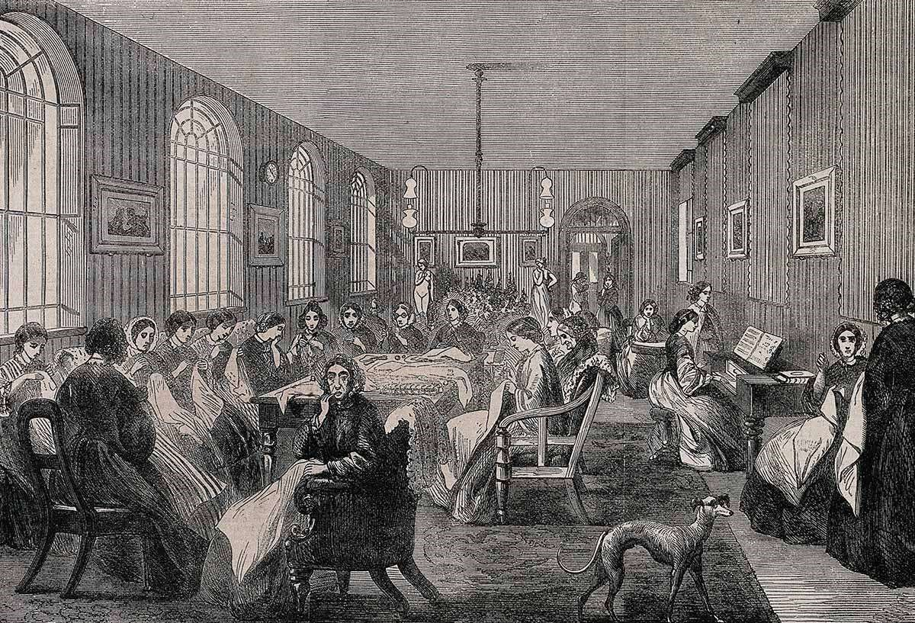
Community Mental Health Services
What Are Community Mental Health Services?
depression and anxiety is very widespread among the UK population, which emphasises the necessity of accessible community services (de la Torre et al., 2020). Lastly, Mind (2023) argues that the community mental health assistance of youths is in demand because of the escalation of emotional distress rates.  Brief History of Community Mental Health Services  Traditionally, mental health in the UK was provided in large psychiatric hospitals, called asylums, in the 19th and early 20th century. Starting in the mid 20th century, the deinstitutionalisation policies changed the placement of care from hospitals to the community to enhance both the quality of life and social inclusion.  The idea of forming a Royal College of Psychiatrists goes as far back as the 1950s, but it was only in 1964 that Council decided to set up the Petition  Committee, which was tasked with starting negotiations with the Privy Council. The Association of Psychiatrists in Training (APIT) and the Society of Clinical Psychiatrists played important roles in lobbying for Royal College status. The 1980s-1990s UK community care reforms have provided | In recent years, mental health disorders among both the youth and adults have grown to a considerable level. However, social forces and the use of digital technology are among the factors that cause increasing levels of anxiety and depression (Twenge, 2020).  There is a correlation between social media exposure, psychological distress and anxiety among working populations (An et al., 2023). The rising prevalence puts strain on community services, which results in waiting lists and limited accessibility.  Social and Environmental Determinants  Urbanisation and changing lifestyle are social and environmental factors that have significant effects on social and mental health. According to Pan et al. (2024), there is a relationship between urbanisation and social change, with increased risk of adolescent depression.  Exposure to technology and screen time are some of the contributors to psychological distress among adolescents (Keles et al., 2020). While health and lifestyle issues like obesity and chronic illness influence the psychological wellbeing as well (Putra et al., 2024).  Thus, these factors make cases handled in community mental health facilities more complicated.
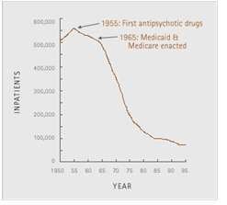
Community Mental Health Services (CMHS) are multidisciplinary care teams of health and social service that provide evaluation, intervention, and follow-ups of individuals with mental disorders as they live in
communities and homes instead of hospitals. These services involveChallenges Facing Community Mental Health
psychiatrists, psychologists, nurses, social workers and occupational
Services
therapists who collaborate to ensure recovery and independence. According to Royal College of Psychiatrists (2025), the purpose of community-based mental health care is to minimize hospitalization and
CMHS are important in helping people with mental problems lead safe, independent and meaningful lives in their localities. Having accessible and person-centred services, these services help service users to control the symptoms, learn coping mechanisms, and engage in social, educational, and occupational activities. Joint efforts of psychiatrists, psychologists, nurses, social workers, and occupational therapists determine the needs of individuals, provide treatment, and psychosocial support; therefore, patients get holistic care depending on their conditions (Royal College of Psychiatrists, 2025). This strategy will lead to fewer people having to be hospitalised and will also ensure recovery and social inclusion, which will increase the quality of life. Although there are these advantages, CMHS are challenged by huge problems. Growth of population, urbanisation and the increased prevalence rate of mental health conditions increase the demand of services, which is usually associated with long waiting times. Other social determinants like poverty, housing insecurities, and technological demands also make the provision of care more difficult and therefore necessitate adapting strategies to continue the effective care provision.

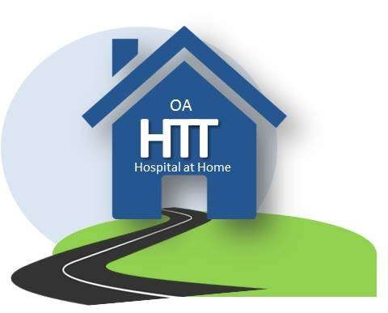
support recovery in familiar surroundings. However, the problem ofRising Demand for Services
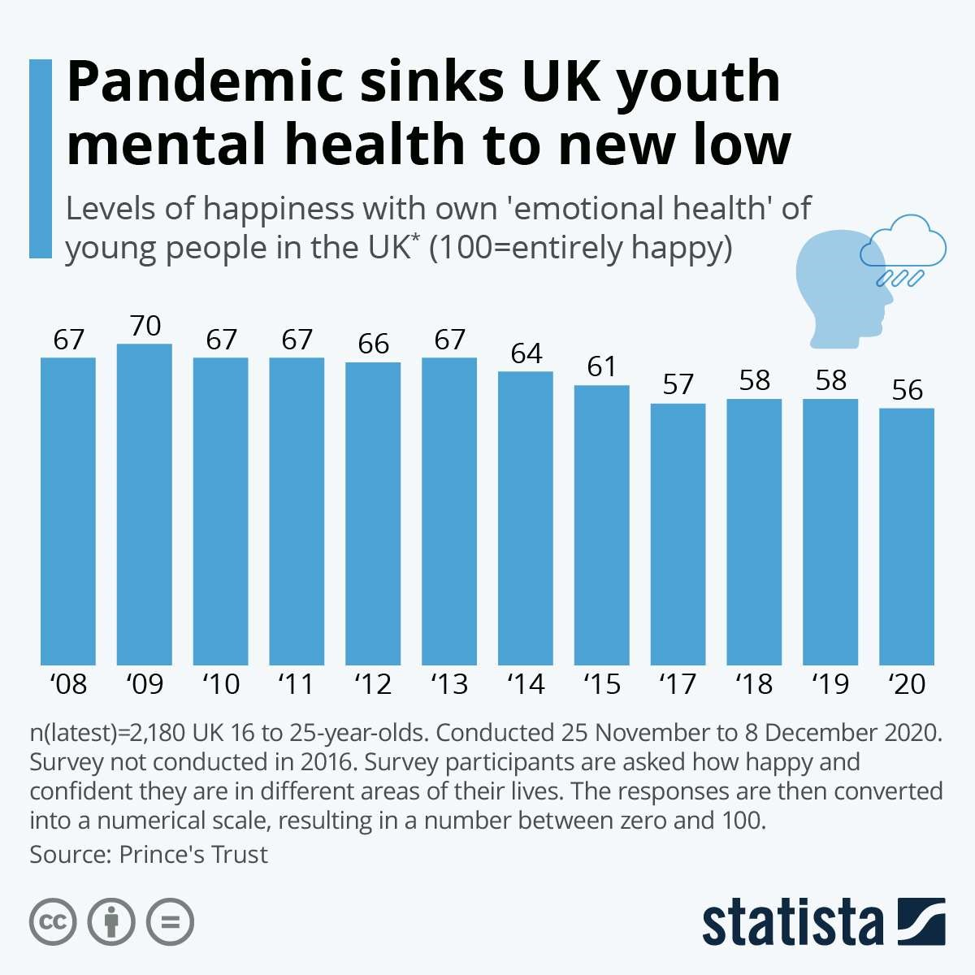
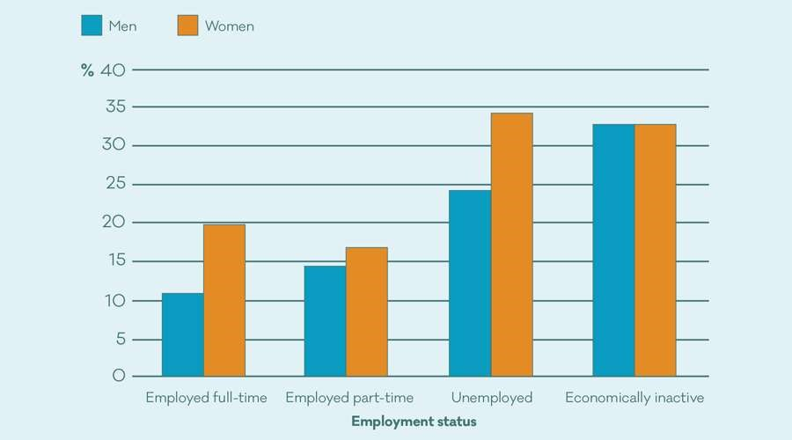

multidisciplinary community mental health teams to substitute the long-stay hospital care. Contemporary CMHS have become the key component of the national mental health policy and the models of recovery-oriented care (Royal College of Psychiatrists, 2025).
How Community Mental Health Services Function
Importance of Community Mental Health
Today
Services
Integrated teams currently operate Community Mental Health Services through The community mental health services are necessary since they facilitate ^{activities that include:} healing and self-reliance, reduce hospital admissions, support social
^{Home-based treatment} inclusion, improve quality of life, and provide early intervention.
Home-based care is provided to patients to prevent hospitalisation and help them to be The idea of community-based care is consistent with current recovery^{independent.} oriented mental health models that prevail with the focus on person-
^{Multidisciplinary assessment} centred support (Royal College of Psychiatrists, 2025).
Needs are assessed through a joint effort of professionals, including psychological, medical, and social aspects.
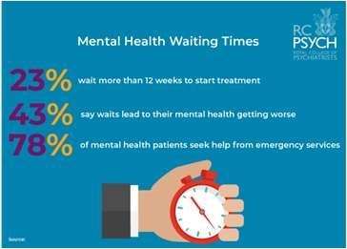
Medication management
Nurses and psychiatrists observe adherence and side effects of treatment.
Psychosocial support
Social workers and therapists deal with housing, employment and relationships, while community care enhances the outcomes as it helps people in their daily settings instead of an institution (Thapar et al., 2022). The social support interventions minimise the risk of depression and enhance the recovery process (Tafoya et al., 2019).
Key Message
References
Akinci, Z., Yurcu, G., & Ekin, Y. (2018). Relationships between student personality traits, mobbing, and depression within the context of sustainable tourism education: The case of a faculty of tourism. Sustainability, 10(10), 3418.https://doi.org/10.3390/su10103418
An, H., Gu, X., Obrenovic, B., & Godinic, D. (2023). The role of job insecurity, social media exposure, and job stress in predicting anxiety among white-collar employees. Psychology research and behavior management, 3303-3318.
Bian, X., Yang, W., Lin, J., Jiang, B., & Shao, X. (2024). Hypothalamic-Pituitary-Adrenal Axis and Epilepsy. Journal of Clinical Neurology
(Seoul, Korea), 20(2), 131. doi: 10.3988/jcn.2023.0308
de la Torre, J. A., Vilagut, G., Ronaldson, A., Dregan, A., Ricci-Cabello, I., Hatch, S. L., Serrano-Blanco, A., Valderas, J. M., Hotopf, M., & Alonso, J. (2020). Prevalence and age patterns of depression in the United Kingdom. A population-based study. Journal of Affective Disorders, 279(1). https://doi.org/10.1016/j.jad.2020.09.129
Jiang, S., Liu, H., & Li, C. (2021). Dietary regulation of oxidative stress in chronic metabolic diseases. Foods, 10(8), 1854.https://doi.org/10.3390/foods10081854
Keles, B., McCrae, N., & Grealish, A. (2020). A systematic review: the influence of social media on depression, anxiety and psychological distress in adolescents. International journal of adolescence and youth, 25(1), 79-93.https://doi.org/10.1080/02673843.2019.1590851
Mayo Clinic. (2022, October 14). Depression (Major Depressive Disorder). Mayo Clinic; Mayo Foundation for Medical Education and Research. https://www.mayoclinic.org/diseases-conditions/depression/symptoms-causes/syc-20356007
Mind. (2023). Facts and figures about young people and mental health. Www.mind.org.uk; Mind. https://www.mind.org.uk/about-us/ourstrategy/doing-more-for-young-people/facts-and-figures-about-young-people-and-mental-health/
NHS. (2023, May 16). Depression in children and young people. Nhs.uk. https://www.nhs.uk/mental-health/children-and-young-adults/advicefor-parents/children-depressed-signs/
Pan, D., Yan, N., Pu, L., He, X., Wang, H., Zhang, X., ... & Li, J. (2024). The association between urbanization and adolescent depression in China. PeerJ, 12, e16888.https://doi.org/10.7717/peerj.16888
Putra, I. G. N. E., Daly, M., Sutin, A., Steptoe, A., Scholes, S., & Robinson, E. (2024). Obesity, psychological well-being related measures, and risk of seven non-communicable diseases: evidence from longitudinal studies of UK and US older adults. International Journal of Obesity, 48(9), 1283-1291.
Royal College of Psychiatrists. 2025. Mental health services and teams in the community. [online] RC PSYCH ROYAL COLLEGE OF PSYCHIATRISTS. Available at: https://www.rcpsych.ac.uk/mental-health/treatments-and-wellbeing/mental-health-services-and-teams-in-thecommunity.
Statista. 2025. Young people’s emotional health in the UK 2022.https://www.statista.com/statistics/1198988/young-people-s-emotional-health-inthe-uk/
Tafoya, S. A., Aldrete–Cortez, V., Ortiz, S., Fouilloux, C., Flores, F., & Monterrosas, A. M. (2019). Resilience, sleep quality and morningness as mediators of vulnerability to depression in medical students with sleep pattern alterations. Chronobiology international, 36(3), 381391.https://doi.org/10.1080/07420528.2018.1552290
Thapar, A., Eyre, O., Patel, V., & Brent, D. (2022). Depression in young people. The Lancet, 400(10352), 617631.https://www.thelancet.com/article/S0140-6736(22)01012-1/abstract
Twenge, J. M. (2020). Increases in depression, self‐harm, and suicide among US adolescents after 2012 and links to technology use: possible mechanisms. Psychiatric Research and Clinical Practice, 2(1), 19-25.https://psychiatryonline.org/doi/full/10.1176/appi.prcp.20190015.
Zablotsky, B. (2024). Daily Screen Time Among Teenagers: United States, July 2021 – December 2023. Daily Screen Time among Teenagers: United States, July 2021–December 2023, 513(513). https://doi.org/10.15620/cdc/168509

Dominique Heath
Student number 2505637

Module: LCHS4003 - Introduction to Health and Social Care

Assignment - Portfolio – Two Tasks
Task 2: A 600-word Essay on Antenatal Midwifery Services

Lecturer: Daniel Hanura

Contents
1. Introduction: What Are Community Antenatal Midwifery Services? 3
2. Origins and Historical Context 3
3. How Community Antenatal Midwifery Services Function Today 4
4. Significance for Quality of Life of Service Users 4
5. Conclusion 5
6. References 6

Introduction: What Are Community Antenatal Midwifery Services?
Community antenatal midwifery services offer prenatal care, which is provided by midwives in the community, either in a household or a local clinic, to ensure maternal and foetal wellbeing during the period of pregnancy. In Guy's and St Thomas NHS Foundation Trust, community-based midwives offer antenatal care, screening, education, and monitoring to the local communities as opposed to hospitals (Guy's and St Thomas' NHS Foundation Trust, 2022). Such services seek to enhance the health outcomes of mothers and safe pregnancy experiences through consistent midwife-led care.
These services also show how midwives can provide person-centred care, early risk detection, and health promotion in the community. However, the community antenatal services are guided by national maternity policies and guidelines, protecting evidence-based practice, which is safe, and continuity of care to minimise health disparities in the various populations.
Moreover, these services emphasise the need for multidisciplinary cooperation of midwives, obstetricians, health visitors, and other healthcare providers to promote healthiness of mothers and babies. The assessment of community antenatal care also assists in determining its effects on improving the pregnancy outcomes, the patient experience, and reducing the pressure that the hospital-based services may have on the contemporary healthcare system, the paramount factors to consider in the current healthcare system.

Origins and Historical Context
The development of community antenatal midwifery services emerged out of the midwifery systems established in the early 19th and early 20th centuries in the UK to help lower the maternal mortality. With the establishment of the NHS in 1948, midwives became part of the publicly funded maternity care and community-based antenatal care was extended. St Thomas’ was founded in the 1100s, Guy’s in the 1720s, Royal Brompton in the 1840s, Evelina Children’s Hospital in 1869 and Harefield Hospital in 1915, respectively (Guys' and St Thomas
Trust NHS Foundation, 2025)
The organisation is not only globally renowned for the quality of our care, but also for its research, ground-breaking innovation, and teaching. However, England began to focus on policy changes that provided midwife-led and community maternity care, as it would lead to better outcomes and fewer inequalities (Dacre, 2021). The concept of care continuity and community access has become central to building modern maternity service models, impacting the evolution of the antenatal midwifery service.

How Community Antenatal Midwifery Services Function Today
In the present day, community antenatal midwives in Guy's and St Thomas's provide holistic pregnancy care such as assessment, monitoring, education, and referral. Midwives are responsible for monitoring the mother's health, foetal development, and the progress of the pregnancy through regular community appointments. Pregnant women are provided with advice concerning nutrition, lifestyle, breastfeeding, and birth preparation. Midwifery-care continuity models in the community enhance the experiences and the perception of safety among women (Khan et al., 2026). However. Deprived urban populations receive better birth outcomes, and inequalities are minimised with the help of targeted caseload midwifery (Hadebe et al., 2021).
By delivering maternity services near the homes and the communities of women, community antenatal midwifery enhances access to maternity care. Continuity care midwife-led increases trust, communication and personalised support to pregnant women (Khan et al., 2026). England has shortages in its midwifery workforce that leads to staffing pressure on the community antenatal services. Nonetheless, using community-based models causes the reduction of health disparities by addressing the disadvantaged groups (Hadebe et al., 2021).
Grollman et al. (2022) explain that midwifery staffing levels are inadequate and, as a result, require service reconfigurations. Limits to continuity and access to antenatal care may be high demand and resource constraints. According to Wiseman et al. (2022), it has logistical and organisational challenges related to the implementation of innovative antenatal models like group antenatal care.

Significance for Quality of Life of Service Users
Community-based antenatal midwifery services contribute effectively to the improvement of the quality of life of pregnant women and families through the enrichment of the experiences of safe pregnancy and positive birth. Khan et al. (2026) argue that antenatal care provided by a midwife enhances maternal confidence, well-being, and preparedness. Community midwifery decreases poor birth outcomes among the disadvantaged groups (Hadebe et al., 2021). While easy access to antenatal education positively affects maternal health behaviours and infant outcomes (Wiseman et al., 2022).
Thus, this encourages emotional well-being by providing emotional support throughout maternity, which is a process of support offered by a professional (Guy’s and St Thomas NHS Foundation Trust, 2022). The continuity-based, accessible, and community-based model of community antenatal midwifery at Guy 3 and St Thomas NHS Foundation Trust is an evidencebased and modern concept of maternity care. The service has historically been formed by public health reforms and the policies of the NHS; the service currently serves as the guarantor of the maternity provision.

Conclusion
Midwifery Community antenatal services can offer accessible, consistent, and woman-centred pregnancy care, enhancing maternal wellbeing, birth outcomes, and health equity. Despite workforce and resource issues, community antenatal midwifery is still crucial towards improving maternal outcomes, limiting inequalities, and enhancing the pregnancy experience.

References
Dacre, J., 2021. The health and social care committee’s expert panel: Evaluation of the government’s progress against its policy commitments in the area of maternity services in England.
Guy’s and St Thomas’ NHS Foundation Trust. (2022). Maternity: care during pregnancy - Community midwives. [online] Available at: https://www.guysandstthomas.nhs.uk/our-services/maternity-care-duringpregnancy/community-midwives.
Grollman, C., Daniele, M.A., Brigante, L., Knight, G.M., Latina, L., Morgan, A.S. and Downe, S., 2022. Maternity service reconfigurations for intrapartum and postnatal midwifery staffing shortages: modelling of low-risk births in England. BMJ open, 12(9), p.e051747.
Hadebe, R., Seed, P.T., Essien, D., Headen, K., Mahmud, S., Owasil, S., Turienzo, C.F., Stanke, C., Sandall, J., Bruno, M. and Khazaezadeh, N., 2021. Can birth outcome inequality be reduced using targeted caseload midwifery in a deprived, diverse inner city population? A retrospective cohort study, London, UK. BMJ open, 11(11), p.e049991.
Khan, Z.A., Turienzo, C.F., Rayment-Jones, H., Vowles, Z., Harding, S. and Sandall, J.,
2026. Women’s experiences of community-based midwifery continuity of care in South London: A longitudinal intersectional study. Women and Birth, 39(1), p.102137.
Wiseman, O., Emmett, L., Hickford, G., Knight, M., Lazar, J., Yuill, C. and McCourt, C.,
2022. The challenges and opportunities for implementing group antenatal care (‘Pregnancy Circles’) as part of standard NHS maternity care: A co-designed qualitative study. Midwifery, 109, p.103333.

