4.1 Introduction
This chapter presents findings from the questionnaire completed by 63 serving police officers and staff. The purpose was to explore perceptions of the Job-Related Fitness Test (JRFT), its relevance to modern policing, and barriers affecting officers’ ability to maintain fitness. The data are organised thematically to address the study objectives: perceptions of the JRFT, barriers to fitness, the influence of mental health, fairness and inclusivity, and suggestions for improvement.
4.2 Demographic Overview
Most participants were male (76.2%), with 23.8% female, consistent with national policing demographics (Home Office, 2024). The majority were aged 25–44 years (73%), representing a predominantly mid-career sample likely to undertake the JRFT regularly. Over half (57.1%) worked in response policing, with others in investigative (14.5%), neighbourhood (11.1%), and specialist (4.8%) roles.
Service length varied, though 46.8% had 2–5 years’ experience, providing balanced representation across ranks and experience levels. This mirrors national data indicating that early-career and response officers make up the largest cohort required to complete the JRFT (College of Policing, 2021).
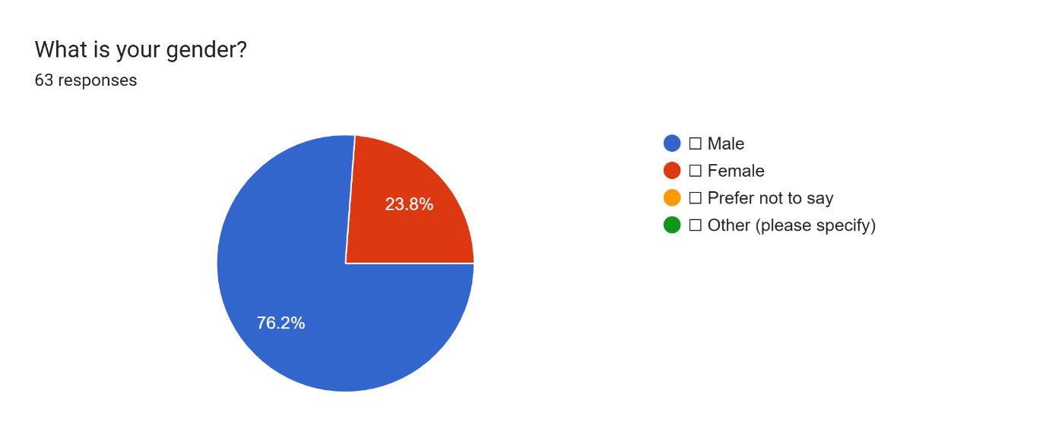
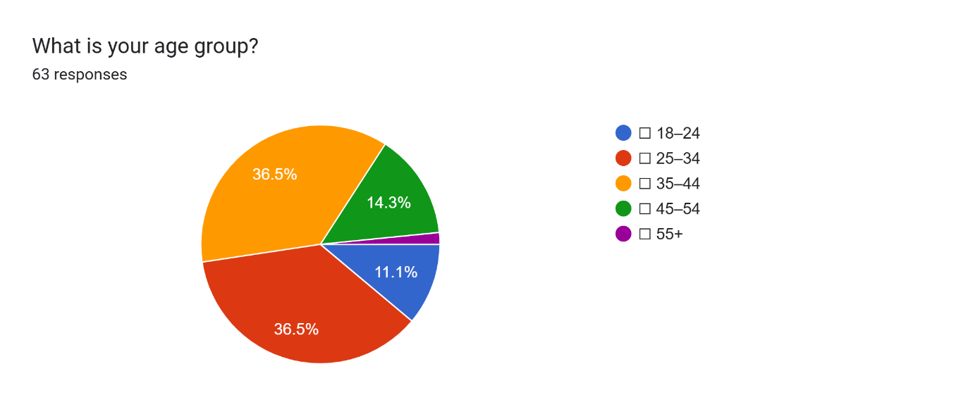
4.3 Familiarity and Perceptions of the JRFT
The JRFT was widely recognised, with 85.2% reporting they were very familiar with it. However, only 1.6% believed it completely reflected frontline demands, while 72.1% felt it did not really or not at all. Similarly, just 26.2% viewed it as highly relevant to their role. These findings suggest officers perceive the JRFT as a procedural requirement rather than a meaningful measure of operational capability.
This supports the College of Policing (2021) and NPCC (2023), which acknowledge that the JRFT based on a 15-metre shuttle run to level 5.4 tests only aerobic capacity and not the strength, power, or agility essential to policing. Lockie et al. (2022) similarly argue that aerobic-only assessments fail to measure the diverse physical abilities required in law enforcement, such as sprinting, restraint, and load carriage.
When asked whether the JRFT improved safety or readiness, 59.7% answered not really or not at all, and only 17.7% said definitely. Officers therefore appear unconvinced that the JRFT contributes to real-world safety or resilience, echoing Boyce et al. (2021), who found that single-component tests have limited predictive value for operational performance.
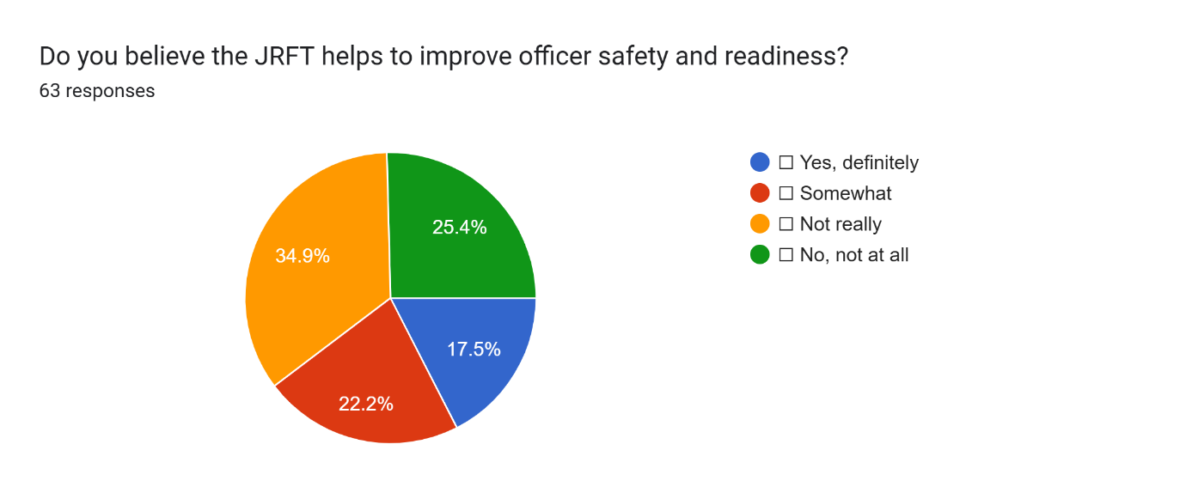
4.4 Stress, Motivation and Mental Health
Although 58.7% said the JRFT never caused stress, almost one-fifth reported occasional or frequent anxiety. Several respondents described pressure or ridicule from peers, reflecting Bullock and Fielding (2021), who found that fitness testing can create psychological strain particularly for officers returning from injury or maternity leave.
Mental wellbeing also influenced motivation: 61.3% said stress or fatigue had often or occasionally reduced their drive to train, and 87% agreed that mental health significantly or somewhat affects fitness maintenance. This aligns with Orr, Pope and Dawes (2022), who identified fatigue and trauma exposure as key inhibitors of physical activity in policing. Integrating wellbeing initiatives with physical training may therefore enhance motivation and reduce attrition.
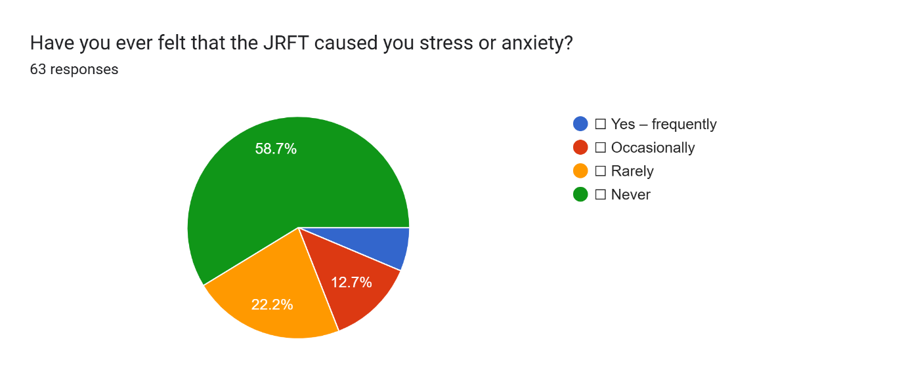
4.5 Barriers to Maintaining Fitness
Time constraints and fatigue were the most cited barriers. 82% identified fatigue from demanding workloads, 59% reported lack of time, and 57.4% cited family or personal commitments. Although 40.3% trained for 3–4 hours weekly, nearly 18% trained less than one hour or not at all.
These results support Dawes et al. (2019), who found that when fitness maintenance is left to individual responsibility, participation rates decline sharply. Without structured time and resources, many officers struggle to maintain consistent conditioning. Almost 73% said workload or shift pattern significantly hindered their ability to train, and 84.1% reported never being given time during work hours for fitness activity. This demonstrates a lack of organisational provision and reinforces the need for institutional support.
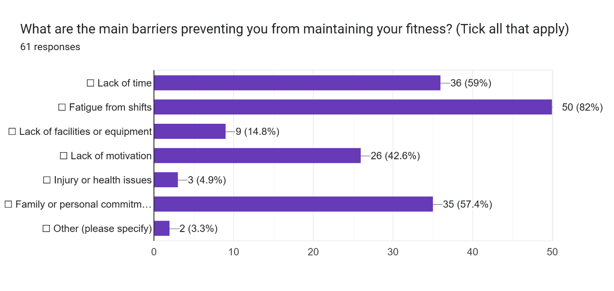
4.6 Fairness and Inclusivity
A majority viewed the JRFT as fair, with 60.3% rating it completely fair and 31.7% mostly fair. However, qualitative feedback described it as “too easy” or “unrealistic,” indicating tension between fairness and validity. The NPCC (2023) similarly recognises the challenge of balancing inclusivity with operational standards.
Regarding adaptations for officers returning from illness or maternity leave, 50.8% said adjustments were made sometimes and 38.1% said always. While generally positive, inconsistency remains between forces, echoing Bullock and Fielding (2021), who noted that variations in policy application can heighten stress and perceptions of inequity.
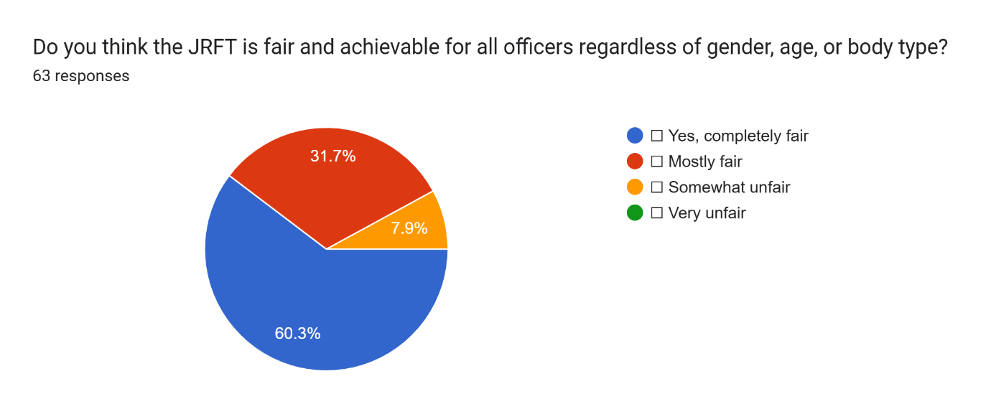
4.7 Proposed Improvements to the JRFT
Open-ended responses showed strong support for reform. Common suggestions included reintroducing strength and resistance components (such as push/pull tests), raising the pass level to better reflect operational demands, and introducing scenario-based or role-specific tests.
Many participants described the bleep test as outdated, proposing obstacle courses, sprints in uniform, or modular tests simulating real policing tasks. Others advocated tiered standards by age or role, similar to those used by the military (Ministry of Defence, 2023). These recommendations align with Boyce et al. (2021) and Lockie et al. (2022), who advocate for multi-dimensional assessments combining aerobic, anaerobic, and agility tasks for improved job relevance.

4.8 Organisational Support and Culture
Support for institutional responsibility was overwhelming, with 92.1% believing structured, on-duty training time should be mandatory. Officers argued this would counter fatigue, improve morale, and normalise a culture of physical readiness. This supports the College of Policing (2021) and Orr, Pope and Dawes (2022), who stress that shared responsibility for fitness enhances wellbeing and performance outcomes.
However, some participants described negative attitudes from peers, where those struggling with the JRFT faced ridicule. Such stigma can discourage participation and erode confidence. Brown (2020) argues that reframing the JRFT as a developmental rather than punitive tool would help foster inclusion and a healthier organisational culture.
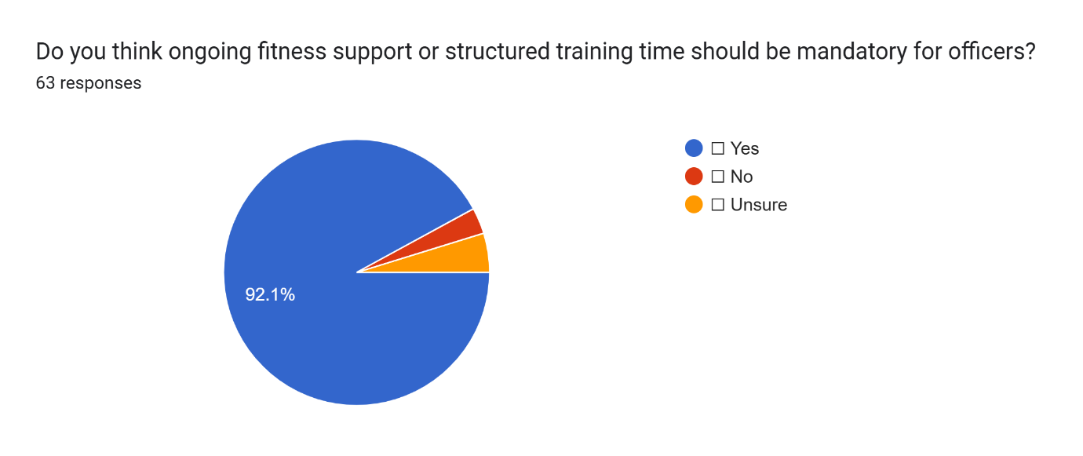
4.9 Overall Findings
The results show that while officers broadly accept the JRFT as a baseline requirement, most consider it unrepresentative of modern policing. Its aerobic focus, lack of strength components, and limited organisational support undermine its value. Fatigue, workload, and inadequate training opportunities were identified as major barriers, while mental health pressures further reduced motivation.
Officers overwhelmingly favoured reform to include strength and scenario-based testing and called for mandatory, on-duty training time. A cultural shift is also required from viewing fitness as a personal responsibility to recognising it as a shared professional standard that supports health, safety, and operational performance.

Bibliography
Boyce, R.W., Jones, G.R., Schumann, T.M. and Orr, R.M. (2021) ‘Functional fitness assessment in law enforcement: validity and future directions’, Journal of Strength and Conditioning Research, 35(8), pp. 2249–2256. [Accessed 16 October 2025].
Brown, J. (2020) ‘Police wellbeing and organisational culture: barriers to reform’, Policing: A Journal of Policy and Practice, 14(4), pp. 895–910. [Accessed 22 October 2025].
Bullock, K. and Fielding, N. (2021) ‘Testing fairness: gender, fitness and organisational culture in policing’, International Journal of Police Science & Management, 23(3), pp. 225–240. [Accessed 22 October 2025].
College of Policing. (2021). Job-related fitness standards | College of Policing. [online] Available at: https://www.college.police.uk/support-forces/health-safety-welfare/job-related-fitness-standards?utm_source. [Accessed 16 October 2025].
Dawes, J.J., Orr, R.M., Siekaniec, C.L., Vanderwoude, A.A. and Peters, B. (2019) ‘Functional movement and fitness among police officers’, International Journal of Occupational Safety and Ergonomics, 25(5), pp. 611–616. [Accessed 18 October 2025].
Home Office (2024) Police workforce, England and Wales: March 2024. London: Home Office Statistical Bulletin. [Accessed 18 October 2025].
Lockie, R.G., Orr, R.M., Moreno, M.R. and Dawes, J.J. (2022) ‘Occupational task performance and physical fitness in police officers: implications for job-related testing’, Journal of Strength and Conditioning Research, 36(9), pp. 2451–2462. [Accessed 22 October 2025].
Army.mod.uk. (2025). Page Restricted. [online] Available at: https://www.army.mod.uk/army-careers/careers/entry-requirements-and-standards/physical-employment-standards/. [Accessed 22 October 2025].
‌National Police Chiefs’ Council (NPCC) (2023) Job Related Fitness Test – Research Results. [Online ] Available at: https://www.npcc.police.uk/SysSiteAssets/media/downloads/publications/disclosure-logs/npcc-central-office/2023/228-2023-session-02-job-related-fitness-test-research-results.pdf [Accessed 18 Oct 2025].
Orr, R.M., Pope, R. and Dawes, J.J. (2022) ‘Optimising physical readiness in tactical populations: role specificity, fatigue and injury risk’, Strength and Conditioning Journal, 44(5), pp. 10–22. . [Accessed 22 October 2025].
Zwingmann, L., Holzgreve, F., Skorning, M. and Ellegast, R. (2021) ‘How fit are special operations police officers? A comparison to elite athletes’, Frontiers in Sports and Active Living, 3, p. 742655. . [Accessed 27 October 2025].

