Owen Williams

Mechanical Engineering

University of Wales Trinity Saint David

ACMA6012 – Computational Methods

3rd January 2024

Table of Contents

1. Introduction 3
2. Heat Equation 3
3. Numerical Method 4
3.1 Taylor Series 4
3.2 Finite Difference Method 7
3.3 Explicit Method 8
4. Initial and Boundary Conditions and Grid Spacing 9
5. Codes Details and Explanations 10
6. Validation of Code 13
7. Sensitivity Analysis of the Code 17
7.1 Influence of Grid Spacing (h) 17
7.2 Influence of Tolerance Condition 18
7.3 Influence of Time Step 19
8. Main Model’s Limitations 20
8.1 Code Limitations 21
9. Improvement and Future Developments 21
10. Conclusion 22
11. References 22
12. Appendix 24

Table of Figures

Figure 1 - Aluminium Plate with Properties and Boundaries 4
Figure 2 - Finite Difference Nodes (Wang 2021) 7
Figure 3 - Grid Spacing on Plate 9
Figure 4 - North Boundary Temperature Profile 10
Figure 5 - Grid Spacing Influence Graph 18
Figure 6 - Influence of Tolerance Graph 19
Figure 7 - Influence of Time Step Graph 20

Introduction
This report looks at the heat equation with some background research and how it is important. Taking the heat equation, it is applied to a problem, where Taylor Series and explicit finite difference scheme is used to approximate derivatives as well as applying a spatial domain to the problem to calculate spacing and therefore the behaviour of the solution.
An introduction to Fourier’s Number is made along with its influence on the solution, from this an understanding of stability and defining it to the solution is carried out. Initial and boundary conditions are applied to the problem with a description of the Dirichlet condition. A full view of the code generated along with descriptions is shown and how the solution was applied to the original fault and what the outcome was, this solution was then compared to an analytical model to compare the two and validate the answers.
Further analysis of the code was then completed to find how altering specific variables changes the overall outcome, this is then represented through a series of tables and graphs with a description as to why the model is behaving like this.
Finally, a full critique of the code and methods is carried out identifying underlining issues with the code and numerical method, as well as possible solutions for improvement and future developments that could be made.

Heat Equation
The heat equation is a partial differential equation which is fundamental in the field of heat transfer, the equation is widely used in engineering, physics, and various other disciplines. In 1822, Joseph Fourier first developed the theory of the heat equation as a way of seeing how a quantity such as heat diffuses through a specific region. The equation simply describes how the distribution of heat or temperature changes over time for a specific area (Incropera & DeWitt 1990). Fourier’s Law along with the conservation of energy states that the rate of heat transfer through a material is proportional to the negative gradient in the temperature and to the area, at 90-degree angles to the gradient where the heat flows (Connor 2019).
Heat is a form of kinetic energy which transfers between two different substances at different temperatures. The flow of energy goes from the substance which has the higher temperature to the substance with the lower temperature (Carmichael 2021). The heat equation for heat propagation across a 2D geometry can be given as (𝜕^2 𝑇)/(𝜕𝑥^2 )+(𝜕^2 𝑇)/(𝜕𝑦^2 )=1/𝛼∙𝜕𝑇/𝜕𝑡.
Where:
t is time.
T is the temperature.
k is the thermal conductivity (W.m-1.K-1).
𝜌 is the density (kg.m-3).
𝑐 is the specific heat (J.kg-1.K-1).
a is the thermal diffusivity (m-1.s-1). This is calculated by using the equation k/(p.c).
This equation also known as the Fourier-Biot equation takes an isotropic and homogenous material and governs the variation of temperature along with space and time whilst under a steady state (Barman 2021).
These complex heat transfer problems are now typically done using numerical techniques on computers. Current numerical techniques include finite element analysis, finite-difference analysis, and finite volume analysis.

Numerical Method
“A constitutive equation is a mathematical relation between two or more physical quantities” (Cheng 2016). To define mathematical relations, the material constants need to be known. These could include energy, angular and linear momentum, and the laws of mass, all of which have different effects on the material. (Reddy 2013) adds to this stating that constitutive equations are for the relations between primary and secondary field variables, also seen as a mathematical model for real behaviour of materials and put against experimental results for validation. Within this document, the temperature distribution in respect to time across an aluminium plate will be shown.
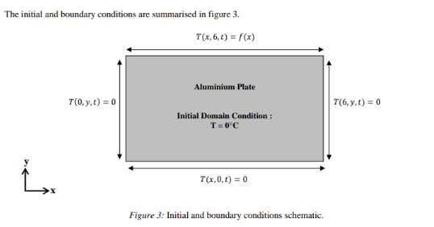

Figure 1 - Aluminium Plate with Properties and Boundaries

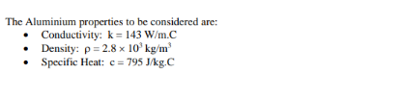

Before using the constitutive equation, it needs to be discretised using the Taylor series. (Weisstein 2023) states that “Taylor Series is an infinite sum of terms where each term has a larger exponent than the previous one.”. Using the Taylor Series will give an approximation on unknown functions whilst also increasing the accuracy of results by using small differences to replace differential quantities.

3.1 Taylor Series
Taylor series of function $f\left(x\right)$ about point $x=x_{0}$is
$$f\left(x\right)=f\left(x_{0}\right)+f^{'}\left(x_{0}\right).\frac{{\left(x-x_{0}\right)}^{1}}{1!}+f^{''}\left(x_{0}\right).\frac{{\left(x-x_{0}\right)}^{2}}{2!}+f^{'''}\left(x_{0}\right).\frac{{\left(x-x_{0}\right)}^{3}}{3!}+f^{\left(4\right)}\left(x_{0}\right).\frac{{\left(x-x_{0}\right)}^{4}}{4!}+⋯$$
The Taylor series that relates the value of a function at a point x₀ to the value of the function at a nearby point (x₀ + h), is
$$f\left(x_{0}+h\right)=f\left(x_{0}\right)+h.f^{'}\left(x_{0}\right)+\frac{h^{2}}{2!}f^{''}\left(x_{0}\right)+\frac{h^{3}}{3!}f^{\left(3\right)}\left(x_{0}\right)+⋯$$
Rearranging the equation will get this
$$\frac{f\left(x_{0}+h\right)-f\left(x_{0}\right)}{h}=f^{'}\left(x_{0}\right)+\frac{h}{2!}f^{''}\left(x_{0}\right)+\frac{h^{2}}{3!}f^{\left(3\right)}\left(x_{0}\right)+⋯$$
From this equation, the Forward Difference Approximation of $f^{'}(x_{0})$ can be made by using,
$$f^{'}\left(x_{0}\right)≈\frac{f\left(x_{0}+h\right)-f\left(x_{0}\right)}{h}$$
This is only an approximation, however, as ‘h’ is becoming smaller the accuracy of the outcome becomes higher. To find out how precisely the accuracy relies on ‘h,’ another equation can be used where $∈_{f}$ denotes the error incurred using the forward difference approximation, then,
$$∈_{f}≡f^{'}\left(x_{0}\right)-\frac{f\left(x_{0}+h\right)-f\left(x_{0}\right)}{h}$$
$$=-\frac{h}{2!}f^{''}\left(x_{0}\right)-\frac{h^{2}}{3!}f^{\left(3\right)}\left(x_{0}\right)+⋯$$
This equation approximates the order of 0 (h). This essentially states that as ‘h’ decreases the error of the forward difference approximation also decreases, in a liner fashion.
By decreasing the value of ‘h’ it can be seen whether a more accurate approximation of the function can be done. This is done by creating the backwards difference approximation, again, using the Taylor Series to write,
$$f\left(x_{0}-h\right)=f\left(x_{0}\right)-h.f^{'}\left(x_{0}\right)+\frac{h^{2}}{2!}f^{''}\left(x_{0}\right)-\frac{h^{3}}{3!}f^{\left(3\right)}\left(x_{0}\right)+⋯$$
Rearranging yields
$$\frac{f\left(x_{0}-h\right)-f\left(x_{0}\right)}{h}={-f}^{'}\left(x_{0}\right)+\frac{h}{2!}f^{''}\left(x_{0}\right)-\frac{h^{2}}{3!}f^{\left(3\right)}\left(x_{0}\right)+⋯$$

Therefore, the following equation is constructed for the Backwards Difference Approximation,
$$f^{'}\left(x_{0}\right)≈\frac{f\left(x_{0}\right)-f\left(x_{0}-h\right)}{h}$$
As stated above, this is an approximation which becomes more accurate as ‘h’ decreases. Using the below equation it can be seen how the error depends on ‘h,’
$$∈_{b}≡f^{'}\left(x_{0}\right)-\frac{f\left(x_{0}\right)-f\left(x_{0}-h\right)}{h}$$
$$=\frac{h}{2!}f^{''}\left(x_{0}\right)-\frac{h^{2}}{3!}f^{\left(3\right)}\left(x_{0}\right)+⋯$$
The approximation is again of order of 0 (h). It can be seen in both equations that as ‘h’ gets smaller the error also gets smaller in a linear fashion. Therefore, there is not any improvement of progress from the forward difference approximation.
However, if both the equations are combined it makes an improved approximation, they combine by taking the backwards difference approximation and subtracting it from the forward difference approximation. This approximation is known as the central difference as it uses both expressions to estimate the derivative (Johnson 2022).
$$f\left(x_{0}+h\right)=f\left(x_{0}\right)+h.f^{'}\left(x_{0}\right)+\frac{h^{2}}{2!}f^{''}\left(x_{0}\right)+\frac{h^{3}}{3!}f^{\left(3\right)}\left(x_{0}\right)+⋯$$

$$f\left(x_{0}-h\right)=f\left(x_{0}\right)-h.f^{'}\left(x_{0}\right)+\frac{h^{2}}{2!}f^{''}\left(x_{0}\right)-\frac{h^{3}}{3!}f^{\left(3\right)}\left(x_{0}\right)+⋯$$
=
$$f\left(x_{0}+h\right)-f\left(x_{0}-h\right) =2.\left[h.f^{'}\left(x_{0}\right)+\frac{h^{3}}{3!}f^{\left(3\right)}\left(x_{0}\right)+⋯\right]$$

Therefore,
$$\frac{f\left(x_{0}+h\right)-f\left(x_{0}-h\right)}{2.h} =f^{'}\left(x_{0}\right)+\frac{h^{2}}{3!}f^{\left(3\right)}\left(x_{0}\right)+⋯$$

So, from this approximation the Central Difference Approximation can be made,
$$f^{'}\left(x_{0}\right)≈\frac{f\left(x_{0}+h\right)-f\left(x_{0}-h\right)}{2.h}$$

The error of approximation can be calculated by,
$$∈_{c}≡f^{'}\left(x_{0}\right)-\frac{f\left(x_{0}+h\right)-f\left(x_{0}-h\right)}{2.h}$$
$$=-\frac{h^{2}}{3!}f^{\left(3\right)}\left(x_{0}\right)+⋯$$
The accuracy of the central difference approximation is to order of 0 (h²). Therefore, when the value of ‘h’ is small, this approximation will typically be better than both the forward and backwards approximations.

3.2 Finite Difference Method
Finite Difference analysis is a numerical method used to approximate a solution with the error being very small. Properties such as temperature are determined at discrete points in a region or material where needed and are known as nodes or nodal points (Stiller 2011). The temperature for example is calculated at a certain point using columns and rows to specify a direct location. Using algebraic expressions, a relationship can be defined between the adjacent nodes on the surface, within the brief of the paper the boundary conditions have been specified for the 2D plate.
Increasing the number of rows and columns means the number of nodes across a specific area also increases, by doing this it is a possibility to that the accuracy of the numerical solution increases and the spatial resolution of the solution.
An example of the finite difference analysis can be seen in Figure 2. This shows how a section would be split up using rows and columns to generate nodes.
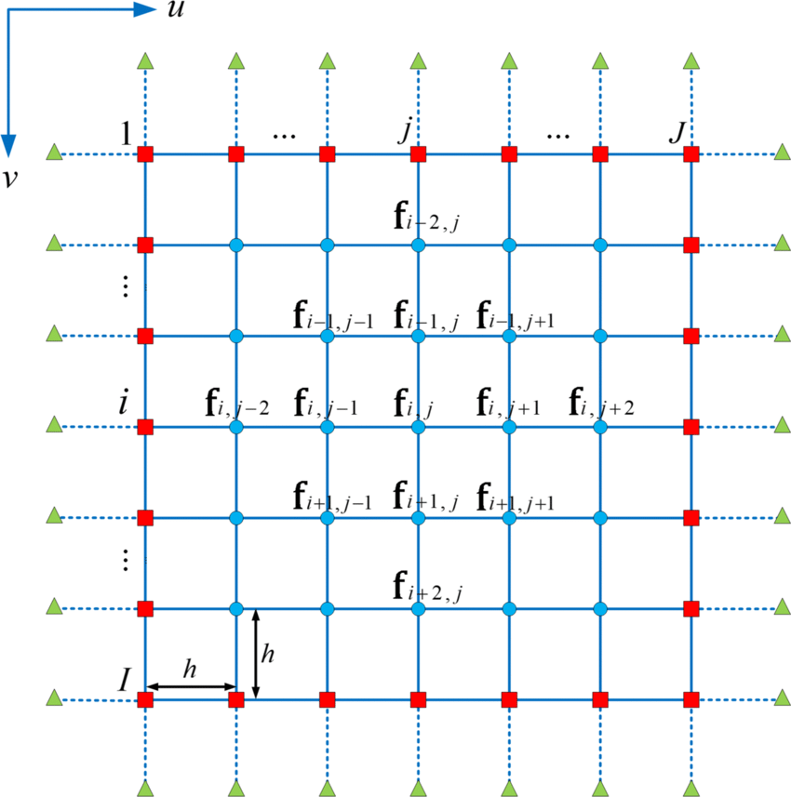
From this along with algebraic solutions the temperature at a specific node can be calculated.

Figure 2 - Finite Difference Nodes (Wang 2021)

The material stated in the brief is a 2D aluminium plate. Heat conduction in solids is described using the thermal diffusivity equation, which is only being used in two-dimensions. In the heat conduction equation 𝛼 is the material characteristics constant, a measurement can be taken to see how quickly the heat can move.
$$∇^{2}T=\frac{1}{α}.\frac{∂T}{∂t}$$
$$∴ \frac{∂^{2}T}{∂x^{2}}+\frac{∂^{2}T}{∂y^{2}}=\frac{1}{α}.$$
Where,
- $∇^{2}$ is the Laplacian defined by $∇^{2}=\frac{∂^{2}}{∂x^{2}}+\frac{∂^{2}}{∂y^{2}}$ in two dimensions
- t is time
- T is the temperature
- $α=k/{(ρ.c)}$ is the thermal diffusivity [m².s⁻¹]
- k is the thermal conductivity [W.m⁻¹.K⁻¹]
- $ρ$ the density [kg.m⁻³]
- $c$ the specific heat [J.kg⁻¹.K⁻¹].

The main reason for finite difference technique is the substitution of the derivatives in the differential thermal diffusion equation by forwards, backwards and central differences according to the Taylor Series Expansion as mentioned above. By doing this it turns the differential thermal equation into an algebraic equation which is solvable due to the initial and boundary conditions. Different characteristics such as speed, convergence, stability, and accuracy are generated through different finite difference methods due to the choice of approximation.

3.3 Explicit Method
Taking the differential thermal diffusion equation and representing it with the finite difference using,
- Central differences to discretize $∇^{2}T$
- Forward differences to discretise ${∂T}/{∂t}$
At the point P
$$\left\{\begin{aligned}\frac{∂^{2}T}{∂x^{2}}=\frac{T_{E}^{t}-2.T_{P}^{t}+T_{W}^{t}}{h^{2}} \\ \frac{∂^{2}T}{∂y^{2}}=\frac{T_{N}^{t}-2.T_{P}^{t}+T_{S}^{t}}{h^{2}}\end{aligned}\right.$$

and
$$\frac{∂T}{∂t}=\frac{T_{P}^{t+∆t}-T_{P}^{t}}{∆t}$$

Taking them both and substituting into the thermal diffusion equation gives the Explicit Finite Difference Equation;
$$T_{P}^{t+∆t}=F_{0}\left(T_{E}^{t}+T_{W}^{t}+T_{N}^{t}+T_{S}^{t}-\left(4-\frac{1}{F_{0}}\right).T_{P}^{t}\right)$$
Where Fo is the Fourier Number;
$$\frac{α∙∆t}{h^{2}}$$
Fourier’s Number is a dimensionless expression and used within the explicit finite difference equation. The reason it is known as the explicit form is because the unknown temperature $T_{P}^{t+∆t}$ can be explicitly determined knowing the temperatures at the previous time step. There is a disadvantage to this however, once $α$ and h are fixed, there is a maximum permissible time-step size $∆t$ which should not exceed the value imposed by the following stability criterion, this value for a 2D plate is, ¼.

Initial and Boundary Conditions and Grid Spacing
The aluminium plate has dimensions of 6 metres by 6 metres along with an initial condition of 0⁰C and a boundary condition of 50⁰C across the North boundary of the plate. The constant boundary condition was given as;

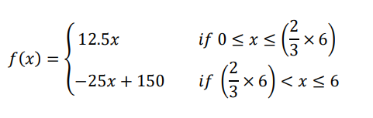

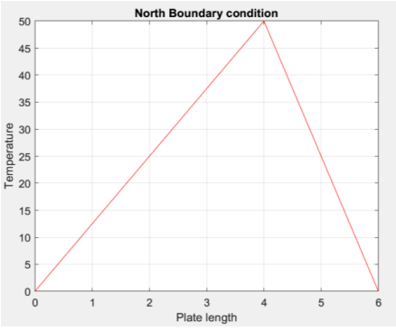
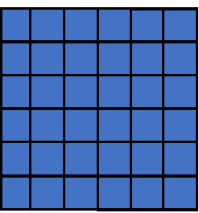
As the plate is 6x6 metres it will be divided up using a grid of discrete points 1m apart as seen below. Using a grid spacing of 1 metre allows for the discrete points to be small enough to capture the behaviour of the solution accurately. With the grid spacing being 1m and the constant boundary being given above, the temperature across the plate can be seen in the graph.

Figure 3 - Grid Spacing on Plate
Figure 4 - North Boundary Temperature Profile
A time step is also needed for the equation. Time Step is discretising the temporal domain by dividing the time interval into a sequence of discrete time steps, this number needs to be small for the solution to be stable. The time step should also be proportional to the grid size. Knowing values of the aluminium properties, $α=k/{(ρ.c)}$ was used to allow for $α$ to be used in the Fo equation.
$$α={143}/{(2.8*10³*795)}$$
$$α=6.424×{10}^{-5}$$
This can then be placed into the Fo equation,
$$F_{0}=\frac{α∙∆t}{h^{2}}=\frac{6.424×{10}^{-5}×3600}{1^{2}}=0.231267$$
As the answer is below ¼ the stability criterion has been fulfilled.

Codes Details and Explanations

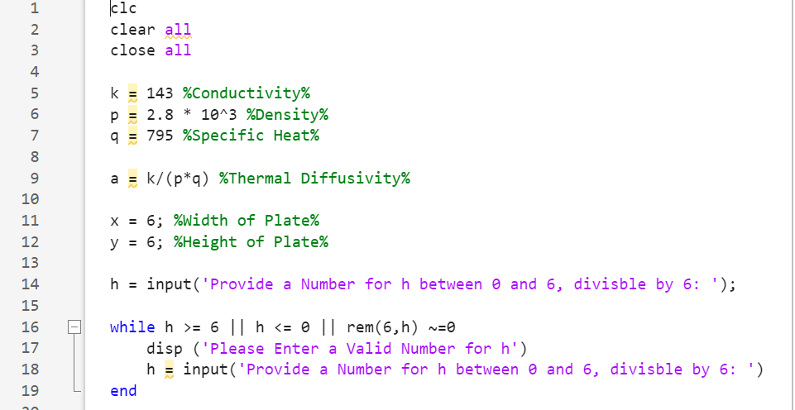
The first part of the code was inputting the material properties and writing the equation for Thermal Diffusivity, which will later be used to calculate Fourier’s Number. Lines 11 and 12 indicate the plate dimensions which as stated in the brief are 6x6. Below this is the ‘h’ value also known as the grid spacing, typically a uniform gird is used therefore the value for it must be divisible by 6 to generate even spacing.
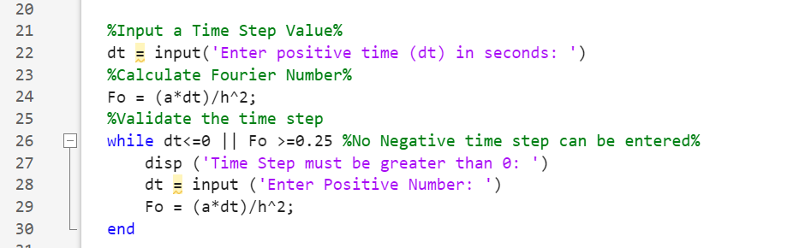
The above screenshot shows the calculation of Fourier’s Number along with input of a time step. To make sure the number is below 0.25 after the calculation a while loop was put in place to make sure the number is greater than 0 and less than 0.25, this meant a positive number must be entered.
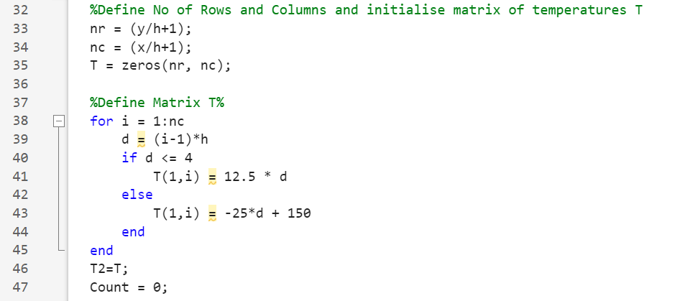
This section of the code simply initialises the matrix in which each node of the plate will we set across for a temperature. The matrix is set at 7 as it includes the starting or ending line for the spacing grid. The second section is the Dirichlet boundary condition, which states the values of the temperature along the north boundary.
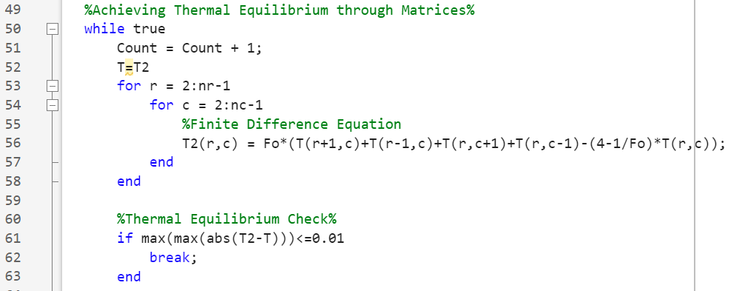
The first part of the screenshot shows the time loop being created whilst also introducing the Finite Difference equation using the specific letter used throughout the script. Below this is the thermal equilibrium check, this is made to show that when the new temperature is within a tolerance of 0.01 of the original temperature, to stop the loop as thermal equilibrium has been achieved.
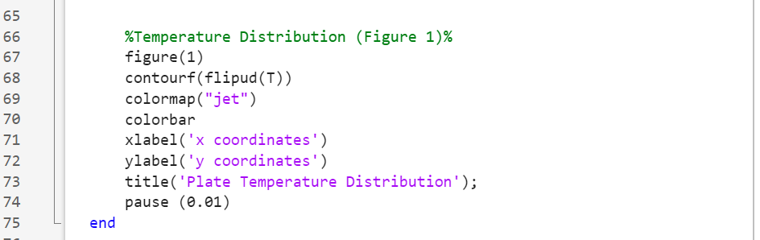
These parameters are put in place for the temperature distribution which is indicated on a colour schemed graph.
The final part of the numerical solution is to find out how long it took the temperatures to reach thermal equilibrium. This part of the code gives a statement at the end saying how long the it took, whether it be in seconds, minutes, hours or even days, this will be stated at the bottom of the command window after the code has run its cycle. This is an important part as when parameters are later adjusted to see the sensitivity of the code, it can be compared with the amount of time it took to reach equilibrium.
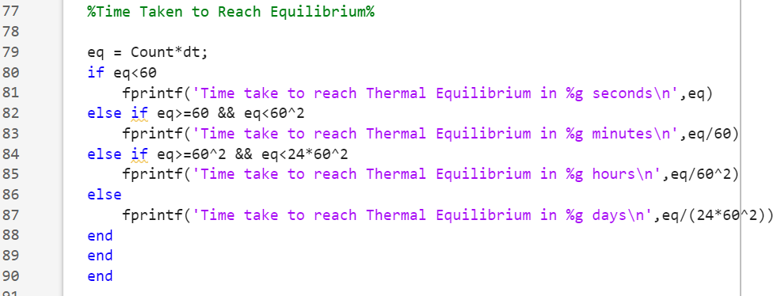
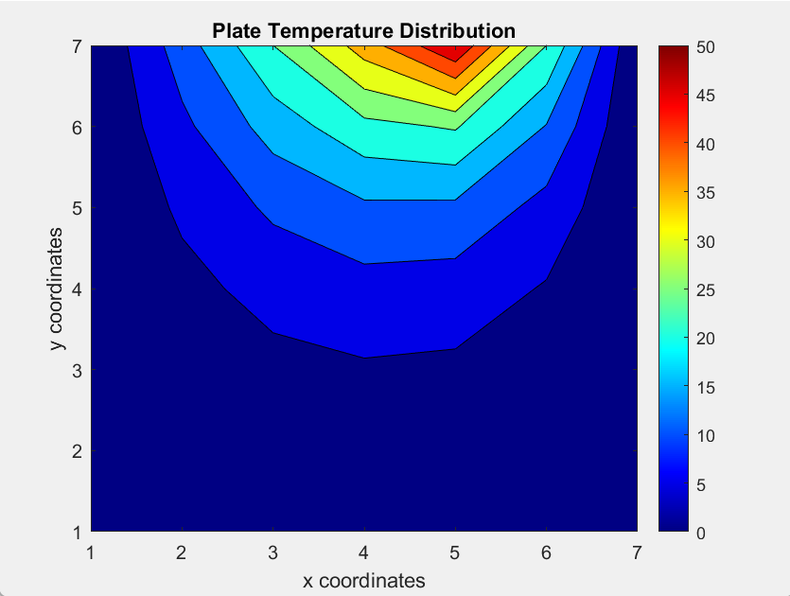
From this part of the code the resulting temperature map was created.

The temperature map shows the constant boundary condition being applied to the northern boundary with the 50⁰C heat source being applied at the fifth node across.

Validation of Code
To validate the code and see whether the results are accurate, the numerical solution compared with results taken from an analytical solution for thermal equilibrium. The analytical equation which we compare it to can be seen below (Daileda R.C., 2012).
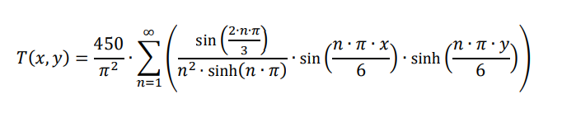

To calculate the analytical solution, it was added on to the original script for the code. Firstly, the matrix had to be calculated along with setting the number of terms known as ‘n’ in the equation. ‘n’ was set at 200 to increase the accuracy of the solution.

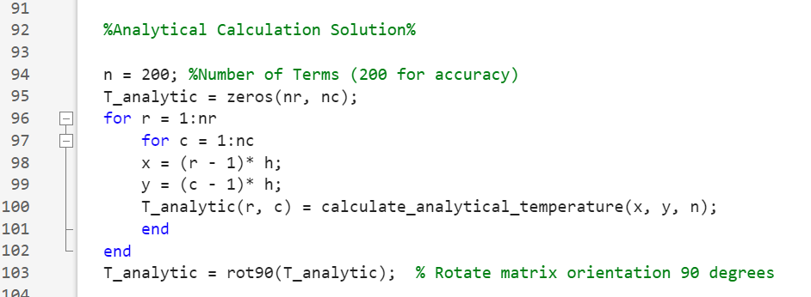
After setting up the calculations for the solution it was added to the code that the results are displayed for the thermal equilibrium from the analytical solution, and once the results are generated to find the difference between the to solutions the temperatures from the analytical solution are subtracted from the temperatures of the numerical equation.

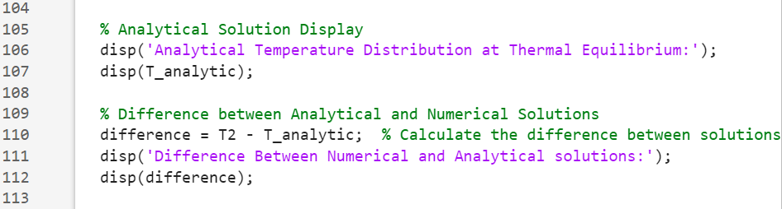
Again, as shown in the original solution, parameters are put in place for a temperature map to be generated from the equation to display the results. The first part of the code below is to create the graph to show the temperature map from the analytical solution, the second part establishes a temperature map showing the difference between the two maps made from the two codes.

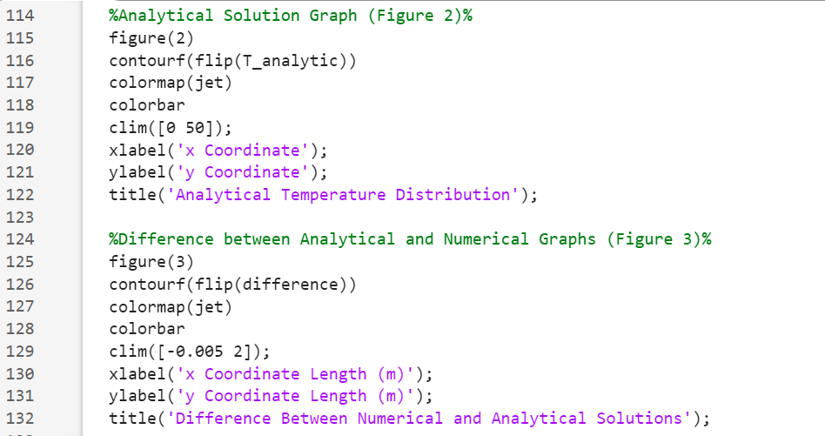
The final part of the code is to apply the analytical code to the matrix made and use the ‘n’ terms along with the grid sizing to fully complete the solution and start the process of calculating the heat. It is critical at this stage to apply the correct letters which have been assigned to parameters of the code and not use the same letter for two different parameters.
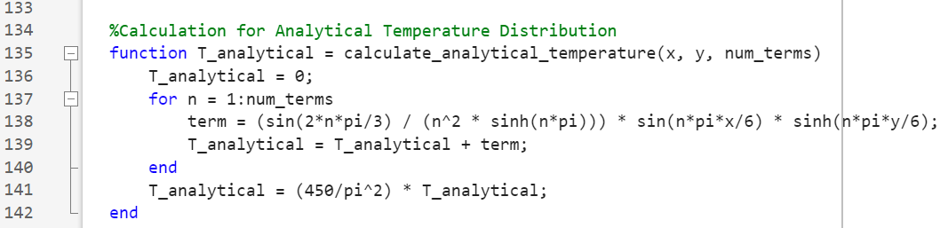
The function use is to tell the code to perform a specific task and to make it reusable.

Below are the temperature maps generated for the analytical solution as well as the difference graph. Along with this are the actual figures for the temperatures at each node on the aluminium plate using both numerical and analytical solutions.
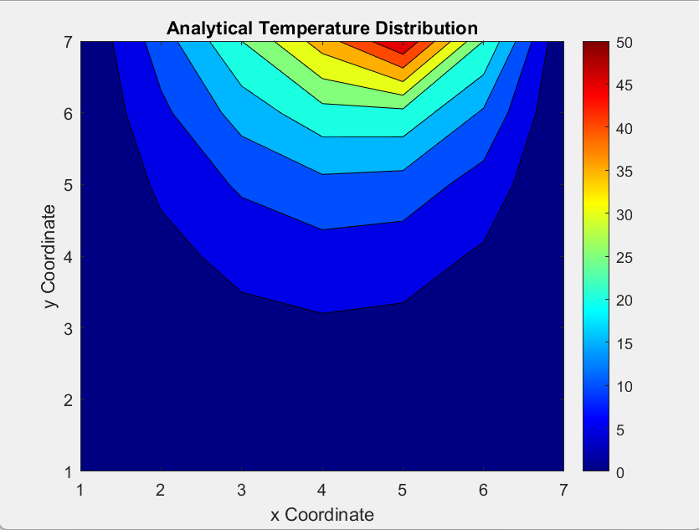

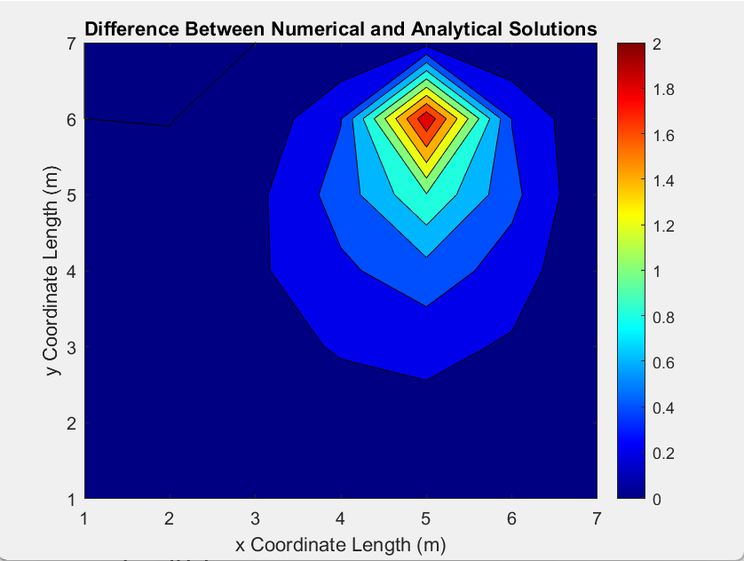

Below are the temperatures at each individual node for the numerical solution.
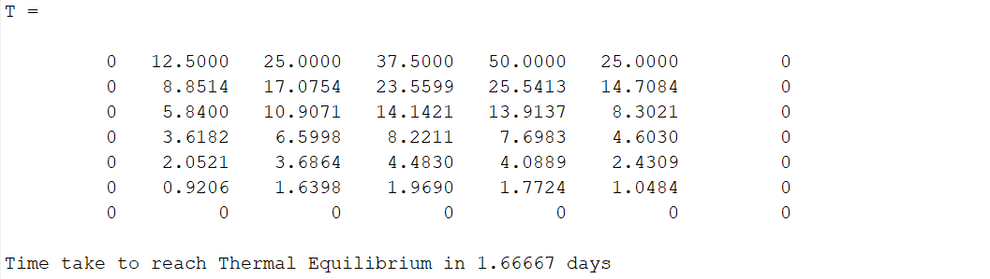

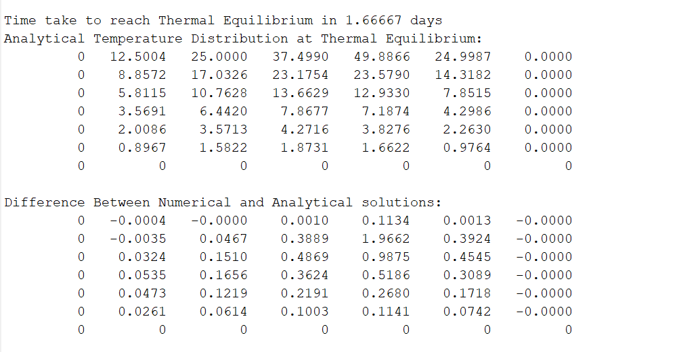
As you can see when looking at the temperatures at the individual nodes for the analytical solution and seeing the difference at each node you can see they are very similar. Therefore, giving the satisfaction that the code is fully validated and has been a success in achieving an accurate outcome.

Sensitivity Analysis of the Code

Changing some of the parameters and continuously running the code can allow for an analysis to carried out for how each of the variations affects the results of the solution. Firstly, looking at the influence of grid spacing also called ‘h.’ Looking at the table below you can see how the time to reach thermal equilibrium fluctuates up and down when the spacing is only increasing. When putting this into a graph you can see that the line oscillates in respect to the varying grid spacing, until it eventually finds the median and slowly begins to flat line. This is because of a term known as size step error. (Cook 2008) claims that as ‘h’ decreases the number of steps increases and therefore arithmetic error increases. When the spacing becomes too small the expressions are too close to each other which is known as the round off error, this can be seen when ‘h’ is set at 0.2 and 0.25 and the time is the same.

Influence of Grid Spacing (h)

Grid Spacing (h) | Time Step (Fixed) | Tolerance (Fixed) | Time for Thermal Equilibrium (s)
0.2 | 150 | 0.001 | 119099.808
0.25 | 150 | 0.001 | 119099.808
0.5 | 150 | 0.001 | 119549.952
0.75 | 150 | 0.001 | 119700.288
1 | 150 | 0.001 | 121049.856
1.2 | 150 | 0.001 | 118050.048
1.5 | 150 | 0.001 | 121500
2 | 150 | 0.001 | 119399.616
3 | 150 | 0.001 | 129300.192

Figure 5 - Grid Spacing Influence Graph
Next, analysis of the tolerance condition will be carried out. This test behaved in the manor which you would expect it too. When the tolerance it was lowered the time taken to reach thermal equilibrium was increased. This would make sense as the error tolerance has been increased the number of iterations required to reach that error would reduce.

Influence of Tolerance Condition

Grid Spacing (h) | Time Step (Fixed) | Tolerance | Time for Thermal Equilibrium (s)
1 | 500 | 0.1 | 29000.016
1 | 500 | 0.01 | 89500.032
1 | 500 | 0.001 | 155500.128
1 | 500 | 0.0001 | 221999.616
1 | 500 | 0.00001 | 287999.712
1 | 500 | 0.000001 | 354500.064

Figure 6 - Influence of Tolerance Graph

The final analysis carried out was for the time step to be altered with different figures. This is a crucial test as increasing the speed of time step can cause the results to not be as accurate and affect the stability of the solution. (Potts 2018) states that as the time step increases whilst the grid spacing remains the same, the time for thermal equilibrium will increase however the overall solution will eventually become unstable.
There is a lower bound to the time step size, and once beyond that boundary the solution may “exhibit spatial oscillations at the initial stages of the analysis” (Cui 2015), this will then lead to errors within the solution these boundaries must be identified. In order to achieve higher accuracy of results, the time step should be increased.

Influence of Time Step

Grid Spacing (h) | Time Step | Tolerance (Fixed) | Time for Thermal Equilibrium (s)
0.75 | 25 | 0.0001 | 134474.688
0.75 | 50 | 0.0001 | 154350.144
0.75 | 100 | 0.0001 | 174199.68
0.75 | 200 | 0.0001 | 193999.968
0.75 | 400 | 0.0001 | 213199.776
0.75 | 600 | 0.0001 | 224399.808
0.75 | 800 | 0.0001 | 232000.416
0.75 | 1000 | 0.0001 | 23800.032
0.75 | 1500 | 0.0001 | 247499.712
0.75 | 2000 | 0.0001 | 253999.584

Figure 7 - Influence of Time Step Graph

As seen from the graphs and table above, they support the original statement made by (Potts 2018) that as the time step increases so will the time taken to reach thermal equilibrium. It should also be noted that the higher time steps are a lot more of an accurate representation.

Main Model’s Limitations

Limitations of Numerical Method
When using computers and software to analyse solutions, errors do occur for different reasons, it is important that these limitations are stated and understood fully before using or following methods.
The first limitation to be made aware of it known as the round-off error. This is the difference between the exact or correct value compared to the approximation of a number used. An example of a round off number would be using π as 3.14159, only using this figure would give an approximation as the true ‘Pi’ is an infinite number. Often within computational methods, round-off error can be exaggerated as any initial errors are carried through more steps of the solution (Weisstein 2024), they sometime occur as computer have size and precision limits on ability to represent numbers.
The Truncation error is quite like round-off error as again it is the use of approximations, with truncation error is where an exact mathematical formulation is approximated. An example of this would be approximation to a derivative using a finite-difference equation and the Taylor series. The truncation error generally increases as step size increases whereas round-off error decreases when time step increases It can occur where you have both Truncation error and the round-off error, this is called the total error and it leads to a point of diminishing returns for time step (Jin 2013).
(Sauer 2013) mentions that without the stability from Fourier’s number the acceleration and speeding of heat can affect the accuracy of the equation. Along with this when trying to achieve higher accuracy from solutions, more complex algorithms are often needed, which can affect the stability of the equation. As well as this, the accumulation of the above errors can eventually cause the stability of the solution to be damaged if round-off errors continue throughout.
It does often occur that complex geometries are needed to be analysed. Generating a suitable grid with effective grid spacing can be difficult as it needs to capture the geometry accurately and efficiently, not doing so can damage the overall accuracy of the solution (Bathe 2011). Complex geometries can often include moving boundaries or interfaces which can make refining it complex. This is how stability and convergence issues arise within the solution.

8.1 Code Limitations
The biggest disadvantage of using coding to generate a thermal equilibrium is that the model is not perfect due to the fact we do not know whether ‘true’ equilibrium has been reached because of accumulative error and time. Due to errors such as round-off error and the tolerance set in the code, thermal equilibrium is said to be reached, however ‘true’ equilibrium will not have been achieved, so typically the code is showing a result which is either just before or just past ‘true’ equilibrium. When using a finite model, statistical noise can occur which will affect how accurate the solution is. This noise becomes more pronounced in small systems, potentially leading to fluctuations that are not representative of true thermal equilibrium as stated by (Newman 2013).

9. Improvement and Future Developments

To overcome issues with stability and even accuracy of the results from the model, some improvements can be made. Alternating direction implicit can be used to generate unconditionally stable results so that it can have larger time steps therefore saving the total number of time integration steps and being more efficient (Li 2021). Implicit finite difference method could also be used, this method again uses larger time steps without affecting stability and being more accurate. Allowing larger time steps whilst not restricting the stability conditions means they are highly efficient. Close care must be taken for the preservation of key physical properties. Depending on the characteristics of the problem will depend on what method will be chosen to tackle it.
The brief on this assignment included a basic 6 x 6 plate so the geometric was not complex. However, if a complex geometry needed to be derived then Finite Element Method would be used. Using FEM, complex shapes can be split into simple ones to form a finite-mesh. Here, field equations can be used to find the physics of the shapes that are needed, these equations can be formulated for each element. When the contributions from all elements are assembled you end up with a large sparse matrix equation system that can be solved by any of a few well-known sparse matrix solvers. (Sjodin 2016).
Finite Volume Method again uses geometry shapes and uses it to find the physical laws of that shape. This is done by stating what goes in one side must leave the shape the other side, from this a formulation that consists of flux conservation equation can be formed, typically good for fluid flow problems.
Future improvements could include using different finite methods, as well as using Euler and Runge-Kutte methods. Further research could also be carried out to test solutions for the convergence and therefore identify limits on the tolerance to produce more accurate results. Being able to use figures which do not suffer from round-off or truncation error would also make results more precise but this would have to be done by using a software with larger bits.

Conclusion

To conclude, this report looks at the heat equation for a 2D plate that has initial and boundary conditions that need to be defined. Using the Taylor series to approximate first and second derivatives and then using the explicit finite difference method to replace the first and second derivatives in the heat equation and replacing them with forward and central difference approximations. By choosing a grid spacing and time step, and understanding the Fourier number for stability, thermal equilibrium can be calculated for the plate in question. Analysis of the code was carried out to see how different variables affected the overall results.
Using Matlab for the numerical code it was critical that it was validated by comparing it to the analytical solution for thermal equilibrium. A full report of the code and what was done is included and the difference between the two results and heat maps. After carrying out the solutions, it was important that limitations and possible improvements were raised as well as future developments.

References

Bathe, K.J (2011) "Isogeometric finite element analysis: Toward integration of CAD and FEA," John Wiley & Sons.
Carmichael, R. (2021) Heat Formula. Available: https://www.toppr.com/. Accessed 2024, January 3rd.
Cheng, A. (2016) Poroelasticity. Constitutive Equations, pages 61 – 82.
Connor, N. (2022) Heat Equation. Available: https://www.thermal-engineering.org/. Accessed 2024, January 3rd.
Cook, J.D. (2008) Step Size. Available: https://www.johndcook.com/. Accessed 2024, January 15th.
Cui, W. (2015) Time Step for Finite Element Analysis. Available: https://onlinelibrary.wiley.com/. Accessed 2024, January 15th.
Daileda, R.C. (2017) Two-Dimensional Heat Equation. Available: http://ramanujan.math.trinity.edu/. Accessed 2023, January 8th.
Frank P. Incropera and David P. DeWitt” Introduction to Heat Transfer".
Jin, C.H. (2013) Round-Off and Truncation Errors. Available: http://isdl.cau.ac.kr/education.data. Accessed 2024, January 15th.
Johnson, H. (2022) Taylor Series, Available: https://uclnatsci.github.io/. Accessed 2024, January 6th.
Li, C. Li, C.; Long, G.; Li, Y.; Zhao, S. 2021. Alternating Direction Implicit (ADI) Methods for Solving Two-Dimensional Parabolic Interface Problems with Variable Coefficients. Available: https:// doi.org/10.3390/computation907007. Accessed 2024, January 18th.
Newman, M. (2013) "Computational Physics," CreateSpace Independent Publishing Platform.
Potts, D.M. (2018) Time Step Constraints. Available: https://www.sciencedirect.com/. Accessed 2024, January 15th.
Reddy, J. N. (2013) An Introduction to Continuum Mechanics. Constitutive Equations Chapter 6.
Sauer, T. (2013) "Numerical Analysis: Pearson New International Edition," Pearson.
Wang, S. (2021) Finite Difference Nodes. Available: https://www.researchgate.net/. Accessed 2024, January 8th.
Weisstein, Eric W. (2023) "Taylor Series." Available: ://mathworld.wolfram.com/TaylorSeries.html. Accessed 2024, January 6th.
Weisstein, Eric W. (2024) Round-Off Error. Available: https://mathworld.wolfram.com. Accessed 2024, January 15th/

Appendix

clc
clear all
close all

k = 143 %Conductivity%
p = 2.8 * 10^3 %Density%
q = 795 %Specific Heat%

a = k/(p*q) %Thermal Diffusivity%

x = 6; %Width of Plate%
y = 6; %Height of Plate%

h = input('Provide a Number for h between 0 and 6, divisble by 6: ');

while h >= 6 || h <= 0 || rem(6,h) ~=0
disp ('Please Enter a Valid Number for h')
h = input('Provide a Number for h between 0 and 6, divisble by 6: ')
end

%Input a Time Step Value%
dt = input('Enter positive time (dt) in seconds: ')
%Calculate Fourier Number%
Fo = (a*dt)/h^2;
%Validate the time step
while dt<=0 || Fo >=0.25 %No Negative time step can be entered%
disp ('Time Step must be greater than 0: ')
dt = input ('Enter Positive Number: ')
Fo = (a*dt)/h^2;
end

%Define No of Rows and Columns and initialise matrix of temperatures T
nr = (y/h+1);
nc = (x/h+1);
T = zeros(nr, nc);

%Define Matrix T%
for i = 1:nc
d = (i-1)*h
if d <= 4
T(1,i) = 12.5 * d
else
T(1,i) = -25*d + 150
end
end
T2=T;
Count = 0;

%Achieving Thermal Equilibrium through Matrices%
while true
Count = Count + 1;
T=T2
for r = 2:nr-1
for c = 2:nc-1
%Finite Difference Equation
T2(r,c) = Fo*(T(r+1,c)+T(r-1,c)+T(r,c+1)+T(r,c-1)-(4-1/Fo)*T(r,c));
end
end

%Thermal Equilibrium Check%
if max(max(abs(T2-T)))<=0.01
break;
end

%Temperature Distribution (Figure 1)%
figure(1)
contourf(flipud(T))
colormap("jet")
colorbar
xlabel('x coordinates')
ylabel('y coordinates')
title('Plate Temperature Distribution');
pause (0.01)
end

%Time Taken to Reach Equilibrium%

eq = Count*dt;
if eq<60
fprintf('Time take to reach Thermal Equilibrium in %g seconds\n',eq)
else if eq>=60 && eq<60^2
fprintf('Time take to reach Thermal Equilibrium in %g minutes\n',eq/60)
else if eq>=60^2 && eq<24*60^2
fprintf('Time take to reach Thermal Equilibrium in %g hours\n',eq/60^2)
else
fprintf('Time take to reach Thermal Equilibrium in %g days\n',eq/(24*60^2))
end
end
end

%Analytical Solution Calcutlation%

n = 200; %Number of Terms (200 for Accuracy)
T_analytic = zeros(nr, nc)
for r = 1:nr
for c = 1:nc
x = (r - 1)* h;
y = (c - 1)* h;
T_analytic(r, c) = calculate_analytical_temperature(x, y, n);
end
end
T_analytic = rot90(T_analytic); %Rotate matrix orientation 90 degrees%

% Analytical Solution Display
disp('Analytical Temperature Distribution at Thermal Equilibrium:');
disp(T_analytic);

% Difference between Analytical and Numerical Solutions
difference = T2 - T_analytic; % Compute the difference between solutions
disp('Difference Between Numerical and Analytical solutions:');
disp(difference);

% Analytical Solution Graph (Figure 2)
figure(2)
contourf(flip(T_analytic))
colormap(jet)
colorbar
clim([0 50]);
xlabel('x Coordinate');
ylabel('y Coordinate');
title('Analytical Temperature Distribution');

% Difference between Analytical and Numerical Graphs (Figure 3)
figure(3)
contourf(flip(difference))
colormap(jet)
colorbar
clim([-0.005 2]);
xlabel('x Coordinate Length (m)');
ylabel('y Coordinate Length (m)');
title('Difference Between Numerical and Analytical Solutions');

% Calculation for Analytical Temperature Distribution%
function T_analytical = calculate_analytical_temperature(x, y, num_terms)
T_analytical = 0;
for n = 1:num_terms
term = (sin(2*n*pi/3) / (n^2 * sinh(n*pi))) * sin(n*pi*x/6) * sinh(n*pi*y/6);
T_analytical = T_analytical + term;
end
T_analytical = (450/pi^2) * T_analytical;
end

