Johnson, Scott
Student ID Number: 2122928

Assignment 1:
Marketing Management

Tesla Inc – Marketing Strategy Analysis

Executive Summary

Tesla Inc are one of the world’s leading companies across any industry and are the leading car manufacturer in terms of value. Tesla poses a marketing style all of their own and this style has no doubt led to them soaring to this position.

Through the research conducted as part of the Group presentation and also in this report the main recommendation to be made is for Tesla to move to a Cobalt free battery design to help underpin their commitment to Corporate Social Responsibility and demonstrate that this is a primary factor in their supply chain as well as the overriding selling point of the product. To do so would not only strengthen the business in terms of how the present themselves to the world as an environmentally and ethically conscious business but would actually drive down the cost of the technology used within their vehicles making them more profitable if the choose.
Table of Contents
Executive Summary 1
1. Introduction 3
1.1. Purpose of report 3
1.2. Intro to Organisation 3
1.3. Intro to what was explored in Part 1 presentation 3
2. Main Findings 4
2.1. Marketing Concept 4
2.2. Macro & Micro Environment 4
2.2.1. Macro Environment 4
2.2.2. Micro Environment 7
2.3. Target Market 8
2.3.1. Segmentation 9
2.3.2. Targeting 9
2.3.3. Positioning 9
2.4. Marketing Mix 10
2.4.1. 7P’s 10
2.5. Marketing Media 10
2.6. Measuring Success 11
3. Conclusion 12
4. Recommendations 13
5. References 14
6. Appendix 17
6.1. Figure 1 - Micro Environment 17
6.2. Figure 2 - Macro Environment 18
6.3. Figure 3 - PESTLE Analysis 19
6.4. Figure 4 - Porters 5 Forces Model of Competitive Advantage 20
6.5. Figure 5 – New Vehicle Registration Data 2014 – 2021 21
6.6. Figure 6 – SWOT Analysis 22
6.7. Figure 7 – Segmentation, Targeting, Positioning Table 23
6.8. Figure 8 – Extended Marketing Mix 24
6.9. Figure 9 – Tesla Marketing Mix 25

Introduction

Purpose of report

This report outlines the findings presented in the presentation delivered previously and deep dives into the role and activities of the marketing department within Tesla Inc (to be called Tesla throughout the report) and makes recommendations for the future opportunities within the identified challenge of Corporate Social Responsibility and in particular the use of Cobalt within key components within the product range.

Intro to Organisation

Tesla was formed in 2003 by Martin Eberhard and Marc Tarpenning with Eberahrd taking the Chief Operations Officer role and Tarpenning taking the Chief Financial Officer role. They set up the business with the aim of proving that drivers don’t have to compromise with an electric vehicle (Tesla Inc, 2022) and providing an electric vehicle that has much lower emissions in comparison to the traditional combustion engine vehicles (Eberhard & Tarpenning, 2006).

At the time of writing, Tesla is ranked as the most valuable Automotive company in the world with an annual revenue of $53 Billion in 2021 (Statista, 2022). Employing just over 99,000 employees according to the 2021 US Securities & Exchange Commission (SEC, 2021) recently moving their Headquarters to Austin, Texas, USA alongside 5 manufacturing sites in the USA, one in Germany and one in China (Inside EV's, 2022).

The main offering from Tesla is their range of electric vehicles but they also sell solar power generation equipment and electric storage solutions as strong offerings into the market (GlobalData, 2022).

Outside of the standard in industry, Tesla does not have a Marketing Department as you would find in a conventional automotive manufacturer but disrupts the way marketing is done (Valentin, n.d.) . They have a Retail Marketing Team that develops content for their showrooms and events. They also have a team that develops events that will gain press interest and therefore publicity. This structure within the company has led to a famous “Zero Dollar” spend on direct marketing and allowed Tesla to have an estimated total marketing budget of approximately $66M compared to Volkswagen’s budget of $6.6B (Evolving Digital, 2022).

Intro to what was explored in Part 1 presentation

During the presentation delivered previously, the group explored the issues faced by Tesla with regards to Corporate Social Responsibility and the specific issue of the use of Cobalt in their key components and how the mining process prevents ethical concerns for working conditions and child labour as well as the reported negative impact on the environment in the mining method.

This report will build on those findings and look in depth at how the marketing department in Tesla deal with that and what they can do to improve the situation in the future.

Main Findings

Marketing Concept

The Marketing Concept is underpinned by the logic that achieving corporate goals can be done through meeting customer needs (Ferrell, et al., 2021). This will only work if you do this better than your competitor or if not, you will need a differentiator between your product to make your offering stand above that competitor (Elliot, 1990).

For Tesla, they have positioned themselves firmly at the top of the Electric Vehicle market and made their name synonymous with electric cars in general. This move has allowed them to scale the business rapidly year on year and gain the position of the world most valuable automotive company in 2021.

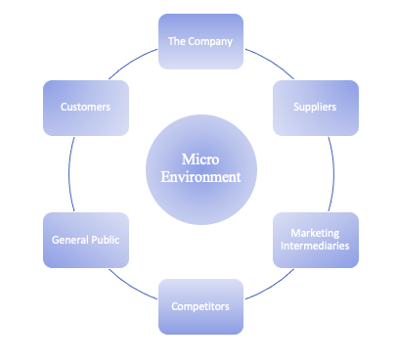
Macro & Micro Environment

Any business in operation will have influences around it with both direct and indirect touch points. This environment is broken down into the Micro and Macro environment.

The Micro environment is the influences that directly affect the business in question through things like performance or even daily activity.
The Micro Environment has 6 main attributes as can be seen here in Figure 1:
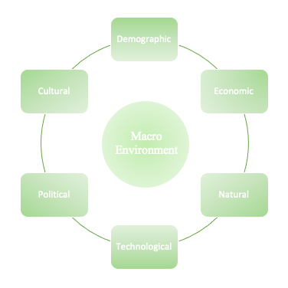

The Macro Environment is the wider influence aspects that cannot be controlled or influenced by the organisation. Similarly, to the Micro Environment, the Macro Environment has 6 main attributes also and can be seen here in Figure 2:

Macro Environment

PESTLE Analysis

Continuing the dive into Tesla, a detailed PESTLE Analysis was conducted to understand the external business environment as PESTLE is one of the most common aides to evaluate the business situationally (Gupta, 2013) as it allows the user to evaluate the dynamic and competitive business environment and give a well-rounded view of aspects such as customers/competitors, wars or political tension alongside industry common factors or banking changes (Perera, 2017). There are many advantages of using PESTLE such as simplicity, encourages higher level thinking or being able to spot potential new opportunities (Rastogi & Trivedi, 2016) but the model also has limitations such as oversimplification of data, capturing too much data, or the pace of change in the modern world making data out of data quickly (CIPD, 2021)

Here in Figure 3 we see the defined environments that were analysed to gain the broader understanding of the current external factors affecting Tesla in the wider context but for this report, I will focus on the items relating specifically to the challenge highlighted in regards to Corporate Social Responsibility and Cobalt mining:

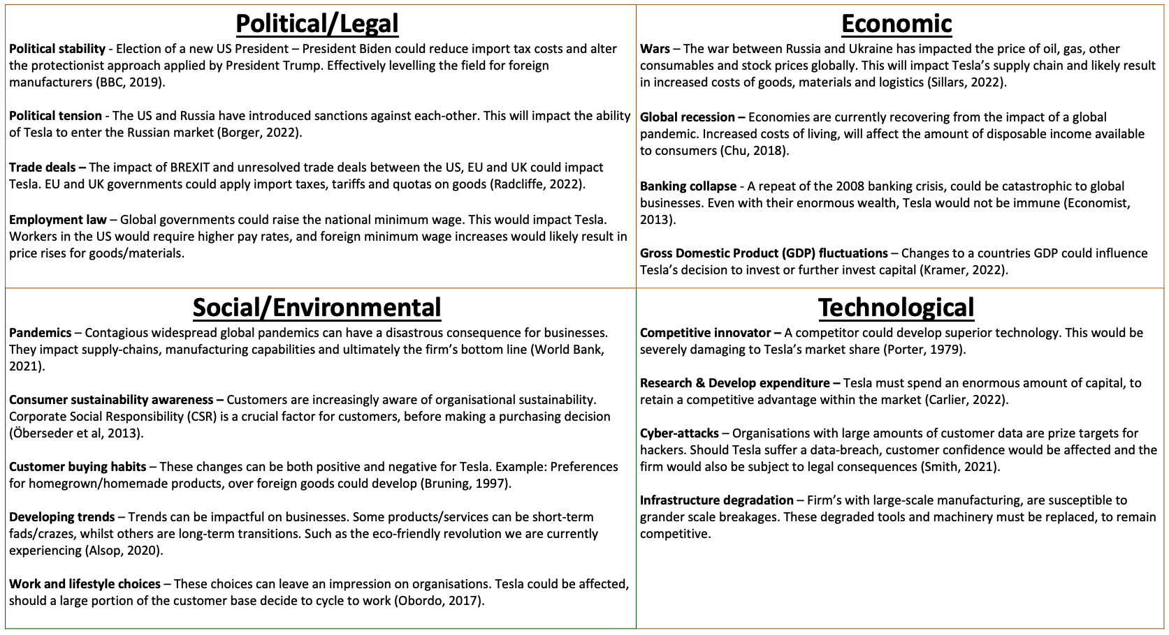

In relation to the aspects mentioned in the presentation, the Marketing Department at Tesla can work in the following manner:

Political/Legal – Trade Deals:
The unresolved situation with BREXIT and the issues that has led to in regard to Trade Deals between the UK and EU as well as new deals being brokered between the UK and USA as an output of BREXIT may leave some uncertainty for Tesla in the out of US markets and how they export their products to the UK. The Marketing Department can act on the present situation and ramp up their marketing within the UK and EU markets to secure orders in those markets ahead of any potential changes. Supply could be changed from other areas outside of UK and EU to shorten the lead times and allow more vehicles to be sold into the market whilst the situation remains as it has been for several years (Gutiérrez Chacón, et al., 2021)

Economic – Global Recession:
The COVID 19 pandemic has led many countries into a Cost-of-Living crisis or a National Recession (World Bank, 2020). This tightening of purse strings on a governmental and personal level has the potential for many individuals to reduce their spend on luxury items like Electric Vehicles with one cost saving example being on how Electric Vehicles do not require as much maintenance as a traditional combustion engine car (Fayziyev, et al., 2022)

Social/Environmental – Consumer Sustainability Awareness:
For many businesses in the 21st century, being ahead on Quality, Cost and Delivery is not seen as a high point but rather as the minimum expected standard for consumers (National Research Council, 2020). Consumers are looking to businesses to see how they are going beyond the ability to be a profitable and therefore stable business and how the business impacts outside of itself as an organisation. Corporate Social Responsibility is becoming an ever more popular facet for a consumer and the desire to understand how the organisation impacts the environment, people outside of its employees, or economies. This was the main challenge focussed on in the presentation and in particular the mining of Cobalt for use in the battery systems that power an electric vehicle.

As the presentation mentioned, there have been highly public cases where large organisations such as Tesla have been taken to court for mistreatment and even causing the deaths of individuals, including children in countries such as the Democratic Republic of Congo (DRC). This presents a sizeable concern for Tesla as a company and the Marketing Department. As a company, Tesla have pledged to move to a Cobalt free battery for its standard range vehicles which will lessen the impact on the environment, reduce the amount of mining in conflict countries like DRC and therefore those being exploited and also reduce the cost as Cobalt is an expensive element to purchase (Morris, 2020) For the marketing Department, this pledge presents a huge opportunity to raise awareness of the company’s desire to do more for its Corporate Social Responsibility as well as move away from the norm in electric vehicle manufacturing and create competitor differentiation as a unique selling point.

Porters 5 Forces Model of Competitive Advantage

Porters 5 Forces Model of Competitive Advantage is designed to explain how businesses can achieve and advantage against their competitors within their particular business sector (Goyal, 2022). This model is equally valuable to businesses selling a product as well as those providing a service.

Below in Figure 4 we see the information collated on Porters 5 Forces of Competitive Advantage for Tesla.

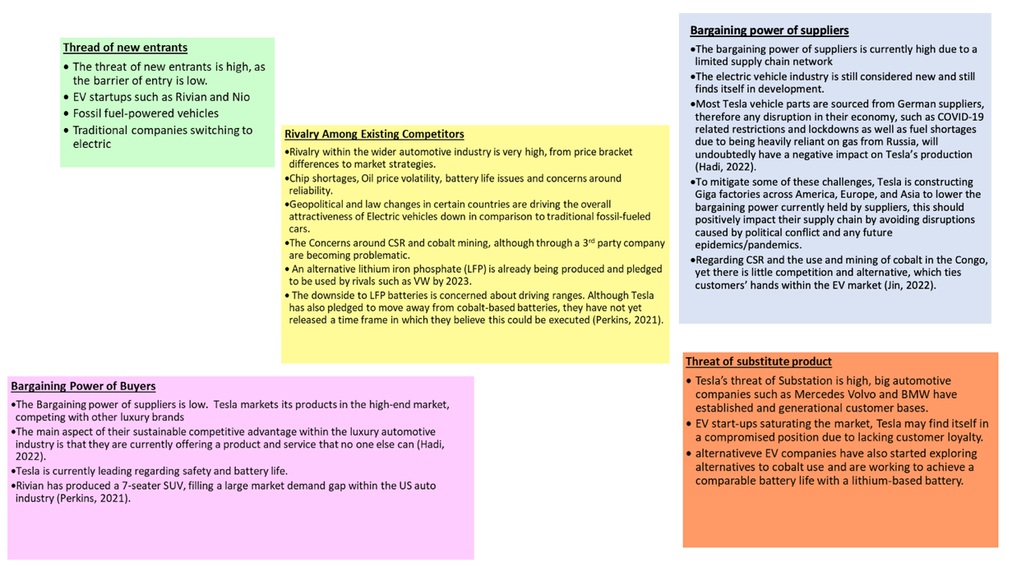
Here we see that the Threat of New Entrants is High due to new start-up brands such as Rivian who were heavily backed by Ford (Speakman, 2021) or Chinese newcomers, Nio.

The threat of substitution is also High as conventional car manufacturers are confidently dipping their toes in the Electric Vehicle market and have years of manufacturing experience behind them.

The bargaining power of Buyers is Low as Tesla offers a fairly unique product in the high-end, luxury Electric Vehicles they produce.

The bargaining power of Suppliers is High due to a limited supply chain network as the whole Electric Vehicle market is relatively new and establishing itself.

Rivalry between existing competitors is Very High as all Electric Vehicle brands are fighting to establish themselves in this new market.

Micro Environment

Competitor Analysis

For the Competitor Analysis a comparison was done between Tesla and other Manufactures based on New Vehicle Registration.
This found that the main competitors were Nissan, Volkswagen, Renault and Hyundai but all were markedly behind the sales volume that Tesla holds in the market. Equally, those competitors are essentially filling a different market sector with their electric vehicles as Tesla is high-end, luxury electric vehicles and the other brands are more functional “family” type vehicles with a lower price point.

Sales by Quarter for 2021 and 2020 as well as overall sales from 2014 to 2019 can be seen below in Figure 5:
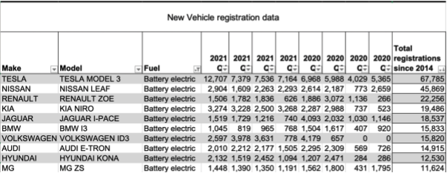

The data seen here clearly shows Tesla’s lead in the Electric Vehicle market and gives some indication as to why Tesla have adopted the marketing strategy of Zero spend.

SWOT Analysis

A thorough SWOT analysis was undertaken looking into the Strengths, Weaknesses, Opportunities and Threats for Tesla in its current form and can be seen below in Figure 6:

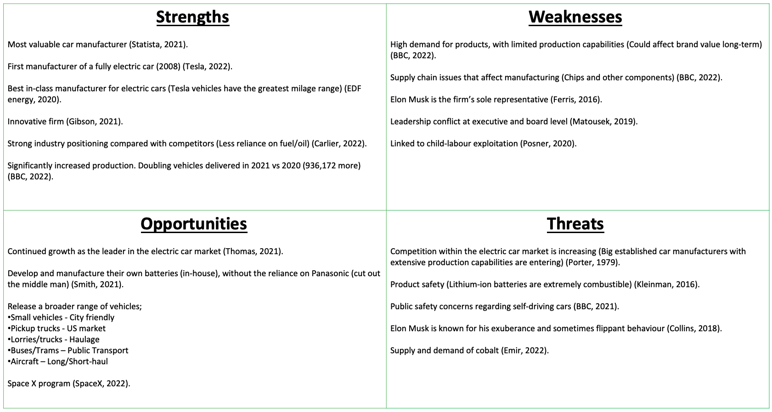

The key take always from this analysis were as follows:
Strength – Most valuable car manufacturer (Statista, 2022) and First manufacturer of a fully electric car in 2008 (Tesla Inc, 2022)
Weakness – Supply Chain issues that could impact the business heavily (BBC, 2022)
Opportunity – Develop and manufacture their own battery in-house (Smith, 2021)
Threat – Traditional car manufacturers moving into the Electric Vehicle market, and supply/demand for Cobalt (Emir, 2022).

Target Market

A targeted approach to marketing allows a business to divide the market into segments and target each segment by appropriately positioning the product/service in the best manner (Camilleri, 2018). The Segmentation, Targeting and Positioning (STP) method will mean the business can satisfy a range of customers wants and needs effectively through directly addressing them in an appropriate manner.

A STP table was drawn up for Tesla as can be seen below in Figure 7:
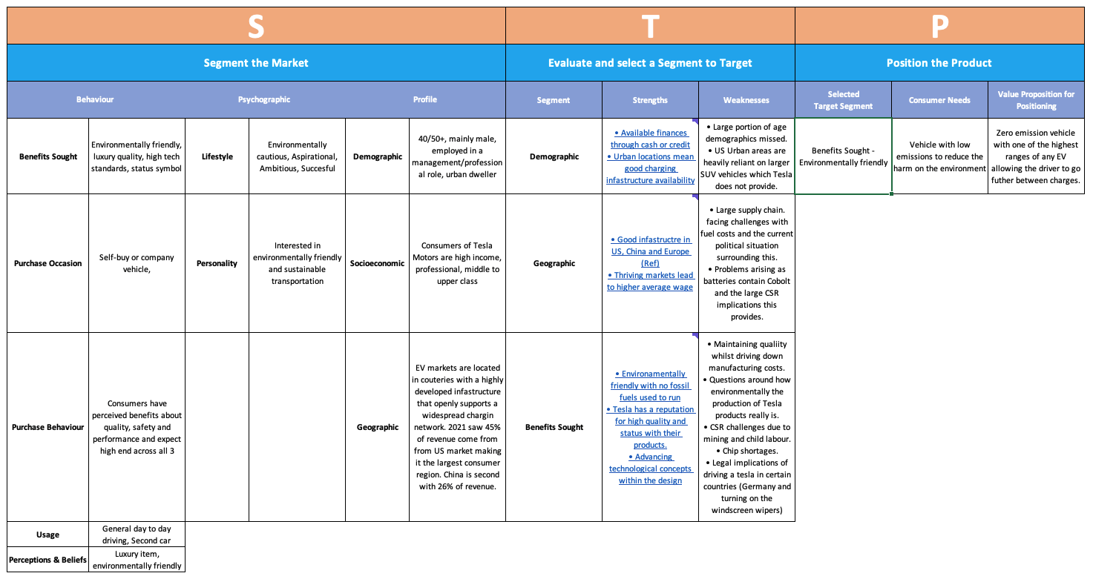

Segmentation

Dividing the whole marketplace down into smaller groups based on characteristics is the first step of the STP process. These small groups will allow Tesla to delve into the characteristics that their buyers have and allow them to target their wants and needs better.

For Tesla, the table explored segments such as Benefits Sought, Purchase Occasion, Lifestyle and Demographic amongst others.

Targeting

Once the marketplace has been broken down into manageable groups through Segmentation, the marketeer can decide which segments are worth targeting. This can be done using tools that have been mentioned earlier in this report such as PESTLE Analysis or Porters 5 Forces.

To home in on the appropriate targets for Tesla, the segments worth targeting were defined as:
Demographic,
Geographic, and
Benefits Sought.

Positioning

Finally, Positioning allows the marketeer to best place the product in front of the consumer defined in the segmentation and targeting done above.

To concentrate the effort on a defined target consumer, Tesla could position their product in the Benefits Sought segment through solving the customers need to have a low emission vehicle to reduce the environmental impact through the value proposition of a zero emission vehicle with one of the highest ranges between charges of any electric vehicle.

Marketing Mix

7P’s

The Extended Marketing Mix consists of 7P’s and can be seen here in Figure 8:
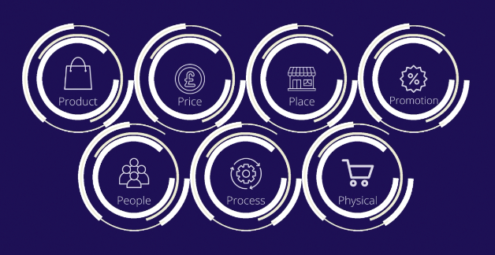

For Tesla the Marketing Mix has been established as follows in Figure 9:
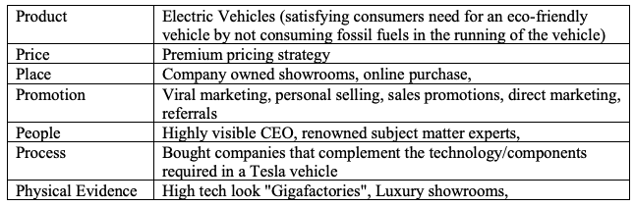

Marketing Media

Tesla relies on media coverage and word of mouth as its main form of marketing (Tesla Inc., 2019). The company also has a heavy helping hand from CEO, Elon Musk via his personal social media accounts that has the ability to reach millions per month for free.
These main methods have led to Tesla not spending on traditional marketing such as TV/Radio or printed press advertisements.

To date, Tesla has pulled off some spectacular stunts that have gathered extremely large amounts of media coverage such as strapping a Tesla Roadster to a SpaceX rocket and sending it to space. This method of garnering at

Measuring Success

Tesla measures success in various methods but holds Customer Satisfaction as the highest priority (Bredenfeld, et al., 2020) and because of this one of the key measures of success is Customer Satisfaction.

In a study recently undertaken (Liang, 2022), Customer Satisfaction was performing very well as can be seen in Figure 10 below:
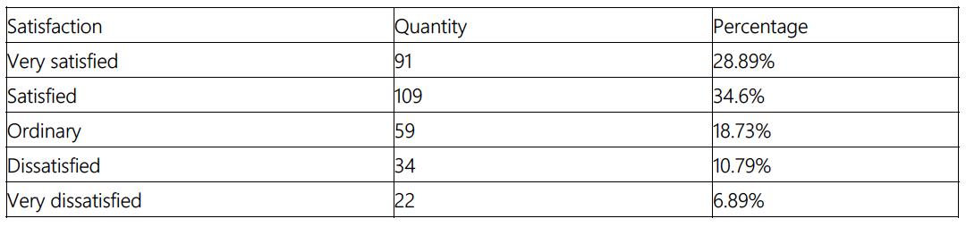

It is also widely reported that Tesla are leading the way in how they market the business especially as it is in such a disruptive manner (Data & Marketing Association, 2018) (Marketing Strategy, 2019) (Sharma, 2016) and this can be taken as a success in its own right, too.

Conclusion

With a Marketing style all of their own, Tesla have managed to position themselves ahead of other vehicle manufacturers in a relatively short timeframe and for a fraction of the cost that other car brands spend.

Tesla have become the most valuable car brand in the market. Their high end, luxury vehicles have become synonymous with Electric Vehicles in the same way that Bic is synonymous with the humble biro or Hoover with the vacuum cleaner. With this in mind, it can be said that their marketing strategy has been very successful and as such, they should continue with this marketing method and incorporate the recommendations into their current marketing schedule.

This unique marketing style has limited the options for recommendations that would have been available in a business with a conventional marketing style, but these recommendations will likely pay bigger dividends for Tesla in comparison to a conventional marketing style undertaking them. The recommendations have been made using PR Smith’s SOSTAC model (Smith, et al., 1999) which is essentially an extension of a SWOT analysis that allows the user to make a systematic approach to a marketing plan (Cowley-Cunningham, 2016).

Recommendations

 | Ramp up campaigns in UK ahead of changes from BREXIT completion | Develop Cobalt free battery as part of doing more within CSR
Situation | Potential changes in trade deal legislation within the EU and UK could cause higher cost implications for imports in Europe. | Negative press associated with the mining of Cobalt in third world countries such as Democratic Republic of Congo has potential to detract customers from the environmental benefits of Electric Vehicles.
Objectives | Increase sales for all car models in UK and EU by a combined total of 15% by Dec 31st 2023 ahead of any potential cost increase. | Move to a Cobalt free battery design on all Electric vehicle models by December 31st 2027.
Strategy | Create UK and EU specific campaigns to gain press within the two defined regions (EU campaign can be utilised through all EU countries). | Increase public awareness of new cobalt. Free battery design and highlight the reason being the negative impact of Cobalt mining taint the other car manufacturers that will still use Cobalt and make customer perception of Tesla to be the most environmentally caring.
Tactics | UK or EU flag branded cars to be utilised in stunts in specific countries with press notification to gain coverage. Teemed with specific offerings as approved by Sales Department to offer an incentive (free charging for 3 years was previously offered). | Engage press through a series of high-profile Tesla staff visits and interviews in locations for Cobalt mining and with those who have been impacted by the process. Develop a factual video series aimed at social media release that documents the Cobalt free battery design whilst highlighting the environmental benefits of doing so at all times and noting the intention to make the technology open source.
Action | Fleet of flag branded cars to be driven by celebrities through Capital cities to a static outdoor event venue with a party attended by major influencers in the country. | Send Elon Musk to DRC to visit a Cobalt Mining operation to highlight to negativity of the mining process environmentally and ethically (through poor human right activities). Publicise the development of a Cobalt free battery. Make technology open source and patent free to allow other manufacturers the ability to move to Cobalt free also. Launch first Cobalt free model in DRC. Engage press throughout all activities through interviews with Elon Musk as well as subject matter experts and former Cobalt miners.
Control | Vehicle orders from online and showrooms data for previous 3 years to be averaged and used as baseline for performance monitoring going forward on a month-by-month basis. | Design process key milestones being achieve on time and within budget. Social media reach and engagement for video series to be tracked month by month once released.

References

BBC, 2022. Tesla expects 50% growth despite supply chain woes. [Online]
Available at: https://www.bbc.co.uk/news/business-60149374
[Accessed 13 06 2022].
Bredenfeld, L. et al., 2020. Tesla Moving Forward. Journal of New Industry and Business, 38(1), pp. 47-70.
Camilleri, M. A., 2018. Market Segmentation, Targeting and Positioning. In: Travel Marketing, Tourism Economics and the Airline Product. Tourism, Hospitality & Event Management. s.l.:Springer, Cham, pp. 69-83.
CIPD, 2021. PETSLE Analysis. [Online]
Available at: https://www.cipd.co.uk/knowledge/strategy/organisational-development/pestle-analysis-factsheet#gref
[Accessed 09 06 2022].
Cowley-Cunningham, M. B., 2016. 'Jellies & Jaffas': Applying PR Smith's SOSTAC Marketing Model to an Online Confectionery Start-Up. s.l.:PEER LEARNING: QQI - Applying Marketing Theory to eBusiness - Confectionery - Digital Marketing Certification Programme DkIT .
Data & Marketing Association, 2018. What can we learn from Tesla's $0 marketing startegy?. [Online]
Available at: https://dma.org.uk/article/what-can-we-learn-from-teslas-0-marketing-strategy
[Accessed 13 06 2022].
Eberhard, M. & Tarpenning, M., 2006. The 21 st century electric car tesla motors, s.l.: Tesla Motors.
Elliot, G. R., 1990. The Marketing Concept – Necessary, but Sufficient? An Environmental View. European Journal of Marketing, 24(8), pp. 23-30.
Emir, C., 2022. New battery technologies and recycling won’t save you from cobalt shortage. [Online]
Available at: https://interestingengineering.com/new-battery-technologies-and-recycling-wont-save-you-from-cobalt-shortage
[Accessed 13 06 2022].
Evolving Digital, 2022. Tesla - A different kind of marketing machine. [Online]
Available at: https://evolving-digital.com/resources/tesla-marketing-machine/
[Accessed 13 06 2022].
Fayziyev, P. R., Ikromov, I. A., Abduraximox, A. A. & Dehqonov, Q. M., 2022. Organization of technological processes for maintenance and repair of electric vehicles. International Journal of Advance Scientific Research, 2(03), pp. 37-41.
Ferrell, O. C., Hartline, M. & Hochstein, B. W., 2021. Marketing Strategy. s.l.:Cengage Learning.
GlobalData, 2022. Tesla Inc: Overview. [Online]
Available at: https://www.globaldata.com/company-profile/tesla-inc/
[Accessed 8 June 2022].
Goyal, A., 2022. A Critical Analysis of Porter’s 5 Forces Model of Competitive Advantage. Journal of Emerging Technologies and Innovative Research, 9(6), pp. 149-152.
Gupta, A., 2013. Environmantal and PEST Analysis: An approach to external business environment. Merit Research Journal of Art, Social Science and Humanities, 1(2), pp. 13-17.
Gutiérrez Chacón, E., Lacuesta, A. & Martin, C., 2021. Brexit: Trade diversion due to trade policy uncertainty. Banco de Espana Working Paper No 2140, 16 11.
Inside EV's, 2022. Tesla Production Sites By Model Assignment, Capacity. [Online]
Available at: https://insideevs.com/news/581460/tesla-production-sites-model-assignment-april2022/
[Accessed 8 June 2022].
Liang, J., 2022. A Case Study of Marketing at Tesla Based on the 4V Theory.. s.l., Atlantis Press.
Marketing Strategy, 2019. How Tesla used a $0 marketing startegy to dominate a market. [Online]
Available at: https://www.marketingstrategy.com/marketing-strategy-studies/how-tesla-used-a-0-marketing-strategy-to-dominate-a-market/
[Accessed 13 06 2022].
Morris, J., 2020. Tesla’s Shift To Cobalt-Free Batteries Is Its Most Important Move Yet. [Online]
Available at: https://www.forbes.com/sites/jamesmorris/2020/07/11/teslas-shift-to-cobalt-free-batteries-is-its-most-important-move-yet/?sh=41e18f6646b4
[Accessed 13 06 2022].
National Research Council, 2020. Quality, Cost, Service and Delivery. In: Surviving Supply Chain Integration: Strategies for Small Manufacturers National Academies of Sciences, Engineering, and Medicine. 2000. Surviving Supply Chain Integration: Strategies for Small Manufacturers. Washington, DC: The National Academies Press.. s.l.:National Academis Press, pp. 50-58.
Perera, R., 2017. The PESTLE analysis. s.l.:Nerdynaut.
Rastogi, N. & Trivedi, M., 2016. PESTLE technique–a tool to identify external risks in construction projects. International Research Journal of Engineering and Technology (IRJET), 3(1), pp. 384-388.
SEC, 2021. Tesla Inc Schedule 14 Information, Washington D.C.: SEC.
Sharma, S., 2016. The Tesla Phenomena: A Business Strategy Report, s.l.: s.n.
Smith, A., 2021. Panasonic’s new Tesla battery lasts five times longer and costs half as much. [Online]
Available at: https://www.independent.co.uk/tech/panasonic-tesla-battery-electric-car-b1958785.html
[Accessed 13 06 2022].
Smith, P. R., Smith, P., Berry, C. & Pulford, A., 1999. Strategic marketing communications: new ways to build and integrate communications. s.l.:Kogan Page Publications.
Speakman, K., 2021. Ford and RIvian Abandon Collaboration to create Electric Vehicle. [Online]
Available at: https://www.forbes.com/sites/kimberleespeakman/2021/11/19/ford-and-rivian-abandon-collaboration-to-create-electric-vehicle/?sh=6849466ec87b
[Accessed 13 06 2022].
Statista, 2022. Most valuable brands within the automotive sector worldwide as of 2021. [Online]
Available at: https://www.statista.com/statistics/267830/brand-values-of-the-top-10-most-valuable-car-brands/
[Accessed 8 June 2022].
Tesla Inc., 2019. Annual Report. [Online]
Available at: https://ir.tesla.com/secfiling.cfm?filingid=1564590-18-2956&cik=1318605
[Accessed 13 06 2022].
Tesla Inc, 2022. About Tesla. [Online]
Available at: https://www.tesla.com/about
[Accessed 8 June 2022].
Valentin, M., n.d. The Te. s.l.:s.n.
World Bank, 2020. Global Outlook: Pandemic, Recession: The Global Economy in Crisis. Global Economic Prospects, 06, pp. 1-66.

Appendix

Figure 1 - Micro Environment

Figure 2 - Macro Environment

Figure 3 - PESTLE Analysis

Figure 4 - Porters 5 Forces Model of Competitive Advantage

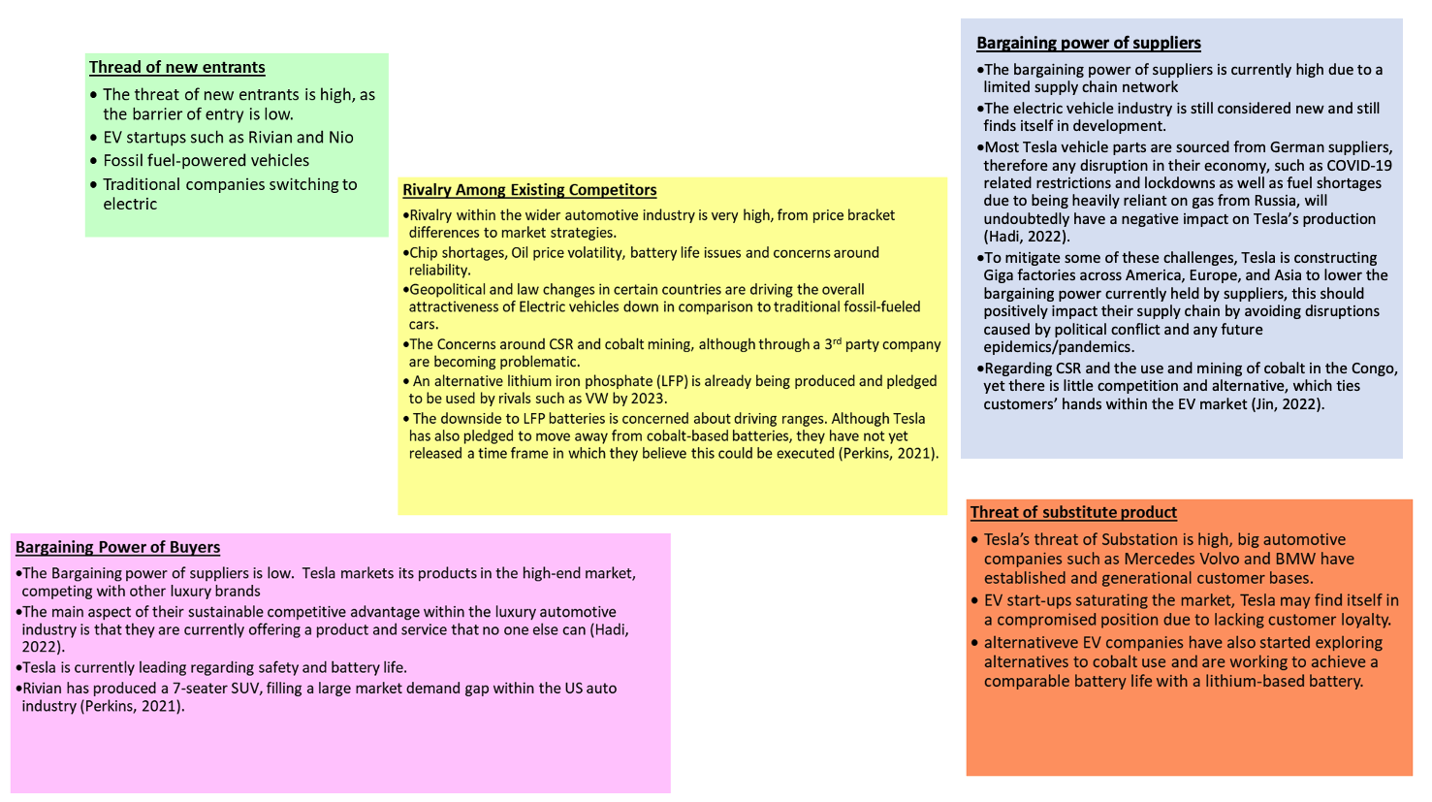

Figure 5 – New Vehicle Registration Data 2014 – 2021

Figure 6 – SWOT Analysis

Figure 7 – Segmentation, Targeting, Positioning Table

Figure 8 – Extended Marketing Mix

Figure 9 – Tesla Marketing Mix

Figure 10 – Customer Satisfaction results

